Assignment –7
Summarizing Data with Aggregate Functions.

- Write a query that counts all orders for October 3.
mysql> Select count(*) AS Total_Orders from ORDERS where Odate = '1990-10-03';
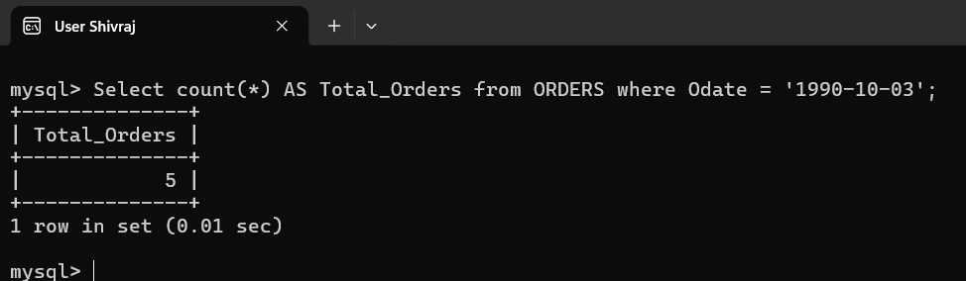

- Write a query that counts the number of different non-NULL city values in the Customers table.
mysql> Select Count(Distinct City) AS 'non-NULL city' from Customers;
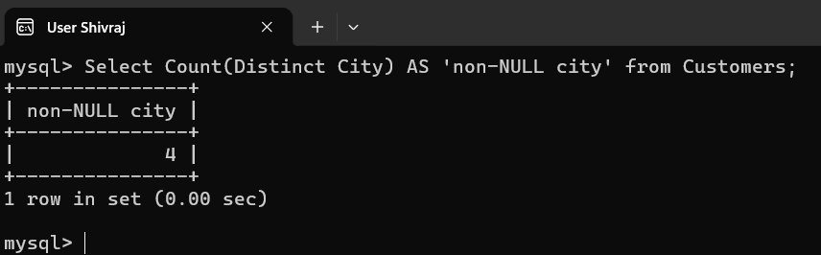

- Write a query that selects each customer’s smallest order.
mysql> Select Cnum,min(Amt) AS Smallest_Order from orders group by cnum order by cnum ;
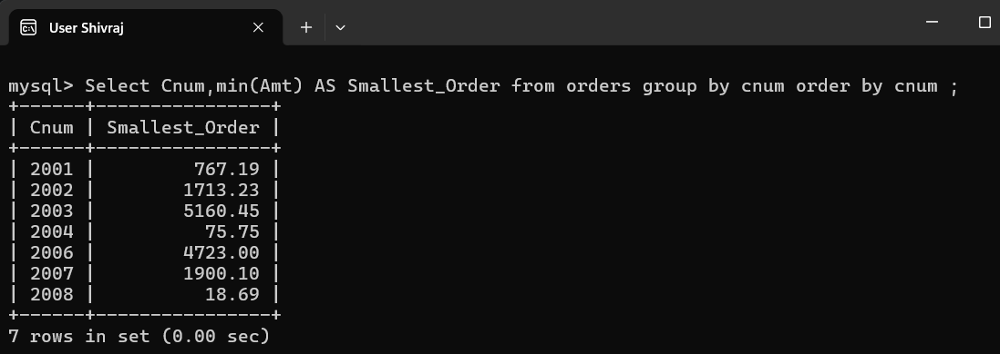

- Write a query that selects the first customer, in alphabetical order, whose name begins with G.
mysql> Select Cname from customers where Cname like 'G%' order by cname asc limit 1;
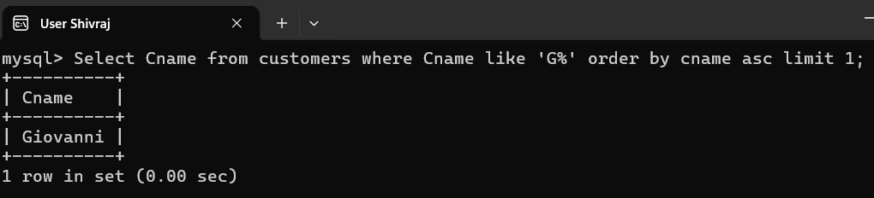
- Write a query that selects the highest rating in each city.
mysql> Select City,Max(Rating) AS Higest_Rating from customers GROUP BY CITY ;
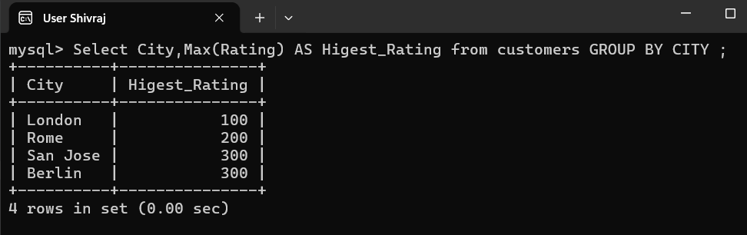

- Write a query that counts the number of salespeople registering orders for each day. (If a salesperson has more than one order on a given day, he or she should be counted only once.).
mysql> Select Odate,count(distinct snum) as Salespeople_count
-> from orders Group by Odate;
