Assignment –8
Formatting Query output.

1) Assume each salesperson has a 12% commission. Write a query on the orders table that will produce the order number, the salesperson number, and the amount of the salesperson’s commission for that order.
mysql> SELECT Onum, Snum, Amt*0.12 AS Commission
-> FROM orders;
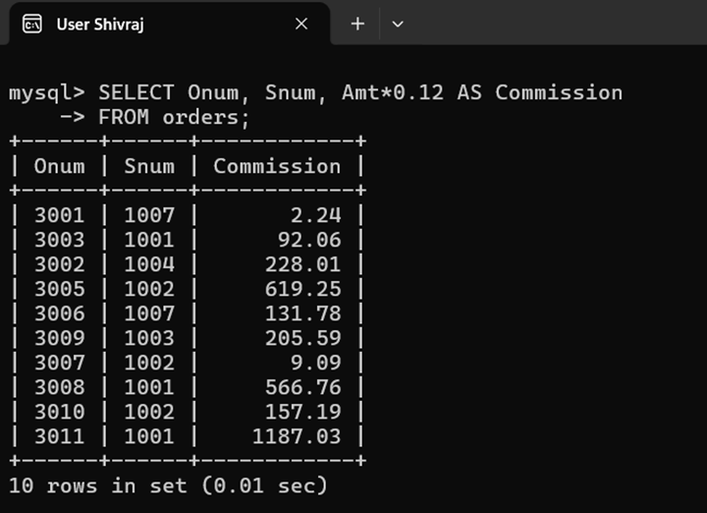

2) Write a query on the Customers table that will find the highest rating in each city. Put the output in this form:

For the city (city), the highest rating is : (rating).

mysql> SELECT CONCAT('For the city ', City, ', the highest rating is : ', MAX(Rating)) AS Result
-> FROM customers
-> GROUP BY City;
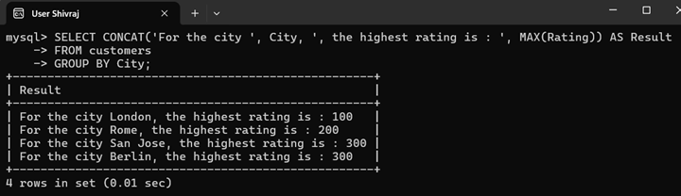

3) Write a query that lists customers in descending order of rating. Output the rating field first, followed by the customer’s name and number.
mysql> Select Rating , Cname, Cnum from Customers
-> Order by Rating desc;
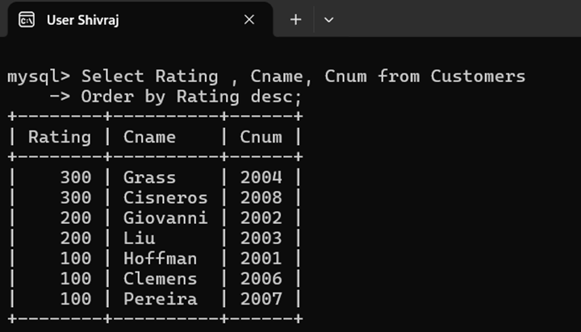

4) Write a query that totals the orders for each day and places the results in descending order.
mysql> SELECT Odate, SUM(Amt) AS Total_Orders
-> FROM orders
-> GROUP BY Odate
-> ORDER BY Total_Orders DESC;
