Assignment – 9 Querying Multiple Tables at Once.

- Write a query that lists each order number followed by the name of the customer who made the order.
SELECT o.Onum, c.Cname
-> FROM orders o
-> JOIN customers c ON o.Cnum = c.Cnum;
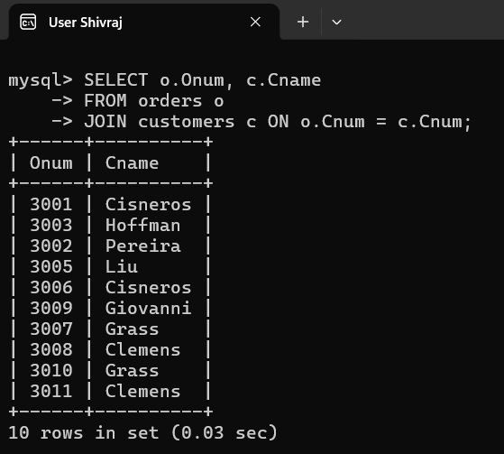

- Write a query that gives the names of both the salesperson and the customer for each order along with the order number.
SELECT o.Onum, c.Cname, s.Sname
FROM orders o
JOIN customers c ON o.Cnum = c.Cnum
JOIN salespeople s ON o.Snum = s.Snum;
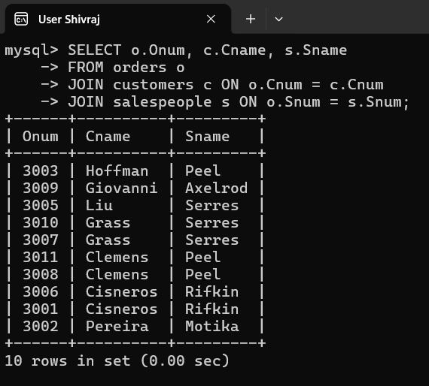

- Write a query that produces all customers serviced by salespeople with a commission above 12%. Output the customer’s name, the salesperson’s name, and the salesperson’s rate of commission.
SELECT c.Cname, s.Sname, s.Comm
FROM customers c
JOIN salespeople s ON c.Snum = s.Snum
WHERE s.Comm > 0.12;
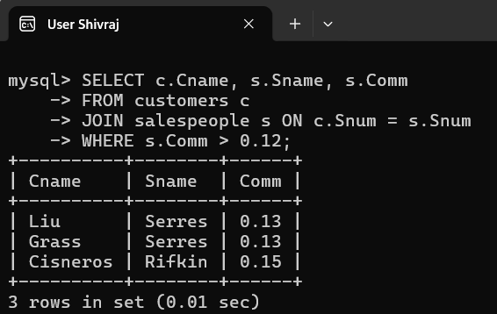

- Write a query that calculates the amount of the salesperson’s commission on each
order by a customer with a rating above 100.
SELECT o.Onum, s.Sname, (o.Amt * s.Comm) AS Commission
FROM orders o
JOIN customers c ON o.Cnum = c.Cnum
JOIN salespeople s ON o.Snum = s.Snum
WHERE c.Rating > 100;
