* **Master Server Installation**

**This section provides both pre-installation preparation information and detailed instructions for installing SysTrack on the master server. So that you can better understand the installation process, this section also includes an overview of the SysTrack architecture. After you have installed SysTrack, you can complete the SysTrack reporting configuration.  After installation is complete, refer to the SysTrack Agent Deployment Guide for deploying the Agent software to endpoints.**

1. **Install On-Premises Server**

To get started, follow these steps:

1. Download the provided installation package.

https://www.lakesidesoftware.com/product-briefs/introducing-systrack-90/

1. Extract the installation files to a location on your SysTrack master system.
2. Right-click the Setup application and select **Run as administrator** from the resulting menu.
3. A prompt may require a system restart before continuing the installation.
4. The installer should start back up automatically when the user logs back in.
5. Text

   Description automatically generatedAt the **Welcome dialog**, mark the checkbox to accept the terms in the Software License Agreement and simple click **Next**.
6. **Install Options**

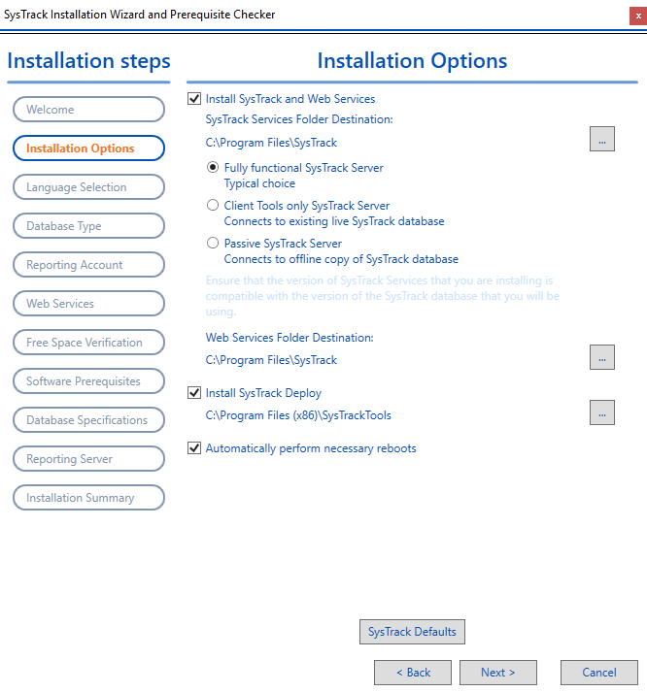There are several installation options to choose from in the Installation Options dialog. Default settings are selected in the following image.

1. **Language Selection**

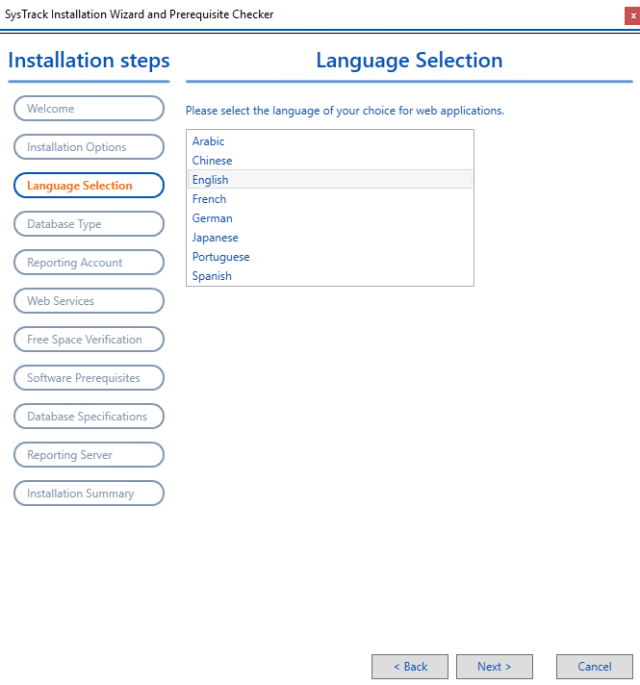In **language selection tab** select the language **English** to be used for SysTrack web-based applications. And click **Next.**

1. **Database Type**

In **Database Type** tab, configure SysTrack to use an existing SQL Server database or to install **SQL Server Express** for the SysTrack database. As a best practice, use the included SQL Express only for SysTrack installations that have fewer than 1500 endpoints. If you have an **existing SQL Server database** which has been configured prior to the SysTrack installation then select **Connect to existing SQL Server** to allow SysTrack services to connect the database.

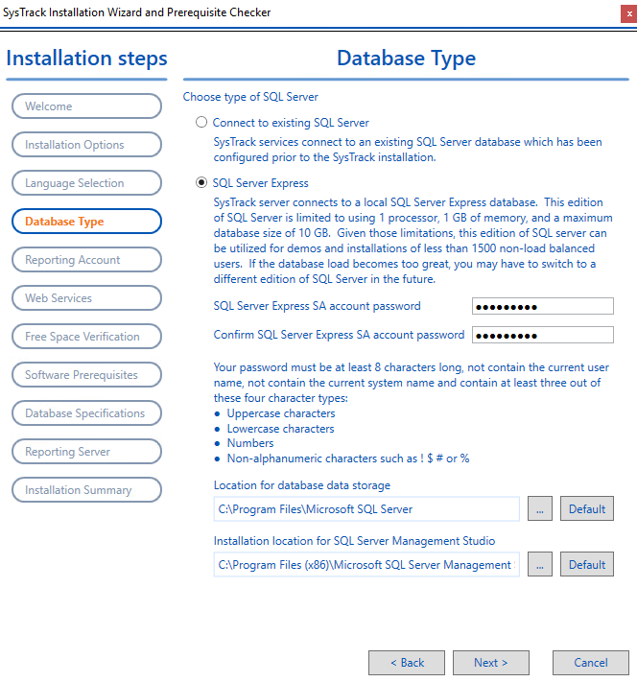

**Connect to Existing SQL Server Database**

If you have an existing **SQL Server database** which has been configured prior to the SysTrack installation, select **Connect to existing SQL Server** to allow SysTrack services to connect the database.

**SQL Server Express**

Select **SQL Server Express** to install SQL Server Express (installations of less than 1500 systems). The SQL Express installation installs the following features:

* SQL Server Database Engine (SQLEngine)
* Client tools, SQL Server Books Online components (Tools)
* Reporting Services components (RS)
* Microsoft has removed the installation of Microsoft SQL Server Management Studio (SSMS) from the main SQL Server installation process. SSMS will be installed separately.
* Set a **strong SA password** during setup.
* **Password** must be at least **8 characters long**.
* Must include 3 of 4: **uppercase, lowercase**, **numbers**, **special characters.**
* **Do not use: spaces, =, ;, ', "..**
* Click **Next** to proceed with installation.

1. **Reporting Account**

A Reporting User Account is needed to enable the following functionality:

* Use the **SysTrack reporting tools**, such as SysTrack Dashboard and SysTrack Visualizer.
* Access the **SQL Server Reporting Services** data source (to extract data from the SysTrack database for the reports).
* Execute **SQL requests** from **SysTrack dashboards** if you don’t specify connection information. **Open SSRS reports** from **SysTrack dashboards.**

**Add the Reporting User Account**

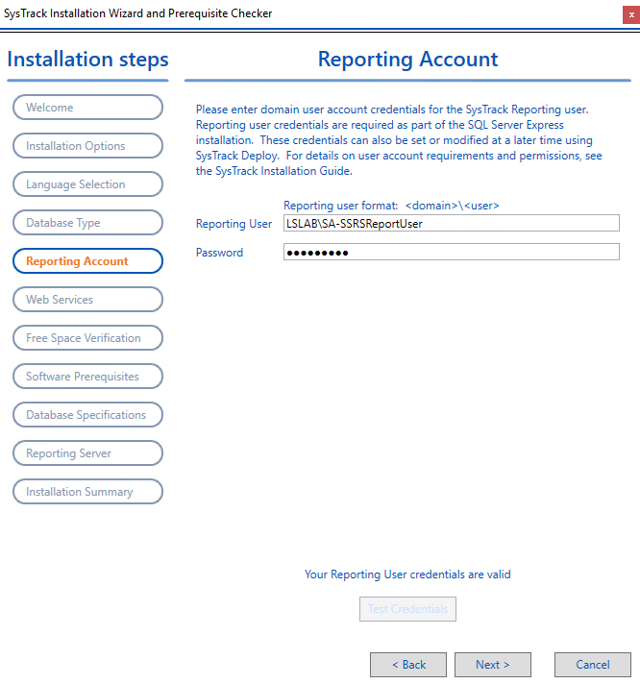

* 1. In **Reporting User**, enter a **Windows domain account** and **user name** in the following format: **<domain>\<user>.**
  2. Enter a **password.**
  3. Click **Test Credentials** to verify the credentials.
  4. Click **Next**.

1. **Web Services**
2. In Web Services logging path, keep the default path (C:\Logs) or enter a different path.
3. In IIS TLS Configuration, select one of the following:
   * Select the first option if a trusted certificate has already been created and installed on the local machine.  The Select Installed Certificate section at the bottom of the dialog shows valid certificates for SysTrack to use.
   * Select the second option to create a self-signed certificate. You must configure all client machines to trust that certificate for the clients to communicate with the server. You can do this by installing the certificate to the trusted certification authorities store on the client machines.

**NOTE:**To maintain STIG compliance when selecting either of the IIS TLS Configuration options, you must complete the Web Services Host Name field and enter the Web Services IP followed by :443 in the Web Services IP field.

* + The third option is available on SysTrack Upgrades where the certificate has already been configured. And click **Next.**

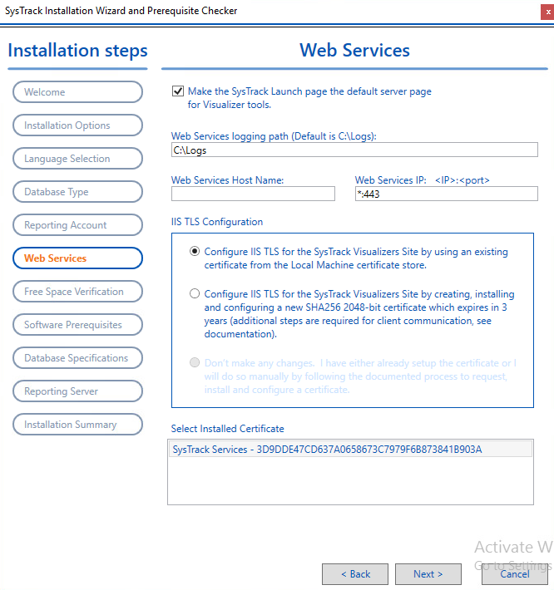

1. **Free Space Verification**

In Free Space Verification, wait while the space checker verifies if the system on which you are installing SysTrack has sufficient space and drive requirements.

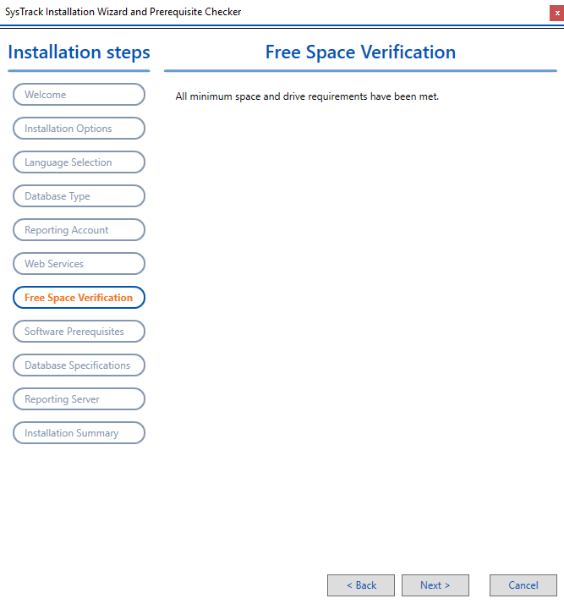

1. If your space requirements are met, click the **Next**.
2. If there is insufficient space to install SysTrack and its components, a message similar to the following example will display. Free up the minimum requirements or redirect SysTrack components to a different drive that has sufficient free space.

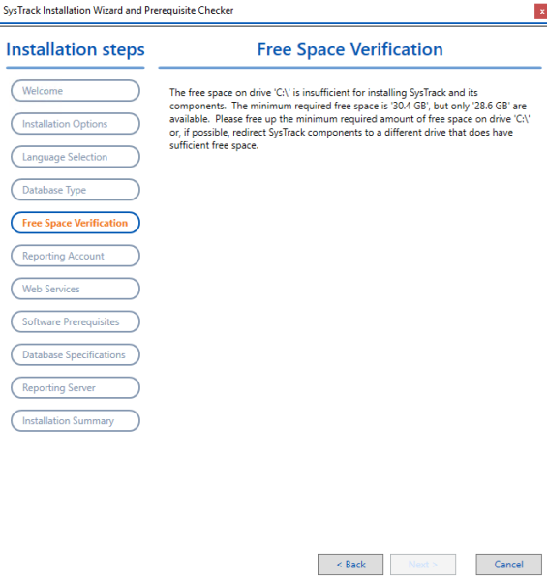

1. **Software Prerequisites**

At the Software Prerequisites dialog, the SysTrack installation determines which required software is already on the system and which software needs to be installed.

1. Run the prerequisite check. A list of prerequisites already installed and those that still need to be installed display.

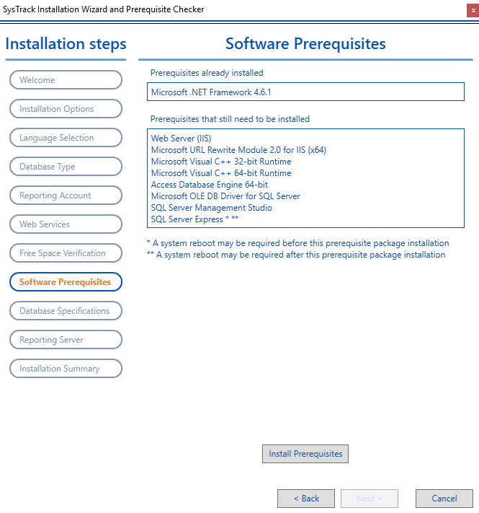

1. If prerequisites need to be installed, click the **Install Prerequisites**.
2. Click **Next**when the prerequisite check and/or installation process is complete.
3. **Database Specifications**
4. At the Database Specifications dialog, enter the account of the user that SysTrack should use when running services or accessing the SysTrack database.

**NOTE:**A Group Managed Service Account (GMSA) is the default and is recommended. Using Windows Domain Account with an expiring password will require manual updates of expired passwords on the SysTrack services and the SysTrack IIS App Pools.

1. Enter the name of your GMSA (make sure to include the dollar sign at the end) or Windows Domain account in the User field.

**NOTE:**GMSA account names always end in a dollar sign ($). Make sure you include the dollar sign when entering a GMSA account name.

* 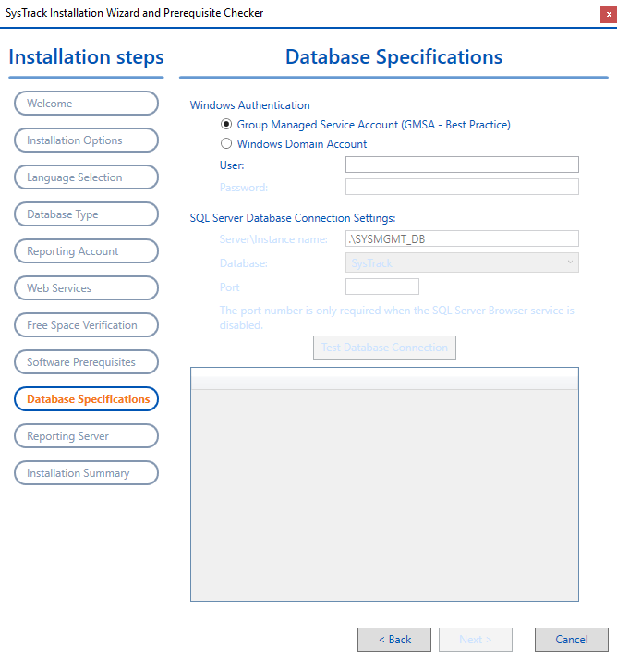If you are using the SQL Express option, the fields will be pre-populated with default information and the login and password you provided on the [Database Type dialog.](https://documentation.lakesidesoftware.com/en/Content/Installation/OnPrem/SysTrackMasterSysInstall/Installing%20SysTrack.htm?tocpath=On-Premises%7COn-Premises%2010.x%20Releases%7CInstallation%20for%20On-Premises%7CMaster%20Server%20Installation%7C_____1#databasetype)
* If you selected the Connect to existing SQL Server option, specify the Login, Password, and Database you created during the [database preparation.](https://documentation.lakesidesoftware.com/en/Content/Installation/OnPrem/SysTrackMasterSysInstall/Pre%20Installation%20Preparation.htm#databasepreparation)

1. Click **Test Database Connection**. The SysTrack Installation verifies the database connection and displays a status progress table.

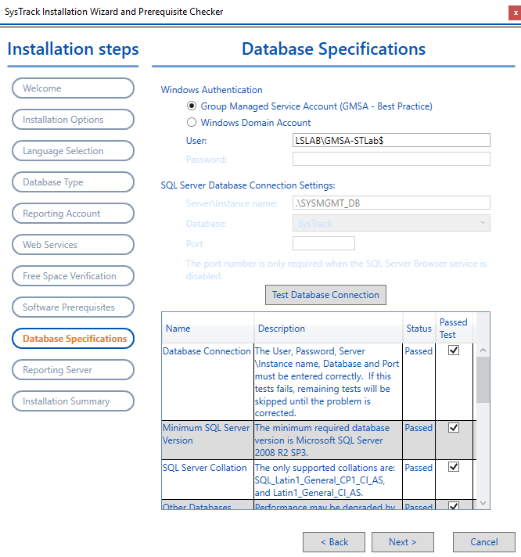

1. If any of the database specifications do not pass the test, follow the recommendations listed in the Description column next to the failed item(s).
2. To continue with the installation process, click **Next**.

**10. Reporting Server**

A SQL Report Server is the central component of a Microsoft SQL Server Reporting Services (SSRS) installation. Using a SQL Report Server allows you to display various reports in SysTrack applications such as SysTrack Visualizer and Transform. Information about installing SSRS is included in [Pre-Installation Preparation.](https://documentation.lakesidesoftware.com/en/Content/Installation/OnPrem/SysTrackMasterSysInstall/Pre%20Installation%20Preparation.htm#preinstallation)

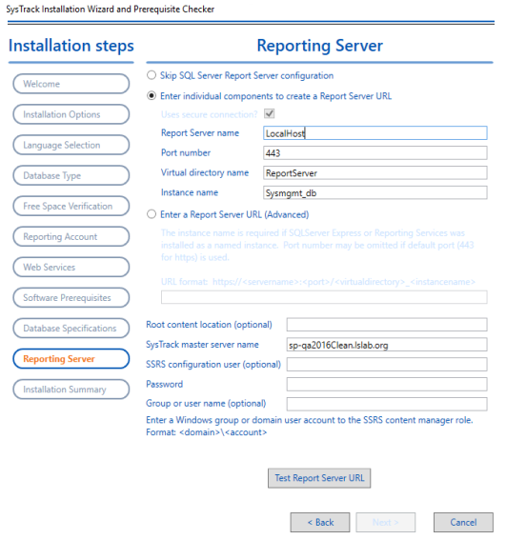**If you are using a SQL Report Server, you need to set up your report server and ensure that it is working correctly.**

1. Choose from one of the following:
   * Select **Enter individual components** to create a Report Server URL option and then complete the information for each field for this option.
   * If you know your report server’s URL, select the Enter a Report Server URL option, and then enter the URL in the provided field.
2. Enter an optional SSRS configuration user account to be used as a reporting account for a successful connection test to the report server.
3. Enter a password.
4. (Optional) Enter a windows domain user or group account to the SSRS Content Manager role in the Group or user name field.
5. Click **Test Report Server URL** to verify the connection.
6. Click **Next**.

**11. Installation Summary**

1. In Installation Summary, click **Process Selections** to proceed with the installation.

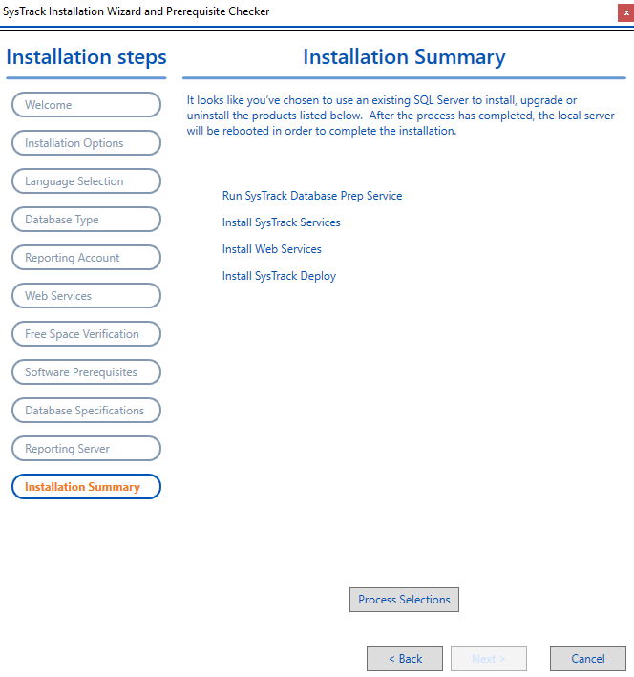

1. Wait while the SysTrack services, Web Services, and Administrative tools (SysTrack Deploy) install.

**NOTE:** The system will reboot to complete the installation.

**Dashboards**

SysTrack dashboards are installed with SysTrack and provide customized views of real-time data, allowing insights into SysTrack data as well as external databases. Dashboards can display this data in a variety of formats, including a grid, different types of charts, gauges, and other visualizations. The user can interact with the dashboard by providing input on selections, modifying filter criteria, and customizing information displayed in the charts.

**Dashboard Viewer**

SysTrack dashboards can be viewed from the SysTrack Dashboard Viewer.

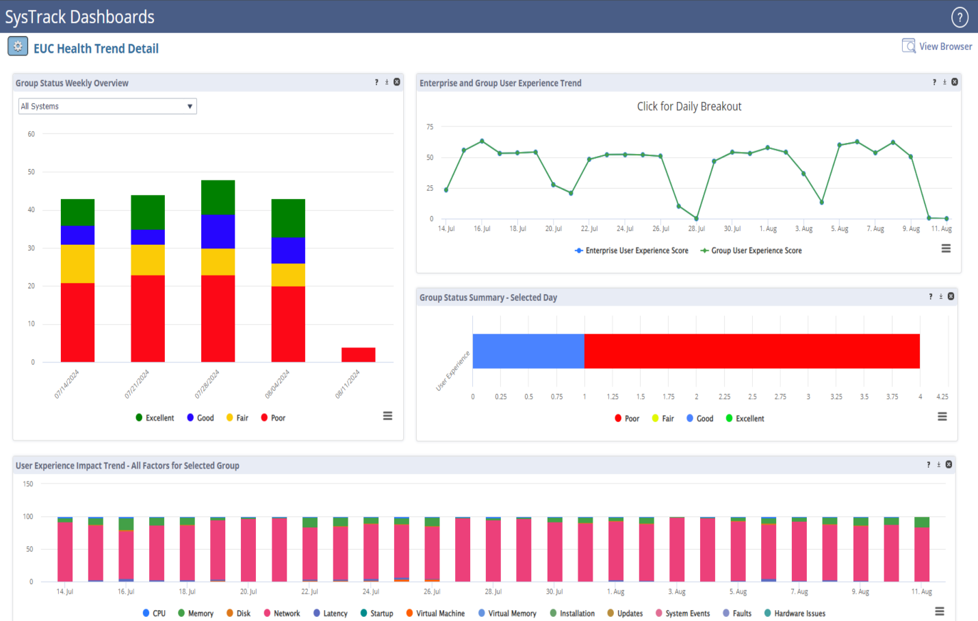

**Dashboard Builder**

Dashboards are created using the [Dashboard Builder](https://documentation.lakesidesoftware.com/en/Content/Dashboard/Builder_Intro/Builder_Intro.htm).

**NOTE:**Access to the SysTrack Dashboard Builder is dependent on your security privileges as set up by your System Administrator in SysTrack Deploy.

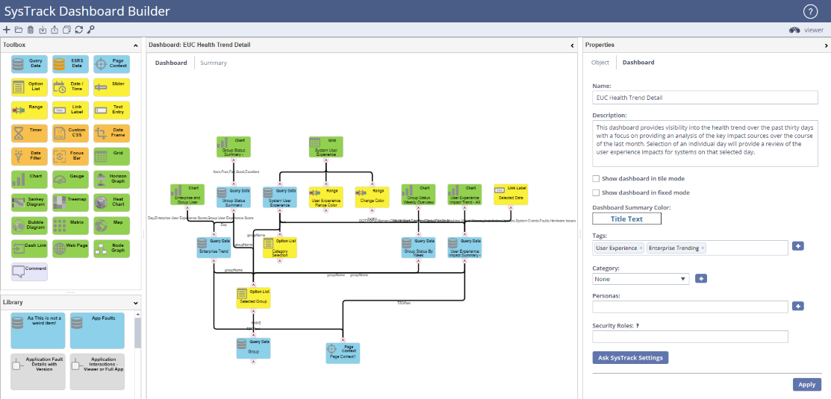

**Build SysTrack Dashboards**

The SysTrack Dashboard Builder provides a means for IT professionals to easily create, save, share and refine custom views of any of the data available to them in their enterprise in a way that is easily accessible to a viewer.

Dashboards are built by using a variety of data blocks and visualization objects on the Dashboard workspace, defining each object's properties, and linking them.

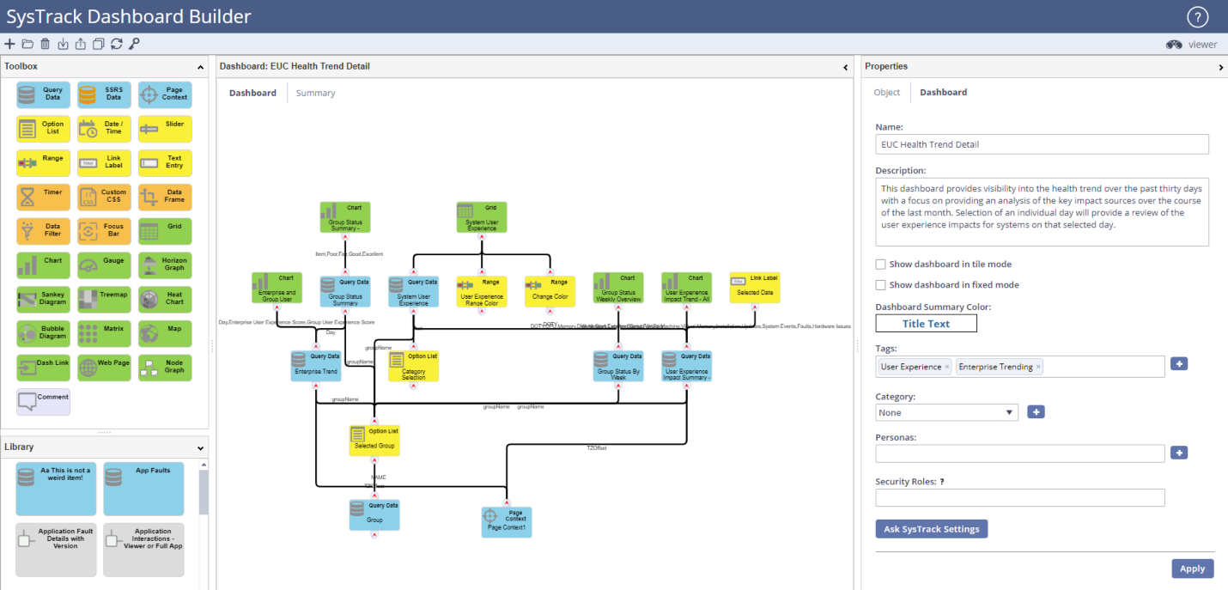

**Build a Basic Dashboard**

Dashboards are built by dragging [data blocks and visualization objects](https://documentation.lakesidesoftware.com/en/Content/Dashboard/Blocks_Objects/Blocks_Objects_Intro.htm) from the Toolbox to the workspace, defining each object's properties, and [linking](https://documentation.lakesidesoftware.com/en/Content/Dashboard/Create_Dashboards/Linking_blocks.htm) them to one another. Before you begin, familiarize yourself with the [Dashboard Builder workspace.](https://documentation.lakesidesoftware.com/en/Content/Dashboard/Builder_Intro/Builder_workspace.htm)

1. Drag a [Query Data block](https://documentation.lakesidesoftware.com/en/Content/Dashboard/Blocks_Objects/Query_Data_Block.htm) to the workspace and define the Query Data block as necessary. The Query Data block retrieves data based on a SQL query and makes it available to a grid or other visualization objects. For users who are not completely familiar with writing SQL queries, the Query Data block also includes a [Query Builder](https://documentation.lakesidesoftware.com/en/Content/Dashboard/Create_Dashboards/Query-Builder.htm) to help you build a SQL query to access SysTrack data.
2. Drag a visualization object block to the workspace (for example, a grid, gauge etc).
3. 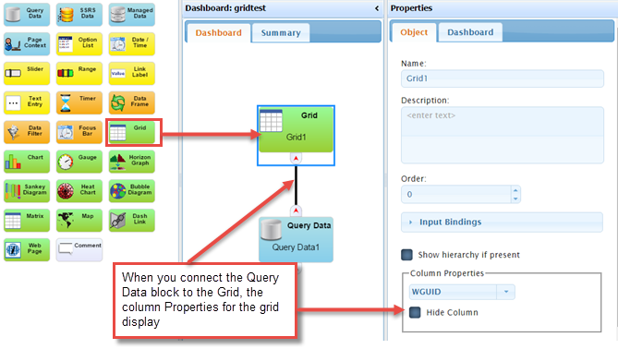[Connect the Query Data Block to the visualization object](https://documentation.lakesidesoftware.com/en/Content/Dashboard/Create_Dashboards/Linking_blocks.htm) to supply data input to the visualization object.
4. Open the [Input Bindings](https://documentation.lakesidesoftware.com/en/Content/Dashboard/Create_Dashboards/Input_Bindings.htm) section, and if necessary select an input. The **Input Bindings** section may be populated automatically if there is only one possible input for the type of object being linked.
5. Set the **Properties** for the visualization object on the **Object** tab (such as the **Column Properties** in the example above).
6. Optionally, supply an **Order** for where on the Dashboard you want the grid to display.
7. Optionally, rename the visualization object block in the **Name** field, and provide a **Description**. The name will appear in the visualization object's title bar when the dashboard is viewed.
8. Click the **Apply** button on the **Dashboard** tab to save your changes.
9. Optionally, select the **Dashboard** tab, then add a **Name** and **Description** and select a **Dashboard Summary Color**. The dashboard name and description will display in any link to the dashboard, such as the Dashboard Browser. The Dashboard Summary Color will be used in the [Dash Link object](https://documentation.lakesidesoftware.com/en/Content/Dashboard/Blocks_Objects/Dash_Link.htm)when it displays a link to this dashboard.
10. 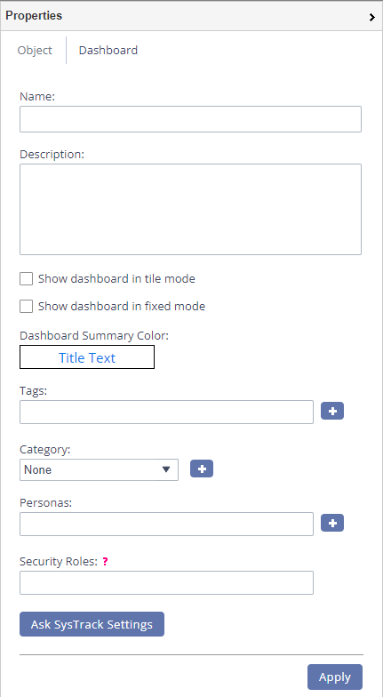Optionally, either select or define any [search tags](https://documentation.lakesidesoftware.com/en/Content/Dashboard/Create_Dashboards/Tags_defining.htm), [categories](https://documentation.lakesidesoftware.com/en/Content/Dashboard/Create_Dashboards/Categories_defining.htm), or [personas](https://documentation.lakesidesoftware.com/en/Content/Dashboard/Create_Dashboards/Personas_defining.htm) you want to include with your dashboard.
11. If you wish to display your dashboard in [Tile mode](https://documentation.lakesidesoftware.com/en/Content/Dashboard/Create_Dashboards/Tile_Mode_Using.htm) select the **Show dashboard in tile mode** check box.
12. If you wish to restrict access to this Dashboard in the Dashboard Viewer select a security role (group or user) from the drop-down list in the **Security Roles** field. Leave this field blank if you wish all Dashboard Viewer users to have access to your dashboard.
13. [Preview your dashboard](https://documentation.lakesidesoftware.com/en/Content/Dashboard/Create_Dashboards/Display_Dashboard_Builder.htm) to see how it displays in the Dashboard Viewer.

**Preview a Dashboard from Dashboard Builder**

Click the **View Dashboard**  icon in the top right corner of the Dashboard Builder page.

To return to the Dashboard Builder from Dashboard Viewer, click the back button in your browser.

**Create a Summary Dashboard**

You can create a summary dashboard composed of dash link panes each of which links to a specific dashboard as shown in the example below.

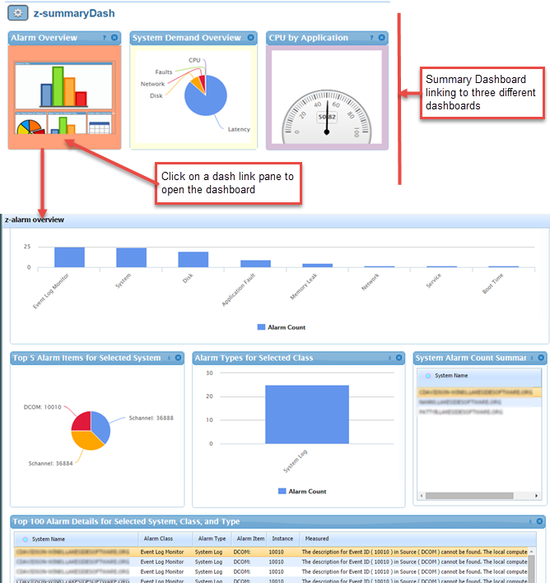

**You can choose to display the following on a summary Dash Link pane:**

* Alternate between displaying a description of the dashboard and a stylized thumbnail
* Alternate between displaying a dashboard description and summary data from a grid, chart, or gauge
* Display only summary data from a Grid, Chart, or Gauge with no alternating description

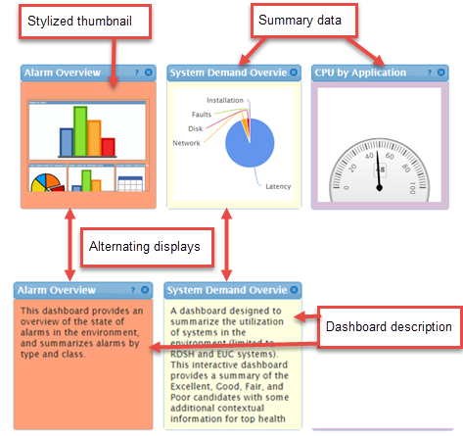

**Create a Summary Dashboard for Linked Dashboards**

1. [Define a Dash Link block](https://documentation.lakesidesoftware.com/en/Content/Dashboard/Blocks_Objects/Dash_Link.htm) on your workspace for each dashboard to which you wish to link.

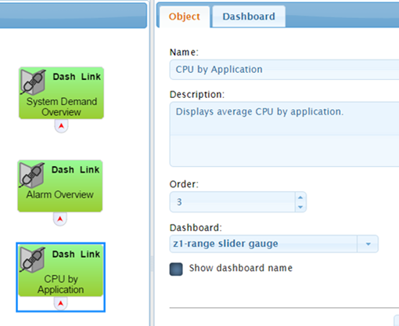

1. Optionally, display summary data on a Dash Link pane:
   1. Open the dashboard to which you wish to link, and click the **Summary** tab.
   2. Using the Data blocks available in the Summary tab Toolbox, build a dashboard for the summary information that you wish to display.

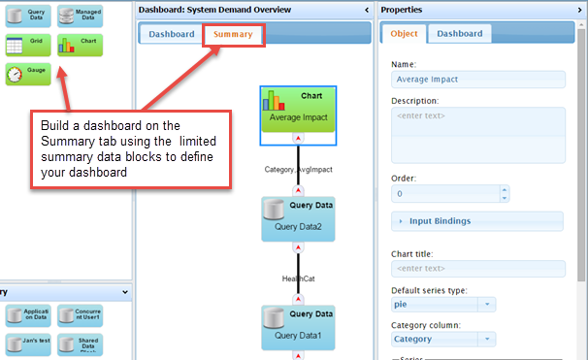

1. If you wish to display a description for your dashboard link, enter a description in the **Description** field on the **Dashboard** tab for the dashboard to which you are linking

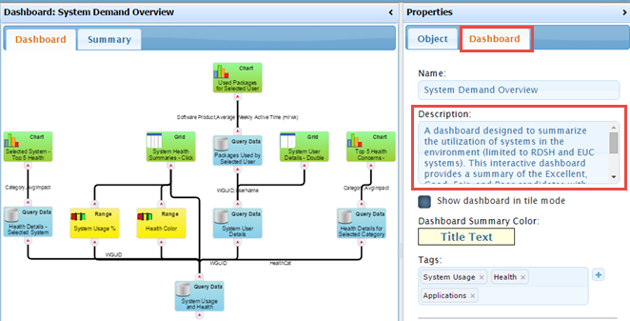

1. Optionally, click the **Dashboard Summary Color** button to select a color to use as the background color for the Dashboard Link Pane.
2. Click **Apply** to save your changes.
3. Repeat steps 2 - 5 for each dashboard to which you wish to link from a Dash Link block.

**1E Dashboards**

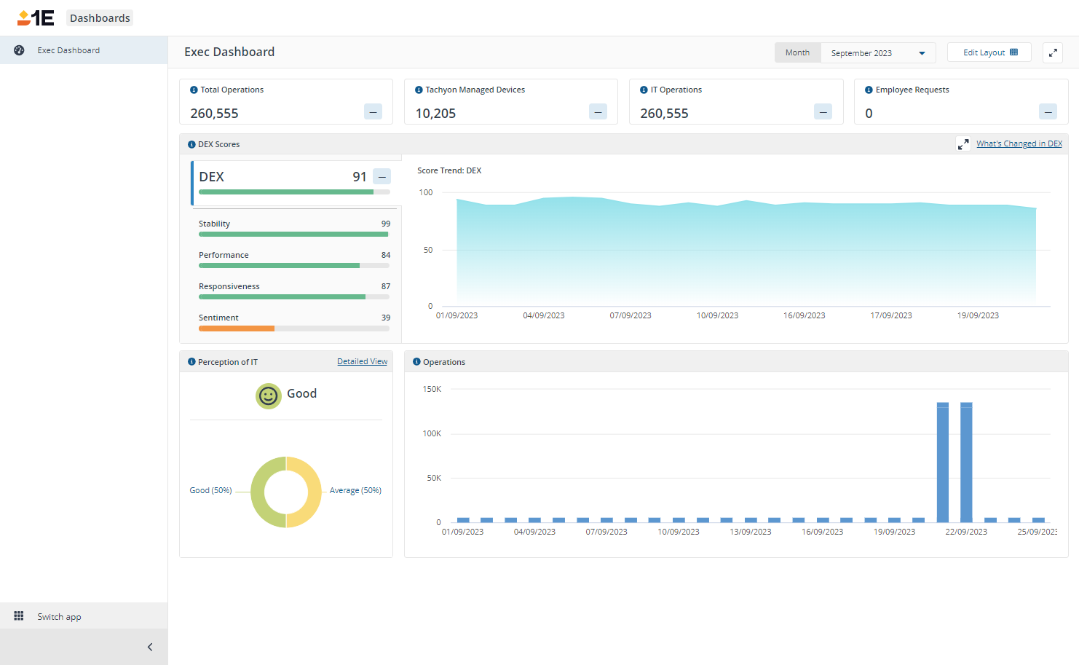Over time, 1E Dashboards will introduce a number of overview dashboards that will give top-level information on the performance of an organization regarding various aspects of their business as measured by 1E platform applications..

In many organizations, the ability to gain insight into your DEX KPIs involves gathering data from multiple applications and departments, then analyzing and correlating it to determine if the user experience and sentiment are trending up or down. A bigger challenge is understanding if the tools and processes you have in place are improving end-user productivity.

Exec Dashboard presents your DEX score and key metrics on a single pane of glass in an easily consumable format. It also provides data on the adoption and usage of the various platform components, so you can quickly see how it is benefiting both end-user productivity and issue resolution. When combined with a measure of employee perception of your IT department - via Sentiment surveys, you are able to quickly see trends impacting DEX across your organization.

The Exec Dashboard displays insights into the following areas:

* Coverage – Volumetric Data (how much is being managed/covered by 1E)
* Experience Insights – Actual Values and Trends that influence your DEX score, including employee perception of IT.

**Exec Dashboard**

The CIO wants to ensure that their IT department is supporting the business goals of the company. Using the information displayed in the Exec Dashboard, the Exec DashboardCIO delegates tasks to IT managers in order to focus on high-level IT strategy and growth. The provides a focused set of charts that give them the big picture without overwhelming detail, so they can initiate the right conversations with their IT team. The Exec Dashboard shows the following information:

* Summary tiles, each tile displays a number that indicates:
  + **Total Operations** - the total number of issues that were resolved during the selected calendar month by: manual actions, automated policy fixes (resolved using Endpoint Automation policies), ITSM actions (service desk tickets), actions (requested using the Virtual Assistant chatbot), and other self-service requests made by end-users
  + **Tachyon Managed Devices** - the number of devices where the installed 1E Client has contacted 1E platform during the selected calendar month
  + **IT Operations** - the number of issues resolved by manual actions and automated policy fixes (resolved via Guaranteed State Policies)
  + **Employee Requests** - the number of issues resolved by ITSM actions, Virtual Assistant actions, and other self-service requests made by end-users.
* **DEX Scores** - you can use this as an indicator of how well your IT systems are working for your end-users.
  + A summary chart showing the Experience Analytics related overall DEX score and individual Stability, Performance, Responsiveness, and Sentiment scores during the selected calendar month.
  + **Score Trend: DEX** - A chart plotting the overall daily DEX scores during the selected calendar month.
  + The CIO can also select to view details on **What's Changed in DEX**. This displays a drawer showing the top 10 largest deltas, up or down, for Experience metrics that have changed during the selected calendar month.
* **Perception of IT** - a tile that shows the feedback given by end-users about their experience of IT services. It consists of averaged responses to the **Perception Of IT** sentiment survey
  + Displayed at the top of the tile, the total average of all the responses during the selected calendar month as it falls into one of the Very Good, Good, Average, Poor and Very Poor response ranges.
  + Displayed beneath that, a donut chart showing the average scores per user - according to which of the five response ranges each user's average falls within - plotted as a percentage of the total number of users that responded.
  + The CIO can also select to view details on the survey responses by clicking on the **Detailed View** link.
* **Operations** - a bar chart showing, for each day in the selected calendar month, three bars that represent: the Actions, Policy Fixes, and ITSM, Virtual Assistant & Self-service operations that took place on that day.