**List of Commands.**

1. **Get Registry Key:-**

* **Retrieves value names and value data for a specified registry key or optionally, a specific value.**

Get-RegistryKey -Key 'HKLM:SOFTWARE\Microsoft\Windows\CurrentVersion\Uninstall\{1AD147D0-BE0E-3D6C-AC11-64F6DC4163F1}'

1. Get-RegistryKey -Key 'HKLM:SOFTWARE\Microsoft\Windows\CurrentVersion\Uninstall\{1AD147D0-BE0E-3D6C-AC11-64F6DC4163F1}'
2. Get-RegistryKey -Key 'HKLM:Software\Wow6432Node\Microsoft\Microsoft SQL Server Compact Edition\v3.5' -Value 'Version'
3. Get-RegistryKey -Key 'HKEY_LOCAL_MACHINE\SYSTEM\CurrentControlSet\Control\Session Manager\Environment' -Value 'Path' -DoNotExpandEnvironmentNames
4. Get-RegistryKey -Key 'HKEY_LOCAL_MACHINE\SOFTWARE\Microsoft\Example' -Value '(Default)'

**2) Set-IniValue**

* **Opens an INI file and sets the value of the specified section and key.**

Set-IniValue -FilePath "$envProgramFilesX86\IBM\Notes\notes.ini" -Section 'Notes' -Key 'KeyFileName' -Value 'MyFile.ID'

1. **Set-ADTIniValue**

* **It allows you to set a value within a specified section and key in an INI file.**

Set-ADTIniValue -FilePath “$envProgramFilesX86\IBM\Notes\notes.ini” -Section “MySection” -Key “MyKey” -Value “MyValue”

1. **Create/Delete/Modify Registry**

**Create a New Key:**

New-Item -Path “HKLM:\Software\MyCompany” -Type Directory -ErrorAction SIlentlyContinue

**Delete a Key:**

Remove-Item -Path “HKLM:\Software\MyCompany” -Recurse -Force -ErrorAction SIlentlyContinue

**Set a Registry Value:**

Set-ItemProperty -Path “HKLM:\Software\MyCompany\MyKey” -Name “MyValue” -Value “MyData”

**Get a Registry Value:**

Get-ItemProperty -Path “HKLM:\Software\MyCompany\MyKey” -Name “MyValue”

1. **Start/Stop Services in psadt.**

**Stop a Service:**

* **Use the Stop-Service cmdlet with the -Name parameter to specify the service name.**

Stop-Service -Name "YourServiceName”

**Start a Service:**

* **Use the Start-Service cmdlet with the -Name parameter to specify the**

**service name.**

Start-Service -Name "YourServiceName”

**Force Stop(if dependencies are present):**

* **Use the -Force parameter with Stop-Service to stop a service even if it has dependent services.**

Stop-Service -Name "YourServiceName” -Force

**Stop with Dependencies:**

* **Use the Stop-ADTServiceAndDependencies function to stop a service and its dependent services.**

Stop-ADTServiceAndDependencies -Name "YourServiceName”

**Start with Dependencies**

* **Use the Start-ServiceAndDependencies function to start a service and its dependent services.**

Start-ServiceAndDependencies -Name "YourServiceName”

**Chrome MSI Deploy Steps**

**Downloading Chrome Setup:**

1. Open any browser and search for Chrome MSI download
2. Link- [Enterprise Browser Download for Windows & Mac - Chrome Enterprise](https://chromeenterprise.google/download/?ref=learnintune.net)
3. Download the Chrome Setup with .msi Extension

**Download PSADT:**

1. From Github download **PSAppDeployToolkit_Template_v4.zip**
2. Link- <https://github.com/PSAppDeployToolkit/PSAppDeployToolkit/releases>
3. Extract this zip file and rename it as **GoogleChrome**
4. In GoogleChrome folder inside **Files** directory put our .msi file

**Open Invoke-AppDeployToolkit:**

1. Navigate to C:\Users\admin\Downloads\GoogleChrome\PSAppDeployToolkit\Frontend\v4
2. Open the **Invoke-AppDeployToolkit.ps1** file in Notepad and Press Ctrl+F and search for VARIABLE and come into the Variable **Declaration** section
3. Enter all the values as shown in the picture
4. Now go to the Installation section and write the command
5. Now go to the Uninstallation section and write the command

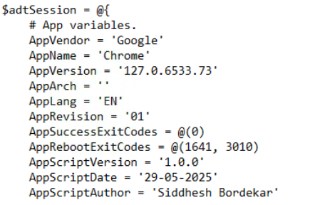

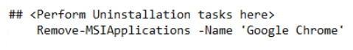

**Open Command Prompt(Run as Administrator):**

1. Navigate to **Downloads** directory and write the command **PsExec.exe -s cmd.exe**
2. After this again navigate to v4 directory inside our GoogleChrome Folder
3. Inside v4 write **.\Invoke-AppDeployToolkit.exe Install** command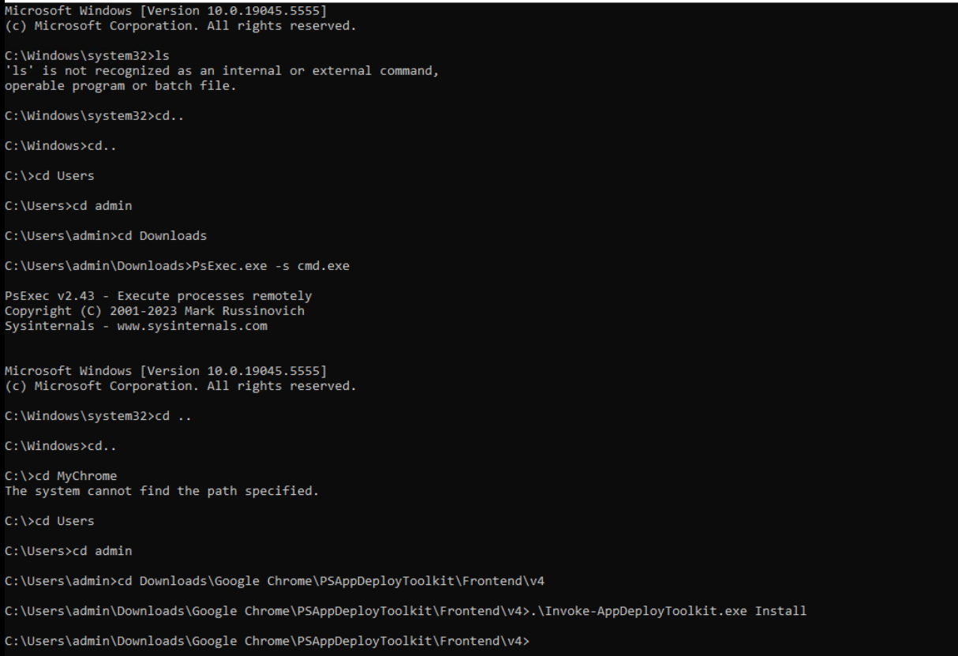

**Run the Invoke-AppDeployToolkit.exe file:**

1. Open GoogleChrome folder and open **Invoke-AppDeployToolkit.exe** file
2. Click on Install when Chrome Installation Wizard opens

