***Steps for Creating a Package using MSIX Packaging Tool***

**Steps:**

1. Download **MSIX Packaging Tool** from Microsoft Store
2. Open MSIX Packaging Tool and in **Select Task** select **Application Package**

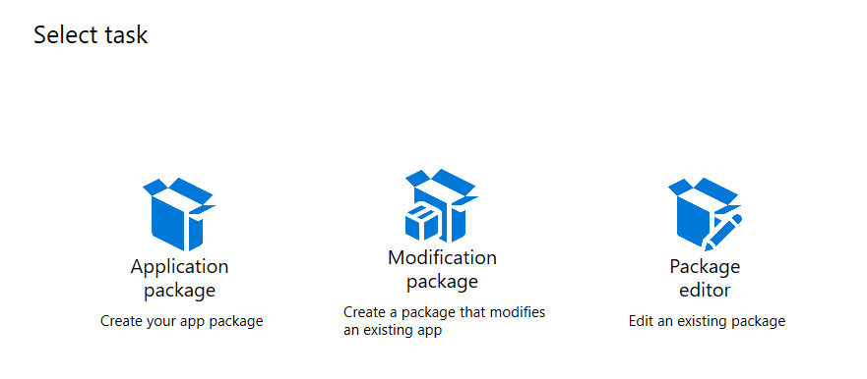

1. In **Select environment** tab, select first radio button **Create package on this computer** and click **Next**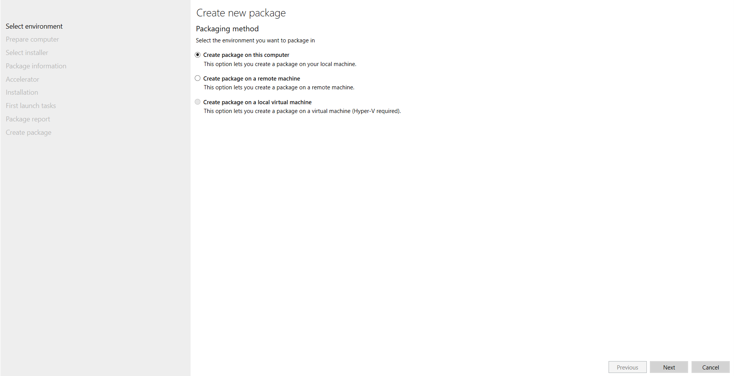
2. In **Prepare computer** tab, after the status shows **Installed**, at the bottom click on checkbox **Windows Search is active** and click **Next**

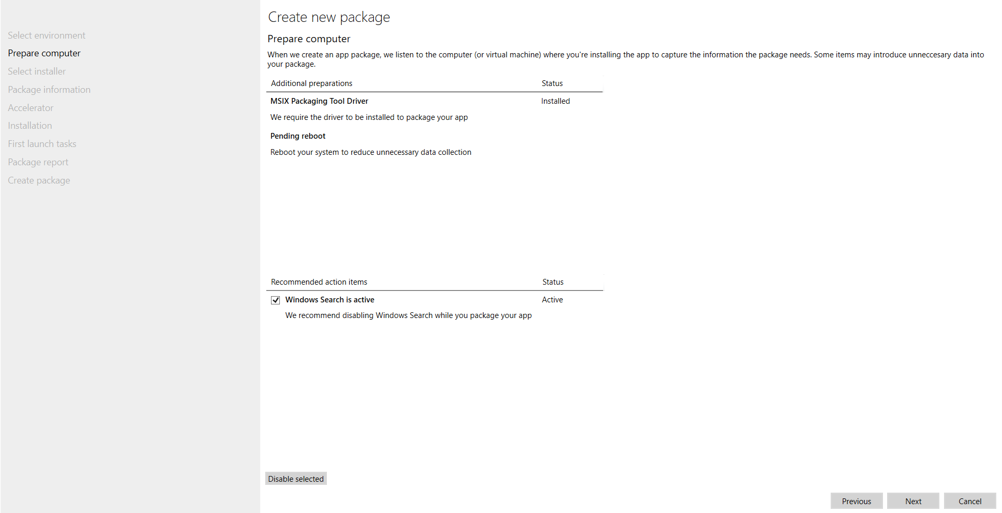

1. In **Select installer** tab, browse our **.msi file (Firefox Setup 139.0.1.msi)** and in **Signing preference** dropdown select **Do not sign package** and click **Next**

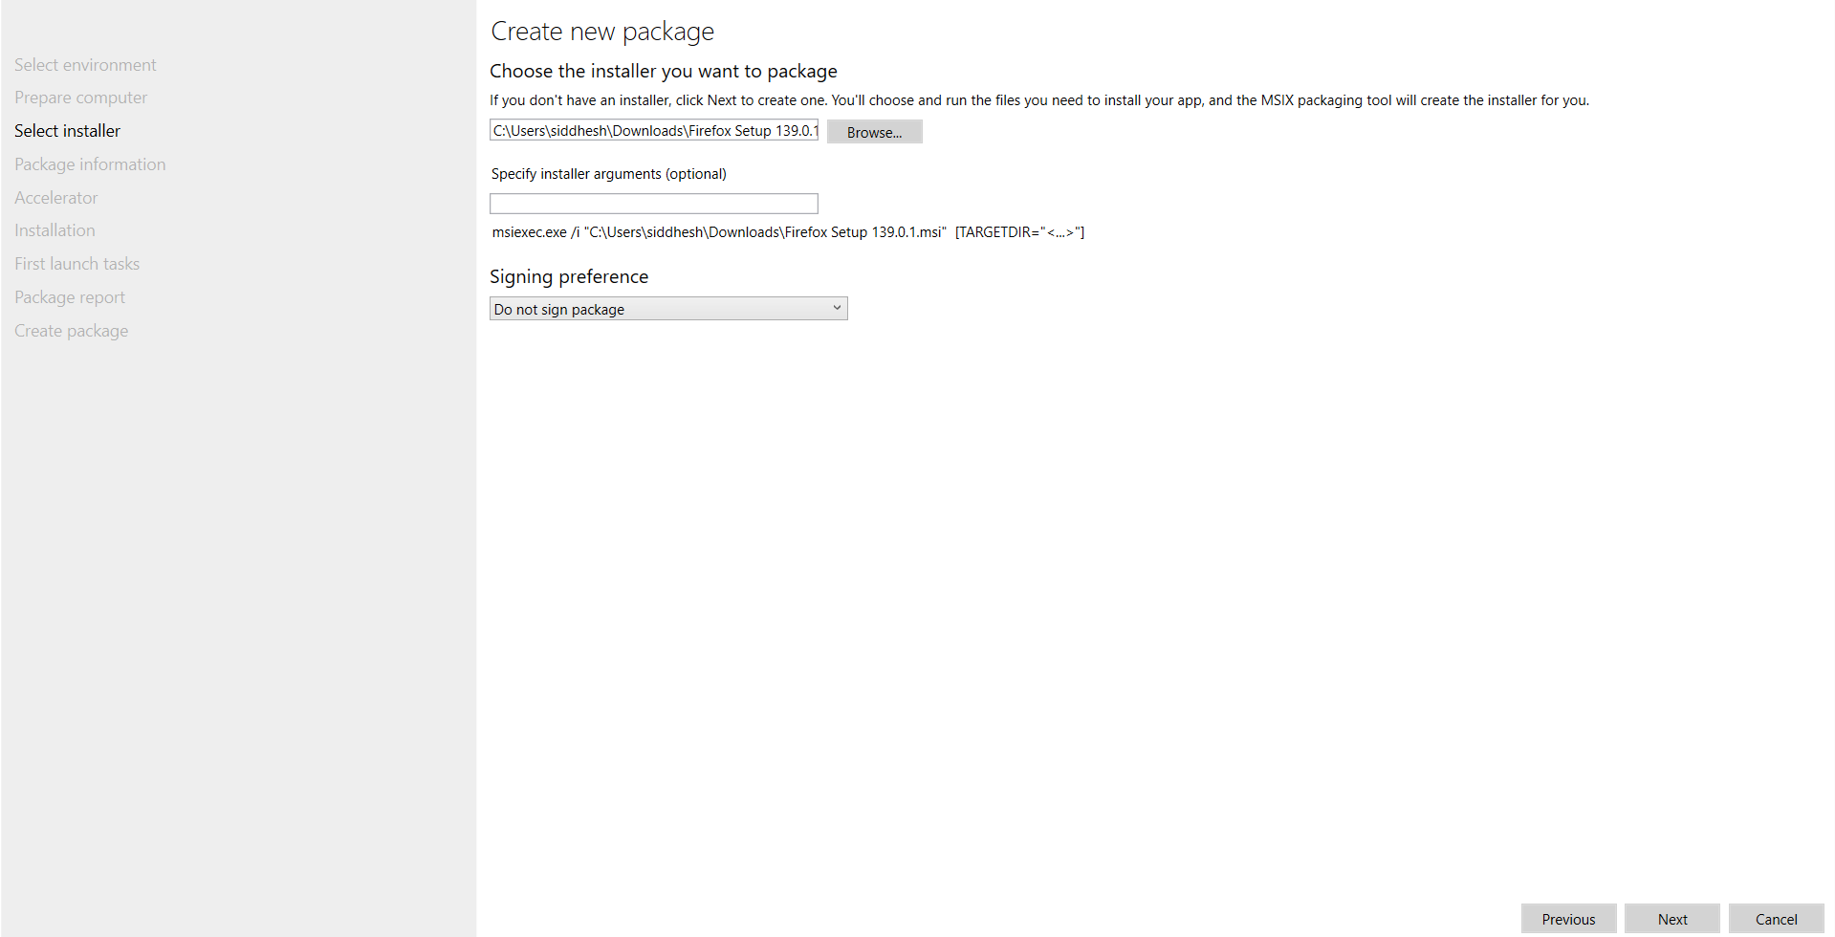

1. In **Package information** tab, in the **Publisher name** textbox write **CN=Mozilla** and click on checkbox **Add support for MSIX Core to this package** and in dropdown select **Windows 10 2016 LTSB (1607) (10.0.14393.0)** and click **Next**

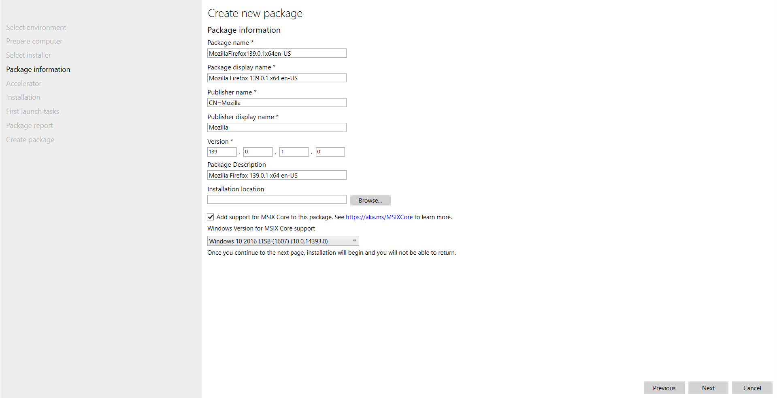

1. In **Accelerator** tab, do nothing and click **Next**

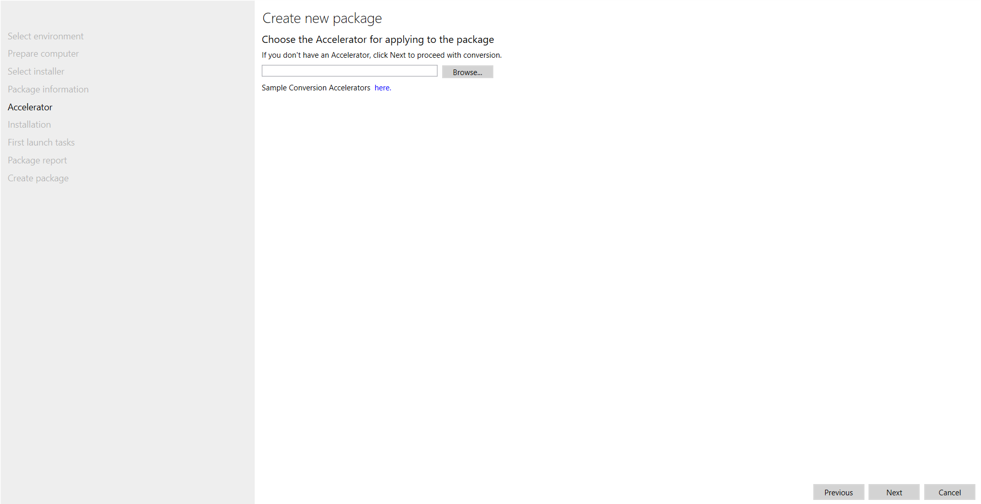

1. In **Installation** tab, do nothing and click **Next**

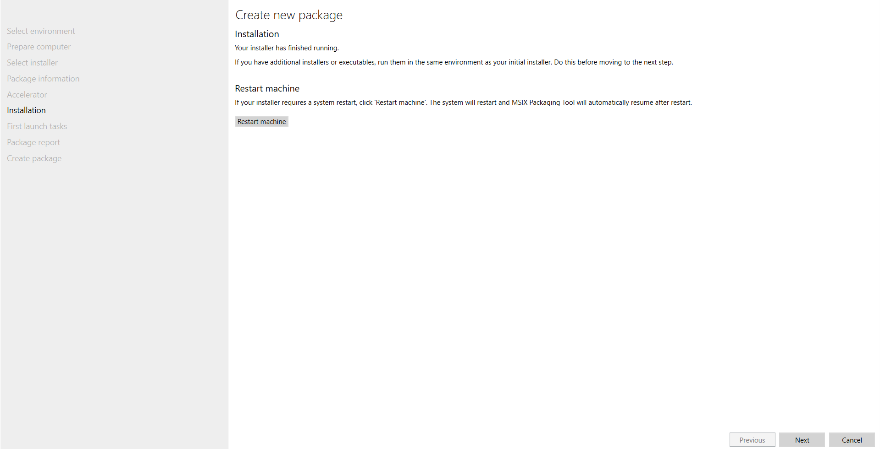

1. 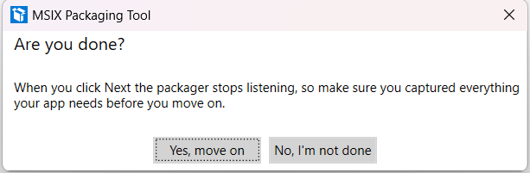In **First launch tasks** tab, do nothing and click **Next** and then a small popup comes asking **Are you done?** so click **Yes, move on** button

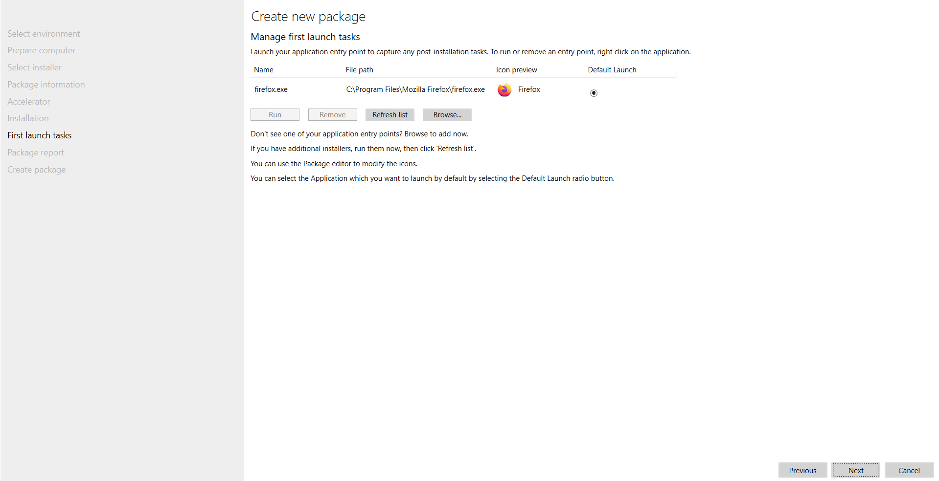

1. In **Package report** tab, do nothing and click **Next**

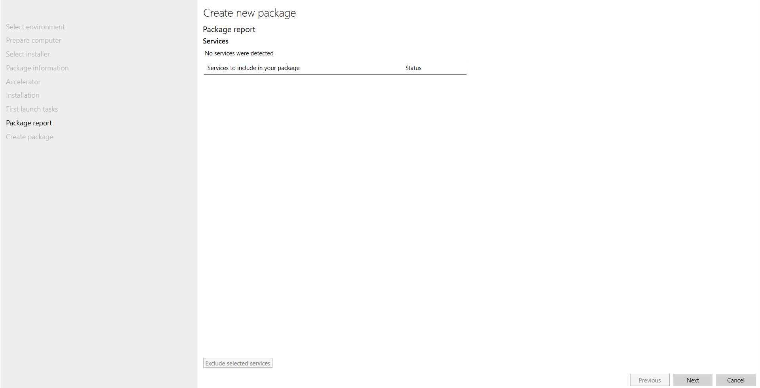

1. 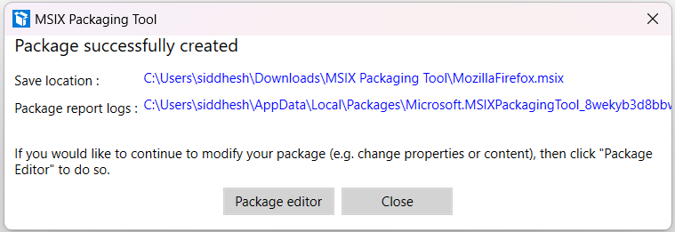In **Create package** tab, browse the path where we want our Package and Files to be placed after getting created and click **Create** and then a small popup comes **Package successfully created** so click **Close** button

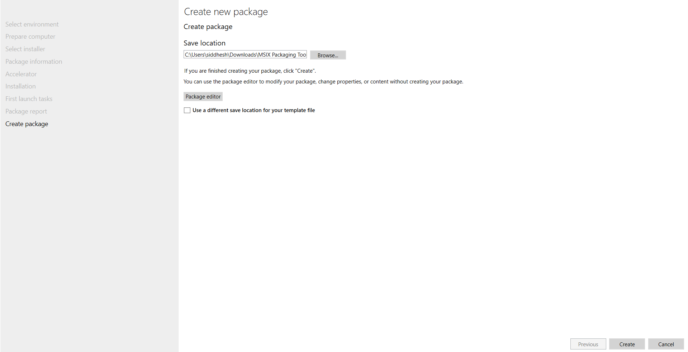

1. Open **File Explorer** and check for **.msix** and **.xml** files in our preferred directory

