**CHAPTER 1**

**INTODUCTION**

In our project named **NEED FOR SPEED** we have referred ACM International Collegiate Programming Contest problem 2017. We are going to solve this problem by usage of logical algorithms and suitable data structure necessary for implementation of the solution.

1. In this ‘Need for Speed’ problem we have to given a fix distance and a particular time, we need to calculate the exact speed of the vehicle.
2. Catch about this problem is that the needle of the speedometer is broken.
3. We have to check exact speed of an vehicle from given input

**1.1 PROBLEM STATEMENT**

The needle of speedometer has placed in wrong direction. So that the speedometer reads wrong speed.

**1.2 OBJECTIVE**

* To calculate the exact speed covered by that vehicle for a given segment.

**1.3 NEED OF PROJECT**

* It helps to calculate error of that speedometer.
* Using this code we can find difference between actual speed and the one display by the speedometer when needle of the speedometer fell off.

**CHAPTER 2**

**SOFTWARE/HARDWARE REQUIREMENT**

**Software requirement**

Operating system: Windows 7 or later versions

Programming Language used: C++

**Hardware requirement**

Processor: Intel core i3 or above

Hard disk: 500 GB

RAM: 2GB

**CHAPTER 3**

**METHODOLOGY**

**Input:**

First row contain no of section of journey (N) and total time (T) (hour). From second row ith column contain distance traveled in each section (in miles), and jth column contain speed on speedometer (miles per hour)

**Output:**

Display the error in speed read by speedometer. (miles per hour).

**Example First:-**

|  |  |  |  |  |  |  |  |  |  |
| --- | --- | --- | --- | --- | --- | --- | --- | --- | --- |
| **INPUT**   |  |  | | --- | --- | | **3** | **5** | | **4** | **-1** | | **4** | **0** | | **10** | **3** | | **OUTPUT**  **3.00000000** |

**Example Second:-**

|  |  |  |  |  |  |  |  |  |  |  |  |
| --- | --- | --- | --- | --- | --- | --- | --- | --- | --- | --- | --- |
| **INPUT**   |  |  | | --- | --- | | **4** | **10** | | **5** | **3** | | **2** | **2** | | **3** | **6** | | **3** | **1** | | **OUTPUT**  **-0.508653377** |

**ALGORITHM**

* Step 1: Start
* Step 2:- Set Number of section “N” and total time “T”.
* Step 4:- Set minimum value and maximum value for the range of “t”.
* Step 4:- Set distance for “N” sections.
* Step 5:- Set Speed for “N” sections.
* Step 6:- For(mx-mn> 1e-6),Repeat step 7
* Step 7 :- Calculate t by using the initially set formulae

Set initially t = 0;

t = d[i] / s[i] + c;

If (t<T), mx = c;

If (t>T), mn = c;

* Step 6:- Display (mx+mn/2)

**CHAPTER NO 4**

**IMPLEMENTATION & RESULT**

Figure 1. Start-up Window

**This is the first output of the project when we execute the code. Then this output will print on the terminal. In this window the welcome window is appear and input window is appeared.**

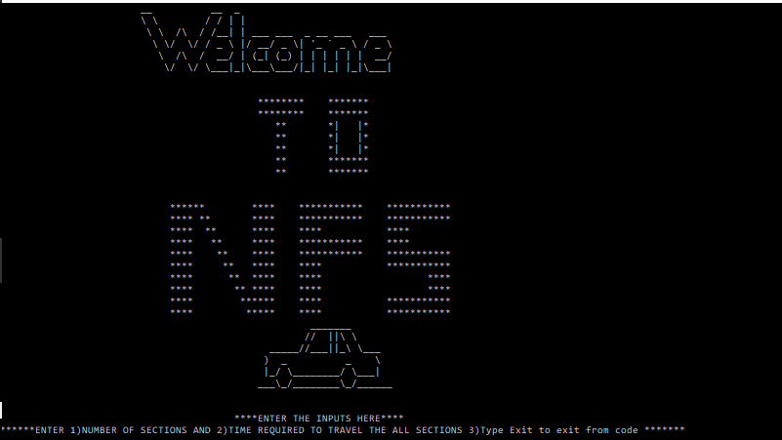

Figure 2.Input Window

In this window we insert the input no of sections and the total time required to travel the section

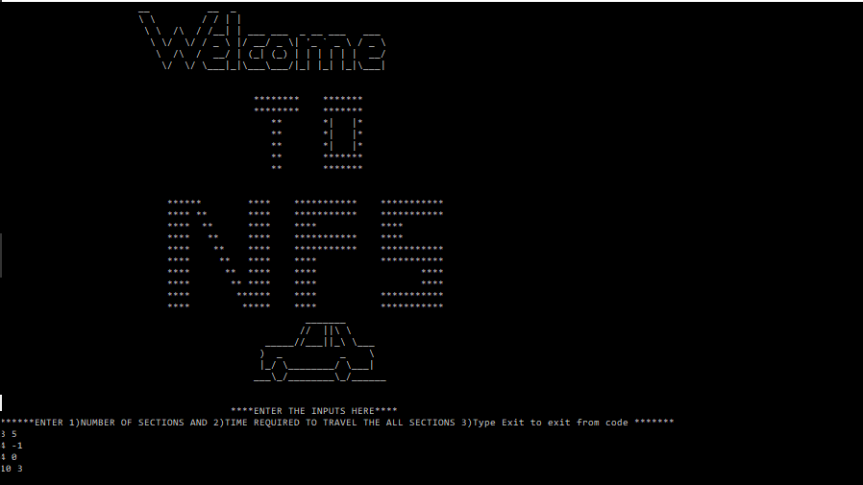

Figure 3.Output Window

In this window output appear while inserting input is shown.

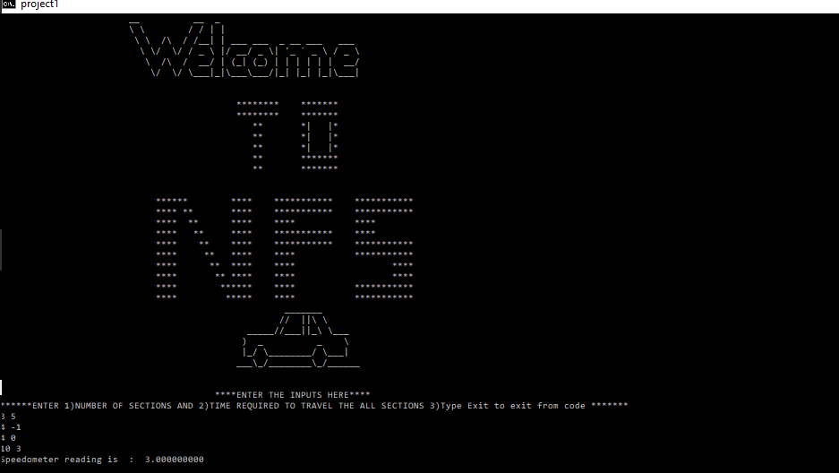

**CHAPTER 5**

**CONCLUSION**

* By this Mini project we successfully calculated the difference between actual speed and the one display by the speedometer.
* Thus we conclude how to find error of speedometer.

**FUTURE SCOPE**

* To get accuracy in industrial work where speedometer is used.
* Using this project, we calculate Time error and Speed Error.

**REFERENCE**

* ACM ICPC Problem -E 2017
* [www.mathc.com](http://www.mathc.com)
* [www.mathword.com](http://www.mathword.com)
* <https://icpc.baylor.edu/worldfinals/problems/icpc-solutions2017>