# MINI PROJECT REPORT ON

# “HOSTEL MANAGEMENT SYSTEM”

## submitted by

PRAJAKTA CHAUDHARI :- PA18 SHWETA CHOUDHARY :- PA23 JANHAVI CHAVAN :- PA62

SHIVRAJ PATIL :- PA63

under the guidance of SHAKTI KINGER MA'AM

at



School of Computer Engineering and Technology

**CONTENTS :**

ABSTRACT ……………………………………………………………………………..……………I

LIST OF FIGURES………..………………………………………………………………………….II

LIST OF TABLES……..……………………………………………………………………………...III

LIST OF ABBREVATIONS…………………………………………………………………………..IV

1. INTRODUCTION

-Objective………………………………………………………………………………………1(b)

-Motivation…………………………………………………………………………………….1(a)

1. PROBLEM STATEMENT
2. TOOLS AND TECHNOLOGIES USED
3. DATABASE DESIGN

-ER Diagram……………………………………………………………………………………2(a)

-Schema…………………………………………………………………………………………2(a)

1. NORMALIZATION

-Normalizing techniques…..……………………………………………………………………3(a)

-Normalized tables………………………………………………………………………………4(a)

1. DATABASE SCHEMA

-Relational schema diagram…………………………………………………………………….5(a)

1. DDL
2. DML (ALONG WITH RESULTS OF QUERIES)

9. DCL

9. TRIGGERES

10. PLSQL PROCEDURE/FUNCTION

11. FRONTEND GUI SCREENSHOTS

12. CONCLUSION

13. REFERENCES

**ABSTRACT**

Hostel management system provides services for a college MITWPU where we have made registration process

totally paperless as keeping manual records is very difficult. This system is takes care of the whole registration process which includes - registration of student , his/her guardian , booking request in his/her choice of hostel and room which are currently available and also provides a source for payment verification. This system also has two users namely - the manager of a particular hostel in MITWPU and the student who are verified as a student in our hostel. We have provided login option for both the users, students and employee.Now that we have registered the student we have created a verification which can be done only by the manager of that particular hostel. We have also implemented two way verification process where we take his phone number and id check with database and if valid then we allow to pass an OTP for login and also as soon as the manager confirms a persons booking in a particular hostel we have sent him a message saying he/she can now login as his booking has been confirmed. We have given specific roles to all the users like student has a student page where he can view all his details and add payment if there is any due and add complaints if any same for manager where he can add new rooms to his/her hostel , change or update the price of the rooms , verify student and also verify the complaints but students , he also has the role to register new employees to the hostel along with that specifying what is the role of the new employee. Keeping MITWPU hostels in mind we have created this whole system for only those who have a valid ERP ID given to us by the college during admission. The main purpose here is to reduce one to one communication and manual work by using GUI in tkinter (python) and reducing keeping records in pages by using mySQL.

### *LIST OF FIGURES:-

* ER DIAGRAM
* SCHEMA DIAGRAM

### *LIST OF TABLES:-

* Books
* Employee
* Guardian
* Hostel
* Payment
* Room
* Std phone
* Student

### *LIST OF ABBREVIATIONS:-

* MySQL:My Structured Query Language
* FK: Foreign key
* PK: Primary key
* Emp: Employee

HOSTEL MANAGEMENT SYSTEM

### *PROBLEM DEFINITION :-

A system is implemented which deals with student registration in a hostel and that shows hostel specification on a interface in created python and is managed by the managers(employees) which is specified in the database created in MYSQL. The system also deals with all registration steps involved namely – If the student is new , if new then allow registration by accepting correct student info and payment requirements and if student already exists in the system allow login using otp and show student details and hostel information required for student to contact or report issues.

### *TOOLS AND TECHNOLOGIES USED :-

Implementation of hostel management system using MYSQL and python.

### *MOTIVATION :-

This system allows the student to register for a specific room from a particular hostel . System displays hostel details and hostel specification. Interaction with the student is done using graphical interface created in python . The system checks if student exists or not by otp login process and if does not exist it allows to register in our system by registration process .The system permits multiple students to share the room depending upon the number of beds available and student requirements. This system also uses face recognition algorithm in by image processing in python and adding those into our database for attendance purposes or any other unique identification functions.

### *OBJECTIVE :-

1. To reduce manual labor of insertion
2. To reduce keeping manual database student records
3. Insertion of new records is easy and fast in this
4. Easy to update student records by giving access to info through otp
5. Allows new students to register easily
6. Payment records / transaction maintenance is easy
7. This also allows to keep track of partial payments and due amounts
8. Access for student needs student_id and face recognition
9. Face recognition algorithm is used to improve/safe implementation

### *ER – DIAGRAM :-

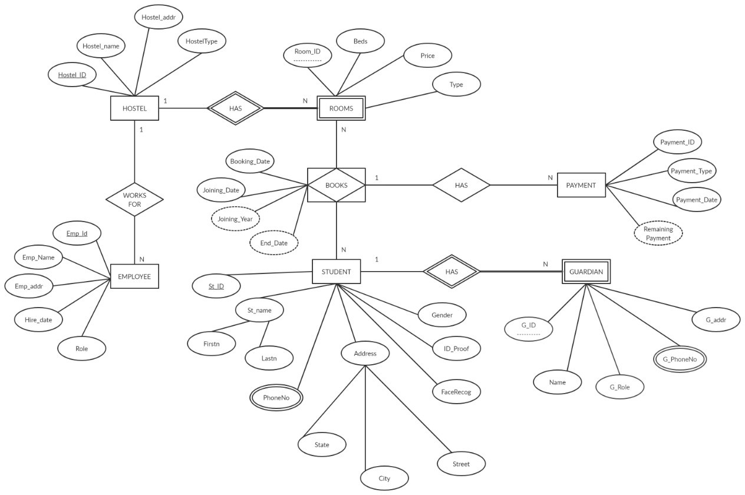

**\* SCHEMA :-**

HOSTEL(hostel_id,hostel_name,hostel_addr,hoteltype)

ROOM (hostel_id,room_id, beds, price,type)

EMPLOYEE (hostel_id,emp_id,emp_name,emp_addr,hiredate,role)

STUDENT (st_id,firstn,lastn,street,city,state,facerecog,id_proof,gender)

STD_PHONE (st_id,phoneno)

GUARDIAN (st_id,g_id,name,g_role,g_addr)

GD_PHONE (st_id,g_id,phoneno)

BOOKS (booking_id,hostel_id,room_id,st_id,booking_date,joining_date)

PAYEMENT (payment_id,booking_id,payment_type,amount,payment_date)

**\*NORMALIZATION :-**

|  |  |  |  |  |  |  |  |
| --- | --- | --- | --- | --- | --- | --- | --- |
| HOSTEL_ID | HOSTEL  _NAME | ROOM_ID | PRICE | BEDS | TYPE | BOOKING_ ID | BOOKING  DATE |
| 101 | Vidya | 2001 | 105000 | 2 | Normal | 1 | 2018-08-12 |
| 101 | Sarthi | 3001 | 125000 | 3 | Balcony | 2 | 2019-08-10 |
| 102 | Shanti | 2001 | 75000 | 2 | Normal | 3 | 2019-08-12 |
| 102 | Avanti | 2001 | 95000 | 2 | Normal | 4 | 2019-08-13 |

|  |  |  |  |  |  |
| --- | --- | --- | --- | --- | --- |
| JOINING_  DATE | ST_ID | ST_NAME | St_Address | Gender | PHONE_  NO |
| 2018-09-12 | 1032170317 | Prajakta | Thane | Female | 912809183 |
| 2019-09-10 | 1032170317 | Prajakta | Thane | Female | 263173791 |
| 2019-09-12 | 1032180389 | Shreyas | Pune | Male | 737173917 |
| 2019-09-13 | 1032180546 | Savay | Solapur | Male | 958945509 |

We have different anomalies in the above table.

->Insertion anomaly: If we want to insert a room in this table we have to add the details of student as well.

->Deletion anomaly:If a student decides to leave the hostel we would have to delete the entire record the Room for that hostel also gets deleted.

->Updation anomaly:With redundant data, when we want to change the value of one columns of a particular Student, for example the ST_NAME, we must update all the Student records that assigned to the particular Hostel roomt otherwise the database will become inconsistent.

The above table is in 1NF.For it to be in 2NF we need to remove the partial dependencies and convert it into new tables.

Primery key:

HOSTEL_ID,ROOM_ID,BOOKING_ID,STUDENT_ID

Functional Dependencies:

HOSTEL_ID,ROOM_ID,BOOKING_ID,ST_ID->PRICE,BEDS,TYPES,BOOKING_DATE,JOINING_ DATE,ST_ID,ST_NAME,ST_ADDR,GENDER,PHONE_NO

HOSTEL_ID,ROOM_ID-->PRICE,BEDS,TYPE (Partial dependency)

ST_ID-->ST_NAME,ST_ADDRESS,GENDER,PHONE_NO. (Partial dependency)

2NF FORM:

Removing the partial dependency and creating a new table:

|  |  |  |  |  |
| --- | --- | --- | --- | --- |
| HOSTEL_ID | ROOM_ID | PRICE | BEDS | TYPE |

|  |  |  |  |  |  |
| --- | --- | --- | --- | --- | --- |
| HOSTEL_ID | ROOM_ID | BOOKING_ID | ST_ID | BOOKING_DATE | JOINING_DATE |

|  |  |  |  |  |
| --- | --- | --- | --- | --- |
| ST_ID | ST_NAME | ST_ADDR | GENDER | PHONE_NO |

3NF FORM:

We have to remove all the transitive dependencies if any.Since there are no transitive dependencies.The table is already in 3NF form.

Therefore,

BOOKING TABLE:

|  |  |  |  |  |  |
| --- | --- | --- | --- | --- | --- |
| HOSTEL_ID | ROOM_ID | BOOKING_ID | ST_ID | BOOKING_DATE | JOINING_DATE |

ROOM TABLE :-

|  |  |  |  |  |
| --- | --- | --- | --- | --- |
| HOSTEL_ID | ROOM_ID | PRICE | BEDS | TYPE |

STUDENT TABLE:

|  |  |  |  |  |
| --- | --- | --- | --- | --- |
| ST_ID | ST_NAME | ST_ADDR | GENDER | PHONE_NO |

### *RELATIONAL SCHEMA DIAGRAM : -

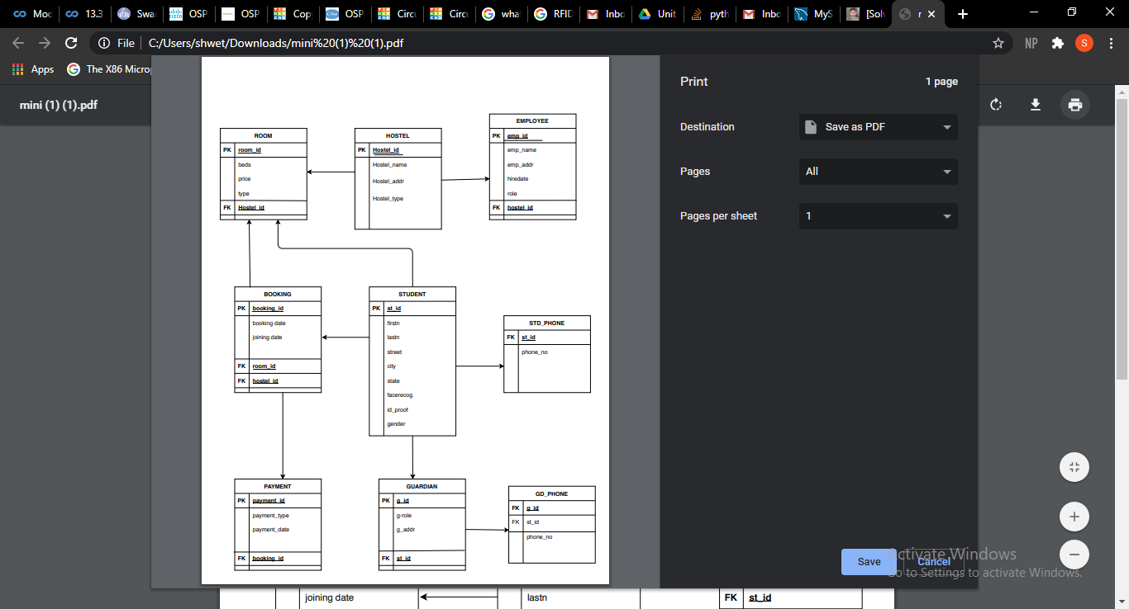

### *DDL COMMANDS : -

mysql> use hostelsm;

Database changed

mysql> show tables;

+--------------------+

| Tables_in_hostelsm |

+--------------------+

| bookingrem |

| books |

| complaints |

| display_guardian |

| display_hostel |

| display_sphone |

| display_student |

| employee |

| existingroom |

| guardian |

| hostel |

| paybalance |

| payment |

| room |

| std_phone |

| student |

+--------------------+

16 rows in set (0.03 sec)

mysql> desc bookingrem;

+--------+------+------+-----+---------+-------+

| Field | Type | Null | Key | Default | Extra |

+--------+------+------+-----+---------+-------+

| countr | int | YES | | NULL | |

| roomid | int | YES | | NULL | |

+--------+------+------+-----+---------+-------+

2 rows in set (0.00 sec)

mysql> desc books;

+--------------+------+------+-----+---------+----------------+

| Field | Type | Null | Key | Default | Extra |

+--------------+------+------+-----+---------+----------------+

| Hostel_ID | int | NO | PRI | NULL | |

| Room_ID | int | NO | PRI | NULL | |

| St_ID | int | NO | PRI | NULL | |

| Booking_ID | int | NO | PRI | NULL | auto_increment |

| Booking_Date | date | YES | | NULL | |

| Joining_Date | date | YES | | NULL | |

| verify | int | YES | | 0 | |

+--------------+------+------+-----+---------+----------------+

7 rows in set (0.00 sec)

mysql> desc display_guardian;

+---------+-------------+------+-----+----------+-------+

| Field | Type | Null | Key | Default | Extra |

+---------+-------------+------+-----+----------+-------+

| St_ID | int | NO | | NULL | |

| G_ID | int | NO | | NULL | |

| G_Name | varchar(30) | NO | | NULL | |

| G_Role | varchar(30) | YES | | Guardian | |

| G_Addr | varchar(50) | YES | | NULL | |

| G_phone | varchar(10) | NO | | NULL | |

+---------+-------------+------+-----+----------+-------+

6 rows in set (0.00 sec)

mysql> desc display_hostel;

+-----------+------+------+-----+---------+-------+

| Field | Type | Null | Key | Default | Extra |

+-----------+------+------+-----+---------+-------+

| hostel_id | int | NO | | NULL | |

| room_id | int | NO | | NULL | |

| st_id | int | NO | | NULL | |

+-----------+------+------+-----+---------+-------+

3 rows in set (0.00 sec)

mysql> desc display_sphone;

+---------+-------------+------+-----+---------+-------+

| Field | Type | Null | Key | Default | Extra |

+---------+-------------+------+-----+---------+-------+

| St_ID | int | YES | | NULL | |

| PhoneNo | varchar(11) | NO | | NULL | |

+---------+-------------+------+-----+---------+-------+

2 rows in set (0.00 sec)

mysql> desc display_student;

+----------+-------------+------+-----+---------+-------+

| Field | Type | Null | Key | Default | Extra |

+----------+-------------+------+-----+---------+-------+

| St_ID | int | NO | | NULL | |

| Firstn | varchar(30) | NO | | NULL | |

| Lastn | varchar(30) | NO | | NULL | |

| Gender | varchar(30) | YES | | NULL | |

| face | longblob | NO | | NULL | |

| ID_Proof | longblob | NO | | NULL | |

| Aptno | varchar(6) | YES | | NULL | |

| Buidg | varchar(30) | YES | | NULL | |

| Street | varchar(20) | YES | | NULL | |

| City | varchar(30) | YES | | NULL | |

| State | varchar(30) | YES | | NULL | |

| verify | int | YES | | 0 | |

+----------+-------------+------+-----+---------+-------+

12 rows in set (0.00 sec)

mysql> desc employee;

+-----------+-------------+------+-----+---------+----------------+

| Field | Type | Null | Key | Default | Extra |

+-----------+-------------+------+-----+---------+----------------+

| Emp_Id | int | NO | PRI | NULL | auto_increment |

| Emp_Name | varchar(30) | NO | | NULL | |

| Emp_Addr | varchar(50) | NO | | NULL | |

| hire_date | date | NO | | NULL | |

| E_Role | varchar(30) | YES | | NULL | |

| Hostel_ID | int | YES | MUL | NULL | |

+-----------+-------------+------+-----+---------+----------------+

6 rows in set (0.00 sec)

mysql> desc existingroom;

+-----------+--------------+------+-----+---------+-------+

| Field | Type | Null | Key | Default | Extra |

+-----------+--------------+------+-----+---------+-------+

| Hostel_ID | int | NO | | NULL | |

| Room_ID | int | NO | | NULL | |

| Beds | int | YES | | 3 | |

| Room_type | varchar(30) | YES | | Normal | |

| Price | decimal(8,0) | NO | | 75000 | |

+-----------+--------------+------+-----+---------+-------+

5 rows in set (0.00 sec)

mysql> desc gd_phone;

+---------+-------------+------+-----+---------+-------+

| Field | Type | Null | Key | Default | Extra |

+---------+-------------+------+-----+---------+-------+

| St_ID | int | YES | MUL | NULL | |

| G_ID | int | YES | | NULL | |

| PhoneNo | varchar(10) | YES | | NULL | |

+---------+-------------+------+-----+---------+-------+

3 rows in set (0.00 sec)

mysql> desc guardian;

+---------+-------------+------+-----+----------+-------+

| Field | Type | Null | Key | Default | Extra |

+---------+-------------+------+-----+----------+-------+

| St_ID | int | NO | PRI | NULL | |

| G_ID | int | NO | PRI | NULL | |

| G_Name | varchar(30) | NO | | NULL | |

| G_Role | varchar(30) | YES | | Guardian | |

| G_Addr | varchar(50) | YES | | NULL | |

| G_phone | varchar(10) | NO | | NULL | |

+---------+-------------+------+-----+----------+-------+

6 rows in set (0.00 sec)

mysql> desc hostel;

+-------------+-------------+------+-----+---------+-------+

| Field | Type | Null | Key | Default | Extra |

+-------------+-------------+------+-----+---------+-------+

| Hostel_ID | int | NO | PRI | NULL | |

| Hostel_Name | varchar(30) | NO | | NULL | |

| Hostel_Addr | varchar(50) | YES | | NULL | |

| HostelType | varchar(30) | NO | | NULL | |

+-------------+-------------+------+-----+---------+-------+

4 rows in set (0.00 sec)

mysql> desc payment;

+--------------+-------------+------+-----+---------+-------+

| Field | Type | Null | Key | Default | Extra |

+--------------+-------------+------+-----+---------+-------+

| Payment_ID | int | NO | PRI | NULL | |

| Payment_Type | varchar(30) | NO | | NULL | |

| Payment_Date | date | NO | | NULL | |

| Booking_ID | int | YES | MUL | NULL | |

+--------------+-------------+------+-----+---------+-------+

4 rows in set (0.00 sec)

mysql> desc room;

+-----------+--------------+------+-----+---------+-------+

| Field | Type | Null | Key | Default | Extra |

+-----------+--------------+------+-----+---------+-------+

| Hostel_ID | int | NO | PRI | NULL | |

| Room_ID | int | NO | PRI | NULL | |

| Beds | int | YES | | 3 | |

| Room_type | varchar(30) | YES | | Normal | |

| Price | decimal(8,0) | NO | | 75000 | |

+-----------+--------------+------+-----+---------+-------+

5 rows in set (0.00 sec)

mysql> desc std_phone;

+---------+-------------+------+-----+---------+-------+

| Field | Type | Null | Key | Default | Extra |

+---------+-------------+------+-----+---------+-------+

| St_ID | int | YES | MUL | NULL | |

| PhoneNo | varchar(11) | NO | | NULL | |

+---------+-------------+------+-----+---------+-------+

2 rows in set (0.00 sec)

mysql> desc student;

+----------+-------------+------+-----+---------+-------+

| Field | Type | Null | Key | Default | Extra |

+----------+-------------+------+-----+---------+-------+

| St_ID | int | NO | PRI | NULL | |

| Firstn | varchar(30) | NO | | NULL | |

| Lastn | varchar(30) | NO | | NULL | |

| Gender | varchar(30) | YES | | NULL | |

| face | longblob | NO | | NULL | |

| ID_Proof | longblob | NO | | NULL | |

| Aptno | varchar(6) | YES | | NULL | |

| Buidg | varchar(30) | YES | | NULL | |

| Street | varchar(20) | YES | | NULL | |

| City | varchar(30) | YES | | NULL | |

| State | varchar(30) | YES | | NULL | |

| verify | int | YES | | 0 | |

+----------+-------------+------+-----+---------+-------+

12 rows in set (0.00 sec)

mysql> create table Employee(Emp_Id int primary key auto_increment,Emp_Name varchar(30) not null,Emp_Addr varchar(50) not null,hire_date date not null,

E_Role varchar(30),Hostel_ID int,foreign key(Hostel_ID) references Hostel(Hostel_ID) ON DELETE CASCADE ON UPDATE CASCADE );

Query OK, 0 rows affected (1.14 sec)

mysql> alter table employee auto_increment=1001;

Query OK, 0 rows affected (0.74 sec)

Records: 0 Duplicates: 0 Warnings: 0

mysql> desc employee;

+-----------+-------------+------+-----+---------+----------------+

| Field | Type | Null | Key | Default | Extra |

+-----------+-------------+------+-----+---------+----------------+

| Emp_Id | int | NO | PRI | NULL | auto_increment |

| Emp_Name | varchar(30) | NO | | NULL | |

| Emp_Addr | varchar(50) | NO | | NULL | |

| hire_date | date | NO | | NULL | |

| E_Role | varchar(30) | YES | | NULL | |

| Hostel_ID | int | YES | MUL | NULL | |

+-----------+-------------+------+-----+---------+----------------+

6 rows in set (0.00 sec)

mysql> alter table student modify face longblob not null;

Query OK, 0 rows affected (1.10 sec)

Records: 0 Duplicates: 0 Warnings: 0

mysql> desc student;

+----------+-------------+------+-----+---------+-------+

| Field | Type | Null | Key | Default | Extra |

+----------+-------------+------+-----+---------+-------+

| St_ID | int | NO | PRI | NULL | |

| Firstn | varchar(30) | NO | | NULL | |

| Lastn | varchar(30) | NO | | NULL | |

| Gender | varchar(30) | YES | | NULL | |

| face | longblob | NO | | NULL | |

| ID_Proof | longblob | NO | | NULL | |

| Aptno | varchar(6) | YES | | NULL | |

| Buidg | varchar(30) | YES | | NULL | |

| Street | varchar(20) | YES | | NULL | |

| City | varchar(30) | YES | | NULL | |

| State | varchar(30) | YES | | NULL | |

| verify | int | YES | | 0 | |

+----------+-------------+------+-----+---------+-------+

12 rows in set (0.13 sec)

mysql> desc display_guardian;

+---------+-------------+------+-----+----------+-------+

| Field | Type | Null | Key | Default | Extra |

+---------+-------------+------+-----+----------+-------+

| St_ID | int | NO | | NULL | |

| G_ID | int | NO | | NULL | |

| G_Name | varchar(30) | NO | | NULL | |

| G_Role | varchar(30) | YES | | Guardian | |

| G_Addr | varchar(50) | YES | | NULL | |

| G_phone | varchar(10) | NO | | NULL | |

+---------+-------------+------+-----+----------+-------+

6 rows in set (0.00 sec)

mysql> desc display_student;

+----------+-------------+------+-----+---------+-------+

| Field | Type | Null | Key | Default | Extra |

+----------+-------------+------+-----+---------+-------+

| St_ID | int | NO | | NULL | |

| Firstn | varchar(30) | NO | | NULL | |

| Lastn | varchar(30) | NO | | NULL | |

| Gender | varchar(30) | YES | | NULL | |

| Face | longblob | NO | | NULL | |

| ID_Proof | longblob | NO | | NULL | |

| Aptno | varchar(6) | YES | | NULL | |

| Buidg | varchar(30) | YES | | NULL | |

| Street | varchar(20) | YES | | NULL | |

| City | varchar(30) | YES | | NULL | |

| State | varchar(30) | YES | | NULL | |

| verify | int | YES | | 0 | |

+----------+-------------+------+-----+---------+-------+

12 rows in set (0.71 sec)

mysql> desc display_hostel;

+------------+------+------+-----+---------+-------+

| Field | Type | Null | Key | Default | Extra |

+------------+------+------+-----+---------+-------+

| hostel_id | int | NO | | NULL | |

| room_id | int | NO | | NULL | |

| st_id | int | NO | | NULL | |

| booking_id | int | NO | | 0 | |

+------------+------+------+-----+---------+-------+

4 rows in set (0.00 sec)

mysql> desc display_sphone;

+---------+-------------+------+-----+---------+-------+

| Field | Type | Null | Key | Default | Extra |

+---------+-------------+------+-----+---------+-------+

| St_ID | int | YES | | NULL | |

| PhoneNo | varchar(11) | NO | | NULL | |

+---------+-------------+------+-----+---------+-------+

2 rows in set (0.00 sec)

mysql> desc paybalance;

+------------+---------------+------+-----+---------+-------+

| Field | Type | Null | Key | Default | Extra |

+------------+---------------+------+-----+---------+-------+

| balance | decimal(31,2) | YES | | NULL | |

| booking_id | int | YES | | NULL | |

| st_id | int | YES | | NULL | |

+------------+---------------+------+-----+---------+-------+

3 rows in set (0.00 sec)

mysql>alter table employee auto_increment=1001;

mysql>alter table books add end_date date ;

mysql>alter table student modify face longblob not null;

mysql>alter table complaints add `status` int default 0;

mysql>alter table complaints drop verify ;

mysql>alter table complaints add `c_date` date;

mysql> desc complaints;

+-----------+--------------+------+-----+---------+-------+

| Field | Type | Null | Key | Default | Extra |

+-----------+--------------+------+-----+---------+-------+

| st_id | int | YES | MUL | NULL | |

| complaint | varchar(100) | YES | | NULL | |

| status | int | YES | | 0 | |

| c_date | date | YES | | NULL | |

+-----------+--------------+------+-----+---------+-------+

4 rows in set (0.00 sec)

### *DML COMMANDS : -

mysql> insert into Hostel values

(1,"Vishwaraj","Kothrud,Pune","Female"),

(2,"Vidyaniketan","Karve Nagar,Pune","Male"),

(3,"Leelawati Hostel","Warjenaka,Pune","Female"),

(4,"Youthville","Badhvan,Pune","Male");

Query OK, 4 rows affected (0.32 sec)

Records: 4 Duplicates: 0 Warnings: 0

mysql> select *from hostel;

+-----------+------------------+------------------+------------+

| Hostel_ID | Hostel_Name | Hostel_Addr | HostelType |

+-----------+------------------+------------------+------------+

| 1 | Vishwaraj | Kothrud,Pune | Female |

| 2 | Vidyaniketan | Karve Nagar,Pune | Male |

| 3 | Leelawati Hostel | Warje naka,Pune | Female |

| 4 | Youthville | Badhvan,Pune | Male |

+-----------+------------------+------------------+------------+

4 rows in set (0.00 sec)

mysql> insert into room(hostel_ID,Room_ID,Beds) values (1,101,3), (1,102,3);

Query OK, 2 rows affected (0.17 sec)

Records: 2 Duplicates: 0 Warnings: 0

mysql> insert into room values(1,103,2,"AC",125000.00);

Query OK, 1 row affected (0.19 sec)

mysql> insert into room(hostel_ID,Room_ID,Beds,Price)values(1,104,2,100000.00);

Query OK, 1 row affected (0.22 sec)

mysql> insert into room values(1,105,2,"Balcony",125000.00);

Query OK, 1 row affected (0.16 sec)

mysql> insert into room(hostel_ID,Room_ID,Beds) values (1,201,3), (1,202,3);

Query OK, 2 rows affected (0.18 sec)

Records: 2 Duplicates: 0 Warnings: 0

mysql> insert into room values(1,203,2,"AC",125000.00);

Query OK, 1 row affected (0.24 sec)

mysql> insert into room(hostel_ID,Room_ID,Beds,Price)values(1,204,2,100000.00);

Query OK, 1 row affected (0.17 sec)

mysql> insert into room values(1,205,2,"Balcony",125000.00);

Query OK, 1 row affected (0.15 sec)

mysql> insert into room(hostel_ID,Room_ID,Beds) values (1,301,3),(1,302,3);

Query OK, 2 rows affected (0.23 sec)

Records: 2 Duplicates: 0 Warnings: 0

mysql> insert into room values(1,303,2,"AC",125000.00);

Query OK, 1 row affected (0.19 sec)

mysql> insert into room(hostel_ID,Room_ID,Beds,Price)values(1,304,2,100000.00);

Query OK, 1 row affected (0.24 sec)

mysql> insert into room values(1,305,2,"Balcony",125000.00);

Query OK, 1 row affected (0.18 sec)

mysql> insert into room(hostel_ID,Room_ID,Beds,Price) values (2,101,3,70000),(2,102,3,70000);

Query OK, 2 rows affected (0.27 sec)

Records: 2 Duplicates: 0 Warnings: 0

mysql> insert into room values(2,103,2,"Balcony",120000.00);

Query OK, 1 row affected (0.16 sec)

mysql> insert into room(hostel_ID,Room_ID,Beds,Price)values

(2,104,2,90000.00),(2,105,2,90000.00);

Query OK, 2 rows affected (0.15 sec)

Records: 2 Duplicates: 0 Warnings: 0

mysql> insert into room values(2,106,2,"Balcony",120000.00);

Query OK, 1 row affected (0.12 sec)

mysql> insert into room(hostel_ID,Room_ID,Beds,Price) values (2,201,3,70000), (2,202,3,70000);

Query OK, 2 rows affected (0.10 sec)

Records: 2 Duplicates: 0 Warnings: 0

mysql> insert into room values(2,203,2,"Balcony",120000.00);

Query OK, 1 row affected (0.16 sec)

mysql> insert into room(hostel_ID,Room_ID,Beds,Price)values

(2,204,2,90000.00),(2,205,2,90000.00);

Query OK, 2 rows affected (0.10 sec)

Records: 2 Duplicates: 0 Warnings: 0

mysql> insert into room values(2,206,2,"Balcony",120000.00);

Query OK, 1 row affected (0.07 sec)

mysql> insert into room(hostel_ID,Room_ID,Beds,Price) values (2,301,3,70000), (2,302,3,70000);

Query OK, 2 rows affected (0.10 sec)

Records: 2 Duplicates: 0 Warnings: 0

mysql> insert into room values(2,303,2,"Balcony",120000.00);

Query OK, 1 row affected (0.15 sec)

mysql> insert into room(hostel_ID,Room_ID,Beds,Price)values

(2,304,2,90000.00),(2,305,2,90000.00);

Query OK, 2 rows affected (0.09 sec)

Records: 2 Duplicates: 0 Warnings: 0

mysql> insert into room values(2,306,2,"Balcony",120000.00);

Query OK, 1 row affected (0.08 sec)

mysql> insert into room(hostel_ID,Room_ID,Beds,Price) values

(3,101,2,120000), (3,102,2,120000);

Query OK, 2 rows affected (0.21 sec)

Records: 2 Duplicates: 0 Warnings: 0

mysql> insert into room values(3,103,2,"Balcony",125000.00);

Query OK, 1 row affected (0.17 sec)

mysql> insert into room(hostel_ID,Room_ID,Price)values

(3,104,90000.00),(3,105,90000.00);

Query OK, 2 rows affected (0.16 sec)

Records: 2 Duplicates: 0 Warnings: 0

mysql> insert into room values(3,106,2,"Balcony",125000.00);

Query OK, 1 row affected (0.21 sec)

mysql> insert into room(hostel_ID,Room_ID,Beds,Price) values

(3,201,2,120000), (3,202,2,120000);

Query OK, 2 rows affected (0.16 sec)

Records: 2 Duplicates: 0 Warnings: 0

mysql> insert into room values(3,203,2,"Balcony",125000.00);

Query OK, 1 row affected (0.12 sec)

mysql> insert into room(hostel_ID,Room_ID,Price)values

(3,204,90000.00),(3,205,90000.00);

Query OK, 2 rows affected (0.13 sec)

Records: 2 Duplicates: 0 Warnings: 0

mysql> insert into room values(3,206,2,"Balcony",125000.00);

Query OK, 1 row affected (0.16 sec)

mysql> insert into room(hostel_ID,Room_ID,Beds,Price) values

(3,301,2,120000), (3,302,2,120000);

Query OK, 2 rows affected (0.16 sec)

Records: 2 Duplicates: 0 Warnings: 0

mysql> insert into room values(3,303,2,"Balcony",125000.00);

Query OK, 1 row affected (0.15 sec)

mysql> insert into room(hostel_ID,Room_ID,Price)values

(3,304,90000.00),(3,305,90000.00);

Query OK, 2 rows affected (0.19 sec)

Records: 2 Duplicates: 0 Warnings: 0

mysql> insert into room values(3,306,2,"Balcony",125000.00);

Query OK, 1 row affected (0.18 sec)

mysql> insert into room(hostel_ID,Room_ID,Beds) values (4,101,3), (4,102,3);

Query OK, 2 rows affected (0.18 sec)

Records: 2 Duplicates: 0 Warnings: 0

mysql> insert into room values(4,103,2,"AC",125000.00);

Query OK, 1 row affected (0.14 sec)

mysql> insert into room(hostel_ID,Room_ID,Beds,Price)values(4,104,2,100000.00);

Query OK, 1 row affected (0.24 sec)

mysql> insert into room values(4,105,2,"Balcony",125000.00);

Query OK, 1 row affected (0.14 sec)

mysql> insert into room(hostel_ID,Room_ID,Beds) values (4,201,3), (4,202,3);

Query OK, 2 rows affected (0.10 sec)

Records: 2 Duplicates: 0 Warnings: 0

mysql> insert into room values(4,203,2,"AC",125000.00);

Query OK, 1 row affected (0.18 sec)

mysql> insert into room(hostel_ID,Room_ID,Beds,Price)values(4,204,2,100000.00);

Query OK, 1 row affected (0.06 sec)

mysql> insert into room values(4,205,2,"Balcony",125000.00);

Query OK, 1 row affected (0.11 sec)

mysql> insert into room(hostel_ID,Room_ID,Beds) values (4,301,3), (4,302,3);

Query OK, 2 rows affected (0.10 sec)

Records: 2 Duplicates: 0 Warnings: 0

mysql> insert into room values(4,303,2,"AC",125000.00);

Query OK, 1 row affected (0.07 sec)

mysql> insert into room(hostel_ID,Room_ID,Beds,Price)values(4,304,2,100000.00);

Query OK, 1 row affected (0.06 sec)

mysql> insert into room values(4,305,2,"Balcony",125000.00);

Query OK, 1 row affected (0.18 sec)

mysql> select *from room;

+-----------+---------+------+-----------+--------+

| Hostel_ID | Room_ID | Beds | Room_type | Price |

+-----------+---------+------+-----------+--------+

| 1 | 101 | 3 | Normal | 75000 |

| 1 | 102 | 3 | Normal | 75000 |

| 1 | 103 | 2 | AC | 125000 |

| 1 | 104 | 2 | Normal | 100000 |

| 1 | 105 | 2 | Balcony | 125000 |

| 1 | 201 | 3 | Normal | 75000 |

| 1 | 202 | 3 | Normal | 75000 |

| 1 | 203 | 2 | AC | 125000 |

| 1 | 204 | 2 | Normal | 100000 |

| 1 | 205 | 2 | Balcony | 125000 |

| 1 | 301 | 3 | Normal | 75000 |

| 1 | 302 | 3 | Normal | 75000 |

| 1 | 303 | 2 | AC | 125000 |

| 1 | 304 | 2 | Normal | 100000 |

| 1 | 305 | 2 | Balcony | 125000 |

| 2 | 101 | 3 | Normal | 70000 |

| 2 | 102 | 3 | Normal | 70000 |

| 2 | 103 | 2 | Balcony | 120000 |

| 2 | 104 | 2 | Normal | 90000 |

| 2 | 105 | 2 | Normal | 90000 |

| 2 | 106 | 2 | Balcony | 120000 |

| 2 | 201 | 3 | Normal | 70000 |

| 2 | 202 | 3 | Normal | 70000 |

| 2 | 203 | 2 | Balcony | 120000 |

| 2 | 204 | 2 | Normal | 90000 |

| 2 | 205 | 2 | Normal | 90000 |

| 2 | 206 | 2 | Balcony | 120000 |

| 2 | 301 | 3 | Normal | 70000 |

| 2 | 302 | 3 | Normal | 70000 |

| 2 | 303 | 2 | Balcony | 120000 |

| 2 | 304 | 2 | Normal | 90000 |

| 2 | 305 | 2 | Normal | 90000 |

| 2 | 306 | 2 | Balcony | 120000 |

| 3 | 101 | 2 | Normal | 120000 |

| 3 | 102 | 2 | Normal | 120000 |

| 3 | 103 | 2 | Balcony | 125000 |

| 3 | 104 | 3 | Normal | 90000 |

| 3 | 105 | 3 | Normal | 90000 |

| 3 | 106 | 2 | Balcony | 125000 |

| 3 | 201 | 2 | Normal | 120000 |

| 3 | 202 | 2 | Normal | 120000 |

| 3 | 203 | 2 | Balcony | 125000 |

| 3 | 204 | 3 | Normal | 90000 |

| 3 | 205 | 3 | Normal | 90000 |

| 3 | 206 | 2 | Balcony | 125000 |

| 3 | 301 | 2 | Normal | 120000 |

| 3 | 302 | 2 | Normal | 120000 |

| 3 | 303 | 2 | Balcony | 125000 |

| 3 | 304 | 3 | Normal | 90000 |

| 3 | 305 | 3 | Normal | 90000 |

| 3 | 306 | 2 | Balcony | 125000 |

| 4 | 101 | 3 | Normal | 75000 |

| 4 | 102 | 3 | Normal | 75000 |

| 4 | 103 | 2 | AC | 125000 |

| 4 | 104 | 2 | Normal | 100000 |

| 4 | 105 | 2 | Balcony | 125000 |

| 4 | 201 | 3 | Normal | 75000 |

| 4 | 202 | 3 | Normal | 75000 |

| 4 | 203 | 2 | AC | 125000 |

| 4 | 204 | 2 | Normal | 100000 |

| 4 | 205 | 2 | Balcony | 125000 |

| 4 | 301 | 3 | Normal | 75000 |

| 4 | 302 | 3 | Normal | 75000 |

| 4 | 303 | 2 | AC | 125000 |

| 4 | 304 | 2 | Normal | 100000 |

| 4 | 305 | 2 | Balcony | 125000 |

+-----------+---------+------+-----------+--------+

66 rows in set (0.00 sec)

mysql> insert into employee(Emp_Name,Emp_Addr,hire_date,E_Role,Hostel_ID) values

("Ishani Panchal","Kothrud,Pune","2018-08-12","Manager",1),

("Anuj Khanna","Kothrud,Pune","2018-08-12","Manager",2), ("Saumya Parekh","Kothrud,Pune","2018-08-12","Manager",3), ("Pranav Bajaj","Kothrud,Pune","2018-08-12","Manager",4), ("Shaurya Pillay","Bavdhan,Pune","2018-08-12","Chef",1), ("Nikhil Parmar","Kothrud,Pune","2018-08-12","Chef",2), ("Parth Rawat","Bavdhan,Pune","2018-08-12","Chef",3), ("Raghav Sinha","Kothrud,Pune","2018-08-12","Chef",4), ("Sunita Salvi","Bavdhan,Pune","2018-08-12","House Keeper",1), ("Tanvi Rawat","Kothrud,Pune","2018-08-12","House Keeper",2), ("Nilima Sane","Bavdhan,Pune","2018-08-12","House Keeper",3), ("Ananya Pandey","Kothrud,Pune","2018-08-12","House Keeper",4);

Query OK, 12 rows affected (0.25 sec)

Records: 12 Duplicates: 0 Warnings: 0

mysql> select * from employee;

+--------+----------------+--------------+------------+--------------+-----------+

| Emp_Id | Emp_Name | Emp_Addr | hire_date | E_Role | Hostel_ID |

+--------+----------------+--------------+------------+--------------+-----------+

| 1001 | Ishani Panchal | Kothrud,Pune | 2018-08-12 | Manager | 1 |

| 1002 | Anuj Khanna | Kothrud,Pune | 2018-08-12 | Manager | 2 |

| 1003 | Saumya Parekh | Kothrud,Pune | 2018-08-12 | Manager | 3 |

| 1004 | Pranav Bajaj | Kothrud,Pune | 2018-08-12 | Manager | 4 |

| 1005 | Shaurya Pillay | Bavdhan,Pune | 2018-08-12 | Chef | 1 |

| 1006 | Nikhil Parmar | Kothrud,Pune | 2018-08-12 | Chef | 2 |

| 1007 | Parth Rawat | Bavdhan,Pune | 2018-08-12 | Chef | 3 |

| 1008 | Raghav Sinha | Kothrud,Pune | 2018-08-12 | Chef | 4 |

| 1009 | Sunita Salvi | Bavdhan,Pune | 2018-08-12 | House Keeper | 1 |

| 1010 | Tanvi Rawat | Kothrud,Pune | 2018-08-12 | House Keeper | 2 |

| 1011 | Nilima Sane | Bavdhan,Pune | 2018-08-12 | House Keeper | 3 |

| 1012 | Ananya Pandey | Kothrud,Pune | 2018-08-12 | House Keeper | 4 |

+--------+----------------+--------------+------------+--------------+-----------+

12 rows in set (0.00 sec)

mysql> SELECT * FROM Hostel WHERE Hostel_id= 1;

+-----------+-------------+--------------+------------+

| Hostel_ID | Hostel_Name | Hostel_Addr | HostelType |

+-----------+-------------+--------------+------------+

| 1 | Vishwaraj | Kothrud,Pune | Female |

+-----------+-------------+--------------+------------+

1 row in set (0.04 sec)

mysql> INSERT INTO books(Hostel_ID,Room_ID,St_ID,Joining_Date) VALUES(1,104,1032180381,curdate());

Query OK, 1 row affected (0.24 sec)

mysql> INSERT INTO Std_Phone(St_ID,PhoneNo) VALUES(1032180381,8454907639);

Query OK, 1 row affected (0.12 sec)

mysql> select a.st_id,a.firstn,a.lastn from student a inner join books b using(st_id) where a.verify = 0 and b.verify = 0 and b.hostel_id = 1;

Empty set (0.00 sec)

mysql> UPDATE Student SET verify = 1 WHERE st_id=1032180381;

Query OK, 0 rows affected (0.03 sec)

Rows matched: 1 Changed: 0 Warnings: 0

mysql> UPDATE Books SET verify = 1 where st_id = 1032180381;

Query OK, 1 row affected (0.08 sec)

Rows matched: 2 Changed: 1 Warnings: 0

mysql> UPDATE books SET booking_date = curdate() where st_id = 1032180381 and verify = 1;

Query OK, 2 rows affected (0.11 sec)

Rows matched: 2 Changed: 2 Warnings: 0

mysql> UPDATE books SET end_date = DATE_ADD(joining_date, INTERVAL 1 YEAR) where st_id = 1032180381;

Query OK, 1 row affected (0.46 sec)

Rows matched: 2 Changed: 1 Warnings: 0

mysql> DELETE FROM Student where st_id=1032180317;

Query OK, 1 row affected (0.45 sec)

mysql> select emp_name from employee where emp_id = 1001;

+----------------+

| emp_name |

+----------------+

| Ishani Panchal |

+----------------+

1 row in set (0.06 sec)

mysql> insert into complaints(st_id,complaint,c_date)

values (1032180381,"CHANGE BED SHEETS",curdate());

Query OK, 1 row affected (0.12 sec)

mysql> select *from complaints where status = 0;

+------------+-------------------+--------+------------+

| st_id | complaint | status | c_date |

+------------+-------------------+--------+------------+

| 1032180381 | CHANGE BED SHEETS | 0 | 2020-09-20 |

+------------+-------------------+--------+------------+

1 row in set (0.00 sec)

mysql> UPDATE complaints SET status = 1 where st_id = 1032180381;

Query OK, 1 row affected (0.05 sec)

Rows matched: 1 Changed: 1 Warnings: 0

mysql> DELETE FROM complaints where st_id = 1032180381;

Query OK, 1 row affected (0.16 sec)

mysql> SET sql_mode=(SELECT REPLACE(@@sql_mode,'ONLY_FULL_GROUP_BY',''));

Query OK, 0 rows affected (0.00 sec)

mysql> select price,beds,room_type from room where hostel_id = 1 group by room_type,beds;

+--------+------+-----------+

| price | beds | room_type |

+--------+------+-----------+

| 85000 | 3 | Normal |

| 125000 | 2 | AC |

| 75000 | 2 | Normal |

| 125000 | 2 | Balcony |

+--------+------+-----------+

4 rows in set (0.04 sec)

mysql> UPDATE room SET price = 750000 where room_type = "AC" and beds = 2;

Query OK, 6 rows affected (0.07 sec)

Rows matched: 6 Changed: 6 Warnings: 0

mysql> select complaint from complaints where st_id =1032180381 and `status` = 0 order by c_date desc;

Empty set (0.00 sec)

mysql> select gender from student where st_id = 1032180381;

+--------+

| gender |

+--------+

| FEMALE |

+--------+

1 row in set (0.00 sec)

### *DCL COMMANDS : -

mysql> CREATE USER "manager"@"localhost" identified by "Manager@hms0202";

Query OK, 0 rows affected (0.47 sec)

mysql> GRANT ALL ON hostelms.* to "manager"@"localhost";

Query OK, 0 rows affected (0.24 sec)

mysql> SHOW GRANTS FOR "manager"@"localhost";

+---------------------------------------------------------------+

| Grants for manager@localhost |

+---------------------------------------------------------------+

| GRANT USAGE ON *.* TO `manager`@`localhost` |

| GRANT ALL PRIVILEGES ON `hostelms`.* TO `manager`@`localhost` |

+---------------------------------------------------------------+

2 rows in set (0.00 sec)

### *PL/SQL PROCEDURE AND FUNCTIONS :-

PROCEDURES

**1.CHECK IF STUDENT IS REGISTERED OR NOT**

create procedure checkstudent (IN id1 int,IN phno varchar(11), OUT ret int)

begin

declare stid int;

declare pno varchar(11);

declare done int default 0 ;

declare ver int default 0;

declare continue handler for not found set done =1;

select phoneno into pno from std_phone where st_id = id1 and PhoneNo = phno;

select st_id into stid from student where st_id = id1;

select verify into ver from student where st_id = id1;

if ver = 1 then

set ret = 1;

elseif ver = 0 and done = 1 then

set ret = -1;

elseif ver = 0 then

set ret = 0;

end if;

END $$

delimiter ;

DELIMITER //

**2.PROCEDURE FOR PRICE**

CREATE PROCEDURE price(IN bed int,IN rtype varchar(30),IN hid int)

BEGIN

SELECT CAST((avg(Price)) AS DECIMAL(8.4)) Cost FROM room WHERE beds=bed AND room_type=rtype AND Hostel_id=hid;

END//

**3.CHECK IF EMPLOYEE IS REGISTERED OR NOT**

Delimiter $$

create procedure checkemployee (IN id1 int,OUT foundemp int)

begin

declare empid int;

declare job varchar(30) default "";

declare exit handler for not found

BEGIN

SET foundemp=-1;

END;

select e_role into job from employee where emp_id=id1;

select emp_id into empid from employee where emp_id=id1;

if job = "manager" then

SET foundemp=1;

else

set foundemp = 0;

end if;

end $$

delimiter ;

**FUNCTIONS**

**1.FUNCTION FOR INSERTION OF STUDENTS**

delimiter $$

CREATE FUNCTION insert_stu ( id1 int ,fname varchar(30) ,lname varchar(30) ,gen varchar(30) , fr longblob , id_p longblob,

apt varchar(6), buildg varchar(30), street varchar(20) , city varchar(30) , state varchar(30) )

returns int deterministic

BEGIN

declare exit handler for 1062

begin

return -1;

end;

INSERT INTO Student

(St_ID,Firstn,Lastn,Gender,Face,ID_Proof,Aptno,Buidg,Street,City,State) VALUES(id1, fname,lname, gen,fr,id_p,apt,buildg,street,city,state);

return 1;

END $$

DELIMITER ;

**2.FUNCTION FOR CHECKING AVAILABILITY OF ROOM**

delimiter $$

CREATE FUNCTION add_room_check(hid int , rid int , bed int , rtype varchar(30) , price decimal(8,0))

RETURNS INT DETERMINISTIC

BEGIN

declare exit handler for 1602

begin

return -1;

end;

insert into room values (hid,rid,bed,rtype,price);

return 1;

END $$

delimiter $$

**3.FUNCTION FOR COUNTING THE NUMBER OF ROOMS**

CREATE FUNCTION countroom(hid int,bed int,rtype varchar(30))

RETURNS INT

DETERMINISTIC

BEGIN

DECLARE count_room INT DEFAULT 0;

SELECT count(room_id) INTO count_room FROM room WHERE beds=bed AND room_type=rtype AND Hostel_ID=hid;

return count_room;

END//

### *CURSOR :-

**1.CURSOR FOR BOOKING**

CREATE PROCEDURE sp_stubooking(IN hid int,IN bed int,IN rtype varchar(30),IN bdate date,OUT rdone int)

BEGIN

DECLARE done int default 0;

DECLARE countroom INT DEFAULT 0;

DECLARE rid INT;

DECLARE C1 CURSOR FOR SELECT r.room_id,ifnull((SELECT count(room_id) FROM books b WHERE b.room_id=r.room_id AND r.beds=bed

AND r.room_type=rtype AND r.Hostel_ID=hid

AND DATE_FORMAT(b.joining_date,"%Y")=DATE_FORMAT("2020-09-10","%Y")),0)

Beds FROM room r WHERE r.beds=bed AND r.room_type=rtype AND r.Hostel_ID=hid;

DECLARE CONTINUE HANDLER FOR NOT FOUND SET done=1;

OPEN C1;

LABEL:LOOP

FETCH C1 INTO rid,countroom;

IF done=1 THEN

LEAVE LABEL;

END IF;

IF countroom<bed THEN

INSERT INTO bookingrem VALUES(countroom,rid);

END IF;

END LOOP LABEL;

CLOSE C1;

SELECT roomid FROM bookingrem;

TRUNCATE TABLE bookingrem;

END//

### *FRONTEND GUI SCREENSHOTS :-

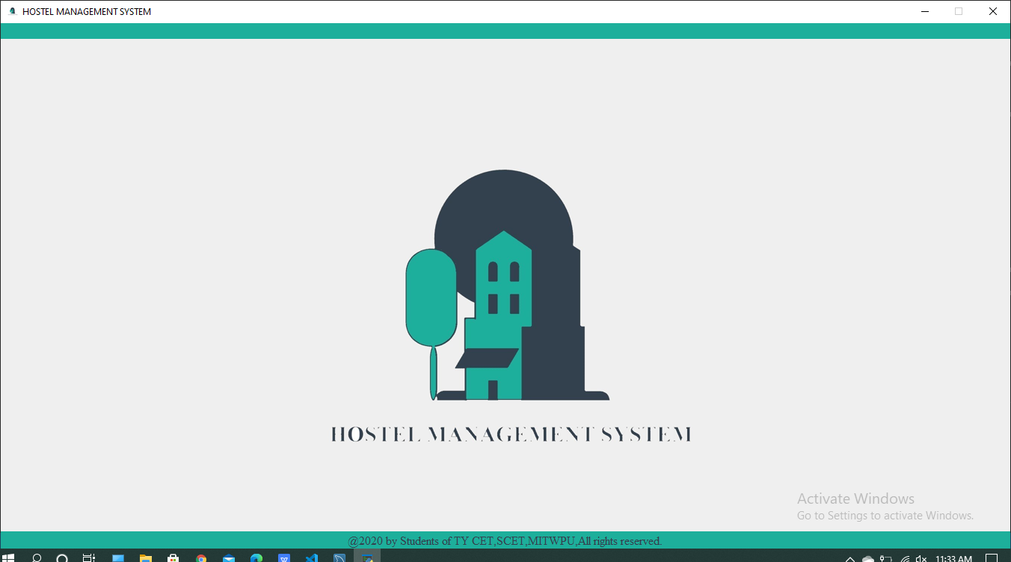



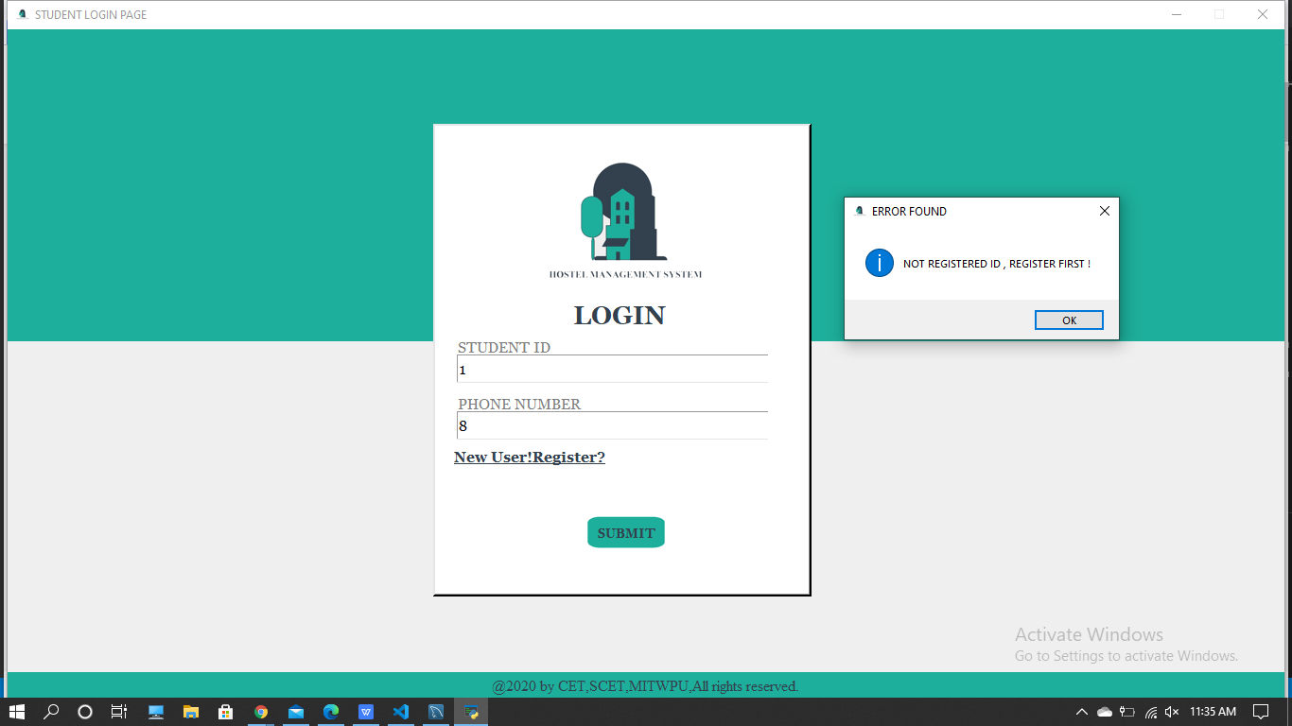

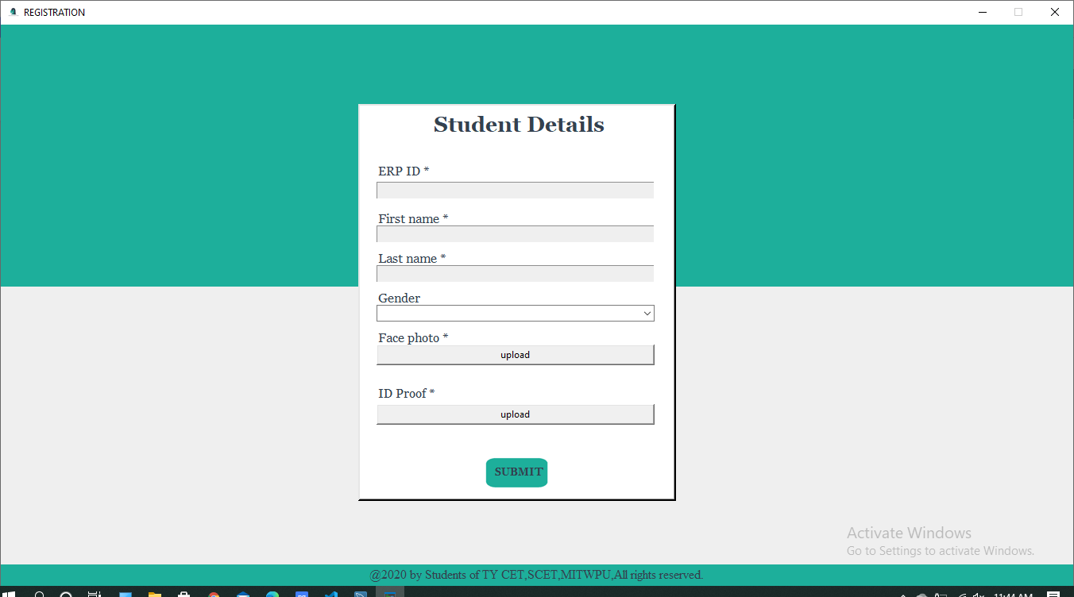

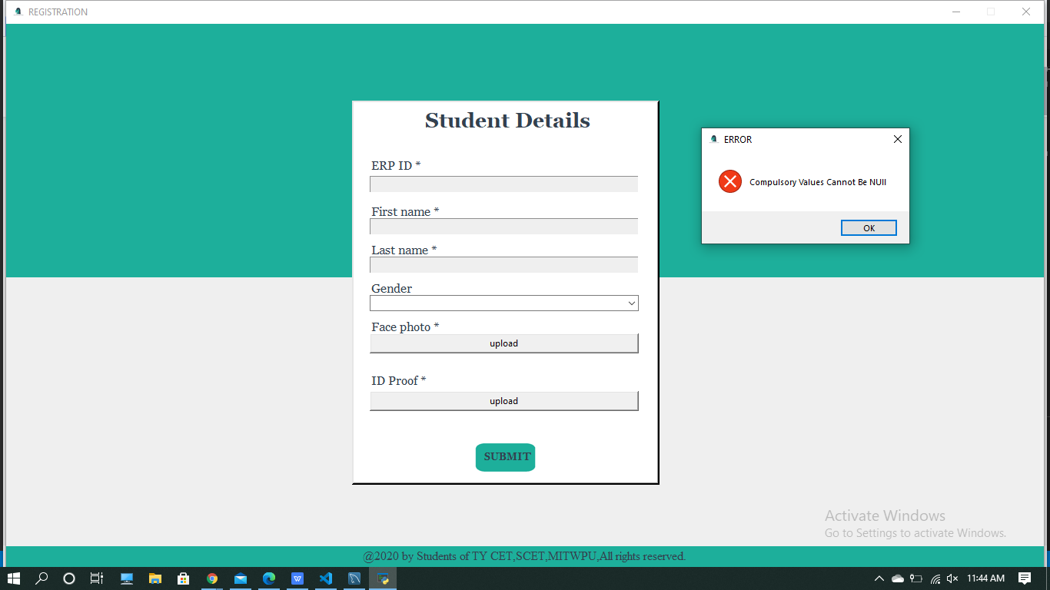

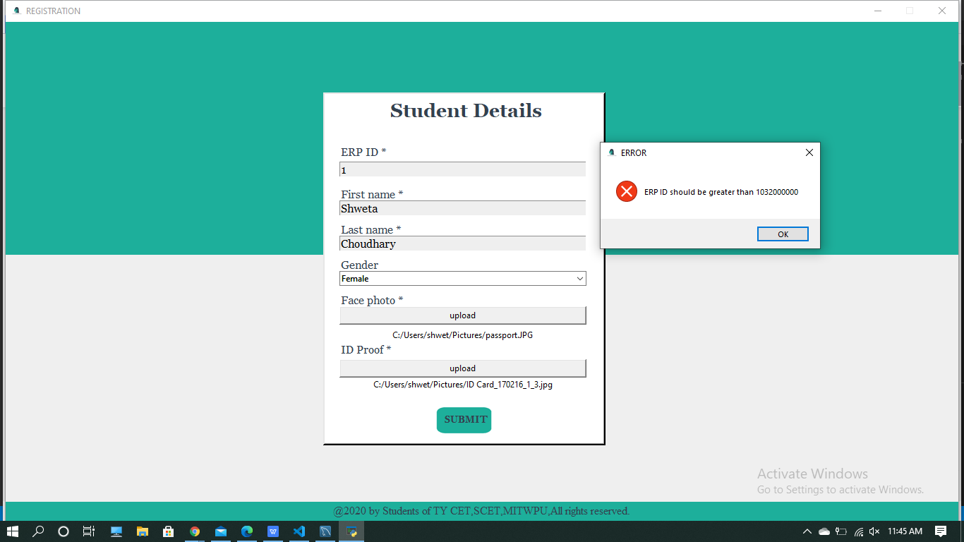

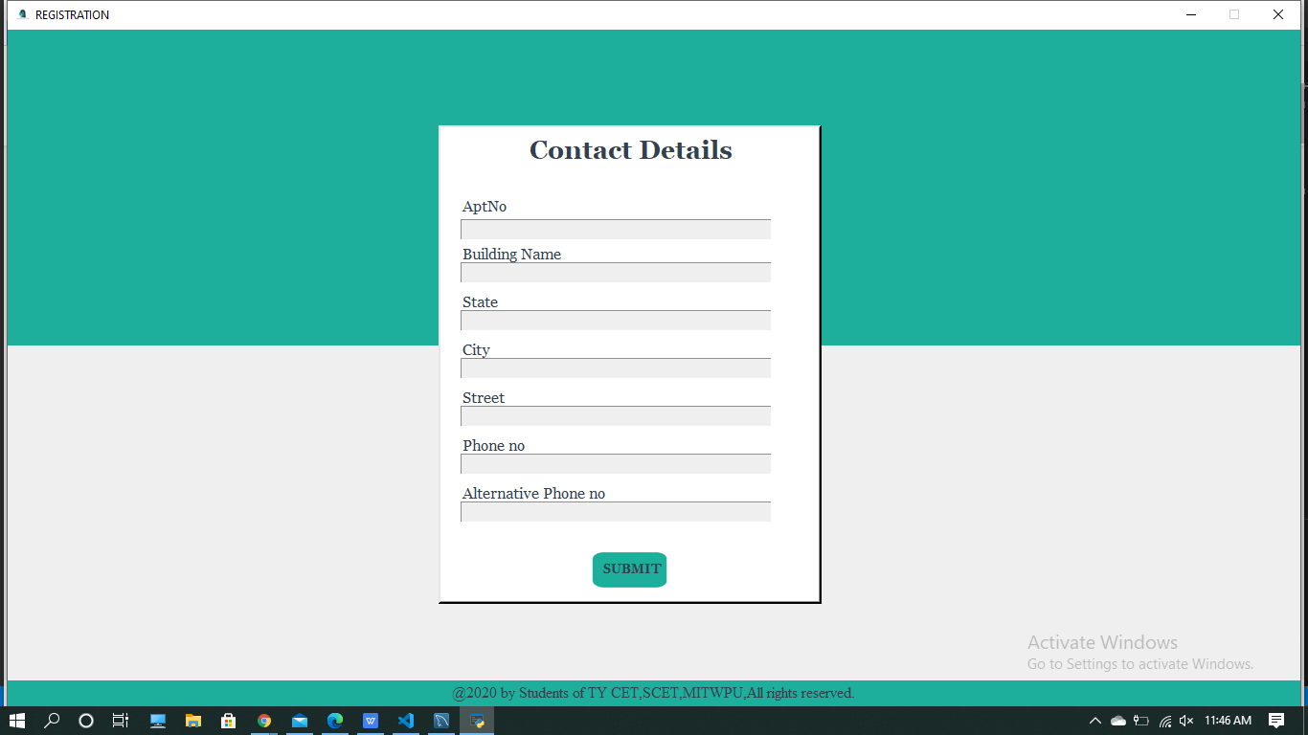

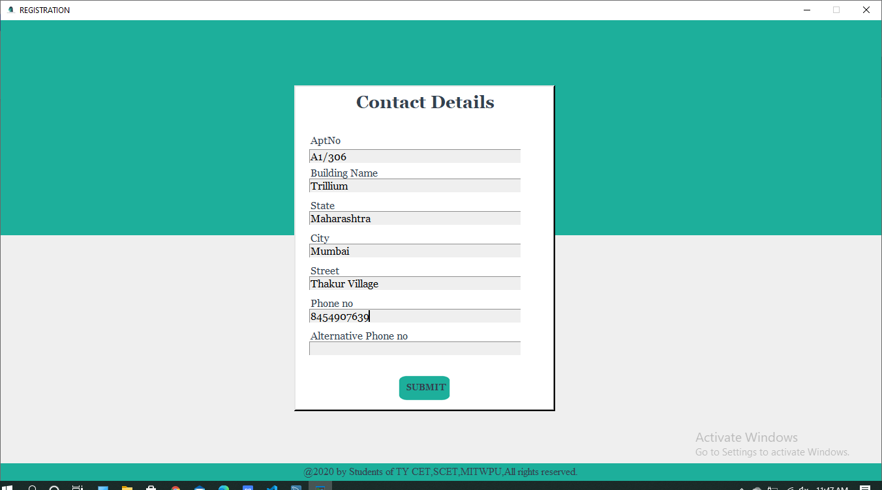

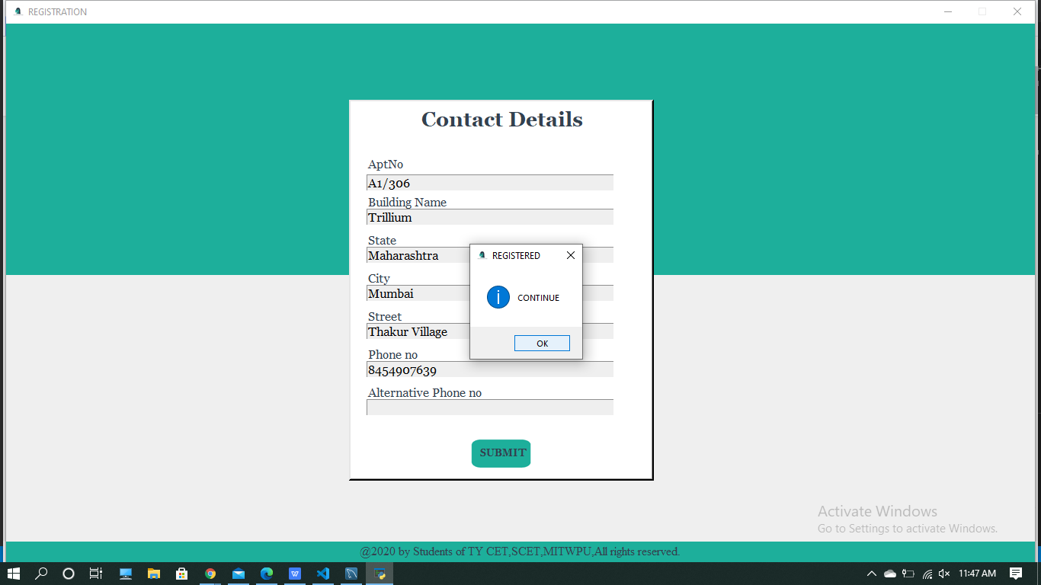

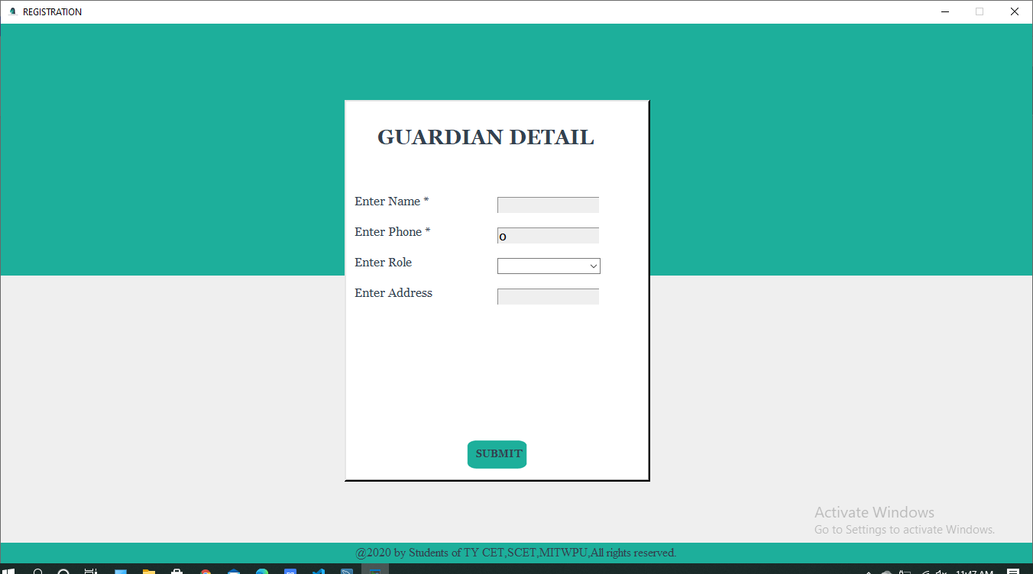

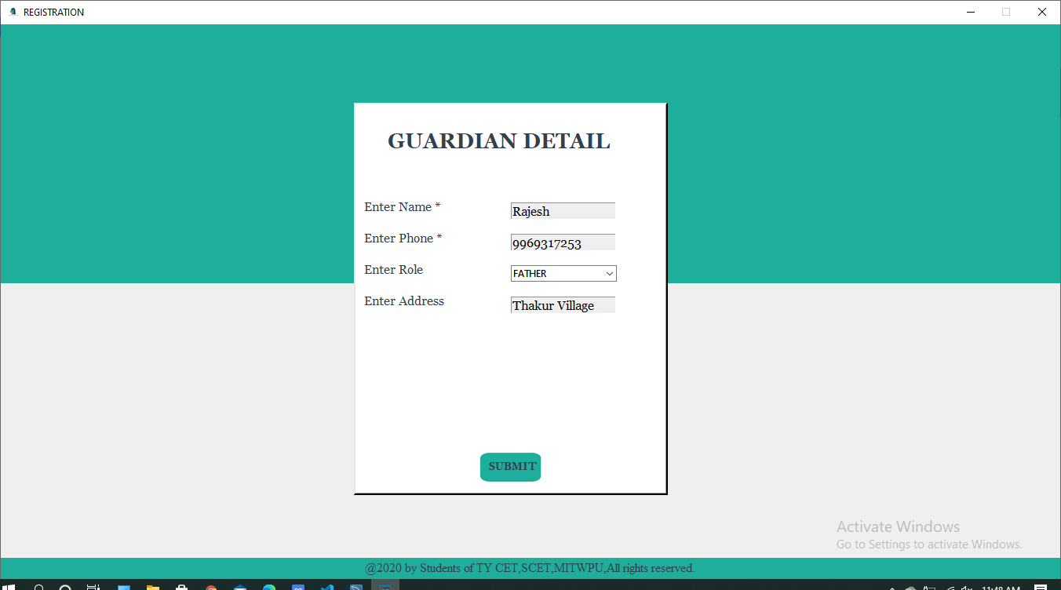

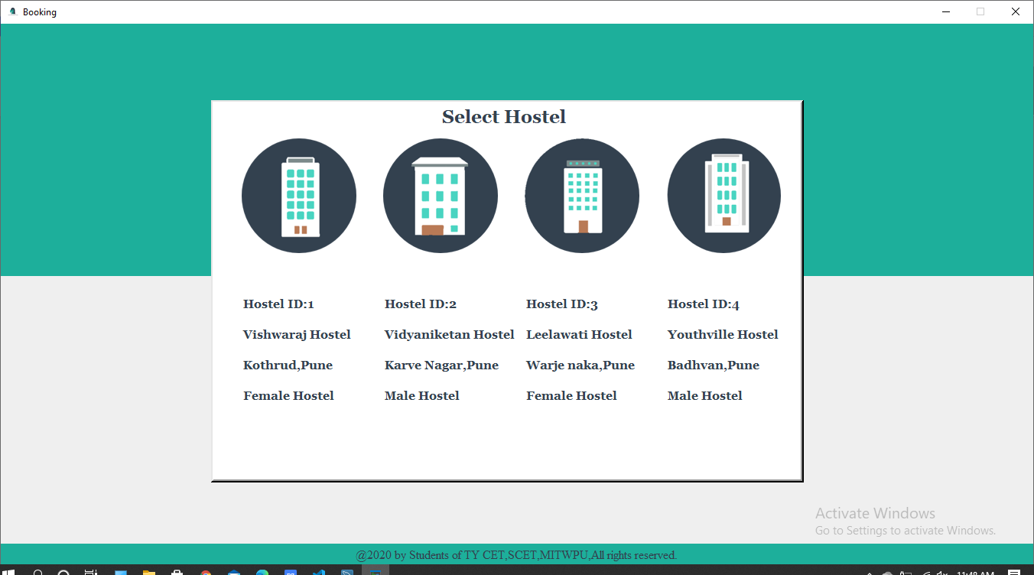

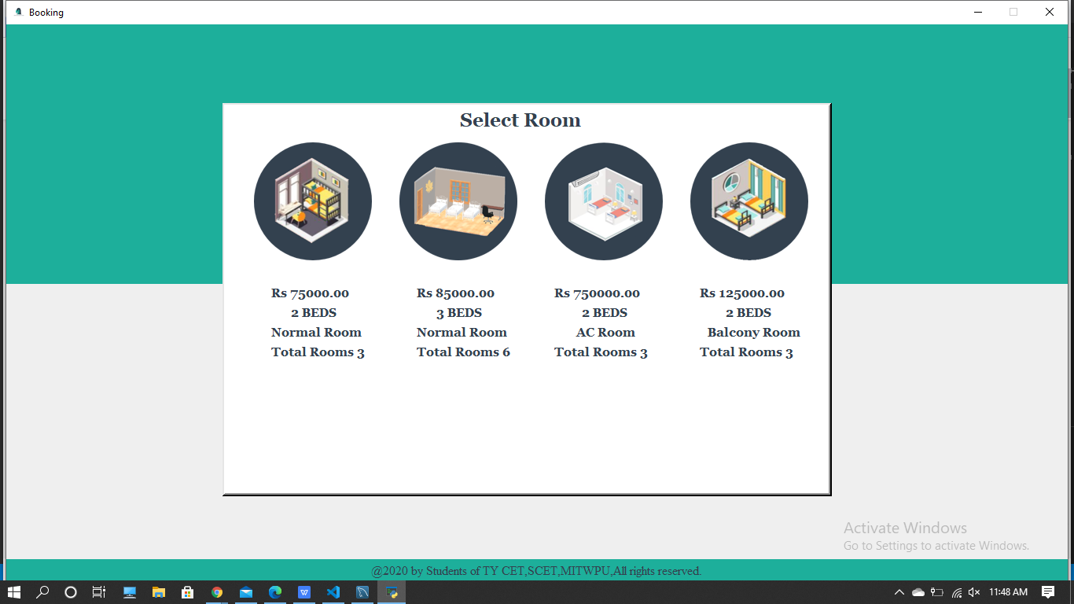

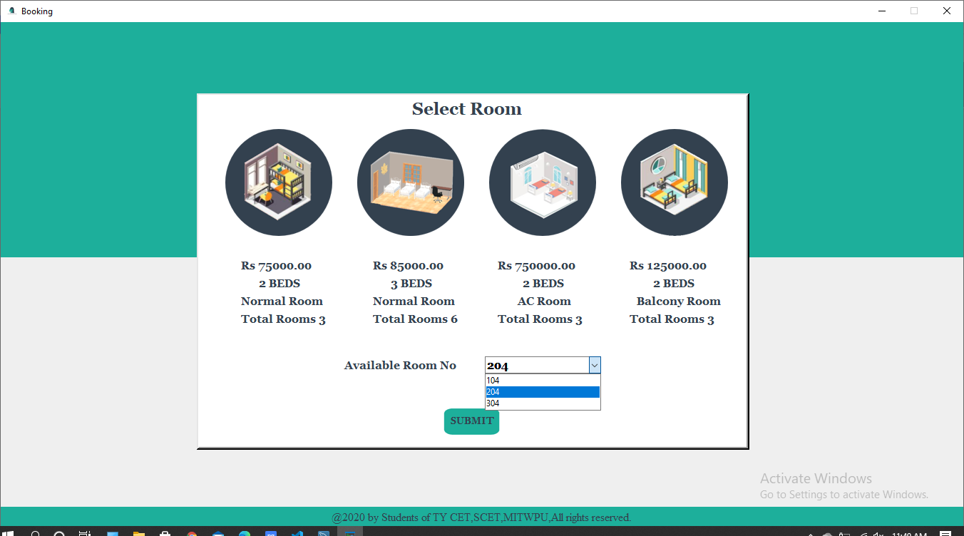

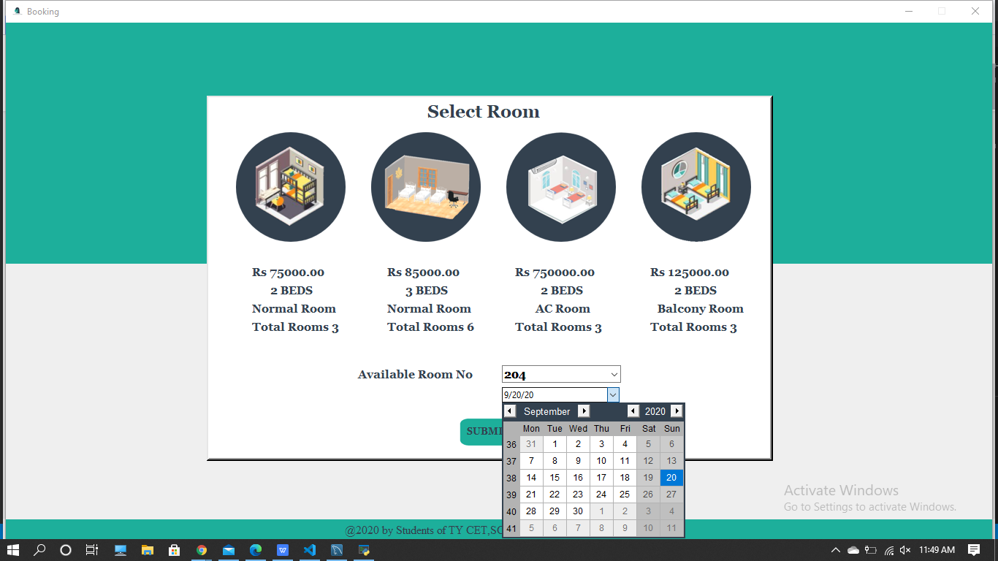

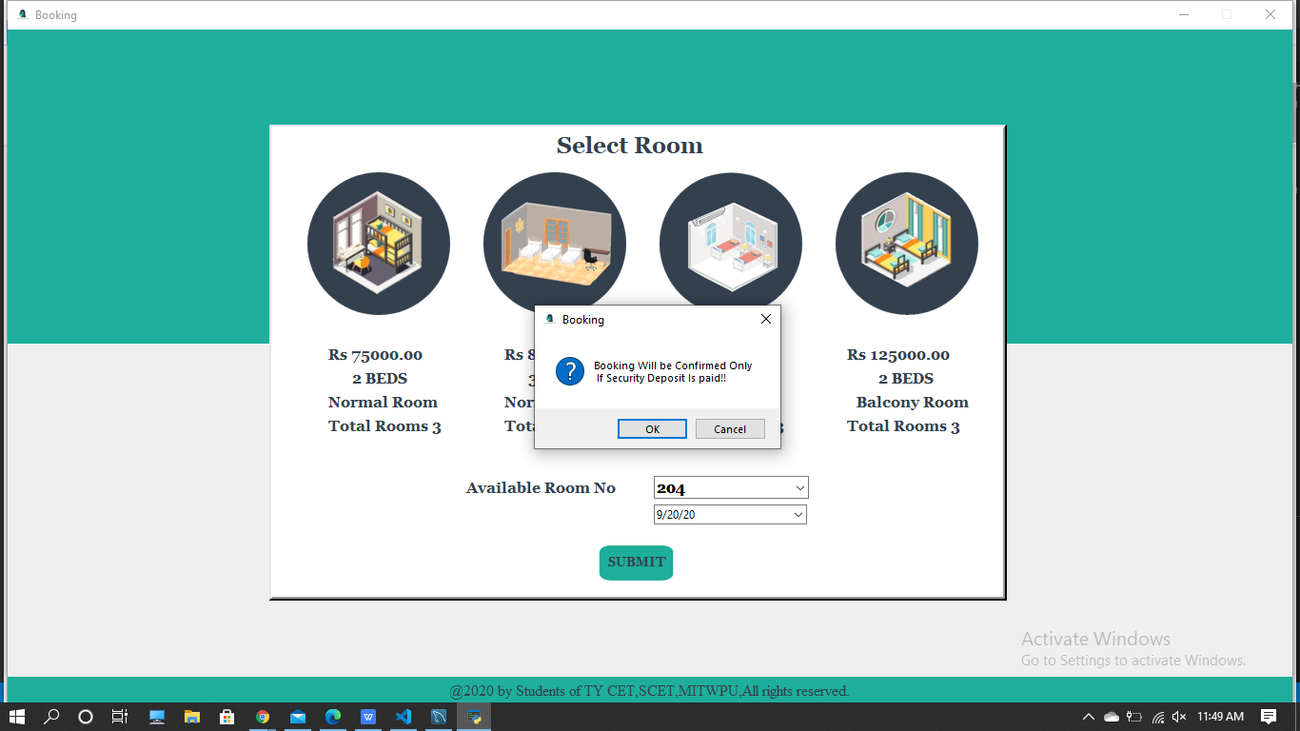

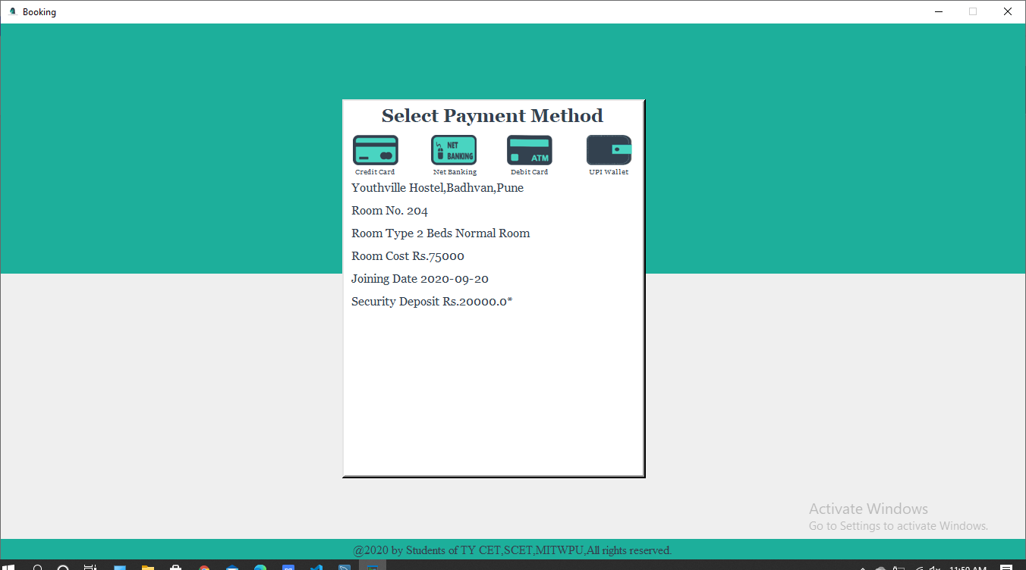

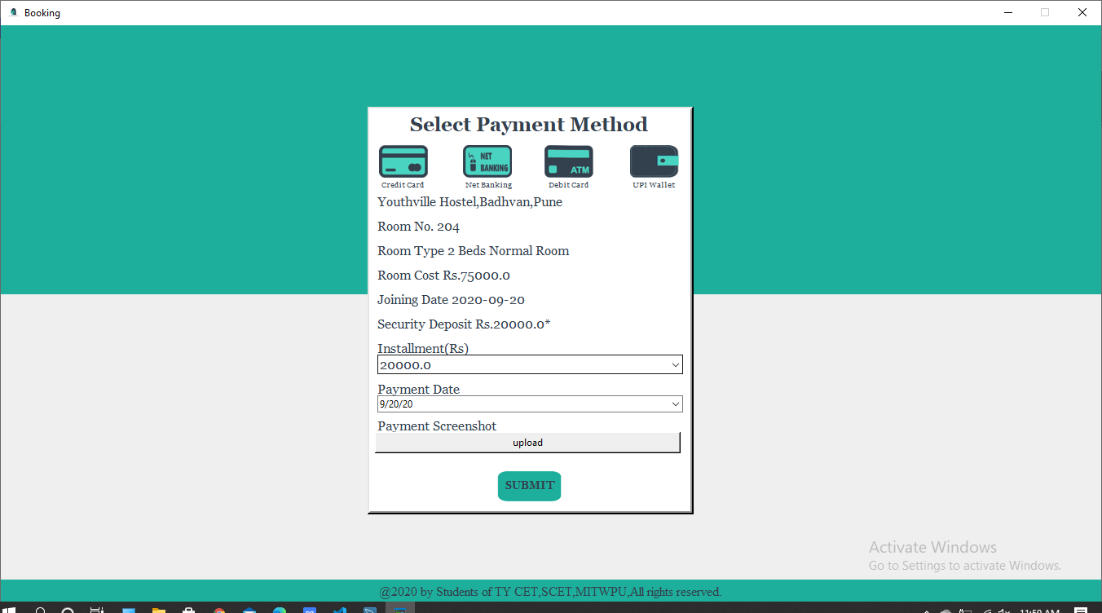

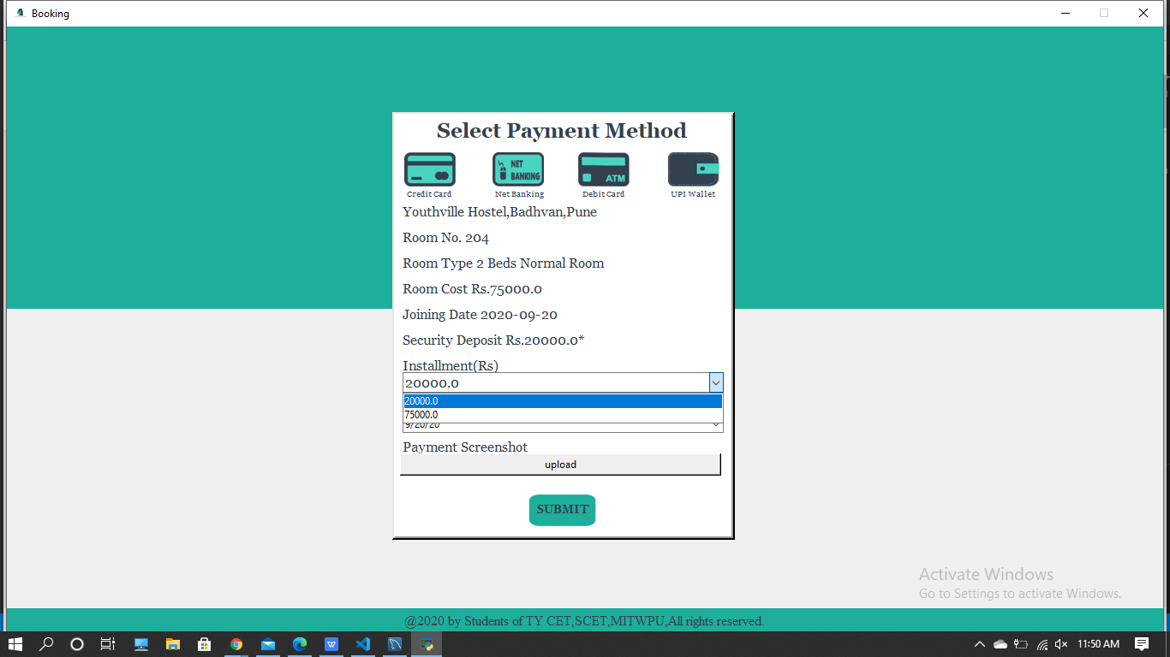

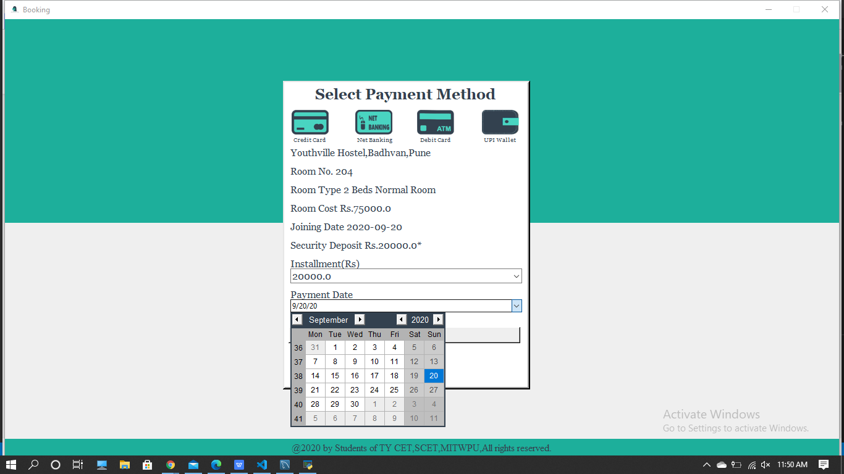

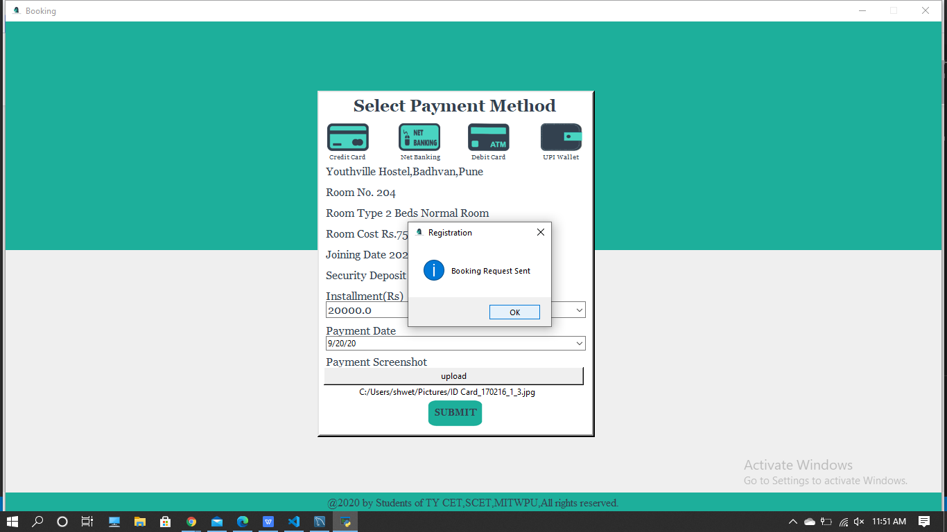

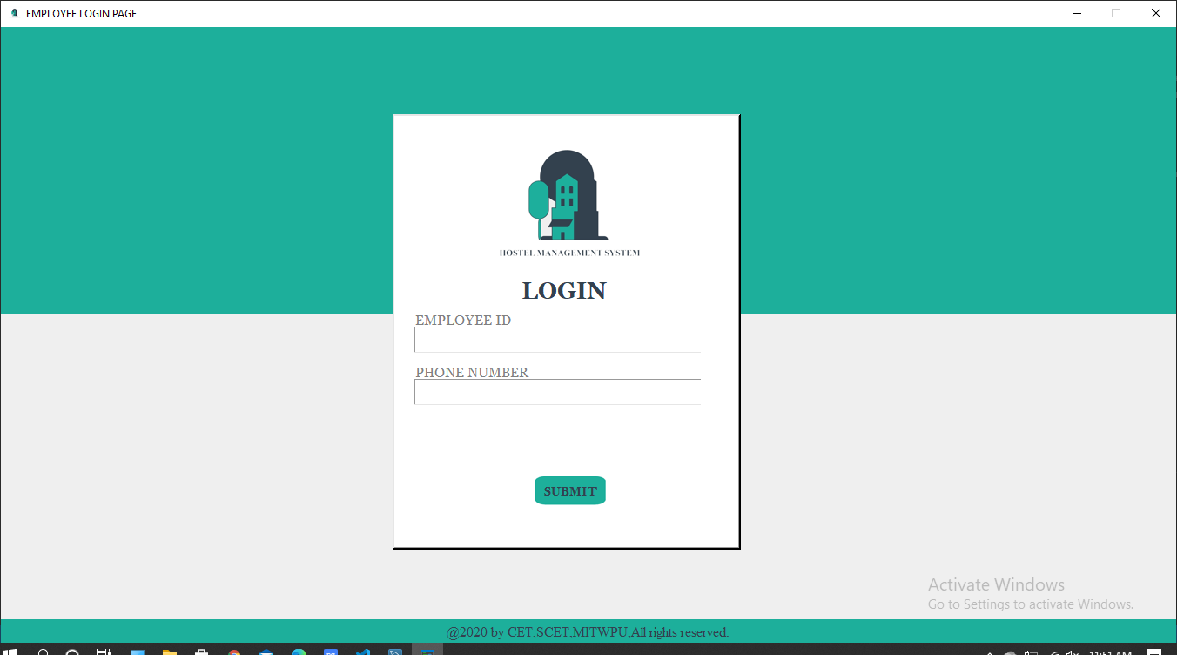

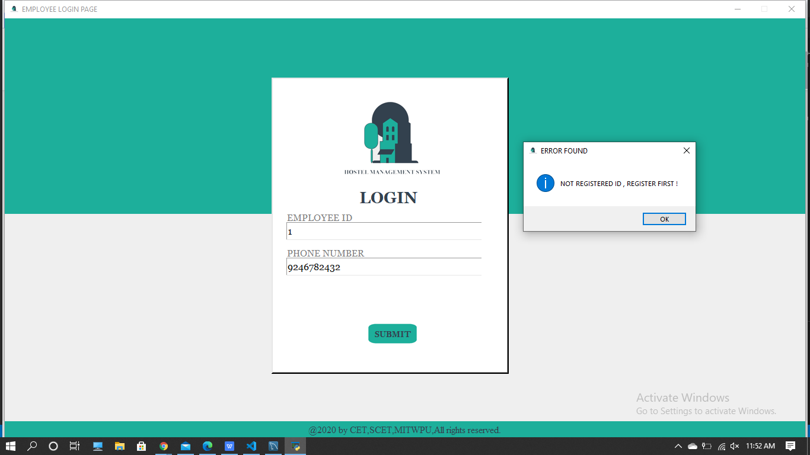

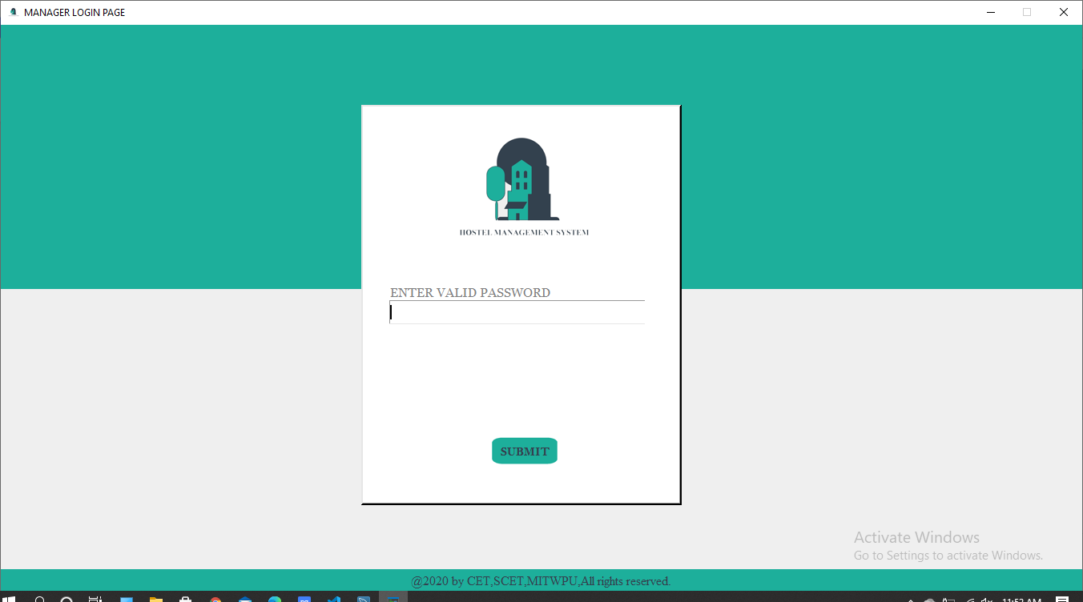

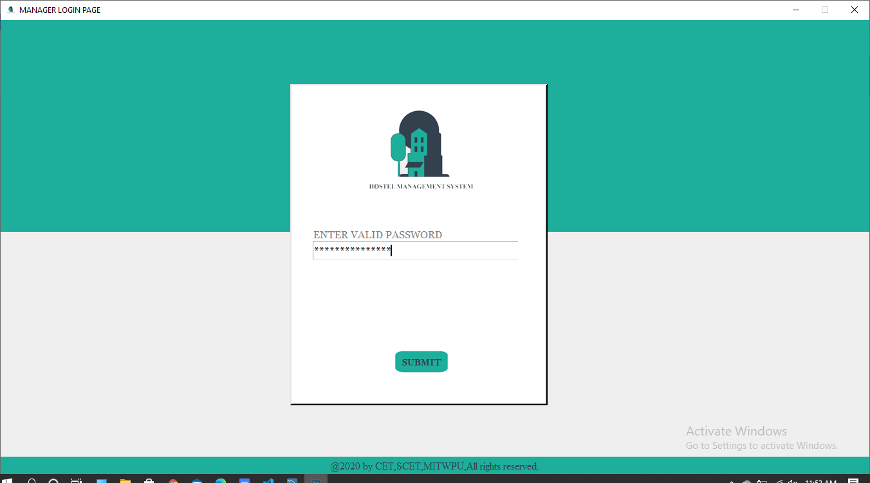

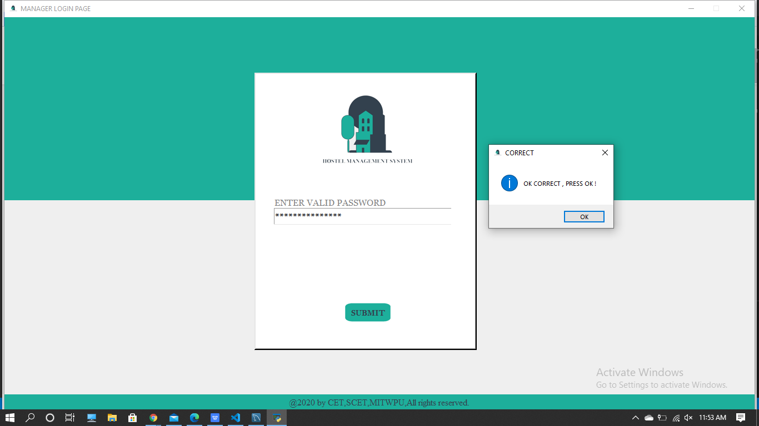

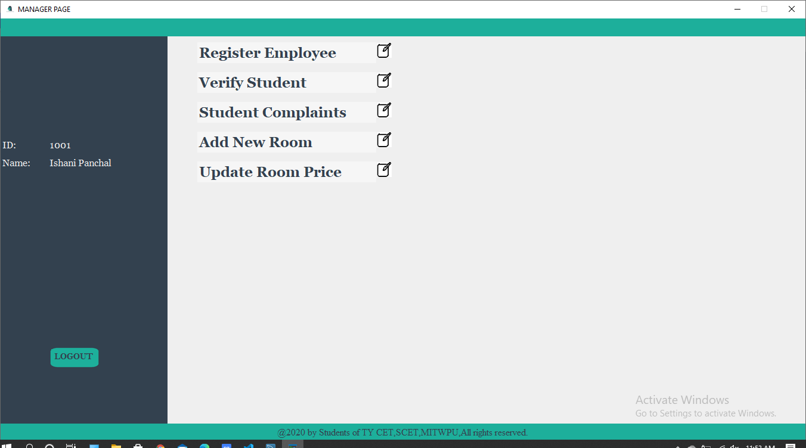

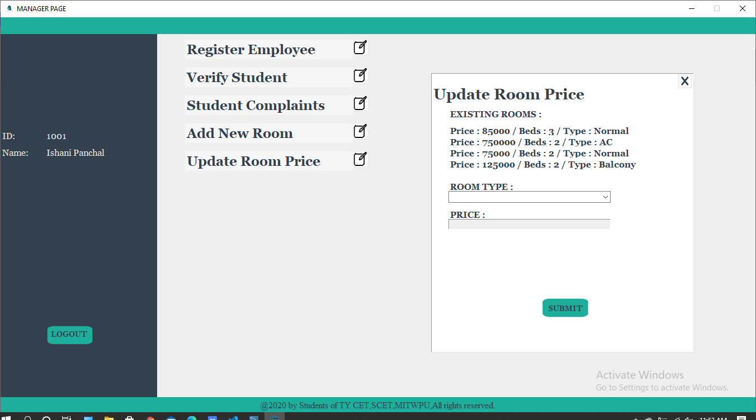

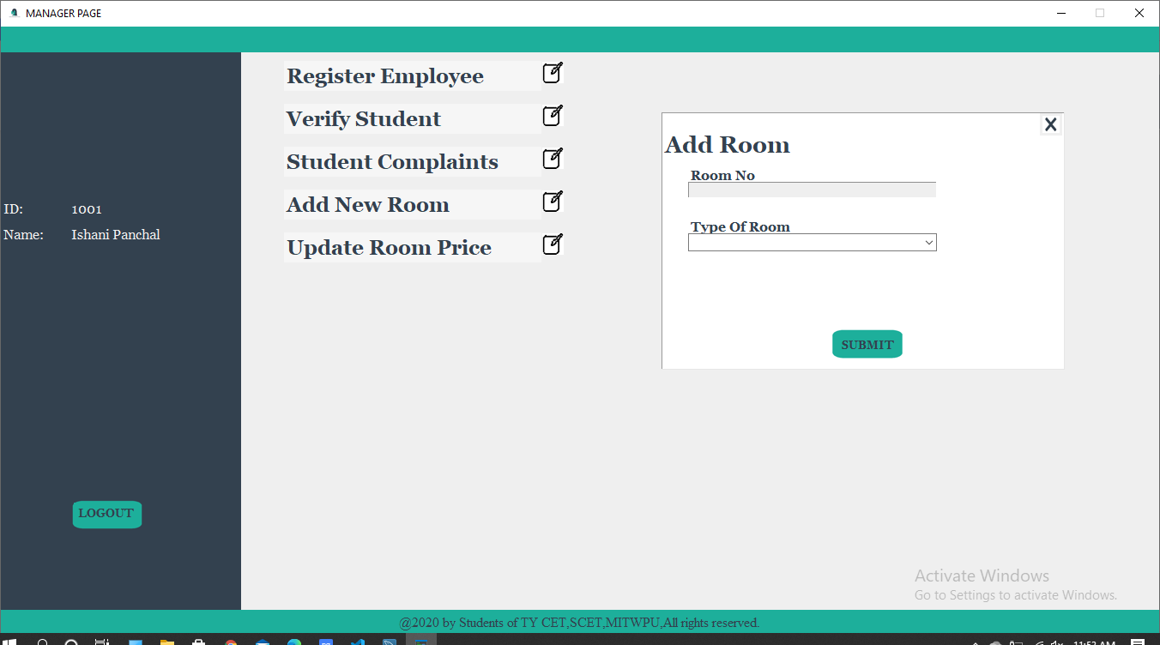

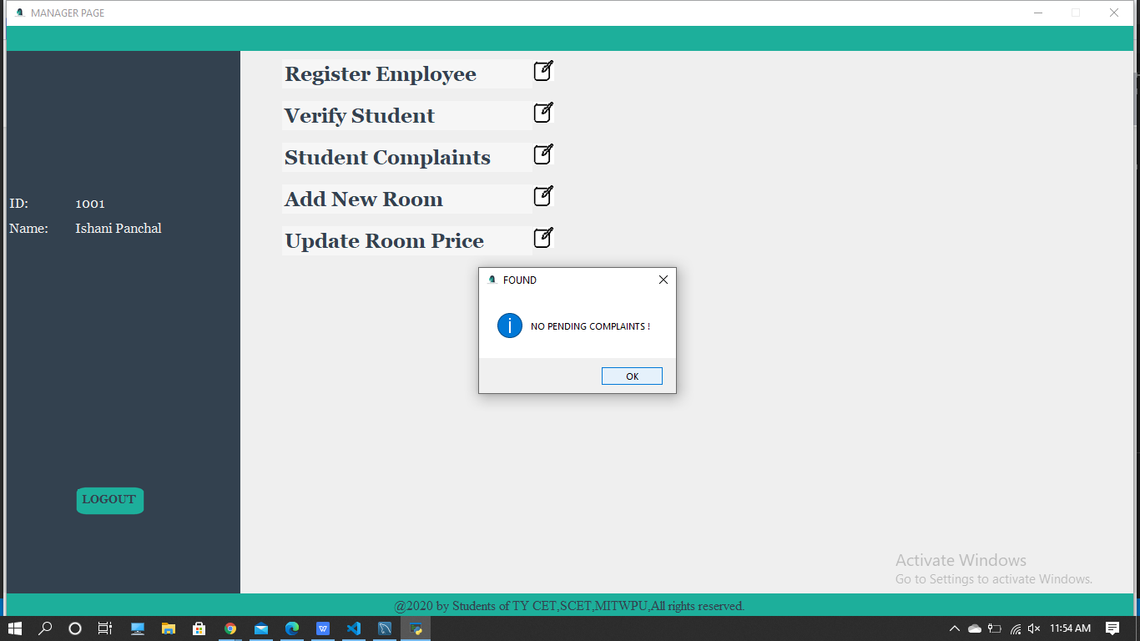

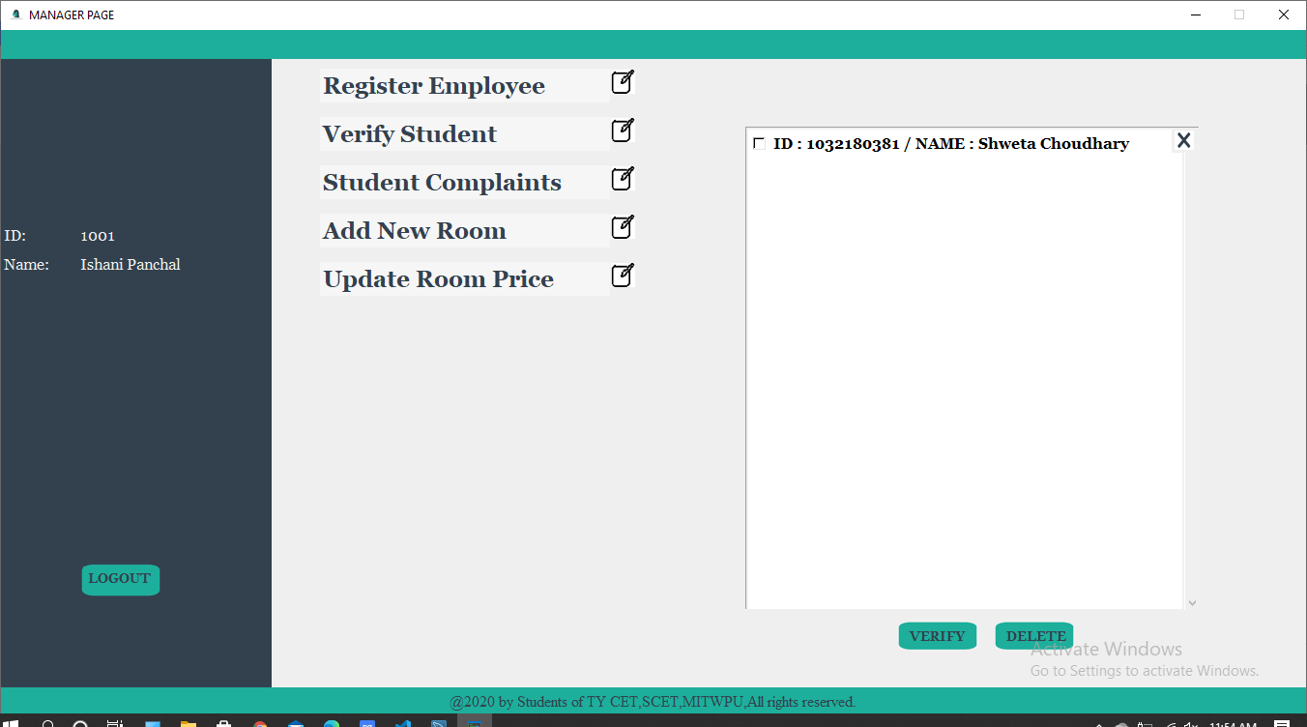

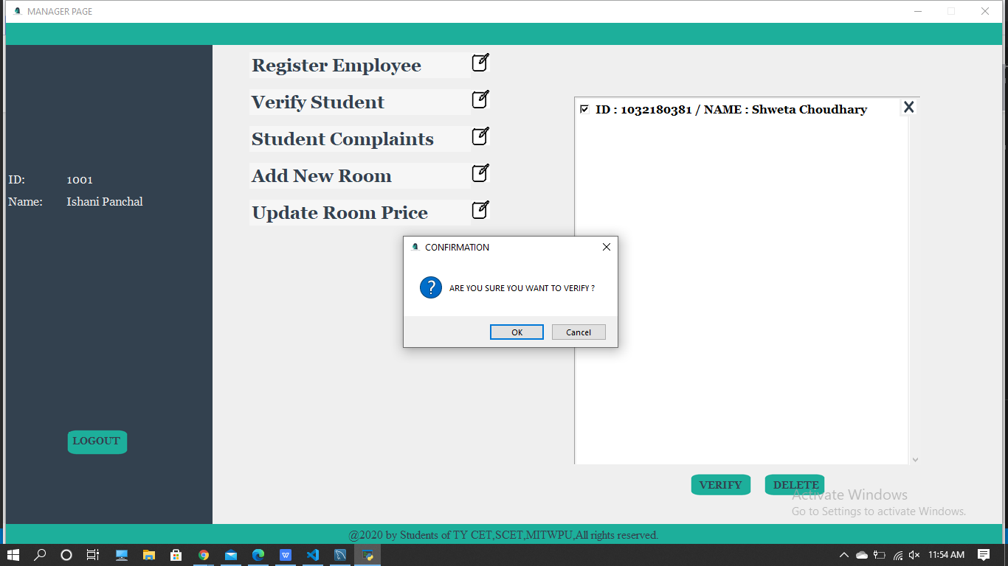

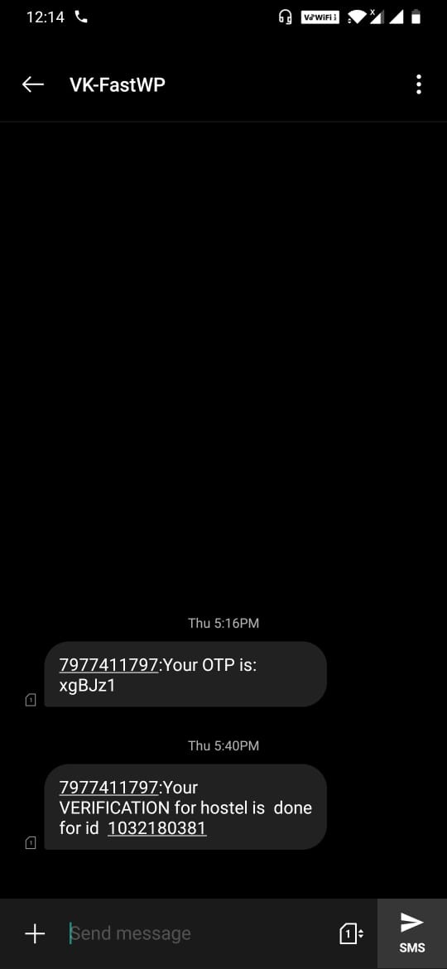

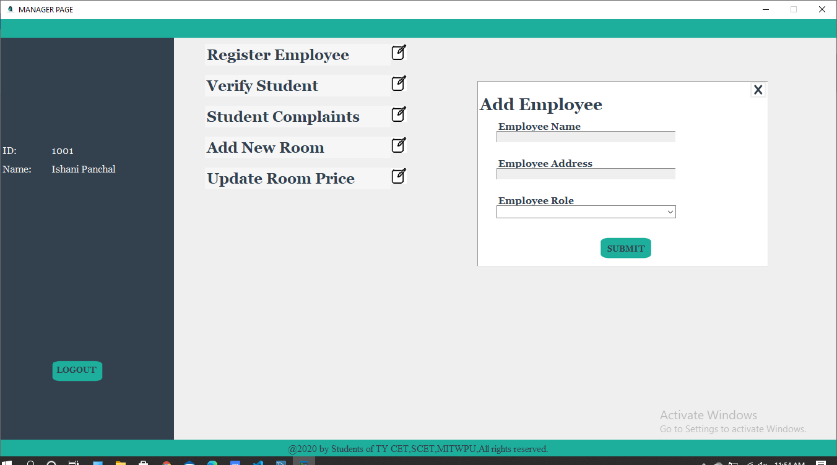

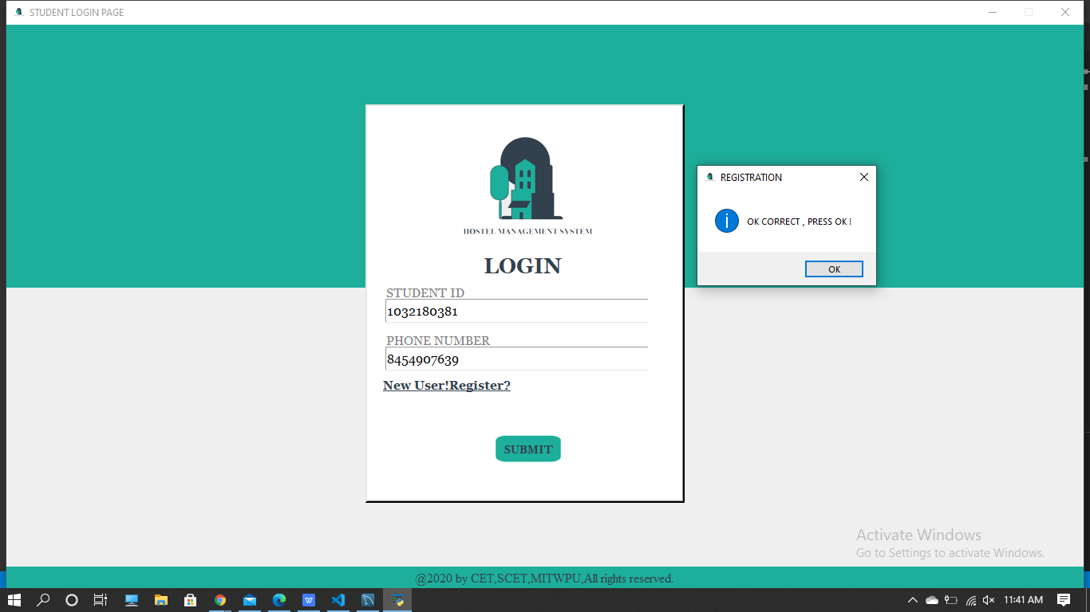

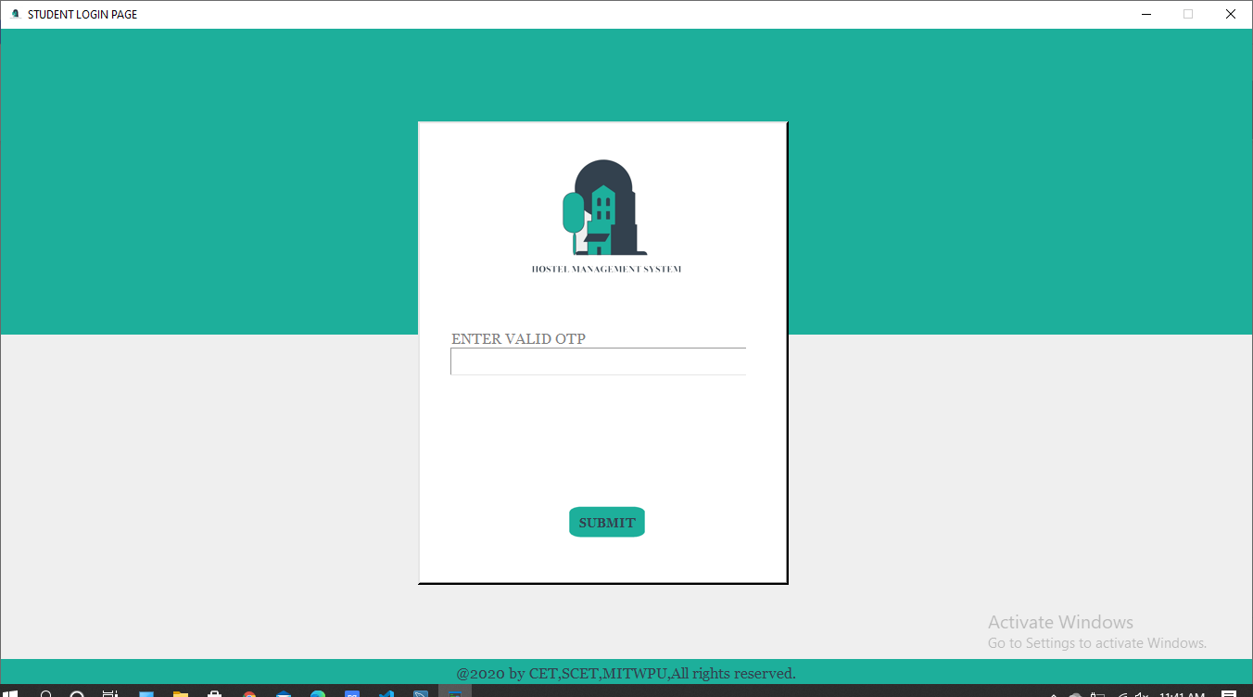

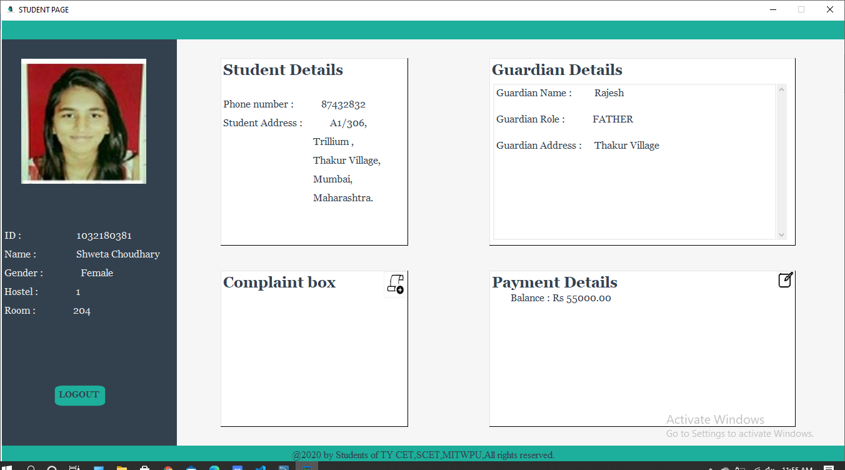

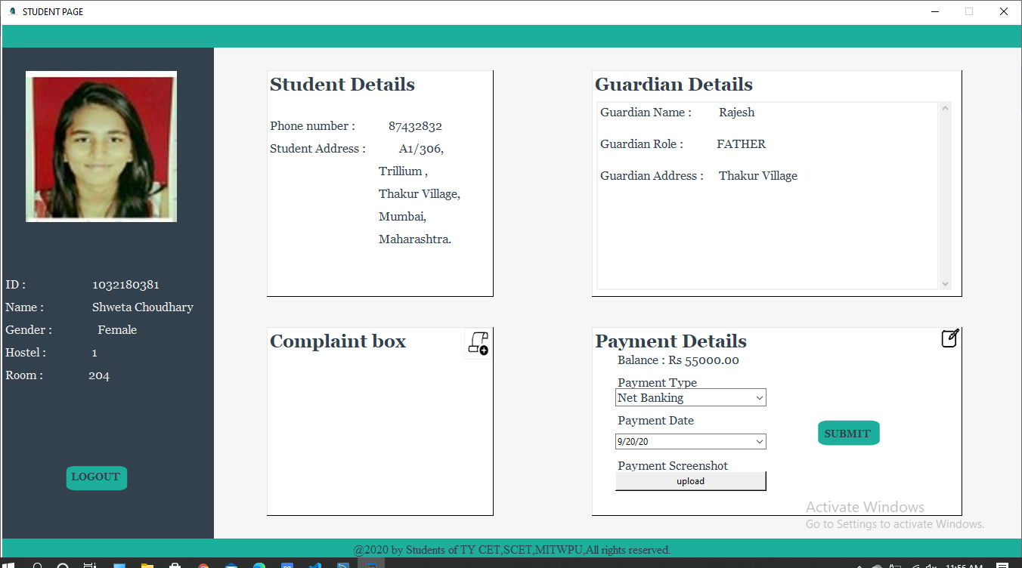

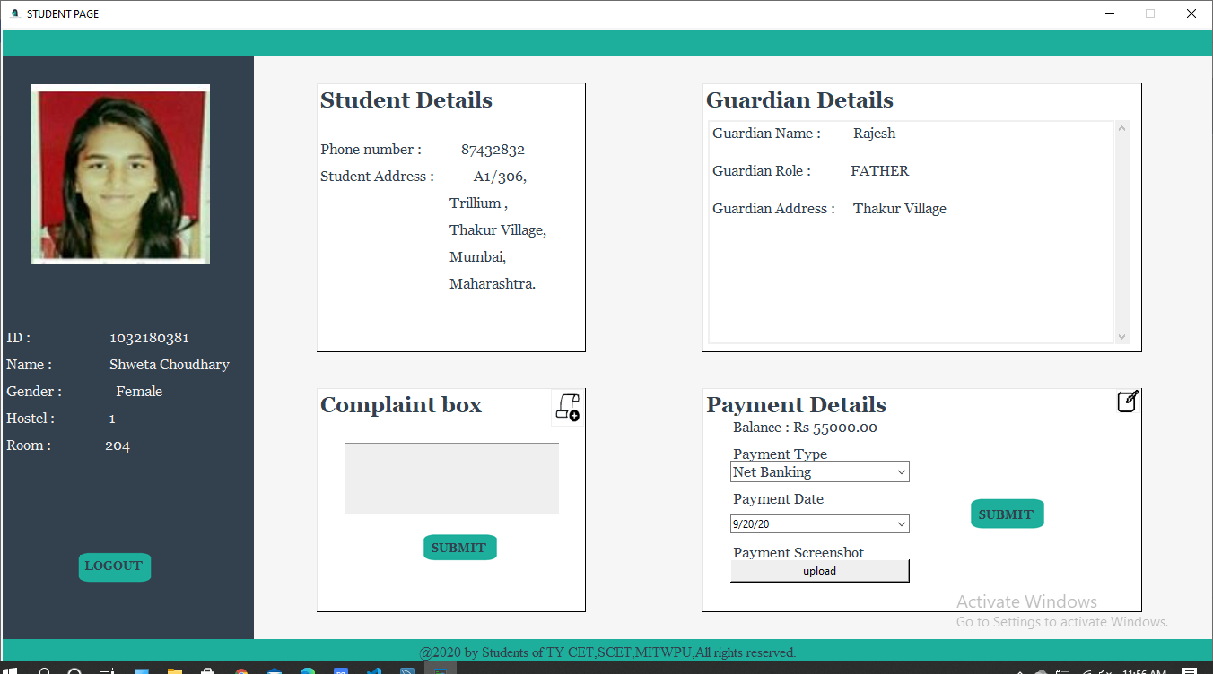

### *CONCLUSION :-

To conclude the description about the project entitled “Hostel Management System” : The project, developed using Python Tkinter GUI and MySQL is based on the requirement of increase in number of hostels by an institution.Thereby the number of hostels are also increasing for the accommodation of the students studying in this institution.Hence there is a lot of strain on the manager who are running the hostel.This particular project deals with the problems managers face while managing admissions to hostels,managing complaints and updation of rooms which occur when carried manually.This hostel management software is designed for people who want to manage various activities in the hostel.This project also tackles registration process for the Students.

This project helped us in gaining valuable information and practical knowledge on several topics like designing GUI applications using Python Tkinter and management of database using MySQL. The entire system is secured. Also the project helped us understanding about the development phases of a project and software development life

cycle.This knowledge will help us further while developing Web pages using MySQL and for making other database systems.

We can further develop this project to a great extent.Several features can be added for eg,Allowing the student to mark his attendance and also adding his leave and in time extension.Another feature which we wished to implement was providing specialization for employees so that different classes of employee can access the options respective to their Jobs .

“Hostel Management System” was successfully completed.

### *REFERENCES :-

* [www.stackoverflow.com](http://www.stackoverflow.com)
* [www.edureka.co](http://www.edureka.co)
* [www.geeksforgeeks.org](http://www.geeksforgeeks.org)
* [www.codemy.com](http://www.codemy.com)