 | JAIDEV EDUCATION SOCIETY’S  J D COLLEGE OF ENGINEERING AND MANAGEMENT  KATOL ROAD, NAGPUR  Website: www.jdcoem.ac.in E-mail: info@jdcoem.ac.in  (An Autonomous Institute, with NAAC "A" Grade)  Affiliated to DBATU, RTMNU & MSBTE Mumbai  Department of Computer Science and Technology  “A Place to Learn, A Chance to Grow”  Session: 2025-26 | 
VISION | MISSION
To be recognized for excellent engineering, developing global leaders both in educational and research in the domain of computer science and wireless engineering. | 1. To create self-learning environment by facilitating leadership qualities, team spirit and ethical responsibilities.
 | 2. To improve department-industry collaboration, interaction with professional society through technical knowledge and internship program.
 | 3. To promote research and development with current techniques through well qualified resources in the area of computer science and wireless engineering.

Experiment no-02
Aim: To Analyze the SaaS delivery model and deploy a G Suite cloud-based application that can be accessed by end users through a web browser without local installation.
Theory:

AWS (Amazon Web Services) is a comprehensive, evolving cloud computing platform provided by Amazon that includes a mixture of infrastructure as a service (IaaS), platform as a service (PaaS) and packaged software as a service (SaaS) offering. AWS services can offer an organization tool such as compute power, database storage and content delivery services.
AWS launched in 2006 from the internal infrastructure that Amazon.com built to handle its online retail operations. AWS was one of the first companies to introduce a pay-as-you- go cloud computing model that scales to provide users with compute, storage or throughput as needed.
AWS offers many different tools and solutions for enterprises and software developers that can be used in data centers in up to 190 countries. Groups such as government agencies, education institutions, nonprofits and private organizations can use AWS services.
How AWS works
AWS is separated into different services; each can be configured in different ways based on the user's needs. Users should be able to see configuration options and individual server maps for an AWS service.
More than 100 services comprise the Amazon Web Services portfolio, including those for compute, databases, infrastructure management, application development and security.
These services, by category, include: Compute, Storage databases Data management Migration, Hybrid cloud Networking, Development tools, Management Monitoring Security, Governance Big data management Analytics, Artificial intelligence (AI) Mobile development, Messages and notification

Amazon EC2 Compute:
Amazon Elastic Compute Cloud (Amazon EC2) provides scalable computing capacity in the Amazon Web Services (AWS) Cloud. Using Amazon EC2 eliminates your need to invest in hardware up front, so you can develop and deploy applications faster. You can use Amazon EC2 to launch as many or as few virtual servers as you need, configure security and networking, and manage storage. Amazon EC2 enables you to scale up or down to handle changes in requirements or spikes in popularity, reducing your need to forecast traffic.
Features of Amazon EC2

Amazon EC2 provides the following features:
- Virtual computing environments, known as instances
- Preconfigured templates for your instances, known as Amazon Machine Images (AMIs), that package the bits you need for your server (including the operating system and additional software)
- Various configurations of CPU, memory, storage, and networking capacity for your instances, known as instance types
- Secure login information for your instances using key pairs (AWS stores the public key, and you store the private key in a secure place)
- Storage volumes for temporary data that's deleted when you stop, hibernate, or terminate your instance, known as instance store volumes
- Persistent storage volumes for your data using Amazon Elastic Block Store (Amazon EBS), known as Amazon EBS volumes
- Multiple physical locations for your resources, such as instances and Amazon EBS volumes, known as Regions and Availability Zones
- A firewall that enables you to specify the protocols, ports, and source IP ranges that can reach your instances using security groups
- Static IPv4 addresses for dynamic cloud computing, known as Elastic IP addresses
- Metadata, known as tags, that you can create and assign to your Amazon EC2 resources
- Virtual networks you can create that are logically isolated from the rest of the AWS Cloud, and that you can optionally connect to your own network, known as virtual private clouds (VPCs)

The Steps to Create and Access Platform as a service on Heroku is as follows:
STEP 1 :

Login to AWS Console.

STEP 2 :

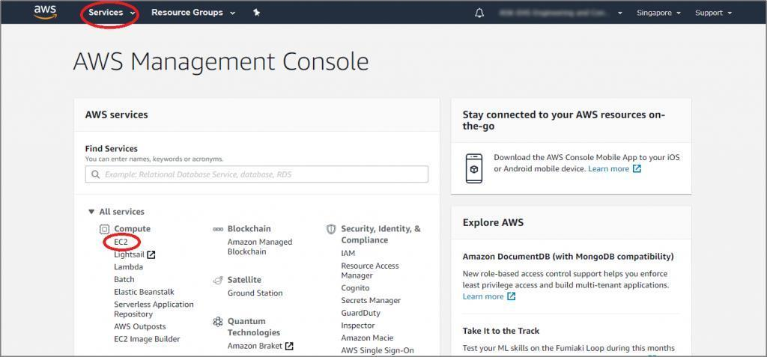
After login successfully, you are on the dashboard page. Select ‘Services’ from the top navigation bar and click ‘EC2’ under the category ‘Compute’.

STEP 3 :
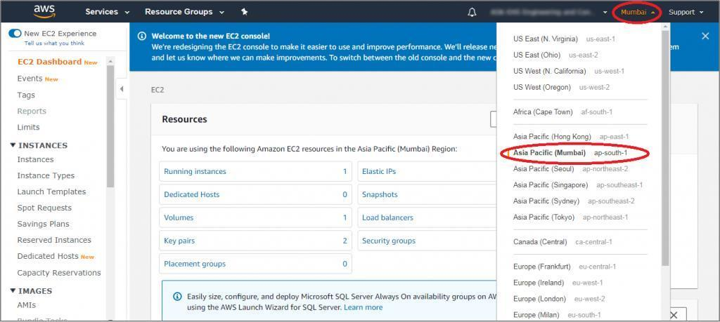
On the EC2 instance dashboard page, select the data center closest to your geographical location.

S TEP 4 :

Scroll down, and in the ‘Launch Instance’ area, check that the selected region appears below the “Launch Instance’ button. Click on the ‘Launch Instance’ button.
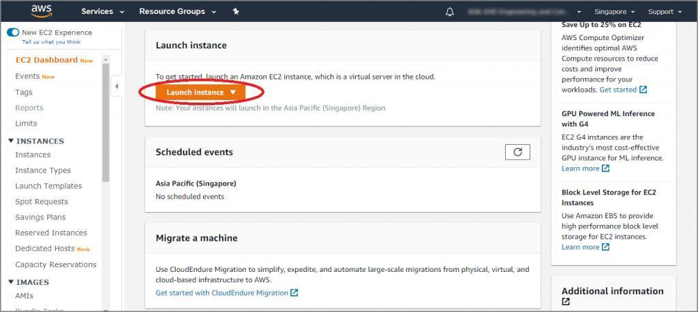

S TEP 5 :

The Amazon Machine Image (AMI) page is displayed. You need to select your operating system for your EC2 instance. E.g., if you want to create Windows Server instance, on the page search, type ‘windows’ as the search option and press ‘enter’.
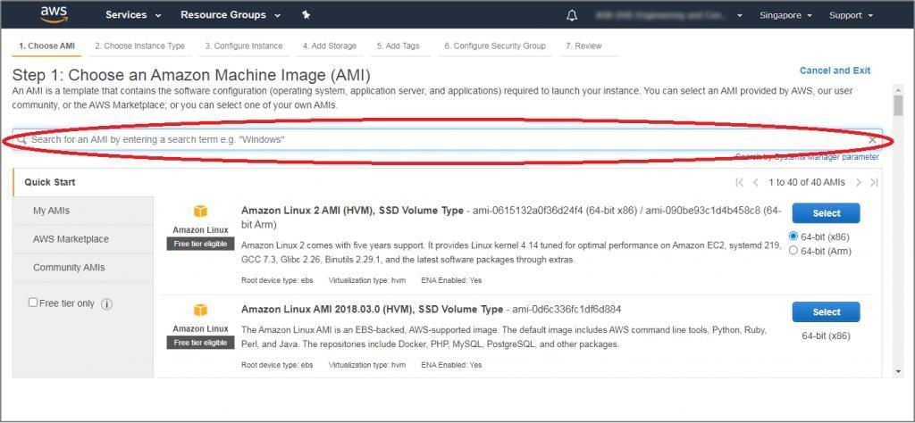

S TEP 6 :

From the list of available images, click on the ‘Select’ button beside the needed image. In this example, we have selected the ‘Microsoft Windows Server 2019 Base’ image.
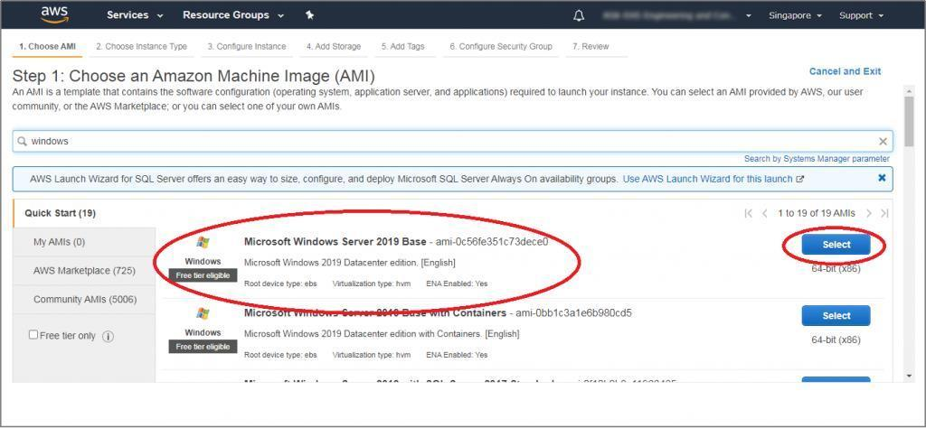

S TEP 7 :

On the next page, select the type of the instance based on your requirement like RAM, network performance, etc. AWS selects the default micro instance and click the ‘Next: Configure Instance Details’ button.

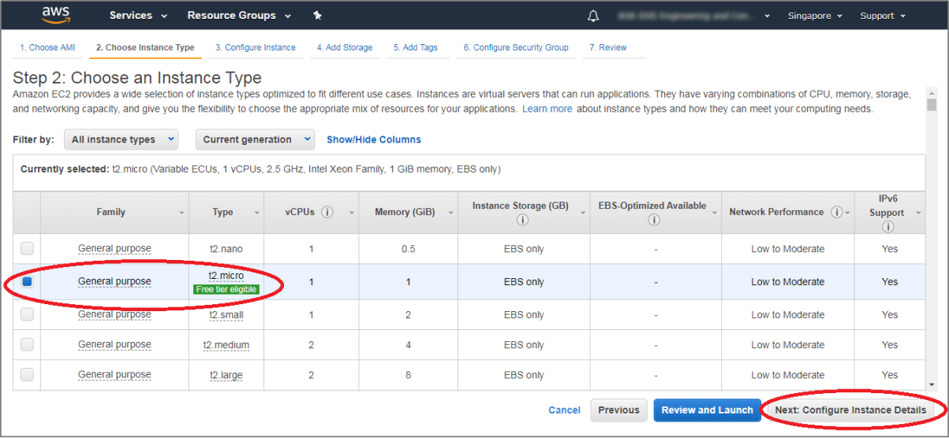

S TEP 8 :

Enter the number of instances in the ‘Configure Instance Details’ page. The default value is 1, and you can create multiple instances based on your need. Click on the ‘Next: Add Storage’ button.
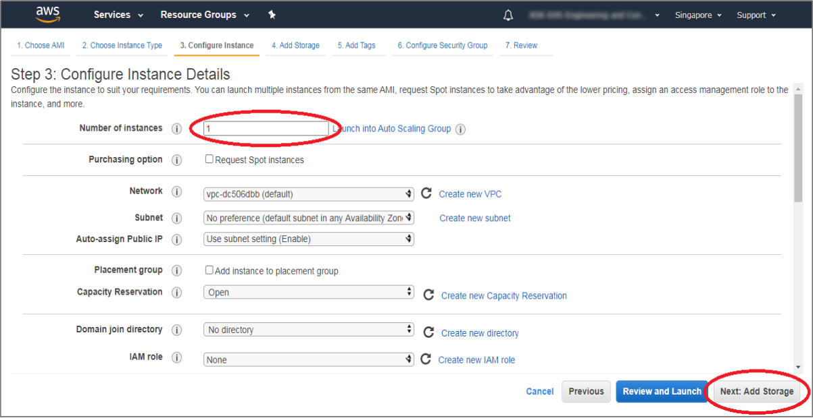

S TEP 9

On the ‘Add Storage’ page, you can add a storage device for storing your files. With the Free Tier, by default, you get 30GB of storage per instance. You can buy additional storage by clicking on the ‘Add New Volume’ button. Next, click on the ‘Next: Add Tags’ button.
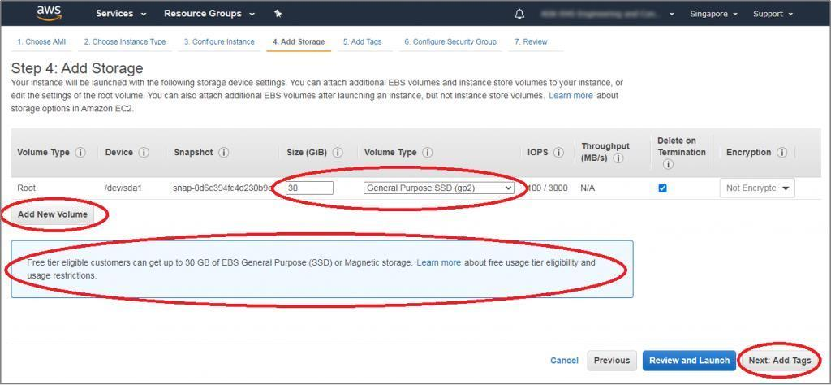

S TEP 10 :

In the ‘Add Tags’ page, click the ‘Click to add the Name tag’.
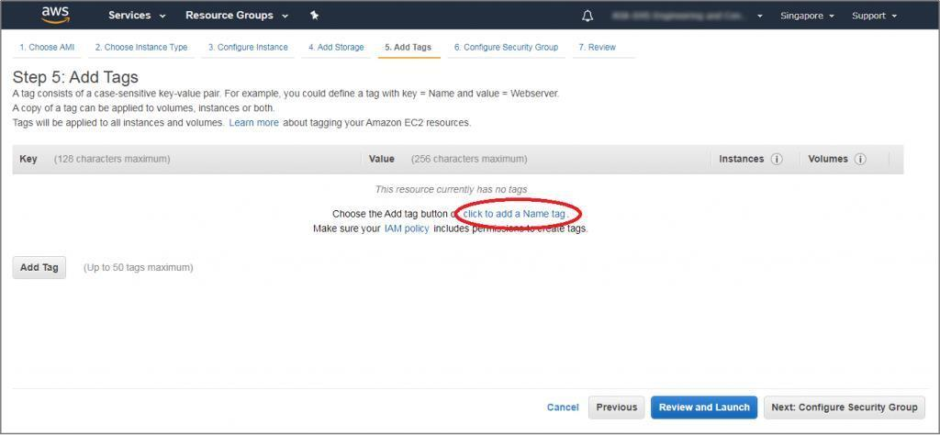

S TEP 11

In the ‘Key’ field’ type ‘Name’ and enter the values as ‘Dev Trial’. Click the ‘Next: Configure Security Group’ button.
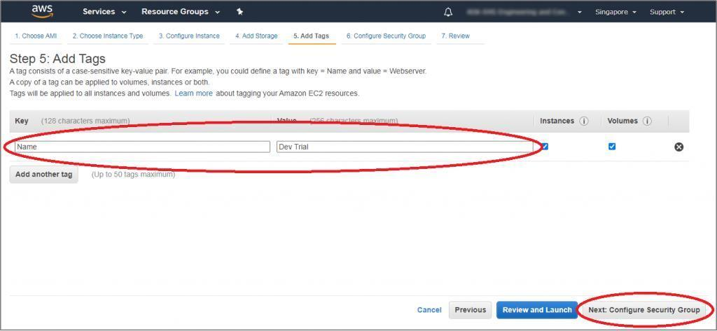

S TEP 12 :

On this page, you can choose the configuration to access this EC2 compute instance. By default, you choose the windows image and its automatically defined RDP connection. By default, ‘Custom’ is selected in the ‘Source’ dropdown. You can change it to ‘Anywhere’ to allow any IP address to access your instance. Alternatively, you can select ‘My IP’, which will restrict its access to your IP or keep ‘Custom’ which will allow you to specify the IP address range that can access your EC2 instance. Now, click the ‘Review and Launch’ button.
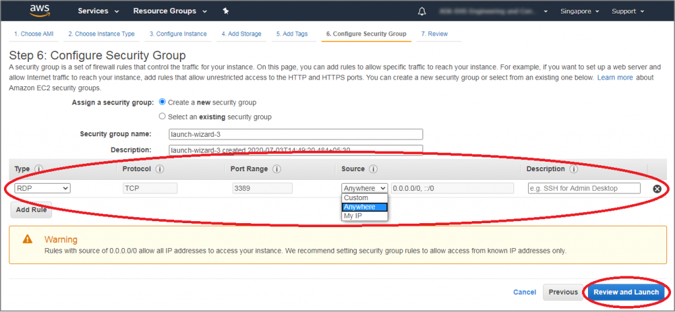

S TEP 13 :

On this page, review all of your selected configurations and click the ‘Launch’ button.
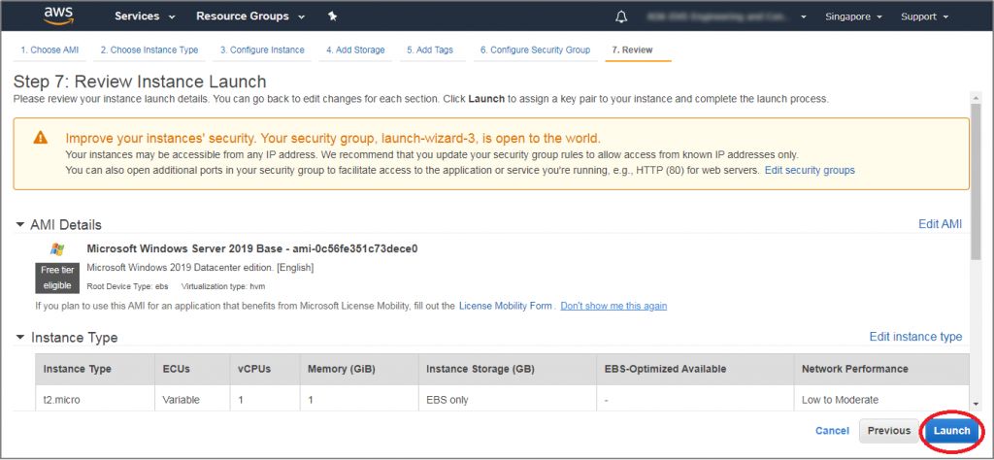

S TEP 14

A ‘Key Pair’ window is prompted. Select the ‘Create a new key pair’ option from the dropdown, and in the next text field, type a unique key pair name. Click the ‘Download Key Pair’ button. It will download the key pair file with ‘.pem’ extension on your computer. It’s crucial for generating unique passwords for the EC2 instance.
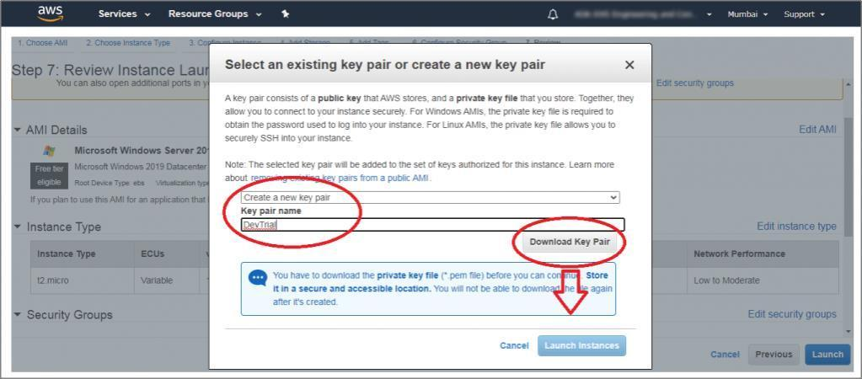

STEP 15 :

Click the ‘Launch Instances’ button, and it’s directed to the launch status page.
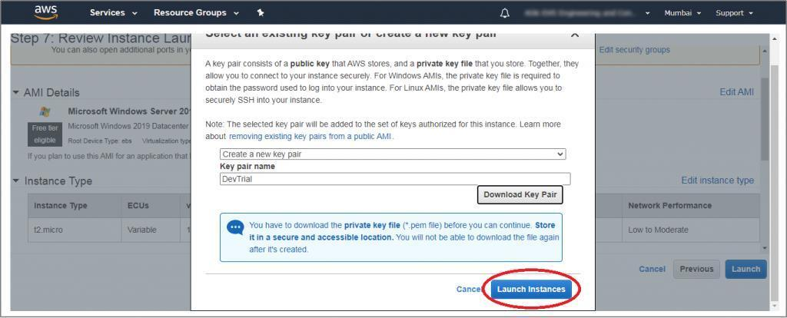

S TEP 16 :
The ‘Launch Status’ page is displayed.

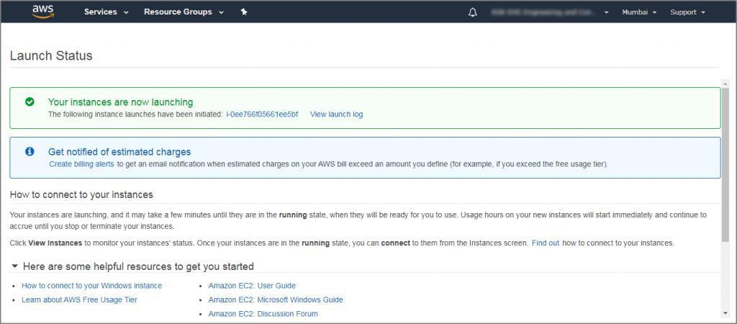

S TEP 17 :

Scroll down the page and click on the ‘View Instances’ button.
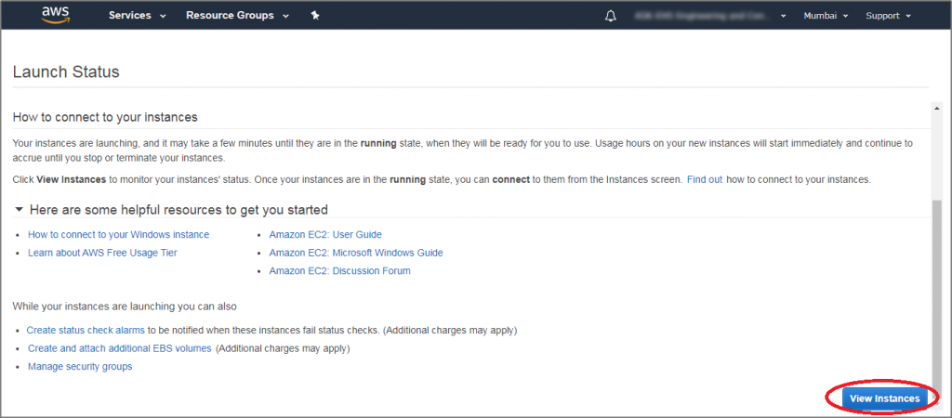

S TEP 18 :
All the available instances are displayed. The following image shows that the ‘Dev Trial’ instance is initializing.

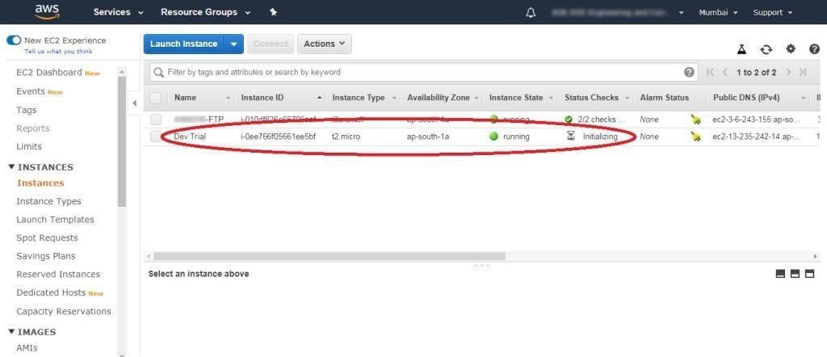

S TEP 19 :

The new instance is shown running in the list of instances.
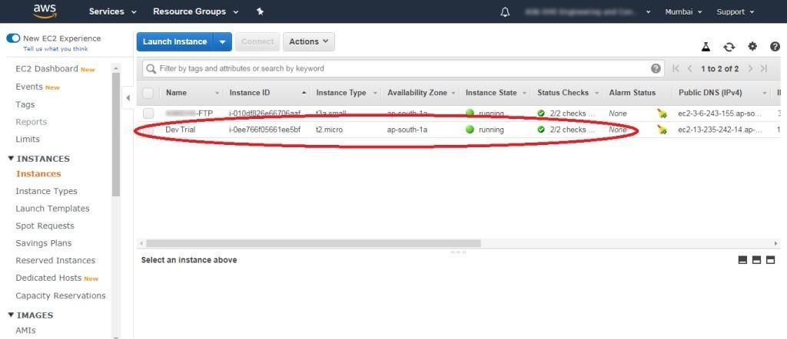

S TEP 20 :

Select the newly created instance (‘Dev Trial’ in this case) and click on the ‘Connect’ button.
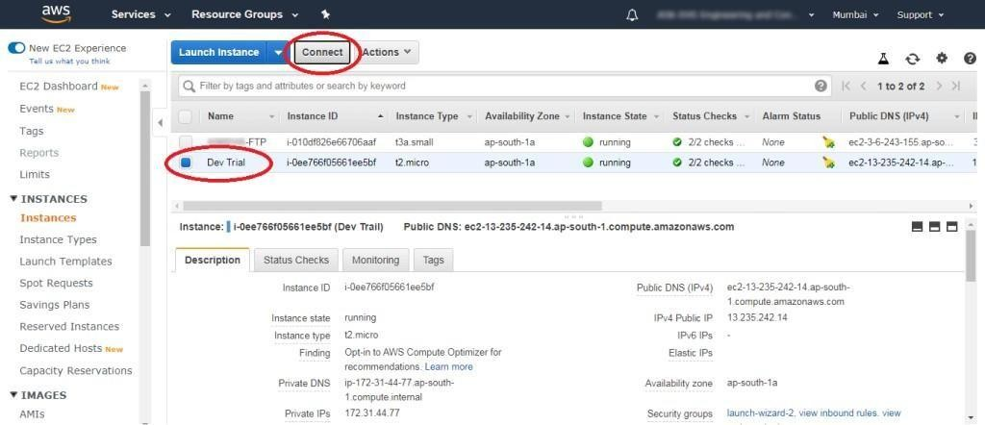

S TEP 21 :

In the ‘Connect to your instance’ window, click the ‘Download the Remote Desktop File’ button to download the RDP file. Save it on your computer.
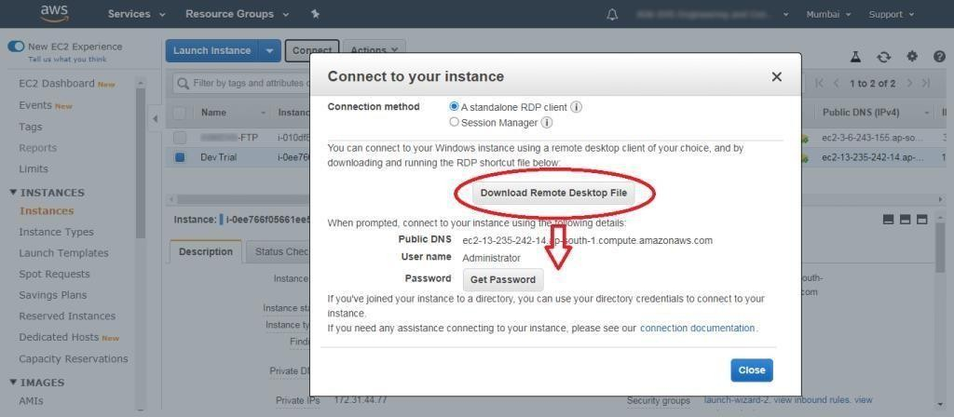

S TEP 22 :
Click the ‘Get Password’ button.
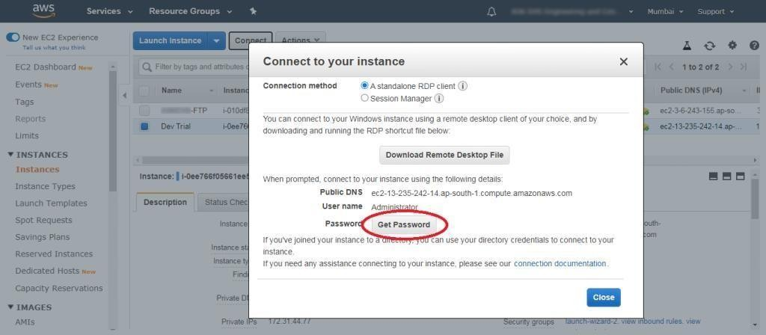

S TEP 23 :

Click on the ‘Choose File’ button and select the already downloaded key pair file. Click on the ‘Decrypt Password’ button.
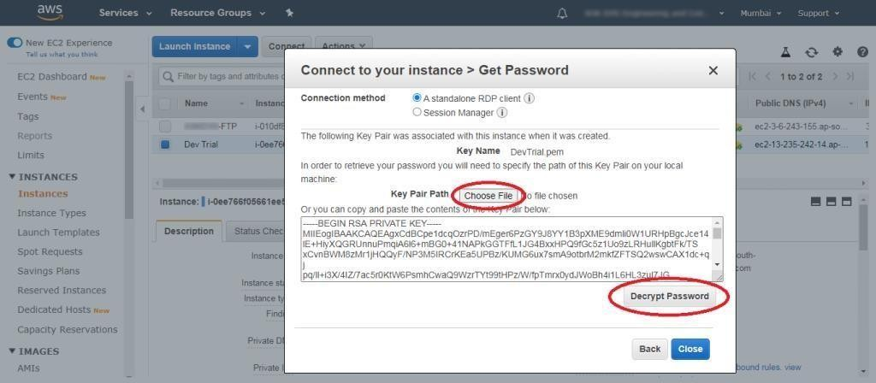

S TEP 24 :
The decrypted password will appear. Copy the Password and paste in any word processor file. Click the ‘Close’ button.
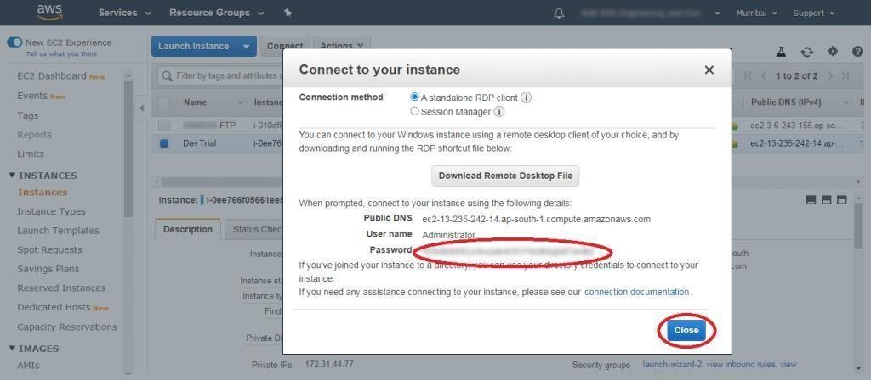

Now, go to your downloaded RDP file. The RDP software prompts to connect with EC2 instance. Click the ‘Connect’ button. In the popped up ‘Windows Login’ window, paste the previously copied password from the AWS console and click the ‘OK’ button. It will start to establish connections with the AWS EC2 instance.

Conclusion: Thus, we Studied and implemented Infrastructure as a Service using Amazon AWS.

