**CI/CD Deployment for Springboot Application**

The code for this project is hosted at <https://github.com/Shivrajkalane/CI-CD-Deployment-for-Springboot-Application.git>

The project is developed by Shivraj Kalane.

**Outputs :**

**Flow chart:**

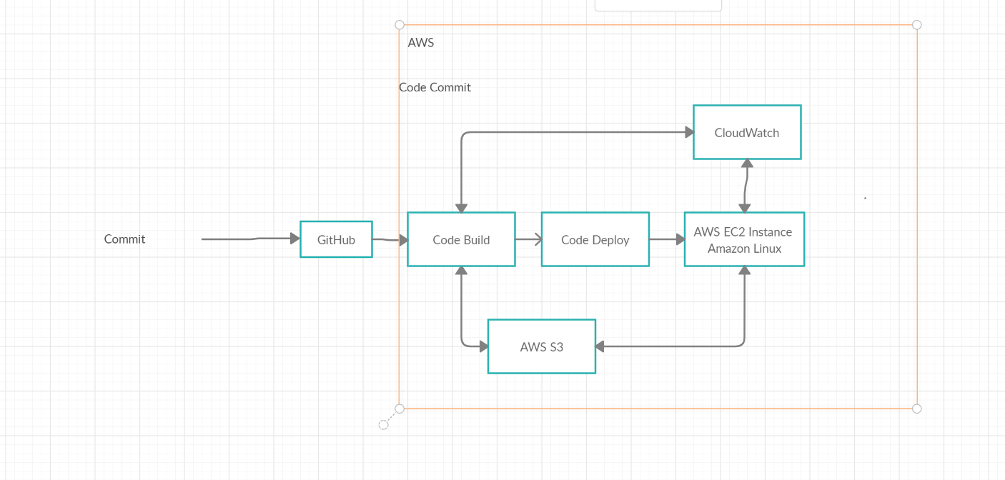

# Eclipse

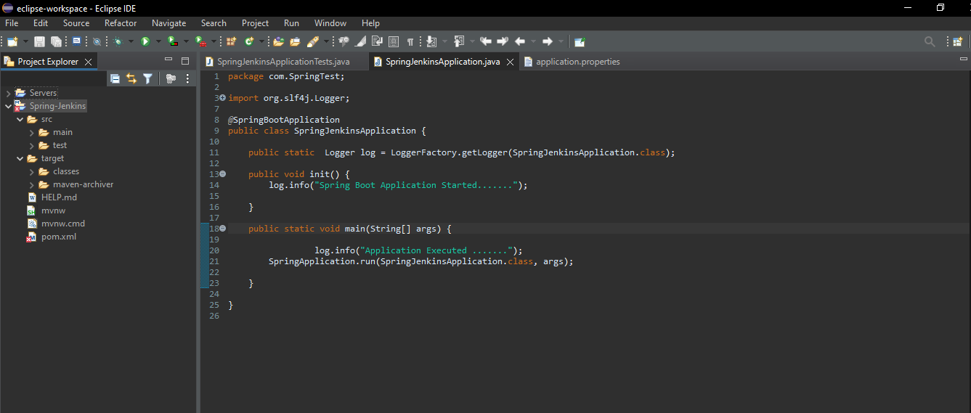

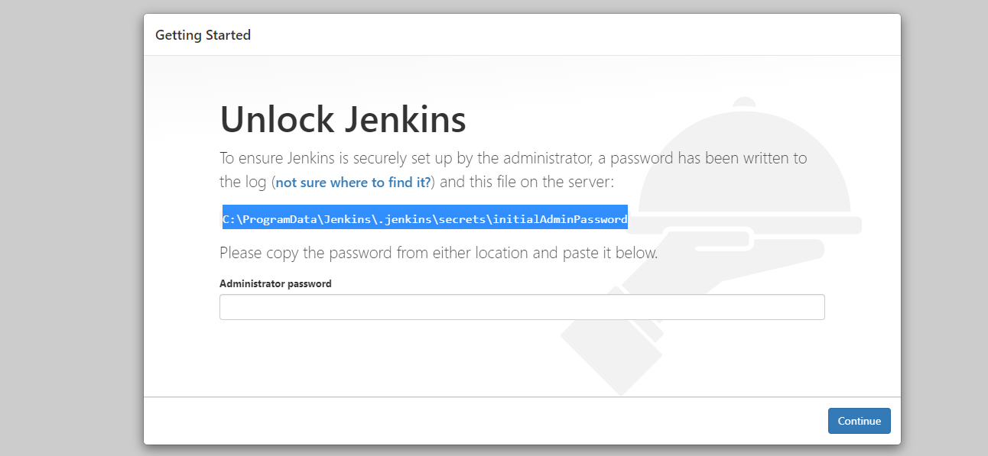

# I create Simple Spring boot Application to build a CI/CD pipeline to demonstrate continuous deployment:

## 

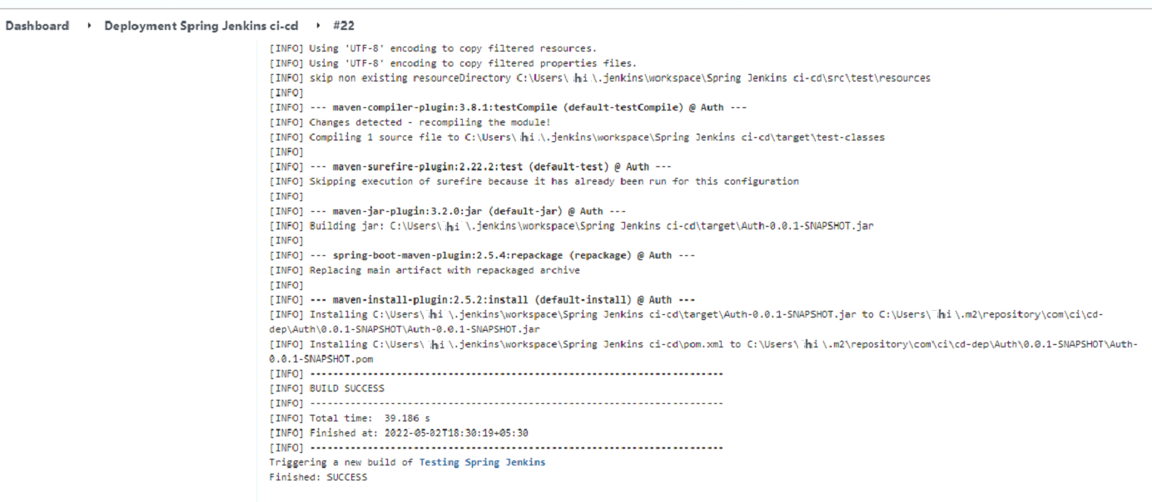

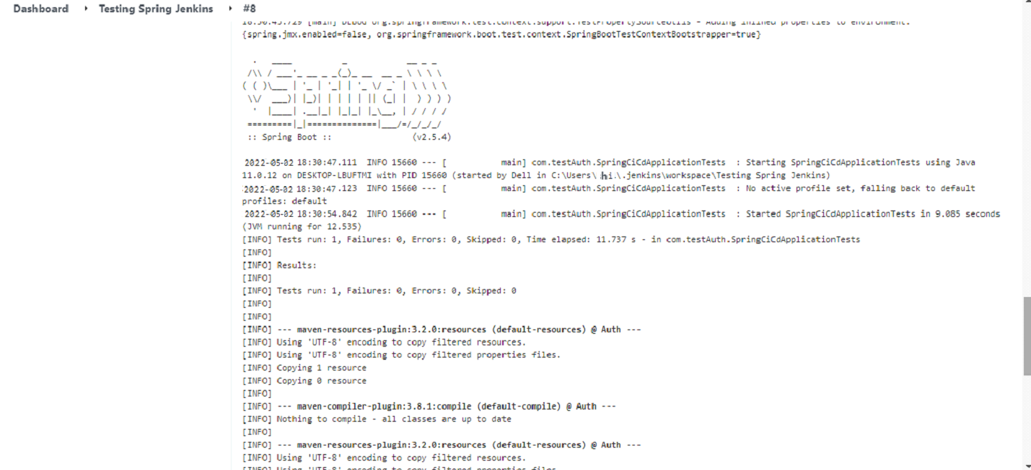

# Git Hub: Application Deploy on git hub:

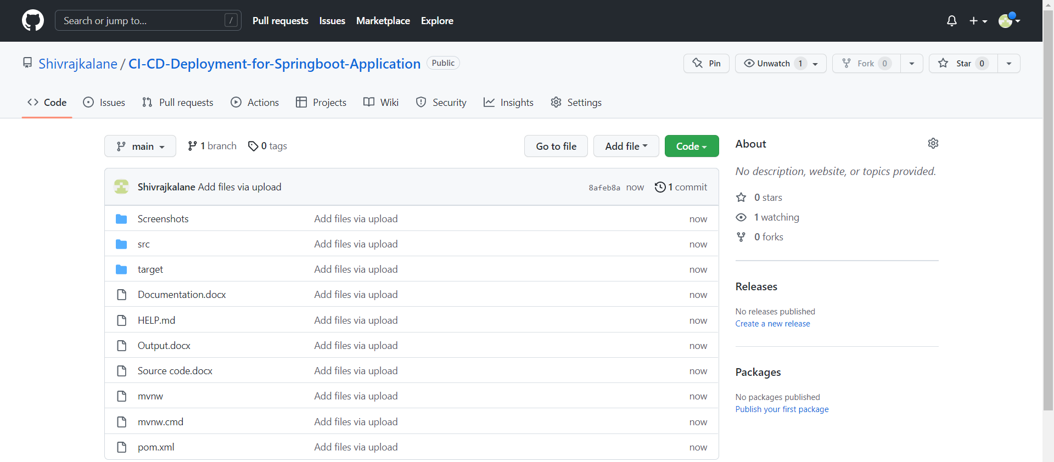

**Github repository:**

<https://github.com/Shivrajkalane/CI-CD-Deployment-for-Springboot-Application.git>

# Jenkins : Run Jenkins

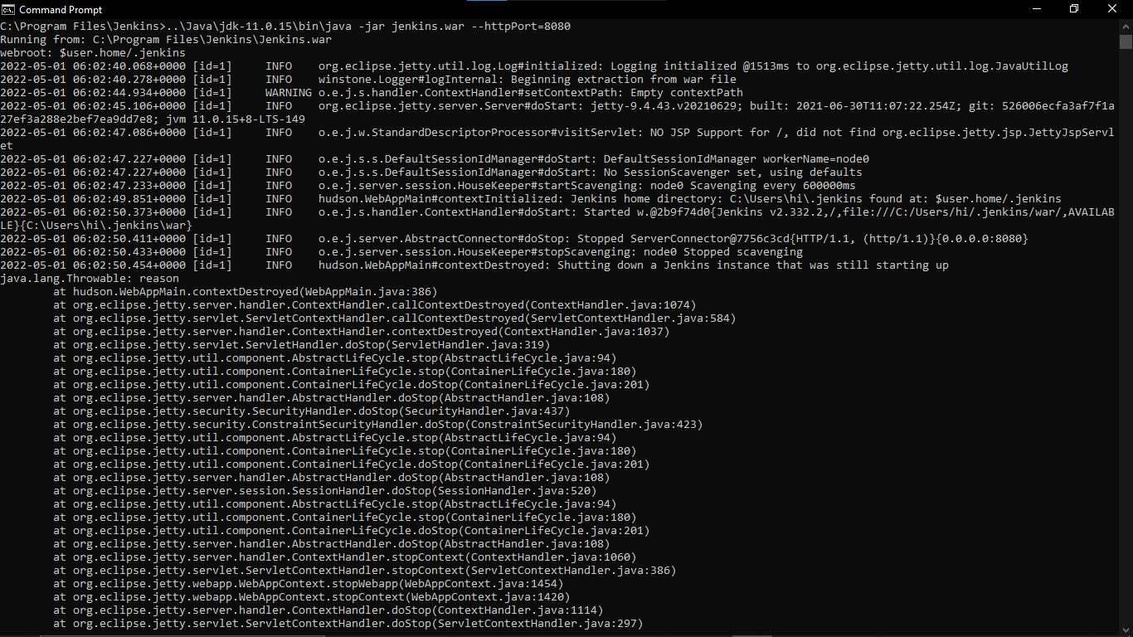

**CREATE THREE JENKINS PROJECT DEPLOYMENT:-**

**DEPLOYMENT-TESTING-PRODUCTION**

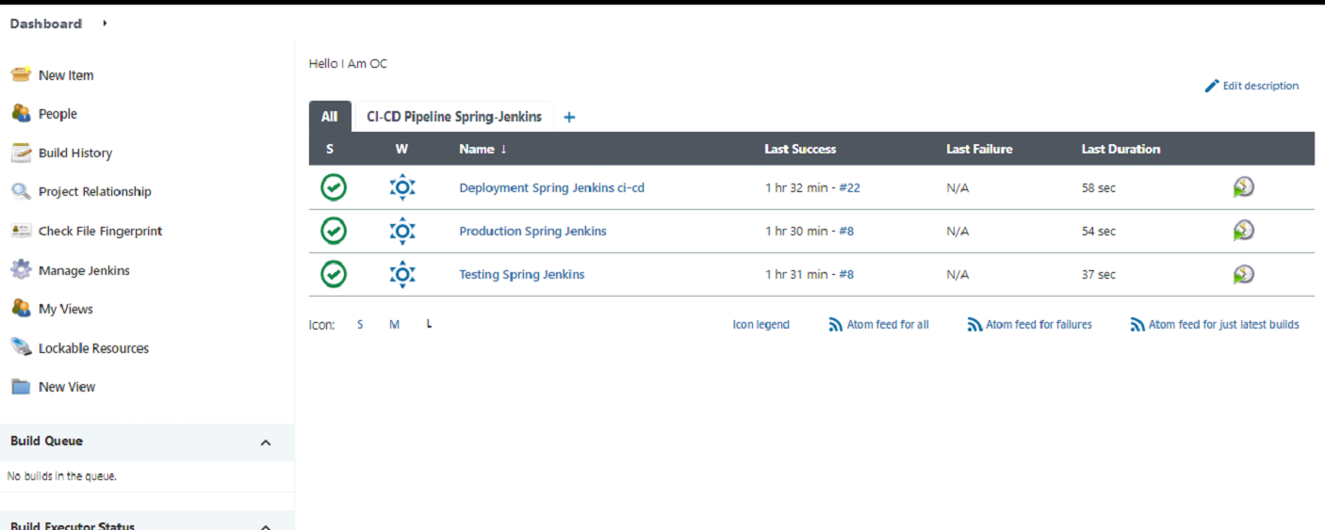



**Final Ouput:**

**Last host the application on AWS EC2 instance:**

