Olympics Dataset Analysis Results:

Results:

1. Total Medals – Countries

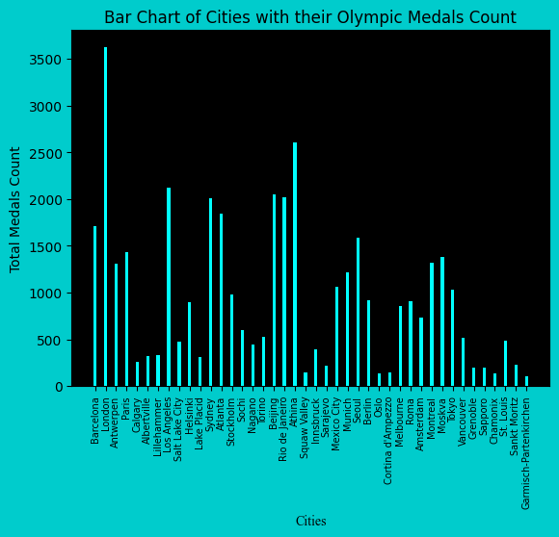

2. Gold Medals – Countries

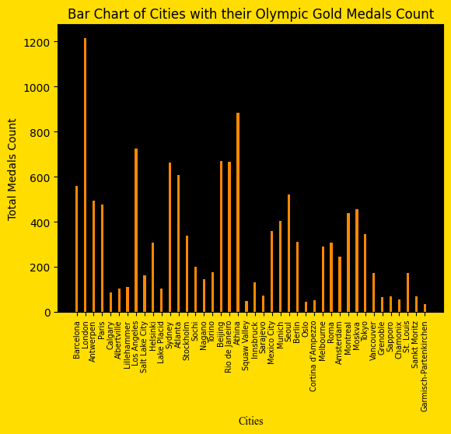

3. Silver Medals – Countries

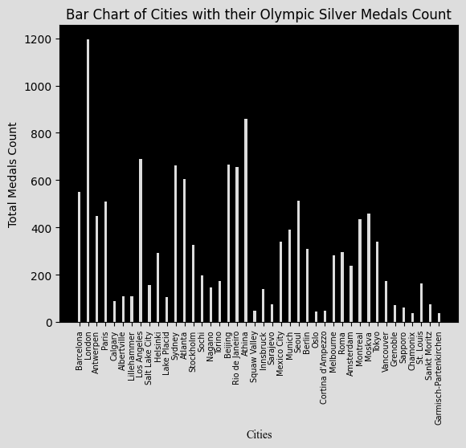

4. Bronze Medals – Countries

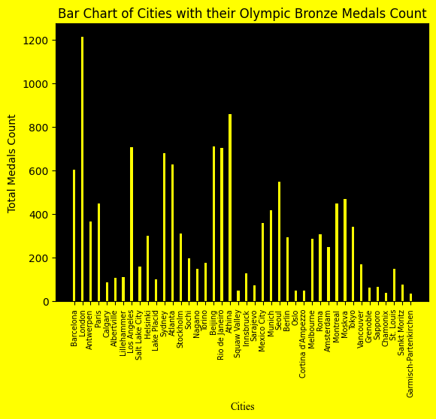

Complete Analysis Chart

