* **Extract File into SSMS:**

1. Open the SQL Server Management Studio (SSMS 2021) and connect to the server.

* ***Note*** *– You can open any SQL Server (MySQL, PostgreSQL, Oracle, etc.) and connect to your server.*

1. Go to the Databases on the left side and click right and select new Database.

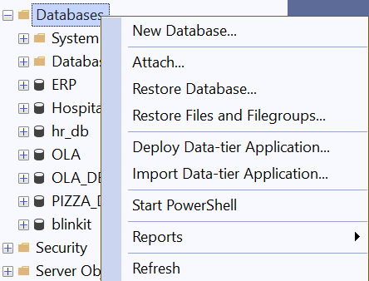

1. Enter the database name as blinkit and click on Ok.

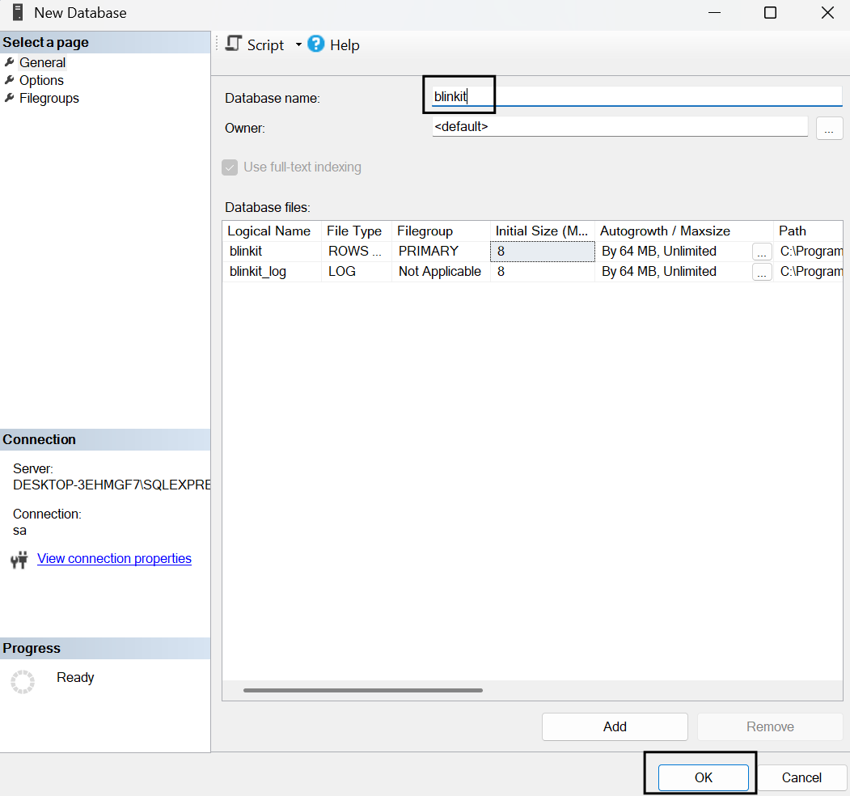

1. Select blinkit database and click right and select Task → Import Flat File…

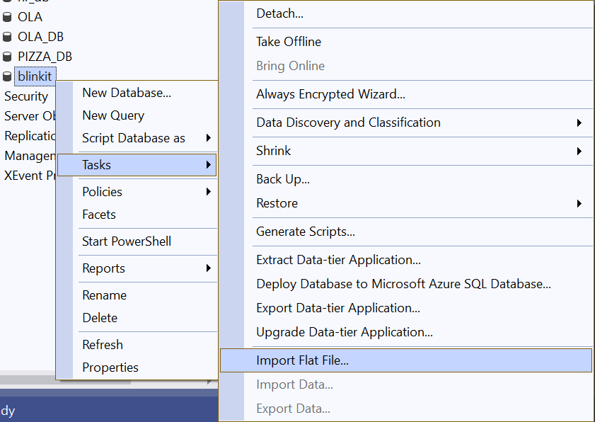

1. The Blinkit.csv file was imported into SQL Server using the Import Flat File Wizard. The file path was selected, the table was named **Blinkit** under the **dbo** schema, and data types were auto-detected. After previewing and confirming the structure, the import was completed by clicking **Finish**, creating the table in our database.

(***Note*** *- The extracted file should be in .csv/.txt.)*

1. You can check that the table has been added to the Blinkit database and, if the table is not there, then refresh the database and then check.

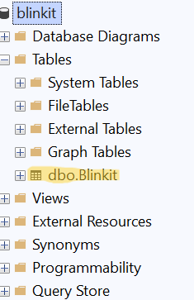

* **CSV data download or show:**



* **Data Transformation in SQL:**

1. While import the CSV file, data types were modified as per the data structure: text columns like Item_Fat_Content, Item_Identifier, and Item_Type were set to varchar, numeric columns like Item_Visibility, Item_Weight, Sales, and Rating were set to float, and Outlet_Establishment_Year was assigned as int. Only the Item_Weight column was allowed to have NULL values.

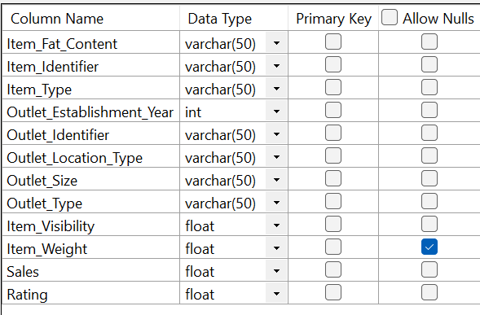

1. Check the table in the database. There are 3 different values for Item_Fat_Content, like LF, low fat and reg, so it has to be changed to LF, low fat → ‘Low Fat’ & reg → ‘Regular’.

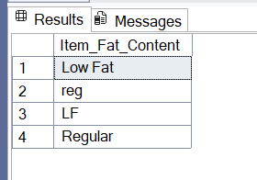

1. Update the table –

UPDATE Blinkit

SET Item_Fat_Content =

CASE

WHEN Item_Fat_Content IN ('LF', 'low fat') THEN 'Low Fat'

WHEN Item_Fat_Content = 'reg' THEN 'Regular'

ELSE Item_Fat_Content

END;

Output –

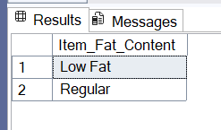

* **Requirements:**
  + 1. **KPI’s:**

1. **Total Sales:** 
   * + - * The overall revenue generated from all items sold.

***Input –***

select

Concat (

cast (

SUM(Sales)/1000000

as decimal (10,2)),

'M') TotalSalesMillion

from blinkit;

***Output –***

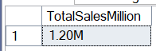

1. **Average Sales:**
   * + - * The average revenue per sale.

***Input –***

select

round (

AVG(Sales),0

) AS AvgSales

from blinkit;

***Output* –**



1. **No of Items:**
   * + - * The total count of different items sold.

***Input –***

select

Count (*) as No_of_ITEMS

from blinkit;

***Output* –**



1. **Average Rating:**
   * + - * The average customer rating for items sold.

***Input –***

select

round (

avg(Rating), 2

) as AvegRating

from blinkit;

***Output* –**



* + 1. **Granular Requirements:**

1. **Total Sales by Fat Content:**

***Input* –**

select

Item_Fat_Content,

Concat (

ROUND (

SUM(Sales)/1000 ,2)

),

'K') as TotalSales

from

blinkit

group by

Item_Fat_Content;

***Output* –**

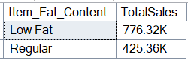

1. **Total Sales by Item Type:**

***Input* –**

select Top 5

Item_Type,

round(SUM(Sales), 2) as TotalSales

from

blinkit

group by

Item_Type

order by

TotalSales DESC;

***Output* –**

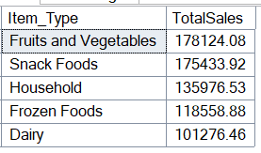

1. **Total sales by Item Fat Content and Outlet Location Type**

***Input* –**

select

Item_Fat_Content,

Outlet_Location_Type,

round(SUM(Sales), 2) AS TotalSales

from

blinkit

group by

Item_Fat_Content,

Outlet_Location_Type

order by

Outlet_Location_Type;

***Output* –**

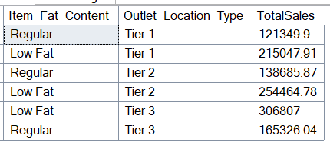

1. **Fat Content by Outlet for Total Sales:**

***Input* –**

select Outlet_Location_Type,

Coalesce ([Low Fat], 0) as Low_Fat,

Coalesce ([Regular], 0) as Regular

from

(select

Item_Fat_Content,

Outlet_Location_Type,

round(SUM(Sales), 2) AS TotalSales

from

blinkit

group by

Item_Fat_Content,

Outlet_Location_Type

) AS SourceTable

PIVOT

(

Sum(TotalSales)

FOR Item_Fat_Content IN ([Low Fat], [Regular])

) AS PivotTable

Order by Outlet_Location_Type;

***Output* –**

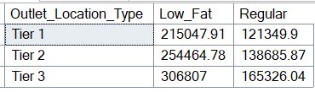

1. **Outlet by Fat Content for Total Sales:**

***Input –***

select

Item_Fat_Content,

Coalesce ([Tier 1], 0) as Tier_1,

Coalesce ([Tier 2], 0) as Tier_2,

Coalesce ([Tier 3], 0) as Tier_3

From

(select

Item_Fat_Content,

Outlet_Location_Type,

round(SUM(Sales), 2) AS TotalSales

from

blinkit

group by

Item_Fat_Content,

Outlet_Location_Type) as SourceTable

PIVOT

(

Sum(TotalSales)

For Outlet_Location_Type IN ([Tier 1], [Tier 2], [Tier 3])

) AS PivotTable

order by Item_Fat_Content;

***Output –***

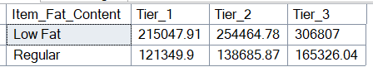

1. **Total Sales by Outlet Establishment (Top 5):**

***Input –***

select TOP 5

Outlet_Establishment_Year,

round(SUM(Sales), 2) AS TotalSales

from

blinkit

group by

Outlet_Establishment_Year

order by

TotalSales desc;

***Output –***

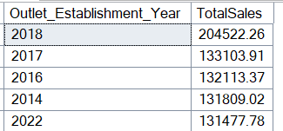

1. **Total Sales by Outlet Establishment (Bottom 5):**

***Input –***

select TOP 5

Outlet_Establishment_Year,

round(SUM(Sales), 2) AS TotalSales

from

blinkit

group by

Outlet_Establishment_Year

order by

TotalSaleS;

***Output –***

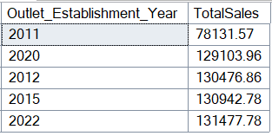

* + 1. **Charts Requirements:**

**Percentage of Sales by Outlet Size:**

***Input –***

select

Outlet_Size,

round(SUM(sales),2) as TotalSales,

round((SUM(Sales) * 100.0 / SUM(SUM(Sales))

OVER ()), 2) as PerSALES

from

blinkit

group by

Outlet_Size

***Output –***

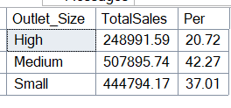

**Sales by Outlet Location:**

***Input –***

select

Outlet_Location_Type,

ROUND(SUM(Sales),2) as TotalSales

from

blinkit

group by

Outlet_Location_Type

***Output*** –

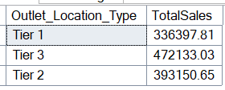

**All Metrics by Outlet Type:**

***Input –***

select

Outlet_Type,

ROUND(SUM(Sales),2) as TotalSales,

round((SUM(Sales) * 100.0 / SUM(SUM(Sales))

OVER ()), 0) as PerSales,

round(AVG(Sales),0) AvgSales,

Count (*) AS No_of_items,

round(avg(Rating), 2) as AvegRating,

ROUND(max(Sales),2) as MaximumSales,

ROUND(min(Sales),2) as MinimumSales

from

blinkit

group by

Outlet_Type

***Output –***

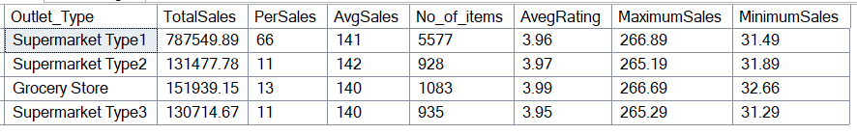

* **Required All Data (SQL View):**

1. **KPI’s:**
2. **Total Sales:** The overall revenue generated from all items sold.

* **select * from vw_totalsales;**

1. **Average Sales:** The average revenue per sale.

* **select * from vw_AVGsales;**

1. **No of Items:** The total count of different items sold.

* **select * from vw_noofitems;**

1. **Average Rating:** The average customer rating for items sold.

* **select * from vw_AVGrating;**

1. **Granular Requirements:**
2. **Total Sales by Fat Content:**

* select * from vw_Sales_FC;

1. **Total Sales by Item Type:**

* select * from vw_Sales_it;

1. **Total sales by Item Fat Content and Outlet Location Type**

* select * from vw_Sales_OLT;

1. **Fat Content by Outlet for Total Sales:**

* select * from vw_Sales_FCO

Order by Outlet_Location_Type;

1. **Outlet by Fat Content for Total Sales:**

* select * from vw_Sales_OFC

order by Item_Fat_Content;

1. **Total Sales by Outlet Establishment (Top 5):**

* select * from vw_Sales_Oet5;

1. **Total Sales by Outlet Establishment (Bottom 5):**

* select * from vw_Sales_Oeb5;

1. **Charts Requirements:**
2. **Percentage of Sales by Outlet Size:**

* select * from vw_PerSales_OS;

1. **Sales by Outlet Location:**

* select * from vw_Sales_OTL;

1. **All Metrics by Outlet Type:**

* select * from vw_Sales_OT;