Game Design Document

Fill up the Following document

1. Write the title of your project.

Alpha!

1. What is the goal of the game?

The goal of the game is to kill the other person(opponent).

1. Write a brief story of your game?

Two people want to conquer to conquer the Land of Diamonds but both only one of them can have it. So, they both fight each other and the person who survives gets the Land of Diamonds.

1. Which are the playing characters of this game?

* Playing characters are the ones which respond to the user based on the input from the user
* Cars, monkeys, dinos, wizards etc, are the playing characters in the game.

|  |  |  |
| --- | --- | --- |
| Number | Character Name | What can this character do? |
| 1 | Player1 | He can shoot the other player and also dodge his attacks. |
| 2 | Player2 | He can shoot the other player and also dodge his attacks. |
| 3 |  |  |
| 4 |  |  |
| 5 |  |  |
| 6 |  |  |
| 7 |  |  |
| 8 |  |  |

1. Which are the Non Playing Characters of this game?

* Non Playing characters are the ones which don't have an action or a behaviour when the user interacts with the game.
* Hurdles, stones, bananas, coins, etc are non playing characters in the game.

|  |  |  |
| --- | --- | --- |
| Number | Character Name | What can this character do? |
| 1 | None |  |
| 2 | None |  |
| 3 | None |  |
| 4 | None |  |
| 5 | None |  |
| 6 | None |  |
| 7 | None |  |
| 8 | None |  |

Draw your imagination of this game. What does this game look like?

* Draw the game either on your computer or on paper,
* Add images of scenes of the game to show each of the playing and non-playing characters at least once.

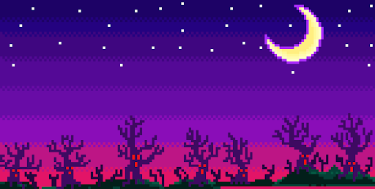

  

Note - In places of the blue and black circle there will be actual images and animations. Also the hearts will come on the top part of the game.

How do you plan to make your game engaging?

The game is an online multiplayer game so you can play it with your friends and family easily. I plan to make the game engaging by adding a health system and power ups which will help the player by increasing his/her health. There will also be guns and you can shoot the other players with and you can dodge by jumping.