Comments:

1. Current look of the paper: All the details of DL models and experiment conducted was very clearly mentioned.
2. What is missing?
3. Specificity:
4. You have to connect the dots…
5. How the current paper to be transformed:?
6. Addressing a specific period of forecasting(Either long/short/..)
7. More on the proposed framework and how it is different from existing work
8. Connectivity between the models.How superior one model from others
9. Challenges in state of art and How it is addressed
10. More emphasis on result oriented discussion
11. Reading the literature papers will give u which one will be ur outcome of the work.
12. Pls check the following is addressed in Abstract:

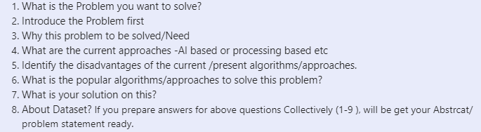

1. Now,we ,I -to be avoided.
2. Page limit -> 8-10 pages .Need to discuss which content to be retained and which must be kept for blog(make a save as and highlight content for blog in some color for easy verification)
3. Short term/ Day ahead natural price forecasting -is the theme of the work.Hence ,Include the same in abstract.Search for research papers relevant to above topic
4. Section overview to be done at the end of Introduction part
5. Please make sure that when u r drafting proposed system and subsequent section from thr, there is a connectivity from one paragraph to another.. Within Paragraph.. sentence to sentence
6. Literature survey section to be filled by reading 20 research papers and summary of the same to be included. Donot choose conference proceedings, use only reputed journals like—Elsevier, ScienceDirect/IEEE xplore /any journal.Year of publication must be between (105-till now).
7. Framework/Block diagram of the proposed model to be given and Modules to be identified .
8. About Preprocessing is not mentioned. Elaborate on Preprocessing and Evaluation metric(in short)-Brief
9. Proposed system should consists of Framework & module description.
10. Include a results & discussion section and tabulate all the models performance in tat section
11. In results & discussion, describe about the dataset and what are the input parameters and target variable
12. About SARIMAX results were not discussed in absrcat
13. Give caption to all figures and table with title. But numbering can be given later. Cite the figure and table either in above /below paragraph of table/figure. Example: Results of the model is illustrated in Fig 1
14. About Fuzzy was mentioned,but we did not conduct any experiments right?
15. References to be added. Certain topics can be cited even in Proposed system as well
16. Conclusion must have
17. Emphasis on why NGP forecasting using DL is important.
18. Your inference on various models
19. Discuss on MAPE metric and say “Out of all these models ,experiment reveals that XXXX model has __% of accuracy than other models”
20. What is the future scope/gap in existing model