Pizza Sales SQL Queries

1. KPI’S
2. Total Revenue:

Select SUM(total_price) [Total Revenue] from pizza_sales

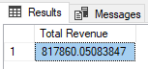

1. Average Order Value

Select SUM(total_price) / COUNT(DISTINCT order_id) [Average Order Value] from pizza_sales

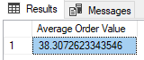

1. Select SUM(quantity) [Total Pizza Sold] from pizza_sales

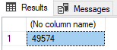

1. Select COUNT(DISTINCT order_id) [Total Order] from pizza_sales

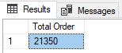

1. Select CAST(CAST(SUM(quantity) AS DECIMAL(10,2)) / CAST(COUNT(DISTINCT order_id) AS DECIMAL(10,2)) AS DECIMAL(10,2)) [Average Pizzas Per Order] from pizza_sales

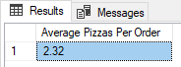

1. Daily Trend for Total Orders

SELECT DATENAME(DW, order_date) [Order day], COUNT(DISTINCT order_id) [Total orders]

FROM pizza_sales

GROUP BY DATENAME(DW, order_date)

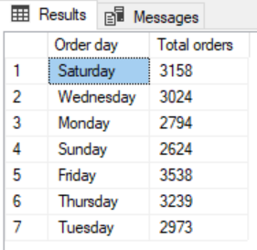

1. Hourly Trend for Orders

SELECT DATEPART(HOUR, order_time) [Order Hours], COUNT(DISTINCT order_id) [Total orders] FROM pizza_sales

GROUP BY DATEPART(HOUR, order_time)

ORDER BY DATEPART(HOUR, order_time)

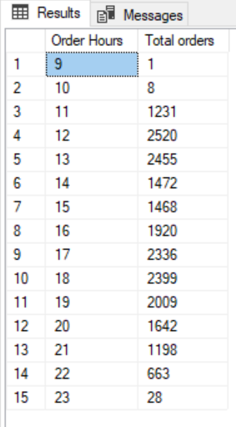

1. % of Sales by Pizza Category

SELECT pizza_category, SUM(total_price) * 100 /

(SELECT SUM(total_price) FROM pizza_sales WHERE MONTH(order_date) = 1) [PCT]

FROM pizza_sales

WHERE MONTH(order_date) = 1

GROUP BY pizza_category

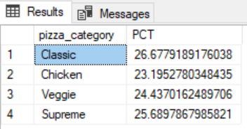

1. % of Sales by Pizza Size

SELECT pizza_size, CAST(SUM(total_price) * 100 /

(SELECT SUM(total_price) FROM pizza_sales WHERE DATEPART(QUARTER, order_date) = 1) AS DECIMAL(10,2)) [PCT]

FROM pizza_sales

WHERE DATEPART(QUARTER, order_date) = 1

GROUP BY pizza_size

ORDER BY PCT DESC

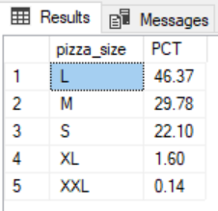

1. Total Pizzas Sold by Pizza Category

SELECT pizza_category, SUM(quantity) [Total Pizza]

FROM pizza_sales

GROUP BY pizza_category

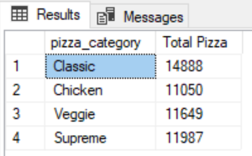

1. Top 5 Best Sellers by Total Pizzas Sold

SELECT TOP 5 pizza_name, SUM(quantity) [Total Pizzas]

FROM pizza_sales

GROUP BY pizza_name

ORDER BY SUM(quantity) DESC

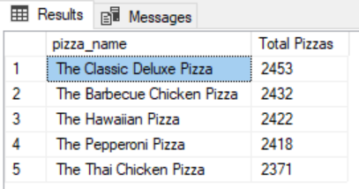

1. Bottom 5 Best Sellers by Total Pizzas Sold

SELECT TOP 5 pizza_name, SUM(quantity) [Total Pizzas]

FROM pizza_sales

GROUP BY pizza_name

ORDER BY SUM(quantity)

