Applied Deep Learning
Semester VII, 2026-27 · Assignment 2
Securities Market Sentiment Analysis (SMSA)
A Flask web application that uses a pre-trained LLM and prompt engineering to determine the market sentiment expressed in financial text
Project Report
Group 3
# | Reg. No. | Name
1 | 2023UG000108 | Sania Vallikar
2 | 2023UG000109 | Shivshankar Mule
3 | 2023UG000110 | Shruti Sen
4 | 2023UG000111 | Sreeja S.
5 | 2023UG000112 | Suresh Chandra Kandpal

Domain: Securities Market / Financial Markets
Course instructor: Narayana Maddala
Submission: October 2026

Contents
1. Introduction and objective
2. System overview
3. Database structure
4. Key components of the system
4.1 Frontend
4.2 Backend
5. LLM integration details
6. Test data set
7. Test results
8. Limitations, conclusion and future work
Appendix A. How to run the system
Appendix B. Test data set with the predictions of every model

Summary of what was built
Assignment requirement | What we delivered
Task 1 – test data set of at least 50 financial texts of five types | 60 labelled texts: 12 each of financial news, company announcements, analyst commentary, investor comments and social-media comments, balanced across Positive / Negative / Neutral.
Task 2 – frontend in Python or HTML & CSS | HTML + CSS + JavaScript frontend with four pages: Analyse, History, Dashboard, Test Results.
Task 3 – Flask backend integrated with a pre-trained LLM | Flask REST API with 13 endpoints. Pre-trained models: gpt-oss-120b through the Groq API (default), Google Gemini as automatic fallback, Qwen2.5-1.5B-Instruct and FinBERT running locally. If Groq fails, Gemini answers; if both cloud APIs fail, the local model answers.
Task 4 – database structure for the LLM responses | Normalised SQLite database with 7 tables and 1 view; every request and LLM response is stored in one transaction.
Deliverable 1(d) – test results | Default configuration: 58/60 correct (96.7%). Local LLM with the engineered prompt: 60/60 (100.0%); zero-shot prompt: 58/60 (96.7%); FinBERT baseline: 50/60 (83.3%).

1. Introduction and objective
Prices in the securities market react to information: quarterly results, regulatory actions, analyst ratings, and increasingly the mood of investors on social media. The objective of this assignment is to build a Python web application that accepts such financial text and uses a Transformer / large language model (LLM) to determine the market sentiment it expresses about a company: Positive, Negative or Neutral.
The example given in the assignment is reproduced exactly by the system:
Input : "The M/s XYZ Limited reported strong quarterly earnings, with revenue increasing
significantly. Analysts expressed optimism about future growth."
Output: Positive (company detected: XYZ Limited)

The work covers the four required tasks: (1) a test data set of financial texts, (2) a frontend that accepts the text, (3) a Flask backend that passes the text to a pre-trained LLM through an engineered prompt and stores the response, and (4) a database structure for those responses. The report follows the order of the expected deliverables: database structure (Section 3), key components (Section 4), LLM integration (Section 5) and test results (Sections 6 and 7).

2. System overview
SMSA is a three-tier application. The browser talks to the Flask backend only through JSON REST calls; the backend builds the prompt, calls the selected LLM, converts the answer into a common result format and writes it to SQLite.
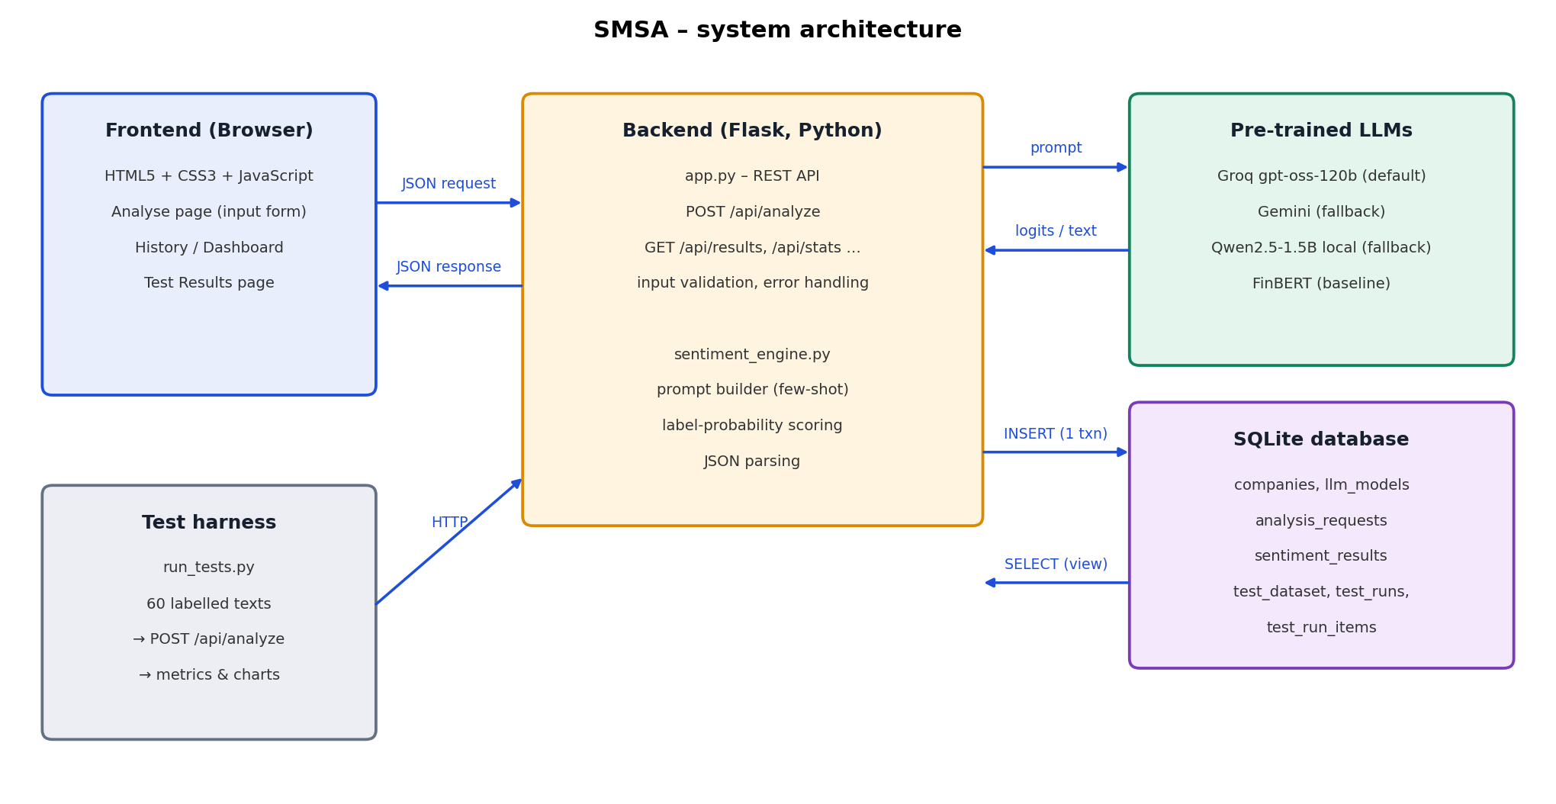
Figure 1: System architecture

Request flow
- The user types or pastes a financial text on the Analyse page, optionally gives the company name and text type, and presses Analyse sentiment.
- JavaScript sends the form as JSON to POST /api/analyze.
- The backend validates the input (length, text type, model name) and returns a clear error message with HTTP 400 if it is invalid.
- The LLM integration layer builds the prompt (role, label definitions, domain rules, few-shot examples, output format) and calls the selected model.
- The answer is converted to a common structure: sentiment, probability of each label, confidence, score, detected company, key factors and one-sentence reasoning.
- The request and the LLM response are stored in the database in a single transaction, and the stored record is returned to the browser, which displays it.

Technology stack
Table 1: Technology stack
Layer | Technology | Purpose
Frontend | HTML5, CSS3, vanilla JavaScript (fetch API), Jinja2 templates | Input form, result display, history, dashboard, test results. No external libraries, so it works offline.
Backend | Python 3, Flask 3 | Page routes and REST API, validation, error handling.
LLM (default) | openai/gpt-oss-120b served by the Groq API (groq Python SDK) | Pre-trained open-weight 120-billion-parameter LLM; JSON-schema-constrained output.
LLM (fallback) | Google Gemini API (google-genai SDK), model gemini-3.5-flash | Answers automatically when the Groq API is unavailable.
LLM (local) | Qwen/Qwen2.5-1.5B-Instruct with Hugging Face Transformers + PyTorch | Pre-trained instruction-tuned LLM running on the laptop; works without internet.
Baseline | ProsusAI/finbert | BERT further trained on financial text; 3-class sentiment classifier.
Database | SQLite 3 (sqlite3 module) | Stores requests, LLM responses, models, test data set and test runs.
Evaluation | scikit-learn, matplotlib | Accuracy, precision / recall / F1, confusion matrices.

3. Database structure
The database is a single SQLite file, database/smsa.db, created from database/schema.sql when the application starts. SQLite was chosen because it needs no server, is part of the Python standard library and the whole database can be submitted as one file. The design is normalised: a request, the response to it, the company it concerns and the model that produced it are separate entities linked by foreign keys.
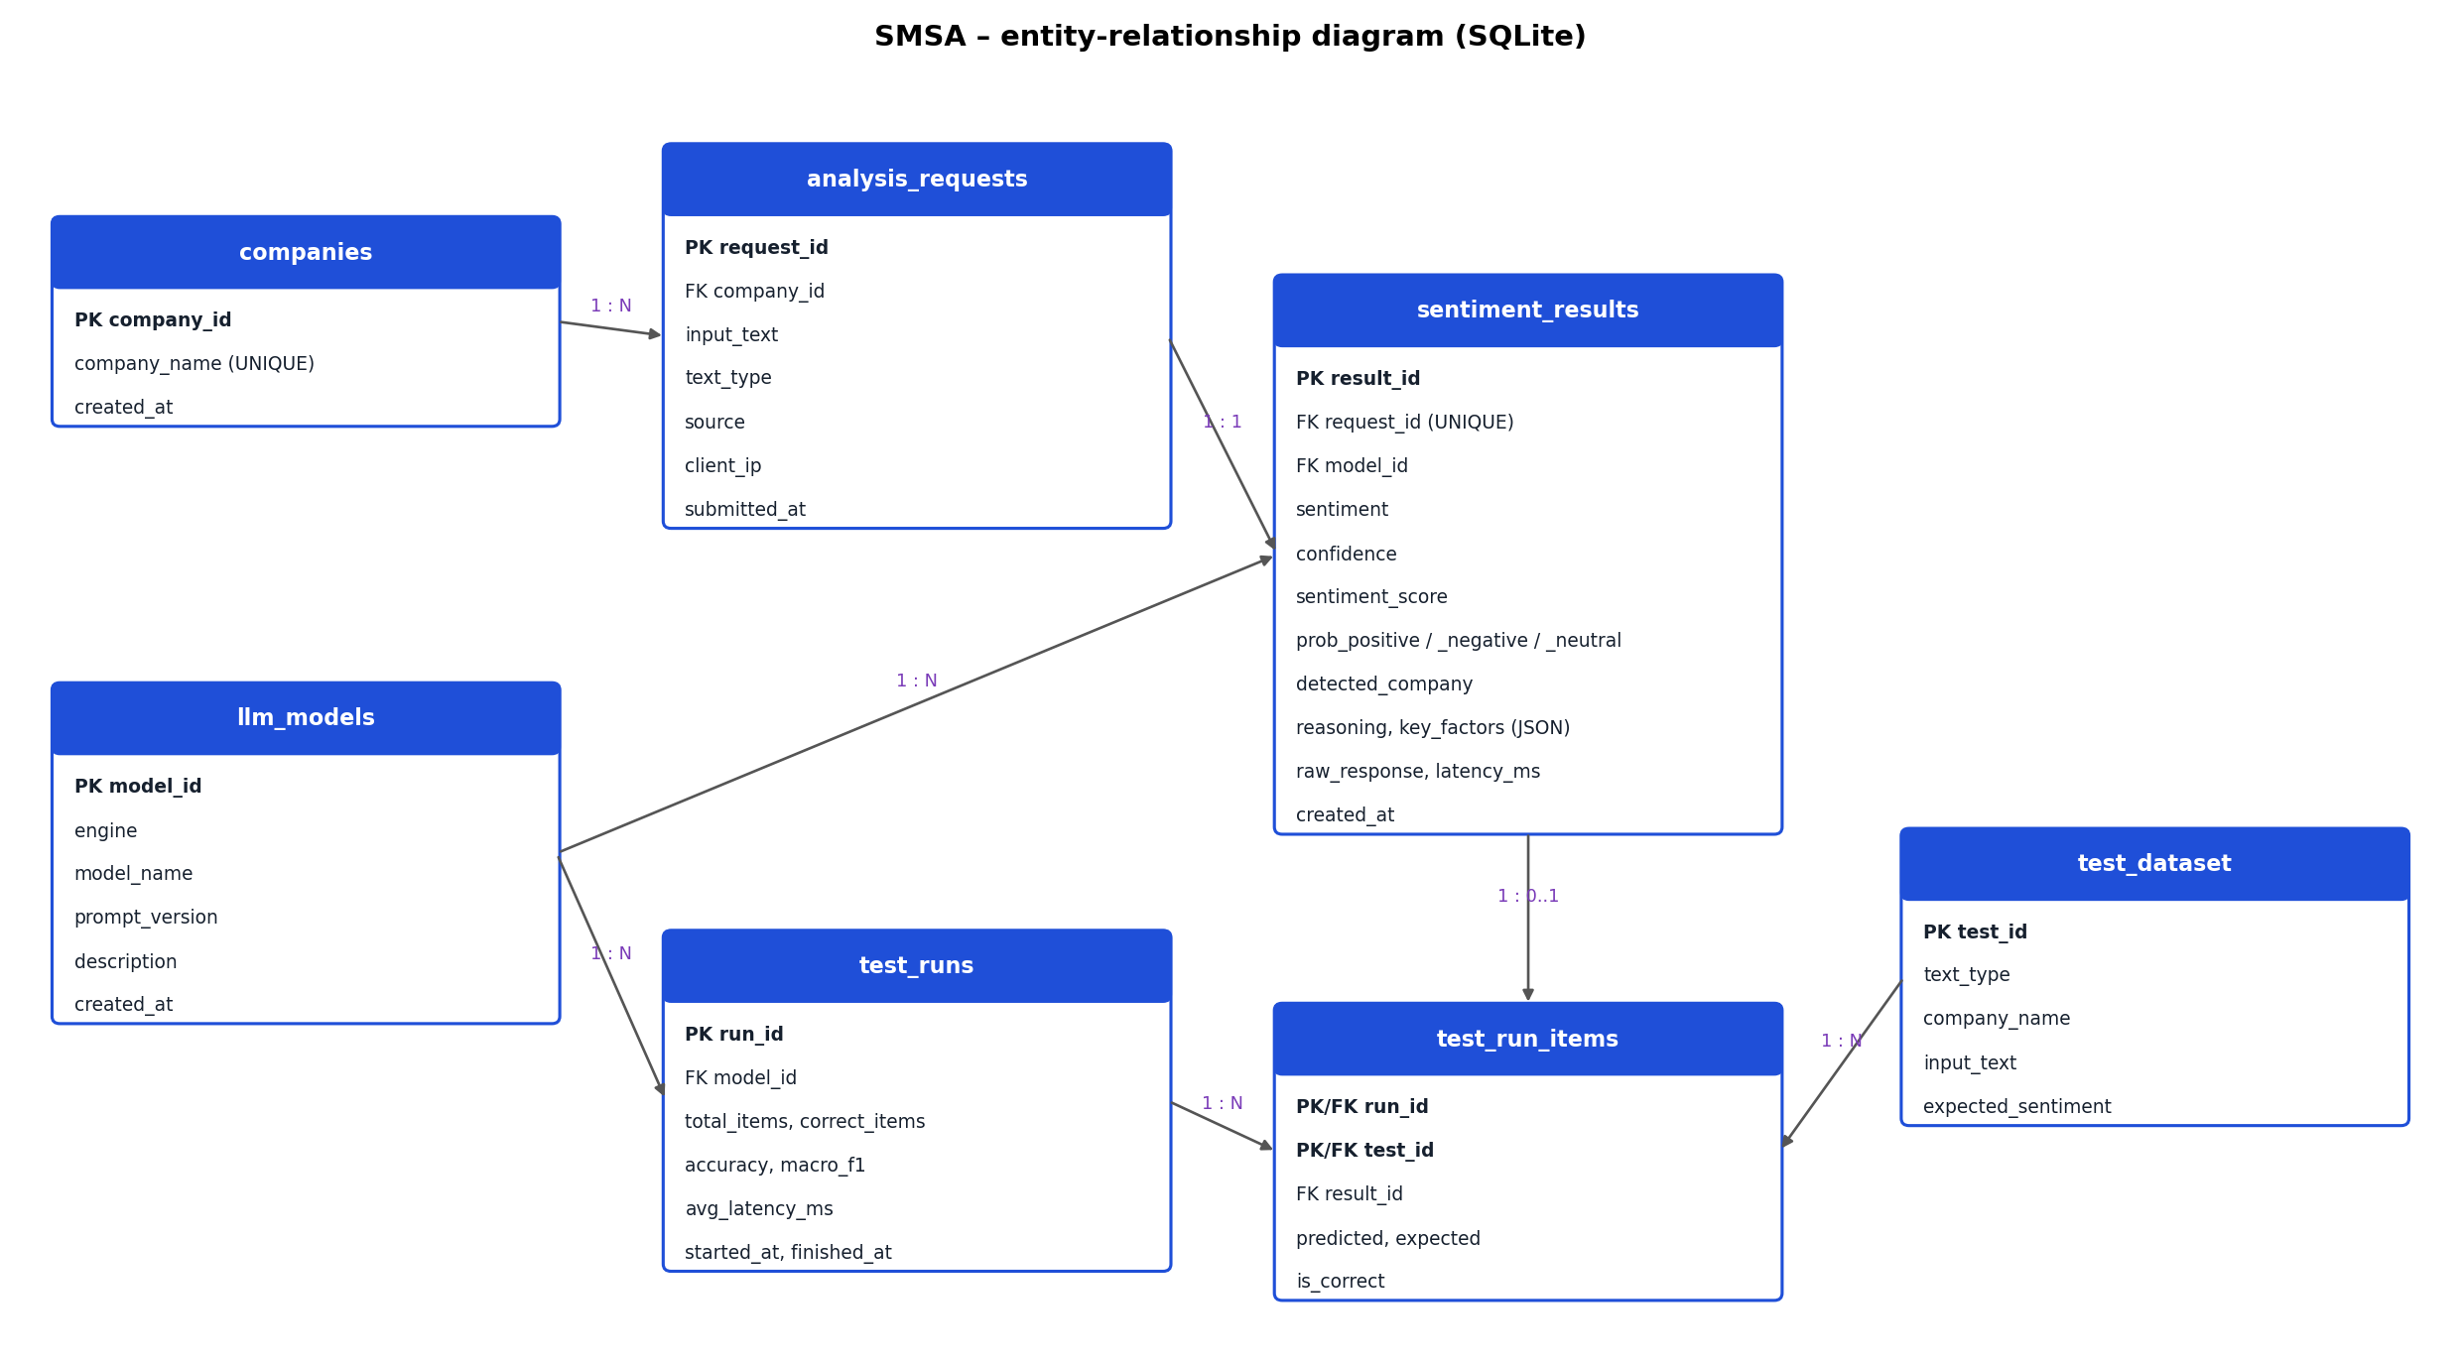
Figure 2: Entity-relationship diagram
Table 2: Tables of the database
Table | Purpose | Rows now
companies | Master list of companies. A company typed by the user or detected by the LLM is inserted once and reused. | 29
llm_models | Every engine / model / prompt-version combination that produced a result, so each stored response is traceable to the exact model and prompt. | 5
analysis_requests | Each financial text submitted: the text, its type, where it came from (web, api, test) and when. | 361
sentiment_results | The market-sentiment response of the LLM for one request. | 361
test_dataset | The labelled test data set (loaded from data/test_dataset.csv). | 60
test_runs | One row per evaluation of the test data set, with accuracy, macro-F1 and latency. | 7
test_run_items | Prediction versus expected label for each test text in a run. | 350

3.1 Table sentiment_results (the LLM response)
Table 3: Columns of sentiment_results
Column | Type | Constraint / meaning
result_id | INTEGER | Primary key, auto-increment.
request_id | INTEGER | Foreign key to analysis_requests, UNIQUE (one response per request), ON DELETE CASCADE.
model_id | INTEGER | Foreign key to llm_models.
sentiment | TEXT | CHECK: one of 'Positive', 'Negative', 'Neutral'.
confidence | REAL | Probability of the chosen label, CHECK between 0 and 1.
sentiment_score | REAL | P(Positive) − P(Negative), CHECK between −1 and +1.
prob_positive, prob_negative, prob_neutral | REAL | Probability of each label.
detected_company | TEXT | Company name identified by the LLM in the text.
reasoning | TEXT | One-sentence explanation written by the LLM.
key_factors | TEXT | JSON array of the drivers of the sentiment.
raw_response | TEXT | Unmodified text returned by the model (audit trail).
latency_ms | INTEGER | Time taken by the model call.
fallback_from | TEXT | Engines that failed before this one answered, with the reason (NULL when the requested engine answered).
created_at | TEXT | Timestamp, default current local time.

3.2 Other tables
Table 4: Columns of the remaining tables
Table | Columns (PK = primary key, FK = foreign key)
companies | company_id PK · company_name UNIQUE, case-insensitive · created_at
llm_models | model_id PK · engine CHECK in (groq, gemini, llm, finbert) · model_name · prompt_version · description · created_at · UNIQUE (engine, model_name, prompt_version)
analysis_requests | request_id PK · company_id FK → companies (SET NULL on delete) · input_text NOT NULL · text_type CHECK in (news, announcement, analyst, investor, social, other) · source CHECK in (web, api, test) · client_ip · submitted_at
test_dataset | test_id PK · text_type · company_name · input_text · expected_sentiment CHECK in the three labels
test_runs | run_id PK · model_id FK → llm_models · total_items · correct_items · accuracy · macro_f1 · avg_latency_ms · started_at · finished_at
test_run_items | (run_id, test_id) composite PK · run_id FK → test_runs (CASCADE) · test_id FK → test_dataset · result_id FK → sentiment_results · predicted · expected · is_correct CHECK in (0, 1)

3.3 Integrity, indexes and the history view
- Referential integrity. Foreign keys are enforced (PRAGMA foreign_keys = ON). Deleting a request deletes its result (CASCADE); deleting a company keeps the request (SET NULL).
- Domain integrity. CHECK constraints restrict the sentiment to the three valid labels and keep probabilities and scores in range, so an invalid LLM answer can never be stored.
- Atomicity. The company, model, request and result rows of one analysis are written in one transaction in database.save_analysis(); if anything fails, everything is rolled back.
- Indexes on analysis_requests(company_id), analysis_requests(submitted_at), sentiment_results(sentiment) and sentiment_results(model_id) support the filters of the History page.
- View v_sentiment_history joins requests, results, models and companies into one flat row per analysed text. The History page, the CSV export and GET /api/results read from this view.
Example – what is stored for the assignment's own example (one row of v_sentiment_history):
result_id : 224
submitted_at : 2026-09-30 22:37:12
source : web
text_type : news
company_name : XYZ Limited
sentiment : Positive
confidence : 0.7
sentiment_score : 0.55
reasoning : The news highlights robust earnings and a notable rise in revenue, both of which are favorable indicators for the company's financial health. Additionally, analysts' optimism about future growth reinforces a positive market outlook, making the overall sentiment clearly positive.
key_factors : ["Strong quarterly earnings", "Significant revenue increase", "Analyst optimism about future growth"]
latency_ms : 1205
engine : groq
model_name : openai/gpt-oss-120b
prompt_version : fewshot-v2

4. Key components of the system
Table 5: Source files
File | Role
app.py | Flask application: page routes, REST API endpoints, input validation, error handlers.
sentiment_engine.py | LLM integration: prompts, few-shot examples, the four engines, response parsing.
database.py | Data-access layer: schema creation, inserts in a transaction, queries, statistics, test runs.
config.py | Configuration: model names, default engine, port, limits; loads API keys from the .env file.
run_tests.py | Sends the test data set through POST /api/analyze and computes the metrics.
templates/*.html | Frontend pages (base layout, Analyse, History, Dashboard, Test Results).
static/style.css, static/app.js | Styling and client-side logic (fetch calls, rendering of results).
database/schema.sql, database/smsa.db | Database definition and the database itself.
data/test_dataset.csv | The 60 labelled test texts.

4.1 Frontend
The frontend is written in HTML and CSS with a small amount of plain JavaScript; the pages are served by Flask through Jinja2 templates. It has four pages, reachable from the navigation bar.
- Analyse – the input form required by Task 2. A text area for the financial text (10 to 4,000 characters, with a live character counter), an optional company field, the text type, the model and the prompt strategy. Load a sample fills the form with a random text from the test data set. The response panel shows the sentiment badge, the detected company, confidence, score, the probability of each label, the key factors and the model's reasoning, and the id under which the result was stored. The five most recent analyses are listed below.
- History – all stored results, read from the database, with search and filters (company, sentiment, text type, source), pagination, a detail dialog, delete and CSV export.
- Dashboard – aggregate statistics computed by SQL: number of texts, sentiment distribution, sentiment by text type, and the average sentiment score per company.
- Test Results – every evaluation run with accuracy and macro-F1, the confusion matrix, accuracy by text type and each prediction next to its expected label.
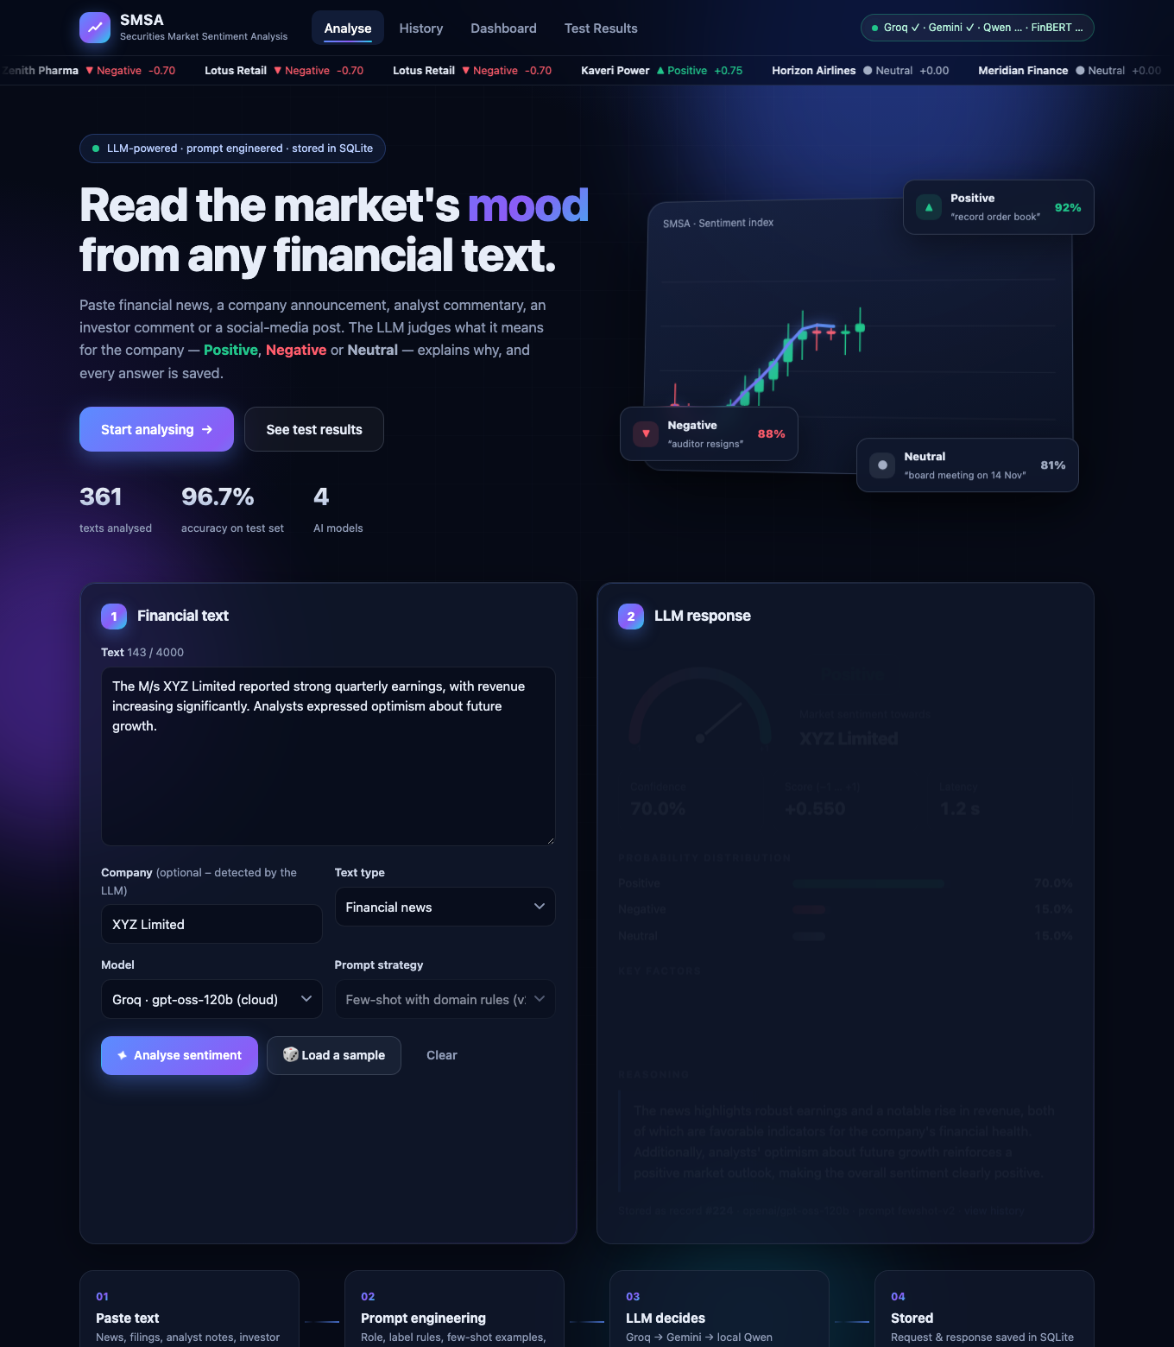
Figure 3: Analyse page – the assignment's example classified as Positive and stored
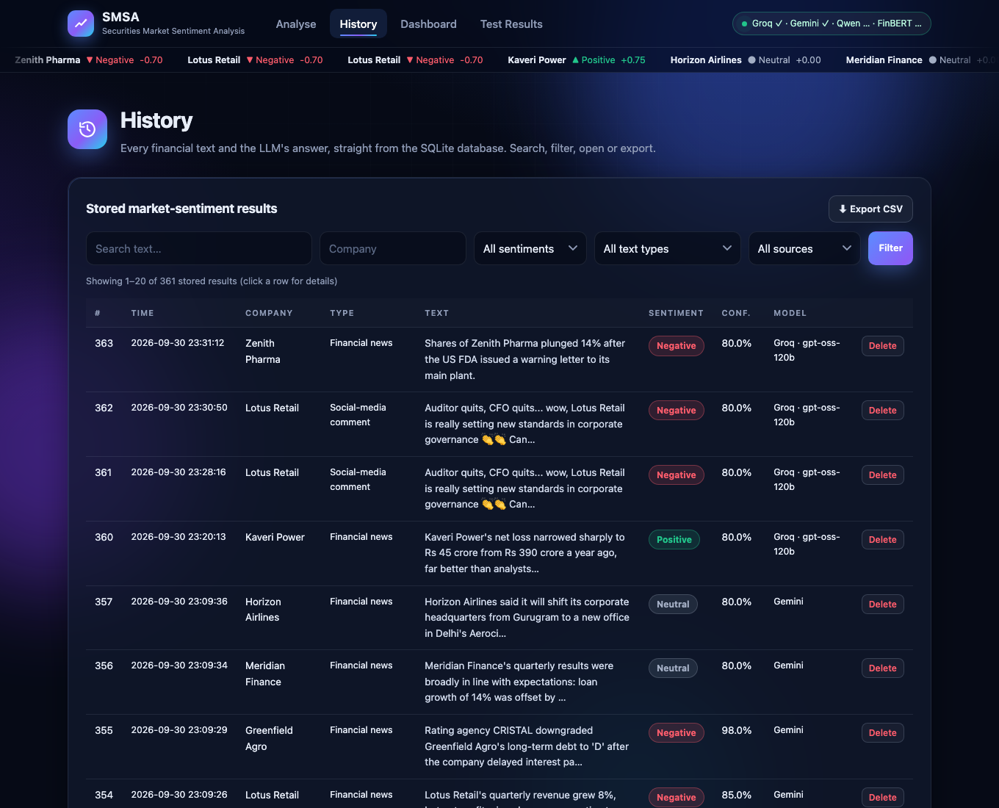
Figure 4: History page – results stored in the database
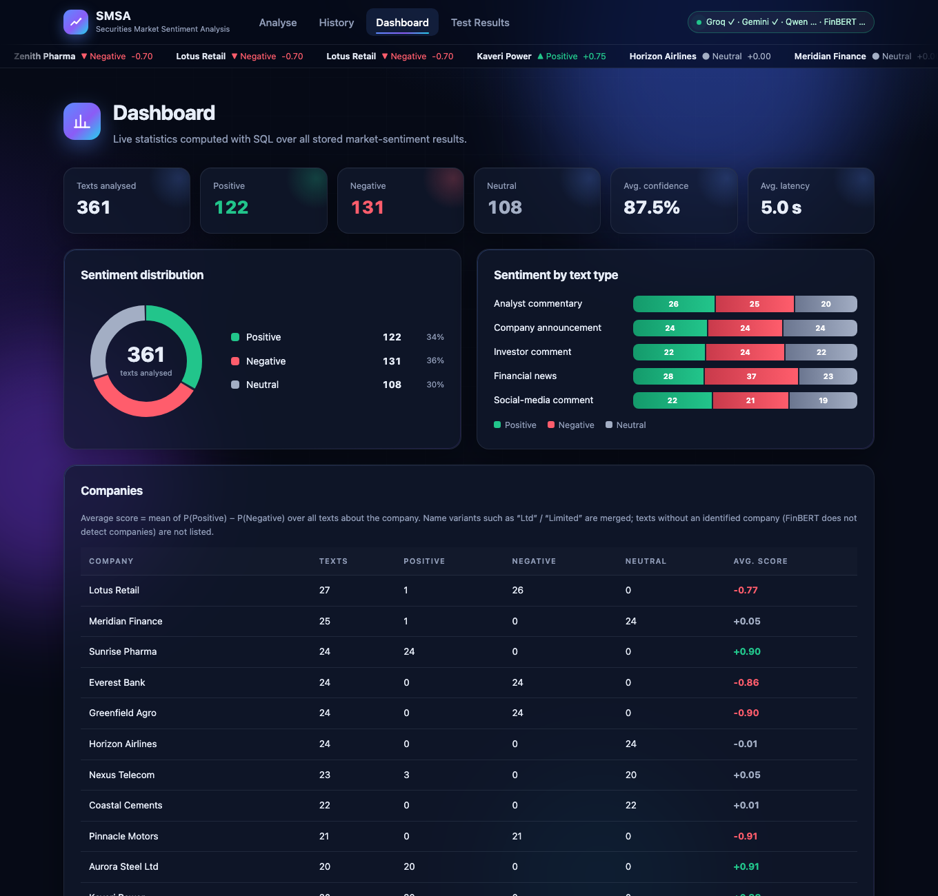
Figure 5: Dashboard page – statistics from the database
Visual design: the interface uses a dark "trading terminal" theme with translucent glass cards and gradient accents. All graphics are drawn with inline SVG and CSS, with no external libraries, so the application also works offline. It includes an animated candlestick chart in the header section, a live ticker tape of the latest sentiments stored in the database, a gauge whose needle swings to the sentiment score, animated probability bars and counters, a donut chart on the dashboard, and a step-by-step progress animation while the LLM is working. Motion is switched off automatically for users whose system asks for reduced motion.
Client-side behaviour: the form is validated before sending; while the LLM is working the button is disabled and a spinner is shown; errors returned by the backend are displayed under the form; all text coming from the database is HTML-escaped before it is inserted into the page. A status indicator in the header shows whether the models are ready. The layout adapts to narrow screens.

4.2 Backend
The backend is a Flask application. Page routes return HTML; everything else is a JSON REST API under /api. The main endpoint is POST /api/analyze, which receives the financial text from the frontend, passes it to the LLM and stores the response.
Table 6: REST API endpoints
Method | Endpoint | Purpose
POST | /api/analyze | Analyse one text with the LLM, store the request and response, return the stored record (201).
POST | /api/analyze/batch | Analyse 1 to 20 texts in one call.
GET | /api/results | List stored results. Filters: sentiment, company, text_type, source, q (search), limit, offset.
GET | /api/results/<id> | One stored result.
DELETE | /api/results/<id> | Delete a stored result (and its request).
GET | /api/results/export.csv | Download all results as CSV.
GET | /api/stats | Aggregate statistics for the dashboard.
GET | /api/companies | Companies in the database with their number of analyses.
GET | /api/models | Available engines, model names and prompt versions.
GET | /api/testset | The labelled test data set.
GET | /api/test-runs | All evaluation runs.
GET | /api/test-runs/<id> | One run with every prediction.
GET | /api/health | Status of the service and of each model.

Page routes: / (Analyse), /history, /dashboard, /test-results.
Request and response of the main endpoint:
POST /api/analyze
{
"text": "The M/s XYZ Limited reported strong quarterly earnings, ...",
"text_type": "news", // news | announcement | analyst | investor | social | other
"company": "", // optional - detected by the LLM when empty
"engine": "groq", // groq | gemini | llm | finbert (optional)
"prompt_version": "fewshot-v2",
"fallback": true // use the fallback chain if the engine fails (default)
}

HTTP 201
{
"status": "success",
"result": {
"result_id": 224, "sentiment": "Positive", "confidence": 0.7,
"sentiment_score": 0.55, "company_name": "XYZ Limited",
"prob_positive": ..., "prob_negative": ..., "prob_neutral": ...,
"key_factors": ["Strong quarterly earnings", "Significant revenue increase", ...],
"reasoning": "The news highlights robust earnings and a notable rise in revenue ...",
"engine": "groq", "model_name": "openai/gpt-oss-120b", "latency_ms": 1205, ...
}
}

Validation and error handling
- If the requested cloud LLM fails, the request is answered by the next engine of the fallback chain (Section 5.4) and the response says which model answered and why the first one failed.
- The text must have between 10 and 4,000 characters; text_type and engine must be known values. Otherwise the API answers HTTP 400 with {"status": "error", "error": "..."}.
- If every engine of the chain fails (or fallback is switched off), the error is returned as HTTP 503 with a readable message and nothing is written to the database.
- Unknown /api paths return a JSON 404. Every SQL statement uses bound parameters, so text submitted by users cannot alter a query.
- The local models are loaded once, in a background thread at start-up, and a lock ensures that only one local inference runs at a time, so the multi-threaded server stays responsive.

5. LLM integration details
All model code is in sentiment_engine.py. The backend calls one function, engine.analyze(text, text_type, company, engine, prompt_version), and receives the same result structure whichever model is used. This keeps the Flask code independent of the model.

5.1 Models
Table 7: Pre-trained models integrated
Engine | Model | How it is used | Why
groq (default) | openai/gpt-oss-120b, an open-weight LLM served by the Groq API | Chat completion with the engineered prompt; output constrained to a JSON schema; temperature 0. | Large model: understands sarcasm, expectations and mixed news; answers in about a second.
gemini (fallback) | gemini-3.5-flash through the Google Gemini API | Same prompt and JSON schema as Groq; temperature 0. | Keeps the application working when Groq is down or rate-limited.
llm | Qwen/Qwen2.5-1.5B-Instruct, loaded locally with Hugging Face Transformers | Same prompt as chat turns; label read from the next-token probabilities, then the explanation is generated. | Runs on the laptop (Apple GPU / CUDA / CPU) with no internet and no API key.
finbert | ProsusAI/finbert | Text-classification pipeline; no prompt. | Domain-specific baseline to measure what prompt engineering with an LLM adds.

The default engine is chosen in config.py: Groq when a Groq API key is configured, then Gemini, otherwise the local Qwen model. It can be changed per request from the frontend or with the environment variable SMSA_DEFAULT_ENGINE.

5.2 Prompt engineering
The final prompt (version fewshot-v2) combines six techniques:
- Role prompting – the model is told it is a senior equity research analyst specialising in market sentiment.
- Explicit label definitions – what Positive, Negative and Neutral mean for an investor in the company, with typical events for each.
- Domain rules – judge the implication for the company and not the tone of the words; compare results with expectations ("profit rose but missed estimates" is Negative, "loss narrowed more than expected" is Positive); interpret market slang and sarcasm; for mixed news choose the dominant side and use Neutral only when it is balanced.
- Few-shot examples – six worked examples covering every text type and every label, including one sarcastic post and one in-line / mixed result. None of them is taken from the test data set.
- Context in the user message – the text type and, if given, the company are stated before the text, and the text is delimited by triple quotes.
- Structured output – the answer must be a JSON object with fixed keys, so the backend can parse it reliably.
System prompt used with the local LLM (the text sent to Groq and Gemini is the same up to rule 4; rule 5 is replaced by the JSON schema and the examples are listed in the system prompt):
You are a senior equity research analyst who specialises in securities-market sentiment analysis. You read financial news, company announcements, analyst commentary, investor comments and social-media posts and decide what the text implies for the market sentiment towards the company (its share price / outlook) from the point of view of an investor in that company.

Sentiment labels (use exactly one):
- Positive : the text is favourable for the company - e.g. earnings beat, revenue or profit growth, new orders or contracts, upgrades, higher targets, dividends/buy-backs, approvals, expansion, bullish investor mood.
- Negative : the text is unfavourable - e.g. losses, earnings miss, falling sales, downgrades, lower targets, debt stress or default, fraud, penalties, lawsuits, resignations of key people, plant shutdowns, bearish investor mood.
- Neutral : factual or procedural information with no clear favourable or unfavourable implication (meeting dates, routine filings, appointments of auditors, in-line results), or a balanced mix where good and bad points cancel out, or a question without an opinion.

Rules:
1. Judge the implication for the company that the text is about, not the tone of the words alone.
2. Compare results with expectations: "profit rose but missed estimates" is Negative; "loss narrowed more than expected" is Positive.
3. Understand market slang and sarcasm in social-media posts: "to the moon", "rocket", "bullish", "buying the dip" are Positive; "bagholder", "rug pull", "dumping", "stay away" are Negative; sarcastic praise of bad news is Negative.
4. If the text contains both good and bad news, choose the side that dominates; choose Neutral only if they are genuinely balanced.
5. Respond ONLY with a JSON object, no other text, in this exact format:
{"sentiment": "Positive|Negative|Neutral", "company": "<company name or Unknown>", "key_factors": ["<factor 1>", "<factor 2>"], "reasoning": "<one short sentence>"}

Few-shot examples (sent to the local LLM as earlier user / assistant turns):
Type | Example text | Label
Financial news | Shares of Coral Textiles Ltd climbed 7% after the company won a Rs 1,200 crore export order from a large European retailer. | Positive
Company announcement | Harbor Logistics Ltd hereby informs the exchange that a meeting of the Board of Directors will be held on 14 November to consider the unaudited results for Q2. | Neutral
Analyst commentary | We downgrade Maple Cement to SELL. Weak demand and rising fuel costs are likely to compress EBITDA margins over the next two quarters. | Negative
Social-media comment | Great, another 'strategic restructuring' at Nimbus Telecom. Bagholders keep bleeding lol #NIMB | Negative
Investor comment | Been holding Orchid Foods for three years; the new CEO's cost discipline is finally showing in the margins. Adding more on every dip. | Positive
Financial news | Vega Motors reported a 4% rise in revenue while operating margin slipped 60 basis points; overall results were in line with street estimates. | Neutral

User message built for each request:
Text type: Financial news
Company: <only if the user typed one>
Text: """<the financial text>"""
Return the JSON answer.

For comparison, a minimal prompt (version zeroshot-v1) contains one instruction sentence and the output format only. Both versions can be selected on the Analyse page, and Section 7 measures the difference.

5.3 How the answer becomes a stored result

Groq and Gemini (cloud LLMs)
- The request carries a JSON schema (sentiment as an enumeration of the three labels, company, probabilities, key_factors, reasoning). The API guarantees that the answer matches it, so no free-text parsing is needed.
- The model also reports its probability for each label as whole-number percentages, which are normalised to sum to 1. Confidence is the probability of the chosen label and the score is P(Positive) − P(Negative). These probabilities are the model's own estimate.
- Temperature is 0 and reasoning effort is low, because this is a short classification task.
- Errors are mapped to readable messages (invalid key, rate limit, connection failure). API keys are read from a local .env file through environment variables and are never in the source code.
A problem found during testing: in the first Groq test run (run 1) two of the 60 requests were rejected by Groq's JSON validator because the model wrote a probability as "0. nine" instead of 0.9. Retrying did not help. Asking for whole-number percentages instead of decimals removed the problem, and a retry for this specific error was kept as a safeguard. The final Groq run (run 6) completed all 60 texts.

Qwen2.5-1.5B-Instruct (local LLM)
- The messages are formatted with the model's chat template, and the beginning of the answer, {"sentiment": ", is appended to the prompt.
- Step 1 – label from the logits. One forward pass gives the probability of the next token. The probabilities of the tokens that start "Positive", "Negative" and "Neutral" are normalised to give P(Positive), P(Negative) and P(Neutral). The highest is the predicted sentiment and its probability is the confidence. The label is therefore always one of the three valid values, and the confidence comes from the model's actual output distribution.
- Step 2 – explanation. The chosen label is inserted and the model continues with greedy decoding (no sampling, so the output is repeatable) to write the company, key factors and reasoning.
- Parsing. The JSON is parsed; if a small model produces imperfect JSON, regular expressions recover the company, factors and reasoning. The label does not depend on this step.

FinBERT
FinBERT returns the probability of positive, negative and neutral directly. It gives no explanation and does not identify the company.

5.4 Automatic fallback between models
A cloud API can fail at any moment: the provider may be overloaded, the free quota of a key may be used up, the key may be revoked or the internet connection may drop. So that the application keeps answering, SentimentEngine.analyze() tries a chain of engines:
Requested engine | Tried next, in order
groq (default) | gemini → llm (local Qwen)
gemini | groq → llm
llm, finbert | no fallback (they run locally)

- Key check at start-up. When the server starts, each configured API key is verified with a free "list models" call that uses no generation quota. An engine whose key fails is marked unavailable: it is greyed out in the model list with the reason as a tooltip, the status indicator in the header shows it with a cross, and the fallback chain skips it without sending a request.
- Any failure of a cloud engine triggers the next one, including an answer that is not valid JSON. An invalid request (for example an empty text) never triggers the fallback.
- The local Qwen model is the last step because it has no quota and needs no internet.
- The stored result names the model that actually answered, and the column fallback_from records which engines failed and why, as one short sentence per engine. The Analyse page shows a notice such as "Groq could not be used (rate limit reached). This answer was produced by the fallback model gemini-3.5-flash."
- The client can switch the fallback off per request ("fallback": false). The test script does this, so every prediction of a test run comes from the model under test.
- The whole chain can be disabled with SMSA_FALLBACK=0 in the .env file.
The mechanism was tested by replacing the API keys with invalid ones:
Situation | Result
Groq and Gemini working | Answered by Groq (gpt-oss-120b).
Groq key invalid | Answered by Gemini; fallback_from = "groq: Groq API key is invalid".
Groq and Gemini keys invalid | Answered by the local Qwen model; both failures recorded.
Groq key invalid, fallback switched off | HTTP 503 with the error message; nothing stored.

6. Test data set
The test data set (data/test_dataset.csv, also stored in the table test_dataset) contains 60 financial texts, more than the 50 required. It covers the five required text types with 12 texts each, and each type has 4 Positive, 4 Negative and 4 Neutral texts, so both the types and the labels are balanced (20 / 20 / 20).
Table 8: Composition of the test data set
Text type | Positive | Negative | Neutral | Total
Financial news | 4 | 4 | 4 | 12
Company announcement | 4 | 4 | 4 | 12
Analyst commentary | 4 | 4 | 4 | 12
Investor comment | 4 | 4 | 4 | 12
Social-media comment | 4 | 4 | 4 | 12
Total | 20 | 20 | 20 | 60

- How it was built. The texts were written by the team in the style of real market text: exchange filings, news-wire reports, broker notes, investor forum posts and social-media posts with cashtags, hashtags and emoji. The 16 company names are fictional, so that no real company is associated with invented news.
- How it was labelled. Each text was labelled by hand with the definitions used in the prompt: the implication for the company from an investor's point of view.
- Difficult cases included on purpose: profit growth that misses estimates (Negative), a loss that is smaller than feared (Positive), sarcastic praise of bad news, market slang ("to the moon", "rug pull", "bagholder"), mixed news that balances out, procedural filings, and questions with no opinion.
Table 9: One example of each text type
Type | Text | Expected
Financial news | Aurora Steel Ltd reported a 32% year-on-year jump in quarterly net profit to Rs 1,845 crore, beating street estimates, as higher realisations and lower coking coal costs lifted margins. The stock rose 6% in early trade. | Positive
Company announcement | Aurora Steel Ltd is pleased to announce that the Board of Directors has approved a buyback of equity shares worth Rs 2,000 crore at a price of Rs 1,450 per share, a premium of 22% to the current market price. | Positive
Analyst commentary | We upgrade Brightwave Technologies to BUY from HOLD and raise our target price to Rs 1,850, implying 28% upside. Strong deal wins and improving margins give us confidence in double-digit earnings growth over FY26-28. | Positive
Investor comment | I've held Sunrise Pharma since 2019 and the management has delivered on every promise. With the new FDA approvals, I'm increasing my position - this is a long-term compounder. | Positive
Social-media comment | $BRWV just smashed earnings and landed a $750M deal 🚀🚀 This one is going to the moon! Loading up more tomorrow #bullish | Positive

The complete data set with the prediction of every model is in Appendix B.

7. Test results
The system was tested end to end with run_tests.py. For every text of the data set the script calls the backend endpoint POST /api/analyze, exactly as the frontend does; the backend calls the LLM and stores the response; the script then compares the stored sentiment with the expected label and records the run in test_runs and test_run_items. The same 60 texts were run through four configurations.
Table 10: Results on the 60-text test data set
Run | Model | Prompt | Correct | Accuracy | Macro-F1 | Median time / text
6 | Groq · openai/gpt-oss-120b | Few-shot v2 + JSON schema | 58 / 60 | 96.7% | 0.967 | 3.42 s
5 | Qwen2.5-1.5B-Instruct (local) | Few-shot v2 | 60 / 60 | 100.0% | 1.000 | 9.63 s
3 | Qwen2.5-1.5B-Instruct (local) | Zero-shot v1 | 58 / 60 | 96.7% | 0.967 | 2.78 s
2 | FinBERT (local) | none (classifier) | 50 / 60 | 83.3% | 0.831 | 0.02 s

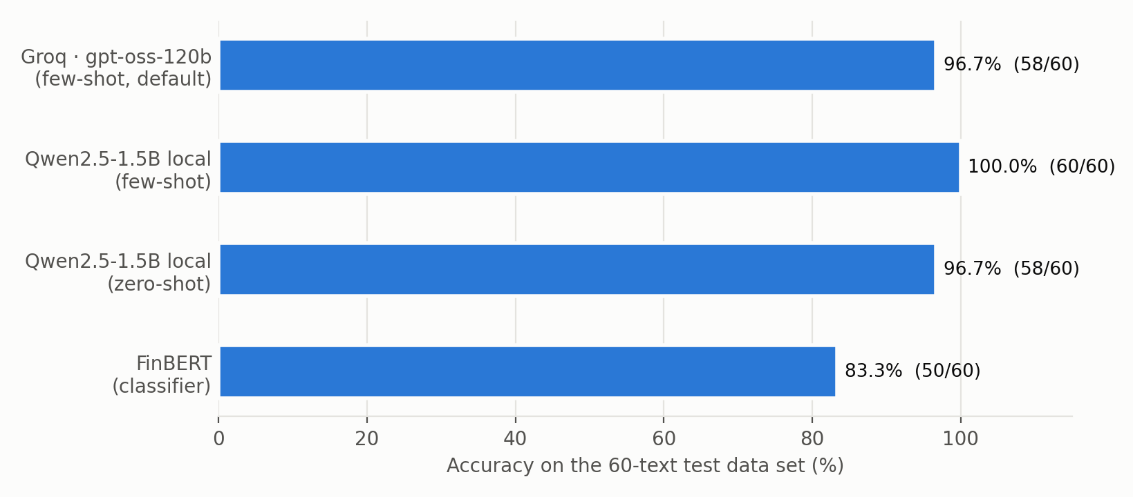
Figure 6: Overall accuracy of the four configurations on the 60 test texts

7.1 Default configuration (Groq · gpt-oss-120b)
The default configuration classified 58 of 60 texts as expected (96.7%, macro-F1 0.967).
Table 11: Precision, recall and F1 per class – default configuration
Class | Precision | Recall | F1 | Texts
Positive | 0.91 | 1.00 | 0.95 | 20
Negative | 1.00 | 1.00 | 1.00 | 20
Neutral | 1.00 | 0.90 | 0.95 | 20

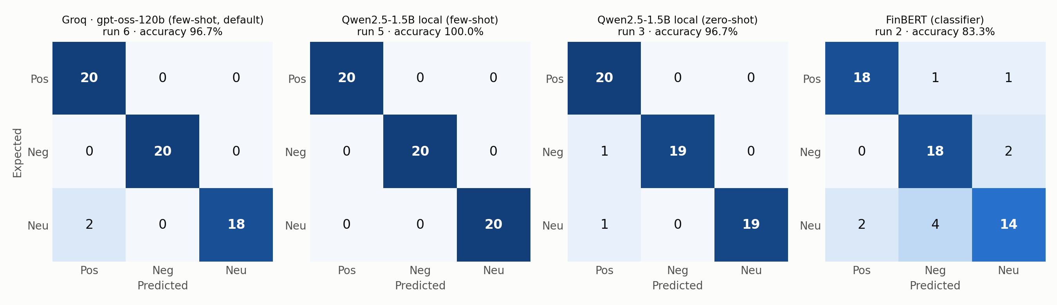
Figure 7: Confusion matrices of the four configurations (rows = expected, columns = predicted)
Table 12: Correct predictions by text type
Text type | Groq gpt-oss-120b | Qwen2.5-1.5B-Instruct FS | Qwen2.5-1.5B-Instruct ZS | FinBERT
Financial news | 11 / 12 | 12 / 12 | 12 / 12 | 10 / 12
Company announcement | 12 / 12 | 12 / 12 | 12 / 12 | 12 / 12
Analyst commentary | 12 / 12 | 12 / 12 | 11 / 12 | 9 / 12
Investor comment | 12 / 12 | 12 / 12 | 12 / 12 | 10 / 12
Social-media comment | 11 / 12 | 12 / 12 | 11 / 12 | 9 / 12

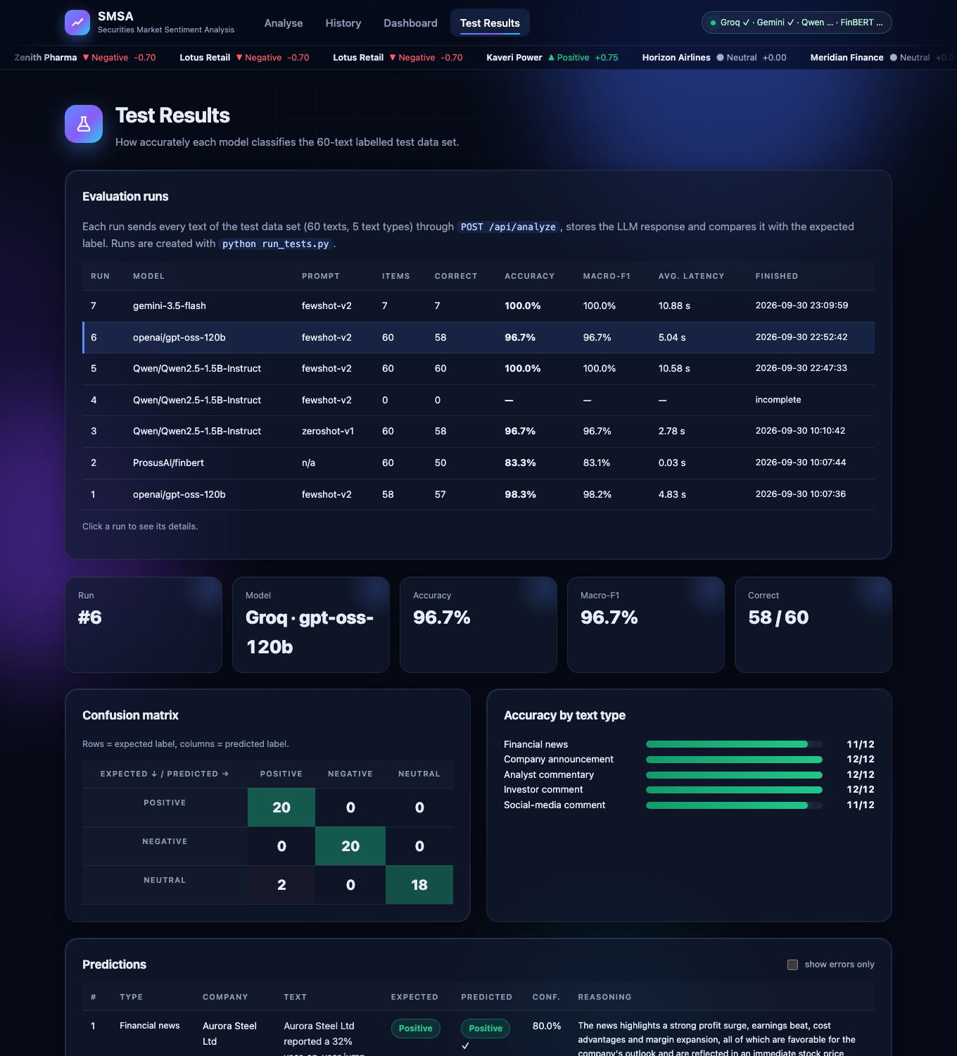
Figure 8: Test Results page of the application

7.2 Effect of prompt engineering
With the same local model, the engineered few-shot prompt scored 60/60 and the minimal zero-shot prompt 58/60. The texts the zero-shot prompt got wrong are the ones the added rules and examples target:
# | Text (shortened) | Expected | Zero-shot | Few-shot
33 | We maintain our HOLD rating on Meridian Finance with an unchanged target price. Loan growth and margins are tracking our estimates, and the current va… | Neutral | Positive | Neutral
54 | Auditor quits, CFO quits... wow, Lotus Retail is really setting new standards in corporate governance 👏👏 Can't wait to see what else they're hiding lo… | Negative | Positive | Negative

The sarcastic post was read literally without the sarcasm rule and example, and an unchanged HOLD rating was read as good news without the definition of Neutral. The few-shot prompt is longer, so the local model needs more time per text (median 9.6 s against 2.8 s).

7.3 LLM versus FinBERT
FinBERT, a classifier trained on financial news, reached 50/60 (83.3%). 6 of its 10 errors are Neutral texts predicted as Positive or Negative: it reacts to individual words such as "offset", "weak" or "excluded" and does not weigh a balanced statement. It also missed slang ("rug pull", "bagholder", "super bullish" were predicted Neutral) and the statement that losses are shrinking (predicted Negative). It was perfect on formal company announcements, the kind of text it was trained on. The prompted LLMs handle these cases because the instruction tells them what to judge, and they also return the company and an explanation, which FinBERT cannot. FinBERT is by far the fastest (21 ms per text).

7.4 Error analysis of the default configuration
# | Type | Text | Expected | Predicted | Model's reasoning
12 | Financial news | Nexus Telecom's shares will be included in the Nifty Midcap 150 index and excluded from the Nifty Smallcap 250 index as part of the semi-annual index rebalancing effective from next month. | Neutral | Positive | Being moved into the Nifty Midcap 150 index raises the company's visibility among institutional investors and signals a perceived upgrade in market capitalization, which is generally viewed favorably by investors. The exclusion from the Smallcap index is a natural consequence of the upgrade and does not imply a negative development. Hence the overall implication for Nexus Telecom's share price outlook is positive.
60 | Social-media comment | Index rebalancing update: Nexus Telecom moves from Smallcap 250 to Midcap 150 from next month. FYI for index fund followers. | Neutral | Positive | The move to a higher‑cap index signals a perceived upgrade in size and quality, which typically attracts index‑fund inflows and boosts investor confidence. This is a favourable development for Nexus Telecom's share price outlook.

Both errors concern the same event: the company moving from a small-cap to a mid-cap index. The team labelled these texts Neutral, because they are factual notices with no opinion. The model argued that moving to a higher index usually brings buying by index funds and more attention from institutional investors, which is favourable for the share price. Many market participants would agree with the model, so these two cases show an ambiguity in the labelling rather than a failure to understand the text. With the rule "factual notices are Neutral" applied strictly, the result is 58/60; if index inclusion is treated as mildly Positive, all 60 answers are acceptable. The local Qwen model followed the literal rule and labelled both Neutral. In a production system this kind of event should be written into the label definitions explicitly.

7.5 Gemini (fallback engine)
Gemini was also run on the test data set (run 7), but the free-tier key available to us allowed only a few requests: 7 of the 60 texts were answered (7 correct); the other requests were rejected by Google with "model currently experiencing high demand" (HTTP 503) or "quota exceeded" (HTTP 429). The run is therefore not comparable with the others and is not included in the tables above. It does show why the fallback chain ends with the local model, which has no quota.

7.6 Response time
Median time per text: Groq 3.42 s (network call), local Qwen with the few-shot prompt 9.6 s on an Apple-silicon laptop GPU, FinBERT 21 ms. The Groq figures include occasional slower responses (mean 5.04 s).

8. Limitations, conclusion and future work

Limitations
- The test set is small and was written by the team. 60 texts cannot represent the variety of real market text, and the same people wrote the texts, the labels and the prompt rules. Scores of 96.7% and 100.0% therefore show that the system works as designed on these cases; accuracy on real, unseen market text will be lower.
- One error is one text out of 60, so differences of one or two texts between configurations are not statistically meaningful. The gap to FinBERT (10 errors) is.
- Sentiment labels are partly subjective, especially between Neutral and a mild Positive / Negative (Section 7.4).
- Confidence of the cloud LLMs is self-reported by the model. Only the local Qwen engine and FinBERT give probabilities computed from the model's output distribution.
- The default engine needs internet and a Groq API key, and is subject to the rate limits of the key. The local engine is the fallback.
- The Gemini key is a free-tier key with a small quota, so Gemini is suitable as an occasional fallback only, and it could not be evaluated on the full test data set.
- The Flask development server and SQLite are suitable for a demonstration, not for many simultaneous users. There is no user login.

Conclusion
All four tasks of the assignment are implemented and working together: a 60-text test data set of the five required types, an HTML / CSS frontend, a Flask backend with REST endpoints integrated with pre-trained LLMs through an engineered prompt, and a normalised database in which every LLM response is stored. On the test data set the prompted LLMs were clearly more accurate than the FinBERT baseline, and the engineered prompt was better than a plain zero-shot instruction with the same model.

Future work
- Test on a public labelled corpus such as the Financial PhraseBank, and on real exchange filings.
- Aspect-level sentiment when one text mentions several companies.
- Fetch news automatically for a ticker and show the sentiment trend of a company over time.
- Fine-tune the small local model on labelled financial text (for example with LoRA).
- Deploy behind a production WSGI server with user accounts.

Appendix A. How to run the system
# 1. install the dependencies
pip install -r requirements.txt

# 2. copy .env.example to .env and put the API keys in it
# GROQ_API_KEY=... (default engine)
# GEMINI_API_KEY=... (fallback engine)
# Without a key the application uses the local Qwen model automatically.

# 3. start the application and open http://127.0.0.1:5050
python app.py

# 4. test the system with the test data set
python run_tests.py --engine groq
python run_tests.py --engine llm --prompt fewshot-v2
python run_tests.py --engine llm --prompt zeroshot-v1
python run_tests.py --engine finbert

- The first start downloads the local models from Hugging Face (Qwen2.5-1.5B-Instruct about 3 GB, FinBERT about 0.4 GB); afterwards they work offline.
- The port is 5050 because on macOS port 5000 is used by AirPlay Receiver; it can be changed with the environment variable SMSA_PORT.
- For a demonstration without internet, set SMSA_DEFAULT_ENGINE=llm in the .env file.
- API keys are not included in the submitted zip. The .env file is listed in .gitignore.
The submitted database also contains test run 1 (the first Groq run described in Section 5.3), an interrupted local run and the partial Gemini run (Section 7.5); they are kept as history and are not used in the comparison tables.

Appendix B. Test data set with the predictions of every model
Expected = label assigned by the team. A prediction that differs from the expected label is shown in red. Groq = gpt-oss-120b with the few-shot prompt; Qwen FS / ZS = local Qwen with the few-shot / zero-shot prompt.
# | Type | Company | Financial text | Expected | Groq | Qwen FS | Qwen ZS | FinBERT
1 | Financial news | Aurora Steel Ltd | Aurora Steel Ltd reported a 32% year-on-year jump in quarterly net profit to Rs 1,845 crore, beating street estimates, as higher realisations and lower coking coal costs lifted margins. The stock rose 6% in early trade. | Positive | Positive | Positive | Positive | Positive
2 | Financial news | Brightwave Technologies | Brightwave Technologies shares hit a 52-week high after the IT services firm signed a five-year, $750 million digital transformation deal with a leading US bank, its largest contract to date. | Positive | Positive | Positive | Positive | Positive
3 | Financial news | Sunrise Pharma | Sunrise Pharma received final approval from the US FDA for its generic version of a blockbuster diabetes drug, opening a market estimated at $1.2 billion annually. Analysts expect the launch to add meaningfully to earnings from next year. | Positive | Positive | Positive | Positive | Positive
4 | Financial news | Kaveri Power Ltd | Kaveri Power's net loss narrowed sharply to Rs 45 crore from Rs 390 crore a year ago, far better than analysts had feared, as plant utilisation improved. Shares surged 9%. | Positive | Positive | Positive | Positive | Positive
5 | Financial news | Pinnacle Motors | Pinnacle Motors shares slumped 11% after the automaker reported a 40% drop in quarterly profit and warned that a semiconductor shortage would hit production for the rest of the year. | Negative | Negative | Negative | Negative | Negative
6 | Financial news | Everest Bank | The central bank imposed a penalty of Rs 25 crore on Everest Bank for lapses in KYC compliance and barred it from onboarding new credit-card customers until the deficiencies are fixed. | Negative | Negative | Negative | Negative | Negative
7 | Financial news | Lotus Retail | Lotus Retail's quarterly revenue grew 8%, but net profit missed consensus estimates by a wide margin as discounting and higher rent costs squeezed margins; the stock fell 5% on the results. | Negative | Negative | Negative | Negative | Negative
8 | Financial news | Greenfield Agro | Rating agency CRISTAL downgraded Greenfield Agro's long-term debt to 'D' after the company delayed interest payments on its non-convertible debentures, citing a severe liquidity crunch. | Negative | Negative | Negative | Negative | Negative
9 | Financial news | Coastal Cements | Coastal Cements will announce its results for the quarter ended September on October 24, the company said in a regulatory filing on Monday. | Neutral | Neutral | Neutral | Neutral | Neutral
10 | Financial news | Meridian Finance | Meridian Finance's quarterly results were broadly in line with expectations: loan growth of 14% was offset by a slight rise in credit costs, and the stock ended the day flat. | Neutral | Neutral | Neutral | Neutral | Negative
11 | Financial news | Horizon Airlines | Horizon Airlines said it will shift its corporate headquarters from Gurugram to a new office in Delhi's Aerocity by March next year. | Neutral | Neutral | Neutral | Neutral | Neutral
12 | Financial news | Nexus Telecom | Nexus Telecom's shares will be included in the Nifty Midcap 150 index and excluded from the Nifty Smallcap 250 index as part of the semi-annual index rebalancing effective from next month. | Neutral | Positive | Neutral | Neutral | Negative
13 | Company announcement | Aurora Steel Ltd | Aurora Steel Ltd is pleased to announce that the Board of Directors has approved a buyback of equity shares worth Rs 2,000 crore at a price of Rs 1,450 per share, a premium of 22% to the current market price. | Positive | Positive | Positive | Positive | Positive
14 | Company announcement | Sunrise Pharma | Sunrise Pharma announces that the Board has recommended a final dividend of Rs 18 per share, the highest in the company's history, in addition to the interim dividend of Rs 7 paid earlier in the year. | Positive | Positive | Positive | Positive | Positive
15 | Company announcement | Vertex Infra Projects | Vertex Infra Projects Ltd hereby informs that it has been declared the lowest bidder (L1) for a Rs 3,400 crore metro rail project, taking the company's order book to a record Rs 28,000 crore. | Positive | Positive | Positive | Positive | Positive
16 | Company announcement | Brightwave Technologies | Brightwave Technologies announces the successful completion of the acquisition of CloudNine Analytics, which is expected to be earnings-accretive from the first full year and adds 120 enterprise clients. | Positive | Positive | Positive | Positive | Positive
17 | Company announcement | Greenfield Agro | Greenfield Agro Ltd informs the exchange that it has defaulted on the repayment of principal and interest of Rs 310 crore due to its lenders on 30 September. | Negative | Negative | Negative | Negative | Negative
18 | Company announcement | Pinnacle Motors | Pinnacle Motors announces the temporary suspension of operations at its Pune manufacturing plant with immediate effect following a major fire; the plant accounts for nearly 35% of the company's output. | Negative | Negative | Negative | Negative | Negative
19 | Company announcement | Lotus Retail | Lotus Retail Ltd informs that its Chief Financial Officer and the statutory auditor have resigned with immediate effect, and the auditor has raised concerns about certain related-party transactions. | Negative | Negative | Negative | Negative | Negative
20 | Company announcement | Everest Bank | Everest Bank announces that the Enforcement Directorate has initiated an investigation into alleged irregularities in loans sanctioned to a group of real-estate companies, and has attached assets worth Rs 800 crore. | Negative | Negative | Negative | Negative | Negative
21 | Company announcement | Coastal Cements | Coastal Cements Ltd hereby informs that a meeting of the Board of Directors is scheduled on 24 October to consider and approve the unaudited financial results for the quarter ended 30 September. | Neutral | Neutral | Neutral | Neutral | Neutral
22 | Company announcement | Meridian Finance | Pursuant to Regulation 30 of the SEBI (LODR) Regulations, Meridian Finance Ltd informs that the trading window for dealing in its securities will remain closed for designated persons until 48 hours after the declaration of results. | Neutral | Neutral | Neutral | Neutral | Neutral
23 | Company announcement | Horizon Airlines | Horizon Airlines Ltd informs that the 18th Annual General Meeting of the company will be held on 12 August through video conferencing, and the record date for the purpose of the AGM is 5 August. | Neutral | Neutral | Neutral | Neutral | Neutral
24 | Company announcement | Nexus Telecom | Nexus Telecom Ltd announces the appointment of M/s Rao & Associates, Chartered Accountants, as the secretarial auditor of the company for a term of five years, subject to shareholders' approval. | Neutral | Neutral | Neutral | Neutral | Neutral
25 | Analyst commentary | Brightwave Technologies | We upgrade Brightwave Technologies to BUY from HOLD and raise our target price to Rs 1,850, implying 28% upside. Strong deal wins and improving margins give us confidence in double-digit earnings growth over FY26-28. | Positive | Positive | Positive | Positive | Positive
26 | Analyst commentary | Aurora Steel Ltd | Aurora Steel remains our top pick in the metals space. Capacity expansion is on track, costs are falling and we see return on equity improving to 20% by FY27. Reiterate OUTPERFORM. | Positive | Positive | Positive | Positive | Positive
27 | Analyst commentary | Kaveri Power Ltd | Kaveri Power's turnaround is gaining momentum: we expect the company to turn profitable next quarter as the new tariff order kicks in. We initiate coverage with a BUY rating and a target of Rs 260. | Positive | Positive | Positive | Positive | Positive
28 | Analyst commentary | Sunrise Pharma | Sunrise Pharma's US pipeline is the strongest among Indian peers, with 12 approvals expected over two years. We raise our FY27 EPS estimate by 15% and maintain ADD with a higher target price. | Positive | Positive | Positive | Positive | Positive
29 | Analyst commentary | Pinnacle Motors | We downgrade Pinnacle Motors to SELL. Rising competition in the EV segment, market-share losses and elevated inventory levels are likely to pressure margins; we cut our target price by 25% to Rs 540. | Negative | Negative | Negative | Negative | Negative
30 | Analyst commentary | Lotus Retail | Lotus Retail's same-store sales growth has decelerated for the fourth consecutive quarter. With store expansion slowing and rentals rising, we see downside risk to consensus earnings and maintain UNDERPERFORM. | Negative | Negative | Negative | Negative | Negative
31 | Analyst commentary | Greenfield Agro | Given the default on its debt and the absence of a credible refinancing plan, we suspend our rating on Greenfield Agro and advise investors to exit; equity holders face a meaningful risk of dilution or loss. | Negative | Negative | Negative | Negative | Negative
32 | Analyst commentary | Everest Bank | Everest Bank's asset-quality deterioration is worse than we expected: gross NPAs rose to 6.8% and slippages in the unsecured book remain high. We cut our earnings estimates by 18% and move to REDUCE. | Negative | Negative | Negative | Negative | Negative
33 | Analyst commentary | Meridian Finance | We maintain our HOLD rating on Meridian Finance with an unchanged target price. Loan growth and margins are tracking our estimates, and the current valuation fairly reflects the company's prospects. | Neutral | Neutral | Neutral | Positive | Positive
34 | Analyst commentary | Coastal Cements | Coastal Cements' results were in line with our forecasts. Volume growth was healthy, but pricing remained weak; we see balanced risks and keep our NEUTRAL stance. | Neutral | Neutral | Neutral | Neutral | Negative
35 | Analyst commentary | Horizon Airlines | Horizon Airlines benefits from strong travel demand, but high fuel prices and a stretched balance sheet offset the positives. We initiate coverage with an EQUAL-WEIGHT rating. | Neutral | Neutral | Neutral | Neutral | Neutral
36 | Analyst commentary | Nexus Telecom | Nexus Telecom's tariff hike should support revenue, but the higher spectrum payments due next year will absorb most of the benefit. Our estimates are unchanged and we reiterate HOLD. | Neutral | Neutral | Neutral | Neutral | Positive
37 | Investor comment | Sunrise Pharma | I've held Sunrise Pharma since 2019 and the management has delivered on every promise. With the new FDA approvals, I'm increasing my position - this is a long-term compounder. | Positive | Positive | Positive | Positive | Positive
38 | Investor comment | Aurora Steel Ltd | Aurora Steel's buyback at a 22% premium shows the promoters believe the stock is undervalued. As a shareholder I'm very happy and will tender part of my holding. | Positive | Positive | Positive | Positive | Positive
39 | Investor comment | Vertex Infra Projects | Vertex Infra's order book is now almost five times its annual revenue. Execution has been solid, so I expect strong earnings visibility for years. Adding more to my portfolio. | Positive | Positive | Positive | Positive | Positive
40 | Investor comment | Kaveri Power Ltd | Finally some good news for Kaveri Power shareholders - losses are shrinking every quarter and the debt is coming down. I think the worst is behind us. | Positive | Positive | Positive | Positive | Negative
41 | Investor comment | Lotus Retail | Sold my entire stake in Lotus Retail today. The auditor resigning and raising red flags about related-party deals is a deal-breaker for me. Corporate governance matters. | Negative | Negative | Negative | Negative | Negative
42 | Investor comment | Greenfield Agro | I'm an investor in Greenfield Agro and I'm deeply disappointed. The company kept assuring us that there was no liquidity problem and now it has defaulted. My investment is down 70%. | Negative | Negative | Negative | Negative | Negative
43 | Investor comment | Pinnacle Motors | Pinnacle Motors keeps losing market share to newer EV players and management has no clear answer. I don't see any reason to hold this stock anymore. | Negative | Negative | Negative | Negative | Negative
44 | Investor comment | Everest Bank | The ED investigation into Everest Bank's loans worries me a lot. Until there is clarity, I'm reducing my exposure - there could be more skeletons in the closet. | Negative | Negative | Negative | Negative | Neutral
45 | Investor comment | Meridian Finance | I hold some Meridian Finance shares. Does anyone know when the record date for the interim dividend is? | Neutral | Neutral | Neutral | Neutral | Neutral
46 | Investor comment | Coastal Cements | Coastal Cements looks fairly valued to me at current levels. I'll keep my existing holding but won't add more until I see the next set of results. | Neutral | Neutral | Neutral | Neutral | Neutral
47 | Investor comment | Horizon Airlines | Horizon Airlines has good passenger growth but carries a lot of debt. The positives and negatives balance out for me, so I'm staying on the sidelines for now. | Neutral | Neutral | Neutral | Neutral | Neutral
48 | Investor comment | Nexus Telecom | Nexus Telecom is moving to the Midcap index next month. Not sure whether that will change anything for long-term investors like me. | Neutral | Neutral | Neutral | Neutral | Neutral
49 | Social-media comment | Brightwave Technologies | $BRWV just smashed earnings and landed a $750M deal 🚀🚀 This one is going to the moon! Loading up more tomorrow #bullish | Positive | Positive | Positive | Positive | Positive
50 | Social-media comment | Vertex Infra Projects | Vertex Infra bagging order after order 🔥 L1 in a Rs 3,400 cr metro project. Infra theme is on fire and $VRTX is leading it. Super bullish! | Positive | Positive | Positive | Positive | Neutral
51 | Social-media comment | Sunrise Pharma | Sunrise Pharma record dividend + FDA nod in the same month?? Dream run for shareholders 💰📈 Holding tight | Positive | Positive | Positive | Positive | Positive
52 | Social-media comment | Kaveri Power Ltd | Kaveri Power up 9% today! The turnaround story is real. Bought the dip last month, feeling great 😎 #KaveriPower | Positive | Positive | Positive | Positive | Positive
53 | Social-media comment | Greenfield Agro | Greenfield Agro defaulted again 🤡 total rug pull. Anyone still holding this is a bagholder. Stay far away!! | Negative | Negative | Negative | Negative | Neutral
54 | Social-media comment | Lotus Retail | Auditor quits, CFO quits... wow, Lotus Retail is really setting new standards in corporate governance 👏👏 Can't wait to see what else they're hiding lol | Negative | Negative | Negative | Positive | Negative
55 | Social-media comment | Pinnacle Motors | $PNCL down 11% after that profit crash 📉📉 Plant fire, chip shortage, losing EV market share... this stock is a disaster. Dumping everything. | Negative | Negative | Negative | Negative | Negative
56 | Social-media comment | Everest Bank | ED raids at Everest Bank 😬 penalty last month, investigation this month. Something is seriously wrong there. Exit before it gets worse. #EverestBank | Negative | Negative | Negative | Negative | Negative
57 | Social-media comment | Coastal Cements | Coastal Cements results are out on Oct 24. What are you all expecting? Drop your estimates below 👇 | Neutral | Neutral | Neutral | Neutral | Neutral
58 | Social-media comment | Meridian Finance | Meridian Finance closed flat today after results. Nothing exciting either way, just in line. #stockmarket | Neutral | Neutral | Neutral | Neutral | Negative
59 | Social-media comment | Horizon Airlines | Just saw that Horizon Airlines is moving its HQ to Aerocity. Interesting move. Anyone know why? | Neutral | Neutral | Neutral | Neutral | Neutral
60 | Social-media comment | Nexus Telecom | Index rebalancing update: Nexus Telecom moves from Smallcap 250 to Midcap 150 from next month. FYI for index fund followers. | Neutral | Positive | Neutral | Neutral | Neutral

