UNIX COMMANDS
GREP COMMAND:
Grep is a Linux / Unix command line tool used to search for a string of characters in a specified file. The text search pattern is called a regular expression. When it finds a match, it prints the line with the result.
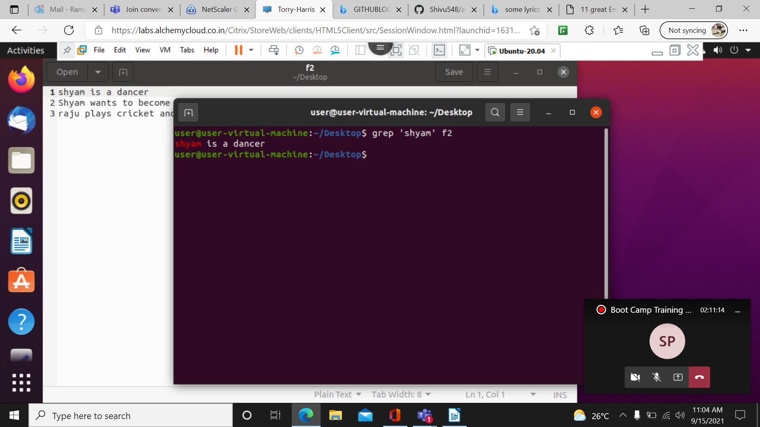

Grep -i ‘word’ filename : used to find the string without case- sensitive

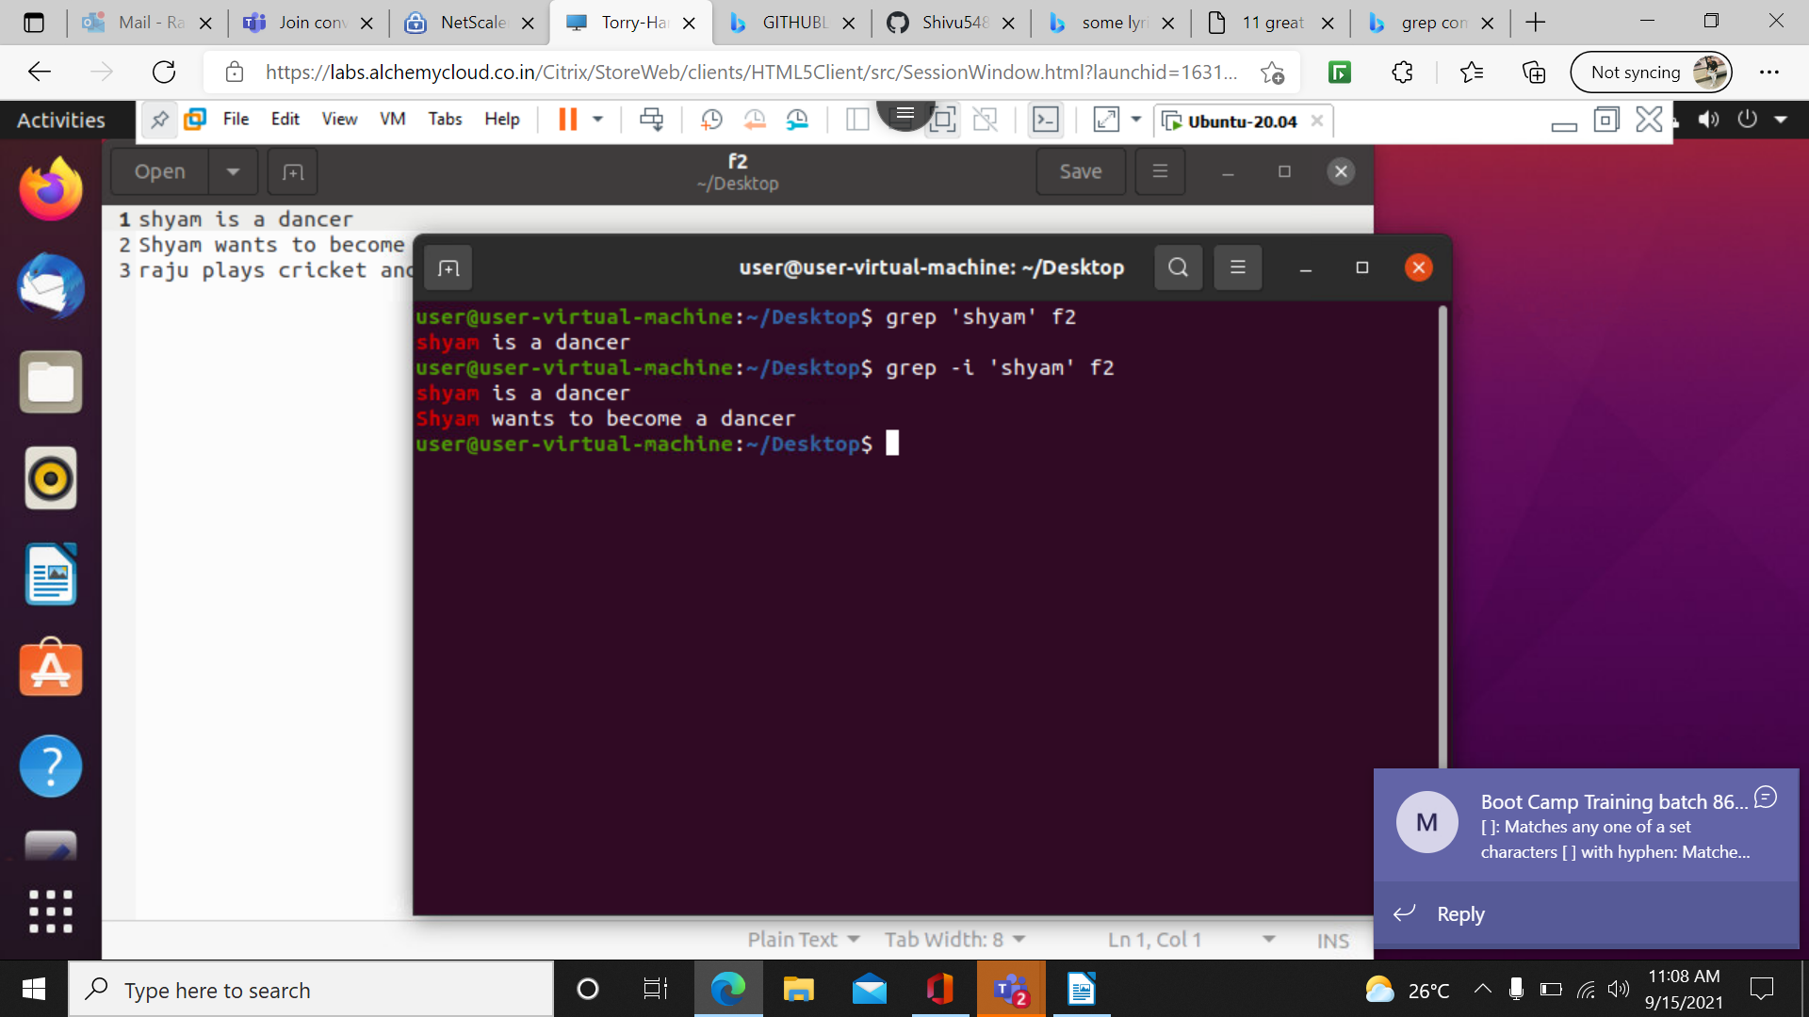

grep -c ‘word’ filename:

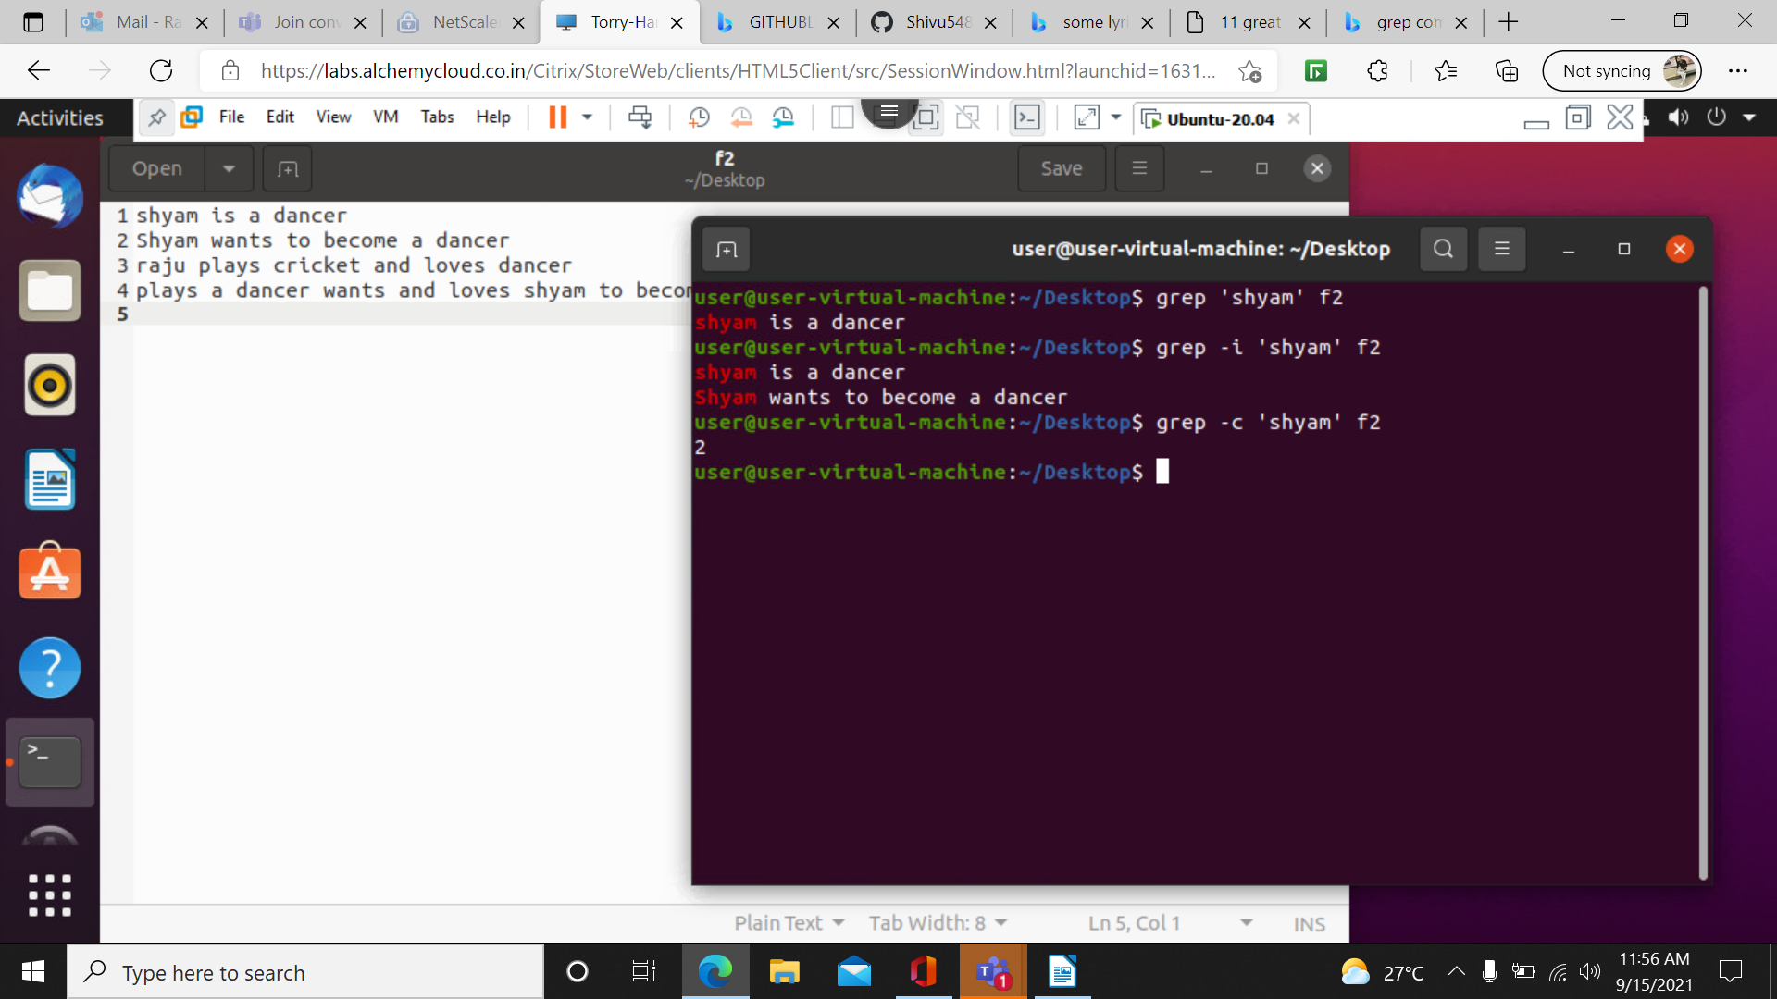

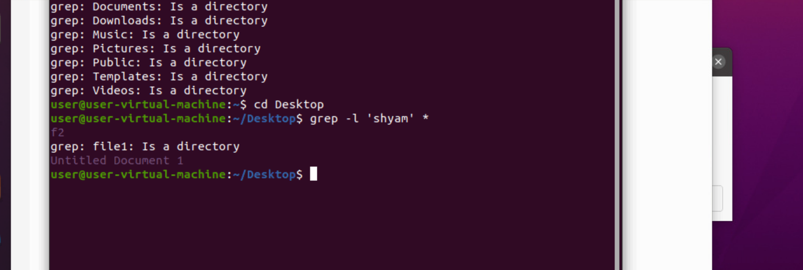
grep -l ‘word’ filename: it will show the directory or files which string contains
grep -w: use ignore the sub string of an a string

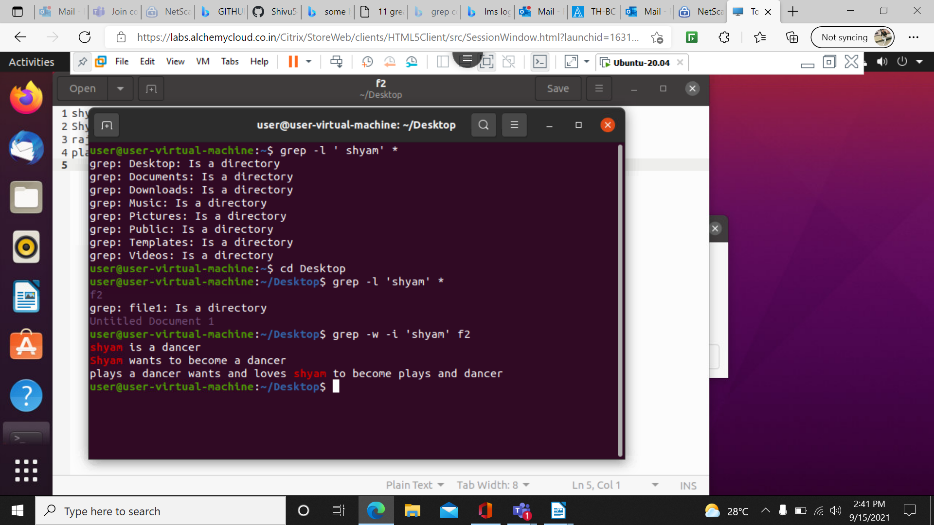

grep -o : it will print matching pattern of the string not sub string and not a whole string

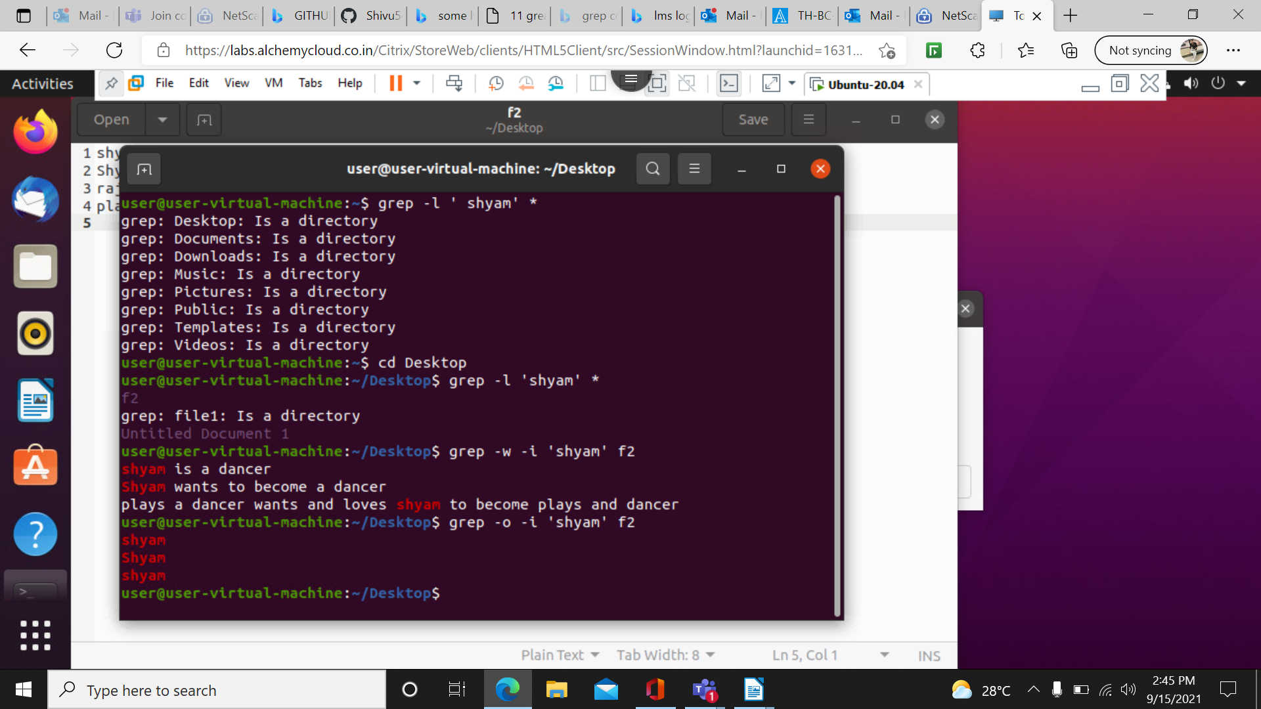

grep -oiw: this will print matching pattern and ignore case sensitive and it will not print sub string

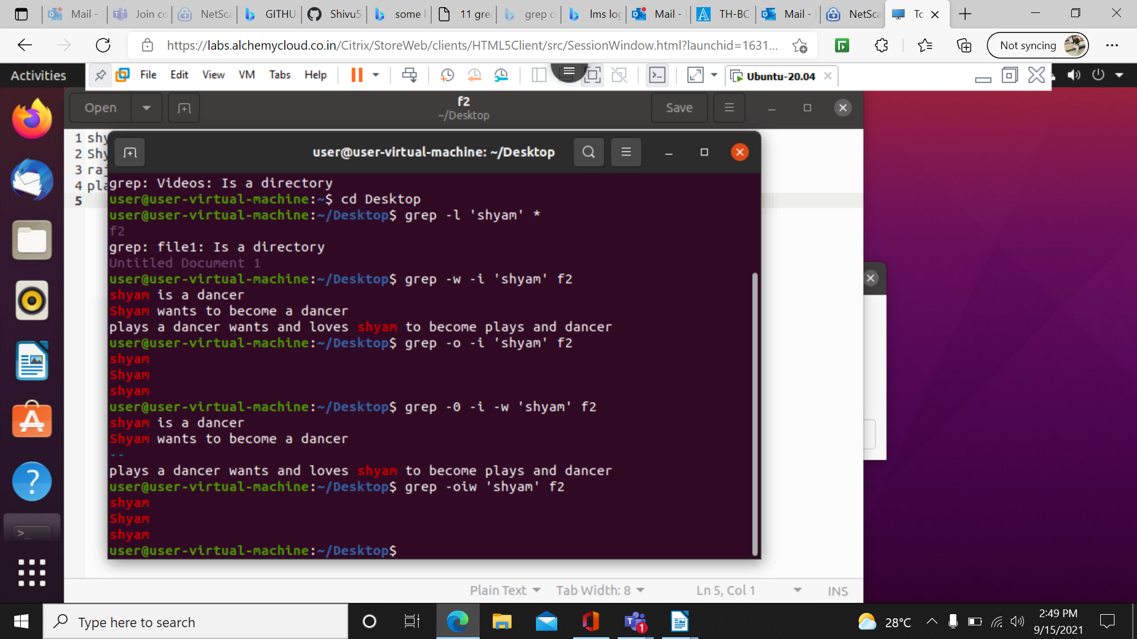
grep -n: it will show the line number of the string

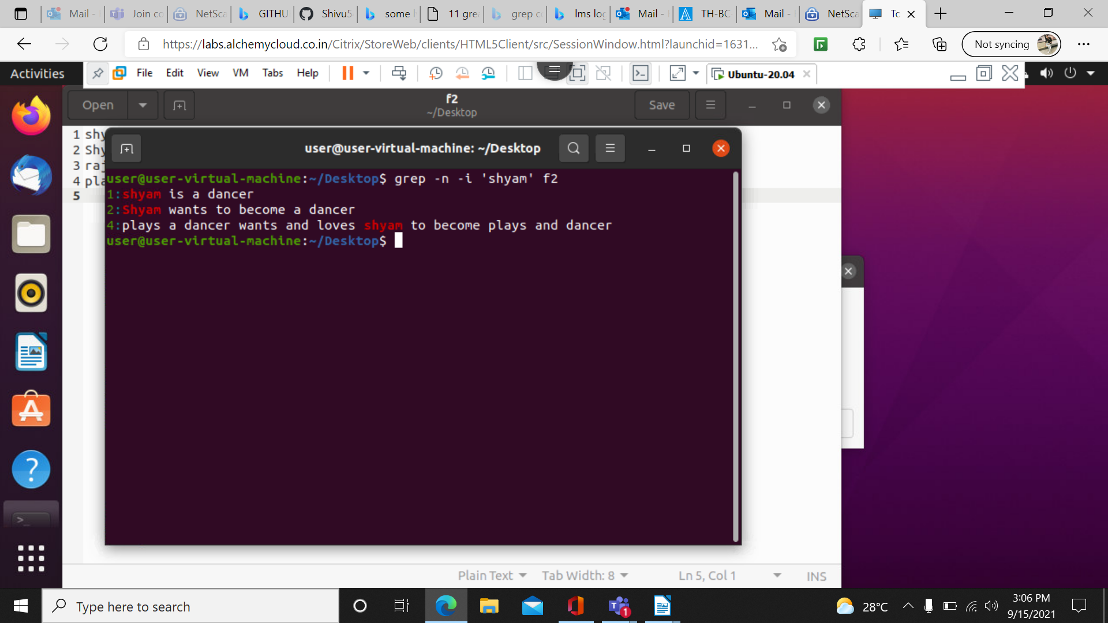
. grep -v -n: it will print whole pattern and line numbers
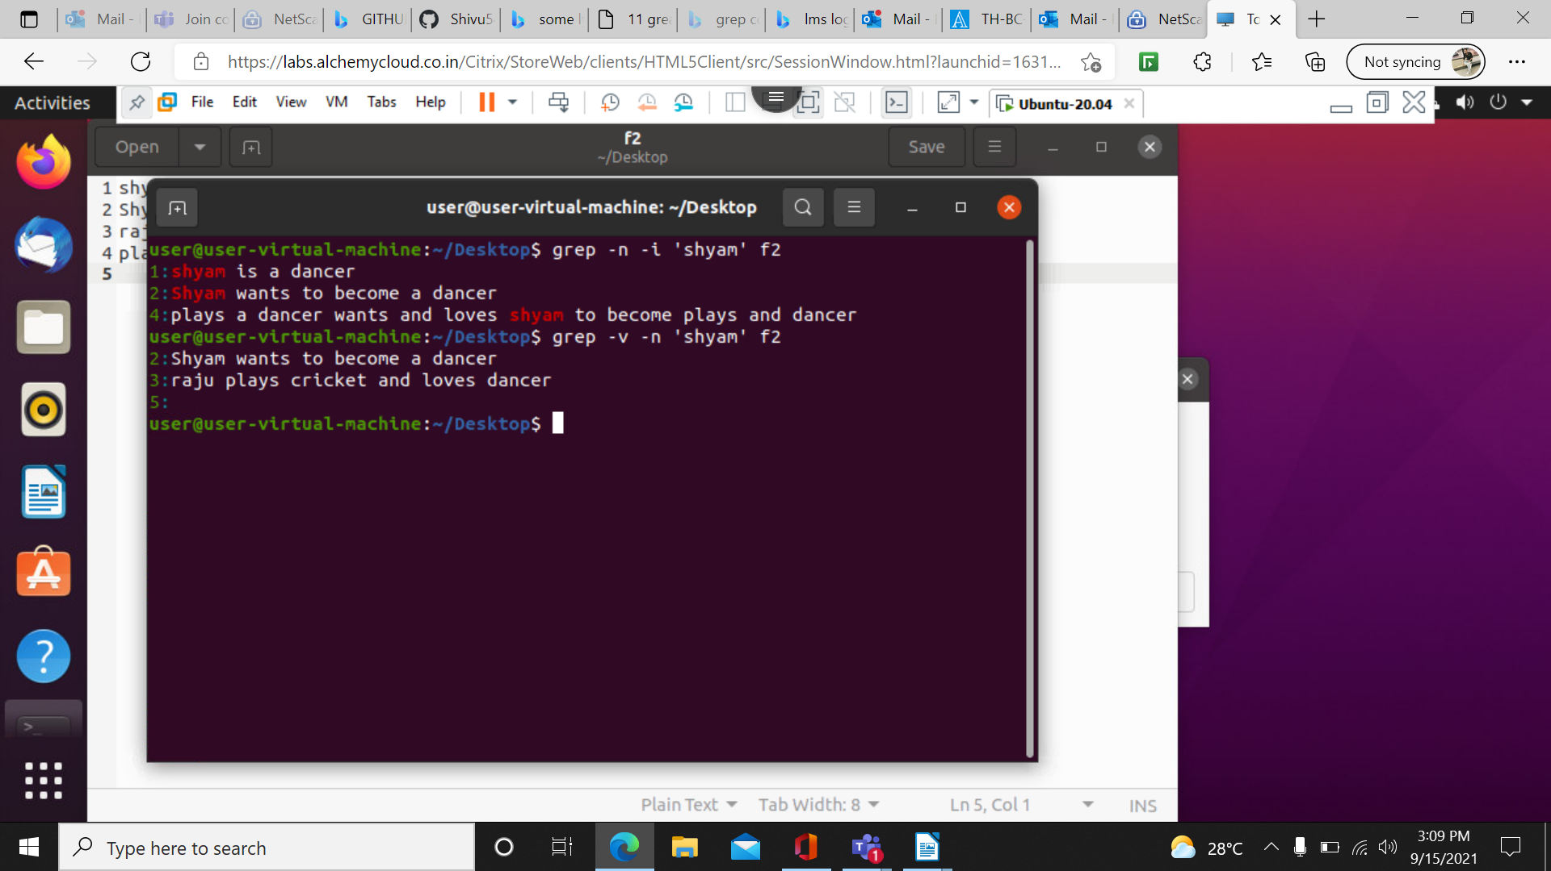
grep -i ‘^shyam’ f1: it will print starting string with it starts

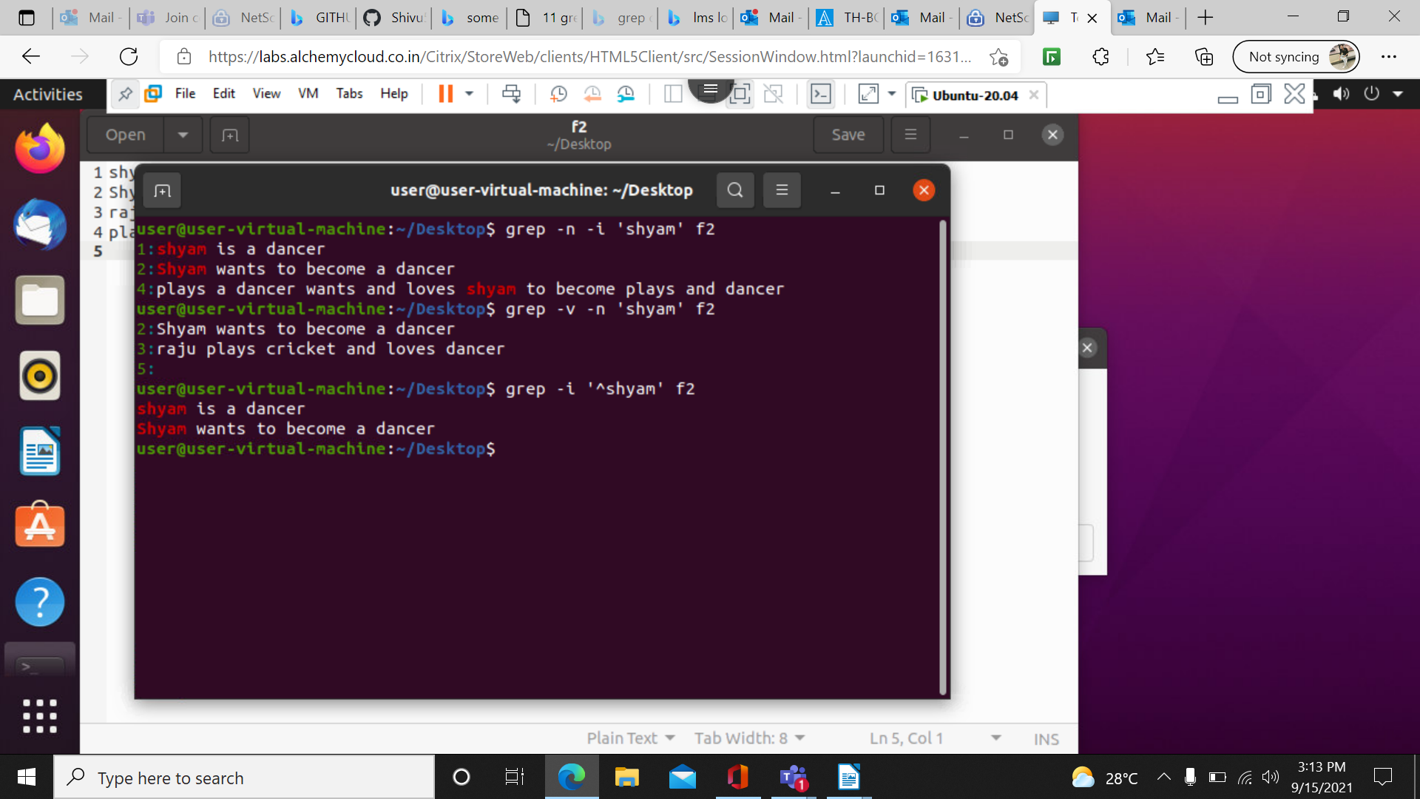
grep -i ‘shyam$’:it will print the string which is ending with the shyam

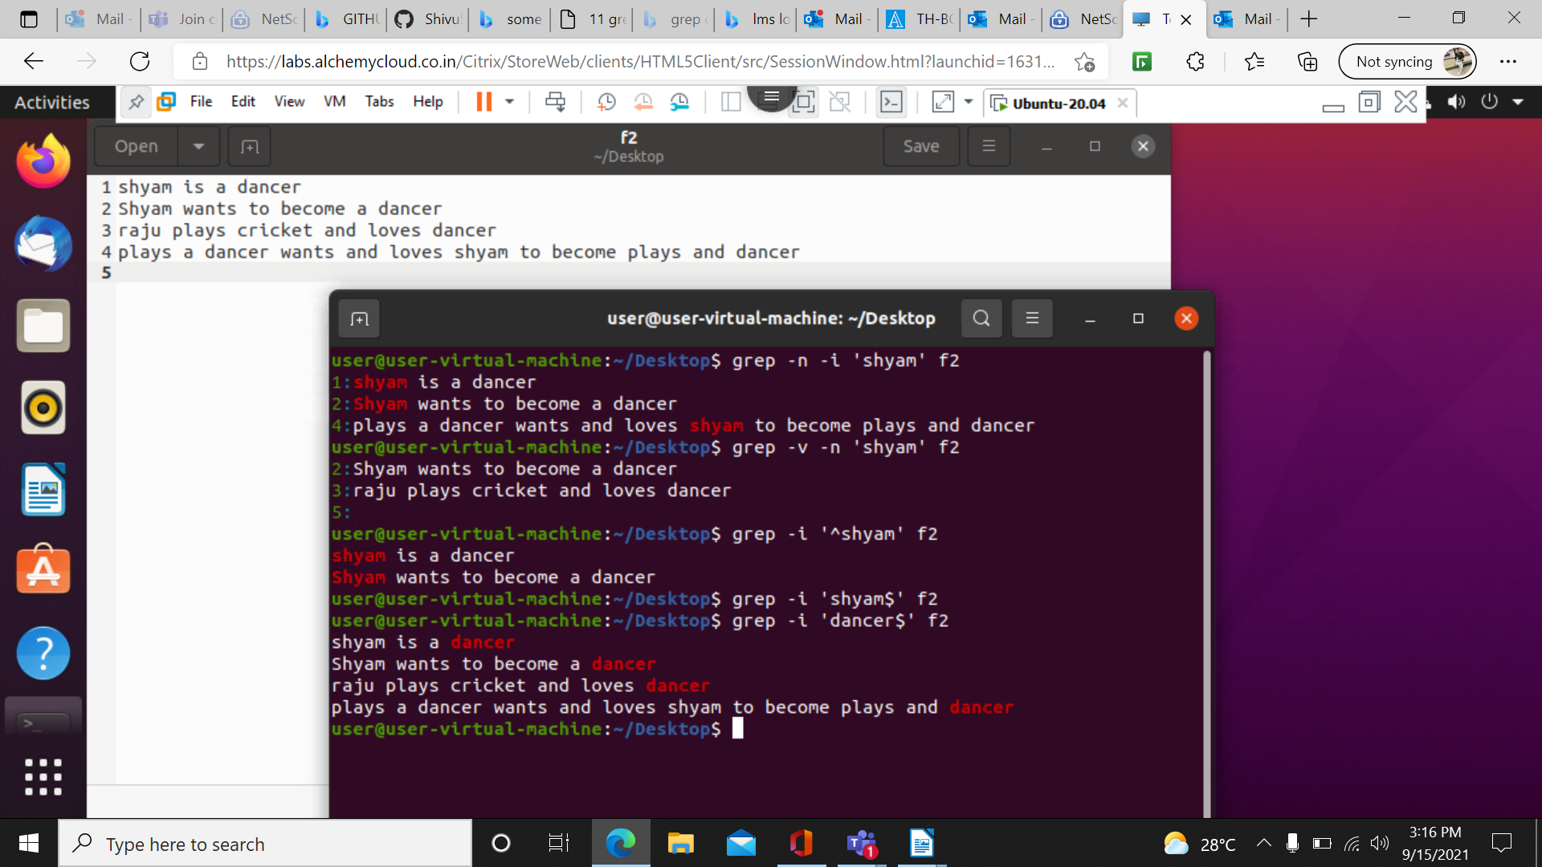

grep -i ‘^os .* os$: this will print both ending staring of the string
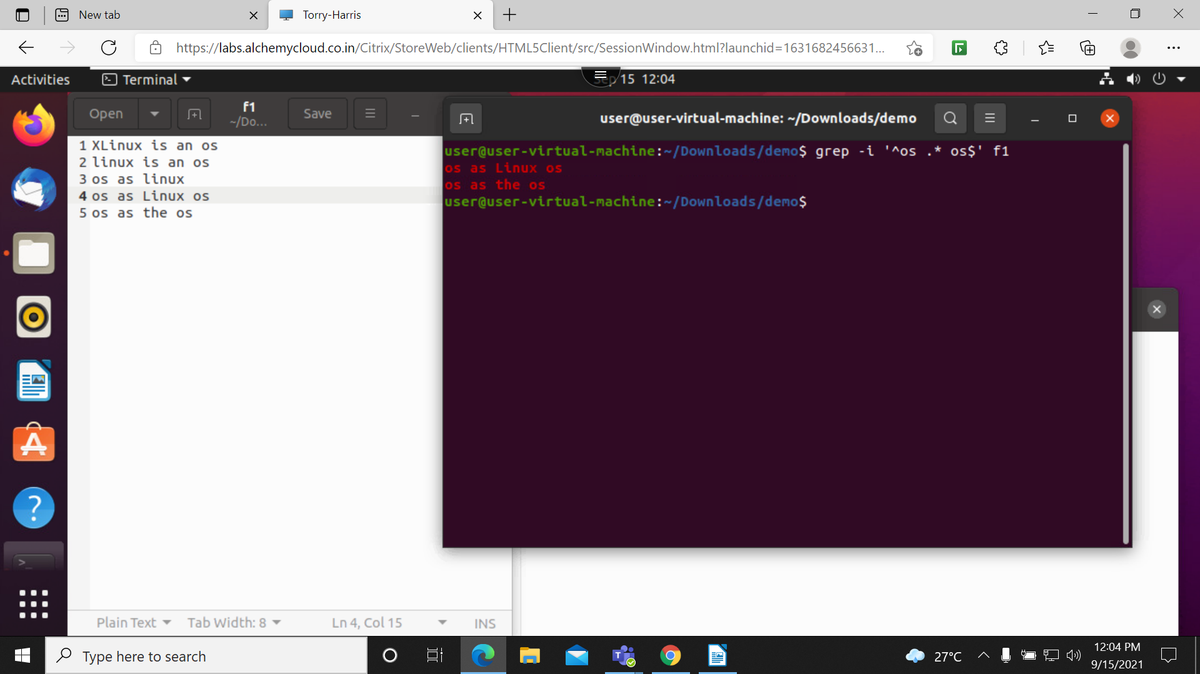

grep -n -i – E ‘^h.p$ : it will print the string which is starting from h and ending from p with character one space

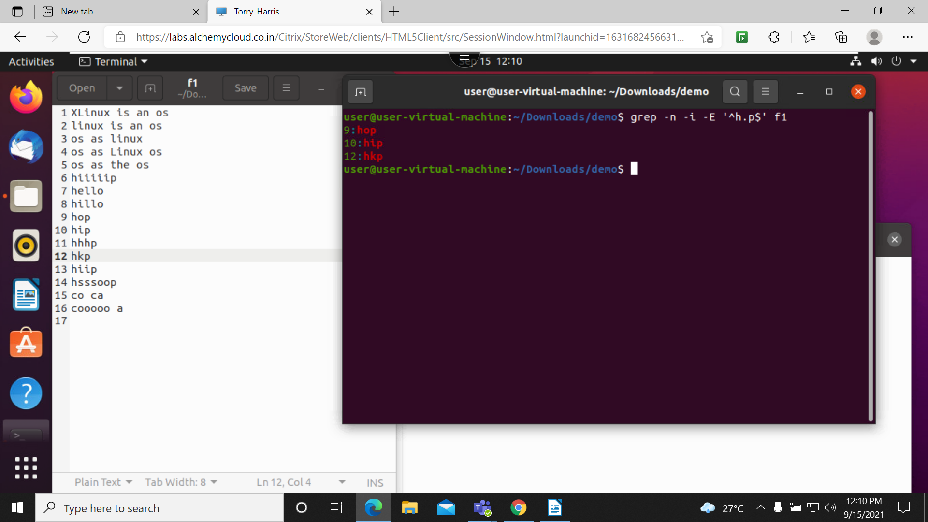

grep -n -i -E ‘^h[i]p$: it will print the occurrence of I in the 2nd string either one or more occurrences

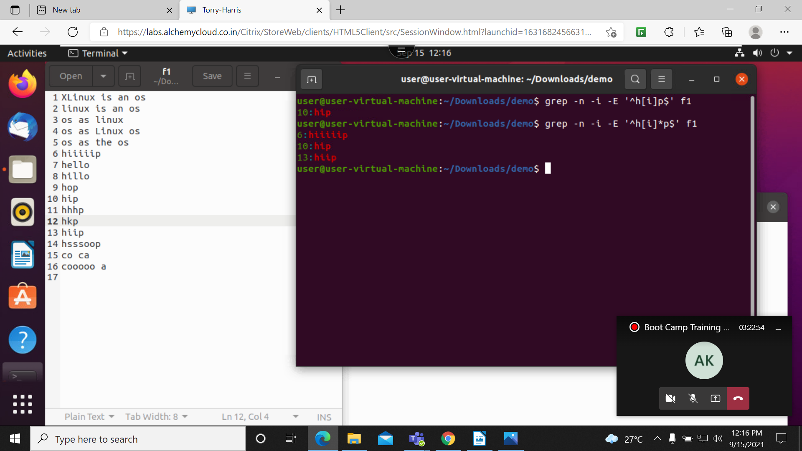
grep -n -i -E ‘^h.*p$: it will print all the strings which is start from h to p

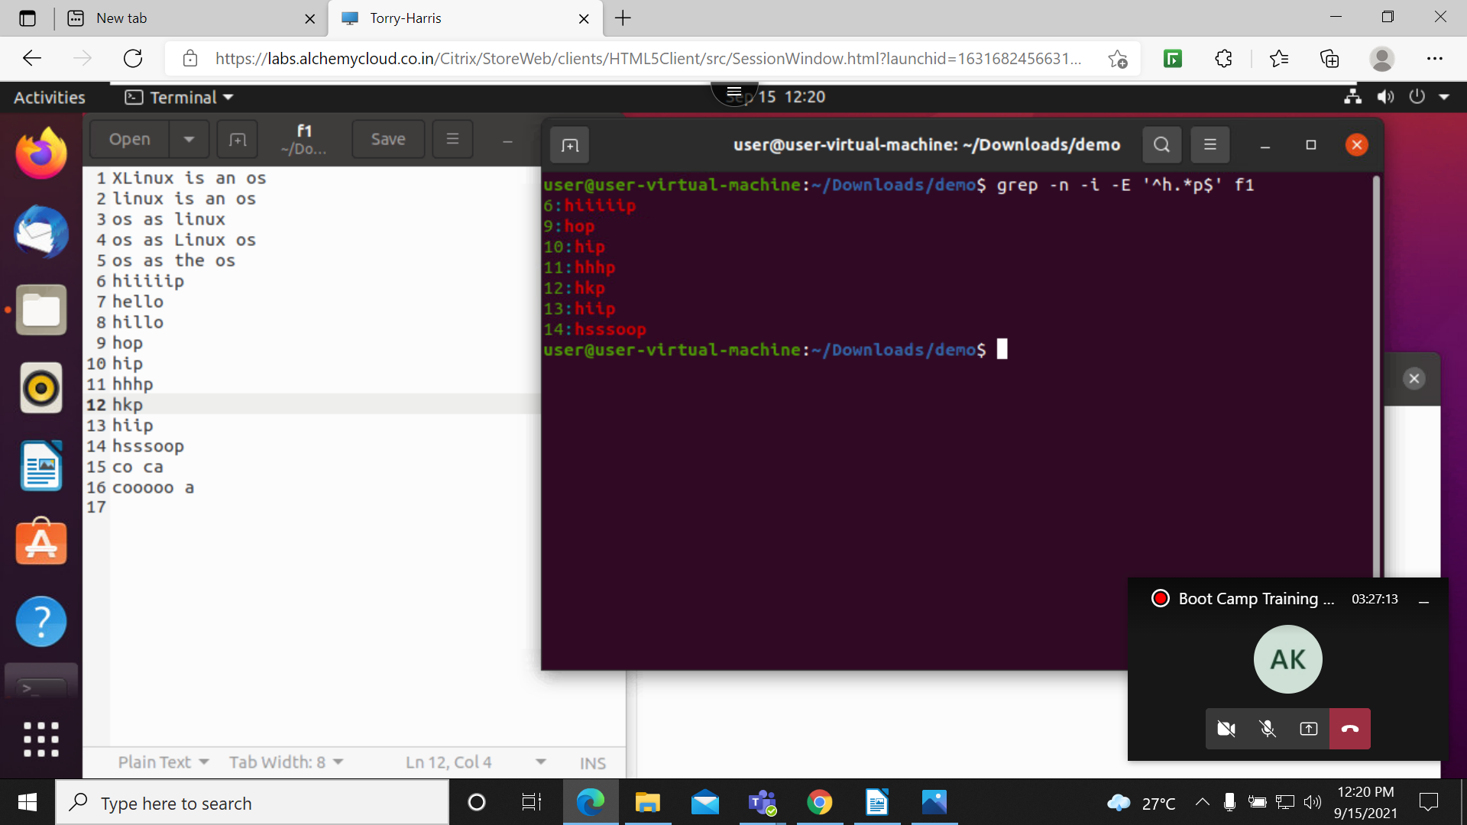
grep -n -i -E ‘^h[el]+o$: this will print all the string which contain el in between the string

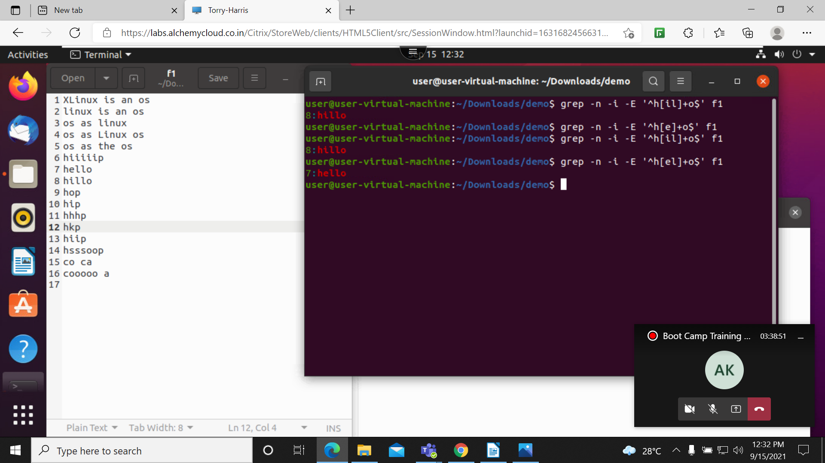
cut -c 1 a: it will print all the items in 1st column

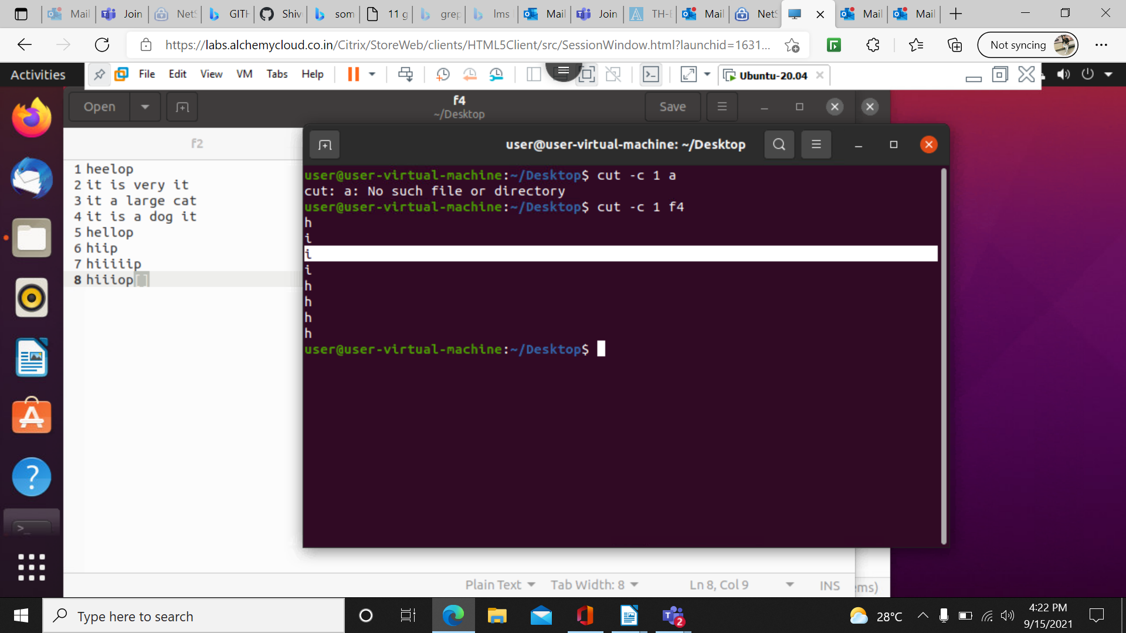
cut c 1 it will print colums from 1-3
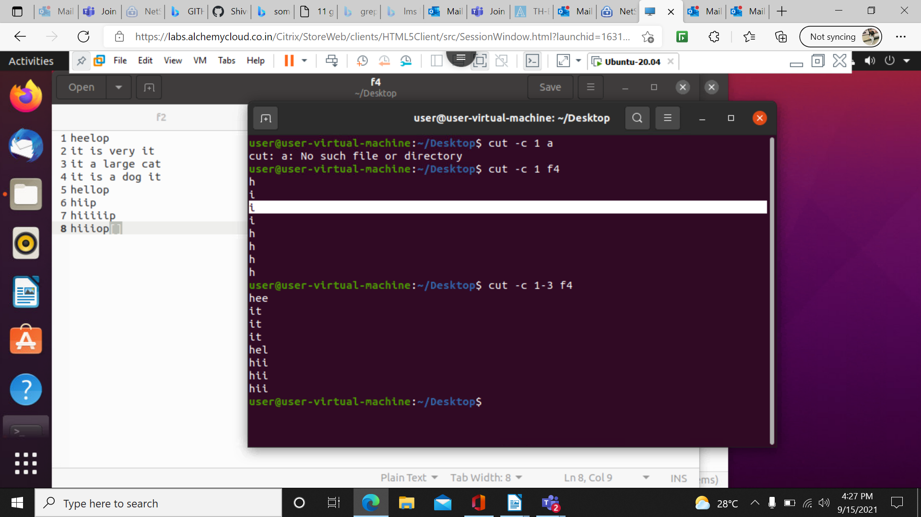
$ cut – c 2- f4 : it will print from column 2

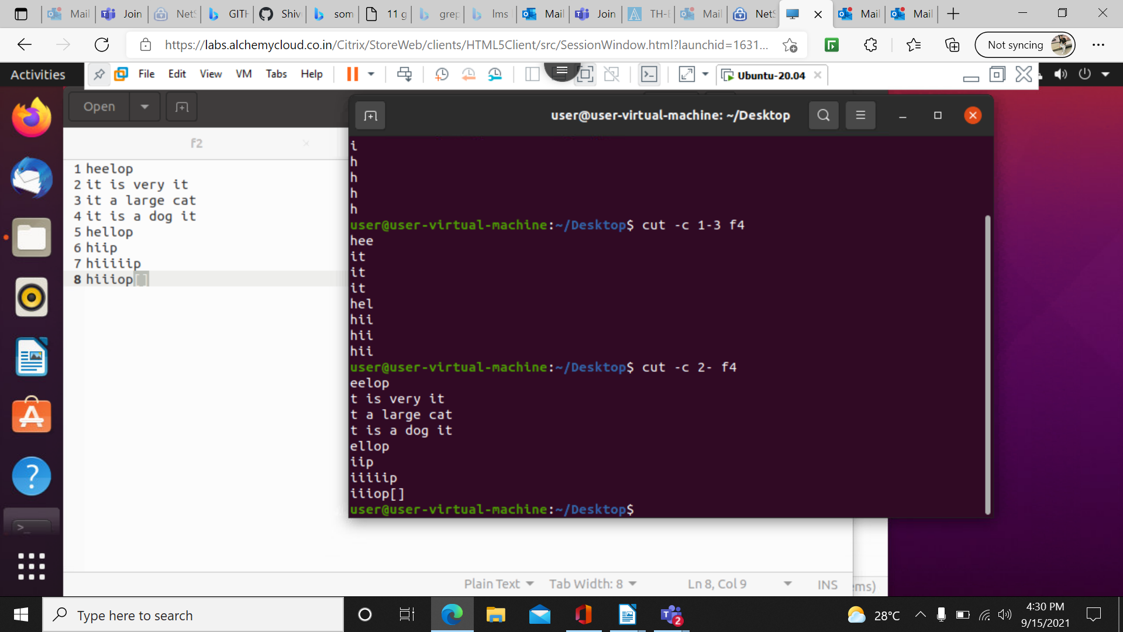
cut -d ‘t’ -f 1 f4: it will eliminate from t

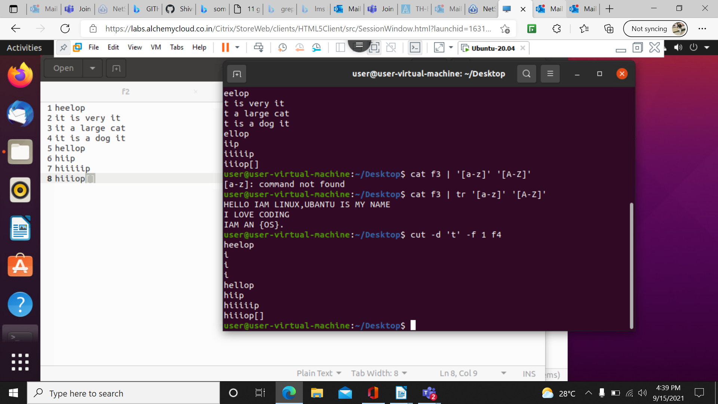

cut –complement -c 2,3 f4 : it will print all the colums except 2 and 3 colums in the f4 file

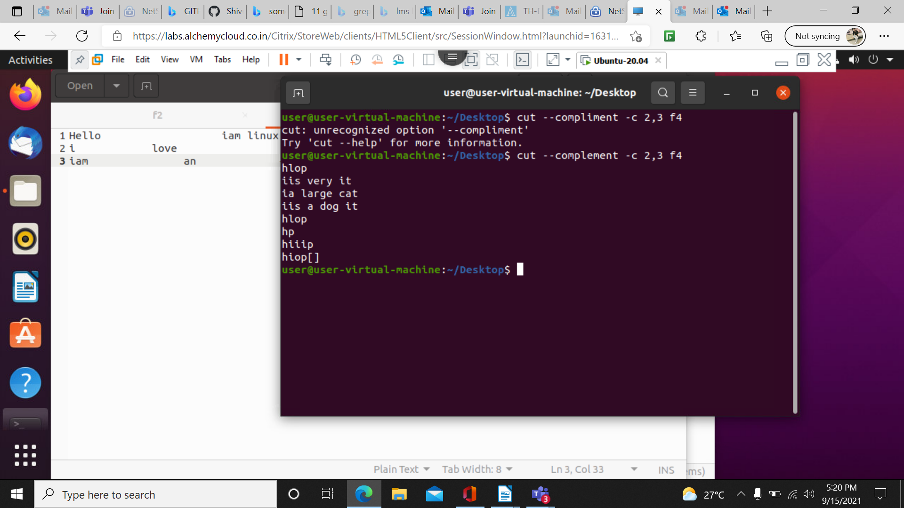

cut -d “ “ -f 1,2 f3 –output-delimiter=’%’ : here cut command changes delimiter(%) in the standard output between the fields which is specified by using -f option

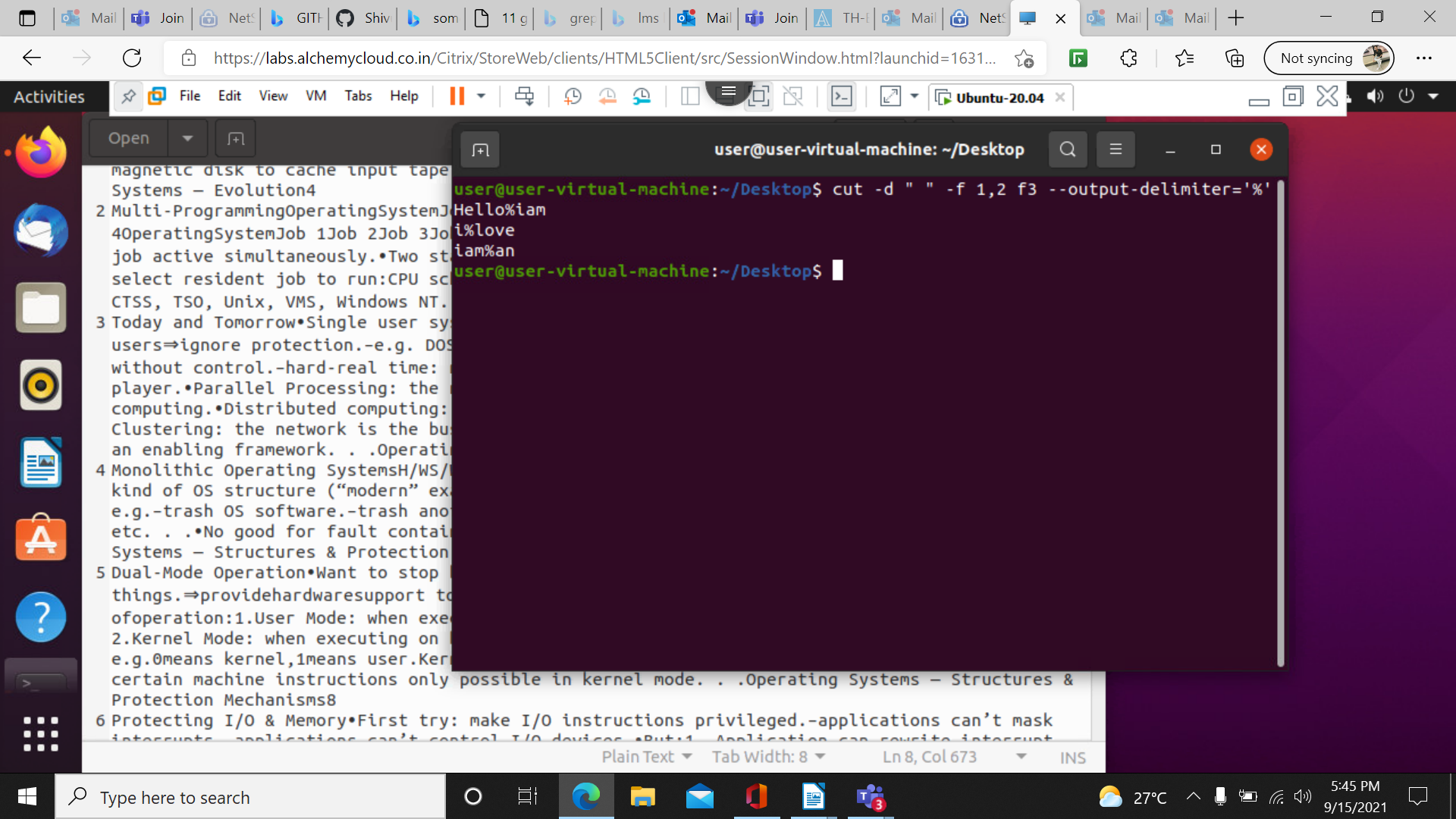
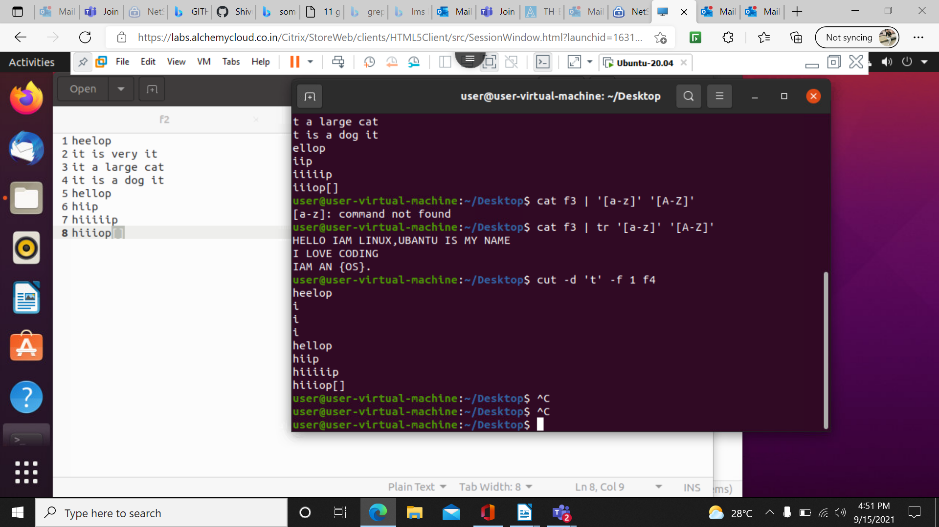
cat f3 | tr ‘[a-z]’ ‘[A-Z]’ ; it converts it from lower to upper

cat f3 | tr ‘[H]’ ‘[o]’ : here in the file f3 h letter is repalced by o

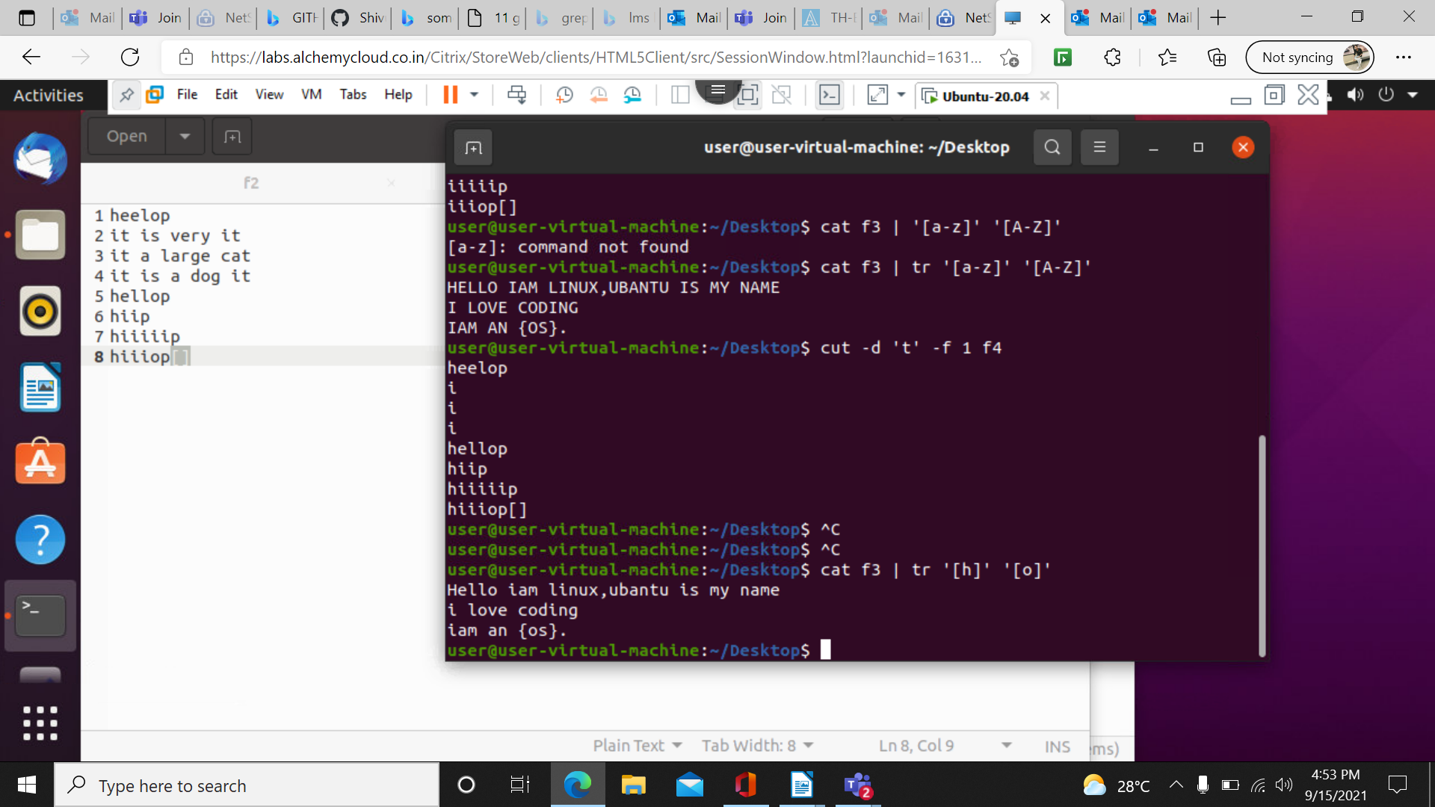

cat f3 | tr -s [:space:]’ ‘ ; to remove extra spacs in the file

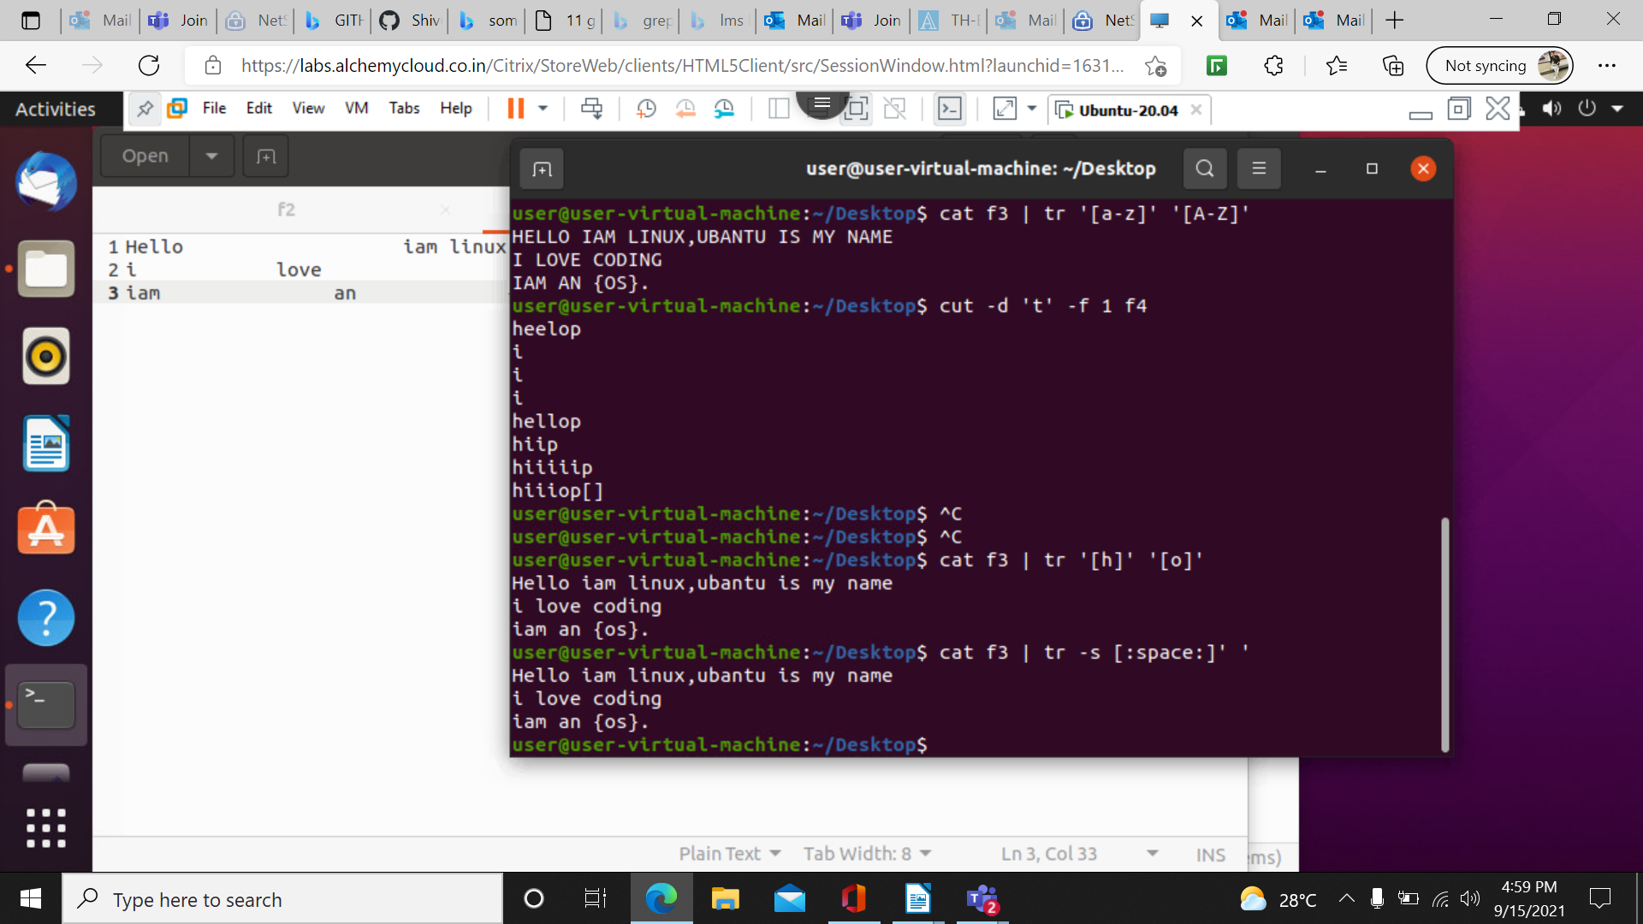

cat f3 | tr -d ‘[hel]’ : it wil delete the el from the file f3

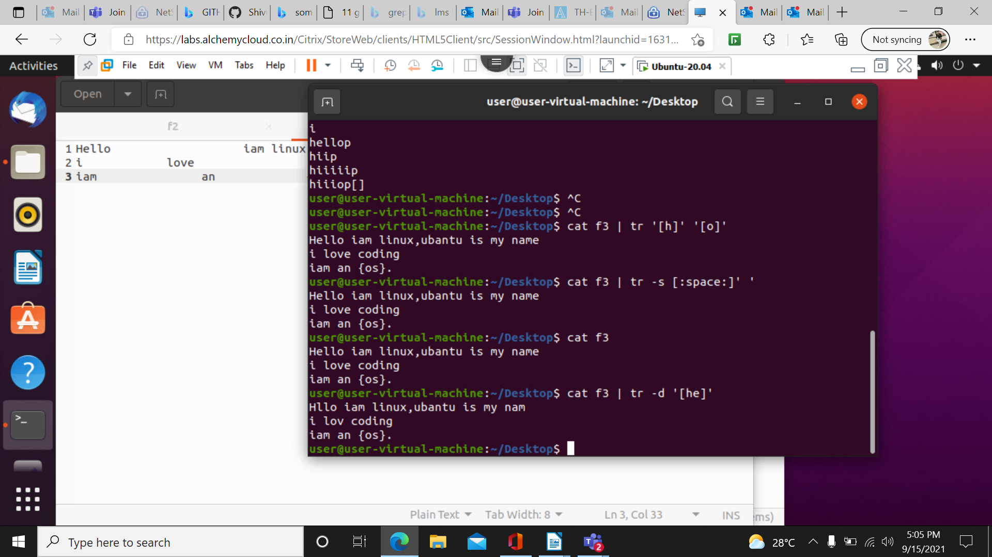

more filename : it is used to dipaly the content of large files.rather cat do the same but it is reliable to use the more when it comes to large data files

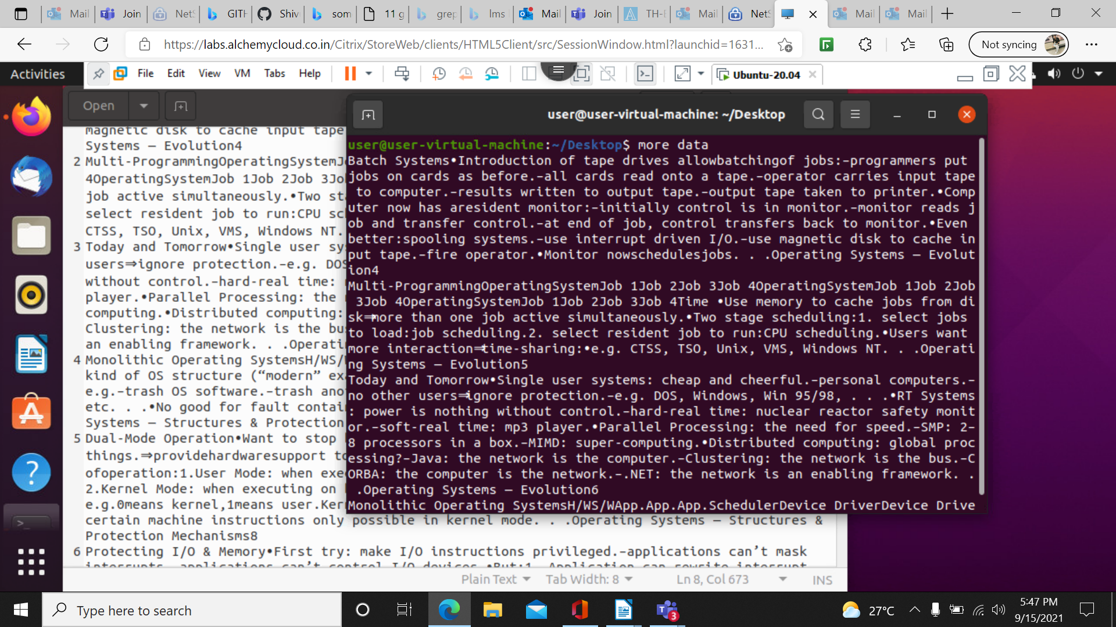

more -d data :it displays user message at right corner
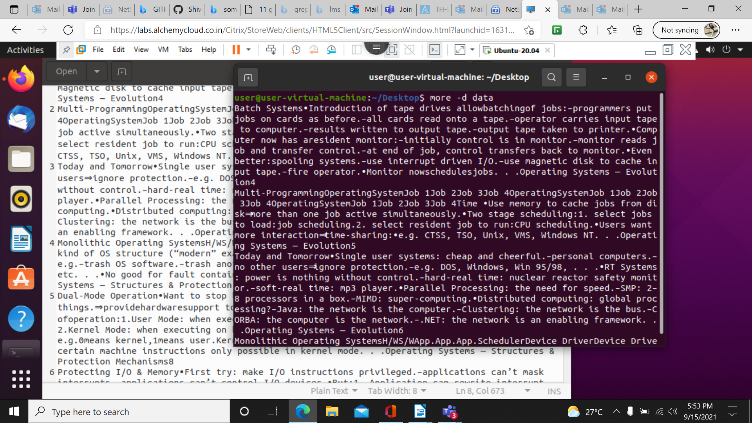

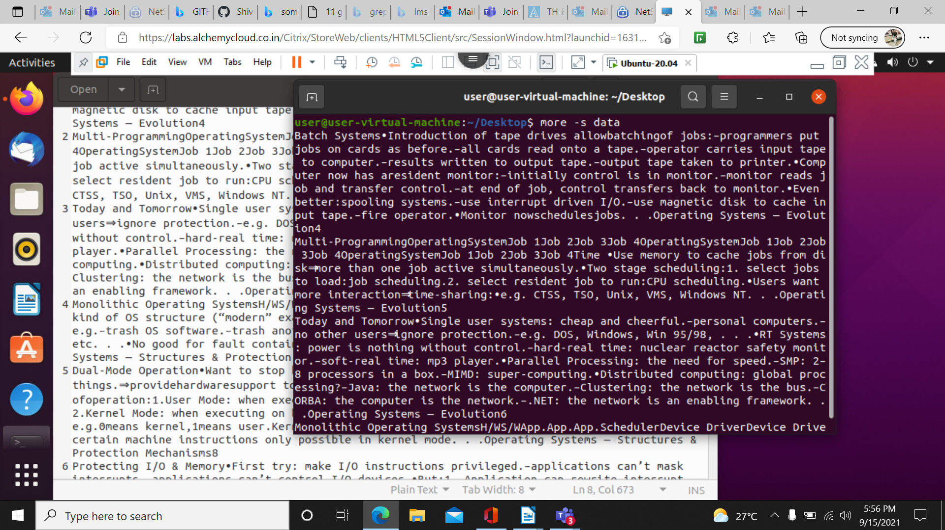
more -s filename : it squuezzes the blanks

