1) pwd command : It prints the path of working directory
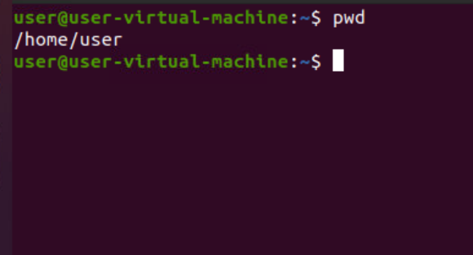
2) ls command : this command allows you to view a list of files and folders in a given directory.
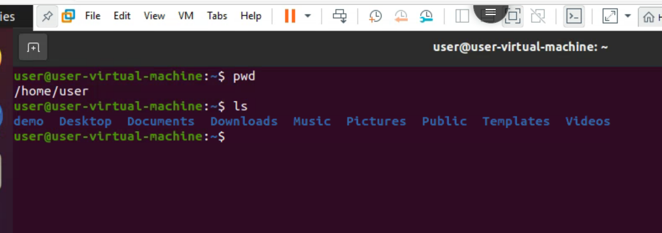

3) clear command : This command allows you to clear the whole screen
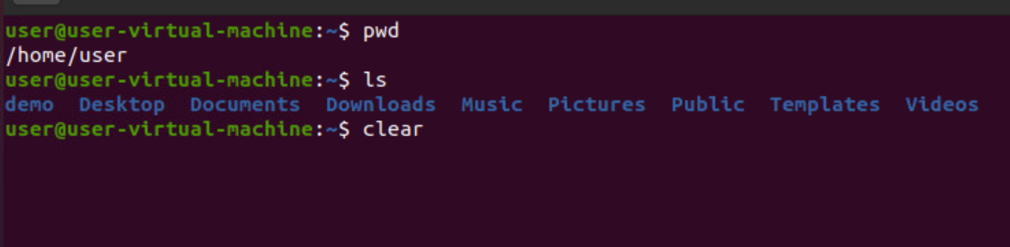
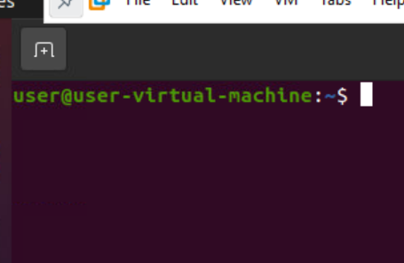

4) ls -l command : it will show the description about list of files in a directory
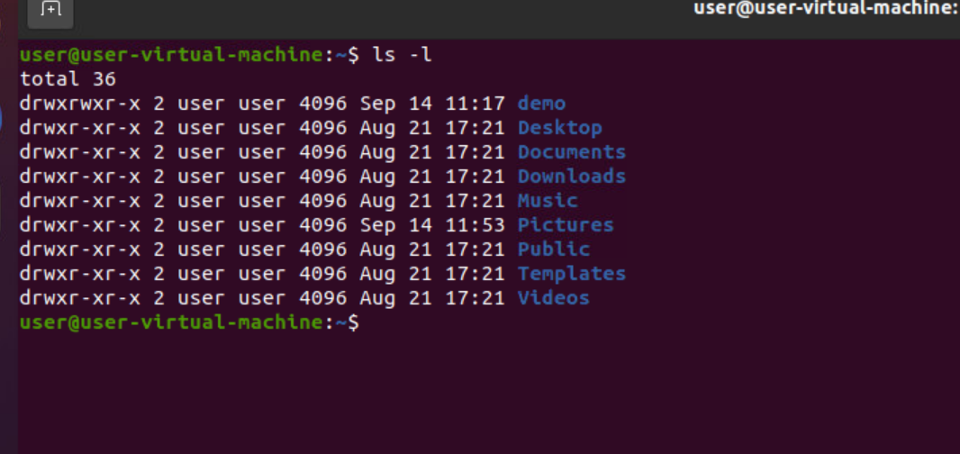

5) ls -A command : the ls -A command is displays all folders except hidden files
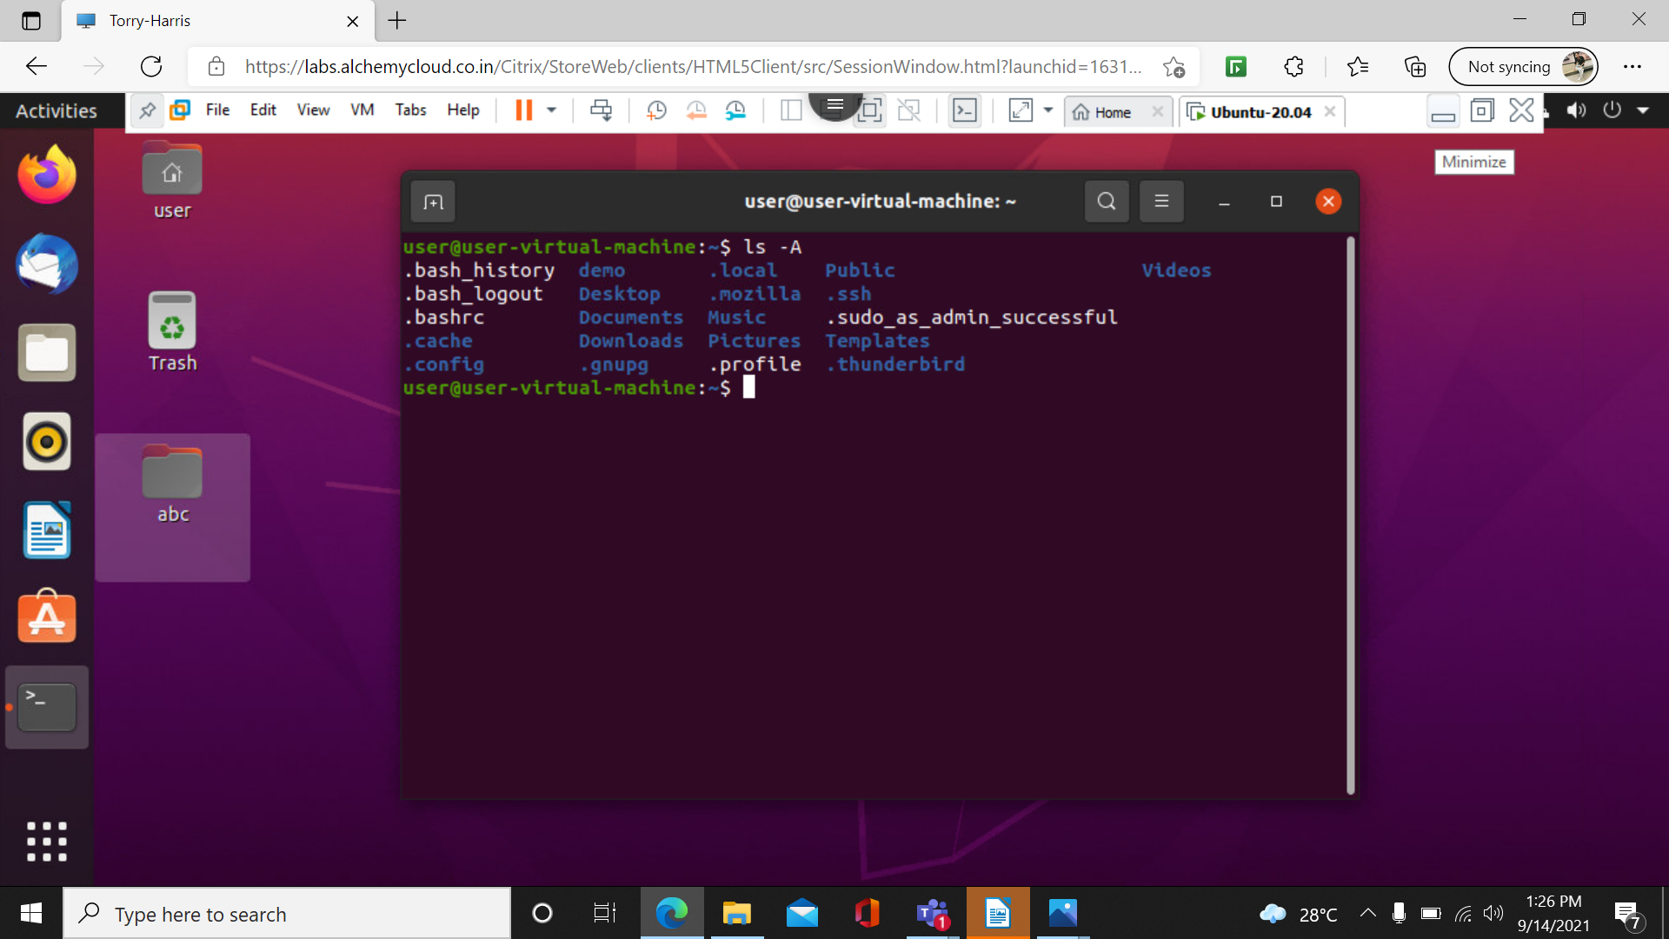

6) cd command : this cd command is used to change the current director
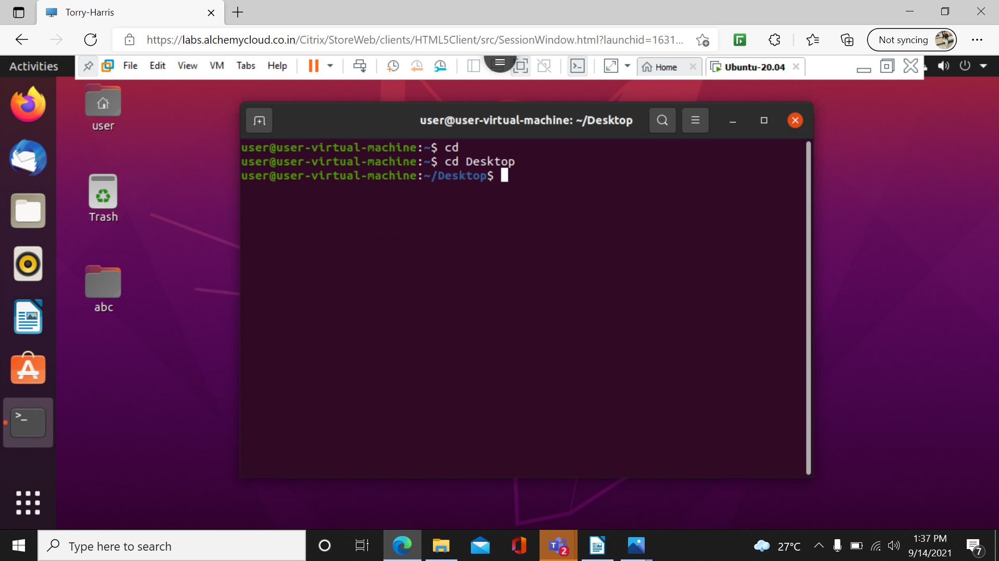

7) cd / command : the cd / command is used to move to root directory
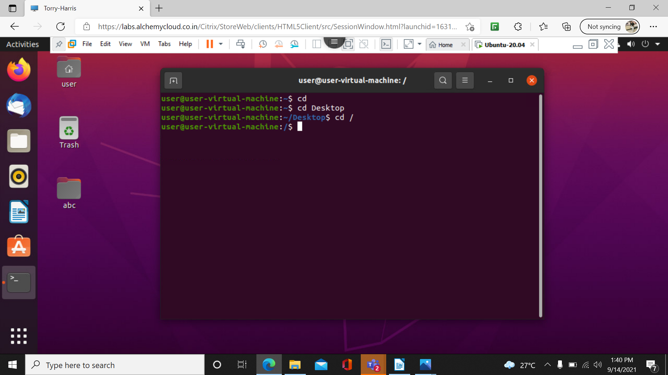

8) cd.. command : the cd .. command is used to move backward
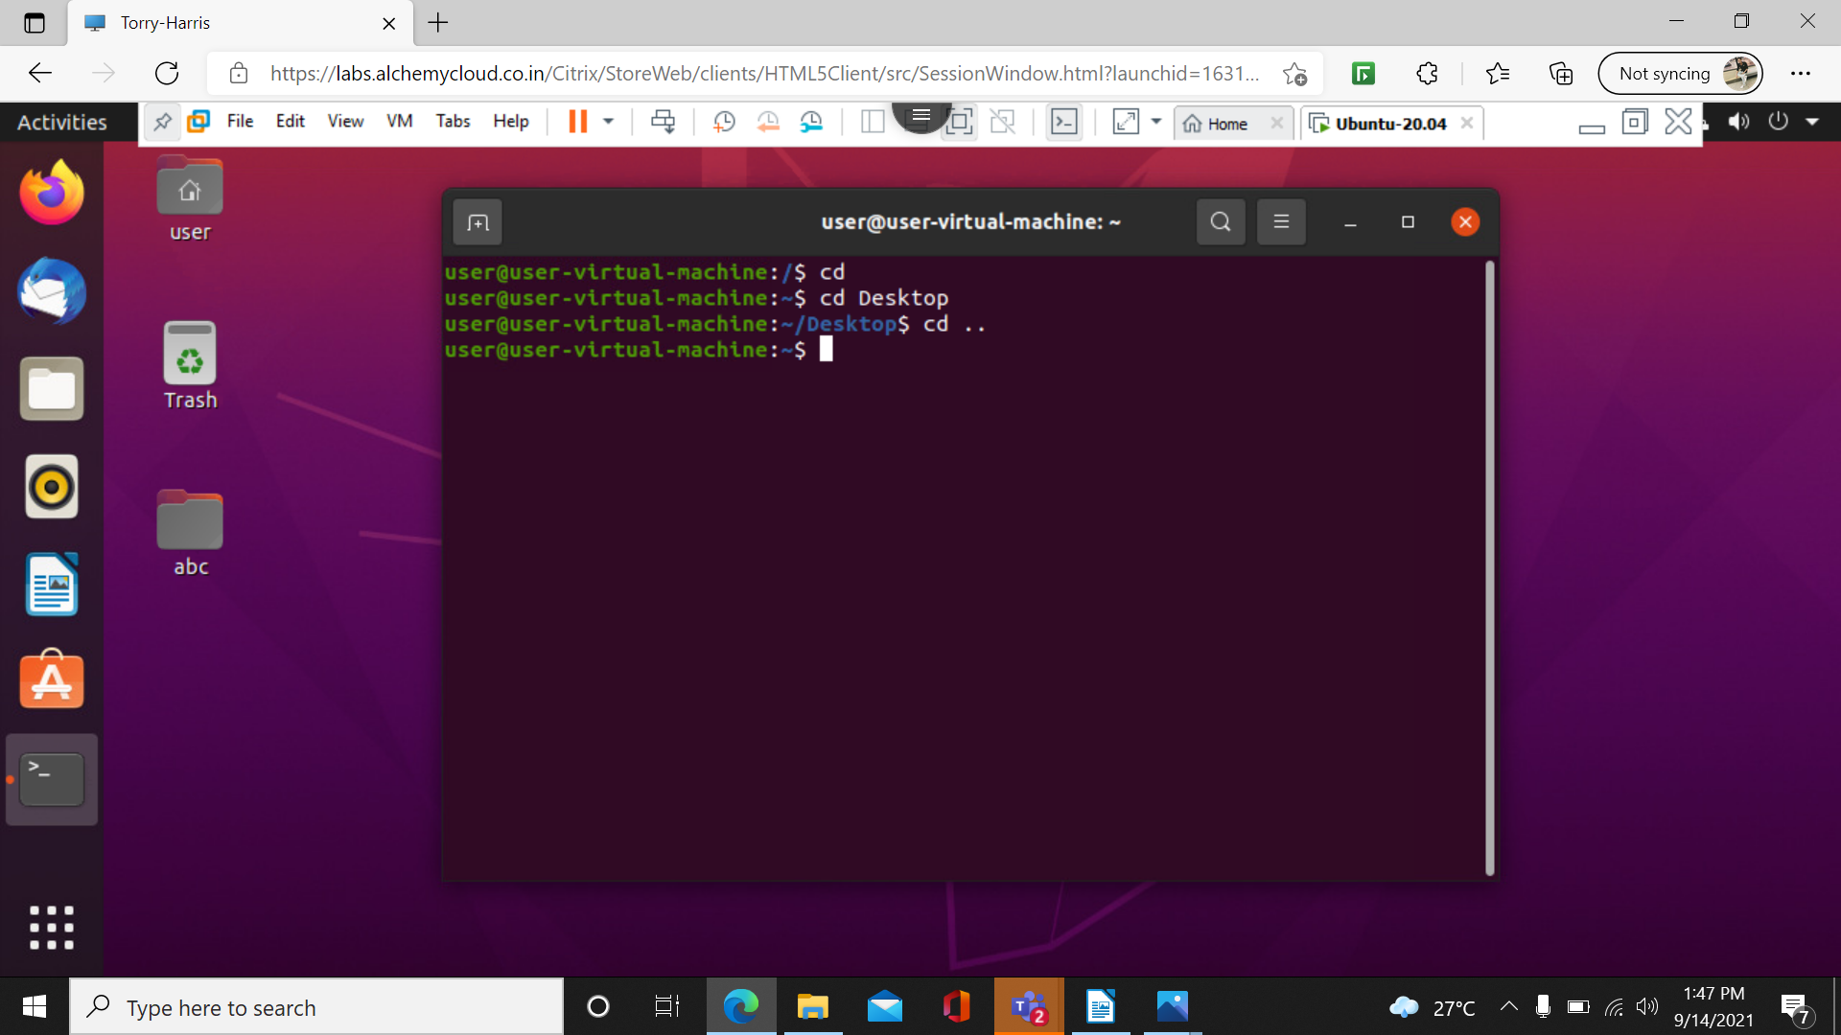

9) cd ~ command : ~ is used to navigate back to the home directory from any other directory.

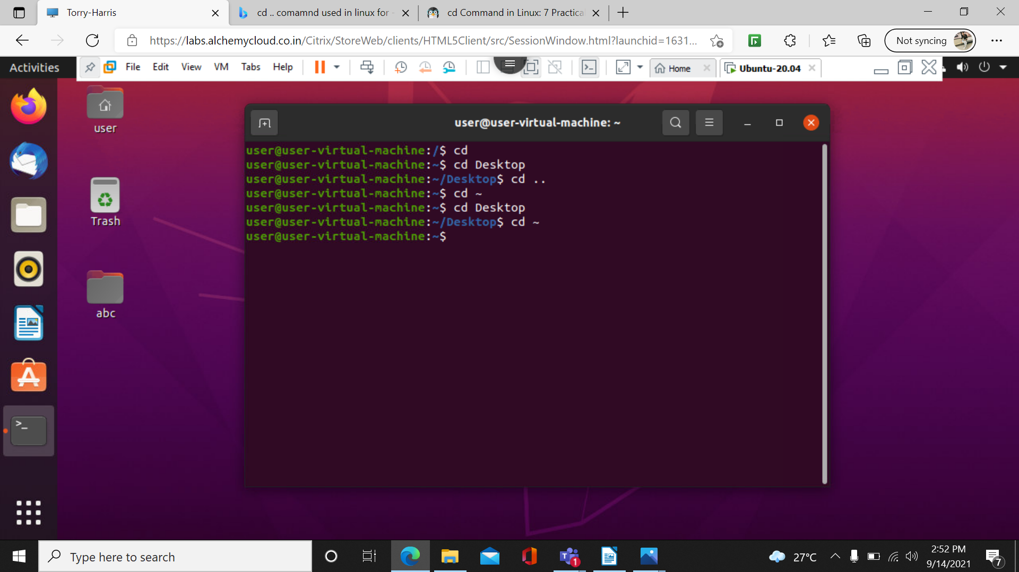

10) ls -f
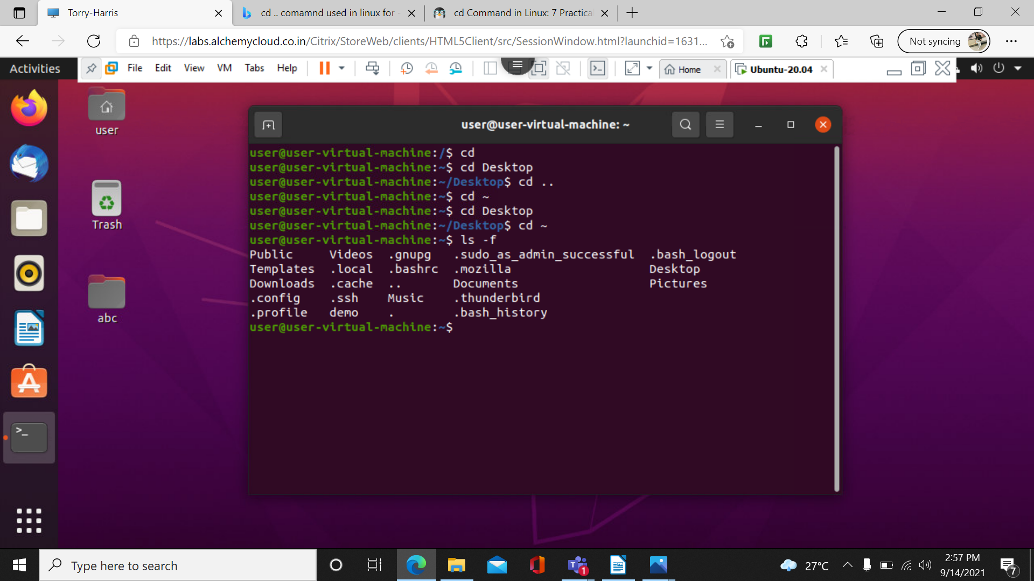

the ls -f list all the folders without formal
11) exit
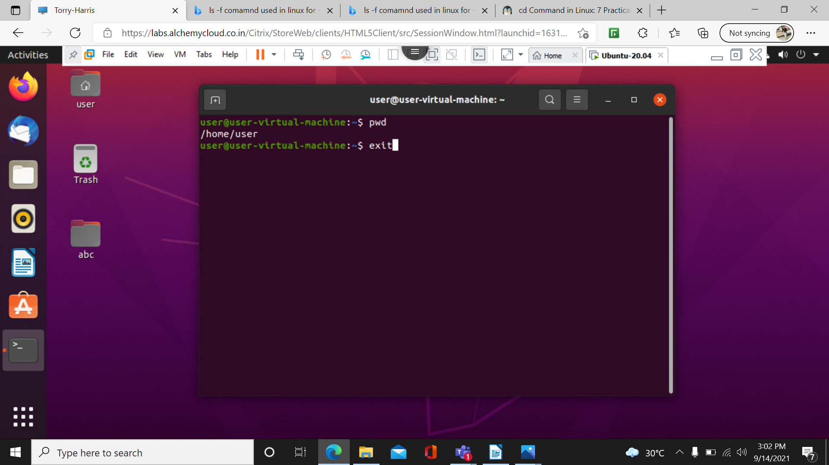

this exit command is used to come out from the terminal

12) cd Desktop/abc command : we can reach into the files by this command

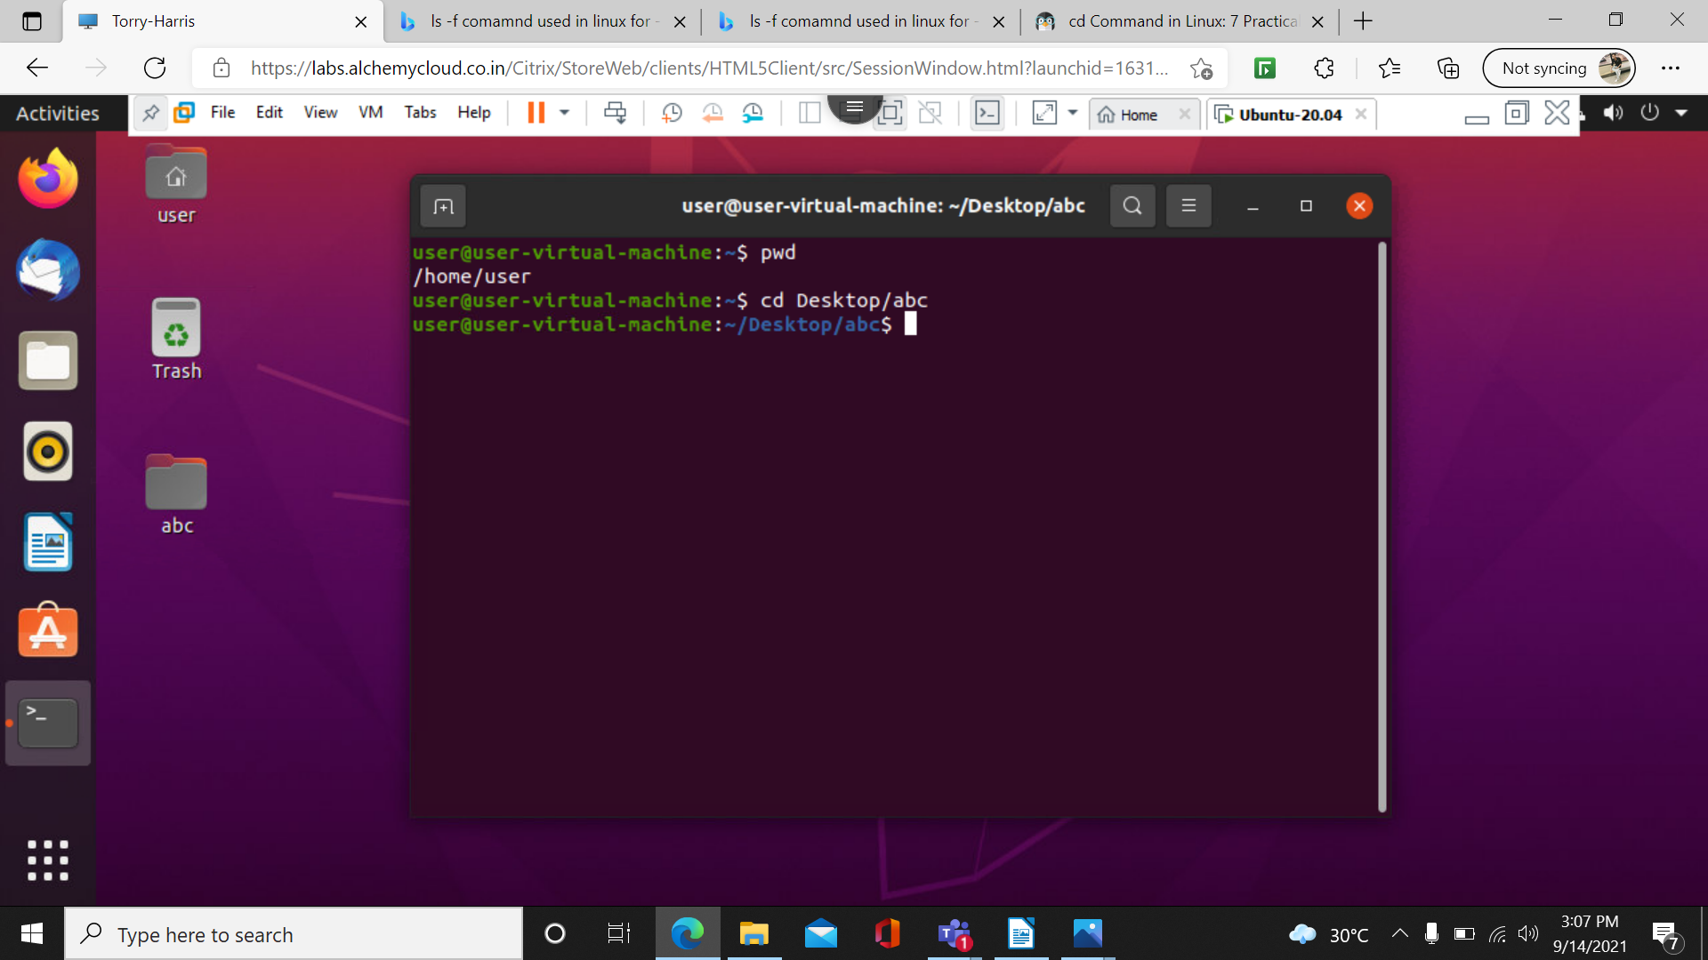

13) cat command : we can read the content of the text file

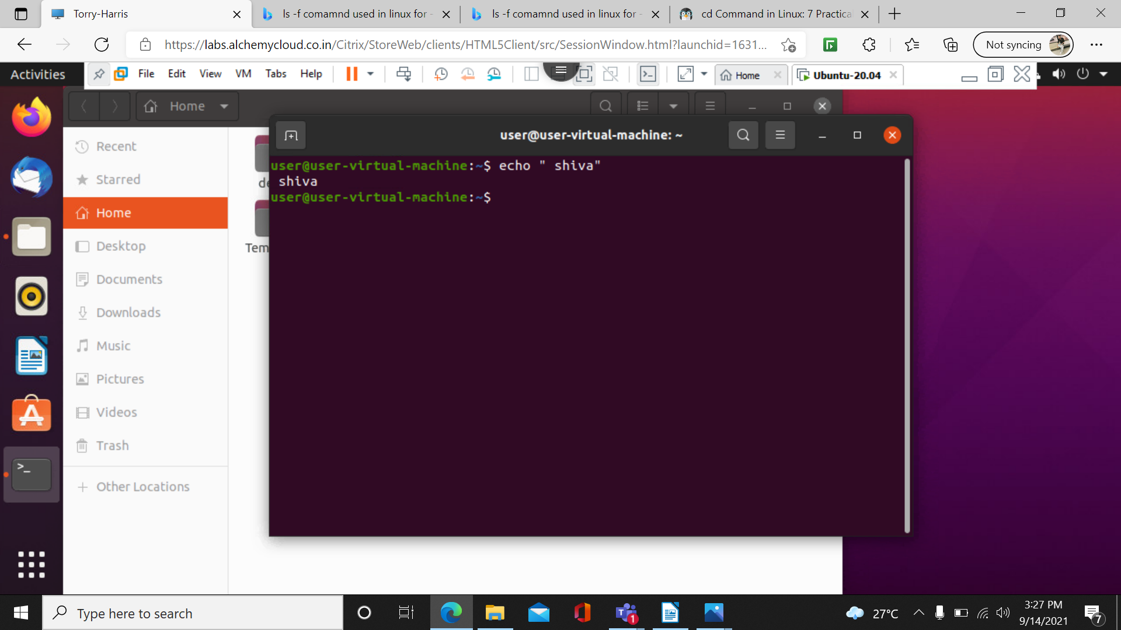
14) echo command : to print something on screen we use echo command

15) mv command : it used to rename as well as for moving files
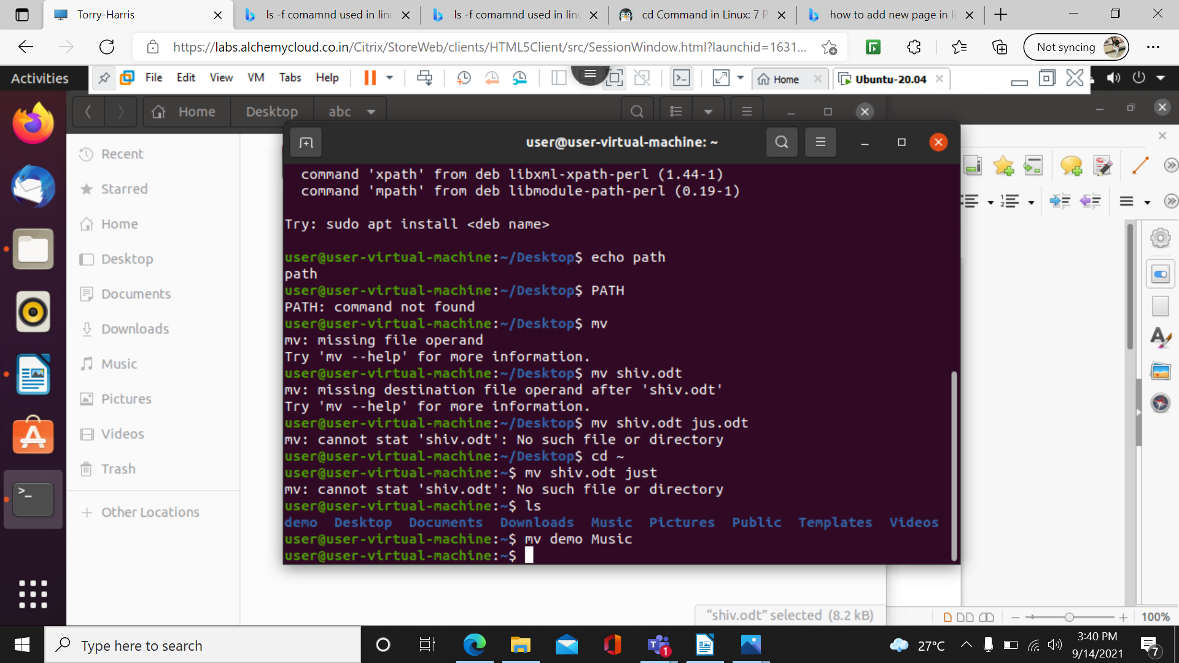

16)mkdir command : is used to make a new directory.
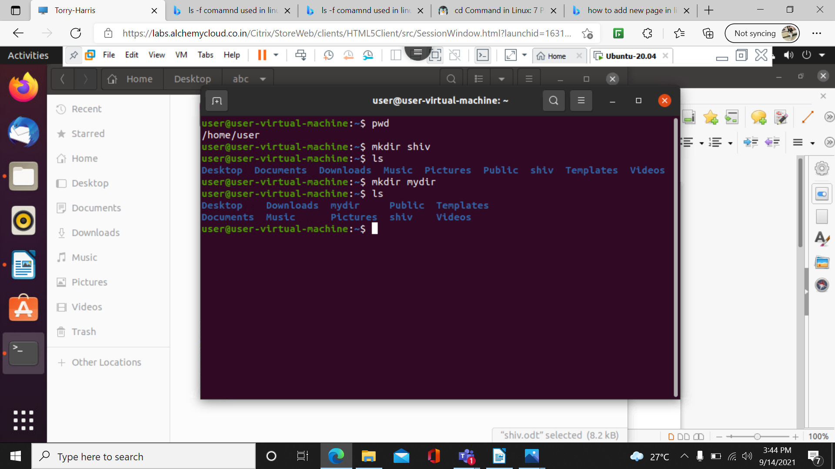

17)rmdir command : it is used to remove the directory
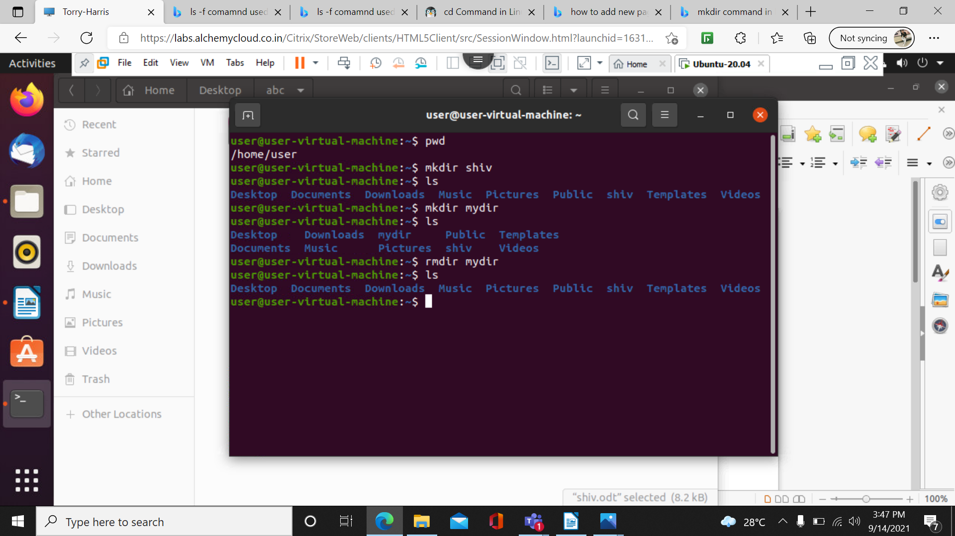

18)who comamnd : this command displays the user and the session
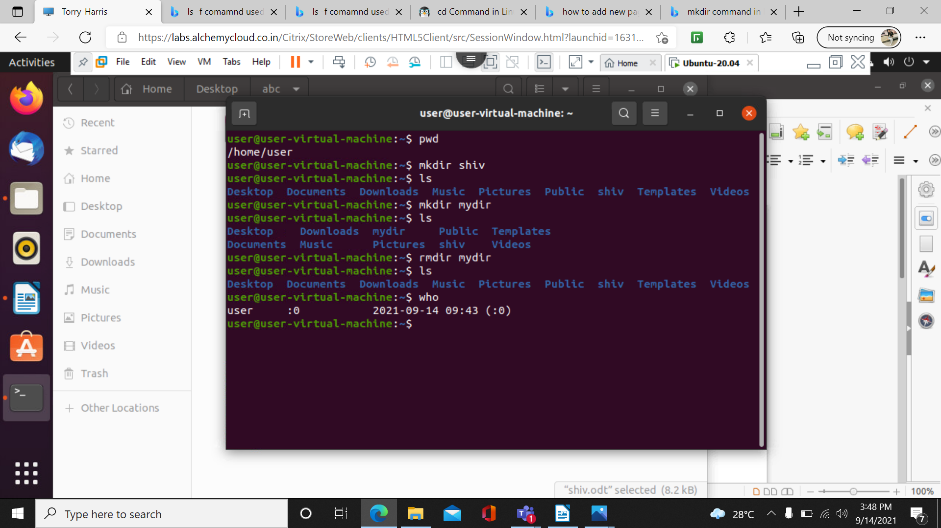

19) date command : it is used to display the date
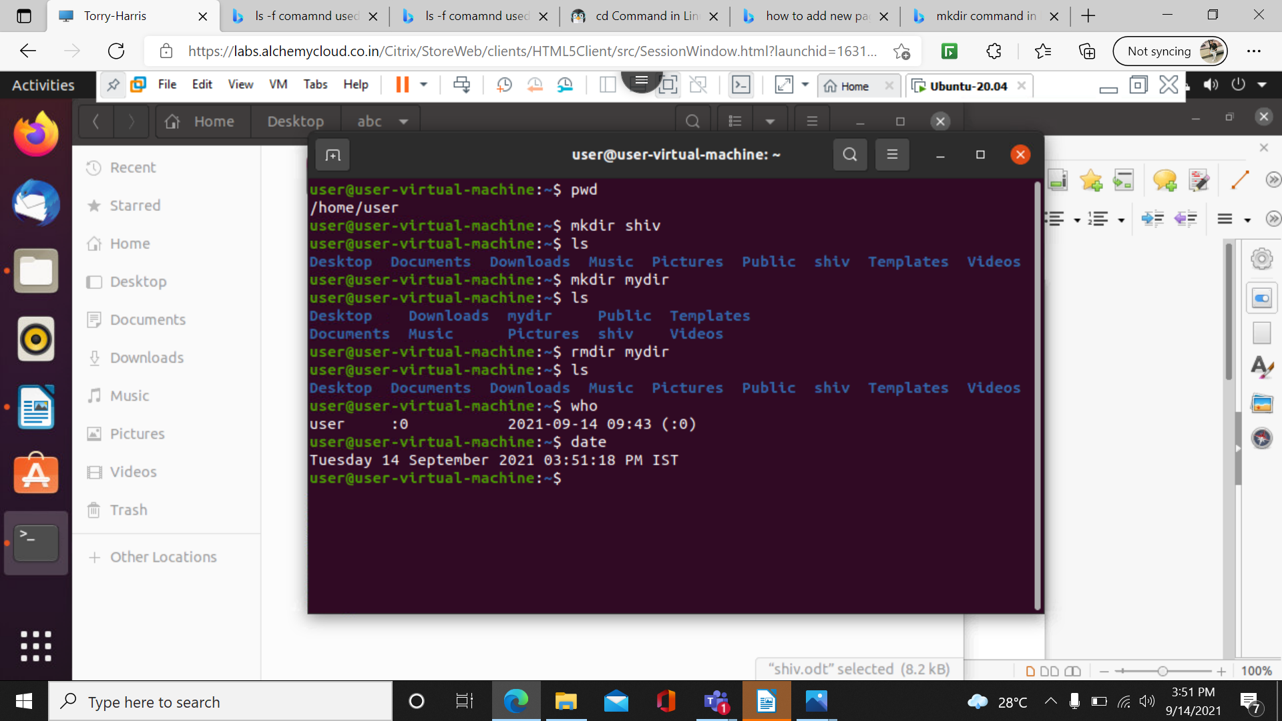

20)cal command : it displays the present calender month

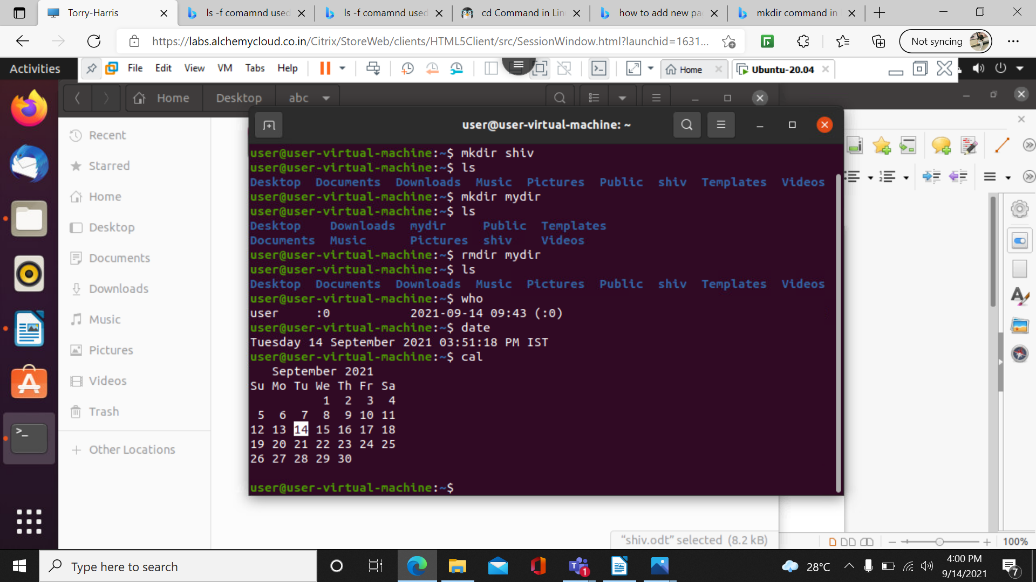

21) touch command :it is used to create a file without any contient.
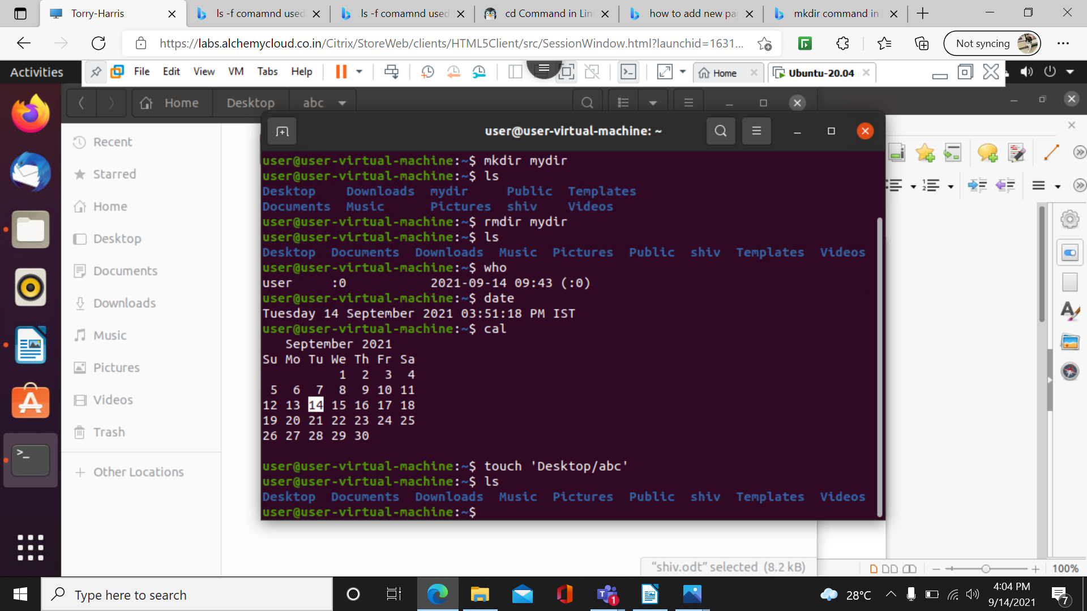

21)mkdir -p a/s/d/f/g/h/ : it creates the files inside the files
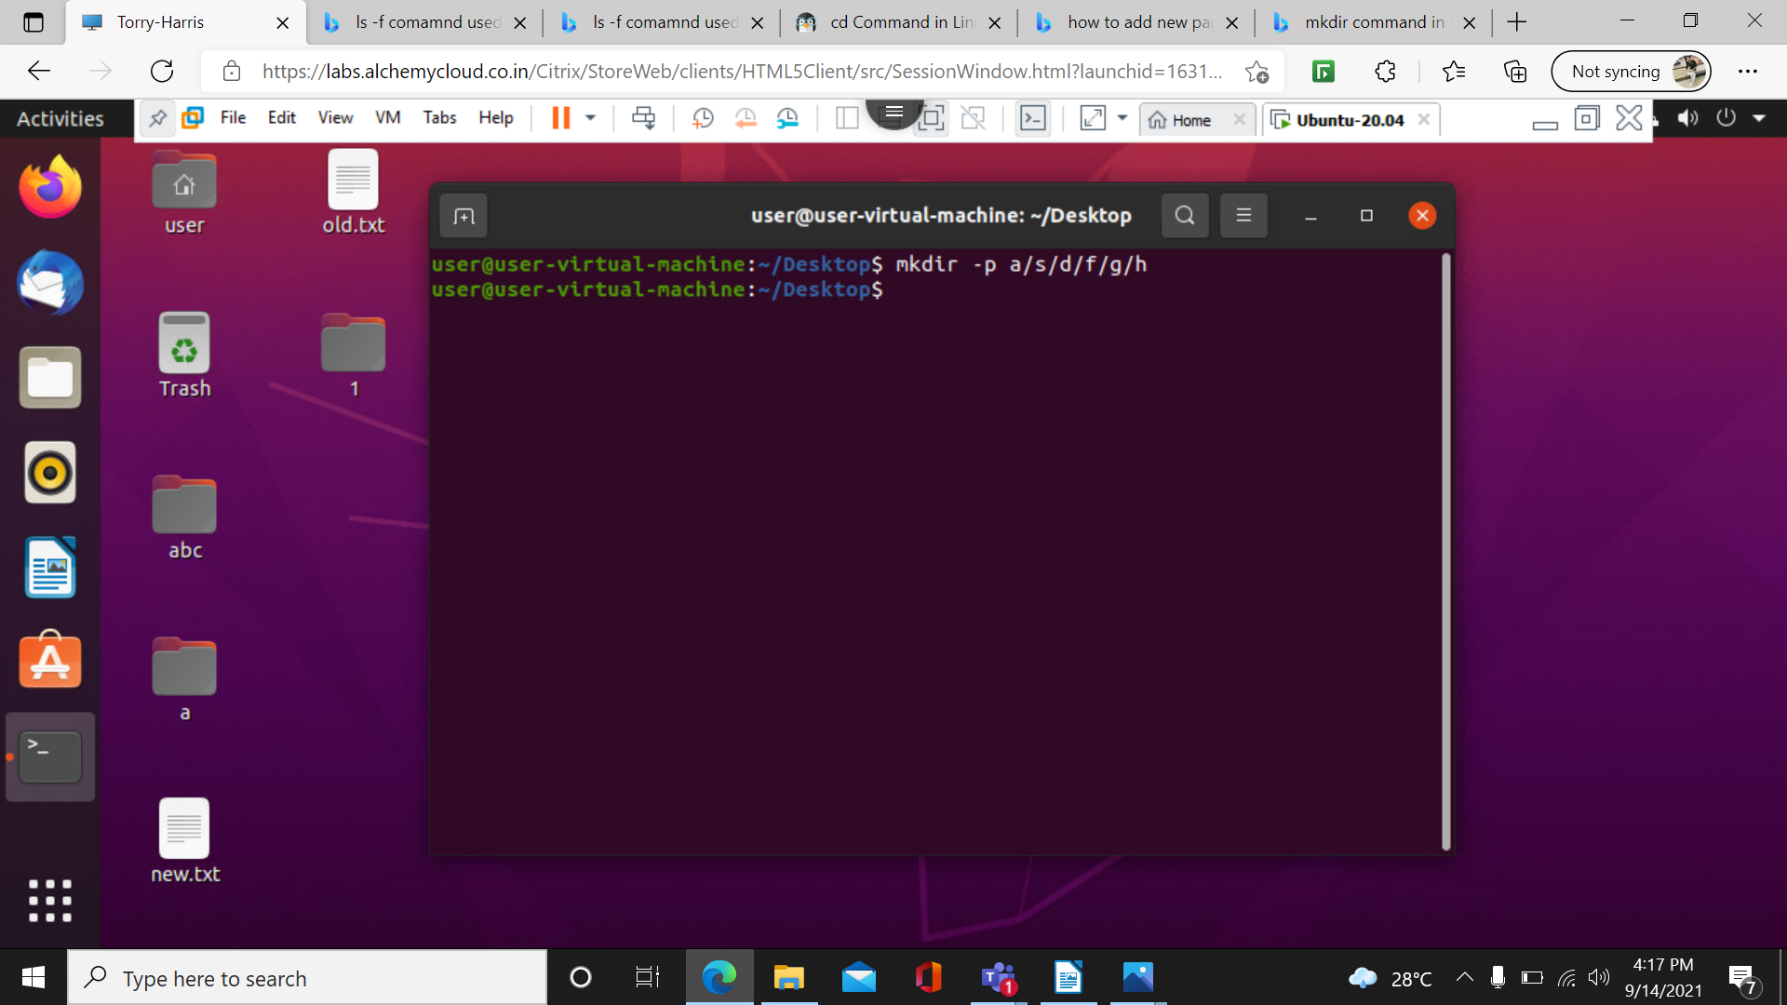
\

22)rm -rf 1: it delest all the folder and cant be recovered

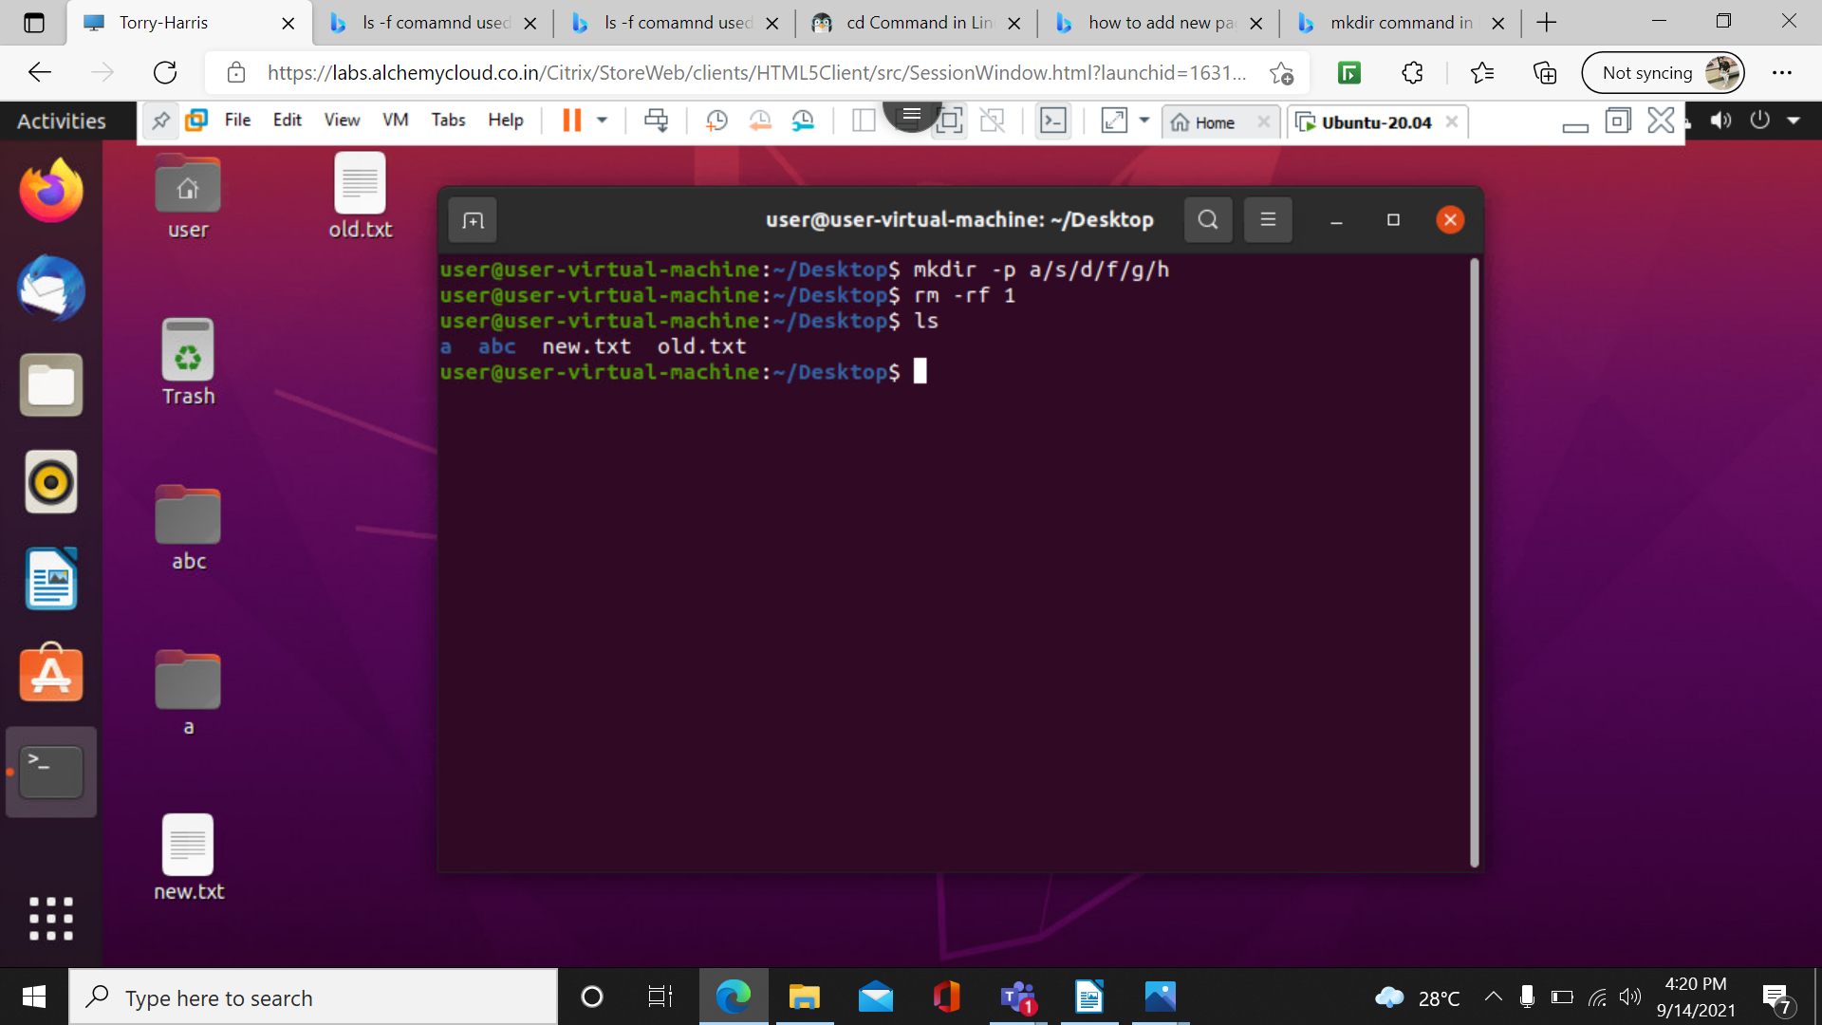

23)ls -l -lr : it shows it in a recurscive way
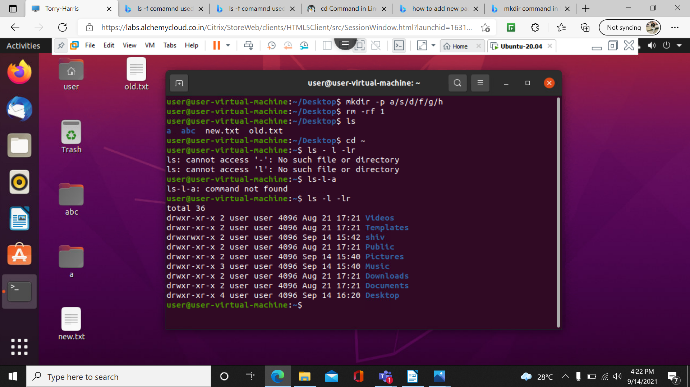

24)ls-l-lar commands

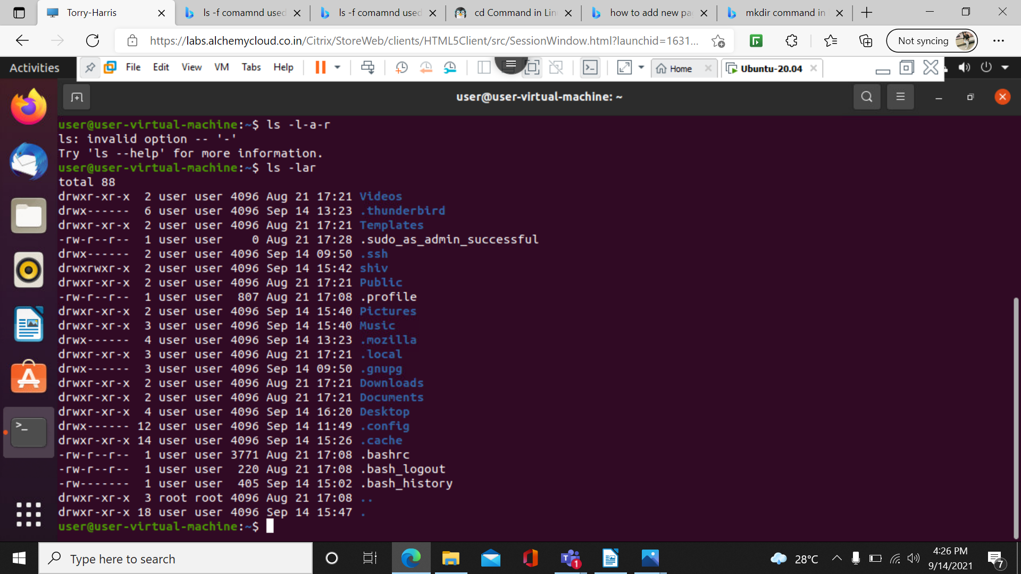

26) passwd command : it is used to change the password
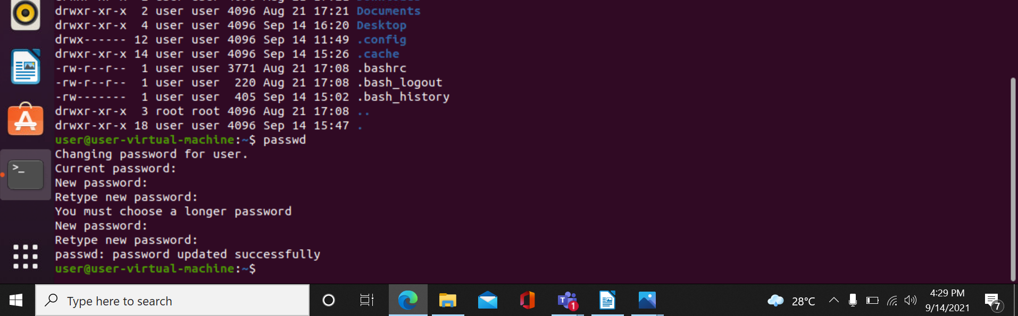
27) tree command : it lists the files in hirarchy

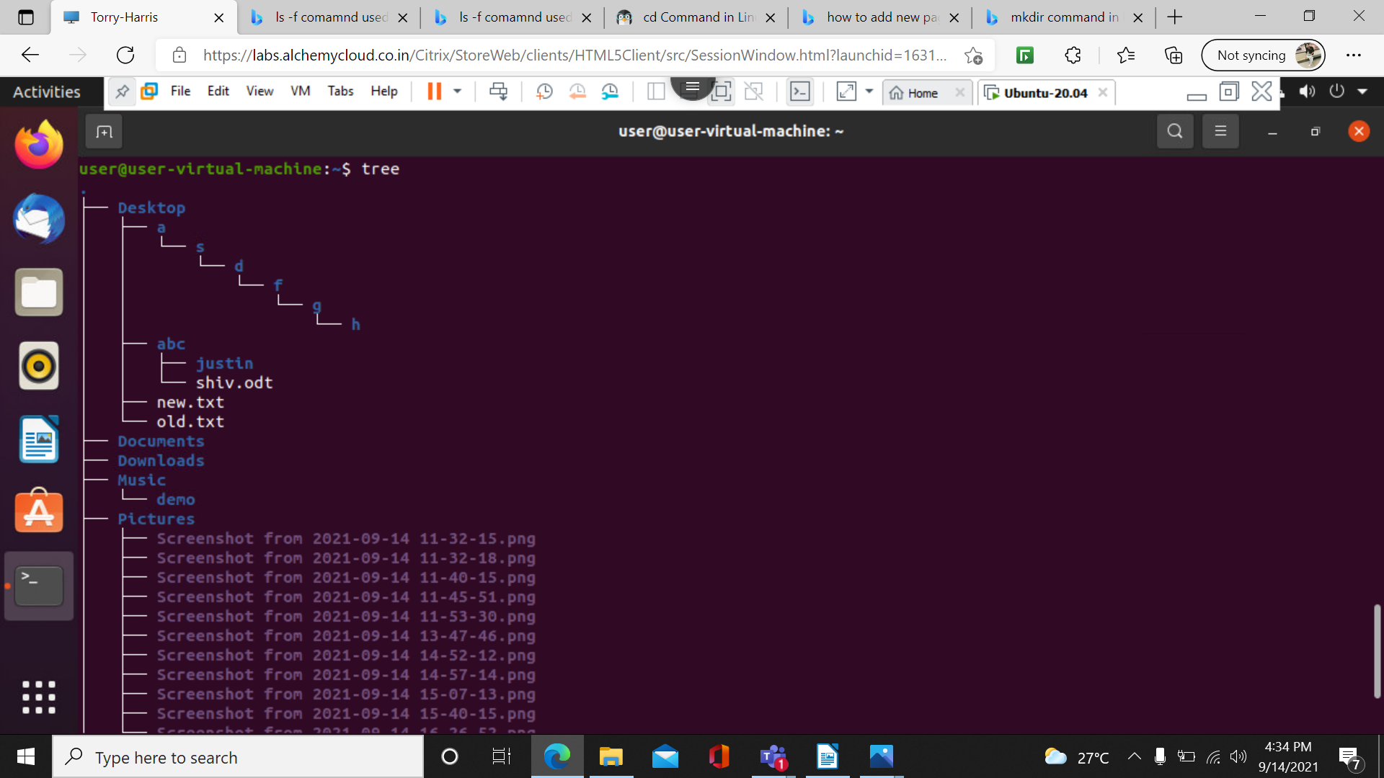
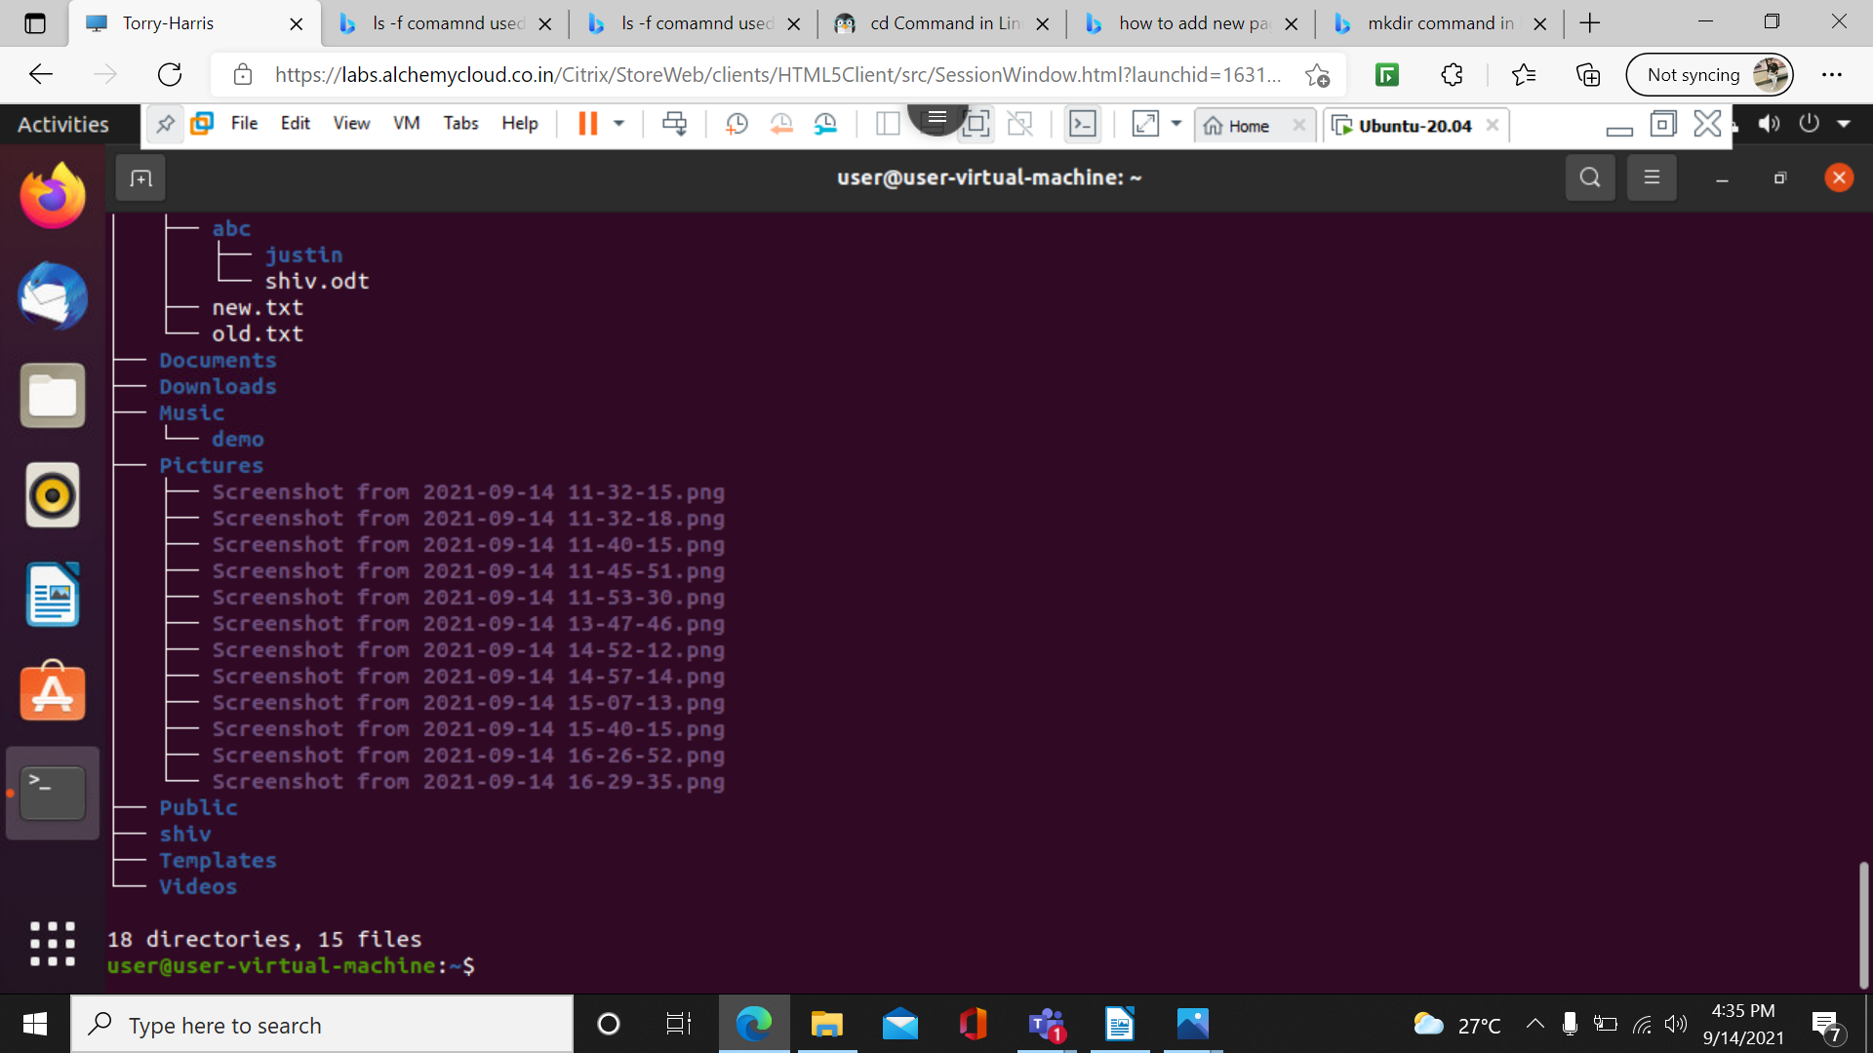
28)sudo apt command : it is used to install any softwares
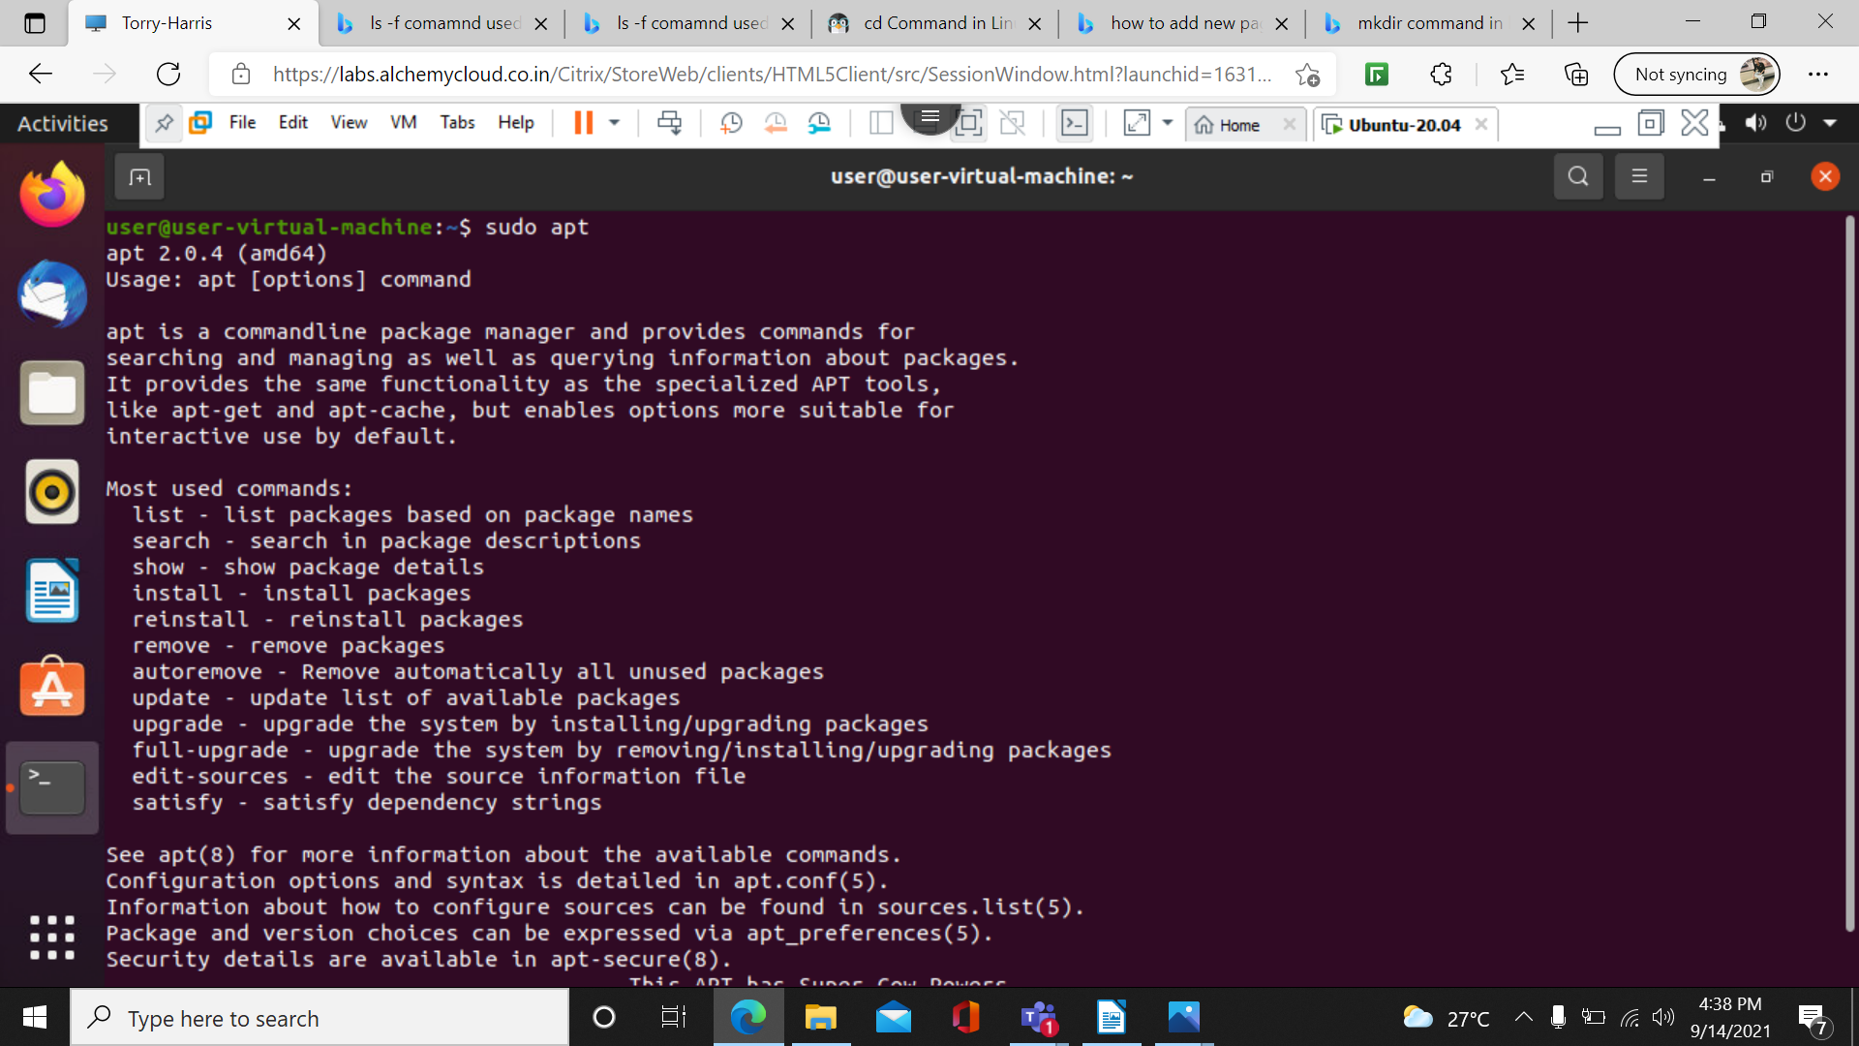
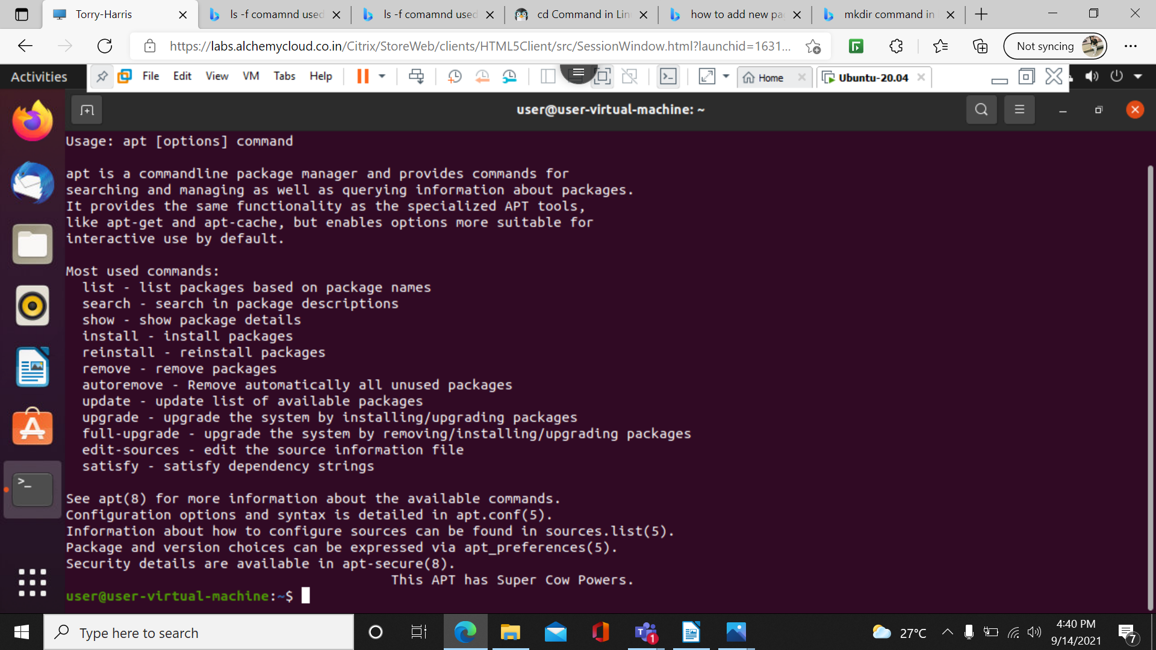

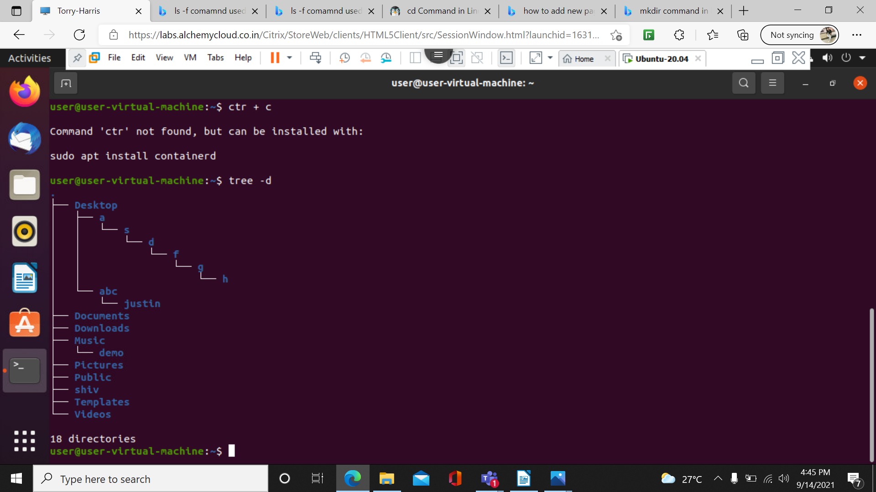
29) tree -d: it shows only directories

30)tree –help : it shows all possible ways

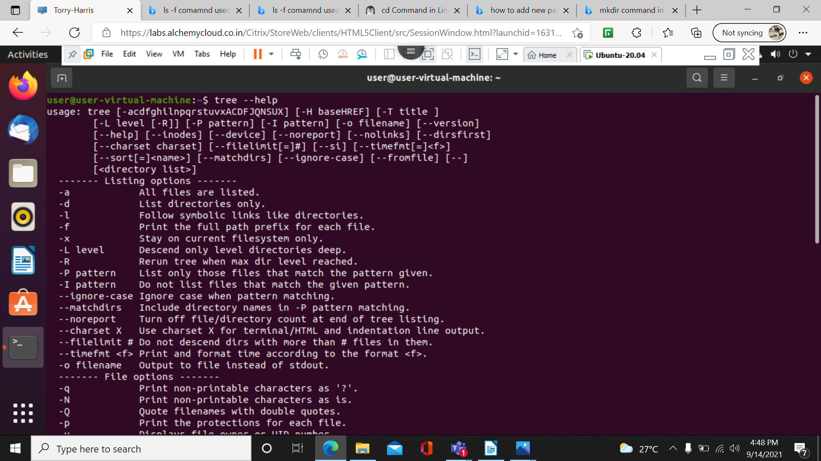
31)sudo apt – get update : to dowload the things

32) sudo apt – get upgrade :to install the things

33) sudo apt – get update && upgrade: for both download and installation

34) sudo apt – get remove tree : to uninstall

