Project Report
on
ALPHA INTELLIGENCE
An AI-Managed Administrative Console

Project report submitted in partial fulfilment of the requirements for award of the degree of
Bachelor of Science in Information Science and Telecommunication
(IST)
2026-2027
Submitted by
SHIVAM MUKHERJEE
B.SC. - IST SEM – IV, RN - UBS24IST036
Under the guidance of
Er. SATYABAN BEHERA, ASST. PROFESSOR
School of
INFORMATION SCIENCE AND TELECOMMUNICATION
(IST)
GANGADHAR MEHER UNIVERSITY, AMRUTA VIHAR
SAMBALPUR-768004, ODISHA, INDIA

Declaration
I hereby declare that the work which is being presented in this project entitled, “Alpha Intelligence — An AI-Managed Administrative Console” submitted to School of Information Science and Telecommunication, Gangadhar Meher University, Amruta Vihar, Sambalpur, Odisha in the partial fulfilment of the requirements for the degree of Bachelor of Science in Information Science and Telecommunication, is an authentic record of my own work carried out under the supervision of Er. Satyaban Behera, Asst. Professor. The work is original and has not been previously submitted for the award of any degree or diploma.
The project was developed as a team-based project during my internship with AediaX Tech Private Limited, Bhubaneswar, Odisha, in which I served as Full-Stack Developer (Authentication & Session Security, Backend Architecture, UI Restructuring). This report is compiled and submitted by me individually, in my own words, and all external sources of information, libraries, and tools used have been duly acknowledged.
Date: ____________________  Place: Sambalpur | Shivam Mukherjee  UBS24IST036

Certificate
This is to certify that the project report entitled “Alpha Intelligence — An AI-Managed Administrative Console” is the original work carried out by Shivam Mukherjee of BSc-IST Sem-VI, bearing roll number UBS24IST036, under my guidance and supervision as per the norms to fulfil the requirements of completing the semester-VI examination of BSc Information Science and Telecommunication (IST).
The project was developed as part of a team-based internship project at AediaX Tech Private Limited, Bhubaneswar, Odisha, in which the student served as Full-Stack Developer (Authentication & Session Security, Backend Architecture, UI Restructuring); this report is submitted individually.
The matter embodied in this project report is an original work carried out by them and has not been submitted either to this university or to any other university / institute for fulfilment of any such requirements.

Guide/Supervisor
Date: ____________________

Acknowledgement
I would like to express my sincere gratitude to Er. Satyaban Behera, Assistant Professor and Coordinator of the Department of IST, for his continuous guidance, encouragement, and valuable support throughout the progress of this project work. His mentorship played an important role in the successful completion of this work.
I am equally grateful to AediaX Tech Private Limited, Bhubaneswar, Odisha, for the internship opportunity, technical mentorship, and infrastructure that shaped the thinking behind this project. I am especially thankful to Mr. Amresh Bhuyan (Training Manager) for his exemplary guidance and constant encouragement throughout the internship, and to Ms. Mausumi Bhuyan (HR Manager) and Mr. Sanat Kumar Bhuyan (Director) for their support throughout my time with the organisation.
I would like to extend my heartfelt thanks to all the faculty members of the School of Information Science and Telecommunication (IST) for their timely assistance, support, and cooperation during the development of this project.
I would also express my sincere gratitude to Mr. Khageswar Sahu, Technical Assistant (IT), for providing access to the laboratory and other necessary facilities, which significantly supported the successful completion of this work.
I am grateful to the authorities of Gangadhar Meher University for providing me with the opportunity, using the resources and other facilities like laboratory, library, e-library, e-journals, internet facility and the overall academic environment required to successfully carry out this project.
I also acknowledge the open-source communities behind React, Vite, Tailwind CSS, Node.js, Express, and the many smaller libraries this project depends on — their documentation and tooling formed the technical backbone of everything described in this report.
Finally, I would like to thank my friends and fellow classmates, along with my family members, for their constant support, motivation, and encouragement, which helped me complete this project successfully in time.
Date: ____________________  Place: Sambalpur | Shivam Mukherjee  UBS24IST036

Abstract
Alpha Intelligence is an administrative management platform built around a single guiding idea: "AI as manager." Rather than an administrator clicking through forms to approve applications, generate certificates, or check system health, the long-term goal is for an administrator to simply describe what they want in plain language and have the system carry it out — while remaining fully auditable and overridable by a human at every step. This report documents the Admin module of Alpha Intelligence: the part of the system an administrator uses to manage interns, review applications, issue documents, and — eventually — talk to the platform through a purpose-built natural-language command layer.
The project is at an early, honestly-documented stage. The frontend is a complete React single-page application with a working authentication flow, a seven-group navigation structure, and a fully built “AI Command Center” screen; the backend is a small, deliberately minimal Express API that already implements real cryptographic authentication (scrypt password hashing, HMAC-signed session tokens, rate limiting, and a CORS allow-list) but has no persistent database behind it yet — it currently serves a fixed, empty-shaped JSON contract that the frontend is already coded against. The natural-language understanding engine referred to in the interface as Alpha-NLU has not been designed or built; the present “AI” response in the Command Center is a simple client-side keyword simulation that stands in for it.
This report presents the system architecture, the planned conceptual data model, the functional workflow the natural-language layer is designed to follow, data-flow diagrams for the current admin processes, a requirement specification, a testing strategy with concrete test cases for the parts that already exist, and an honest account of what remains to be designed and built — principally the Alpha-NLU engine, the persistent database layer, and the document-generation pipeline.
Extension to the complete platform. Alpha Intelligence is not only an administrator’s console. It is a two-sided platform: the Admin Console described above, and a student-facing User Portal (also referred to in its repository as the AediaX Internship Portal / InternPath) through which students discover internships, create profiles, submit applications, follow their selection progress, and later view stipend information, certificates and notifications. The User Portal frontend is built in React 19 with Material UI and Tailwind CSS 3 and uses Firebase Authentication (email/password and Google) and Cloud Firestore for its accounts and its first two data collections, users and applications. This report has therefore been extended so that it documents the whole platform — both frontends, the shared backend that has yet to be built, and the way data travels from the user side to the admin side and back.
Expected backend and API layer. Neither frontend has a complete backend behind it today. The report specifies the expected backend in full: a single Node.js / Express API serving both applications, verifying Firebase ID tokens for students and the existing HMAC session tokens for administrators, persisting to a shared datastore (Cloud Firestore is recommended because the User Portal already uses it), and publishing domain events so that a student’s action — for example submitting an application — appears on the admin side without manual hand-off. The specification catalogues 168 REST endpoints in 11 groups (5 already exist, 163 are planned), of which 41 serve the User Portal and 100 serve the Admin Console, together with the integration endpoints that carry data from the user side to the admin side. As elsewhere in the report, everything is labelled as implemented, simulated or planned.

Keywords
AI-assisted administration, natural language processing (planned), admin dashboard, React single-page application, Express REST API, session-based authentication, conceptual data modelling, audit logging.
Additional keywords: student-facing internship portal, Firebase Authentication, Cloud Firestore, shared REST API design, user-to-admin data synchronisation, application lifecycle, object-level authorisation, domain events, API catalogue.

List of Figures
Figure No. | Title
Fig. 1.1 | Concept Illustration — “AI as Manager”
Fig. 3.1 | System Architecture of Alpha Intelligence (Admin Console)
Fig. 3.2 | Functional Workflow — Natural-Language Command Processing
Fig. 3.3 | Module / Navigation Map of the Admin Console
Fig. 3.4 | Data Flow Diagram — Level 0 (Context Diagram)
Fig. 3.5 | Data Flow Diagram — Level 1 (Admin Console Processes)
Fig. 4.1 | Conceptual Data Model (Planned)
Fig. 6.1 | Illustrative Wireframe — Admin Console Layout
Fig. 7.1 | Sequence Diagram — Admin Login and Session Validation
Fig. 9.1 | Testing Strategy — Layered Test Approach
Fig. 3.6 | Integrated System Architecture — User Portal, Admin Console, Backend and Data Layer
Fig. 3.7 | Data Flow Diagram — Level 0 (User Portal Context Diagram)
Fig. 3.8 | Data Flow Diagram — Level 1 (User Portal Processes and Hand-off to Admin)
Fig. 3.9 | Sequence Diagram — Application Submission (User) to Decision (Admin) and Back
Fig. 3.10 | Application Status Lifecycle (State Diagram)
Fig. 3.11 | Expected Layered Backend Architecture
Fig. 4.2 | Extended Conceptual Data Model (Admin and User Entities)
Fig. 6.2 | User Portal Route and Navigation Map
Fig. 6.3 | Illustrative Wireframe — User Portal Layout
Fig. 7.2 | Sequence Diagram — User Sign-in and Backend Token Verification
Fig. 9.2 | API and Integration Test Approach

List of Tables
Table No. | Title
Table 5.1 | Functional Requirements
Table 5.2 | Non-Functional Requirements
Table 6.1 | Screen Inventory
Table 7.1 | Module-wise Implementation Status
Table 8.1 | Technology Stack and Justification
Table 9.1 | Test Cases
Table 1.1 | Platform Components at a Glance
Table 2.1 | Comparison of Administrative Approaches
Table 2.2 | Comparison of Student-Facing Internship Platforms
Table 3.1 | Domain Events Exchanged Between User Side and Admin Side
Table 3.2 | Application Status Lifecycle
Table 3.3 | Expected Backend Middleware Order
Table 3.4 | API Groups and Endpoint Counts
Table 3.5 | Public, System and Admin Authentication APIs
Table 3.6 | User Account and Profile APIs
Table 3.7 | User Internship, Application and Progress APIs
Table 3.8 | User Stipend, Certificate, Notification and Dashboard APIs
Table 3.9 | Admin Dashboard, Analytics, Task and Document Vault APIs
Table 3.10 | Admin AI Command Center, Telemetry and NLP Mapping APIs
Table 3.11 | Admin User Directory APIs (Users, Applications, Records)
Table 3.12 | Admin Internship Posting, Stipend and Notification APIs
Table 3.13 | Admin System Logs, Settings and Backup APIs
Table 3.14 | Admin Security, Alert, Template and Document-Generation APIs
Table 3.15 | User-to-Admin Integration, Sync and Internal Service APIs
Table 4.1 | Extended Data Dictionary
Table 4.2 | Origin of Each Field in the Admin Data Contract
Table 4.3 | Planned Firestore Collections, Indexes and Access Rules
Table 5.3 | User-Side Functional Requirements
Table 5.4 | Backend and Integration Functional Requirements
Table 5.5 | Additional Non-Functional Requirements
Table 5.6 | Role–Capability Matrix
Table 6.2 | User Portal Screen Inventory
Table 7.2 | Module-wise Implementation Status — User Portal and Backend
Table 7.3 | Planned Backend Modules and Responsibilities
Table 8.2 | User Portal Technology Stack
Table 8.3 | Admin Console versus User Portal — Stack Comparison
Table 8.4 | Candidate Backend Additions
Table 9.2 | Planned Test Cases — User Portal and API
Table 9.3 | Planned End-to-End Integration Scenarios
Table 10.1 | Integration Risks and Mitigations
Table 11.1 | Proposed Integration Roadmap

List of Abbreviations
Abbreviation | Expansion
AI | Artificial Intelligence
API | Application Programming Interface
CORS | Cross-Origin Resource Sharing
CRUD | Create, Read, Update, Delete
DFD | Data Flow Diagram
DXA | Twentieths of a Point (Word document measurement unit)
FK | Foreign Key
HMAC | Hash-based Message Authentication Code
JSON | JavaScript Object Notation
NLP / NLU | Natural Language Processing / Understanding
ORM | Object-Relational Mapping
PK | Primary Key
REST | Representational State Transfer
SPA | Single-Page Application
UI / UX | User Interface / User Experience
BaaS | Backend-as-a-Service
CRA | Create React App
CSV | Comma-Separated Values
DPDP | Digital Personal Data Protection (Act, 2023, India)
HTTP | Hypertext Transfer Protocol
JWT | JSON Web Token
MUI | Material UI (React component library)
OTP | One-Time Password
RBAC | Role-Based Access Control
SDK | Software Development Kit
SSE | Server-Sent Events
UID | Unique Identifier (Firebase user id)
UFR / BFR | User-side / Backend Functional Requirement
URL | Uniform Resource Locator

Table of Contents
Declaration 2
Certificate 3
Acknowledgement 4
Abstract 5
List of Figures 7
List of Tables 8
List of Abbreviations 10
Table of Contents 11
1. Introduction 14
1.1 Purpose of the Report 14
1.2 Background and Motivation — “AI as Manager” 14
1.3 Problem Statement 15
1.4 Objectives 15
1.5 Scope of the Present Report 16
1.6 Organisation of the Report 17
1.7 Platform Overview — User Portal, Admin Console and Backend 17
2. Literature Survey and Review of Existing Systems 18
2.1 Existing Administrative / Dashboard Panels 18
2.2 Existing Conversational / Command-Driven Admin Tools 18
2.3 Identified Gap and Positioning of Alpha Intelligence 18
2.4 Existing Student-Facing Internship Platforms 19
2.5 Backend-as-a-Service and the Choice of Firebase for the User Side 19
3. System Analysis and Design 21
3.1 Feasibility Study 21
3.2 System Architecture 21
3.3 Functional Workflow — Natural-Language Command Processing 22
3.4 Module / Navigation Map of the Admin Console 23
3.5 Data Flow Diagrams 24
3.6 Current Development Phase 26
3.7 Integrated System Architecture 26
3.8 User Portal Data Flow Diagrams 27
3.9 User-Side to Admin-Side Data Flow 29
3.10 Application Status Lifecycle 31
3.11 Expected Backend Architecture 32
3.12 REST API Specification 33
4. Database Design (Planned) 42
4.1 Conceptual Data Model 42
4.2 Candidate Database Engines and Selection Criteria 43
4.3 Interim Data Strategy — the Stub API Contract 43
4.4 Extended Conceptual Data Model 43
4.5 Origin of the Admin Data Contract Fields 45
4.6 Firestore Collections, Indexes and Access Rules 46
4.7 Consistency, Denormalisation and Synchronisation 46
5. Requirement Specification 48
5.1 Functional Requirements 48
5.2 Non-Functional Requirements 50
5.3 User Requirements 51
5.4 System Requirements 51
5.5 Backend and API Requirements 52
5.6 Integration Requirements 52
6. UI Design 54
6.1 Design Approach 54
6.2 Screen Inventory 54
6.3 Navigation and Layout Principles 55
6.4 User Portal Navigation and Screen Flow 56
6.5 User Portal Layout 56
7. Implementation — Work Done So Far 58
7.1 Repository and Deployment 58
7.2 Backend — Implemented 58
7.3 Frontend — Implemented 59
7.4 Module-wise Implementation Status 60
7.5 User Portal Frontend — Implemented 61
7.6 User Authentication Flow 61
7.7 Current Data Access Pattern (User Side) 62
7.8 Expected Backend — Not Yet Built 62
7.9 Migration Path from Direct Firestore Access to the API 63
8. Technology Stack 65
8.1 Planned Additions 66
8.2 Admin Console versus User Portal — Stack Comparison 66
8.3 Candidate Backend Additions 66
9. Testing 68
9.1 Testing Strategy 68
9.2 Test Cases Executed 69
9.3 User-Side and API Test Cases (Planned) 69
9.4 API and Integration Testing 70
10. Results and Discussion 72
10.1 What Works Today 72
10.2 Honest Limitations 72
10.3 Discussion 72
10.4 Integration Risks and Mitigations 73
11. Conclusion and Future Scope 74
11.1 Conclusion 74
11.2 Future Scope 74
11.3 Proposed Integration Roadmap 75
References 76
Appendix A — Source Code Excerpts 77
Appendix B — Links and Environment 79
Appendix C — API Request and Response Samples (Proposed) 80
Appendix D — Admin Screen-to-API Traceability Matrix 82

1. Introduction

1.1 Purpose of the Report
The purpose of this report is to present, in a structured and academically rigorous manner, the design, current implementation status, and planned direction of the Admin module of Alpha Intelligence. It documents what has been built, how it works, what remains to be designed, and how the finished parts and the planned parts fit into a single coherent architecture, so that the work can be evaluated by faculty and resumed by its own author without having to reconstruct context from scratch.
User-side extension. The purpose of the report has been widened beyond the Admin module. It now also records the design, current implementation status and expected backend of the student-facing User Portal, and the way the two applications exchange data through a shared backend, so that the complete Alpha Intelligence platform — not just its administrative half — can be evaluated and resumed without reconstructing context. Where a statement concerns the user side, the report says so explicitly, and it keeps the same three-way distinction between implemented, simulated and planned behaviour.

1.2 Background and Motivation — “AI as Manager”
Most administrative dashboards are built around forms: an administrator clicks through menus, fills fields, and presses buttons to approve an application, generate a certificate, or check a log. Alpha Intelligence starts from a different premise — that a large share of this routine administrative work can instead be described in plain language and delegated to an AI layer that understands intent, executes the corresponding action, and reports back, while a human administrator retains full visibility and override authority over everything it does. This is the sense in which the project's core idea is “AI as manager”: not an AI that replaces the administrator, but one that takes on the repetitive parts of the job under the administrator's direction and audit.
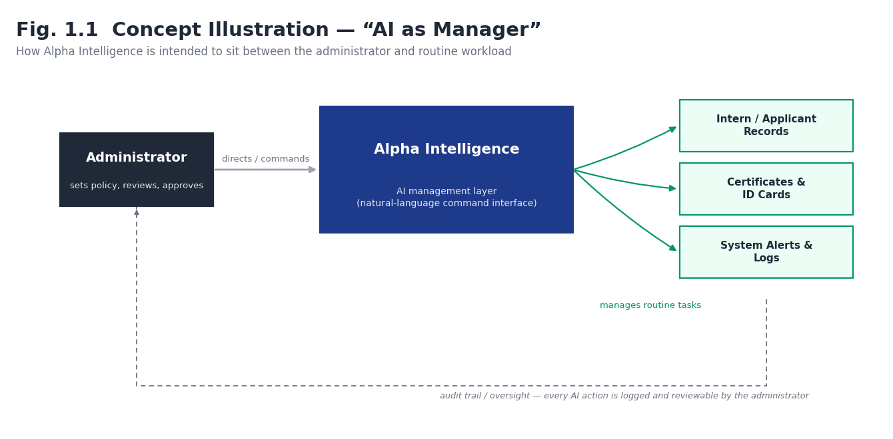
Fig. 1.1 Concept Illustration — “AI as Manager”

The Admin Console is the surface through which this idea is expressed today. It already gives an administrator a conventional, form-based way to manage interns, applications, and documents; layered on top of it is an “AI Command Center” screen designed as the eventual single point of natural-language control for all of the above.
The other half of the platform. An administrator cannot approve applications that nobody can submit. The Admin Console’s User Directory, Applications, Document Vault and Certificate screens are all fed by things students do: they register, complete a profile, apply to an internship, complete the internship and ask for a certificate. The User Portal is the surface through which students do this, and the backend is the channel through which their actions reach the administrator. “AI as manager” therefore has two sides: the administrator instructs the platform, and the platform manages the flow of student data toward the administrator so that routine steps need no manual copying between systems.

1.3 Problem Statement
Administrative workflows around intern and applicant management — reviewing applications, issuing certificates and ID cards, tracking status changes, and responding to anomalies — are largely manual, repetitive, and spread across disconnected screens even within a single dashboard. There is no lightweight, self-hosted way for a small team to describe an administrative action in natural language and have it executed safely, with the same action also being auditable after the fact. Alpha Intelligence — Admin sets out to close this gap by pairing a conventional, secure admin console with a purpose-built, rule-based natural-language command layer (“Alpha-NLU”) rather than relying on a third-party general-purpose assistant.
User-side problem statement. For the student the picture is symmetrical. Internship information is scattered across notices and messages, applications are submitted through generic forms whose outcome is not visible afterwards, and a student cannot easily see where an application stands, what stipend is due, or when a certificate will be ready. Even where a student-side portal exists, it is disconnected from the administrator’s tooling, so every status change must be relayed by hand. The complete platform sets out to close both gaps at once: a portal in which the student sees the live state of their own application, connected through one API to an admin console in which the administrator acts on it.

1.4 Objectives
- Design and implement a secure, role-restricted admin console for managing intern applications, records, and generated documents.
- Design (and, in a later phase, implement) Alpha-NLU: a lightweight, intent-and-keyword-based natural-language command engine that the admin console can call instead of, or in addition to, its form-based screens.
- Define a conceptual data model that the current stub API is already shaped to grow into, so that connecting a real database later requires no rework of the frontend contract.
- Establish an audit trail so that every administrative action — whether triggered by a click or, later, by a natural-language command — is logged and reviewable.
- Document the system honestly at every stage of completion, distinguishing clearly between what is implemented, what is a working placeholder, and what is only planned.
- Deliver a student-facing User Portal for internship discovery, application, profile management, selection-progress tracking, stipend information, certificates and notifications, with authentication handled by Firebase.
- Design the expected backend — a single Express API serving both frontends — including token verification for two identity types, layered structure, validation, error handling and rate limiting.
- Define the complete user-to-admin data flow, including the application lifecycle and the domain events that make a student action appear on the admin side, and an admin decision appear on the student side.
- Specify a comprehensive REST API catalogue (168 endpoints, 11 groups) that covers every admin screen and every user screen, not only the five routes that exist today.
- Extend the conceptual data model, requirements, testing strategy and roadmap so that they cover the platform as a whole.

1.5 Scope of the Present Report
This report covers the Admin module only — authentication, the admin dashboard shell, the seven functional page groups reachable from it, the AI Command Center interface, and the data and NLP design the module is intended to grow into. It does not cover an end-user-facing chat interface or any public-facing part of Alpha Intelligence, as none has been built at the time of writing. Sections describing the Alpha-NLU engine and the persistent database are explicitly marked as planned design, not implemented behaviour, in keeping with the actual state of the codebase referenced throughout (github.com/Shivzm/Alpha-Intelligence---Admin).
Scope extension. The paragraph above describes the scope as it stood when the report covered the Admin module alone, including the statement that no user-facing part of Alpha Intelligence had been built. That statement is superseded by this extension: the report now also covers the User Portal frontend (repository: https://github.com/sidhartha091027/internshipmanagement-userpannel) and the expected backend and API layer that will connect it to the Admin Console. The User Portal frontend exists as source code; the shared backend for it, the persistent database, Alpha-NLU and document generation remain designed-but-not-built, exactly as described elsewhere in this report.

1.6 Organisation of the Report
Chapter 2 reviews existing approaches to admin dashboards and NL-driven tooling and positions Alpha Intelligence relative to them. Chapter 3 covers system analysis and design, including the architecture, the planned NL command workflow, the module map, and data-flow diagrams. Chapter 4 covers the planned database design. Chapter 5 specifies functional and non-functional requirements. Chapter 6 covers UI design. Chapter 7 documents implementation work completed to date, including source-code excerpts. Chapter 8 justifies the technology stack. Chapter 9 presents the testing strategy and test cases. Chapter 10 discusses results. Chapter 11 concludes and outlines future scope.
The extension adds, to each chapter, the material that concerns the user side: user-side literature and positioning in Chapter 2; the integrated architecture, user-side data-flow diagrams, the application lifecycle, the expected backend architecture and the complete REST API specification in Chapter 3; the extended data model in Chapter 4; user-side, backend and integration requirements in Chapter 5; the User Portal screens in Chapter 6; the User Portal implementation and the expected backend in Chapter 7; the user-side stack in Chapter 8; user-side and integration tests in Chapter 9; results, risks and roadmap in Chapters 10 and 11; and API samples and a screen-to-API traceability matrix in Appendices C and D.

1.7 Platform Overview — User Portal, Admin Console and Backend
Alpha Intelligence is made up of three cooperating parts. Table 1.1 lists them with their source repositories, stacks and honest status. The two frontends are independent single-page applications built by different members of the project team, with different tooling; they meet at the backend API, which is the single place where rules are enforced and where data from the user side is made available to the admin side.
Table 1.1 Platform Components at a Glance
Component | Source / URL | Stack | Status
Admin Console (frontend) | github.com/Shivzm/Alpha-Intelligence---Admin; live preview alpha-admin-gold.vercel.app | React 19, Vite 8, Tailwind CSS 4, React Router 7 | Implemented; data is a stub
Admin backend (auth + stub) | backend/ folder of the Admin repository | Node.js, Express 5, Helmet, express-rate-limit, Node crypto | Implemented (auth); stub data
User Portal (frontend) | github.com/sidhartha091027/internshipmanagement-userpannel | React 19, Create React App (react-scripts 5), MUI 9, Tailwind CSS 3, React Router 6, Firebase SDK 12 | Implemented (frontend); uses Firebase directly
Shared backend / API for the User Portal and the integration layer | Not built — specified in Section 3.11 and 3.12 | Expected: Node.js / Express, Firebase Admin SDK, shared datastore | Not started
Shared datastore | Cloud Firestore (users, applications exist); remaining collections planned | Firestore + file storage | Partly in use (user side); admin side not connected

2. Literature Survey and Review of Existing Systems

2.1 Existing Administrative / Dashboard Panels
Conventional admin panels — whether custom-built with frameworks such as React and Express, or generated through low-code platforms — organise functionality into sidebars, tables, and forms. They are reliable and predictable but require the administrator to already know exactly which screen and which field corresponds to the action they want to take. As the number of manageable entities grows (applicants, interns, documents, alerts, backups, and so on, as in this project), the number of screens grows with it, and routine multi-step actions (for example, “approve every pending intern application from the last week and generate their ID cards”) have no single point of entry; they must be performed screen by screen.
Student-side view. A conventional admin panel also has a mirror image that is easy to overlook: the student-facing application that feeds it. Where the two are built separately and joined by exports or manual re-entry, the administrator’s screens are only as current as the last copy-paste, which is the same screen-by-screen friction described above, moved one step earlier in the process.

2.2 Existing Conversational / Command-Driven Admin Tools
Chat-ops style tools (for example, Slack- or Teams-integrated bots that respond to slash-commands) and general-purpose AI assistants embedded into SaaS dashboards represent one response to this limitation. Slash-command bots are fast but rigid — the administrator must memorise exact command syntax. General-purpose AI assistants are flexible with language but are typically third-party services, which raises cost, data-residency, and reliability concerns for a small internal admin tool, and they are usually not designed around a fixed, auditable set of system actions.
Relevance to the user side. Neither slash-command bots nor general-purpose assistants address the student. Students do not issue commands; they need a predictable, self-explanatory interface that shows the state of their own application. For the platform as a whole the command layer is therefore an administrator-side feature, while the user side relies on conventional, form-based screens whose data the command layer can act upon.

2.3 Identified Gap and Positioning of Alpha Intelligence
The gap Alpha Intelligence targets sits between these two extremes: a self-contained, intent-and-keyword-based command layer (Alpha-NLU) that understands a bounded vocabulary of administrative intents defined by the admin themselves through the NLP Keyword Mapping screen, rather than a general-purpose language model. This keeps the system's behaviour predictable and auditable — every recognised command maps to exactly one system action — while still letting the administrator phrase requests in their own words rather than memorising a command syntax. Table 2.1 summarises the comparison.
Positioning of the user side. The same positioning applies to the User Portal: it is a lightweight, self-contained portal owned by the organisation running the internship programme rather than a listing on a third-party marketplace, and it shares one backend with the admin console so that a student’s status and the administrator’s view are the same data rather than two copies.
Approach | Flexibility of input | Predictability of action | Hosting / cost
Form-based admin panel | Low (fixed fields) | High | Self-hosted, no extra cost
Slash-command chat-ops bot | Low (fixed syntax) | High | Usually third-party platform
General-purpose AI assistant | High | Low – Medium (open-ended) | Third-party API, ongoing cost
Alpha-NLU (this project, planned) | Medium (natural phrasing, bounded intents) | High (fixed intent → action map) | Self-hosted, no external AI cost

2.4 Existing Student-Facing Internship Platforms
Student-facing internship platforms fall into a few recognisable families. Large public marketplaces (for example Internshala or LinkedIn) offer wide reach and mature search but are multi-employer, third-party services: an organisation running its own programme has little control over the application form, the status vocabulary, or the data it collects, and the student’s view of an application is governed by the marketplace rather than by the organisation. Institutional placement or ERP portals give the institution control but are typically heavyweight and rarely designed around a single short-term internship programme. Spreadsheet-and-form workflows are the most common fallback for small programmes; they are cheap and flexible but give the student no visibility of progress and give the administrator no audit trail. Table 2.2 summarises the comparison.
Table 2.2 Comparison of Student-Facing Internship Platforms
Approach | Strength | Limitation | Relevance to this project
Public internship marketplace | Reach, mature search and matching | Third-party control of forms, data and status vocabulary | Reference for search and filter behaviour
Institutional placement / ERP portal | Institutional control and records | Heavyweight; not shaped around short programmes | Reference for record and certificate needs
Spreadsheet + form workflow | Cheap and flexible | No student visibility; weak audit trail; manual re-entry | The workflow this platform replaces
Alpha Intelligence User Portal (this project) | Self-hosted; student sees live status; one API shared with the admin console | Backend not yet built; single programme scope | Subject of the user-side chapters

2.5 Backend-as-a-Service and the Choice of Firebase for the User Side
Backend-as-a-Service products bundle authentication, a managed database and file storage behind client SDKs, letting a frontend team build a working application without writing a server. Firebase is the best-known example and is what the User Portal uses: Firebase Authentication for email/password and Google sign-in, and Cloud Firestore for documents. This is an appropriate choice for an early frontend because it removes the need to implement password storage, email verification flows and social sign-in from scratch. Its known trade-off is that business rules then live either in client code or in database security rules, which are hard to test and easy to get wrong. The user-side repository’s own README acknowledges this by noting that Firestore security rules must be configured before production so that users can read and write only their own profile and applications. The design in Chapters 3 and 4 keeps Firebase for identity and storage but moves business rules into the shared backend, which is the standard remedy.

3. System Analysis and Design

3.1 Feasibility Study
Technical feasibility is high for the parts already built: the chosen stack (React, Vite, Express, deployed on Vercel) is free at this project's scale, well documented, and already proven working in the deployed preview at alpha-admin-gold.vercel.app. The main technical risk lies ahead — in the Alpha-NLU engine and the database — both of which are deliberately scoped down for feasibility: Alpha-NLU is planned as a rule-based keyword/intent matcher rather than a trained model, which is realistic to build and evaluate within an academic project timeline, and the database candidates under consideration (Section 4.2) are all managed, low-setup-cost services suited to a small team.
Economic feasibility is favourable: every dependency used (Section 8) is open-source, and the current Vercel-hosted deployment fits comfortably within free-tier limits. Operational feasibility depends on maintaining development momentum after this report's submission; the module-wise status table in Chapter 7 and the future-scope items in Chapter 11 are intended to make the remaining work concrete and schedulable.
User-side feasibility. The User Portal adds no new hosting cost at the present scale: its production build is a static bundle, and Firebase Authentication and Firestore offer free usage quotas that are adequate for a pilot cohort (quotas should be re-checked against current Firebase pricing before launch). The technical risk is concentrated in the not-yet-built backend that must reconcile two identity systems and one datastore; Sections 3.7 to 3.12 scope that work as an ordinary REST API in the same Express stack already in use, which is realistic within an academic timeline.

3.2 System Architecture
The system follows a three-tier layout. Tier 1 is the React client — a Vite-built single-page application using Tailwind CSS v4 and React Router v7, holding session state in React Context and caching the session token in sessionStorage. Tier 2 is the application/API layer — a Node.js/Express 5 REST API deployed as a single Vercel serverless function, fronted by Helmet (security headers), a CORS allow-list driven by the FRONTEND_URL environment variable, and a rate limiter on the authentication routes. Tier 3, the data and intelligence layer, is the planned layer: a persistent database, the Alpha-NLU engine, a document-generation service, and a notification/audit sink. Tier 3 is drawn with dashed borders throughout this report to mark it as designed-but-not-yet-built.
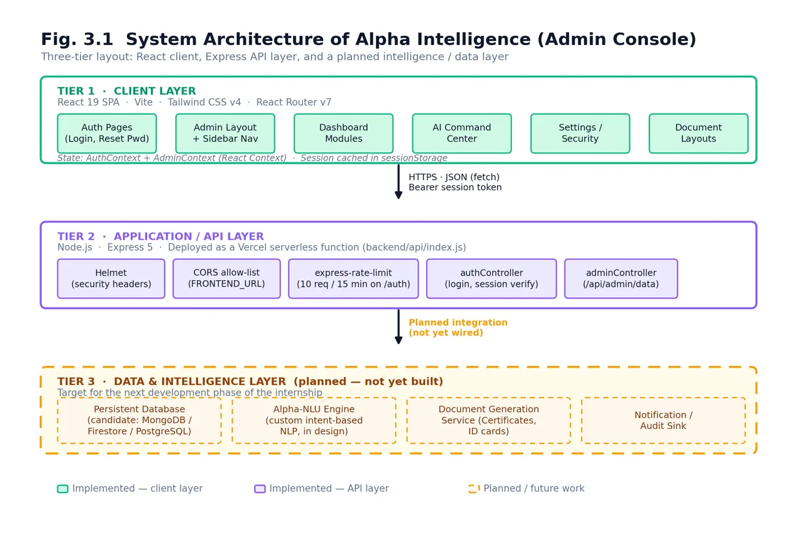
Fig. 3.1 System Architecture of Alpha Intelligence (Admin Console)
Integrated view. Figure 3.1 shows the Admin Console’s three tiers. The complete platform adds a second Tier-1 client, the User Portal, which talks to the same Tier-2 API. The integrated architecture, with both clients, the shared API, the domain services behind it and the data layer, is shown in Figure 3.6 in Section 3.7.

3.3 Functional Workflow — Natural-Language Command Processing
Figure 3.2 traces a command from the moment an administrator types it into the AI Command Center to the point a response is rendered and logged. Steps 1, 2 and 6 are implemented today: the terminal-style input screen, the authenticated request to the API, and the rendering-plus-audit step (the audit step is presently illustrative on the frontend rather than backed by a real AuditLog store — see Section 4.3). Steps 3 to 5, shaded in the figure, are the planned behaviour of Alpha-NLU: matching the free-text command against the Intent/keyword table an administrator defines on the NLP Keyword Mapping screen, checking the resulting confidence score against a per-intent threshold (confidenceMin), and then either executing the mapped system action or raising an Alert for a low-confidence or unmatched command.
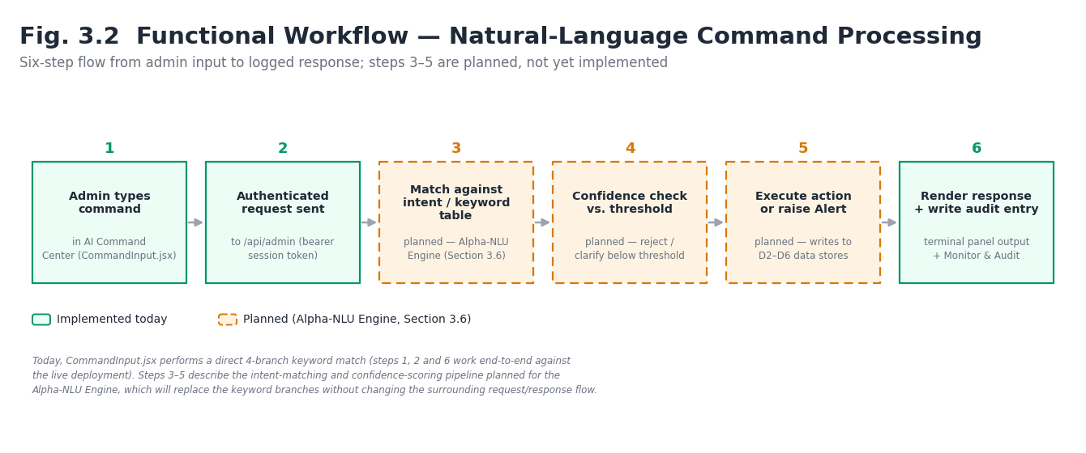
Fig. 3.2 Functional Workflow — Natural-Language Command Processing
In the current build, the “AI” response inside CommandInput.jsx is a client-side simulation: a short, hard-coded if/else chain checks the submitted text for keywords such as “generate”/“create”, “revoke”/“delete”, and “status”/“health”, and returns a canned response for each. This is intentionally structured to be a drop-in replacement point: once Alpha-NLU exists, the same function signature (raw text in, action-or-alert out) can call the real engine instead of the keyword stub.
Interaction with user-side data. The natural-language layer acts on data that originates on the user side. A command such as “approve all pending applications from the last week” resolves to a bulk status change on applications that students submitted through the User Portal; the same change must produce the notification and timeline entry the student sees. The command layer therefore calls the same application service as the form-based Applications screen (Section 3.11), so an action has identical side effects whether it is clicked or typed, and both are recorded in the AuditLog with their source.

3.4 Module / Navigation Map of the Admin Console
All authenticated screens live under the protected /admin/* route tree and share the same sidebar and layout (AdminLayout.jsx). The sidebar organises the console into seven functional groups — Dashboard, AI Command Center, User Directory, System Logs, Settings, Security & Access, and Document Layouts — spanning eighteen individual pages in total, all already routed and rendering in the current build (Section 7.2 records which of them are wired to live data versus placeholder state).
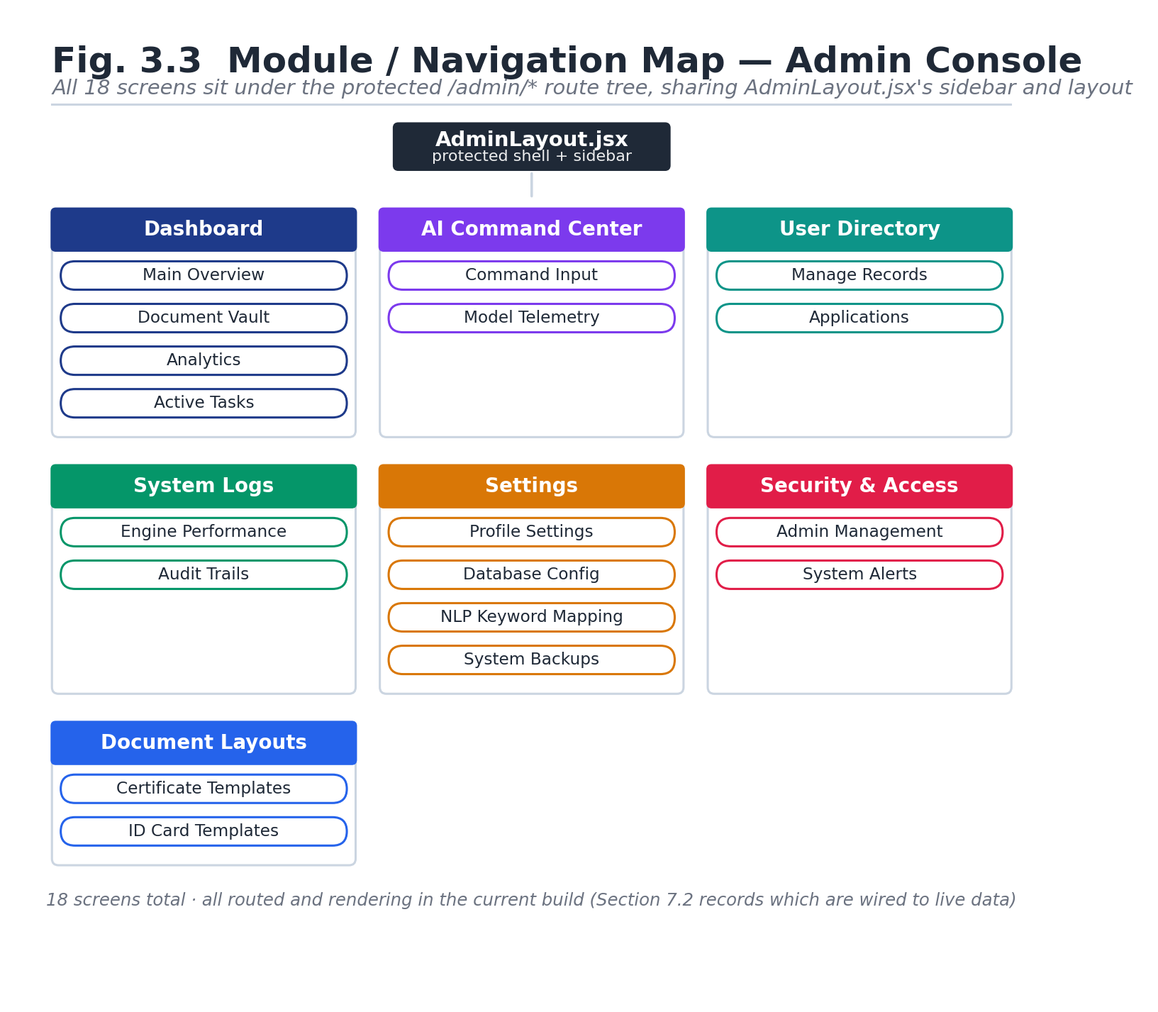

Fig. 3.3 Module / Navigation Map of the Admin Console
User Portal map. The User Portal has its own, smaller navigation structure: public pages (landing, sign-in, sign-up, forgot-password) and a protected area (dashboard, internships, applications, profile, progress, stipend, certificate, notifications). It is mapped in Section 6.4 (Fig. 6.2) and inventoried, with the API each screen depends on, in Table 6.2.

3.5 Data Flow Diagrams
Figure 3.4 is the Level-0 context diagram: it places the Alpha Intelligence admin system between the administrator, the intern/applicant data source, document output, and the planned Alpha-NLU engine. Figure 3.5 decomposes the system into its five constituent processes — authenticate admin, manage intern directory, process NL command, generate documents, and monitor/audit — together with their data stores. The dashed, amber-noted flow between “Process NL Command” and the Alpha-NLU engine marks the one integration point that does not exist yet; every other flow shown is either already implemented or is a direct, already-coded consequence of the stub API contract described in Section 4.3.
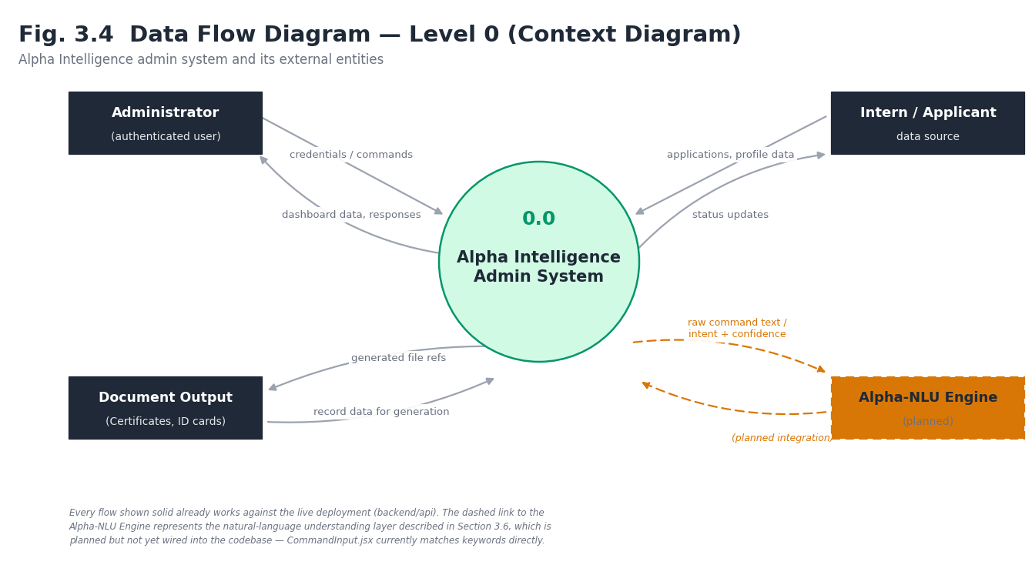
Fig. 3.4 Data Flow Diagram — Level 0 (Context Diagram)
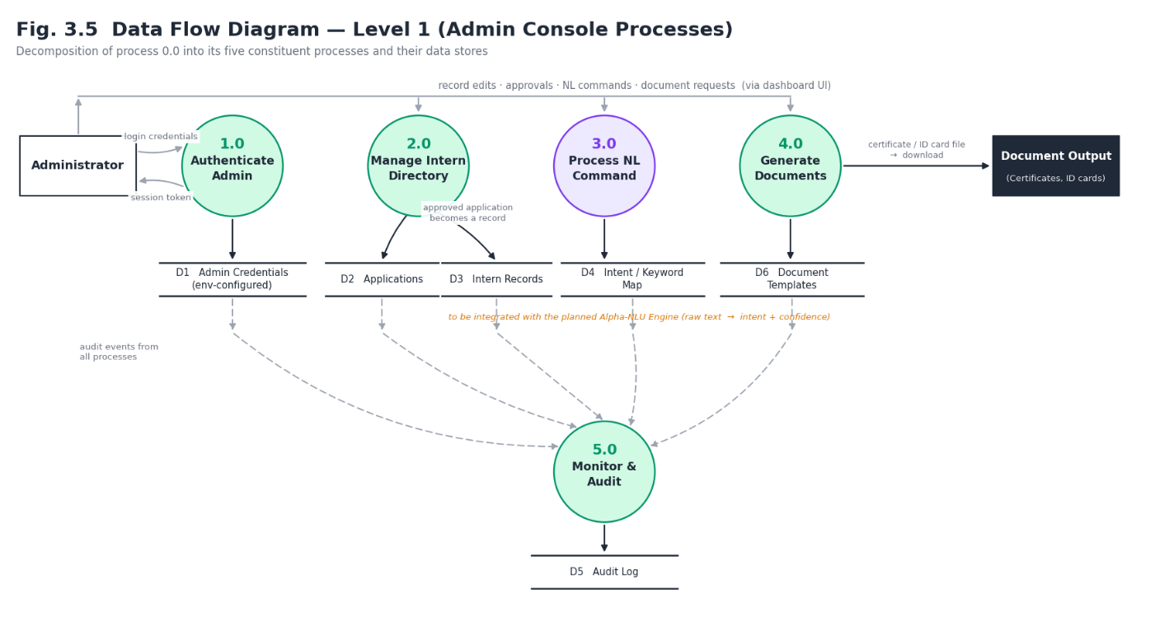
Fig. 3.5 Data Flow Diagram — Level 1 (Admin Console Processes)
User-side data flow. The Level-0 and Level-1 data-flow diagrams for the User Portal, and the hand-off of its data to the admin side, are given in Section 3.8 (Figures 3.7 and 3.8). The Admin diagrams above and the User diagrams there share the same data stores: an Application written on the user side is the same Application is read on the admin side and is approved or rejected by the admin on the admin panel.

3.6 Current Development Phase
At the time of writing, the project is in an early implementation phase. The frontend shell (routing, layout, authentication flow, and all eighteen admin screens) is complete; the backend implements real authentication and session security but exposes only a stub data contract; and the database and Alpha-NLU engine are at the design stage, represented in this report by Figures 3.2 and 4.1 rather than by working code. The next development phase (Chapter 11) is to connect a real database behind the existing API contract and begin implementing Alpha-NLU against the Intent schema already defined.
User-side phase. The User Portal frontend has been built and is running against Firebase directly; no backend exists for it. The Admin Console’s backend implements real authentication but serves a stub contract. Both halves are therefore waiting on the same missing piece — a shared backend with a persistent datastore — which is why Sections 3.7 to 3.12 and Chapter 4 specify it once for both.

3.7 Integrated System Architecture
The complete platform is arranged in four tiers. Tier 1 — clients: the Admin Console (React 19, Vite) and the User Portal (React 19, Create React App), each a static single-page application. Tier 2 — API: one Node.js / Express service, deployed as a serverless function, exposing the REST endpoints in Section 3.12. It accepts two kinds of bearer credential — a Firebase ID token from students and the existing HMAC-signed session token from administrators — and applies a different middleware to each route family. Tier 3 — domain services: application service, notification service, document service, audit service and, when built, Alpha-NLU. These are plain modules called by controllers, so that a form click, a natural-language command and a scheduled job all run the same code. Tier 4 — data layer: Firebase Authentication for student identities, a shared Cloud Firestore database, and file storage for résumés, photos and generated documents.
Two design decisions follow from this. First, the browser never talks to the datastore for anything privileged: after the migration described in Section 7.9 the User Portal reads and writes through the API, and Firestore security rules are tightened to deny direct client writes to protected fields. Second, there is exactly one place where a rule such as “a student may apply to an internship only once” is enforced, which is the application service, rather than one copy in each frontend.
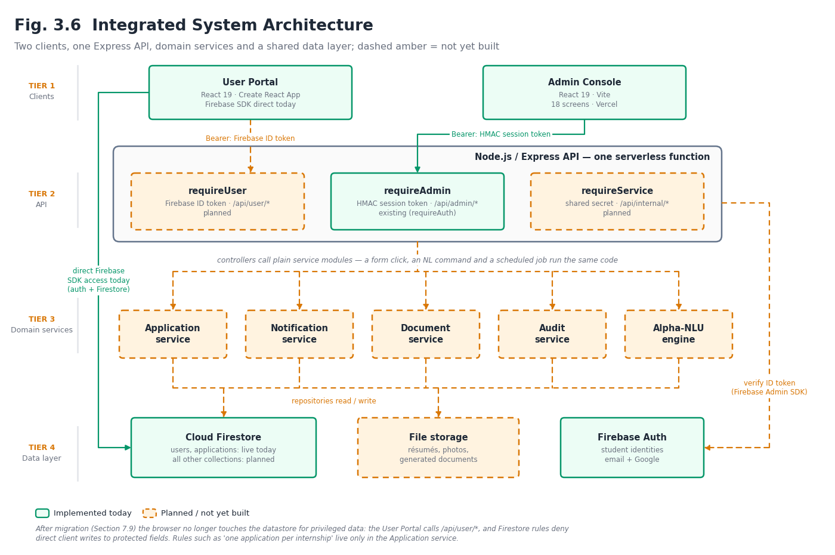Fig. 3.6 Integrated System Architecture — User Portal, Admin Console, Backend and Data Layer

3.8 User Portal Data Flow Diagrams
Level 0 (Fig. 3.7). The context diagram places the User Portal between four external entities: the Student, the Administrator (who consumes the student’s data through the Admin Console), Firebase Authentication (identity provider) and file storage. The flows into the system are sign-up and sign-in credentials, profile data, application submissions and notification read-receipts; the flows out are internship listings, application status, stipend information, certificates and notifications.
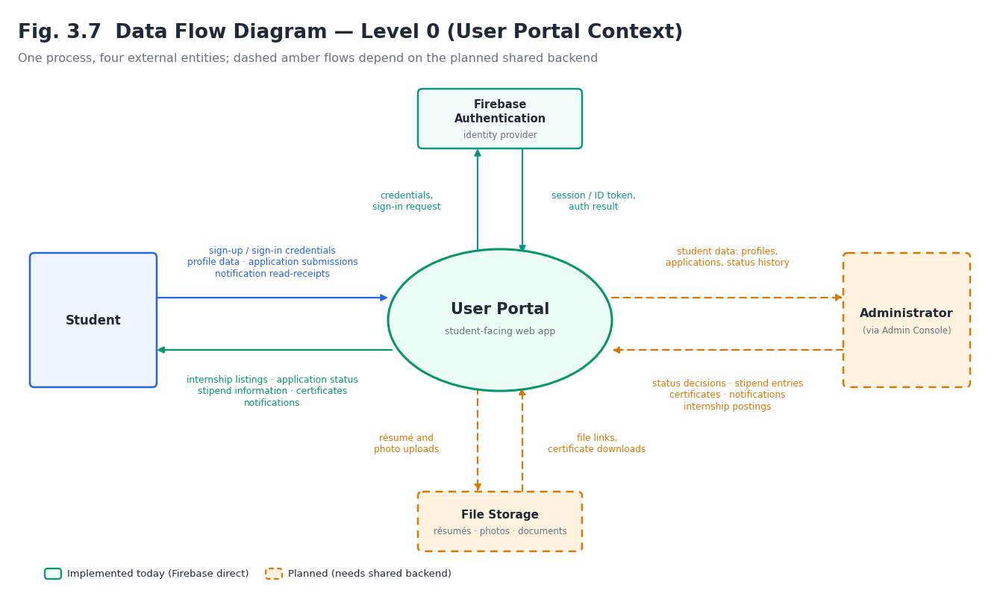Fig. 3.7 Data Flow Diagram — Level 0 (User Portal Context Diagram)
Level 1 (Fig. 3.8). The system decomposes into six processes: P1 authenticate user, P2 manage profile, P3 discover internships, P4 apply and track application, P5 view stipend and certificates, and P6 receive notifications. Their data stores are D1 users, D2 internships, D3 applications, D4 application history, D5 stipends, D6 certificates and D7 notifications. The hand-off to the admin side is drawn as flows out of D1, D3 and D4 into the Admin Console’s User Directory, Applications and Dashboard processes, and as flows back from the Admin Console into D3, D4, D5, D6 and D7 (status decisions, stipend entries, generated certificates, notifications). D2 is written by the Admin Console’s internship-posting process and read by P3.
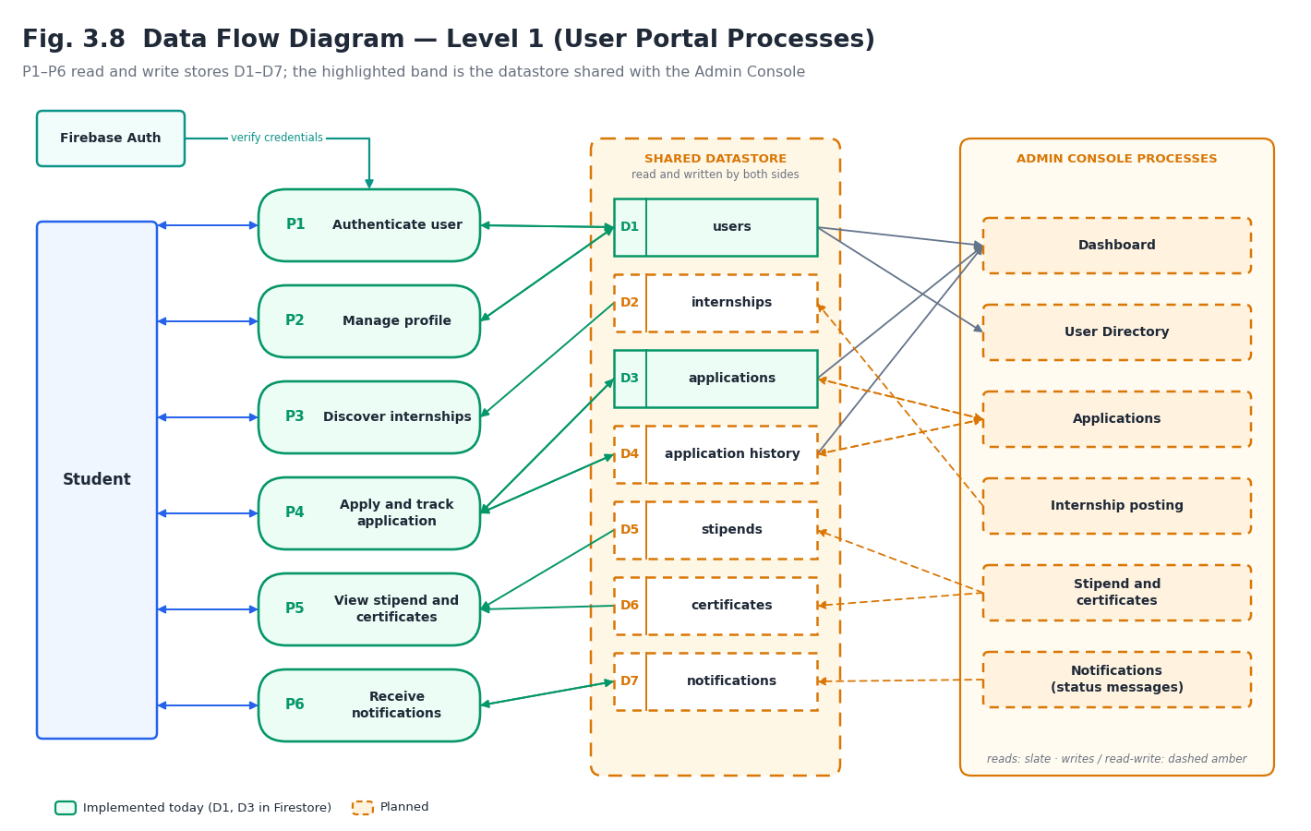Fig. 3.8 Data Flow Diagram — Level 1 (User Portal Processes and Hand-off to Admin)

3.9 User-Side to Admin-Side Data Flow
The requirement that data “get from the user side to the admin side” is met by a single principle: the user side and the admin side never exchange data with each other; both read and write the same records through the backend, and every state change emits a domain event. The end-to-end flow for the central use case is:
- The student submits an application from the Internships or Applications screen. The User Portal calls POST /api/user/applications with the Firebase ID token.
- The backend verifies the token, checks that the internship is open, that the student’s profile is complete and that no application for the same internship exists, then writes the Application (status Submitted) and its first history entry in one transaction.
- The application service emits the event application.submitted. Its handlers create an admin inbox item, an AuditLog entry with source = user, and update the dashboard counters.
- The Admin Console, polling GET /api/admin/sync/changes?since=<cursor>, receives the new application; the Applications screen, the dashboard counter and the sidebar inbox badge update.
- The administrator (or a natural-language command) sets a decision with PATCH /api/admin/applications/:id/status. The backend writes the new status, a history entry, an AuditLog entry (source = ui or nl) and a Notification for the student, again in one transaction.
- The student’s Progress and Notifications screens show the new status and message on their next request; the unread badge is served by GET /api/user/notifications/unread-count.
- When the student accepts the offer, an InternRecord is created; later the administrator records stipend payments and issues a certificate, each of which produces a notification and appears on the corresponding user screen.
Because the deployment target is serverless, the admin side uses pull with a cursor (short-interval polling of the sync endpoint) rather than a long-lived connection. Should the backend later move to a persistent host, the same events can be pushed over Server-Sent Events without changing their content. Table 3.1 lists the events.
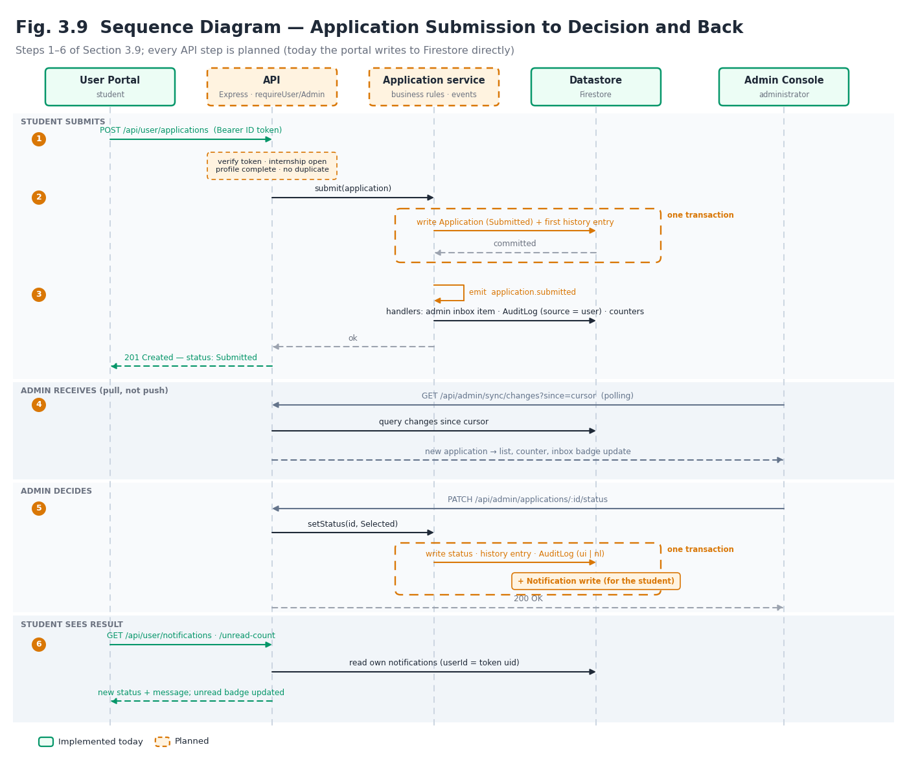Fig. 3.9 Sequence Diagram — Application Submission (User) to Decision (Admin) and Back
Table 3.1 Domain Events Exchanged Between User Side and Admin Side
Event | Origin | Effects on the other side
user.registered | User | users record created; admin inbox item; dashboard user counter
profile.updated | User | Profile visible in User Directory; flag if résumé changed
application.submitted | User | Appears in Applications; inbox item; dashboard pending count; audit (source = user)
application.edited / withdrawn | User | Status and history updated; inbox item; audit
offer.accepted / declined | User | InternRecord created (accepted); inbox item; audit
certificate.requested | User | Entry in certificate-request queue; inbox item
enquiry.submitted | Public | Entry in enquiries list; inbox item
account.deletion.requested | User | Admin inbox item; account soft-deleted after review
application.status.changed | Admin / NL | Notification to student; timeline entry; audit (source = ui | nl)
record.created / updated | Admin | Student’s Progress and Dashboard reflect onboarding
stipend.recorded | Admin | Appears on Stipend screen; notification
certificate.issued / revoked | Admin | Appears on Certificate screen; notification; verification code becomes valid / revoked
internship.published / closed | Admin | Listing on Internships screen and landing page updates
notification.broadcast | Admin | Notification created for each targeted student

3.10 Application Status Lifecycle
The user-side README records that each application document carries a status field but does not enumerate its values. This section proposes the vocabulary that both frontends and the backend will share, so that “status” means the same thing on the student’s Progress timeline and on the administrator’s Applications screen. Transitions are enforced by the application service; an invalid transition (for example Rejected to Selected without reopening) returns HTTP 409.
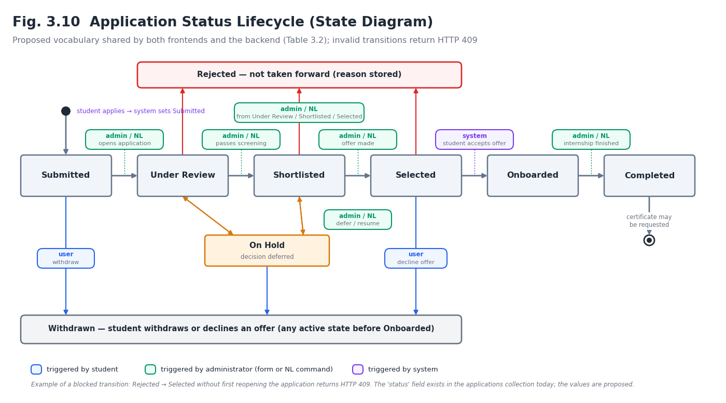Fig. 3.10 Application Status Lifecycle (State Diagram)
Table 3.2 Application Status Lifecycle
Status | Meaning | Set by | Student sees
Submitted | Application received and stored | System (on apply) | Application submitted
Under Review | An administrator has opened it | Admin / NL | Under review
Shortlisted | Passed initial screening | Admin / NL | Shortlisted
On Hold | Decision deferred | Admin | On hold
Selected | Offer made | Admin / NL | Selected — accept or decline
Rejected | Not taken forward (reason stored) | Admin / NL | Not selected
Withdrawn | Student withdrew | User | Withdrawn
Onboarded | Offer accepted; InternRecord created | System (on accept) | Internship active
Completed | Internship finished; certificate may be requested | Admin | Completed

3.11 Expected Backend Architecture
The backend is expected to remain in the stack already used for the Admin API — Node.js and Express — so that the existing authentication controller, middleware and deployment can be reused rather than rewritten. It is organised in layers (Fig. 3.11): routes map paths to controllers and declare which middleware applies; middleware performs authentication, validation, rate limiting and error handling; controllers translate HTTP into service calls and back; services hold business rules and emit domain events; repositories are the only code that touches the datastore; and an event bus delivers domain events to handlers that write notifications, inbox items and audit entries. Because repositories are the sole data-access layer, the database decision left open in Section 4.2 changes one layer, not the whole backend.
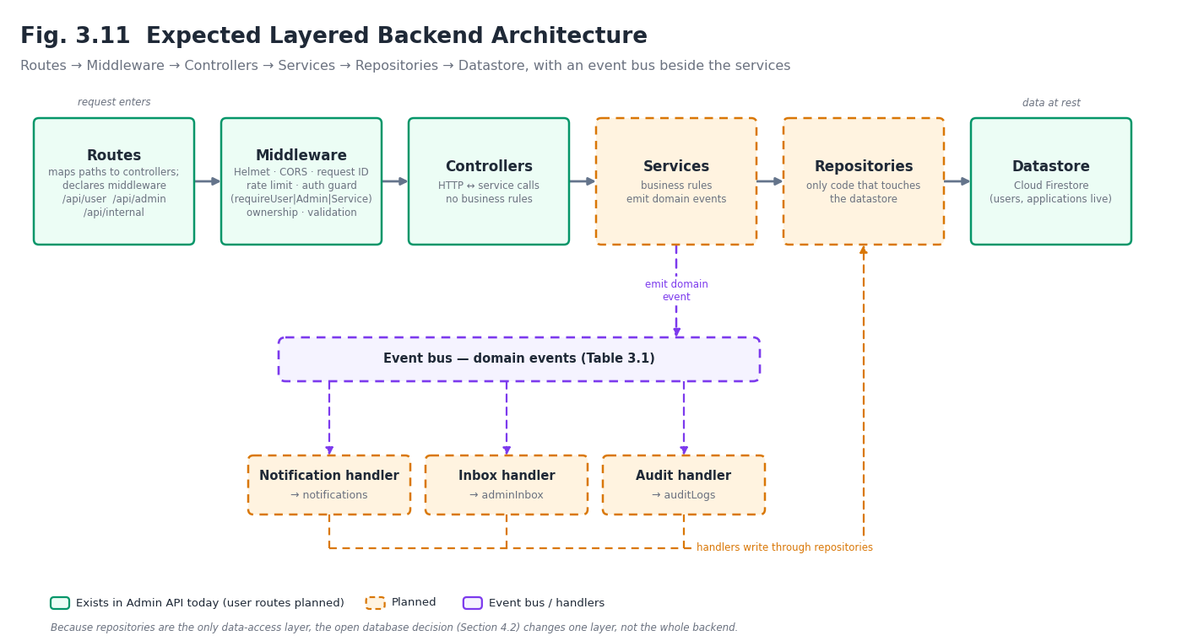Fig. 3.11 Expected Layered Backend Architecture
Identity. Students authenticate with Firebase; the User Portal obtains a Firebase ID token and sends it as a bearer token. The backend verifies it with the Firebase Admin SDK (signature, expiry, audience and issuer) and reads a role claim. Administrators continue to use the existing HMAC session token; it is verified by the existing requireAuth logic, which is renamed requireAdmin in the new route tree. The two middleware are mutually exclusive: a user token presented to an admin route, or an admin token presented to a user route, is rejected. A third, requireService, protects /api/internal/* with a shared secret. Table 3.3 gives the order in which middleware runs.
Table 3.3 Expected Backend Middleware Order
Order | Middleware | Purpose | Status
1 | Helmet | Security headers | Existing
2 | CORS allow-list | Origins from FRONTEND_URL (comma-separated, so the User Portal origin is added without code change) | Existing
3 | Request ID + logger | Correlate logs and audit entries | Planned
4 | express.json (size-limited) / multipart | Parse bodies; cap upload size and type | Existing / Planned
5 | Rate limiter | Auth: 10 per 15 min (existing); user writes and reads with higher planned limits | Existing / Planned
6 | requireUser | requireAdmin | requireService | Authenticate the caller for the route family | Existing (admin) / Planned
7 | Ownership / permission guard | Object-level authorisation: user may touch only own resources; admin role checked | Planned
8 | Validation | Schema-validate params, query and body | Planned
9 | Controller → service → repository | Business rules and data access | Planned
10 | Error handler | Uniform error envelope; no stack traces to clients | Planned

3.12 REST API Specification
The Admin API in the repository today exposes five routes. That is enough to log in and to prove the frontend contract, but it cannot carry data between the two sides of the platform: there is no route by which a student can submit anything and none by which an administrator can read it individually or act on it. This section specifies the complete API. It contains 168 endpoints in 11 groups; 5 exist and the remaining 163 are planned. Table 3.4 gives the breakdown, and Tables 3.5 to 3.15 list every endpoint. Sample payloads are in Appendix C, and Appendix D maps every Admin screen to its endpoints.

Conventions
- Base and format. All routes are under /api; request and response bodies are JSON (UTF-8), except file uploads (multipart/form-data) and downloads. Timestamps are ISO 8601 in UTC.
- Route families. /api/public/* (no authentication), /api/auth/* (admin authentication), /api/user/* (Firebase ID token), /api/admin/* (admin session token) and /api/internal/* (shared secret, service-to-service only).
- Response envelope. Success: { data, meta } where meta carries pagination (page, limit, total). Failure: { error: { code, message, details, requestId } } with a stable machine-readable code.
- Status codes. 200/201/204 for success; 400 validation; 401 missing or invalid credential; 403 wrong role or not the owner; 404 not found (also used instead of 403 for other users’ resources, to avoid confirming they exist); 409 conflict (duplicate application, invalid status transition); 413/415 upload limits; 422 business-rule failure; 429 rate limited.
- Pagination and filtering. List endpoints accept page, limit (default 20, maximum 100), sort and endpoint-specific filters; the same parameters are used on user and admin lists.
- Idempotency. Creating an application uses a deterministic key (userId + internshipId), so a repeated submit cannot create a duplicate; other POSTs that create resources accept an optional Idempotency-Key header.
- Audit. Every write under /api/admin/* and every user write that changes an application, record or certificate produces an AuditLog entry recording actor, source (ui, nl, user, system), entity and before/after values.
- Rate limits. Authentication routes keep the existing 10 requests per 15 minutes; the design targets (to be tuned) are 60 writes and 300 reads per minute per user, and 600 per minute per admin.
- Uploads. Résumés (PDF) and photos (PNG / JPEG) are limited in size (design target: 5 MB), type-checked by content, stored outside the database and returned only as short-lived signed URLs.
Table 3.4 API Groups and Endpoint Counts
Table | Group | Path prefixes | Consumer | Endpoints
3.5 | Public, System and Admin Authentication APIs | /, /api/health, /api/public/*, /api/auth/* | Public / Admin | 13 (4 existing)
3.6 | User Account and Profile APIs | /api/user/session, me, profile | User Portal | 13 (0 existing)
3.7 | User Internship, Application and Progress APIs | /api/user/internships, applications, progress | User Portal | 12 (0 existing)
3.8 | User Stipend, Certificate, Notification and Dashboard APIs | /api/user/stipend, certificates, notifications, dashboard | User Portal | 16 (0 existing)
3.9 | Admin Dashboard, Analytics, Task and Document Vault APIs | /api/admin/data, dashboard, analytics, tasks, documents | Admin Console | 14 (1 existing)
3.10 | Admin AI Command Center, Telemetry and NLP Mapping APIs | /api/admin/commands, telemetry, intents | Admin Console | 12 (0 existing)
3.11 | Admin User Directory APIs (Users, Applications, Records) | /api/admin/users, applications, records | Admin Console | 17 (0 existing)
3.12 | Admin Internship Posting, Stipend and Notification APIs | /api/admin/internships, stipends, notifications | Admin Console | 13 (0 existing)
3.13 | Admin System Logs, Settings and Backup APIs | /api/admin/logs, profile, settings, backups | Admin Console | 16 (0 existing)
3.14 | Admin Security, Alert, Template and Document-Generation APIs | /api/admin/admins, alerts, templates, documents | Admin Console | 28 (0 existing)
3.15 | User-to-Admin Integration, Sync and Internal Service APIs | /api/admin/inbox, sync, certificate-requests, enquiries; /api/internal/* | Admin Console, services | 14 (0 existing)
 | Total |  |  | 168 (5 existing)

Table 3.5 Public, System and Admin Authentication APIs
Method | Endpoint | Description | Access | Status
GET | / | Service banner returning { name, ok }. | Public | Existing
GET | /api/health | Health check; to be extended to report database and Firebase Admin connectivity. | Public | Existing
GET | /api/public/internships | Landing-page preview of open internships (limited fields, cached). | Public | Planned
GET | /api/public/stats | Aggregate counters for the landing page (open roles, applicants, certificates issued). | Public | Planned
POST | /api/public/enquiries | Submit a contact / enquiry form from the marketing pages. | Public | Planned
GET | /api/public/certificates/verify/:code | Verify a certificate by its public verification code (valid / revoked / not found). | Public | Planned
POST | /api/auth/login | Admin login; returns a signed session token. | Public | Existing
POST | /api/auth/forgot-password | Request an admin password-reset link (always HTTP 202). | Public | Existing
POST | /api/auth/reset-password | Complete a reset using a one-time, expiring token. | Public | Planned
POST | /api/auth/logout | Revoke the current admin token (deny-list until its expiry). | Admin | Planned
GET | /api/auth/me | Current admin identity, role and permissions. | Admin | Planned
POST | /api/auth/refresh | Issue a fresh token before expiry (sliding session aligned with the 15-minute idle rule). | Admin | Planned
PUT | /api/auth/password | Change admin password after verifying the current one. | Admin | Planned

Table 3.6 User Account and Profile APIs
Method | Endpoint | Description | Access | Status
POST | /api/user/session | Called after Firebase sign-in / sign-up: verifies the ID token, creates or syncs the users record, returns role and profile summary. | User | Planned
GET | /api/user/me | Current user identity, account status and profile completeness. | User | Planned
POST | /api/user/session/logout | Revoke the user’s Firebase refresh tokens server-side. | User | Planned
DELETE | /api/user/me | Request account deletion (soft delete; admin is notified). | User | Planned
GET | /api/user/profile | Read the full student profile. | User | Planned
PUT | /api/user/profile | Update the profile (validated server-side). | User | Planned
PATCH | /api/user/profile/education | Update the education block (college, degree, branch, year). | User | Planned
PATCH | /api/user/profile/skills | Update skills and external links. | User | Planned
POST | /api/user/profile/resume | Upload a résumé (PDF, size-limited); returns a storage reference. | User | Planned
GET | /api/user/profile/resume | Short-lived signed download URL for the résumé. | User | Planned
DELETE | /api/user/profile/resume | Remove the stored résumé. | User | Planned
POST | /api/user/profile/photo | Upload a profile photo (image, size-limited). | User | Planned
GET | /api/user/profile/completeness | Percentage complete and list of missing fields (gates applications). | User | Planned

Table 3.7 User Internship, Application and Progress APIs
Method | Endpoint | Description | Access | Status
GET | /api/user/internships | Search and list open internships (q, domain, mode, location, duration, stipend, sort, page, limit). | User | Planned
GET | /api/user/internships/filters | Facet values and counts for the filter panel. | User | Planned
GET | /api/user/internships/:id | Full internship detail. | User | Planned
POST | /api/user/applications | Apply to an internship; enforces open posting, profile completeness and no duplicates. | User | Planned
GET | /api/user/applications | List own applications (status filter, pagination). | User | Planned
GET | /api/user/applications/:id | Detail of one own application. | User | Planned
PATCH | /api/user/applications/:id | Edit cover note / answers while status is Submitted. | User | Planned
POST | /api/user/applications/:id/withdraw | Withdraw an application. | User | Planned
GET | /api/user/applications/:id/timeline | Status history that drives the progress timeline. | User | Planned
POST | /api/user/applications/:id/offer/accept | Accept a selection / offer (triggers record creation). | User | Planned
POST | /api/user/applications/:id/offer/decline | Decline a selection / offer. | User | Planned
GET | /api/user/progress | Consolidated selection progress across all applications (drives /progress). | User | Planned

Table 3.8 User Stipend, Certificate, Notification and Dashboard APIs
Method | Endpoint | Description | Access | Status
GET | /api/user/stipend | Stipend summary (rate, total paid, next payment). | User | Planned
GET | /api/user/stipend/payments | Payment history for the signed-in intern. | User | Planned
GET | /api/user/stipend/payments/:id/receipt | Download a payment receipt. | User | Planned
GET | /api/user/certificates | List certificates issued to the user. | User | Planned
GET | /api/user/certificates/:id | Certificate detail and verification code. | User | Planned
GET | /api/user/certificates/:id/download | Download the certificate PDF. | User | Planned
POST | /api/user/certificates/requests | Request a certificate on completion of the internship. | User | Planned
GET | /api/user/certificates/requests | Own certificate requests and their status. | User | Planned
GET | /api/user/notifications | List notifications (unread filter, pagination). | User | Planned
GET | /api/user/notifications/unread-count | Unread badge count. | User | Planned
PATCH | /api/user/notifications/:id/read | Mark one notification as read. | User | Planned
POST | /api/user/notifications/read-all | Mark all notifications as read. | User | Planned
DELETE | /api/user/notifications/:id | Dismiss a notification. | User | Planned
GET | /api/user/notification-preferences | Read notification channel preferences. | User | Planned
PUT | /api/user/notification-preferences | Update notification channel preferences. | User | Planned
GET | /api/user/dashboard | Aggregated home-screen data (counts, latest status, unread notifications). | User | Planned

Table 3.9 Admin Dashboard, Analytics, Task and Document Vault APIs
Method | Endpoint | Description | Access | Status
GET | /api/admin/data | Bootstrap aggregate (existing stub contract); to be capped / paginated once granular endpoints exist. | Admin | Existing
GET | /api/admin/dashboard/stats | KPI counters: pending applications, active interns, open alerts, documents. | Admin | Planned
GET | /api/admin/dashboard/activity | Recent activity feed, including user-originated events. | Admin | Planned
GET | /api/admin/analytics/applications | Application time series (range, groupBy). | Admin | Planned
GET | /api/admin/analytics/funnel | Funnel: submitted → shortlisted → selected → active → completed. | Admin | Planned
GET | /api/admin/analytics/domains | Breakdown by internship domain and college. | Admin | Planned
GET | /api/admin/tasks | List active tasks. | Admin | Planned
POST | /api/admin/tasks | Create a task. | Admin | Planned
PATCH | /api/admin/tasks/:id | Update task status / assignee / due date. | Admin | Planned
DELETE | /api/admin/tasks/:id | Delete a task. | Admin | Planned
GET | /api/admin/documents | Document Vault listing (type, owner, date filters). | Admin | Planned
GET | /api/admin/documents/:id | Document metadata. | Admin | Planned
GET | /api/admin/documents/:id/download | Download a stored document. | Admin | Planned
DELETE | /api/admin/documents/:id | Archive (soft-delete) a document. | Admin | Planned

Table 3.10 Admin AI Command Center, Telemetry and NLP Mapping APIs
Method | Endpoint | Description | Access | Status
POST | /api/admin/commands | Submit a natural-language command; Alpha-NLU returns intent, confidence and a proposed action or alert. | Admin | Planned
GET | /api/admin/commands | Command history for the Command Input screen. | Admin | Planned
GET | /api/admin/commands/:id | Command detail with matched intent and audit reference. | Admin | Planned
POST | /api/admin/commands/:id/confirm | Confirm and execute a pending action (human-in-the-loop). | Admin | Planned
POST | /api/admin/commands/:id/cancel | Cancel a pending command. | Admin | Planned
GET | /api/admin/telemetry | Model Telemetry: intent hit-rate, mean confidence, latency. | Admin | Planned
GET | /api/admin/telemetry/inferences | List individual inference records. | Admin | Planned
GET | /api/admin/intents | List intents / keyword mappings. | Admin | Planned
POST | /api/admin/intents | Create an intent (name, systemAction, keywords[], confidenceMin). | Admin | Planned
PUT | /api/admin/intents/:id | Update an intent. | Admin | Planned
DELETE | /api/admin/intents/:id | Delete an intent. | Admin | Planned
POST | /api/admin/intents/test | Dry-run a phrase against the mappings without executing anything. | Admin | Planned

Table 3.11 Admin User Directory APIs (Users, Applications, Records)
Method | Endpoint | Description | Access | Status
GET | /api/admin/users | List portal users (search, status, college, pagination). | Admin | Planned
GET | /api/admin/users/:uid | User detail with profile and applications. | Admin | Planned
PATCH | /api/admin/users/:uid/status | Suspend or reactivate a user account. | Admin | Planned
GET | /api/admin/applications | List applications (status, internshipId, domain, date range, q, sort, pagination). | Admin | Planned
GET | /api/admin/applications/:id | Application detail with applicant snapshot and history. | Admin | Planned
PATCH | /api/admin/applications/:id/status | Shortlist / approve / reject / hold with reason; notifies the user and writes audit. | Admin | Planned
POST | /api/admin/applications/bulk-status | Apply one decision to many applications. | Admin | Planned
POST | /api/admin/applications/:id/notes | Add an internal note (not visible to the user). | Admin | Planned
GET | /api/admin/applications/:id/history | Full status history. | Admin | Planned
GET | /api/admin/applications/export | CSV export of the filtered view. | Admin | Planned
GET | /api/admin/records | Manage Records: list intern records. | Admin | Planned
POST | /api/admin/records | Create a record (automatic on approval, or manual). | Admin | Planned
GET | /api/admin/records/:id | Record detail. | Admin | Planned
PUT | /api/admin/records/:id | Update a record. | Admin | Planned
PATCH | /api/admin/records/:id/status | Mark active / completed / terminated. | Admin | Planned
DELETE | /api/admin/records/:id | Archive a record. | Admin | Planned
GET | /api/admin/records/export | CSV export of records. | Admin | Planned

Table 3.12 Admin Internship Posting, Stipend and Notification APIs
Method | Endpoint | Description | Access | Status
GET | /api/admin/internships | List internship postings (status filter). | Admin | Planned
POST | /api/admin/internships | Create a posting (draft or open). | Admin | Planned
GET | /api/admin/internships/:id | Posting detail. | Admin | Planned
PUT | /api/admin/internships/:id | Update a posting. | Admin | Planned
PATCH | /api/admin/internships/:id/status | Open, close or return to draft. | Admin | Planned
DELETE | /api/admin/internships/:id | Archive a posting. | Admin | Planned
GET | /api/admin/internships/:id/applications | Applicants of one posting. | Admin | Planned
GET | /api/admin/stipends | List stipend payments (record, status, period). | Admin | Planned
POST | /api/admin/stipends | Record a stipend payment for an intern. | Admin | Planned
PUT | /api/admin/stipends/:id | Correct a stipend entry. | Admin | Planned
GET | /api/admin/records/:id/stipend | Stipend ledger of one intern. | Admin | Planned
POST | /api/admin/notifications | Send a notification to one user or a segment. | Admin | Planned
GET | /api/admin/notifications | Log of notifications sent. | Admin | Planned

Table 3.13 Admin System Logs, Settings and Backup APIs
Method | Endpoint | Description | Access | Status
GET | /api/admin/logs/engine | Engine Performance: latency, error rate, uptime. | Admin | Planned
GET | /api/admin/logs/audit | Audit Trails (actor, action, entity, date, source = ui | nl | user | system). | Admin | Planned
GET | /api/admin/logs/audit/:id | One audit entry with before / after snapshot. | Admin | Planned
GET | /api/admin/logs/audit/export | CSV export of audit entries. | Admin | Planned
GET | /api/admin/profile | Read the admin’s own profile. | Admin | Planned
PUT | /api/admin/profile | Update the admin’s own profile. | Admin | Planned
GET | /api/admin/settings/database | Read database configuration (secrets masked). | Admin | Planned
PUT | /api/admin/settings/database | Update database configuration. | Admin | Planned
POST | /api/admin/settings/database/test | Real “Test Connection” replacing the simulated button. | Admin | Planned
GET | /api/admin/backups | List system backups. | Admin | Planned
POST | /api/admin/backups | Create a backup on demand. | Admin | Planned
GET | /api/admin/backups/:id/download | Download a backup archive. | Admin | Planned
POST | /api/admin/backups/:id/restore | Restore from a backup (requires confirmation). | Admin | Planned
DELETE | /api/admin/backups/:id | Delete a backup. | Admin | Planned
GET | /api/admin/backups/schedule | Read the automatic backup schedule. | Admin | Planned
PUT | /api/admin/backups/schedule | Update the automatic backup schedule. | Admin | Planned

Table 3.14 Admin Security, Alert, Template and Document-Generation APIs
Method | Endpoint | Description | Access | Status
GET | /api/admin/admins | Admin Management: list admin accounts. | Admin | Planned
POST | /api/admin/admins | Invite / create an admin account. | Admin | Planned
PUT | /api/admin/admins/:id | Update an admin account. | Admin | Planned
PATCH | /api/admin/admins/:id/role | Change an admin’s role. | Admin | Planned
DELETE | /api/admin/admins/:id | Remove an admin account. | Admin | Planned
GET | /api/admin/permissions | List roles and permissions. | Admin | Planned
GET | /api/admin/alerts | System Alerts list (severity, resolved filters). | Admin | Planned
GET | /api/admin/alerts/:id | Alert detail. | Admin | Planned
PATCH | /api/admin/alerts/:id/resolve | Resolve / acknowledge an alert. | Admin | Planned
GET | /api/admin/alert-channels | List alert delivery channels. | Admin | Planned
PUT | /api/admin/alert-channels/:id | Update a channel. | Admin | Planned
POST | /api/admin/alert-channels/:id/test | Send a test alert through a channel. | Admin | Planned
GET | /api/admin/templates/certificates | List certificate templates. | Admin | Planned
POST | /api/admin/templates/certificates | Create a certificate template. | Admin | Planned
GET | /api/admin/templates/certificates/:id | Read one certificate template. | Admin | Planned
PUT | /api/admin/templates/certificates/:id | Update a certificate template. | Admin | Planned
DELETE | /api/admin/templates/certificates/:id | Delete a certificate template. | Admin | Planned
POST | /api/admin/templates/certificates/:id/preview | Render a preview with sample data. | Admin | Planned
GET | /api/admin/templates/id-cards | List ID-card templates. | Admin | Planned
POST | /api/admin/templates/id-cards | Create an ID-card template. | Admin | Planned
GET | /api/admin/templates/id-cards/:id | Read one ID-card template. | Admin | Planned
PUT | /api/admin/templates/id-cards/:id | Update an ID-card template. | Admin | Planned
DELETE | /api/admin/templates/id-cards/:id | Delete an ID-card template. | Admin | Planned
POST | /api/admin/templates/id-cards/:id/preview | Render an ID-card preview. | Admin | Planned
POST | /api/admin/documents/certificates/generate | Generate certificates for one or many records. | Admin | Planned
POST | /api/admin/documents/id-cards/generate | Generate ID cards for one or many records. | Admin | Planned
POST | /api/admin/documents/:id/revoke | Revoke an issued document. | Admin | Planned
POST | /api/admin/documents/:id/reissue | Re-issue a document with corrected data. | Admin | Planned

Table 3.15 User-to-Admin Integration, Sync and Internal Service APIs
Method | Endpoint | Description | Access | Status
GET | /api/admin/inbox | Unified feed of user-originated items needing attention (new applications, withdrawals, certificate requests, enquiries). | Admin | Planned
GET | /api/admin/inbox/unread-count | Badge count for the admin sidebar. | Admin | Planned
PATCH | /api/admin/inbox/:id/ack | Acknowledge an inbox item. | Admin | Planned
GET | /api/admin/sync/changes | Delta feed: ?since=<cursor> returns created / updated applications, users and requests. | Admin | Planned
GET | /api/admin/users/:uid/activity | Chronological activity of one portal user. | Admin | Planned
GET | /api/admin/certificate-requests | Queue of user certificate requests. | Admin | Planned
PATCH | /api/admin/certificate-requests/:id | Approve or reject a request; approval triggers generation. | Admin | Planned
GET | /api/admin/enquiries | Public enquiries submitted from the landing page. | Admin | Planned
PATCH | /api/admin/enquiries/:id | Update enquiry status / reply note. | Admin | Planned
POST | /api/internal/events | Service-to-service event ingestion (shared-secret header), e.g. from cloud functions. | Service | Planned
POST | /api/internal/firebase/user-created | Webhook: a Firebase Auth user was created. | Service | Planned
POST | /api/internal/firebase/user-deleted | Webhook: a Firebase Auth user was deleted. | Service | Planned
POST | /api/internal/jobs/backup-run | Scheduled trigger for backups (e.g. Vercel Cron). | Service | Planned
POST | /api/internal/jobs/cleanup | Scheduled trigger: expire tokens, archive stale drafts, purge read notifications. | Service | Planned

Note: “Existing” marks the five routes present in the Admin repository today (Section 7.2). Every other route is a design specification, not implemented behaviour. Path names and payload shapes are proposals intended to be frozen at the start of backend implementation.

4. Database Design (Planned)
No database is connected at the time of writing. This chapter documents the schema the current admin API (Section 4.3) is deliberately shaped to grow into, so that connecting a real database later is a backend-only change with no impact on the already-built frontend.
User-side extension. The schema documented in this chapter now also covers the entities the User Portal produces and consumes. Two of them already exist as live Firestore collections — users and applications — so, unlike the admin-side entities, part of this data model is in use today.

4.1 Conceptual Data Model
Figure 4.1 shows eight planned entities. Admin, Application and InternRecord support the existing user-directory workflow (an approved Application becomes an InternRecord). Intent and Alert support the planned Alpha-NLU engine: Intent mirrors the exact shape already produced by the NLP Keyword Mapping screen (name, systemAction, keywords[]), and a low-confidence or unmatched command is designed to raise an Alert rather than fail silently. DocumentTemplate and GeneratedDocument support certificate/ID-card generation. AuditLog is written to by every administrative action, whether triggered through a form or — once built — through a natural-language command.
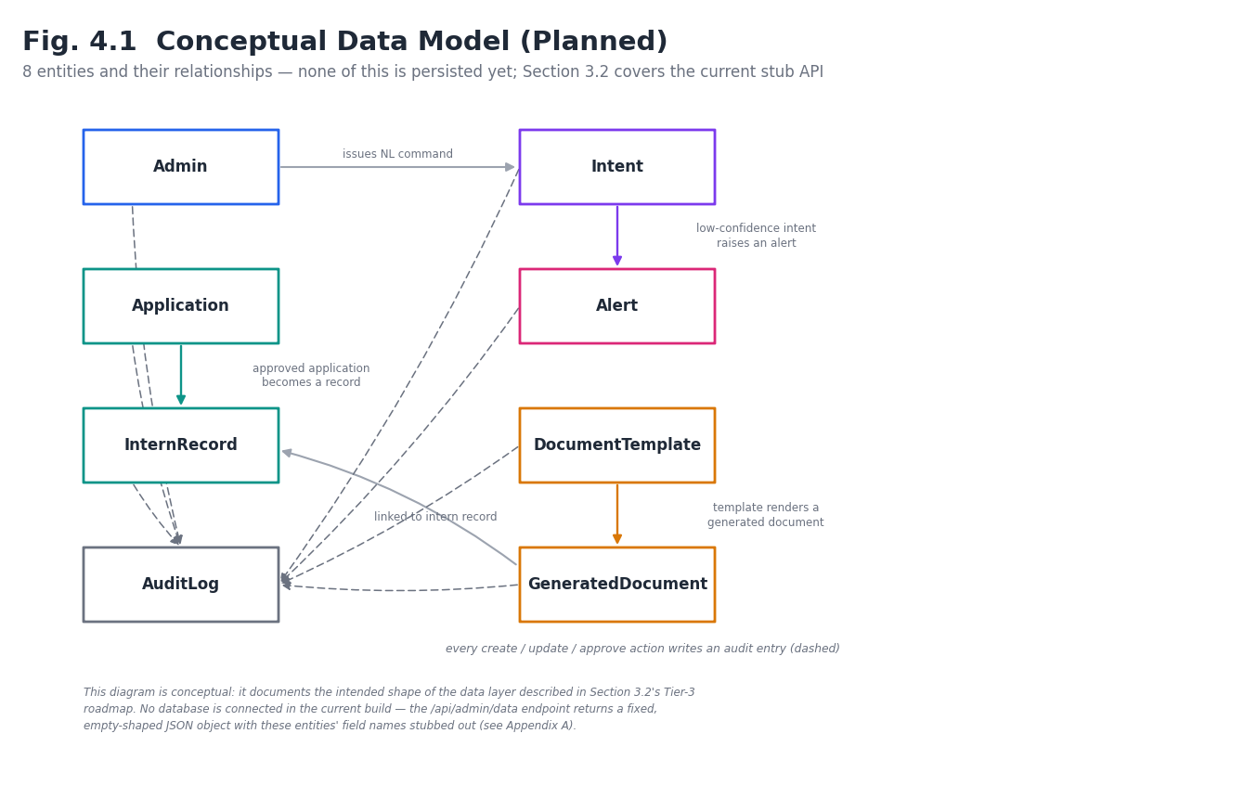
Fig. 4.1 Conceptual Data Model (Planned)
Extended model. Figure 4.1 shows the entities required by the Admin Console. The User Portal adds six more — User, Internship, ApplicationHistory, Notification, StipendPayment and CertificateRequest — and an AdminInbox that surfaces user-originated items to administrators. The combined model is drawn in Figure 4.2 in Section 4.4. Application is the entity where the two sides meet: it is created by a student, decided by an administrator, and read by both.

4.2 Candidate Database Engines and Selection Criteria
Three candidates are under consideration, as noted on the architecture diagram (Figure 3.1): MongoDB, Firestore, and PostgreSQL. The selection criteria are (a) low operational overhead to maintain and extend, (b) a generous free tier compatible with the current Vercel deployment, (c) straightforward modelling of the mostly document-shaped entities in Figure 4.1, and (d) a Node.js driver that integrates cleanly with the existing Express controllers without a large rewrite. A relational engine (PostgreSQL) would benefit the foreign-key-heavy relationships between Application, InternRecord, DocumentTemplate and GeneratedDocument; a document store (MongoDB or Firestore) would better fit the variable-shaped keywords[] array on Intent and would require the least change to the JSON-shaped stub the frontend already consumes. This trade-off is the specific decision the next development phase needs to resolve before Section 4.1's field types can be finalised.
Update in light of the User Portal. The choice among MongoDB, Firestore and PostgreSQL was left open in this section. The User Portal has since been built on Firebase Authentication and Cloud Firestore, and two collections already hold live documents. This tips the balance toward Cloud Firestore as the shared datastore: it is JSON-document-shaped (matching the stub contract and the keywords[] array), the student data already lives in it, and Firebase Authentication identities map directly onto user documents by UID. The trade-offs are the ones listed above — no joins, so the admin-facing Applications list is served from a denormalised applicant snapshot stored on each Application, and reporting uses aggregation queries or maintained counters. The final decision remains with the project team; Sections 4.4 to 4.7 are written to hold under either a document store or PostgreSQL because all access goes through repositories (Section 3.11).

4.3 Interim Data Strategy — the Stub API Contract
Until a database is chosen and connected, backend/src/controllers/adminController.js exposes a single authenticated endpoint, GET /api/admin/data, that returns a fixed-shape JSON object with every field present but empty (applications: [], records: [], intents: [], auditLogs: [], databaseConfig: {}, and so on). This is a deliberate interim strategy rather than an oversight: it lets the entire frontend — all eighteen screens and their React state in AdminContext.jsx — be built and tested against a real, stable API shape before any storage engine exists. Connecting a database in the next phase means populating this same contract from real queries rather than redesigning it.
Contract growth. The single GET /api/admin/data endpoint is retained as a bootstrap payload. With real data behind it, returning every application, record and log in one response will not scale, so in the extended API each field of the contract is also served by a paginated, filterable endpoint (Section 3.12; Table 4.2 gives the origin of each field), and /api/admin/data is reduced to counts and the first page of each list.

4.4 Extended Conceptual Data Model
Figure 4.2 combines the eight admin entities of Figure 4.1 with the user-side entities. Relationships: a User (identified by Firebase UID) submits many Applications; an Internship receives many Applications; an Application has many ApplicationHistory entries and, once accepted, exactly one InternRecord; an InternRecord has many StipendPayments and many GeneratedDocuments; a User receives many Notifications; a User raises CertificateRequests against an InternRecord; every state change writes an AuditLog entry, and user-originated changes also write an AdminInbox item.
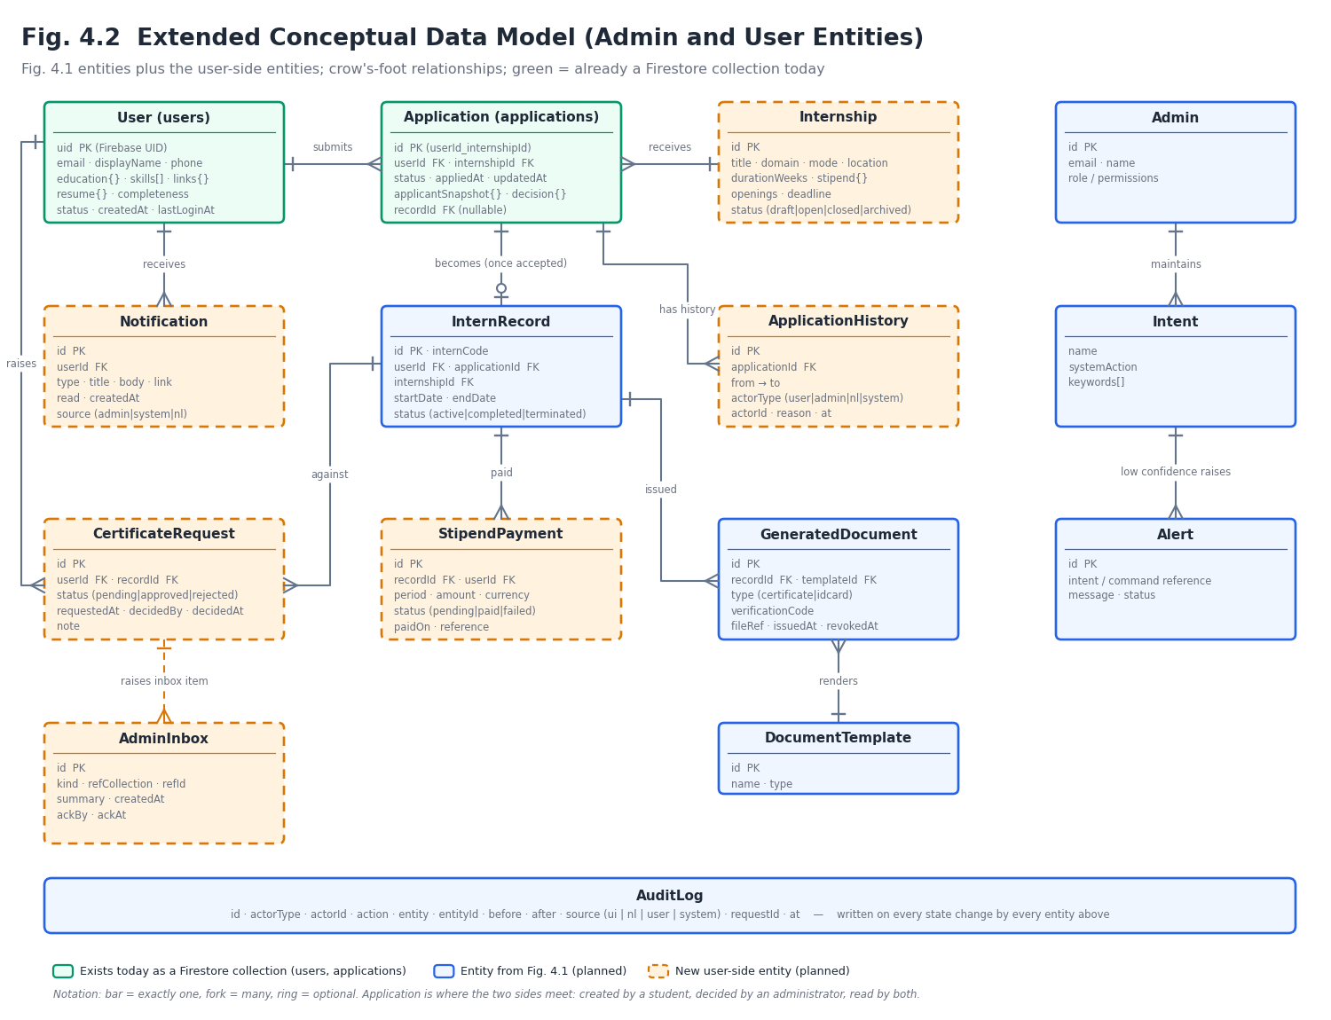Fig. 4.2 Extended Conceptual Data Model (Admin and User Entities)
Table 4.1 Extended Data Dictionary
Entity (collection) | Key fields | Written by | Read by
User (users)† | uid (PK = Firebase UID), email, displayName, phone, education{college, degree, branch, year}, skills[], links{}, resume{path, name, uploadedAt}, completeness, status, createdAt, updatedAt, lastLoginAt | User (via API); Admin (status) | User; Admin
Internship (internships) | id, title, domain, description, requirements[], mode, location, durationWeeks, stipend{amount, currency, type}, openings, deadline, status (draft | open | closed | archived), createdBy, createdAt | Admin | User; Admin; public
Application (applications)† | id (userId_internshipId), userId (FK), internshipId (FK), status, appliedAt, updatedAt, coverNote, answers{}, applicantSnapshot{name, email, college, domain}, decision{by, reason, at}, recordId (FK, nullable) | User (create/edit/withdraw); Admin (status) | User; Admin
ApplicationHistory (applicationHistory) | id, applicationId (FK), from, to, actorType (user | admin | nl | system), actorId, reason, at | Backend only | User (timeline); Admin
InternRecord (records) | id, internCode, userId (FK), applicationId (FK), internshipId (FK), startDate, endDate, status (active | completed | terminated), mentor | Backend / Admin | User (progress); Admin
StipendPayment (stipends) | id, recordId (FK), userId (FK), period, amount, currency, status (pending | paid | failed), paidOn, reference, createdBy | Admin | User (own); Admin
GeneratedDocument (certificates) | id, recordId (FK), userId (FK), templateId (FK), type (certificate | idcard), verificationCode, fileRef, issuedAt, revokedAt, issuedBy | Admin / NL | User (own); Admin; public verify
CertificateRequest (certificateRequests) | id, userId (FK), recordId (FK), status (pending | approved | rejected), requestedAt, decidedBy, decidedAt, note | User (create); Admin (decide) | User (own); Admin
Notification (notifications) | id, userId (FK), type, title, body, link, read, createdAt, source (admin | system | nl) | Backend (event handlers); Admin (broadcast) | User (own)
AdminInbox (adminInbox) | id, kind, refCollection, refId, summary, createdAt, ackBy, ackAt | Backend (event handlers) | Admin
Enquiry (enquiries) | id, name, email, message, status, createdAt | Public | Admin
AuditLog (auditLogs) — extended | id, actorType, actorId, action, entity, entityId, before, after, source (ui | nl | user | system), requestId, at | Backend only | Admin
† These collections exist today. Per the User Portal README: users/{uid} stores profile data, and applications/{applicationId} stores userId, internshipId, status and appliedAt. All other fields and collections in Table 4.1 are proposed extensions.

4.5 Origin of the Admin Data Contract Fields
Table 4.2 shows where each field of the stub contract returned by GET /api/admin/data (Section 7.2) will come from once real data exists. It also makes explicit which fields depend on data originating on the user side.
Table 4.2 Origin of Each Field in the Admin Data Contract
Contract field | Populated from | Depends on user side?
applications | applications joined with users and internships | Yes — created by students
records | records | Indirectly — created when a student accepts an offer
dashboardStats | Counts over applications by status, active records, open alerts, documents | Yes
recentActivity | Latest applicationHistory, adminInbox and auditLogs entries | Yes
tasks | tasks | No
documents, certificateTemplates, idCardTemplates | certificates and document templates | Partly — certificate requests
auditLogs | auditLogs | Yes — entries with source = user
backups, databaseConfig | backup metadata; system configuration | No
alerts, alertChannels | alerts, alert channel settings | Partly — anomalies in user activity
intents, commandHistory, inferences | intents, commands, inferences (Alpha-NLU) | No
adminProfile, profileData, adminPermissions | admins, roles | No

4.6 Firestore Collections, Indexes and Access Rules
The layout below assumes Cloud Firestore. Collections are top-level (not nested under users) so that the admin side can query across all students without collection-group queries. Table 4.3 lists the collections, the composite indexes the main queries need, and the access principle applied to each.
Table 4.3 Planned Firestore Collections, Indexes and Access Rules
Collection | Document ID | Main indexes | Client access after migration
users | Firebase UID | status + createdAt; college | Owner read; protected fields (status, role) write-denied
internships | auto id | status + deadline; domain + status | Read where status = open; write denied
applications | userId_internshipId | userId + appliedAt; internshipId + status; status + appliedAt | Owner read; write denied (API only)
applicationHistory | auto id | applicationId + at | Owner read via API; write denied
records | auto id | userId; status + startDate | Owner read; write denied
stipends | auto id | recordId + period; userId + paidOn | Owner read; write denied
certificates | auto id; verificationCode unique | userId + issuedAt; verificationCode | Owner read; write denied
notifications | auto id | userId + read + createdAt | Owner read; only read flag update (via API)
adminInbox, auditLogs, enquiries | auto id | createdAt; ackAt; source + at | No client access; backend only

The rules follow the warning in the User Portal README that users must be able to read and write only their own data. In the target design that is tightened further: because the backend uses the Firebase Admin SDK, which is not subject to security rules, the rules can simply deny all client writes to privileged collections and allow only owner reads.

4.7 Consistency, Denormalisation and Synchronisation
- Atomic multi-write. Changing an application’s status writes the Application, an ApplicationHistory entry, an AuditLog entry, a Notification and (for user-originated changes) an AdminInbox item in one transaction or batched write, so the two sides can never disagree about state.
- Denormalised applicant snapshot. Each Application stores the applicant’s name, email, college and domain at the time of applying, so the admin list needs no per-row lookup. The snapshot is refreshed when the profile is updated while the application is still open.
- Deterministic identifiers. Application ID = userId_internshipId enforces uniqueness without a query-then-insert race.
- Change cursor. Every write sets updatedAt from the server clock; GET /api/admin/sync/changes?since= returns documents changed after the cursor and a new cursor, which is what the Admin Console polls.
- Counters. Dashboard counts use aggregation queries or counters updated in the same transaction as the status change, avoiding full collection scans.
- Retention and privacy. Student data is personal data. Only fields the programme needs are collected; deleted accounts are soft-deleted then purged on a schedule; access follows the principles of the Digital Personal Data Protection Act, 2023 (India), subject to institutional legal review.

5. Requirement Specification

5.1 Functional Requirements
Table 5.1 lists the functional requirements of the Admin module, drawn directly from the screens and API routes that exist in the repository plus the behaviour Alpha-NLU is designed to provide once built. Each requirement is tagged with its current status.
User-side and backend requirements. Table 5.1 covers the Admin module. Tables 5.3 and 5.4 below cover the User Portal (prefix UFR) and the backend and integration layer (prefix BFR); Table 5.5 adds non-functional requirements that arise from having two frontends and one shared backend. Status for user-side items reflects the User Portal repository’s README (routes and Firebase integration are listed there); “Planned” means nothing exists yet.
ID | Requirement | Status
FR-1 | Admin shall authenticate with email + password over a rate-limited endpoint. | Implemented
FR-2 | System shall issue a signed, time-limited session token on successful login. | Implemented
FR-3 | System shall auto-expire a session after 15 minutes of inactivity. | Implemented
FR-4 | Admin shall be able to request a password reset link. | Implemented (stub — always 202, no email sent yet)
FR-5 | Admin shall view a dashboard summarising tasks, applications and alerts. | Implemented (UI); backed by empty stub data
FR-6 | Admin shall manage intern/applicant records (view, and eventually approve/reject). | UI implemented; write actions planned
FR-7 | Admin shall issue an NL command and receive a system response. | Implemented as a keyword-matched simulation
FR-8 | System shall map NL commands to system actions via an editable Intent/keyword table. | Planned (Alpha-NLU)
FR-9 | System shall log every administrative action to an audit trail. | UI implemented; persistent storage planned
FR-10 | Admin shall generate certificates and ID cards from templates. | Planned
FR-11 | System shall raise an Alert when a command cannot be confidently matched. | Planned (Alpha-NLU)
FR-12 | Admin shall configure the database connection from the Settings screen. | UI implemented (simulated “Test Connection”)
Table 5.3 User-Side Functional Requirements
ID | Requirement | Status
UFR-1 | Visitor shall be able to view the public landing page without signing in. | Implemented (UI)
UFR-2 | Student shall be able to create an account with email and password. | Implemented (Firebase Auth)
UFR-3 | Student shall be able to sign in with email/password or Google. | Implemented (Firebase Auth)
UFR-4 | Student shall be able to request a password-reset email. | Implemented (route + Firebase)
UFR-5 | Protected pages shall be reachable only by an authenticated student. | Implemented (protected dashboard routes)
UFR-6 | Student shall see a dashboard summarising their applications and account. | Implemented (UI)
UFR-7 | Student shall be able to search and browse internships. | Implemented (searchable listing UI)
UFR-8 | Student shall be able to apply to an internship, creating an application with status and applied-at date. | Implemented against Firestore; server-side rules planned
UFR-9 | Student shall be able to view the list and status of their applications. | Implemented (UI)
UFR-10 | Student shall be able to view and edit their profile. | Implemented (users/{uid})
UFR-11 | Student shall be able to follow the selection progress of an application as a timeline. | UI implemented; live data planned
UFR-12 | Student shall be able to view stipend information. | UI implemented; data planned
UFR-13 | Student shall be able to view and download certificates. | UI implemented; generation planned
UFR-14 | Student shall be able to view notifications. | UI implemented; delivery planned
UFR-15 | Student shall be able to edit or withdraw an application before it is reviewed. | Planned
UFR-16 | Student shall be able to upload a résumé and profile photo. | Planned
UFR-17 | Student shall be able to accept or decline an offer. | Planned
UFR-18 | Student shall be able to request a certificate after completion. | Planned
UFR-19 | Student shall be able to set notification preferences. | Planned

Table 5.4 Backend and Integration Functional Requirements
ID | Requirement | Status
BFR-1 | Backend shall verify the Firebase ID token on every /api/user/* request. | Planned
BFR-2 | Backend shall create or sync the users record on first sign-in. | Planned
BFR-3 | Backend shall validate and persist applications, rejecting duplicates, closed postings and incomplete profiles. | Planned
BFR-4 | Applications submitted by students shall appear in the Admin Console’s Applications screen within the polling interval (design target: 30 s). | Planned
BFR-5 | An admin status decision shall update the application, history, audit log and student notification atomically. | Planned
BFR-6 | Every user- and admin-originated state change shall be written to the AuditLog with its source. | Planned
BFR-7 | Internship postings created by admins shall be the only listings shown to students. | Planned
BFR-8 | An InternRecord shall be created when a student accepts an offer. | Planned
BFR-9 | Stipend entries recorded by admins shall be visible to the owning student only. | Planned
BFR-10 | Certificates shall carry a public verification code, verifiable without signing in. | Planned
BFR-11 | A student shall be able to access only their own resources (object-level authorisation). | Planned
BFR-12 | All write endpoints shall be validated and rate-limited. | Planned
BFR-13 | The backend shall provide an admin inbox and a cursor-based sync feed for user-originated events. | Planned
BFR-14 | All endpoints shall return a uniform error envelope and consistent pagination. | Planned
BFR-15 | Résumés, photos and generated documents shall be stored outside the database and served by signed, expiring URLs. | Planned
BFR-16 | The Alpha-NLU command layer shall invoke the same services as the form-based screens. | Planned

5.2 Non-Functional Requirements
ID | Requirement | Notes
NFR-1 | Security | Passwords hashed with scrypt; sessions HMAC-signed; Helmet security headers; CORS allow-list
NFR-2 | Availability | Deployed as a Vercel serverless function — scales to zero, no server to maintain
NFR-3 | Usability | Sidebar navigation groups 18 screens into 7 task-oriented categories
NFR-4 | Auditability | Every AI-triggered action is designed to be traceable to an AuditLog entry (Fig. 4.1)
NFR-5 | Portability | Stateless REST API — any Node-compatible host can serve it; frontend is a static SPA build
NFR-6 | Maintainability | Component-based React frontend; controller-based Express backend; single stub contract
NFR-7 | Cost | Every dependency is open-source; current deployment fits free-tier hosting limits
Table 5.5 Additional Non-Functional Requirements
ID | Requirement | Notes
NFR-8 | Data isolation | A student can never read or modify another student’s data; enforced in the backend and in Firestore rules
NFR-9 | Interoperability | One API and one status vocabulary serve two frontends built with different tooling
NFR-10 | Performance (design target) | p95 latency under 500 ms for list endpoints at about 10,000 applications
NFR-11 | Consistency | User and admin views of an application never disagree (atomic multi-write, Section 4.7)
NFR-12 | Privacy | Minimal collection, soft-delete then purge, résumé access only by signed URL; aligned with the principles of the DPDP Act, 2023
NFR-13 | Scalability | Stateless API on serverless hosting; pagination on every list
NFR-14 | Observability | Request IDs in logs, audit entries and error responses
NFR-15 | Device support | User Portal usable on phones (students’ primary device); responsive layout
NFR-16 | Accessibility | Use MUI’s accessible components and keyboard-reachable forms; target WCAG 2.1 AA

5.3 User Requirements
The single user role at this stage is the Administrator — the system currently has no multi-role support; Section 3.6 and the Security & Access screen group (Admin Management) are designed as the seam through which additional admin accounts and roles would be added in a later phase.
Second user role. The statement above describes the Admin module. The complete platform has three actors: the Guest (unauthenticated visitor), the Student / Intern (a User Portal account), and the Administrator. A fourth, non-human actor, the Service (scheduled jobs and webhooks), calls /api/internal/*. Table 5.6 summarises what each may do; the Admin’s own multi-role extension (Admin Management) remains as described above.
Table 5.6 Role–Capability Matrix
Capability | Guest | Student | Admin
View landing page and public listings | Yes | Yes | Yes
Verify a certificate by code | Yes | Yes | Yes
Sign up / sign in (Firebase) | Yes | — | —
Sign in to Admin Console (email + password) | — | — | Yes
Edit own profile, résumé | — | Yes | —
Search internships and apply | — | Yes | —
View / withdraw own applications | — | Yes | —
View own stipend, certificates, notifications | — | Yes | —
View all applications and users | — | — | Yes
Approve / reject applications | — | — | Yes
Create and close internship postings | — | — | Yes
Record stipends, issue certificates | — | — | Yes
Issue natural-language commands | — | — | Yes
Manage admins, backups, templates, alerts | — | — | Yes (by role)

5.4 System Requirements
- Client: any modern evergreen browser (Chrome, Edge, Firefox, Safari) with JavaScript enabled.
- Server: Node.js 18+ runtime (Vercel serverless functions), no persistent filesystem required by the current stub API.
- Build tooling: Node.js and npm for both frontend (Vite) and backend (Express) packages.
- No database server is required to run the current build; one becomes a requirement once Chapter 4's schema is implemented.
- User Portal (build and run): Node.js and npm; the repository uses react-scripts 5 (npm start serves on http://localhost:3000; npm run build produces the static bundle; npm test -- --watchAll=false runs tests).
- User Portal (services): a Firebase project with Email/Password and Google sign-in enabled and a Firestore database; the Firebase web-app values are supplied through .env.local (copied from .env.example) and are never committed.
- Backend (expected): Node.js 18+ and the Firebase Admin SDK credentials as an environment secret; a shared datastore; file storage; and an FRONTEND_URL allow-list containing both frontend origins.
- Two local frontends: the User Portal’s development server defaults to port 3000, so the Admin frontend and the backend must be configured to different ports during local development.

5.5 Backend and API Requirements
- Every route belongs to exactly one family (public, auth, user, admin, internal) and applies exactly one authentication middleware.
- Every list endpoint is paginated and filterable; every write endpoint validates its input; every write produces an audit entry.
- Errors use one envelope and stable codes; the same status vocabulary (Section 3.10) is used everywhere.
- Business rules live in services, not controllers or frontends, so that form-driven, natural-language-driven and scheduled actions behave identically.
- The API is versionable: routes can be prefixed /api/v1 without changing payloads when the contract is frozen.
- The 168-endpoint catalogue in Section 3.12 is the acceptance checklist for backend completion; each endpoint has at least one test in Table 9.2 or its successors.

5.6 Integration Requirements
- A student action shall become visible on the admin side, and an admin decision on the student side, without manual copying (BFR-4, BFR-5).
- The two frontends shall share one backend and one datastore; neither shall keep a private copy of application data.
- The User Portal shall keep Firebase Authentication as its identity provider; the backend shall not store student passwords.
- The existing Admin authentication (scrypt, HMAC token, 15-minute idle timeout) shall be preserved unchanged for administrators.
- CORS shall permit both frontend origins through the existing FRONTEND_URL list.
- Migration from direct Firestore access to API access shall be incremental (Section 7.9): the User Portal must remain working at each step.

6. UI Design

6.1 Design Approach
The interface follows a dark, terminal-influenced aesthetic for the AI-facing screens (the AI Command Center) and a lighter, conventional dashboard aesthetic for the form-based screens, so that the two interaction styles — typed commands versus clicked forms — are visually distinguishable at a glance. Figure 6.1 is an original, low-fidelity wireframe of the layout, drawn directly from AdminLayout.jsx and the routing structure in App.jsx; no screenshots exist in the repository at the time of writing, so no photographic UI capture is included in this report.
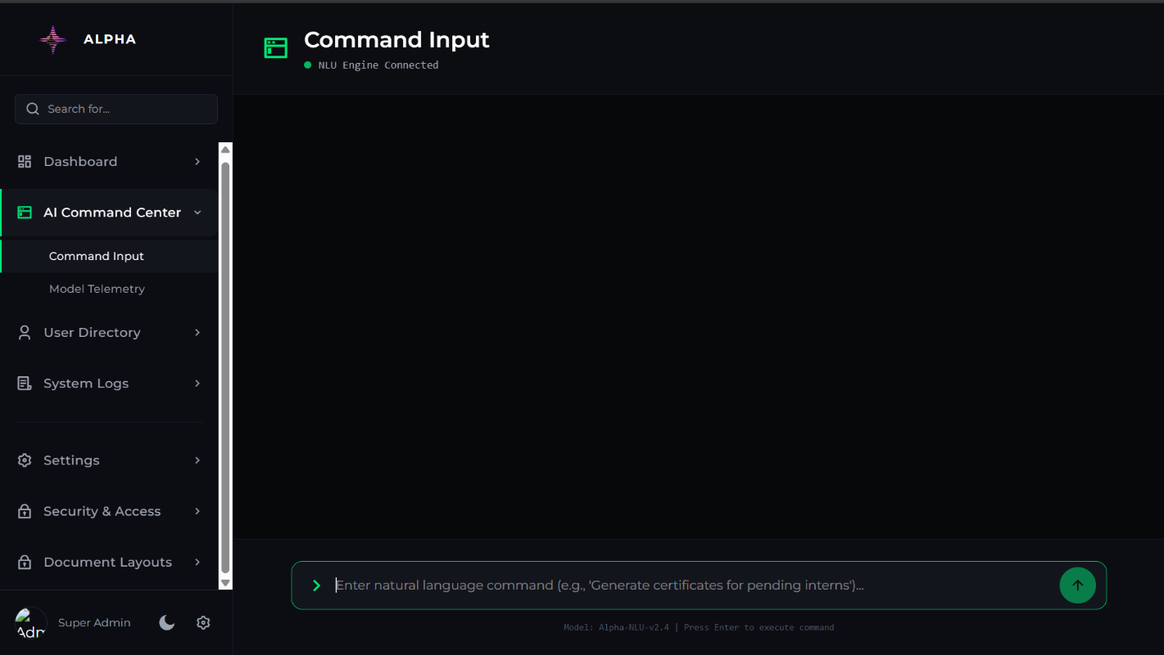
Fig. 6.1 Illustrative Wireframe — Admin Console Layout
User Portal design approach. The User Portal serves a different audience — students, often on phones — and so follows a different visual language from the admin console. It uses Material UI (with Emotion and MUI icons) for accessible, familiar components, with Tailwind CSS 3 for layout and utility styling. It has a public marketing area (landing, sign-in, sign-up, forgot-password) and an authenticated area (dashboard, internships, applications, profile, progress, stipend, certificate, notifications). The two products deliberately differ in tone — dense and terminal-flavoured for administrators, open and guided for students — but share the status vocabulary of Table 3.2 so that a label means the same thing on both sides.

6.2 Screen Inventory
Table 6.1 lists all eighteen screens reachable under the protected /admin/* route tree, grouped as they appear in the sidebar.
Group | Screens
Dashboard | Main Overview, Document Vault, Analytics, Active Tasks
AI Command Center | Command Input, Model Telemetry
User Directory | Manage Records, Applications
System Logs | Engine Performance, Audit Trails
Settings | Profile Settings, Database Config, NLP Keyword Mapping, System Backups
Security & Access | Admin Management, System Alerts
Document Layouts | Certificate Templates, ID Card Templates
User Portal screens. Table 6.2 lists the twelve routes documented in the User Portal repository, together with the API each will call once the backend exists.
Table 6.2 User Portal Screen Inventory
Route | Screen | Purpose | Primary API (planned)
/ | Landing page | Public introduction to the programme; calls to action | GET /api/public/internships, /api/public/stats
/signin | Sign in | Email/password and Google sign-in | Firebase Auth; POST /api/user/session
/signup | Create account | Register a student account | Firebase Auth; POST /api/user/session
/forgot-password | Password reset | Request reset email | Firebase Auth (sendPasswordResetEmail)
/dashboard | Dashboard home | Summary of applications, progress, notifications | GET /api/user/dashboard
/internships | Internships | Searchable listing; apply | GET /api/user/internships, /filters; POST /api/user/applications
/applications | My applications | Submitted applications and their status | GET /api/user/applications; POST .../withdraw
/profile | Profile | View and edit student profile | GET/PUT /api/user/profile; POST .../resume
/progress | Selection progress | Application timeline | GET /api/user/progress; .../timeline
/stipend | Stipend | Stipend information and payments | GET /api/user/stipend, /payments
/certificate | Certificates | View, download, request certificates | GET /api/user/certificates; POST .../requests
/notifications | Notifications | Account notifications | GET /api/user/notifications; PATCH .../read

6.3 Navigation and Layout Principles
- A persistent left sidebar (AdminLayout.jsx) keeps the seven groups one click away from any screen.
- The AI Command Center is placed second in the sidebar — directly under Dashboard — to signal it as a first-class alternative to clicking through forms, in line with the project's “AI as manager” premise.
- A 15-minute idle timeout (AuthContext.jsx) protects the console without requiring the admin to manually lock the screen.
- Colour is used consistently per group in the sidebar (Fig. 3.3) so the admin can orient by colour before reading labels.
- User Portal navigation. Public routes are reachable by anyone; the eight authenticated routes sit behind a protected area that redirects unauthenticated visitors to sign-in. The dashboard is the post-login landing screen and links to each of the others.
- Consistency across products. Statuses, terminology (Application, Internship, Certificate) and date formats are shared with the Admin Console (Table 3.2) so screenshots or messages from one side are understandable on the other.

6.4 User Portal Navigation and Screen Flow
The typical student journey is: land on / → sign up → complete profile → browse internships → apply → follow progress → (on selection) accept → view stipend → request and download certificate, with notifications running alongside. Figure 6.2 maps the routes and the transitions between them.
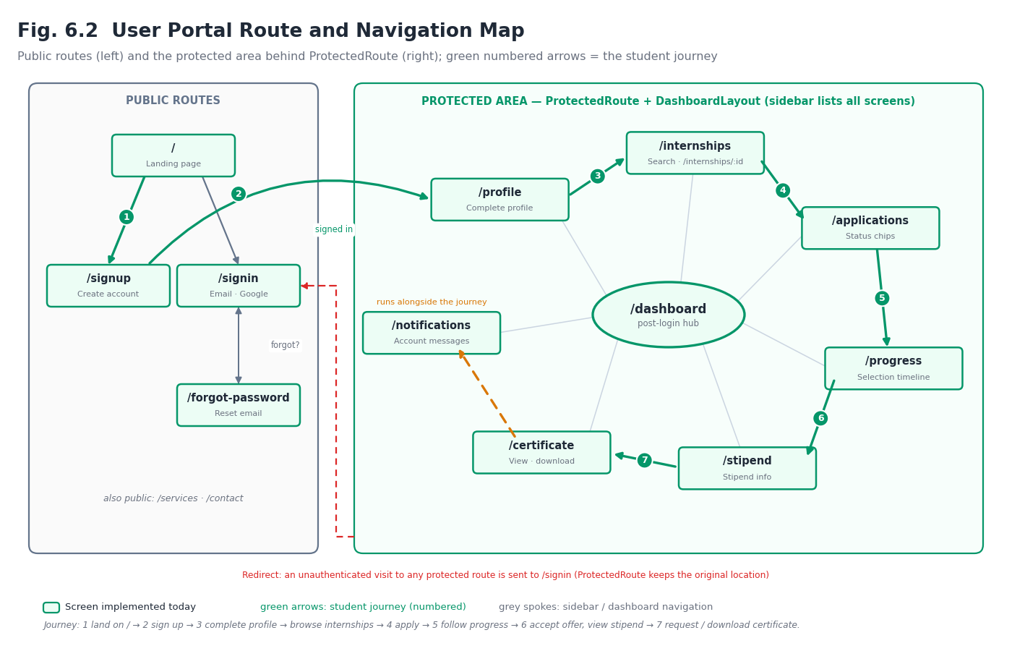Fig. 6.2 User Portal Route and Navigation Map

6.5 User Portal Layout
Figure 6.3 is an illustrative low-fidelity wireframe of the authenticated layout (top bar with notification badge and profile menu, navigation for the eight protected screens, and a content area), drawn from the route structure documented in the repository; as with Figure 6.1, it is a design illustration and not a screenshot.
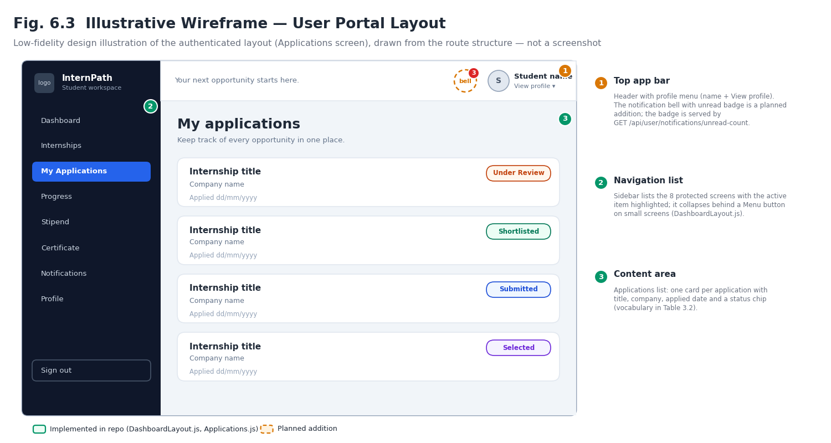Fig. 6.3 Illustrative Wireframe — User Portal Layout

7. Implementation — Work Done So Far

7.1 Repository and Deployment
Source code: https://github.com/Shivzm/Alpha-Intelligence---Admin (public, main branch). Live preview deployment: https://alpha-admin-gold.vercel.app. The backend is deployed as a single Vercel serverless function (backend/api/index.js → backend/src/server.js); the frontend is a statically built Vite/React single-page application.
User Portal repository. Source code: https://github.com/sidhartha091027/internshipmanagement-userpannel (public, main branch; two commits at the time of writing). It contains src/ (application source), build/ (a committed Create React App production build), README.md, package.json and package-lock.json, and the Tailwind and PostCSS configuration files. The package is named user_panel_frontend (version 0.1.0). No live deployment of the User Portal is referenced in the repository. The frontend is intended to be built as a static bundle and could be hosted alongside the Admin frontend on the same static hosting; the backend it will need is described in Section 7.8.

7.2 Backend — Implemented
The backend is a Node.js / Express 5 application (CommonJS). Global middleware, in order, is: Helmet (security headers), a CORS allow-list built from the FRONTEND_URL environment variable (comma-separated, trailing slashes stripped, checked via an exact origin callback), and express.json(). A rate limiter (express-rate-limit, 10 requests per 15 minutes, draft-8 headers) is applied to /api/auth only.
Route | Method | Behaviour
/ | GET | Returns { name: "Alpha Admin API", ok: true }
/api/health | GET | Health check
/api/auth/login | POST | Verifies credentials, returns a signed session token
/api/auth/forgot-password | POST | Always returns HTTP 202 with a generic message (no email sent)
/api/admin/data | GET | requireAuth-protected; returns the fixed-shape stub JSON contract
Authentication uses a single, hard-coded admin account sourced from environment variables (ADMIN_EMAIL, ADMIN_PASSWORD_HASH stored as salt:hash scrypt output, AUTH_SECRET). Password verification uses crypto.scryptSync combined with crypto.timingSafeEqual to avoid timing side-channels. A session token is constructed as base64url(JSON{email, expiresAt}) + "." + HMAC-SHA256(payload, AUTH_SECRET), with an 8-hour expiry; requireAuth middleware reads it from the Authorization: Bearer header on every protected request. Figure 7.1 traces this flow end to end.
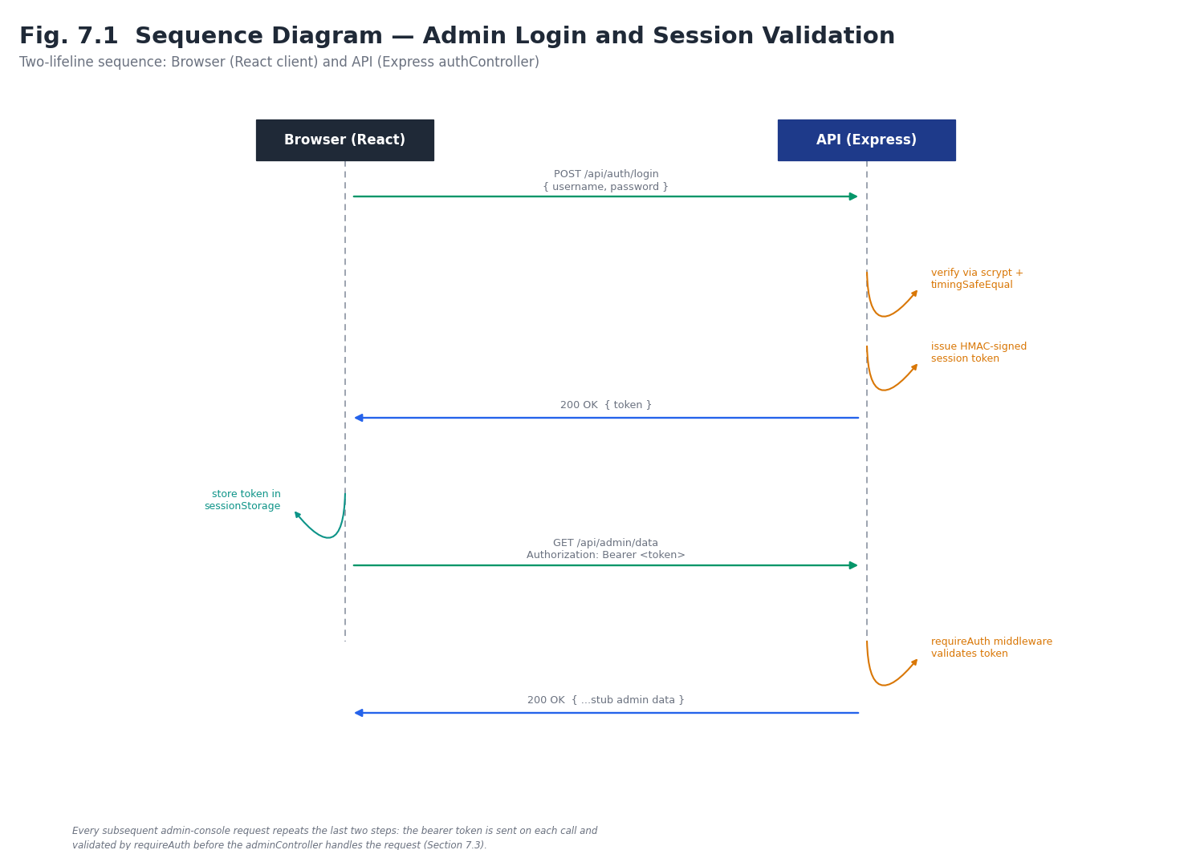Fig. 7.1 Sequence Diagram — Admin Login and Session Validation
adminController.js currently exposes getAdminData, which returns one fixed-shape object with every field present but empty or default: adminProfile, profileData, applications, records, dashboardStats, recentActivity, tasks, documents, certificateTemplates, idCardTemplates, auditLogs, backups, alerts, alertChannels, intents, databaseConfig, commandHistory, inferences, and adminPermissions. This contract is the seam Chapter 4 designs a real database behind.
Scope of this backend. The Express application described in this section serves only the Admin Console. It has no route that a student can call, no user-side data model, and no integration with Firebase; the User Portal currently communicates with Firebase directly and therefore bypasses it entirely. Sections 7.8 and 7.9 describe the backend that will serve both applications and the path for moving the User Portal onto it.

7.3 Frontend — Implemented
The frontend is React 19 built with Vite, styled with Tailwind CSS v4, routed with React Router DOM v7, and iconised with lucide-react and remixicon. App.jsx defines the public routes (/ for the login page, /reset-password) and the protected /admin-dashboard route, then wraps the remaining eighteen screens in AdminLayout. AuthContext.jsx holds the session token in sessionStorage under the key alpha_auth_token and resets a 15-minute idle timer on mousemove, keydown, scroll and click events, alerting and redirecting to / on expiry.
The AI Command Center's CommandInput.jsx is the most representative implemented-but-simulated piece of the system: handleSubmit introduces a one-second delay, then a plain if/else chain checks the submitted text for the substrings “generate”/“create”, “revoke”/“delete”, and “status”/“health”, returning one of four canned response strings, or “Intent unrecognized. Please check NLP mappings or rephrase your command.” for anything else. This function's signature — raw text in, action-or-alert out — is deliberately shaped to match what Alpha-NLU will eventually return, so wiring the real engine in later is a drop-in replacement (see the exact source in Appendix A).
NLPKeywordMapping.jsx presents a keyword-array editor for defining Intents, and DatabaseConfig.jsx exposes a form for connection settings with a simulated “Test Connection” button — both are complete UI for features whose backing logic (Chapters 4 and part of Chapter 3) is still planned.
Cross-reference. The User Portal frontend implementation is described in Section 7.5, its authentication in Section 7.6 and its present data access pattern in Section 7.7.

7.4 Module-wise Implementation Status
Table 7.1 summarises implementation status across the whole system, consolidating the detail given in Sections 7.2 and 7.3.
Module | Status | Notes
Authentication & sessions | Implemented | Real scrypt hashing, HMAC session tokens, idle timeout
Admin console shell & routing | Implemented | All 18 screens routed and rendering
AI Command Center (UI) | Implemented | Terminal-style input, response rendering
AI Command Center (NLP) | Simulated | Keyword if/else stub — see Section 7.3
Admin data API | Implemented (stub) | Fixed-shape, empty JSON contract
Persistent database | Not started | Design only — Chapter 4
Alpha-NLU engine | Not started | Design only — Sections 3.3, 4.1
Document generation (certificates/ID cards) | Not started | UI screens exist; generation logic planned
Audit logging | UI only | AuditLog persistence planned alongside the database
User Portal and backend status. Table 7.2 extends the status view above to the user side and to the not-yet-built shared backend.
Table 7.2 Module-wise Implementation Status — User Portal and Backend
Module | Status | Notes
User Portal routing and protected area | Implemented | 12 routes documented in the repository README
User authentication (Firebase) | Implemented | Email/Password and Google providers; state via AuthContext
Landing / marketing pages | Implemented | Public route /
Internship discovery UI | Implemented | Searchable listing at /internships
Applications (create, list) | Implemented (direct to Firestore) | applications/{id}: userId, internshipId, status, appliedAt
Profile management | Implemented (direct to Firestore) | users/{uid}
Progress, stipend, certificate, notification screens | UI implemented | Backing data and generation logic planned
Firestore security rules | Not verified | README states they must be configured before production
Shared backend API for users | Not started | Section 3.11 and 3.12
Admin-side APIs for real data | Not started | Only /api/admin/data stub exists
User-to-admin sync (inbox, events) | Not started | Section 3.9
Internship posting management (admin) | Not started | No admin screen exists yet; required so students have listings to see
Stipend and certificate issuing | Not started | Depends on document generation and stipend ledger
Notification service | Not started | Event handlers in Section 3.9

7.5 User Portal Frontend — Implemented
The User Portal is a React 19 application created with Create React App (react-scripts 5) and routed with React Router DOM 6. Components come from Material UI 9 with Emotion and @mui/icons-material; Tailwind CSS 3.4 with PostCSS and Autoprefixer provides utility styling. The Firebase JavaScript SDK (v12) provides authentication and Firestore access; per the README, all Firebase code is kept in src/services/, and authentication state is exposed to the rest of the application through src/context/AuthContext.js. The dev and test tooling are the CRA defaults plus Testing Library packages and web-vitals.
The route table documented in the repository is: / (landing), /signin, /signup, /forgot-password, /dashboard (protected home), /internships (searchable listing), /applications (submitted applications), /profile, /progress (selection timeline), /stipend, /certificate and /notifications. Section 6.2 (Table 6.2) inventories them. Commands are npm start, npm run build and npm test -- --watchAll=false.

7.6 User Authentication Flow
A student signs up or signs in through Firebase Authentication, with either email and password or Google. Firebase returns the session to the client SDK, which persists it; AuthContext exposes the current user and loading state to the protected area. Password storage, email flows and Google OAuth are handled by Firebase, so unlike the Admin Console’s own scrypt-and-HMAC design the User Portal stores no passwords of its own. In the target design the client, after sign-in, obtains a Firebase ID token and calls POST /api/user/session; the backend verifies it with the Firebase Admin SDK, creates or syncs the users record and returns the role and profile summary. Every later call to /api/user/* carries the ID token as a bearer credential. Figure 7.2 traces this flow.
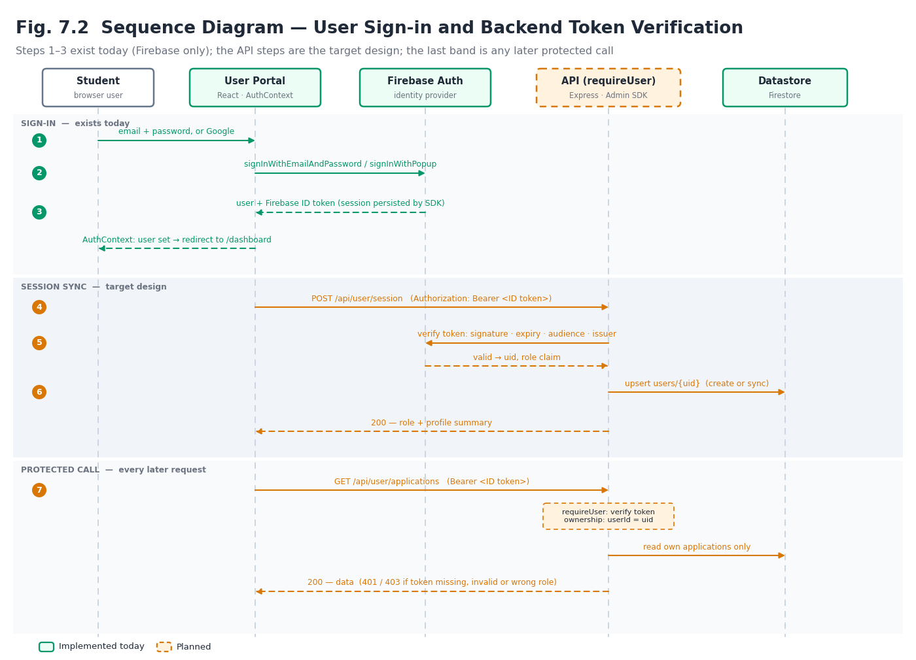Fig. 7.2 Sequence Diagram — User Sign-in and Backend Token Verification

7.7 Current Data Access Pattern (User Side)
The User Portal today reads and writes Firestore directly from the browser. Two collections are documented: users/{uid} (profile data) and applications/{applicationId} (userId, internshipId, status, appliedAt). This pattern is quick to build and suits a prototype, and it means that student data already exists in Firestore. It has three limitations that the shared backend addresses: business rules (duplicates, open postings, valid status changes) cannot be enforced by the client; the administrator has no way to reach the data except through Firestore itself; and correctness depends entirely on security rules, which the README notes still have to be configured.

7.8 Expected Backend — Not Yet Built
The backend has not been started. It is expected to extend the Admin API repository’s backend/ folder, reusing its Express 5 application, Helmet, CORS allow-list, rate limiter and admin authentication, and adding the layers of Section 3.11. The expected structure is shown below; folder and file names are proposals.
backend/
api/index.js # Vercel entry (existing)
src/
server.js # app setup, middleware order (existing, extended)
config/ # env, firebase-admin init, datastore client
middleware/
requireAdmin.js # existing HMAC check, renamed
requireUser.js # Firebase ID-token verification
requireService.js # shared-secret guard for /api/internal
ownership.js # object-level authorisation
validate.js errorHandler.js requestId.js
routes/ # public, auth, user, admin, internal
controllers/ # HTTP <-> service translation
services/ # application, notification, document,
# audit, stipend, inbox, nlu (later)
repositories/ # only code that touches the datastore
events/ # event bus + handlers (notify, inbox, audit)
jobs/ # backup, cleanup (invoked by /api/internal/jobs)
tests/ # unit + API contract tests

Environment. In addition to the existing PORT, FRONTEND_URL, ADMIN_EMAIL, ADMIN_PASSWORD_HASH and AUTH_SECRET, the expected variables are: the Firebase Admin service-account credential (as a secret), the datastore connection settings, a storage bucket name, INTERNAL_API_SECRET for /api/internal/*, and optional mail-provider credentials for password-reset and notification emails. FRONTEND_URL is already a comma-separated allow-list, so adding the User Portal’s origin needs no code change. Table 7.3 lists the planned modules.
Table 7.3 Planned Backend Modules and Responsibilities
Module | Responsibility | Serves
Identity (user) | Verify Firebase ID tokens; sync users; revoke sessions | User Portal
Identity (admin) | Existing scrypt / HMAC authentication; add logout, refresh, reset, change-password | Admin Console
Application service | Create, edit, withdraw, decide; enforce lifecycle; emit events | Both
Internship service | Postings CRUD; visibility rules | Both
Record and stipend service | InternRecord creation; stipend ledger | Both
Document service | Templates, certificate / ID-card generation, verification codes, revocation | Admin; user download
Notification service | Create, list, mark read, broadcast, preferences | Both
Inbox and sync service | Admin inbox, cursor-based delta feed | Admin Console
Audit service | Write and query AuditLog with source and before/after | Admin Console
NLU service (later) | Alpha-NLU: match commands to intents; confirm; execute via other services | Admin Console
Jobs | Backups, cleanup, digest | System

7.9 Migration Path from Direct Firestore Access to the API
- Step 1 — keep identity. Leave Firebase Authentication as is; add POST /api/user/session and requireUser so the backend knows each student.
- Step 2 — read APIs. Point the read-only screens (dashboard, progress, stipend, certificate, notifications) and the internship listing at the API; create the Internship postings from the admin side.
- Step 3 — write APIs. Move application creation and profile updates behind the API; enable the application service rules and the events of Section 3.9.
- Step 4 — admin read/write. Replace the stub /api/admin/data with the admin endpoints (Section 3.12) so that the Applications, User Directory and Dashboard screens show real, user-originated data.
- Step 5 — lock the door. Change Firestore rules to deny client writes to protected collections and allow only owner reads.
At every step the User Portal keeps working, and each step can be tested independently (Chapter 9).

8. Technology Stack
Table 8.1 lists every major dependency actually present in the repository's package.json files, with the reason it was chosen.
Layer | Technology | Why
Frontend framework | React 19 | Component model; large ecosystem; team familiarity
Build tool | Vite 8 | Fast dev server and production builds; first-class React support
Styling | Tailwind CSS 4 (@tailwindcss/vite) | Utility-first styling without a separate CSS build step
Routing | React Router DOM 7 | Nested/protected routes for the AdminLayout shell
Icons | lucide-react, remixicon | Consistent icon sets already used across all 18 screens
Compiler | babel-plugin-react-compiler | Automatic memoisation without hand-written useMemo/useCallback
Backend framework | Express 5 | Minimal, well-understood REST framework
Security middleware | Helmet | Sensible default security headers
Rate limiting | express-rate-limit (draft-8) | Brute-force protection on /api/auth
Auth cryptography | Node crypto (scrypt, HMAC-SHA256, timingSafeEqual) | No extra dependency; constant-time comparison
Hosting | Vercel (serverless functions + static frontend) | Free tier sufficient at current scale; zero server maintenance
User Portal stack. Table 8.2 lists the major dependencies actually present in the User Portal’s package.json.
Table 8.2 User Portal Technology Stack
Layer | Technology | Why
Frontend framework | React 19.2, react-dom | Component model; shared skill set with the Admin Console
Build / scripts | Create React App (react-scripts 5.0.1) | Zero-config build, dev server and test runner
UI components | MUI (@mui/material 9, @mui/icons-material) with Emotion | Accessible, ready-made components for a student-facing UI
Styling | Tailwind CSS 3.4, PostCSS, Autoprefixer | Utility-first layout and spacing alongside MUI
Routing | React Router DOM 6 | Public and protected route groups
Identity and data | Firebase JS SDK 12 (Authentication, Firestore) | Managed sign-in (email, Google) and document storage
Testing | Testing Library (dom, react, jest-dom, user-event) | Component and behaviour tests via the CRA runner
Metrics | web-vitals | Standard CRA performance reporting

8.1 Planned Additions
- Database: one of MongoDB, Firestore, or PostgreSQL (Section 4.2) — not yet selected.
- Alpha-NLU: planned as a self-contained rule-based intent/keyword matcher, not a third-party AI API, to avoid external cost and data-residency concerns (Section 2.3).
- A document-generation library (for certificates / ID cards) once DocumentTemplate and GeneratedDocument (Fig. 4.1) are backed by real storage.
- Backend additions for the platform: Firebase Admin SDK (verify ID tokens, manage users), a validation library, multipart upload handling, a PDF-generation library for certificates and ID cards, an email provider client, a structured logger, and test tooling for HTTP-level tests (Table 8.4).
- Datastore decision: Cloud Firestore is recommended because the User Portal already uses it (Section 4.2 update); the decision is to be confirmed by the project team.

8.2 Admin Console versus User Portal — Stack Comparison
The two frontends were built independently and differ in tooling. None of the differences prevents them from sharing one backend, but they matter for maintenance and are recorded so that they can be reconciled deliberately.
Table 8.3 Admin Console versus User Portal — Stack Comparison
Aspect | Admin Console | User Portal | Consequence
React | 19 | 19.2 | Compatible
Build tool | Vite 8 | Create React App 5 | Different dev ports and env-variable conventions; CRA is in maintenance mode, so a later move to Vite is worth considering
Styling | Tailwind CSS 4 | Tailwind CSS 3.4 + MUI 9 | Different config formats; MUI adds a component layer on the user side only
Router | React Router DOM 7 | React Router DOM 6 | Independent apps; no shared routing code
Identity | Custom scrypt + HMAC token | Firebase Authentication | Two middleware on one backend (Section 3.11)
Data access today | Stub API over HTTP | Direct Firestore SDK | Migrate the user side to the API (Section 7.9)
Hosting | Vercel (static + serverless) | Static build; no deployment recorded | Can share hosting; add origin to FRONTEND_URL

8.3 Candidate Backend Additions
Table 8.4 Candidate Backend Additions
Need | Candidate | Why
Verify student tokens | firebase-admin | Official SDK for ID-token verification and user management
Request validation | zod, joi or express-validator | Declarative schemas; uniform 400 responses
File uploads | multer (or signed direct-to-storage uploads) | Size and type limits before storage
PDF generation | pdf-lib or Puppeteer | Render certificate and ID-card templates to PDF
Email | Nodemailer or a transactional-email API | Password reset and notification emails
Logging | pino or winston | Structured logs with request IDs
Testing | Jest + Supertest | HTTP-level tests of the endpoint catalogue
Scheduling | Vercel Cron calling /api/internal/jobs/* | No always-on server needed

These are candidates for evaluation, not commitments; none is installed in either repository today.

9. Testing
The project currently has no automated test suite (the backend's package.json test script intentionally fails with an instructive message rather than silently passing). Testing to date has therefore been manual and exploratory, run against both the local dev servers and the live Vercel deployment. Figure 9.1 shows the layered strategy this chapter follows and the layers still to be built out.
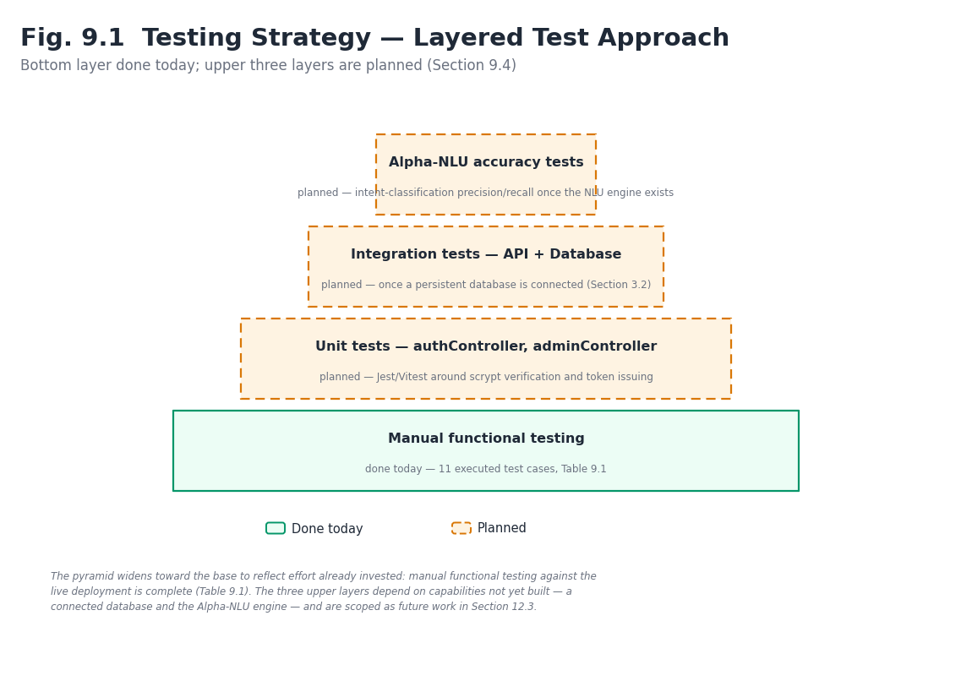
Fig. 9.1 Testing Strategy — Layered Test Approach

9.1 Testing Strategy
- Manual functional testing of every implemented screen and API route (this chapter).
- Planned: unit tests for authController.js (scrypt verification, token issuance/expiry) once a test runner is added.
- Planned: integration tests against the stub /api/admin/data contract, then against the real database once connected.
- Planned: Alpha-NLU intent-matching accuracy tests once the engine exists, using the same command strings exercised manually in Table 9.1.
- User Portal: the repository ships with the CRA test runner and Testing Library dependencies and a test script; component tests for sign-in, protected routes, internship search and application submission are planned (Section 9.3). No user-side test results are reported here because none were executed as part of this report.
- API: HTTP-level tests of every endpoint in Section 3.12, grouped by route family, with authentication, authorisation, validation and happy-path cases (Section 9.4).
- Integration: end-to-end scenarios that cross the two sides (a student action observed on the admin side and back) once the shared backend exists (Table 9.3).

9.2 Test Cases Executed
ID | Test case | Steps | Expected result | Actual result
TC-1 | Valid admin login | POST /api/auth/login with correct email + password | 200, session token returned | Pass
TC-2 | Invalid admin login | POST /api/auth/login with wrong password | 401, generic error, no user enumeration | Pass
TC-3 | Rate limiting | 11 login attempts within 15 minutes | 11th request throttled (429) | Pass
TC-4 | Protected route without token | GET /api/admin/data with no Authorization header | 401 Unauthorized | Pass
TC-5 | Protected route with expired token | GET /api/admin/data with a token past its 8-hour expiry | 401 Unauthorized | Pass
TC-6 | Idle session timeout | Log in, leave the tab idle for 15 minutes | Alert shown, redirected to / | Pass
TC-7 | CORS allow-list | Request from an origin not in FRONTEND_URL | Request blocked by CORS | Pass
TC-8 | NL command — recognised keyword | Type “generate certificates for pending interns” | Canned success response shown | Pass (simulated, not real NLU)
TC-9 | NL command — unrecognised text | Type an unrelated sentence | “Intent unrecognized” message shown | Pass
TC-10 | Route protection (frontend) | Navigate to /admin/* without a token | Redirected to login | Pass
TC-11 | Password reset request | POST /api/auth/forgot-password with any email | 202 with generic message, regardless of whether the email exists | Pass

Table 9.1 reflects the number of test cases actually exercisable against the current build; it will grow substantially once the database and Alpha-NLU exist, as noted in Section 9.1.

9.3 User-Side and API Test Cases (Planned)
The cases below are designed against the requirements in Chapter 5 and the API in Section 3.12. None has been executed: the backend for them does not exist yet. They are listed so that the test plan is ready when it does, and so that the same case IDs can be reused in the results chapter later.
Table 9.2 Planned Test Cases — User Portal and API
ID | Test case | Steps | Expected result | Status
TC-U1 | Student sign-up | Register with a new email; call POST /api/user/session | Account created; users record exists | Planned
TC-U2 | Google sign-in | Sign in with Google | Session established; user synced | Planned
TC-U3 | Invalid credentials | Sign in with a wrong password | Error shown; no session | Planned
TC-U4 | Protected route guard | Open /dashboard signed out | Redirected to sign-in | Planned
TC-U5 | No token | GET /api/user/me without Authorization | 401 | Planned
TC-U6 | Expired / tampered ID token | Call /api/user/me with a modified token | 401 | Planned
TC-U7 | Wrong role | Admin token on /api/user/*; user token on /api/admin/* | 401 / 403 | Planned
TC-U8 | Object-level authorisation | User A GETs an application owned by user B | 404 (no disclosure) | Planned
TC-U9 | Apply to open internship | POST /api/user/applications | 201; status Submitted; visible to admin | Planned
TC-U10 | Duplicate application | Apply twice to the same internship | 409 | Planned
TC-U11 | Apply to closed internship | Apply after admin closes posting | 422 | Planned
TC-U12 | Incomplete profile | Apply with missing required fields | 422 listing missing fields | Planned
TC-U13 | Withdraw | POST .../withdraw | Status Withdrawn; admin inbox item | Planned
TC-U14 | Search and filters | GET internships with q, domain, page | Correct, paginated results | Planned
TC-U15 | Profile validation | PUT profile with an invalid phone number | 400 with field errors | Planned
TC-U16 | Résumé limits | Upload an oversized or non-PDF file | 413 / 415 | Planned
TC-U17 | Admin approves | PATCH .../status = Selected | Timeline entry and notification for the student | Planned
TC-U18 | Bulk decision | POST bulk-status for 10 applications | All changed; one audit entry each | Planned
TC-U19 | Notifications | Read one; call read-all; check unread-count | Counts update correctly | Planned
TC-U20 | Certificate issue and verify | Generate certificate; GET public verify by code | Valid; student can download | Planned
TC-U21 | Revoked certificate | Revoke, then verify by code | Reported revoked | Planned
TC-U22 | Stipend visibility | Admin records payment | Appears only on that student’s stipend screen | Planned
TC-U23 | Rate limiting | Exceed write limit on /api/user/* | 429 | Planned
TC-U24 | Sync cursor | GET sync/changes?since=<cursor> after one new application | Only the new application returned | Planned

9.4 API and Integration Testing
API tests exercise the running Express app over HTTP, without a browser, using fixture accounts for a student, a second student and an administrator. They are organised by route family and check for each endpoint: authentication (missing, invalid, wrong-role credentials), authorisation (own versus others’ data), validation (bad and missing fields), the happy path, and the audit and event side effects. Figure 9.2 shows how these layers stack on top of the manual tests of Chapter 9.
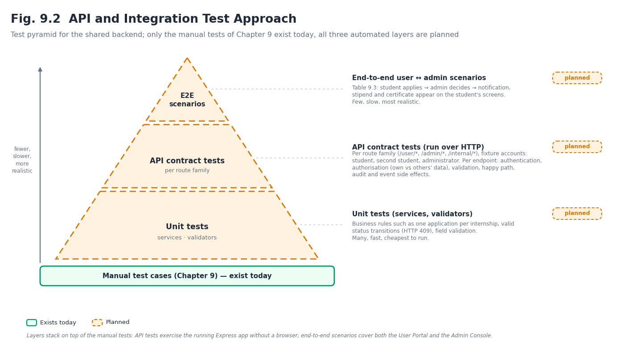Fig. 9.2 API and Integration Test Approach
Table 9.3 Planned End-to-End Integration Scenarios
ID | Scenario | Pass criteria
E2E-1 | Student registers, completes profile, applies; administrator sees the application in the Applications screen | Visible within the polling interval; applicant snapshot correct; audit entry with source = user
E2E-2 | Administrator selects the applicant; student accepts | Student sees status and notification; InternRecord exists; history complete
E2E-3 | Administrator records a stipend and issues a certificate | Both appear on the student’s screens; verification code validates
E2E-4 | Natural-language command approves pending applications (once Alpha-NLU exists) | Same side effects and notifications as the form-based action; audit source = nl
E2E-5 | Student withdraws while the administrator is reviewing | No lost update; final state consistent on both sides

10. Results and Discussion

10.1 What Works Today
- A deployed, publicly reachable admin console with real authentication (https://alpha-admin-gold.vercel.app).
- All 18 admin screens routed, styled, and rendering, organised into 7 sidebar groups.
- A stable, well-defined stub API contract that the entire frontend already consumes, de-risking the eventual database integration.
- A fully worked-out (though not yet implemented) conceptual data model and NL command workflow, both already reflected in the frontend's shape.
- A User Portal frontend in source form with twelve documented routes, Firebase email/password and Google authentication, a protected area, and Firestore-backed profile and application records.
- A complete, reviewable design of the missing pieces — integrated architecture, application lifecycle, event model, extended data model and a 168-endpoint API catalogue — so that backend implementation is a matter of building to a specification.

10.2 Honest Limitations
- No persistent database — all admin data resets to empty defaults on every request.
- Alpha-NLU does not exist yet; the AI Command Center's intelligence is a four-branch keyword stub.
- No automated test suite; all testing in Chapter 9 was manual.
- Document generation (certificates, ID cards) has UI screens but no generation logic behind them.
- Single hard-coded admin account — no multi-admin or role-based access yet.
- User side: no backend for the User Portal; it talks to Firestore directly, so business rules are not enforced server-side and Firestore rules are unverified.
- Integration: the Admin Console and User Portal do not yet share data at all; the admin screens still show the empty stub, and there is no admin screen for creating the internship postings students would see.
- Status vocabulary: the application status values in Table 3.2 are a proposal; the user repository records only that a status field exists.
- Verification: the user-side description is based on the repository’s README and package.json; behaviour beyond what they state has not been independently exercised or tested in this report.
- API catalogue: 163 of 168 endpoints are specifications only.

10.3 Discussion
The results show a project that has deliberately front-loaded the parts of the system that are cheapest to get right early and hardest to retrofit later: authentication security, the overall route/screen structure, and an API contract stable enough for the whole frontend to be built against before a database exists. This ordering trades a currently “empty” feeling admin console for a lower-risk path to the two hardest remaining pieces — the database and Alpha-NLU — both of which now have a concrete, already-validated shape (Fig. 4.1 and Fig. 3.2) to be built against rather than designed from scratch under time pressure.
Discussion — the user side. The same front-loading logic applies to the user side: the parts that are cheap to change late (screens) are built, while the parts that are expensive to change late — identity, the lifecycle vocabulary, and where business rules live — are now decided in writing before the backend exists. The main new risk is the seam between two independently built frontends and two identity systems; Table 10.1 lists it and the other integration risks with mitigations.

10.4 Integration Risks and Mitigations
Table 10.1 Integration Risks and Mitigations
Risk | Impact | Mitigation
Direct Firestore writes bypass business rules | Duplicate or invalid applications; inconsistent state | Migrate writes behind the API (Section 7.9); deny client writes in rules
Two identity systems | Confusion over which token is valid where | Separate middleware per route family; reject cross-use (TC-U7)
Unverified Firestore rules | Students could read others’ data | Review and test rules before any public deployment; owner-only reads
Status vocabulary drift between frontends | A label means different things on each side | Single shared table (Table 3.2) and status enum in the backend
Polling delay on admin side | Admin sees new applications late | Short cursor-based interval; upgrade to SSE on a persistent host
Serverless cold starts and function limits | Slow first request; long jobs cut off | Keep handlers light; run backups and generation as scheduled jobs
Different build tools and dev ports | Local-development friction | Documented ports and env conventions; consider moving the user frontend to Vite
Personal data of students | Privacy and compliance exposure | Data minimisation, signed URLs, soft-delete + purge, legal review (NFR-12)

11. Conclusion and Future Scope

11.1 Conclusion
This report has documented the Admin module of Alpha Intelligence at an early, honestly-labelled stage of development: a secure, fully-routed frontend shell and a minimal-but-real authentication backend, both deployed and reachable, sitting on top of a deliberately stubbed data contract that is already shaped for the database and Alpha-NLU engine designed — but not yet built — in Chapters 3 and 4. The core idea, “AI as manager,” is expressed today through the AI Command Center's interface and workflow design even though its intelligence is presently simulated, giving the project a concrete, de-risked path to the remaining work.
Conclusion — the complete platform. The report now describes Alpha Intelligence as two frontends and one yet-to-be-built backend. The Admin Console has a secure authentication backend and a fully routed interface; the User Portal has a working Firebase-based frontend with its main screens. What links them — a shared API, a shared datastore, a single application lifecycle and an event model that carries a student’s action to the administrator and the administrator’s decision back — is specified in detail in Chapters 3 and 4 and catalogued as 168 endpoints, but not yet built. That is the honest state of the work, and it is the most valuable piece to build next because it converts two separate interfaces into one working system.

11.2 Future Scope
- Select and connect a database (Section 4.2) behind the existing /api/admin/data contract.
- Design and implement Alpha-NLU as a rule-based intent/keyword matcher against the Intent schema in Fig. 4.1, replacing CommandInput.jsx's if/else stub.
- Implement document generation for certificates and ID cards from the existing template-editor screens.
- Persist the audit trail so AuditLog entries in Fig. 4.1 are written by both form-based and NL-command-based actions.
- Add automated tests (unit tests for authController.js; integration tests for the API) once the codebase stabilises further.
- Extend beyond a single hard-coded admin account to proper multi-admin, role-based access.
- Replace the illustrative wireframe (Fig. 6.1) with real product screenshots once the UI is closer to final.
- Build the shared backend: requireUser with Firebase Admin token verification, the application, internship, notification and inbox services, and the user-facing endpoints of Section 3.12.
- Implement the admin-side endpoints so that every Admin screen reads and writes real data (Appendix D), replacing the /api/admin/data stub.
- Add an internship-posting screen to the Admin Console so that students have real listings, and an inbox indicator for user-originated items.
- Move the User Portal from direct Firestore access to the API, then lock the Firestore rules (Section 7.9).
- Agree and freeze the application status vocabulary and the error envelope between both frontends.
- Add API and end-to-end tests (Tables 9.2 and 9.3) and run them on every change.
- Consider aligning the two frontends’ tooling (for example moving the User Portal from Create React App to Vite) once the integration is stable.
- Add email delivery for password-reset and notification messages, and real-time push for the admin inbox if a persistent host is adopted.

11.3 Proposed Integration Roadmap
Table 11.1 orders the remaining work so that each phase leaves a working, demonstrable system. Phase durations are deliberately not stated; they depend on team capacity after submission.
Table 11.1 Proposed Integration Roadmap
Phase | Deliverable | Demonstrates
1 | Datastore selected and connected; repositories; requireUser; POST /api/user/session | A student signs in and a backend-verified user record exists
2 | Internship postings (admin API + admin screen) and user read APIs | Admin publishes an internship; student sees it
3 | Application service, events, admin applications API, inbox and sync | Student applies; administrator sees it and decides; student is notified
4 | Records, stipends, certificate requests, document generation | Full intern journey from application to certificate
5 | Alpha-NLU against the intent schema; audit source = nl | Natural-language bulk approval with identical side effects
6 | API and E2E test suite; security review; Firestore rules lock-down | Release-quality confidence

References
- React documentation — https://react.dev
- Vite documentation — https://vitejs.dev
- Tailwind CSS documentation — https://tailwindcss.com/docs
- React Router documentation — https://reactrouter.com
- Express.js documentation — https://expressjs.com
- Helmet.js documentation — https://helmetjs.github.io
- express-rate-limit documentation — https://express-rate-limit.mjackson.dev
- Node.js crypto module documentation (scrypt, HMAC, timingSafeEqual) — https://nodejs.org/api/crypto.html
- Vercel documentation (serverless functions, deployments) — https://vercel.com/docs
- Alpha Intelligence — Admin, source repository — https://github.com/Shivzm/Alpha-Intelligence---Admin
- Alpha Intelligence — Admin, live deployment — https://alpha-admin-gold.vercel.app
- Alpha Intelligence — User Portal, source repository — https://github.com/sidhartha091027/internshipmanagement-userpannel
- Firebase Authentication documentation — https://firebase.google.com/docs/auth
- Cloud Firestore documentation — https://firebase.google.com/docs/firestore
- Firebase Admin SDK — verify ID tokens — https://firebase.google.com/docs/auth/admin/verify-id-tokens
- Firestore security rules — https://firebase.google.com/docs/firestore/security/get-started
- Material UI documentation — https://mui.com
- Create React App documentation — https://create-react-app.dev
- Tailwind CSS v3 documentation — https://v3.tailwindcss.com
- RFC 7519, JSON Web Token (JWT) — https://www.rfc-editor.org/rfc/rfc7519
- OWASP API Security Top 10 — https://owasp.org/API-Security
- Digital Personal Data Protection Act, 2023 (India) — Government of India, Ministry of Electronics and Information Technology

Appendix A — Source Code Excerpts
The excerpts below are taken directly from the repository referenced throughout this report and are reproduced here to support Chapter 7's implementation discussion.

A.1 CommandInput.jsx — simulated intent matching (frontend)
The core of the current “AI” response in the AI Command Center. Its input/output shape (raw text in, one response string out) is the exact seam Alpha-NLU will plug into.
const handleSubmit = (e) => {
e.preventDefault();
setLoading(true);
setTimeout(() => {
const lowerInput = input.toLowerCase();
let response;
if (lowerInput.includes("generate") || lowerInput.includes("create")) {
response = "Operation successful. 42 documents generated and pushed to Document Vault.";
} else if (lowerInput.includes("revoke") || lowerInput.includes("delete")) {
response = "Access revoked successfully.";
} else if (lowerInput.includes("status") || lowerInput.includes("health")) {
response = "All systems operational.";
} else {
response = "Intent unrecognized. Please check NLP mappings or rephrase your command.";
}
setHistory((h) => [...h, { input, response }]);
setLoading(false);
}, 1000);
};

A.2 authController.js — password verification and session tokens (backend)
Password check uses constant-time comparison; the session token is a signed, self-contained payload with an embedded expiry.
function verifyPassword(password, storedHash) {
const [salt, hash] = storedHash.split(":");
const derived = crypto.scryptSync(password, salt, 64);
return crypto.timingSafeEqual(Buffer.from(hash, "hex"), derived);
}

function issueToken(email) {
const expiresAt = Date.now() + 8 * 60 * 60 * 1000;
const payload = Buffer.from(JSON.stringify({ email, expiresAt })).toString("base64url");
const sig = crypto.createHmac("sha256", process.env.AUTH_SECRET).update(payload).digest("base64url");
return `${payload}.${sig}`; }
Note: the excerpts above are reconstructed from repository behaviour observed while building this report and lightly simplified for readability; refer to the live repository for the exact, current source.

A.3 User Portal — Firestore document shapes (from the repository README)
The User Portal README documents two collections. They are reproduced here in JSON-like form for reference; only the fields the README names are shown.
// users/{uid} -> student profile data (fields defined by the profile screen)
// applications/{applicationId}
{
userId: "<firebase uid>",
internshipId: "<internship id>",
status: "<status string>",
appliedAt: <timestamp>
}
The README also states that Firestore security rules must be configured before production so that users can read and write only their own profile and applications.

A.4 Proposed requireUser middleware (expected backend — NOT implemented)
The excerpt below is a design sketch, not repository code. It shows the intended shape of the student-token check that sits beside the existing admin check.
const admin = require("firebase-admin");

async function requireUser(req, res, next) {
const header = req.headers.authorization || "";
const token = header.startsWith("Bearer ") ? header.slice(7) : null;
if (!token) return res.status(401).json({ error: { code: "UNAUTHENTICATED" } });
try {
const decoded = await admin.auth().verifyIdToken(token);
req.user = { uid: decoded.uid, email: decoded.email, role: decoded.role || "student" };
return next();
} catch (e) {
return res.status(401).json({ error: { code: "INVALID_TOKEN" } });
}
}
Note: A.1 and A.2 are excerpts of existing code (with the simplification noted). A.3 reflects the user repository README. A.4 is proposed and is included to make the expected backend concrete.

Appendix B — Links and Environment
Item | Value
Source repository | https://github.com/Shivzm/Alpha-Intelligence---Admin
Live deployment | https://alpha-admin-gold.vercel.app
Backend env vars | PORT, FRONTEND_URL, ADMIN_EMAIL, ADMIN_PASSWORD_HASH, AUTH_SECRET
Frontend framework / build | React 19, Vite 8, Tailwind CSS 4, React Router DOM 7
Backend framework | Express 5 (CommonJS), deployed as a Vercel serverless function
Internship organisation | AediaX Tech Private Limited, Bhubaneswar, Odisha
User Portal repository | https://github.com/sidhartha091027/internshipmanagement-userpannel
User Portal stack | React 19.2, Create React App (react-scripts 5), MUI 9, Tailwind CSS 3.4, React Router DOM 6, Firebase SDK 12
User Portal run / build | npm install; npm start (http://localhost:3000); npm run build; npm test -- --watchAll=false
User Portal services | Firebase Authentication (Email/Password, Google); Cloud Firestore; values via .env.local (from .env.example)
User Portal routes | /, /signin, /signup, /forgot-password, /dashboard, /internships, /applications, /profile, /progress, /stipend, /certificate, /notifications
Firestore collections (existing) | users/{uid}; applications/{applicationId} (userId, internshipId, status, appliedAt)
Expected backend env vars (additional) | Firebase Admin service-account credential, datastore settings, storage bucket, INTERNAL_API_SECRET, optional mail-provider credentials
Planned API size | 168 endpoints in 11 groups (5 existing, 163 planned)

Appendix C — API Request and Response Samples (Proposed)
The samples below illustrate the proposed conventions of Section 3.12. They are design examples; none is produced by running code, and field names may change when the contract is frozen.

C.1 Submit an application (User)
POST /api/user/applications
Authorization: Bearer <Firebase ID token>
{ "internshipId": "int_web_001", "coverNote": "I have built two React projects...", "answers": { "availability": "Immediate" } }

201 Created
{ "data": { "id": "uid123_int_web_001", "status": "Submitted", "appliedAt": "2026-10-05T09:12:44Z" } }

C.2 List applications (Admin)
GET /api/admin/applications?status=Submitted&internshipId=int_web_001&page=1&limit=20
Authorization: Bearer <admin session token>

200 OK
{ "data": [ { "id": "uid123_int_web_001", "status": "Submitted",
"applicant": { "name": "A. Student", "email": "a@example.com", "college": "GMU" },
"appliedAt": "2026-10-05T09:12:44Z" } ],
"meta": { "page": 1, "limit": 20, "total": 1 } }

C.3 Decide an application (Admin)
PATCH /api/admin/applications/uid123_int_web_001/status
{ "to": "Selected", "reason": "Strong portfolio" }

200 OK
{ "data": { "id": "uid123_int_web_001", "status": "Selected", "history": [
{ "from": "Submitted", "to": "Selected", "actorType": "admin", "at": "2026-10-06T10:00:00Z" } ] } }

// Side effects in the same transaction: history entry, AuditLog (source = ui),
// Notification for the student ("You have been selected").

C.4 Sync feed (Admin)
GET /api/admin/sync/changes?since=2026-10-06T09:59:00Z

200 OK
{ "data": { "applications": [ ... ], "users": [ ... ], "certificateRequests": [ ... ] },
"meta": { "cursor": "2026-10-06T10:00:31Z" } }

C.5 Error envelope and conflict
POST /api/user/applications (second attempt for the same internship)

409 Conflict
{ "error": { "code": "ALREADY_APPLIED", "message": "You have already applied to this internship.",
"details": null, "requestId": "req_8f2c" } }

C.6 Public certificate verification
GET /api/public/certificates/verify/AIX-2026-7F3K9Q

200 OK
{ "data": { "valid": true, "holder": "A. Student", "program": "Web Development Internship",
"issuedAt": "2026-12-20T00:00:00Z", "revoked": false } }

Appendix D — Admin Screen-to-API Traceability Matrix
Table D.1 traces each of the eighteen existing Admin screens (Table 6.1) to the endpoints in Section 3.12 that feed it, so that backend work can be planned screen by screen and each screen can be shown to have the data path it needs. The last three rows are screens that do not exist yet but are required so that the data coming from the user side has somewhere to be seen and acted on.
Table D.1 Admin Screen-to-API Traceability Matrix
Admin screen | Endpoints (see Section 3.12)
Dashboard — Main Overview | GET /api/admin/data; /dashboard/stats; /dashboard/activity
Dashboard — Document Vault | GET /api/admin/documents; /documents/:id/download
Dashboard — Analytics | GET /api/admin/analytics/applications, /funnel, /domains
Dashboard — Active Tasks | GET/POST /api/admin/tasks; PATCH/DELETE /tasks/:id
AI Command Center — Command Input | POST /api/admin/commands; GET /commands; POST /commands/:id/confirm
AI Command Center — Model Telemetry | GET /api/admin/telemetry; /telemetry/inferences
User Directory — Manage Records | GET/POST /api/admin/records; GET/PUT/PATCH/DELETE /records/:id; GET /records/export; /users; /users/:uid
User Directory — Applications | GET /api/admin/applications; PATCH /applications/:id/status; POST /applications/bulk-status; GET /sync/changes; /inbox
System Logs — Engine Performance | GET /api/admin/logs/engine
System Logs — Audit Trails | GET /api/admin/logs/audit; /logs/audit/:id; /logs/audit/export
Settings — Profile Settings | GET/PUT /api/admin/profile; PUT /api/auth/password
Settings — Database Config | GET/PUT /api/admin/settings/database; POST /settings/database/test
Settings — NLP Keyword Mapping | GET/POST /api/admin/intents; PUT/DELETE /intents/:id; POST /intents/test
Settings — System Backups | GET/POST /api/admin/backups; POST /backups/:id/restore; GET /backups/:id/download; /backups/schedule
Security — Admin Management | GET/POST /api/admin/admins; PUT/PATCH/DELETE /admins/:id; GET /permissions
Security — System Alerts | GET /api/admin/alerts; PATCH /alerts/:id/resolve; /alert-channels
Document Layouts — Certificate Templates | GET/POST /api/admin/templates/certificates; GET/PUT/DELETE /:id; POST /:id/preview; POST /documents/certificates/generate
Document Layouts — ID Card Templates | GET/POST /api/admin/templates/id-cards; GET/PUT/DELETE /:id; POST /:id/preview; POST /documents/id-cards/generate
Required new screen — Internship Postings | GET/POST /api/admin/internships; PUT/PATCH/DELETE /internships/:id; GET /internships/:id/applications
Required new screen — Stipends and Broadcasts | GET/POST /api/admin/stipends; POST /api/admin/notifications
Required new screen — Inbox, Certificate Requests, Enquiries | GET /api/admin/inbox; PATCH /inbox/:id/ack; GET/PATCH /certificate-requests; GET/PATCH /enquiries

Table D.1 is not listed in the List of Tables because it belongs to the appendix.

