CaptionBot for Assistive Vision

In this project we are using CNN, LSTM and vocabulary model to caption images and we train LSTM encoder and decoder to identify caption from images and then use vocabulary object to caption/extract meaningful sentence from images or videos.

To implement this project we have designed following modules

1. Generate & Load LSTM Caption Model: using this module we will generate and load CNN image features extraction model and LSTM caption model
2. Upload Image: using this module we will upload test images to application
3. Extract Caption from Image: Using this module CNN identify objects from images and then used LSTM and vocabulary object to make meaningful caption. Extracted caption will be displayed on image and then play as an audio file
4. Extract Caption from Video: using this module we can upload videos and then application read frames from video and then extract caption and play the extracted caption as audio

SCREEN SHOTS

To run project double click on ‘run.bat’ file to get below screen

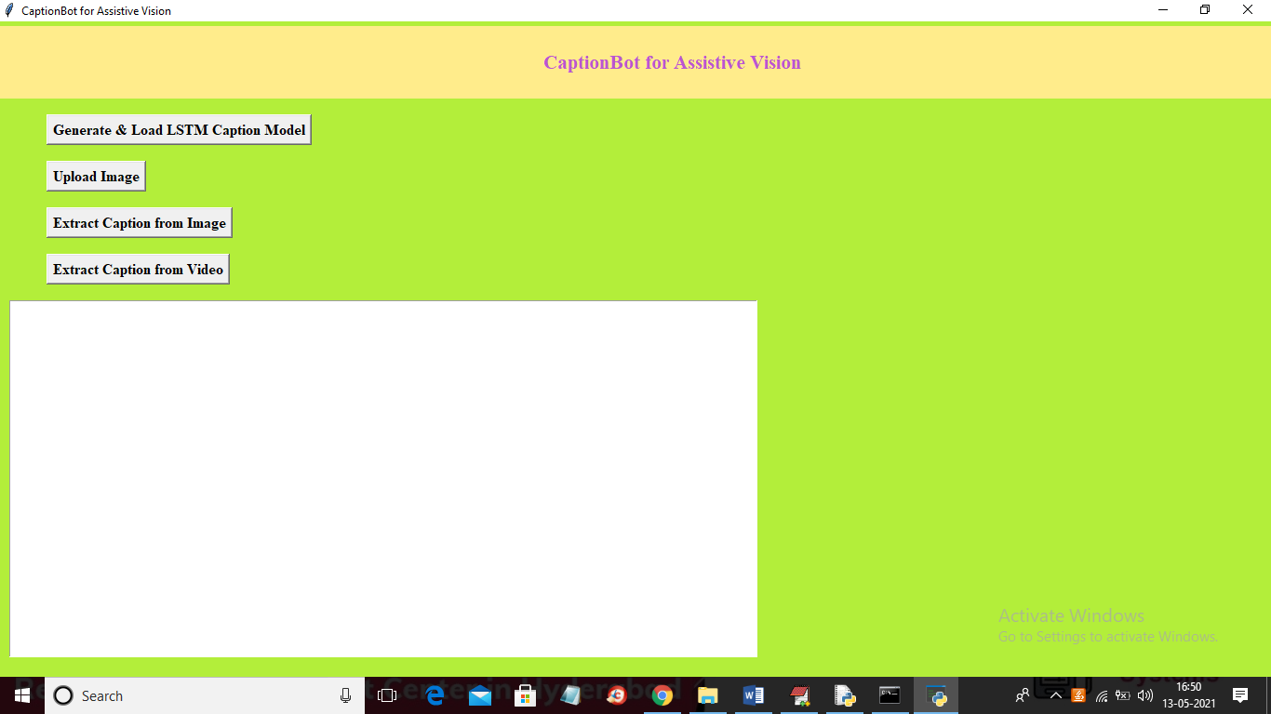

In above screen click on ‘Generate & Load LSTM Caption Model’ button to generate and load LSTM model

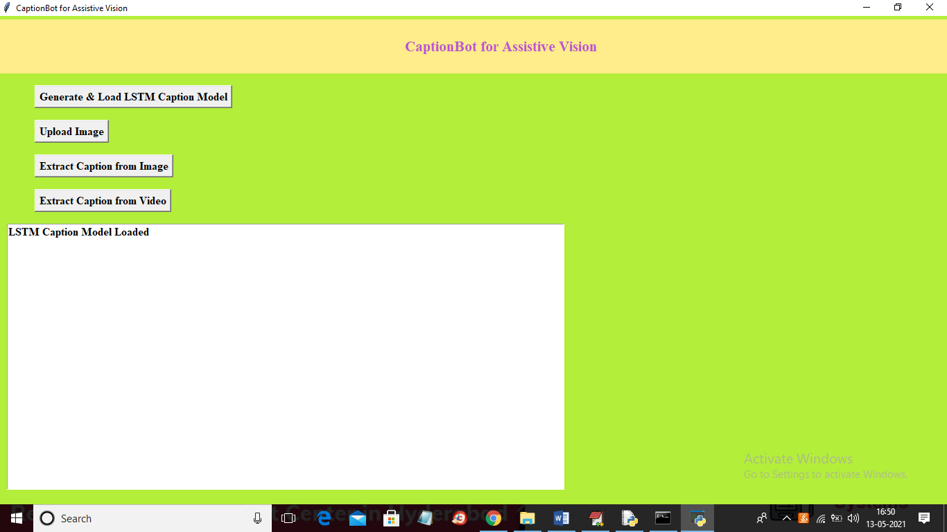

In above screen LSTM model generated and now click on ‘Upload Image’ button to upload image

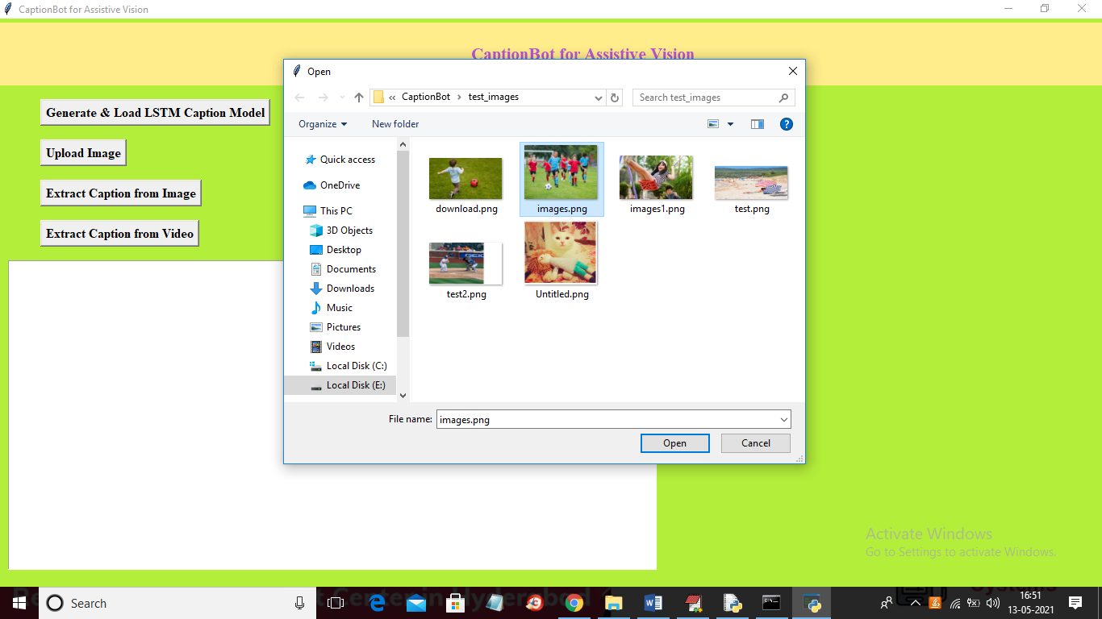

In above screen selecting and uploading ‘images.png’ file and then click on ‘Open’ button to load image and to get below screen

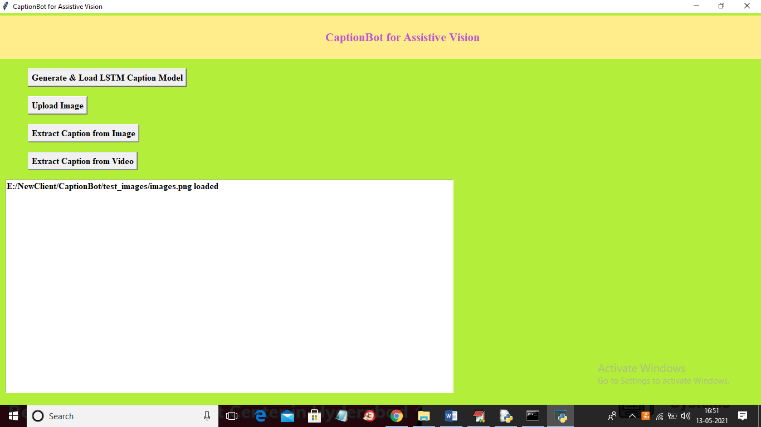

In above screen image loaded and now click on ‘Extract Caption from Image’ to extract data from image

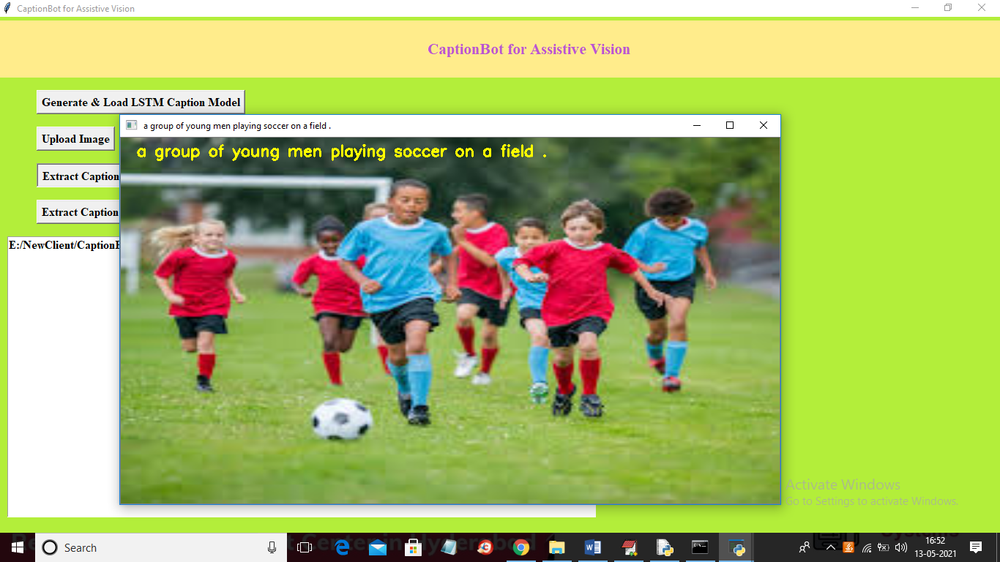

In above screen LSTM extract caption from image and then we are displaying extracted caption on image in yellow colour and this extracted caption will play as audio file also and in your laptop you can hear it and I am saving all extracted audio files in audio folder and you can see in below screen

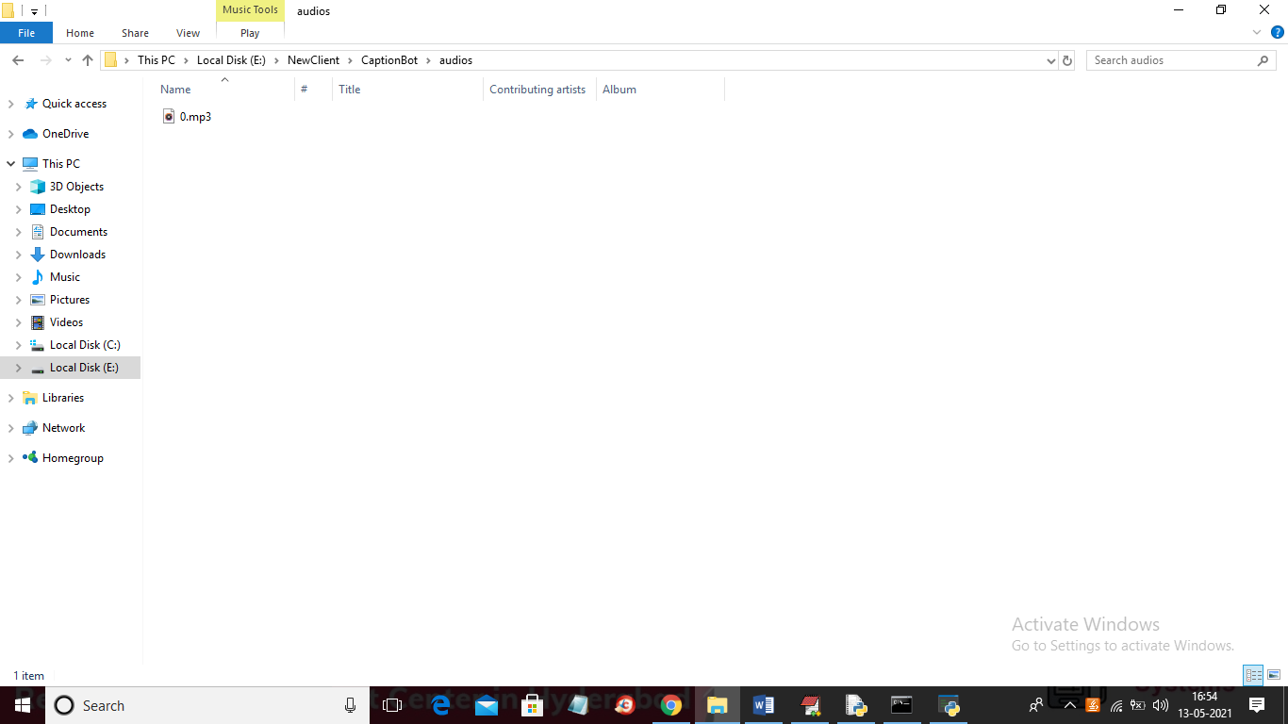

In above screen you can see MP3 audio file generated using extracted caption and similarly you can upload videos and extract caption from it

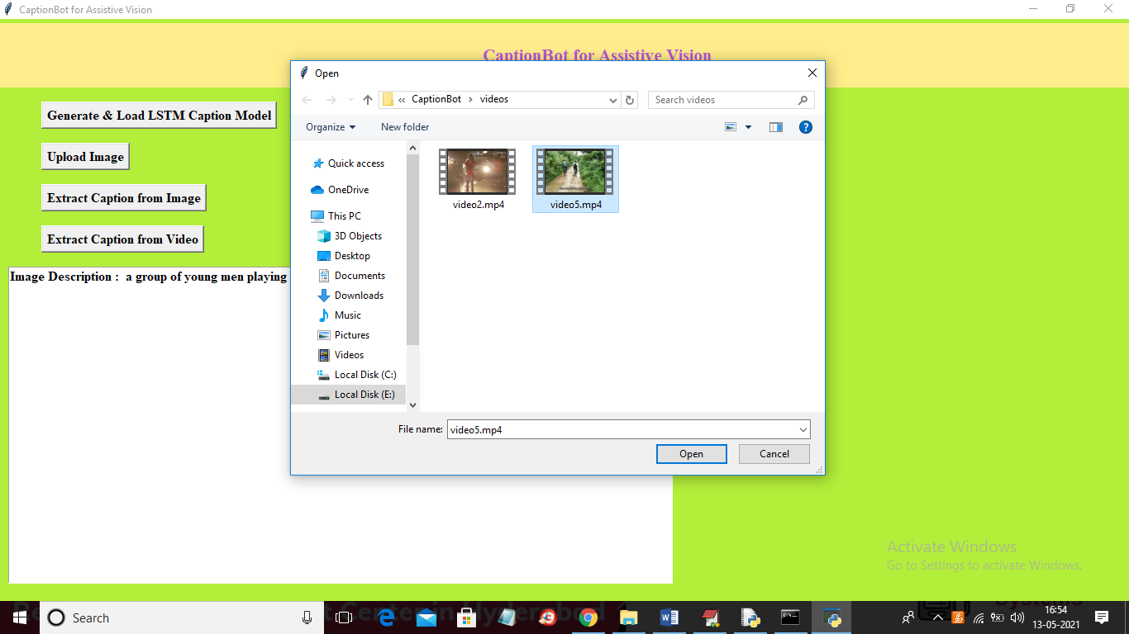

In above screen selecting and uploading ‘video5.mp4’ and then click on ‘Open’ button to get below output

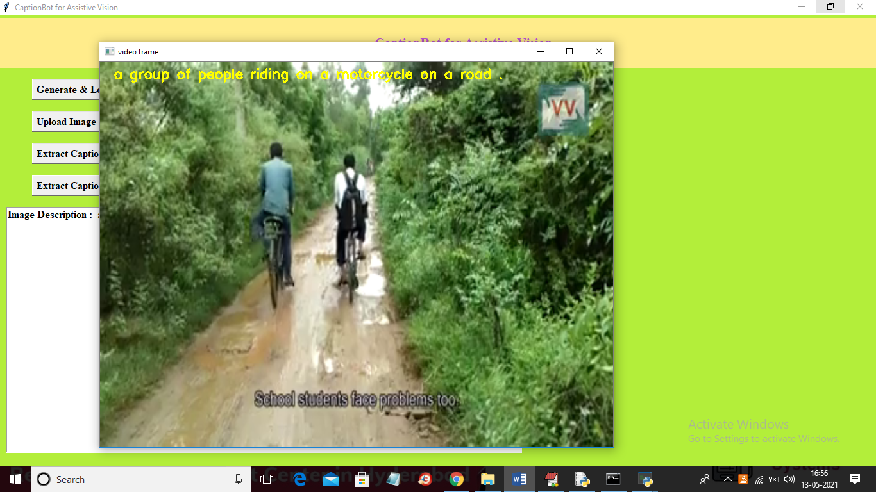

In above screen you can see video is playing and LSTM will extract caption and then play it as an audio. You can connect to webcam also and can extract caption