**Q3. Tuples Trap**

Match the codes with their output.

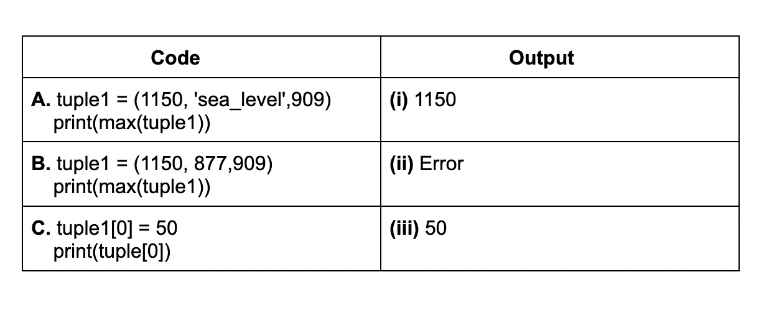

**i) A-i, B-i, C-ii**

**ii) A-i, B-ii, C-iii**

**iii) A-ii, B-i, C-ii**

**iv) A-ii, B-ii, C-iii**

**Answer:** iii