cd:

1. Absolute path:exact path
2. Relative path:related path from the present directory

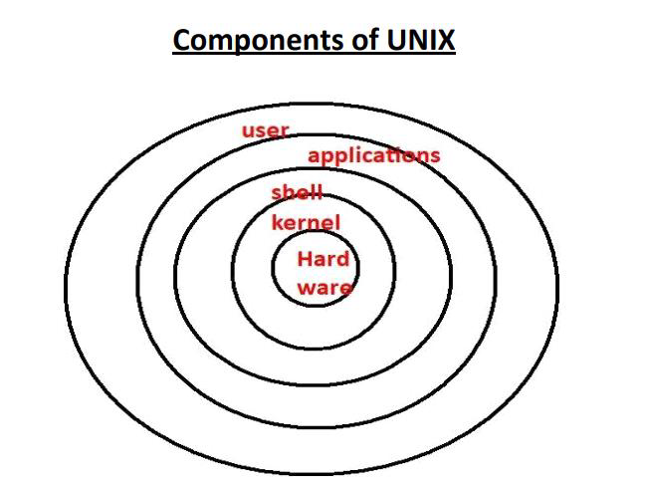

Ctrl+alt+t:shortcut to open terminal in ubuntu

Ctrl+d:shortcut to close the terminal

**NOTE: cd /:to go to the root directory**

**Shell:**

✽It is the outer layer of UNIX operating System.

✽It reads our command, verify syntax and check whether the corresponding command

related application is available or not.

✽If everything is proper, then shell interprets our command into kernal understandable

form and handover to the kernal.

✽Shell acts as interface between user and kernal.

**Kernal:**

✽It is the core component of UNIX operating system.

✽It is responsible to execute our commands.

✽It is responsible to interact with hardware components.

✽Memory allocation and processor allocation will takes care by kernal

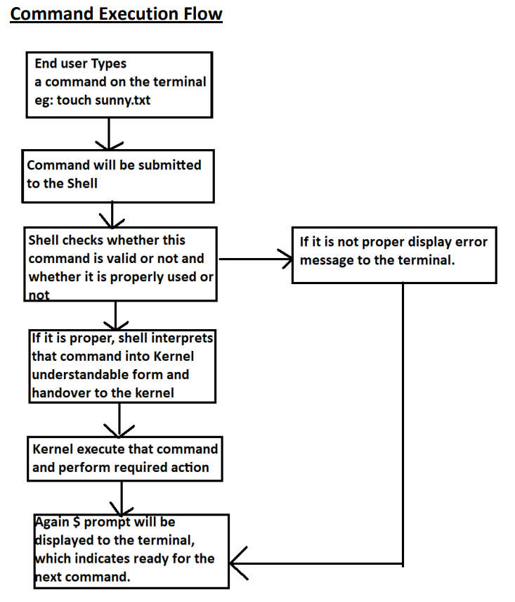

**Linux File System Structure :-**

**1. /bin**:-bin -stands for binary.s. (command: ls /bin)

Binary is a file which contains the compiled source code.

We can also call it as executable, because it can be executed on the computer.

/bin is a sub-directory of the root directory in Unix/Linux OS.

this directory contains basic commands which is enough for the minimal system function

ex :-ls, cat, cp

2.**/sbin:** system binaries or super user binaries.

 This folder contains commands which are required for changing system properties.

Ex:-adduser,reboot,shutdown0

3**. /boot:**

The contents are mostly Linux kernel files and bootloaderfiles(files needed to start up the operating system)

4.**/dev :**

This contains device files

This file represents your speaker device,keyboard

5. **/etc:**-

it contains all system related configuration files in here or in its sub-directories

A "configuration file" is defined as a local file used to control the operation of a program;

it cannot be an executable binary.

Ex:-adduser.conf, theme config

**6. /cdrom:**-

directory is a standard practice to mount cd, but not necessary. We use media and mnt to mount anything these days

In Linux and other Unix-like operating systems, **/cdrom** is commonly used as the default directory where the contents of a CD or DVD inserted into the computer's optical drive are mounted.

When you insert a CD or DVD, the system may automatically mount it to the /cdrom directory (or it could be mounted manually).

You can view the contents of the disc by navigating to this directory in the terminal.

**7 ./home :**-

The home directory can be said as a personal working space for all the users except root.

There is a separate directory for every user.

 For example, two users ‘satyam' and ‘jack' will have directories like "/home/satyam“ and "/home/jack“

**8 ./lib :-**

The /lib directory contains **shared libraries** and **kernel modules** that are necessary to boot and run the system.

These libraries are used by essential system binaries located in directories like /bin and /sbin.

Shared libraries are files that contain code or data that multiple programs can use simultaneously.

Instead of having the same code duplicated in every executable, the system allows programs to load a shared library into memory when they need it. This improves efficiency and saves disk space.

The shared libraries in /lib are generally required by programs in /bin (basic user commands) and /sbin (system administration commands). Without these shared libraries, programs might fail to run

**Difference between lib, lib32, lib64, libx32**

lib :-architecture independent files.

lib32 :-for 32 bit architecture libraries

lib64 :-for 64 bit architecture libraries

libx32 :-for 64 bit architecture libraries but the pointer size is 32 bit,

Normally software using the x86-64 instruction set uses 64-bit pointer size.