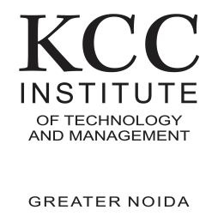

**Shiwani Kanojiya**

B.Tech, CSE (Pre-final Year))   
Contact No: +91-8928724756

Email: shiwanisbtechiotcse2024@kccitm.edu.in

**____________________EDUCATION**

| 2024 | B.Tech (Pursuing) | KCCITM Greater Noida (AKTU) | 7/10 |
| --- | --- | --- | --- |
| 2020 | Twelfth | BRV Inter college Nashrullahpur (UP board) | 73% |
| 2018 | Tenth | BRV Inter college Nashrullahpur (UP board) | 85.6℅ |

**____________________PROJECTS  
 Heart Attack Prediction**July 22 | KCCITM Gr. Noida

* This model works on ML model.
* We used Logistic Regression,Support vector machine,K- Nearest Neighbor(KNN) Algorithm for the machine learning part.

**login page /**Jun,22 | KCC ITM Gr. Noida

* Used HTML-CSS for Frontend and JavaScript.

**____________________SKILLS**

**Computer Languages:** C, Python **Intermediate:** HTML-CSS, Javascript.

**Languages Known:** English and Hindi (Proficient)

**Certifications: python** by Coding Ninjas

**____________________ACHIEVEMENTS / EXTRACURRICULARS**

* THREE STAR in Hackerrank (python)
  + 4 Star in C Language ( HackerRank).

**_______________**