|  |
| --- |
| Bayer healthcare Doc41 Web UI |
| Design Specification |
| Business Units SD, QM, PT |
|  |
| **Ingo Kaulbach, Bayer Business Services** |
| **30.10.2013** |

|  |
| --- |
|  |

Content

1 General Requirements 4

2 Doc41 Web UI Core System Architecture 5

3 Permissions 6

4 Roles 8

Technical Admin 8

Business Admin 8

Observer 8

Carrier 9

Customs Broker 10

Material Supplier 10

Product Supplier 10

ViewerCountry 11

ViewerCustomer 11

Layout Supplier 12

PM supplier 12

5 Workflow 13

Carrier 13

Download: Air waybill 13

Download: Bill of Lading 14

Download: Shippers declaration 15

Download: Waybill 16

Download: FDA certificate 17

Download: CMR (outgoing) 18

Upload: CMR (incoming) 19

Upload: Air waybill 20

Upload: Bill of Lading 21

Customs Broker 22

Download: Air waybill 22

Download: Bill of Lading 22

Download: Shippers declaration 23

Download: Waybill 23

Download: FDA certificate 24

Material Supplier 25

Upload: Supplier CoA 25

Product Supplier 26

Upload: Delivery Certificate 26

ViewerCountry 27

Download: Delivery Certificate 27

ViewerCustomer 28

Download: Delivery Certificate 28

Layout Supplier 29

Download: HighRes Layout 29

Download: LowRes Artwork 30

Upload: HighRes Layout 31

PM supplier 32

Download: Packaging specification 32

Download: Technical drawing 33

Download: Technical packaging and Delivery requirements 34

6 Workflow User Management 35

User Overview 35

Create internal user 36

Create external user 38

Change internal user data 39

Change external user data 40

New password for external user 41

7 Java Server Pages 42

documents 42

login 42

maintenance 42

monitoring 42

translations 42

useradmin 43

userprofile 43

8 Java Class Definition 44

# General Requirements

Doc41 Web UI will be an internet web application hosted on the Bayer HealthCare BOE environment for external users from Bayer partners who are authorized to download and/or upload Bayer-relevant documents to the Bayer HealthCare KGS Store via the Doc41 core project results.

The application provides an integrated user management for external users with a role concept which allows to bind Doc41 document types to certain roles. External users will have one or more roles to interact with the system and download and upload documents of an allowed type derived from their role set.

Doc41 Web UI will use - if possible - the RFC interfaces already in place for the internal Doc41 Webclient for downloading and uploading documents.

Furthermore, Doc41 Web UI will need several RFCs to the BHC P2R system in order to work properly during the authorization workflow for external users downloading or uploading documents from the Doc41 core system.

# Doc41 Web UI Core System Architecture



The page visible in the browser of the user is an html document which was constructed from a JSP-File for the design and a Form class containing the data of the page.

A controller class controls which pages are visible to the user and what data will be put into the form class to be displayed in the page.

The use case will do the logic and manage all requests from the controller to receive data. The use case connects to different repositories to retrieve data from database and/or SAP-Systems.

The repository takes the data retrieve request from the use case and performs a call to a DAO (data access object) for database request or a call to a RFC (remote function call) and returns the data to the use case.

# Permissions

|  |  |  |
| --- | --- | --- |
| CODE | PERMISSION NAME | PERMISSION DESCRIPTION |
| ADDINTERNALUSERTOLOGGROUP | AddInternalUserToLogGroup | Add Internal User To Log Group |
| DOC_ARTWORK_DOWN | DocumentArtworkLowRes | Download Artwork Low Res |
| DOC_AWB_DIRECT_DOWN | DocumentAirWaybillDirectDown | Download Air Waybill DirectDown |
| DOC_AWB_DOWN | DocumentAirWaybill | Download Air Waybill |
| DOC_AWB_UP | DocumentAirWaybillUpload | Upload Air Waybill |
| DOC_BOL_DIRECT_DOWN | DocumentBillofLadingDirectDown | Download Bill of Lading DirectDown |
| DOC_BOL_DOWN | DocumentBillofLading | Download Bill of Lading |
| DOC_BOL_UP | DocumentBillOfLadingUpload | Upload Bill of Lading |
| DOC_CMROUT_DOWN | DocumentCMROutgoing | Download CMR Outgoing |
| DOC_CMR_UP | DocumentCMRUpload | Upload CMR |
| DOC_COO_DOWN | DocumentCertificateOfOriginDownload | Download Certificate of Origin |
| DOC_DELCERT_DOWN_COUNTRY | DocumentDeliveryCertificateCountry | Download Delivery Certificate Country |
| DOC_DELCERT_DOWN_CUSTOMER | DocumentDeliveryCertificateCustomer | Download Delivery CertificateCustomer |
| DOC_DELCERT_UP | DocumentDeliveryCertificateUpload | Upload Delivery Certificate |
| DOC_FDACERT_DIRECT_DOWN | DocumentFDACertificateDirectDown | Download FDA Certificate DirectDown |
| DOC_FDACERT_DOWN | DocumentFDACertificate | Download FDA Certificate |
| DOC_LAYOUT_DOWN | DocumentLayoutHighRes | Download Layout High Res |
| DOC_LAYOUT_UP | DocumentLayoutHighResUpload | Upload Layout High Res |
| DOC_PMS_DOWN | DocumentPackagingMaterialSpecification | Download Packaging Material Specification |
| DOC_PZ_DOWN | DocumentTechnicalDrawingPZ | Download Technical Drawing PZ |
| DOC_SHIPDECL_DIRECT_DOWN | DocumentShippersDeclarationDirectDown | Download Shippers Declaration DirectDown |
| DOC_SHIPDECL_DOWN | DocumentShippersDeclaration | Download Shippers Declaration |
| DOC_SUPCOA_UP | DocumentSupplierCoAUpload | Upload Supplier CoA |
| DOC_TPACKDELREQ_DOWN | DocumentTechPackandDelivRequirements | Download Tech. Pack. and Deliv. Requirements |
| DOC_WB_DIRECT_DOWN | DocumentWaybillDirectDown | Download Waybill DirectDown |
| DOC_WB_DOWN | DocumentWaybill | Download Waybill |
| MONITORING | Monitoring | Monitoring |
| NAV_MONITORING | NavMonitoring | Show Navigation Entry Monitoring |
| NAV_PROFILEPERMISSIONS | NavProfilePermissions | Show Navigation Entry Profile Permissions |
| NAV_RFCMETADATA | NavRFCMetadata | Show Navigation Entry RFC Metadata |
| NAV_SUPPORTCONSOLE | NavSupportConsole | Show Navigation Entry Support Console |
| NAV_TRANSLATIONS | NavTranslations | Show Navigation Entry Translations |
| NAV_UNTRANSLATEDLABELS | NavUntranslatedLabels | Show Navigation Untranslated Labels |
| PROFILEPERMISSIONS | ProfilePermissions | Profile Permissions View |
| READ_ONLY | ReadOnly | Allow only read access |
| RFCMETADATA | RFCMetadata | RFC Metadata View |
| TOPNAV_DOWNLOAD | TopNavDownload | Show TopNav Entry Download |
| TOPNAV_MAINTENANCE | TopNavMaintenance | Show TopNav Entry Maintenance |
| TOPNAV_MANAGEMENT | TopNavManagement | Show TopNav Entry Management |
| TOPNAV_MYPROFILE | TopNavMyProfile | Show TopNav Entry My Profile |
| TOPNAV_UPLOAD | TopNavUpload | Show TopNav Entry Upload |
| TRANSLATION | Translation | Translation |
| UNTRANSLATEDLABELS | UntranslatedLabels | Show Untranslated Labels View |
| USER_CREATE | UserCreate | User Create |
| USER_EDIT | UserEdit | User Edit |
| USER_IMPORT | UserImport | User Import |
| USER_LIST | UserList | User List |
| USER_LOOKUP | UserLookup | User Lookup |

# Roles

## Technical Admin

|  |  |
| --- | --- |
| **Top Navigation** | * My Profile * Maintenance |
| **Navigation** | **Maintenance**   * Support Console * Translations * Interface Monitoring * Profile Permissions View |
| **Download Document** |  |
| **Upload Document** |  |

## Business Admin

|  |  |
| --- | --- |
| **Top Navigation** | * My Profile * User Management |
| **Navigation** | **Management**   * User Management |
| **Download Document** |  |
| **Upload Document** |  |

## Observer

User with role Observer cannot make changes into database.  
Observer should be used as an **additional** role!

|  |  |
| --- | --- |
| **Top Navigation** |  |
| **Navigation** |  |
| **Download Document** |  |
| **Upload Document** |  |

## Carrier

|  |  |
| --- | --- |
| **Top Navigation** | * My Profile * Download * Upload |
| **Navigation** | **Download**   * Air waybill * Bill of Lading * Shippers declaration * Waybill * FDA certificate * CMR (outgoing)   **Upload**   * CMR (incoming) * Air waybill * Bill of Lading |
| **Download Document** | * Air waybill * Bill of Lading * Shippers declaration * Waybill * FDA certificate * CMR (outgoing) |
| **Upload Document** | * CMR (incoming) * Air waybill * Bill of Lading |

## Customs Broker

Can directly download documents by a given link, no download menu.

|  |  |
| --- | --- |
| **Top Navigation** | * My Profile |
| **Navigation** |  |
| **Download Document** | * Air waybill * Bill of Lading * Shipper’s declaration * Waybill * FDA certificate |
| **Upload Document** |  |

## Material Supplier

|  |  |
| --- | --- |
| **Top Navigation** | * My Profile * Upload |
| **Navigation** | **Upload**   * Supplier CoA |
| **Download Document** |  |
| **Upload Document** | * Supplier CoA |

## Product Supplier

|  |  |
| --- | --- |
| **Top Navigation** | * My Profile * Upload |
| **Navigation** | **Upload**   * Delivery Certificate |
| **Download Document** |  |
| **Upload Document** | * Delivery Certificate |

## ViewerCountry

|  |  |
| --- | --- |
| **Top Navigation** | * My Profile * Download |
| **Navigation** | **Download**   * Delivery Certificate Country |
| **Download Document** |  |
| **Upload Document** | * Delivery Certificate (Country) |

## ViewerCustomer

|  |  |
| --- | --- |
| **Top Navigation** | * My Profile * Download |
| **Navigation** | **Download**   * Delivery Certificate Customer |
| **Download Document** |  |
| **Upload Document** | * Delivery Certificate (Customer) |

## Layout Supplier

|  |  |
| --- | --- |
| **Top Navigation** | * My Profile * Download * Upload |
| **Navigation** | **Download**   * HighRes Layout * LowRes Layout   **Upload**   * HighRes Layout |
| **Download Document** | * HighRes Layout * LowRes Layout |
| **Upload Document** | * HighRes Layout |

## PM supplier

|  |  |
| --- | --- |
| **Top Navigation** | * My Profile * Download |
| **Navigation** | **Download**   * Packaging specification * Technical drawing * Technical packaging and Delivery requirements |
| **Download Document** | * Packaging specification * Technical drawing * Technical packaging and Delivery requirements |
| **Upload Document** |  |

# Workflow

## Carrier

### Download: Air waybill

|  |  |
| --- | --- |
| **Title** | Air waybill |
| **Short description** | Download Air waybill |
| **Type** | Download |
| **Search parameter**  **(mandatory)** | * Partner number * Reference number |
| **Search parameter**  **(optional)** | * Filename |
| **JSP** | documentsearch |
| **Form** | SearchForm |
| **Controller** | SearchController |
| **UseCase** | AWBDocumentType, SDDocumentType, DocumentUC |
| **Repository** | TranslationsRepository |
| **DAO** | TranslationsDAO |
| **RFC** | AuthorizationRFCService, KgsRFCService |
| **Design** |  |

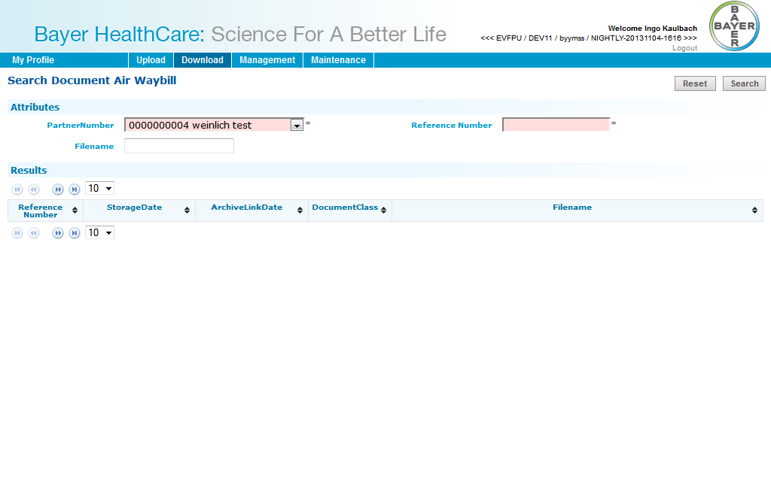

### Download: Bill of Lading

|  |  |
| --- | --- |
| **Title** | Bill of Lading |
| **Short description** | Download Bill of Lading |
| **Type** | Download |
| **Search parameter**  **(mandatory)** | * Partner number * Reference number |
| **Search parameter**  **(optional)** | * Filename |
| **JSP** | documentsearch |
| **Form** | SearchForm |
| **Controller** | SearchController |
| **UseCase** | BOLDocumentType, SDDocumentType, DocumentUC |
| **Repository** | TranslationsRepository |
| **DAO** | TranslationsDAO |
| **RFC** | AuthorizationRFCService, KgsRFCService |
| **Design** |  |

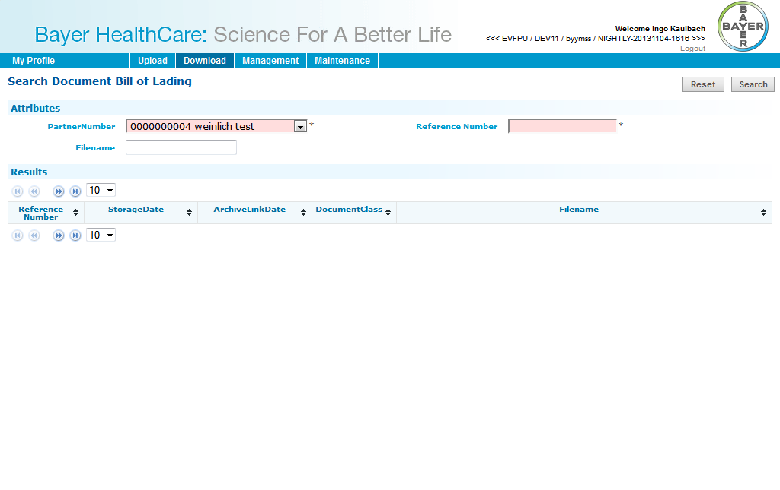

### Download: Shippers declaration

|  |  |
| --- | --- |
| **Title** | Shippers declaration |
| **Short description** | Download Shippers Declaration |
| **Type** | Download |
| **Search parameter**  **(mandatory)** | * Partner number * Reference number |
| **Search parameter**  **(optional)** | * Filename |
| **JSP** | documentsearch |
| **Form** | SearchForm |
| **Controller** | SearchController |
| **UseCase** | ShippersDeclDocumentType, SDDocumentType, DocumentUC |
| **Repository** | TranslationsRepository |
| **DAO** | TranslationsDAO |
| **RFC** | AuthorizationRFCService, KgsRFCService |
| **Design** |  |

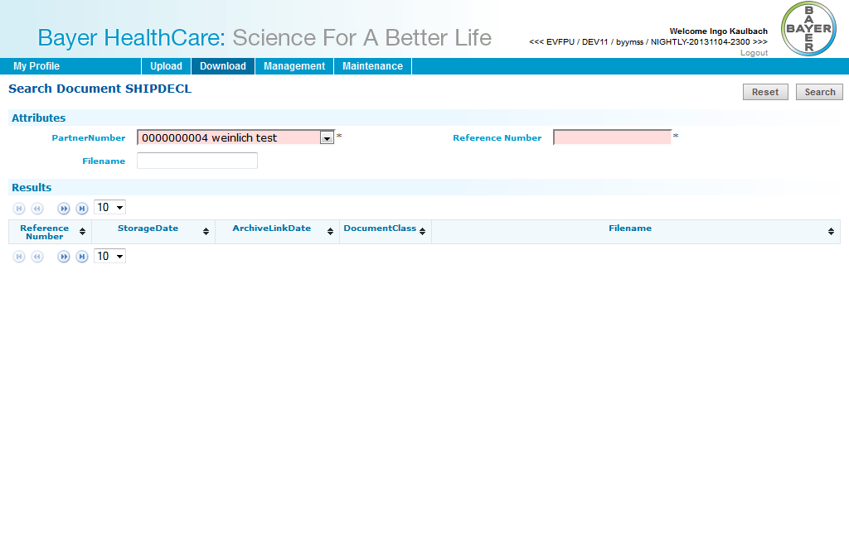

### Download: Waybill

|  |  |
| --- | --- |
| **Title** | Waybill |
| **Short description** | Download Waybill |
| **Type** | Download |
| **Search parameter**  **(mandatory)** | * Partner number * Reference number |
| **Search parameter**  **(optional)** | * Filename |
| **JSP** | documentsearch |
| **Form** | SearchForm |
| **Controller** | SearchController |
| **UseCase** | WaybillDocumentType, SDDocumentType, DocumentUC |
| **Repository** | TranslationsRepository |
| **DAO** | TranslationsDAO |
| **RFC** | AuthorizationRFCService, KgsRFCService |
| **Design** |  |

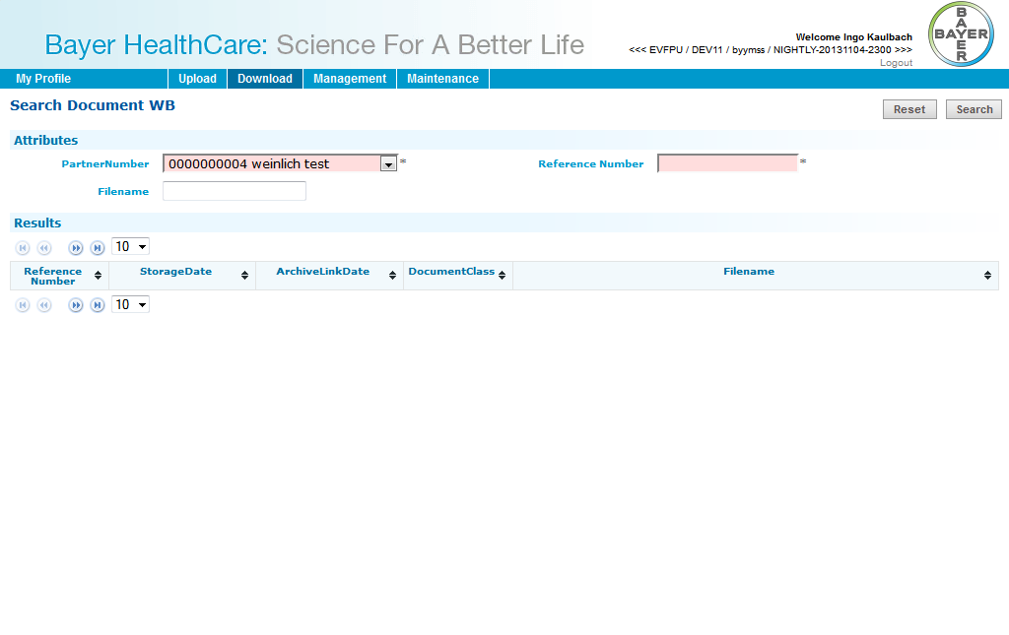

### Download: FDA certificate

|  |  |
| --- | --- |
| **Title** | FDA certificate |
| **Short description** | Download FDA certificate |
| **Type** | Download |
| **Search parameter**  **(mandatory)** | * Partner number * Reference number |
| **Search parameter**  **(optional)** | * Filename |
| **JSP** | documentsearch |
| **Form** | SearchForm |
| **Controller** | SearchController |
| **UseCase** | FDACertDocumentType, SDDocumentType, DocumentUC |
| **Repository** | TranslationsRepository |
| **DAO** | TranslationsDAO |
| **RFC** | AuthorizationRFCService, KgsRFCService |
| **Design** |  |

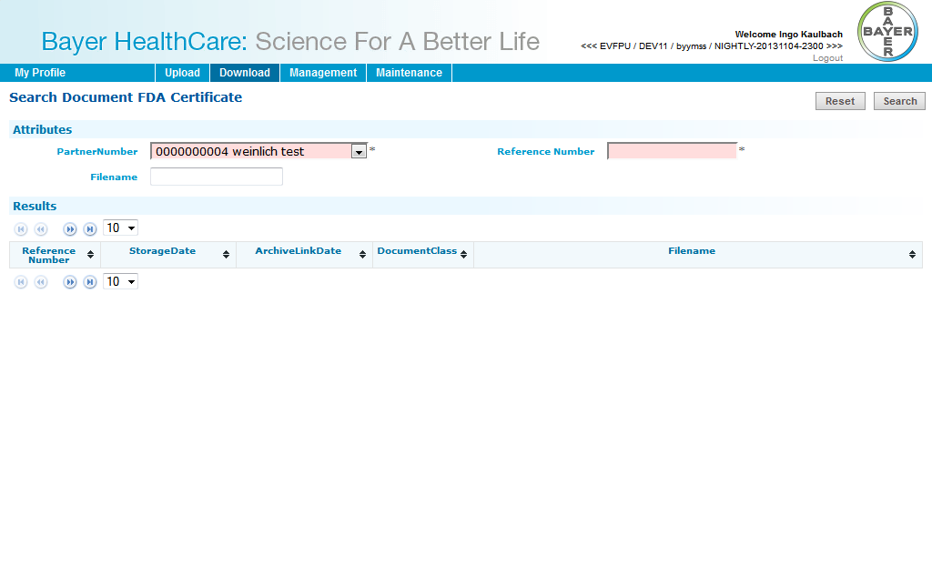

### Download: CMR (outgoing)

|  |  |
| --- | --- |
| **Title** | CMR (outgoing) |
| **Short description** | Download CMR Outgoing |
| **Type** | Download |
| **Search parameter**  **(mandatory)** | * Partner number * Reference number |
| **Search parameter**  **(optional)** | * Filename |
| **JSP** | documentsearch |
| **Form** | SearchForm |
| **Controller** | SearchController |
| **UseCase** | CMROutDocumentType, SDDocumentType, DocumentUC |
| **Repository** | TranslationsRepository |
| **DAO** | TranslationsDAO |
| **RFC** | AuthorizationRFCService, KgsRFCService |
| **Design** |  |

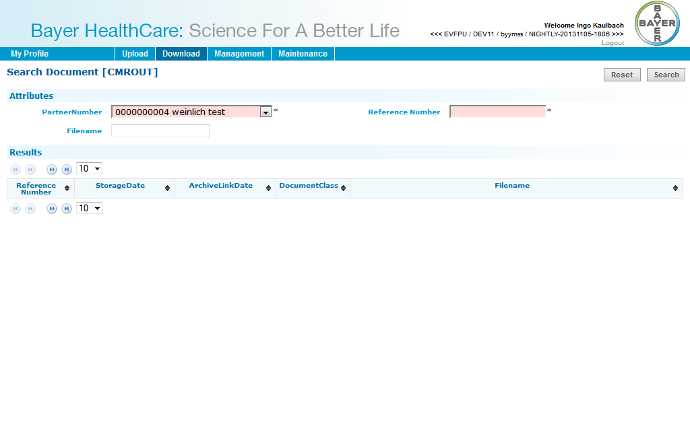

### Upload: CMR (incoming)

|  |  |
| --- | --- |
| **Title** | Confirmation of Arrival (CMR) (incoming) |
| **Short description** | Upload Confirmation of Arrival |
| **Type** | Upload |
| **Search parameter**  **(mandatory)** | * Partner number * Reference number |
| **Search parameter**  **(optional)** |  |
| **JSP** | sdupload |
| **Form** | UploadForm |
| **Controller** | SDUploadController |
| **UseCase** | CMRDocumentType, SDDocumentType, DocumentUC |
| **Repository** | TranslationsRepository |
| **DAO** | TranslationsDAO |
| **RFC** | AuthorizationRFCService, KgsRFCService |
| **Design** |  |

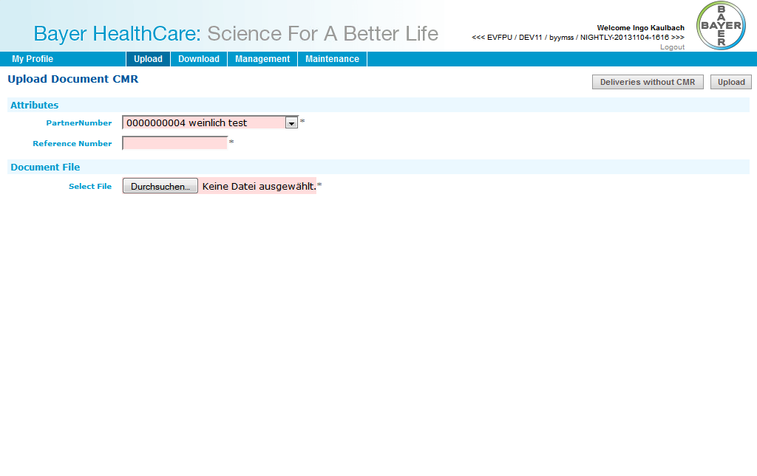

### Upload: Air waybill

|  |  |
| --- | --- |
| **Title** | Air waybill |
| **Short description** | Upload Air waybill |
| **Type** | Upload |
| **Search parameter**  **(mandatory)** | * Partner number * Reference number |
| **Search parameter**  **(optional)** |  |
| **JSP** | sdupload |
| **Form** | UploadForm |
| **Controller** | SDUploadController |
| **UseCase** | AWBDocumentType, SDDocumentType, DocumentUC |
| **Repository** | TranslationsRepository |
| **DAO** | TranslationsDAO |
| **RFC** | AuthorizationRFCService, KgsRFCService |
| **Design** |  |

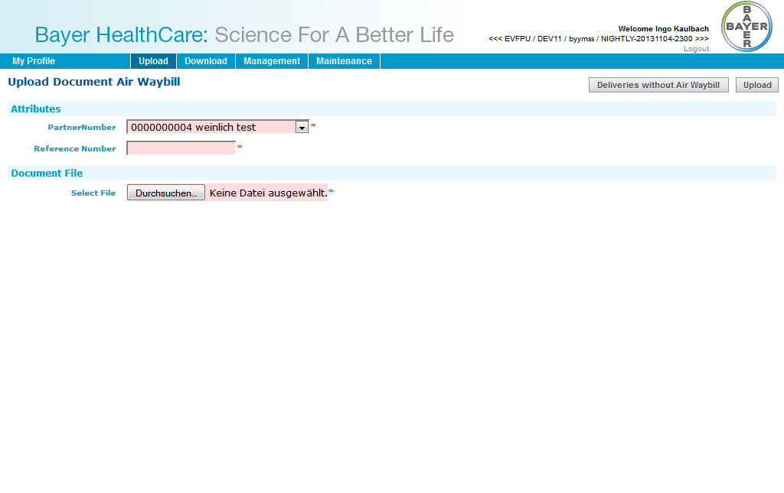

### Upload: Bill of Lading

|  |  |
| --- | --- |
| **Title** | Bill of Lading |
| **Short description** | Upload Bill of Lading |
| **Type** | Upload |
| **Search parameter**  **(mandatory)** | * Partner number * Reference number |
| **Search parameter**  **(optional)** |  |
| **JSP** | sdupload |
| **Form** | UploadForm |
| **Controller** | SDUploadController |
| **UseCase** | BOLDocumentType, SDDocumentType, DocumentUC |
| **Repository** | TranslationsRepository |
| **DAO** | TranslationsDAO |
| **RFC** | AuthorizationRFCService, KgsRFCService |
| **Design** |  |

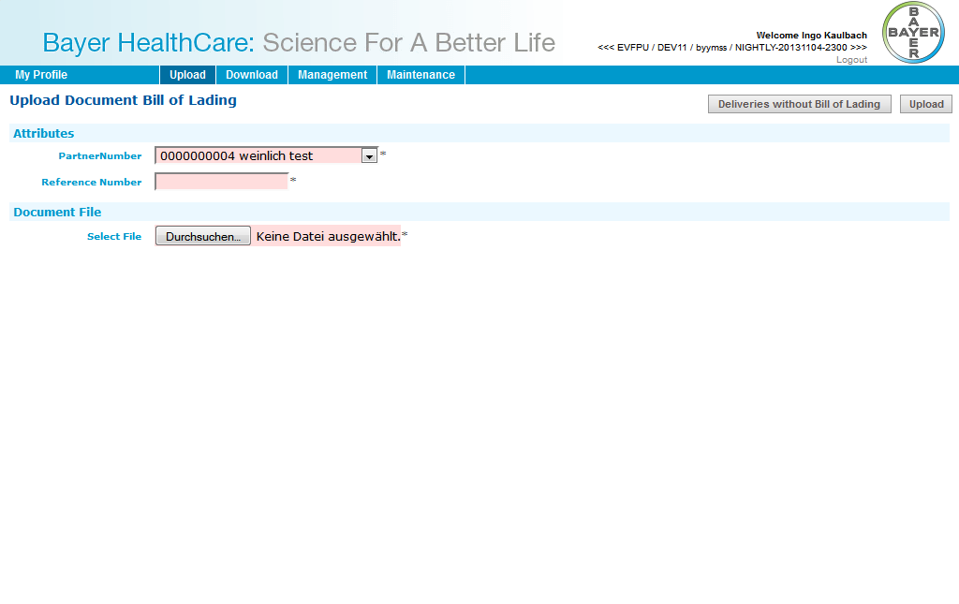

## Customs Broker

### Download: Air waybill

|  |  |
| --- | --- |
| **Title** | Air waybill |
| **Short description** | Download Air waybill |
| **Type** | DirectDownload |
| **Search parameter**  **(mandatory)** | * Object ID |
| **Search parameter**  **(optional)** |  |
| **JSP** |  |
| **Form** |  |
| **Controller** | DirectDownloadController |
| **UseCase** | AWBDocumentType, SDDocumentType, DocumentUC |
| **Repository** |  |
| **DAO** |  |
| **RFC** | AuthorizationRFCService, KgsRFCService |
| **Design** |  |

### Download: Bill of Lading

|  |  |
| --- | --- |
| **Title** | Bill of Lading |
| **Short description** | Download Bill of Lading |
| **Type** | DirectDownload |
| **Search parameter**  **(mandatory)** | * Object ID |
| **Search parameter**  **(optional)** |  |
| **JSP** |  |
| **Form** |  |
| **Controller** | DirectDownloadController |
| **UseCase** | BOLDocumentType, SDDocumentType, DocumentUC |
| **Repository** |  |
| **DAO** |  |
| **RFC** | AuthorizationRFCService, KgsRFCService |
| **Design** |  |

### Download: Shippers declaration

|  |  |
| --- | --- |
| **Title** | Shippers declaration |
| **Short description** | Download Shippers Declaration |
| **Type** | DirectDownload |
| **Search parameter**  **(mandatory)** | * Object ID |
| **Search parameter**  **(optional)** |  |
| **JSP** |  |
| **Form** |  |
| **Controller** | DirectDownloadController |
| **UseCase** | ShippersDeclDocumentType, SDDocumentType, DocumentUC |
| **Repository** |  |
| **DAO** |  |
| **RFC** | AuthorizationRFCService, KgsRFCService |
| **Design** |  |

### Download: Waybill

|  |  |
| --- | --- |
| **Title** | Waybill |
| **Short description** | Download Waybill |
| **Type** | DirectDownload |
| **Search parameter**  **(mandatory)** | * Object ID |
| **Search parameter**  **(optional)** |  |
| **JSP** |  |
| **Form** |  |
| **Controller** | DirectDownloadController |
| **UseCase** | WaybillDocumentType, SDDocumentType, DocumentUC |
| **Repository** |  |
| **DAO** |  |
| **RFC** | AuthorizationRFCService, KgsRFCService |
| **Design** |  |

### Download: FDA certificate

|  |  |
| --- | --- |
| **Title** | FDA certificate |
| **Short description** | Download FDA certificate |
| **Type** | DirectDownload |
| **Search parameter**  **(mandatory)** | * Object ID |
| **Search parameter**  **(optional)** |  |
| **JSP** |  |
| **Form** |  |
| **Controller** | DirectDownloadController |
| **UseCase** | FDACertDocumentType, SDDocumentType, DocumentUC |
| **Repository** |  |
| **DAO** |  |
| **RFC** | AuthorizationRFCService, KgsRFCService |
| **Design** |  |

## Material Supplier

### Upload: Supplier CoA

|  |  |
| --- | --- |
| **Title** | Supplier CoA |
| **Short description** | Upload Supplier CoA |
| **Type** | Upload |
| **Search parameter**  **(mandatory)** | * Partner number * Vendor batch * Plant |
| **Search parameter**  **(optional)** |  |
| **JSP** | supcoaupinput |
| **Form** | UploadForm |
| **Controller** | SupCoaUploadController |
| **UseCase** | SupplierCOADocumentType, DocumentUC |
| **Repository** | TranslationsRepository |
| **DAO** | TranslationsDAO |
| **RFC** | AuthorizationRFCService, KgsRFCService |
| **Design** |  |

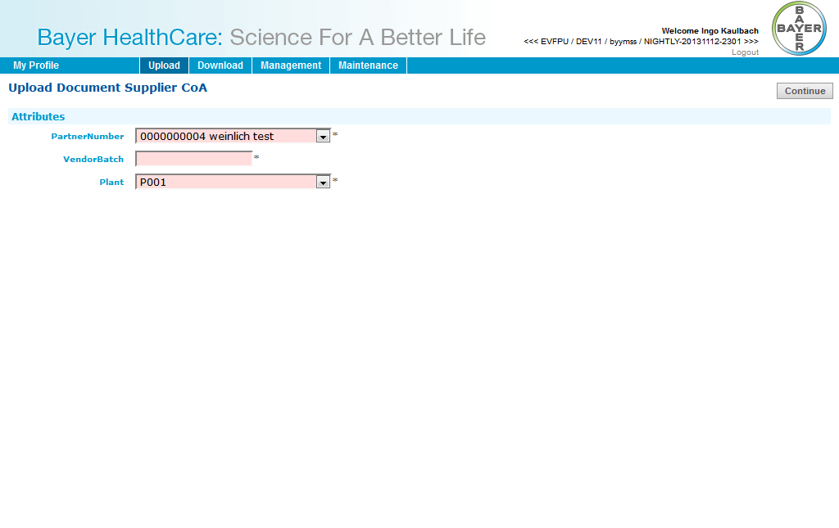

## Product Supplier

### Upload: Delivery Certificate

|  |  |
| --- | --- |
| **Title** | Delivery Certificate |
| **Short description** | Upload Delivery Certificate |
| **Type** | Upload |
| **Search parameter**  **(mandatory)** | * Partner number * Plant |
| **Search parameter**  **(optional)** | * Material * Batch * Order |
| **JSP** | delcertupinput |
| **Form** | UploadForm |
| **Controller** | DelCertUploadController |
| **UseCase** | DeliveryCertUploadDocumentType, AbstractDeliveryCertDocumentType, DocumentUC |
| **Repository** | TranslationsRepository |
| **DAO** | TranslationsDAO |
| **RFC** | AuthorizationRFCService, KgsRFCService |
| **Design** |  |

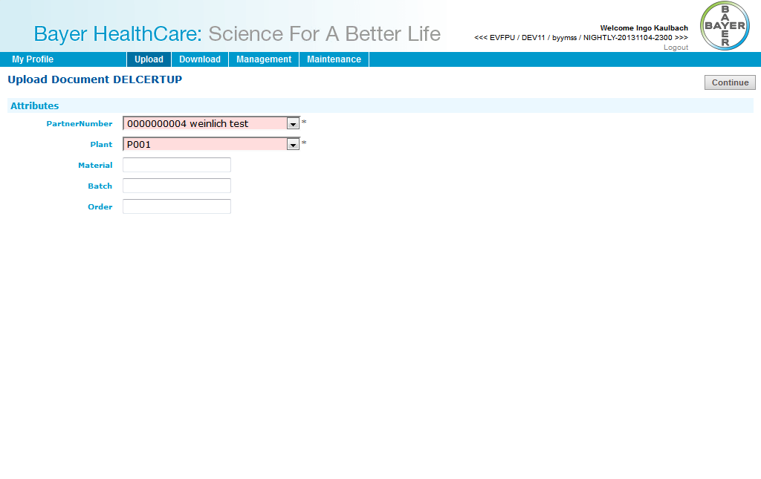

## ViewerCountry

### Download: Delivery Certificate

|  |  |
| --- | --- |
| **Title** | Delivery Certificate Country |
| **Short description** | Download Delivery Certificate |
| **Type** | Download |
| **Search parameter**  **(mandatory)** | * Country |
| **Search parameter**  **(optional)** | * Material number * Batch |
| **JSP** | documentsearch |
| **Form** | SearchForm |
| **Controller** | SearchController |
| **UseCase** | DeliveryCertDownCountryDocumentType, AbstractDeliveryCertDocumentType, DocumentUC |
| **Repository** | TranslationsRepository |
| **DAO** | TranslationsDAO |
| **RFC** | AuthorizationRFCService, KgsRFCService |
| **Design** |  |

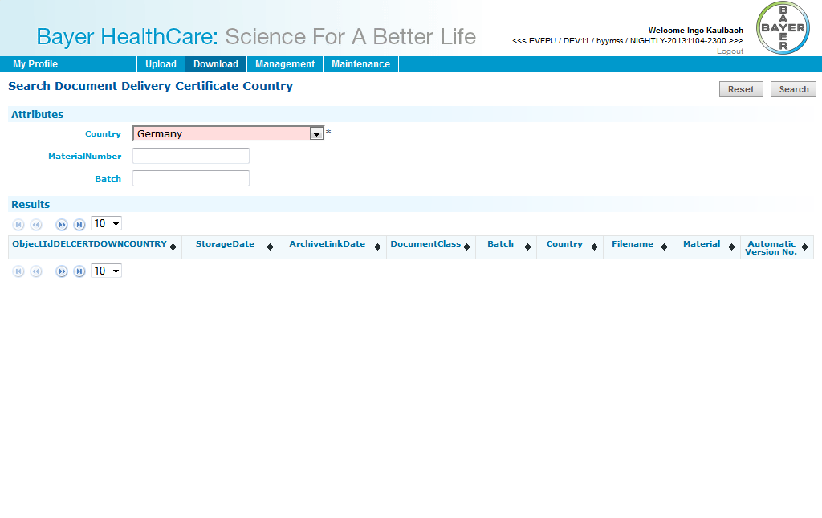

## ViewerCustomer

### Download: Delivery Certificate

|  |  |
| --- | --- |
| **Title** | Delivery Certificate Customer |
| **Short description** | Download Delivery Certificate |
| **Type** | Download |
| **Search parameter**  **(mandatory)** | * Partner number * Country * Delivery number |
| **Search parameter**  **(optional)** | * Material number * Batch |
| **JSP** | documentsearch |
| **Form** | SearchForm |
| **Controller** | SearchController |
| **UseCase** | DeliveryCertDownCustomerDocumentType, AbstractDeliveryCertDocumentType, DocumentUC |
| **Repository** | TranslationsRepository |
| **DAO** | TranslationsDAO |
| **RFC** | AuthorizationRFCService, KgsRFCService |
| **Design** |  |

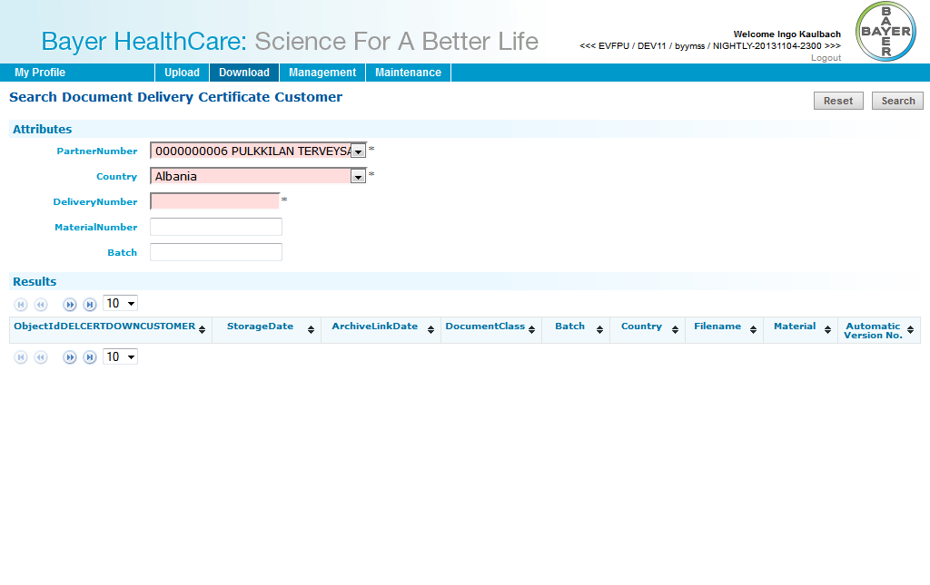

## Layout Supplier

### Download: HighRes Layout

|  |  |
| --- | --- |
| **Title** | HighRes Layout |
| **Short description** | Download HighRes Layout |
| **Type** | Download |
| **Search parameter**  **(mandatory)** | * Partner number * Object ID |
| **Search parameter**  **(optional)** | * Filename * Vendor |
| **JSP** | documentsearch |
| **Form** | SearchForm |
| **Controller** | SearchController |
| **UseCase** | LayoutDocumentType, DocumentUC |
| **Repository** | TranslationsRepository |
| **DAO** | TranslationsDAO |
| **RFC** | AuthorizationRFCService, KgsRFCService |
| **Design** |  |

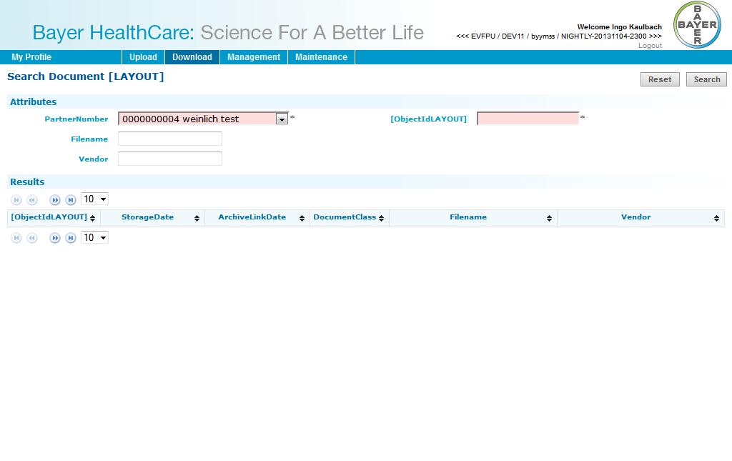

### Download: LowRes Artwork

|  |  |
| --- | --- |
| **Title** | LowRes Artwork |
| **Short description** | Download LowRes Artwork |
| **Type** | Download |
| **Search parameter**  **(mandatory)** | * Partner number * Object ID |
| **Search parameter**  **(optional)** | * Filename * Vendor |
| **JSP** | documentsearch |
| **Form** | SearchForm |
| **Controller** | SearchController |
| **UseCase** | LayoutDocumentType, DocumentUC |
| **Repository** | TranslationsRepository |
| **DAO** | TranslationsDAO |
| **RFC** | AuthorizationRFCService, KgsRFCService |
| **Design** |  |

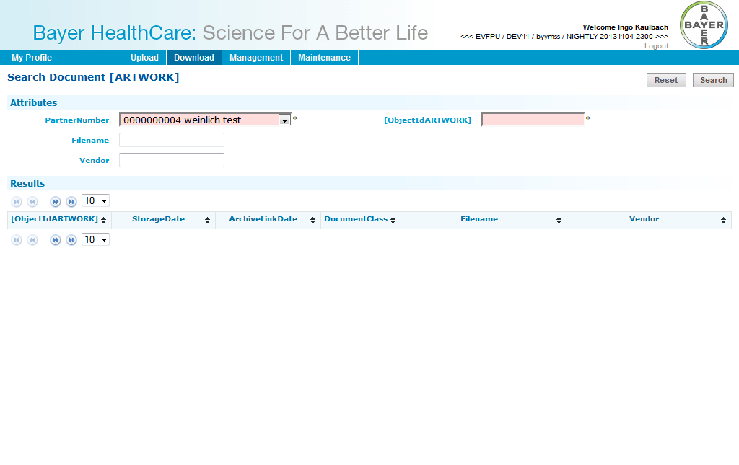

### Upload: HighRes Layout

|  |  |
| --- | --- |
| **Title** | HighRes Layout |
| **Short description** | Upload HighRes Layout |
| **Type** | Upload |
| **Search parameter**  **(mandatory)** | * Partner number * Object ID |
| **Search parameter**  **(optional)** | * Vendor |
| **JSP** | ptupload |
| **Form** | PTUploadForm |
| **Controller** | DelCertUploadController |
| **UseCase** | LayoutDocumentType, DocumentUC |
| **Repository** | TranslationsRepository |
| **DAO** | TranslationsDAO |
| **RFC** | AuthorizationRFCService, KgsRFCService |
| **Design** |  |

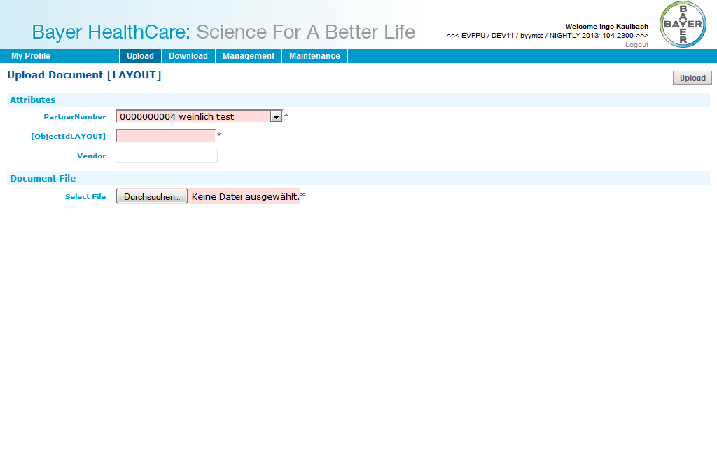

## PM supplier

### Download: Packaging specification

|  |  |
| --- | --- |
| **Title** | Packaging specification |
| **Short description** | Download Packaging specification |
| **Type** | Download |
| **Search parameter**  **(mandatory)** | * Partner number * Purchase Order number * Object ID |
| **Search parameter**  **(optional)** | * Document description |
| **JSP** | documentsearch |
| **Form** | SearchForm |
| **Controller** | SearchController |
| **UseCase** | PackMatSpecDocumentType, PMSupplierDownloadDocumentType, DocumentUC |
| **Repository** | TranslationsRepository |
| **DAO** | TranslationsDAO |
| **RFC** | AuthorizationRFCService, KgsRFCService |
| **Design** |  |

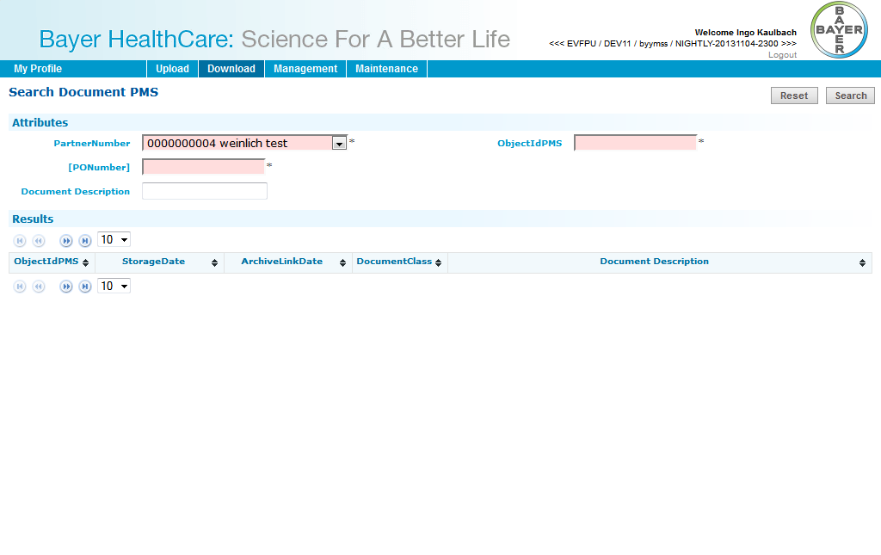

### Download: Technical drawing

|  |  |
| --- | --- |
| **Title** | Technical drawing |
| **Short description** | Download Technical drawing |
| **Type** | Download |
| **Search parameter**  **(mandatory)** | * Partner number * Purchase Order number * Object ID |
| **Search parameter**  **(optional)** | * Document description |
| **JSP** | documentsearch |
| **Form** | SearchForm |
| **Controller** | SearchController |
| **UseCase** | PZTecDrawingDocumentType, PMSupplierDownloadDocumentType, DocumentUC |
| **Repository** | TranslationsRepository |
| **DAO** | TranslationsDAO |
| **RFC** | AuthorizationRFCService, KgsRFCService |
| **Design** |  |

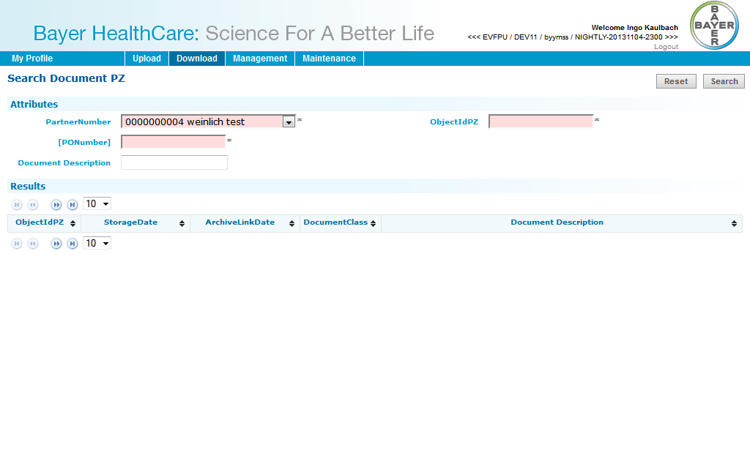

### Download: Technical packaging and Delivery requirements

|  |  |
| --- | --- |
| **Title** | Technical packaging and Delivery requirements |
| **Short description** | Download Technical packaging and Delivery requirements |
| **Type** | Download |
| **Search parameter**  **(mandatory)** | * Partner number * Purchase Order number * Object ID |
| **Search parameter**  **(optional)** | * Document description |
| **JSP** | documentsearch |
| **Form** | SearchForm |
| **Controller** | SearchController |
| **UseCase** | PZTecDrawingDocumentType, PMSupplierDownloadDocumentType, DocumentUC |
| **Repository** | TranslationsRepository |
| **DAO** | TranslationsDAO |
| **RFC** | AuthorizationRFCService, KgsRFCService |
| **Design** |  |

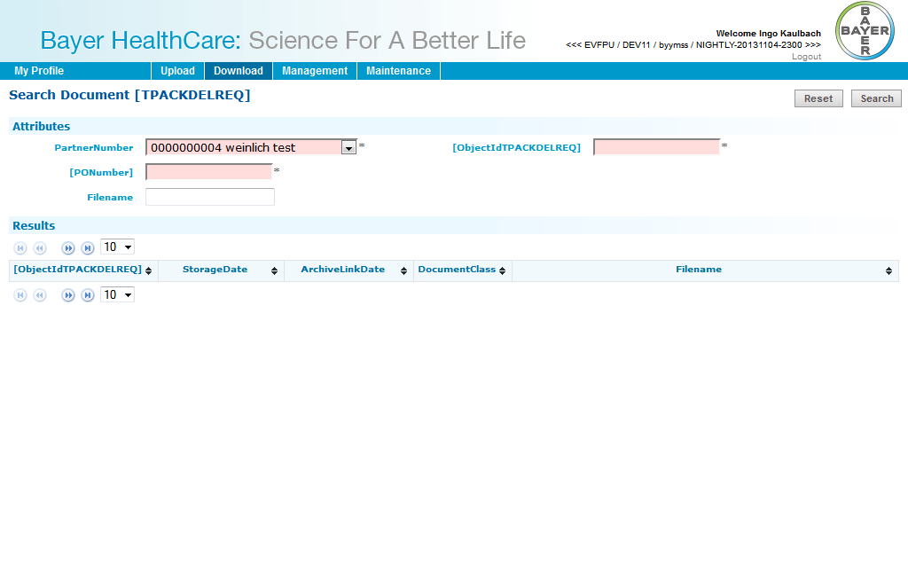

# Workflow User Management

## User Overview

|  |  |
| --- | --- |
| **Title** | User Overview |
| **Short description** | Display list of DOC41WebUI users |
| **Type** | UserManagement |
| **JSP** | userlist |
| **Form** | UserListFilter |
| **Controller** | UserlistController |
| **UseCase** | UserManagementUC |
| **Repository** | UserManagementRepository |
| **DAO** | UserManagementDAO |
| **RFC** |  |
| **Design** |  |

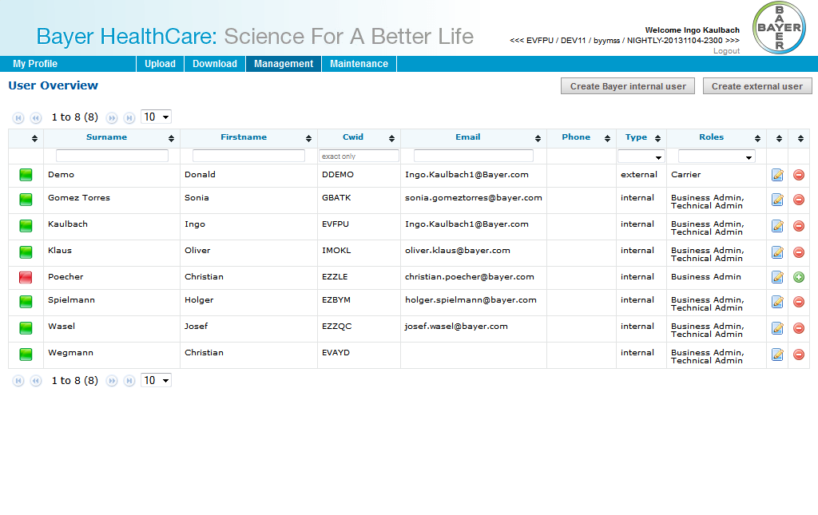

## Create internal user

|  |  |
| --- | --- |
| **Title** | Create internal user |
| **Short description** | Create internal user |
| **Type** | UserManagement |
| **JSP** | userlookup, userimport |
| **Form** | UserLookupForm, UserEditForm |
| **Controller** | UserlookupController, UsereditController |
| **UseCase** | UserManagementUC |
| **Repository** | UserManagementRepository |
| **DAO** | UserManagementDAO, LdapDAO |
| **RFC** |  |
| **Design** |  |

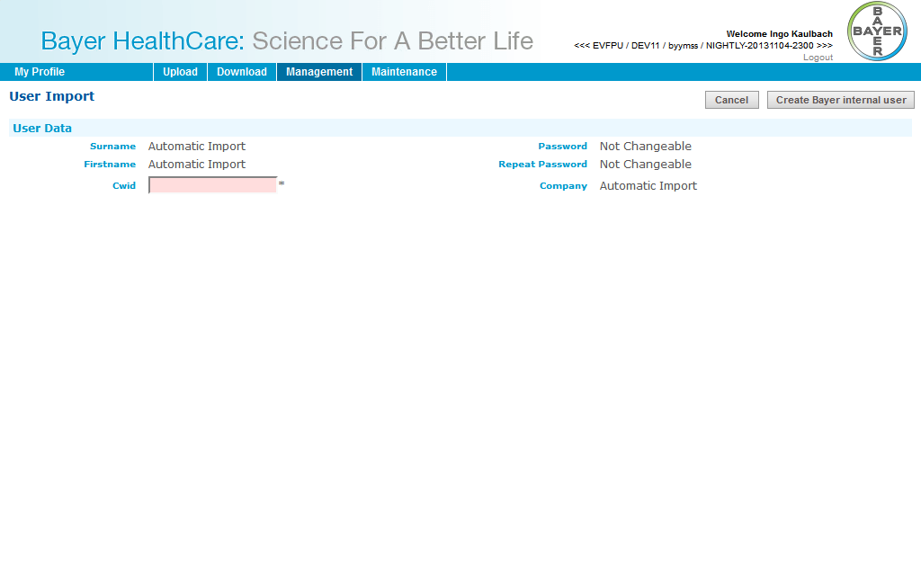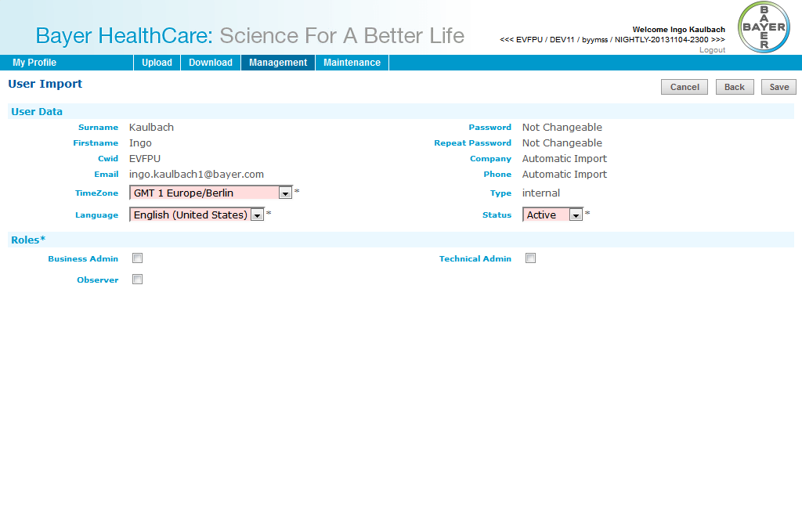

## Create external user

|  |  |
| --- | --- |
| **Title** | Create external user |
| **Short description** | Create external user |
| **Type** | UserManagement |
| **JSP** | usercreate |
| **Form** | UserEditForm |
| **Controller** | UsercreateController, UsereditController |
| **UseCase** | UserManagementUC |
| **Repository** | UserManagementRepository |
| **DAO** | UserManagementDAO, LdapDAO |
| **RFC** |  |
| **Design** |  |

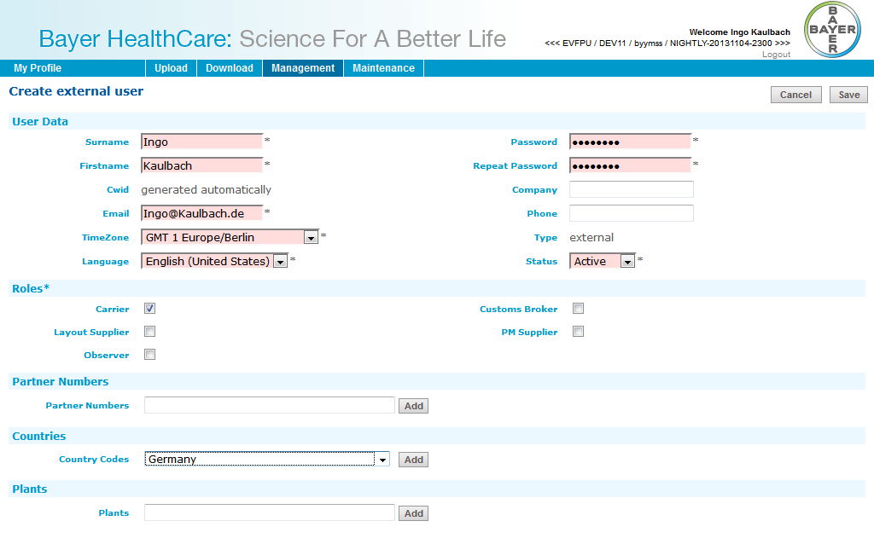

## Change internal user data

|  |  |
| --- | --- |
| **Title** | Change internal user data |
| **Short description** | Change internal user data |
| **Type** | UserManagement |
| **JSP** | useredit |
| **Form** | UserEditForm |
| **Controller** | UsereditController |
| **UseCase** | UserManagementUC |
| **Repository** | UserManagementRepository |
| **DAO** | UserManagementDAO, LdapDAO |
| **RFC** | AuthorizationRFCService |
| **Design** |  |

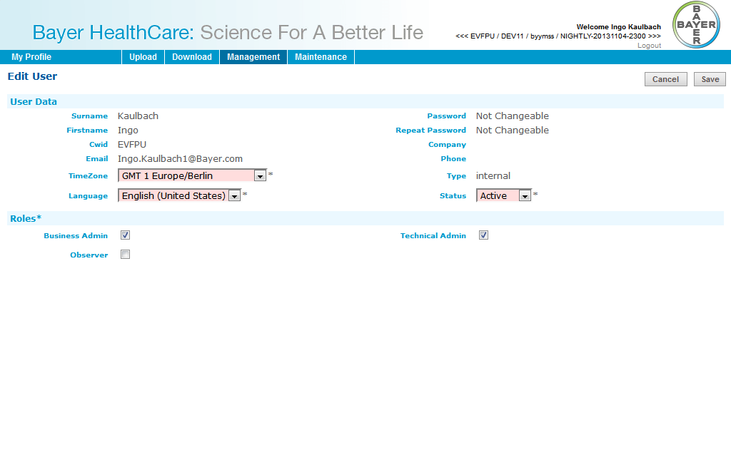

## Change external user data

|  |  |
| --- | --- |
| **Title** | Change external user data |
| **Short description** | Change external user data |
| **Type** | UserManagement |
| **JSP** | useredit |
| **Form** | UserEditForm |
| **Controller** | UsereditController |
| **UseCase** | UserManagementUC |
| **Repository** | UserManagementRepository |
| **DAO** | UserManagementDAO, LdapDAO |
| **RFC** | AuthorizationRFCService |
| **Design** |  |

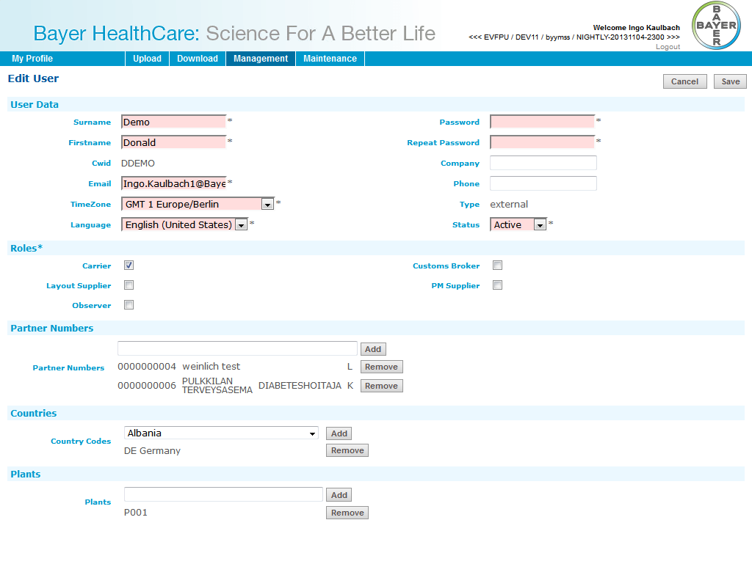

## New password for external user

|  |  |
| --- | --- |
| **Title** | New password for external user |
| **Short description** | New password for external user |
| **Type** | UserManagement |
| **JSP** | useredit |
| **Form** | UserEditForm |
| **Controller** | UsereditController |
| **UseCase** | UserManagementUC |
| **Repository** | UserManagementRepository |
| **DAO** | UserManagementDAO, LdapDAO |
| **RFC** | AuthorizationRFCService |
| **Design** |  |

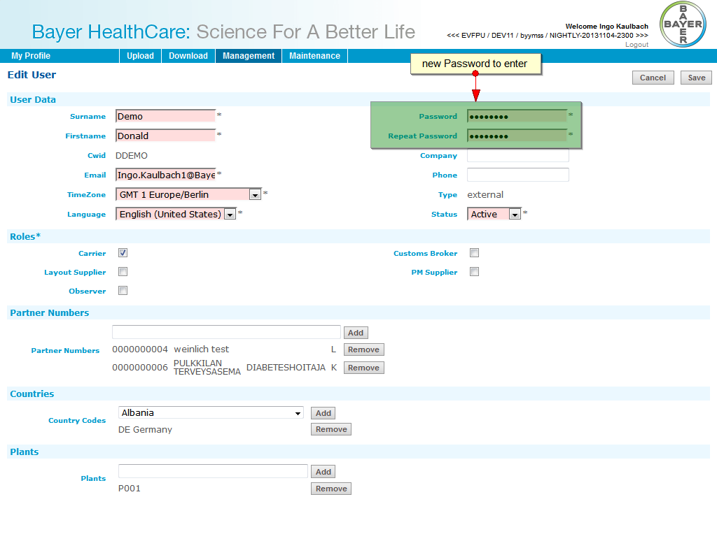

# Java Server Pages

* error404.jsp
* exception.jsp
* sc.jsp

## documents

* delcertupinput.jsp
* delcertuplist.jsp
* delcertupload.jsp
* documentsearch.jsp
* opendeliveries.jsp
* ptupload.jsp
* sdupload.jsp
* searchdelcertcountry.jsp
* searchdelcertcustomer.jsp
* searchpmsupplier.jsp
* supcoaupinput.jsp
* supcoauplist.jsp
* supcoaupload.jsp
* uploadsuccess.jsp

## login

* forbidden.jsp
* login.jsp

## maintenance

* profilePermissions.jsp
* rfcMetadata.jsp
* untranslatedLabels.jsp

## monitoring

* addContactPerson.jsp
* addInterface.jsp
* editContactPerson.jsp
* monitoringHistory.jsp
* monitoringOverview.jsp
* viewContactPerson.jsp

## translations

* translationAdd.jsp
* translationEdit.jsp
* translationOverview.jsp

## useradmin

* countries.jspf
* partners.jspf
* plants.jspf
* roles.jspf
* usercreate.jsp
* useredit.jsp
* userimport.jsp
* userlist.jsp
* userlookup.jsp

## userprofile

* myprofile.jsp

# Java Class Definition

|  |  |
| --- | --- |
| **Package Name** | com.bayer.bhc.doc41webui.container |
| **Class Name** | UserListFilter |
| **Superclass** | java.lang.Object |
| **Interfaces** | java.io.Serializable |
| **Methodes** | |  |  | | --- | --- | | **Name** | toString | | **Static Method** | False | | **Parameter Type Names** |  | | **Return Type** | class java.lang.String |  |  |  | | --- | --- | | **Name** | getType | | **Static Method** | False | | **Parameter Type Names** |  | | **Return Type** | class java.lang.String |  |  |  | | --- | --- | | **Name** | reset | | **Static Method** | False | | **Parameter Type Names** |  | | **Return Type** | void |  |  |  | | --- | --- | | **Name** | setStatus | | **Static Method** | False | | **Parameter Type Names** | java.lang.String | | **Return Type** | void |  |  |  | | --- | --- | | **Name** | setSurname | | **Static Method** | False | | **Parameter Type Names** | java.lang.String | | **Return Type** | void |  |  |  | | --- | --- | | **Name** | setFirstname | | **Static Method** | False | | **Parameter Type Names** | java.lang.String | | **Return Type** | void |  |  |  | | --- | --- | | **Name** | setCwid | | **Static Method** | False | | **Parameter Type Names** | java.lang.String | | **Return Type** | void |  |  |  | | --- | --- | | **Name** | setEmail | | **Static Method** | False | | **Parameter Type Names** | java.lang.String | | **Return Type** | void |  |  |  | | --- | --- | | **Name** | setType | | **Static Method** | False | | **Parameter Type Names** | java.lang.String | | **Return Type** | void |  |  |  | | --- | --- | | **Name** | setRole | | **Static Method** | False | | **Parameter Type Names** | java.lang.String | | **Return Type** | void |  |  |  | | --- | --- | | **Name** | setOrderBy | | **Static Method** | False | | **Parameter Type Names** | java.lang.String | | **Return Type** | void |  |  |  | | --- | --- | | **Name** | getSurname | | **Static Method** | False | | **Parameter Type Names** |  | | **Return Type** | class java.lang.String |  |  |  | | --- | --- | | **Name** | getFirstname | | **Static Method** | False | | **Parameter Type Names** |  | | **Return Type** | class java.lang.String |  |  |  | | --- | --- | | **Name** | getCwid | | **Static Method** | False | | **Parameter Type Names** |  | | **Return Type** | class java.lang.String |  |  |  | | --- | --- | | **Name** | getEmail | | **Static Method** | False | | **Parameter Type Names** |  | | **Return Type** | class java.lang.String |  |  |  | | --- | --- | | **Name** | getCompany | | **Static Method** | False | | **Parameter Type Names** |  | | **Return Type** | class java.lang.String |  |  |  | | --- | --- | | **Name** | setCompany | | **Static Method** | False | | **Parameter Type Names** | java.lang.String | | **Return Type** | void |  |  |  | | --- | --- | | **Name** | getRole | | **Static Method** | False | | **Parameter Type Names** |  | | **Return Type** | class java.lang.String |  |  |  | | --- | --- | | **Name** | getStatus | | **Static Method** | False | | **Parameter Type Names** |  | | **Return Type** | class java.lang.String |  |  |  | | --- | --- | | **Name** | getOrderBy | | **Static Method** | False | | **Parameter Type Names** |  | | **Return Type** | class java.lang.String | |

|  |  |
| --- | --- |
| **Package Name** | com.bayer.bhc.doc41webui.integration.db |
| **Class Name** | TranslationsDAO |
| **Superclass** | com.bayer.bhc.doc41webui.integration.db.AbstractDAOImpl |
| **Interfaces** |  |
| **Methodes** | |  |  | | --- | --- | | **Name** | findTags | | **Static Method** | False | | **Parameter Type Names** | com.bayer.bhc.doc41webui.container.TranslationPagingRequest | | **Return Type** | class com.bayer.bhc.doc41webui.common.paging.PagingResult |  |  |  | | --- | --- | | **Name** | storeTag | | **Static Method** | False | | **Parameter Type Names** | com.bayer.ecim.foundation.business.sbcommon.TranslationsDC | | **Return Type** | void |  |  |  | | --- | --- | | **Name** | getTagById | | **Static Method** | False | | **Parameter Type Names** | java.lang.Long | | **Return Type** | class com.bayer.ecim.foundation.business.sbcommon.TranslationsDC |  |  |  | | --- | --- | | **Name** | deleteTagById | | **Static Method** | False | | **Parameter Type Names** | java.lang.Long | | **Return Type** | void |  |  |  | | --- | --- | | **Name** | getComponentList | | **Static Method** | False | | **Parameter Type Names** |  | | **Return Type** | interface java.util.List |  |  |  | | --- | --- | | **Name** | getPageList | | **Static Method** | False | | **Parameter Type Names** | java.lang.String | | **Return Type** | interface java.util.List |  |  |  | | --- | --- | | **Name** | findTags4Component | | **Static Method** | False | | **Parameter Type Names** | java.lang.String  java.lang.String  java.lang.String | | **Return Type** | interface java.util.List |  |  |  | | --- | --- | | **Name** | findTags4Component | | **Static Method** | False | | **Parameter Type Names** | java.lang.String  java.lang.String | | **Return Type** | interface java.util.List |  |  |  | | --- | --- | | **Name** | distributeTags | | **Static Method** | False | | **Parameter Type Names** |  | | **Return Type** | class java.lang.String |  |  |  | | --- | --- | | **Name** | isTagExist | | **Static Method** | False | | **Parameter Type Names** | com.bayer.ecim.foundation.business.sbcommon.TranslationsDC | | **Return Type** | int |  |  |  | | --- | --- | | **Name** | getTemplateComponentName | | **Static Method** | False | | **Parameter Type Names** |  | | **Return Type** | class java.lang.String |  |  |  | | --- | --- | | **Name** | getTemplateSubComponentName | | **Static Method** | False | | **Parameter Type Names** |  | | **Return Type** | class java.lang.String | |

|  |  |
| --- | --- |
| **Package Name** | com.bayer.bhc.doc41webui.usecase.documenttypes |
| **Class Name** | AbstractDeliveryCertDocumentType |
| **Superclass** | java.lang.Object |
| **Interfaces** | com.bayer.bhc.doc41webui.usecase.documenttypes.DocumentType |
| **Methodes** | |  |  | | --- | --- | | **Name** | getSapTypeId | | **Static Method** | False | | **Parameter Type Names** |  | | **Return Type** | class java.lang.String |  |  |  | | --- | --- | | **Name** | getObjectIdFillLength | | **Static Method** | False | | **Parameter Type Names** |  | | **Return Type** | int | |

|  |  |
| --- | --- |
| **Package Name** | com.bayer.bhc.doc41webui.container |
| **Class Name** | UserLookupForm |
| **Superclass** | java.lang.Object |
| **Interfaces** | java.io.Serializable |
| **Methodes** | |  |  | | --- | --- | | **Name** | setCwid | | **Static Method** | False | | **Parameter Type Names** | java.lang.String | | **Return Type** | void |  |  |  | | --- | --- | | **Name** | getCwid | | **Static Method** | False | | **Parameter Type Names** |  | | **Return Type** | class java.lang.String | |

|  |  |
| --- | --- |
| **Package Name** | com.bayer.bhc.doc41webui.integration.db |
| **Class Name** | UserManagementDAO |
| **Superclass** | com.bayer.bhc.doc41webui.integration.db.AbstractDAOImpl |
| **Interfaces** |  |
| **Methodes** | |  |  | | --- | --- | | **Name** | updateUser | | **Static Method** | False | | **Parameter Type Names** | com.bayer.ecim.foundation.web.usermanagementN.UMUserNDC | | **Return Type** | void |  |  |  | | --- | --- | | **Name** | getUserByCWID | | **Static Method** | False | | **Parameter Type Names** | java.lang.String | | **Return Type** | class com.bayer.ecim.foundation.web.usermanagementN.UMUserNDC |  |  |  | | --- | --- | | **Name** | getUMUserNDCs | | **Static Method** | False | | **Parameter Type Names** | com.bayer.bhc.doc41webui.container.UserPagingRequest | | **Return Type** | class com.bayer.bhc.doc41webui.common.paging.PagingResult |  |  |  | | --- | --- | | **Name** | createUser | | **Static Method** | False | | **Parameter Type Names** | java.util.Locale | | **Return Type** | class com.bayer.ecim.foundation.web.usermanagementN.UMUserNDC |  |  |  | | --- | --- | | **Name** | insertUser | | **Static Method** | False | | **Parameter Type Names** | com.bayer.ecim.foundation.web.usermanagementN.UMUserNDC | | **Return Type** | class com.bayer.ecim.foundation.web.usermanagementN.UMUserNDC |  |  |  | | --- | --- | | **Name** | removeUserProfile | | **Static Method** | False | | **Parameter Type Names** | java.lang.Long | | **Return Type** | void |  |  |  | | --- | --- | | **Name** | getProfilesByUser | | **Static Method** | False | | **Parameter Type Names** | java.lang.Long | | **Return Type** | interface java.util.List |  |  |  | | --- | --- | | **Name** | createUserProfile | | **Static Method** | False | | **Parameter Type Names** | java.util.Locale | | **Return Type** | class com.bayer.ecim.foundation.web.usermanagementN.UMUserProfileNDC |  |  |  | | --- | --- | | **Name** | getProfileByName | | **Static Method** | False | | **Parameter Type Names** | java.lang.String  java.util.Locale | | **Return Type** | class com.bayer.ecim.foundation.web.usermanagementN.UMProfileNDC |  |  |  | | --- | --- | | **Name** | saveUserProfile | | **Static Method** | False | | **Parameter Type Names** | com.bayer.ecim.foundation.web.usermanagementN.UMUserProfileNDC | | **Return Type** | void |  |  |  | | --- | --- | | **Name** | getPartnersByUser | | **Static Method** | False | | **Parameter Type Names** | java.lang.Long | | **Return Type** | interface java.util.List |  |  |  | | --- | --- | | **Name** | createUserPartner | | **Static Method** | False | | **Parameter Type Names** | java.util.Locale | | **Return Type** | class com.bayer.bhc.doc41webui.integration.db.dc.UserPartnerDC |  |  |  | | --- | --- | | **Name** | saveUserPartner | | **Static Method** | False | | **Parameter Type Names** | com.bayer.bhc.doc41webui.integration.db.dc.UserPartnerDC | | **Return Type** | void |  |  |  | | --- | --- | | **Name** | getUserPartner | | **Static Method** | False | | **Parameter Type Names** | java.lang.Long  java.lang.String | | **Return Type** | class com.bayer.bhc.doc41webui.integration.db.dc.UserPartnerDC |  |  |  | | --- | --- | | **Name** | deleteUserPartner | | **Static Method** | False | | **Parameter Type Names** | com.bayer.bhc.doc41webui.integration.db.dc.UserPartnerDC | | **Return Type** | void |  |  |  | | --- | --- | | **Name** | getCountriesByUser | | **Static Method** | False | | **Parameter Type Names** | java.lang.Long | | **Return Type** | interface java.util.List |  |  |  | | --- | --- | | **Name** | createUserCountry | | **Static Method** | False | | **Parameter Type Names** | java.util.Locale | | **Return Type** | class com.bayer.bhc.doc41webui.integration.db.dc.UserCountryDC |  |  |  | | --- | --- | | **Name** | saveUserCountry | | **Static Method** | False | | **Parameter Type Names** | com.bayer.bhc.doc41webui.integration.db.dc.UserCountryDC | | **Return Type** | void |  |  |  | | --- | --- | | **Name** | getUserCountry | | **Static Method** | False | | **Parameter Type Names** | java.lang.Long  java.lang.String | | **Return Type** | class com.bayer.bhc.doc41webui.integration.db.dc.UserCountryDC |  |  |  | | --- | --- | | **Name** | deleteUserCountry | | **Static Method** | False | | **Parameter Type Names** | com.bayer.bhc.doc41webui.integration.db.dc.UserCountryDC | | **Return Type** | void |  |  |  | | --- | --- | | **Name** | getPlantsByUser | | **Static Method** | False | | **Parameter Type Names** | java.lang.Long | | **Return Type** | interface java.util.List |  |  |  | | --- | --- | | **Name** | createUserPlant | | **Static Method** | False | | **Parameter Type Names** | java.util.Locale | | **Return Type** | class com.bayer.bhc.doc41webui.integration.db.dc.UserPlantDC |  |  |  | | --- | --- | | **Name** | saveUserPlant | | **Static Method** | False | | **Parameter Type Names** | com.bayer.bhc.doc41webui.integration.db.dc.UserPlantDC | | **Return Type** | void |  |  |  | | --- | --- | | **Name** | getUserPlant | | **Static Method** | False | | **Parameter Type Names** | java.lang.Long  java.lang.String | | **Return Type** | class com.bayer.bhc.doc41webui.integration.db.dc.UserPlantDC |  |  |  | | --- | --- | | **Name** | deleteUserPlant | | **Static Method** | False | | **Parameter Type Names** | com.bayer.bhc.doc41webui.integration.db.dc.UserPlantDC | | **Return Type** | void |  |  |  | | --- | --- | | **Name** | getTemplateComponentName | | **Static Method** | False | | **Parameter Type Names** |  | | **Return Type** | class java.lang.String |  |  |  | | --- | --- | | **Name** | getProfilePermissions | | **Static Method** | False | | **Parameter Type Names** |  | | **Return Type** | interface java.util.List | |

|  |  |
| --- | --- |
| **Package Name** | com.bayer.bhc.doc41webui.usecase.documenttypes |
| **Class Name** | ShippersDeclDocumentType |
| **Superclass** | com.bayer.bhc.doc41webui.usecase.documenttypes.SDDocumentType |
| **Interfaces** | com.bayer.bhc.doc41webui.usecase.documenttypes.DirectDownloadDocumentType  com.bayer.bhc.doc41webui.usecase.documenttypes.DownloadDocumentType |
| **Methodes** | |  |  | | --- | --- | | **Name** | getTypeConst | | **Static Method** | False | | **Parameter Type Names** |  | | **Return Type** | class java.lang.String |  |  |  | | --- | --- | | **Name** | getSapTypeId | | **Static Method** | False | | **Parameter Type Names** |  | | **Return Type** | class java.lang.String |  |  |  | | --- | --- | | **Name** | getPermissionDownload | | **Static Method** | False | | **Parameter Type Names** |  | | **Return Type** | class java.lang.String |  |  |  | | --- | --- | | **Name** | getPermissionDirectDownload | | **Static Method** | False | | **Parameter Type Names** |  | | **Return Type** | class java.lang.String | |

|  |  |
| --- | --- |
| **Package Name** | com.bayer.bhc.doc41webui.web.documents |
| **Class Name** | SupCoaUploadController |
| **Superclass** | com.bayer.bhc.doc41webui.web.documents.UploadController |
| **Interfaces** |  |
| **Methodes** | |  |  | | --- | --- | | **Name** | getInspLots | | **Static Method** | False | | **Parameter Type Names** | java.lang.String  com.bayer.bhc.doc41webui.container.VendorBatchForm  org.springframework.validation.BindingResult  org.springframework.web.servlet.ModelAndView | | **Return Type** | class org.springframework.web.servlet.ModelAndView |  |  |  | | --- | --- | | **Name** | getUpload | | **Static Method** | False | | **Parameter Type Names** | java.lang.String  com.bayer.bhc.doc41webui.domain.InspectionLot | | **Return Type** | class org.springframework.ui.ModelMap |  |  |  | | --- | --- | | **Name** | postUpload | | **Static Method** | False | | **Parameter Type Names** | com.bayer.bhc.doc41webui.container.UploadForm  org.springframework.validation.BindingResult | | **Return Type** | class java.lang.String |  |  |  | | --- | --- | | **Name** | getVBatch | | **Static Method** | False | | **Parameter Type Names** | java.lang.String | | **Return Type** | class com.bayer.bhc.doc41webui.container.VendorBatchForm | |

|  |  |
| --- | --- |
| **Package Name** | com.bayer.bhc.doc41webui.service.repository |
| **Class Name** | TranslationsRepository |
| **Superclass** | com.bayer.bhc.doc41webui.service.repository.AbstractRepository |
| **Interfaces** |  |
| **Methodes** | |  |  | | --- | --- | | **Name** | getCountryCodes | | **Static Method** | False | | **Parameter Type Names** |  | | **Return Type** | interface java.util.Map |  |  |  | | --- | --- | | **Name** | getLanguageCodes | | **Static Method** | False | | **Parameter Type Names** |  | | **Return Type** | interface java.util.Map |  |  |  | | --- | --- | | **Name** | findTags | | **Static Method** | False | | **Parameter Type Names** | com.bayer.bhc.doc41webui.container.TranslationPagingRequest | | **Return Type** | class com.bayer.bhc.doc41webui.common.paging.PagingResult |  |  |  | | --- | --- | | **Name** | getTranslationsMapper | | **Static Method** | False | | **Parameter Type Names** |  | | **Return Type** | class com.bayer.bhc.doc41webui.service.mapping.TranslationsMapper |  |  |  | | --- | --- | | **Name** | createTag | | **Static Method** | False | | **Parameter Type Names** | com.bayer.bhc.doc41webui.domain.Translation | | **Return Type** | void |  |  |  | | --- | --- | | **Name** | editTag | | **Static Method** | False | | **Parameter Type Names** | com.bayer.bhc.doc41webui.domain.Translation | | **Return Type** | void |  |  |  | | --- | --- | | **Name** | getTagById | | **Static Method** | False | | **Parameter Type Names** | java.lang.Long | | **Return Type** | class com.bayer.bhc.doc41webui.domain.Translation |  |  |  | | --- | --- | | **Name** | deleteTagById | | **Static Method** | False | | **Parameter Type Names** | java.lang.Long | | **Return Type** | void |  |  |  | | --- | --- | | **Name** | setLanguageCodes | | **Static Method** | False | | **Parameter Type Names** | java.util.Map | | **Return Type** | void |  |  |  | | --- | --- | | **Name** | setCountryCodes | | **Static Method** | False | | **Parameter Type Names** | java.util.Map | | **Return Type** | void |  |  |  | | --- | --- | | **Name** | getComponentList | | **Static Method** | False | | **Parameter Type Names** |  | | **Return Type** | interface java.util.List |  |  |  | | --- | --- | | **Name** | getPageList | | **Static Method** | False | | **Parameter Type Names** | java.lang.String | | **Return Type** | interface java.util.List |  |  |  | | --- | --- | | **Name** | findTags4Component | | **Static Method** | False | | **Parameter Type Names** | java.lang.String  java.lang.String | | **Return Type** | interface java.util.Map |  |  |  | | --- | --- | | **Name** | distributeTags | | **Static Method** | False | | **Parameter Type Names** |  | | **Return Type** | void |  |  |  | | --- | --- | | **Name** | isTagExist | | **Static Method** | False | | **Parameter Type Names** | com.bayer.bhc.doc41webui.domain.Translation | | **Return Type** | int |  |  |  | | --- | --- | | **Name** | getTranslationsDAO | | **Static Method** | False | | **Parameter Type Names** |  | | **Return Type** | class com.bayer.bhc.doc41webui.integration.db.TranslationsDAO | |

|  |  |
| --- | --- |
| **Package Name** | com.bayer.bhc.doc41webui.usecase.documenttypes |
| **Class Name** | SupplierCOADocumentType |
| **Superclass** | java.lang.Object |
| **Interfaces** | com.bayer.bhc.doc41webui.usecase.documenttypes.UploadDocumentType |
| **Methodes** | |  |  | | --- | --- | | **Name** | getTypeConst | | **Static Method** | False | | **Parameter Type Names** |  | | **Return Type** | class java.lang.String |  |  |  | | --- | --- | | **Name** | getSapTypeId | | **Static Method** | False | | **Parameter Type Names** |  | | **Return Type** | class java.lang.String |  |  |  | | --- | --- | | **Name** | getPermissionUpload | | **Static Method** | False | | **Parameter Type Names** |  | | **Return Type** | class java.lang.String |  |  |  | | --- | --- | | **Name** | checkForUpload | | **Static Method** | False | | **Parameter Type Names** | org.springframework.validation.Errors  com.bayer.bhc.doc41webui.usecase.DocumentUC  java.lang.String  java.lang.String  java.util.Map  java.util.Map | | **Return Type** | class com.bayer.bhc.doc41webui.usecase.documenttypes.CheckForUpdateResult |  |  |  | | --- | --- | | **Name** | getPartnerNumberType | | **Static Method** | False | | **Parameter Type Names** |  | | **Return Type** | class java.lang.String |  |  |  | | --- | --- | | **Name** | getObjectIdFillLength | | **Static Method** | False | | **Parameter Type Names** |  | | **Return Type** | int | |

|  |  |
| --- | --- |
| **Package Name** | com.bayer.bhc.doc41webui.usecase |
| **Class Name** | DocumentUC |
| **Superclass** | java.lang.Object |
| **Interfaces** |  |
| **Methodes** | |  |  | | --- | --- | | **Name** | checkForUpload | | **Static Method** | False | | **Parameter Type Names** | org.springframework.validation.Errors  java.lang.String  java.lang.String  java.lang.String  java.util.Map  java.util.Map | | **Return Type** | class com.bayer.bhc.doc41webui.usecase.documenttypes.CheckForUpdateResult |  |  |  | | --- | --- | | **Name** | getPartnerNumberType | | **Static Method** | False | | **Parameter Type Names** | java.lang.String | | **Return Type** | class java.lang.String |  |  |  | | --- | --- | | **Name** | checkDeliveryForPartner | | **Static Method** | False | | **Parameter Type Names** | java.lang.String  java.lang.String | | **Return Type** | class com.bayer.bhc.doc41webui.domain.SDReferenceCheckResult |  |  |  | | --- | --- | | **Name** | checkForDownload | | **Static Method** | False | | **Parameter Type Names** | org.springframework.validation.Errors  java.lang.String  java.lang.String  java.util.List  java.util.Map  java.util.Map | | **Return Type** | void |  |  |  | | --- | --- | | **Name** | checkForDirectDownload | | **Static Method** | False | | **Parameter Type Names** | java.lang.String  java.lang.String | | **Return Type** | void |  |  |  | | --- | --- | | **Name** | getBatchObjectsForSupplier | | **Static Method** | False | | **Parameter Type Names** | java.lang.String  java.lang.String  java.lang.String  java.lang.String  java.lang.String | | **Return Type** | interface java.util.List |  |  |  | | --- | --- | | **Name** | getUploadPermission | | **Static Method** | False | | **Parameter Type Names** | java.lang.String | | **Return Type** | class java.lang.String |  |  |  | | --- | --- | | **Name** | getAttributeDefinitions | | **Static Method** | False | | **Parameter Type Names** | java.lang.String  boolean | | **Return Type** | interface java.util.List |  |  |  | | --- | --- | | **Name** | checkForVirus | | **Static Method** | False | | **Parameter Type Names** | org.springframework.web.multipart.MultipartFile | | **Return Type** | class java.io.File |  |  |  | | --- | --- | | **Name** | uploadDocument | | **Static Method** | False | | **Parameter Type Names** | java.lang.String  java.io.File  java.lang.String | | **Return Type** | class java.lang.String |  |  |  | | --- | --- | | **Name** | setAttributesForNewDocument | | **Static Method** | False | | **Parameter Type Names** | java.lang.String  java.lang.String  java.util.Map  java.lang.String  java.lang.String  java.lang.String  java.lang.String | | **Return Type** | void |  |  |  | | --- | --- | | **Name** | getDocumentFillLength | | **Static Method** | False | | **Parameter Type Names** | java.lang.String | | **Return Type** | int |  |  |  | | --- | --- | | **Name** | isPartnerNumberUsed | | **Static Method** | False | | **Parameter Type Names** | java.lang.String | | **Return Type** | boolean |  |  |  | | --- | --- | | **Name** | checkArtworkLayoutForVendor | | **Static Method** | False | | **Parameter Type Names** | java.lang.String  java.lang.String | | **Return Type** | class java.lang.String |  |  |  | | --- | --- | | **Name** | getInspectionLotsForVendorBatch | | **Static Method** | False | | **Parameter Type Names** | java.lang.String  java.lang.String  java.lang.String | | **Return Type** | interface java.util.List |  |  |  | | --- | --- | | **Name** | getMetadata | | **Static Method** | False | | **Parameter Type Names** | java.lang.String | | **Return Type** | class com.bayer.bhc.doc41webui.domain.DocMetadata |  |  |  | | --- | --- | | **Name** | getTypeLabel | | **Static Method** | False | | **Parameter Type Names** | java.lang.String  java.lang.String | | **Return Type** | class java.lang.String |  |  |  | | --- | --- | | **Name** | getOpenDeliveries | | **Static Method** | False | | **Parameter Type Names** | java.lang.String  java.lang.String | | **Return Type** | interface java.util.List |  |  |  | | --- | --- | | **Name** | searchDocuments | | **Static Method** | False | | **Parameter Type Names** | java.lang.String  java.util.List  java.util.Map  int  boolean | | **Return Type** | interface java.util.List |  |  |  | | --- | --- | | **Name** | downloadDocument | | **Static Method** | False | | **Parameter Type Names** | javax.servlet.http.HttpServletResponse  java.lang.String  java.lang.String | | **Return Type** | class java.lang.String |  |  |  | | --- | --- | | **Name** | getDownloadPermission | | **Static Method** | False | | **Parameter Type Names** | java.lang.String | | **Return Type** | class java.lang.String |  |  |  | | --- | --- | | **Name** | getDirectDownloadPermission | | **Static Method** | False | | **Parameter Type Names** | java.lang.String | | **Return Type** | class java.lang.String |  |  |  | | --- | --- | | **Name** | checkPOAndMaterialForVendor | | **Static Method** | False | | **Parameter Type Names** | java.lang.String  java.lang.String  java.lang.String | | **Return Type** | class java.lang.String |  |  |  | | --- | --- | | **Name** | getBatchObjectsForCustomer | | **Static Method** | False | | **Parameter Type Names** | java.lang.String  java.lang.String  java.lang.String  java.lang.String  java.lang.String | | **Return Type** | interface java.util.List | |

|  |  |
| --- | --- |
| **Package Name** | com.bayer.bhc.doc41webui.web.useradmin |
| **Class Name** | UserlistController |
| **Superclass** | com.bayer.bhc.doc41webui.web.AbstractDoc41Controller |
| **Interfaces** |  |
| **Methodes** | |  |  | | --- | --- | | **Name** | getAllRoles | | **Static Method** | False | | **Parameter Type Names** |  | | **Return Type** | class [Ljava.lang.String; |  |  |  | | --- | --- | | **Name** | getTable | | **Static Method** | False | | **Parameter Type Names** | com.bayer.bhc.doc41webui.common.paging.TableSorterParams | | **Return Type** | interface java.util.Map |  |  |  | | --- | --- | | **Name** | deleteTranslation | | **Static Method** | False | | **Parameter Type Names** | java.lang.String | | **Return Type** | class java.lang.String | |

|  |  |
| --- | --- |
| **Package Name** | com.bayer.bhc.doc41webui.web.documents |
| **Class Name** | SDUploadController |
| **Superclass** | com.bayer.bhc.doc41webui.web.documents.UploadController |
| **Interfaces** |  |
| **Methodes** | |  |  | | --- | --- | | **Name** | get | | **Static Method** | False | | **Parameter Type Names** | java.lang.String | | **Return Type** | class com.bayer.bhc.doc41webui.container.UploadForm |  |  |  | | --- | --- | | **Name** | postUpload | | **Static Method** | False | | **Parameter Type Names** | com.bayer.bhc.doc41webui.container.UploadForm  org.springframework.validation.BindingResult | | **Return Type** | class java.lang.String | |

|  |  |
| --- | --- |
| **Package Name** | com.bayer.bhc.doc41webui.service.repository |
| **Class Name** | UserManagementRepository |
| **Superclass** | com.bayer.bhc.doc41webui.service.repository.AbstractRepository |
| **Interfaces** |  |
| **Methodes** | |  |  | | --- | --- | | **Name** | updateUser | | **Static Method** | False | | **Parameter Type Names** | com.bayer.bhc.doc41webui.domain.User  boolean  boolean  boolean  boolean  boolean | | **Return Type** | void |  |  |  | | --- | --- | | **Name** | getLdapDAO | | **Static Method** | False | | **Parameter Type Names** |  | | **Return Type** | class com.bayer.bhc.doc41webui.integration.db.LdapDAO |  |  |  | | --- | --- | | **Name** | setLdapDAO | | **Static Method** | False | | **Parameter Type Names** | com.bayer.bhc.doc41webui.integration.db.LdapDAO | | **Return Type** | void |  |  |  | | --- | --- | | **Name** | getUserManagementDAO | | **Static Method** | False | | **Parameter Type Names** |  | | **Return Type** | class com.bayer.bhc.doc41webui.integration.db.UserManagementDAO |  |  |  | | --- | --- | | **Name** | setUserManagementDAO | | **Static Method** | False | | **Parameter Type Names** | com.bayer.bhc.doc41webui.integration.db.UserManagementDAO | | **Return Type** | void |  |  |  | | --- | --- | | **Name** | setUserMapper | | **Static Method** | False | | **Parameter Type Names** | com.bayer.bhc.doc41webui.service.mapping.UserMapper | | **Return Type** | void |  |  |  | | --- | --- | | **Name** | getUserByCwid | | **Static Method** | False | | **Parameter Type Names** | java.lang.String | | **Return Type** | class com.bayer.bhc.doc41webui.domain.User |  |  |  | | --- | --- | | **Name** | getUsers | | **Static Method** | False | | **Parameter Type Names** | com.bayer.bhc.doc41webui.container.UserPagingRequest | | **Return Type** | class com.bayer.bhc.doc41webui.common.paging.PagingResult |  |  |  | | --- | --- | | **Name** | lookupUser | | **Static Method** | False | | **Parameter Type Names** | java.lang.String | | **Return Type** | class com.bayer.bhc.doc41webui.domain.User |  |  |  | | --- | --- | | **Name** | isAuthenticated | | **Static Method** | False | | **Parameter Type Names** | java.lang.String  java.lang.String | | **Return Type** | boolean |  |  |  | | --- | --- | | **Name** | createUser | | **Static Method** | False | | **Parameter Type Names** | com.bayer.bhc.doc41webui.domain.User | | **Return Type** | void | |

|  |  |
| --- | --- |
| **Package Name** | com.bayer.bhc.doc41webui.usecase.documenttypes |
| **Class Name** | BOLDocumentType |
| **Superclass** | com.bayer.bhc.doc41webui.usecase.documenttypes.SDDocumentType |
| **Interfaces** | com.bayer.bhc.doc41webui.usecase.documenttypes.UploadDocumentType  com.bayer.bhc.doc41webui.usecase.documenttypes.DirectDownloadDocumentType  com.bayer.bhc.doc41webui.usecase.documenttypes.DownloadDocumentType |
| **Methodes** | |  |  | | --- | --- | | **Name** | getTypeConst | | **Static Method** | False | | **Parameter Type Names** |  | | **Return Type** | class java.lang.String |  |  |  | | --- | --- | | **Name** | getSapTypeId | | **Static Method** | False | | **Parameter Type Names** |  | | **Return Type** | class java.lang.String |  |  |  | | --- | --- | | **Name** | getPermissionUpload | | **Static Method** | False | | **Parameter Type Names** |  | | **Return Type** | class java.lang.String |  |  |  | | --- | --- | | **Name** | getPermissionDownload | | **Static Method** | False | | **Parameter Type Names** |  | | **Return Type** | class java.lang.String |  |  |  | | --- | --- | | **Name** | getPermissionDirectDownload | | **Static Method** | False | | **Parameter Type Names** |  | | **Return Type** | class java.lang.String | |

|  |  |
| --- | --- |
| **Package Name** | com.bayer.bhc.doc41webui.web.documents |
| **Class Name** | SearchController |
| **Superclass** | com.bayer.bhc.doc41webui.web.AbstractDoc41Controller |
| **Interfaces** |  |
| **Methodes** | |  |  | | --- | --- | | **Name** | get | | **Static Method** | False | | **Parameter Type Names** | com.bayer.bhc.doc41webui.container.SearchForm  org.springframework.validation.BindingResult  java.lang.String | | **Return Type** | class com.bayer.bhc.doc41webui.container.SearchForm |  |  |  | | --- | --- | | **Name** | download | | **Static Method** | False | | **Parameter Type Names** | java.lang.String  javax.servlet.http.HttpServletResponse | | **Return Type** | void |  |  |  | | --- | --- | | **Name** | getDelCertCountry | | **Static Method** | False | | **Parameter Type Names** | com.bayer.bhc.doc41webui.container.SearchForm  org.springframework.validation.BindingResult  java.lang.String | | **Return Type** | class org.springframework.ui.ModelMap |  |  |  | | --- | --- | | **Name** | getDelCertCustomer | | **Static Method** | False | | **Parameter Type Names** | com.bayer.bhc.doc41webui.container.SearchForm  org.springframework.validation.BindingResult  java.lang.String | | **Return Type** | class org.springframework.ui.ModelMap |  |  |  | | --- | --- | | **Name** | getPMSupplier | | **Static Method** | False | | **Parameter Type Names** | com.bayer.bhc.doc41webui.container.SearchForm  org.springframework.validation.BindingResult  java.lang.String | | **Return Type** | class org.springframework.ui.ModelMap | |

|  |  |
| --- | --- |
| **Package Name** | com.bayer.bhc.doc41webui.usecase.documenttypes |
| **Class Name** | DeliveryCertDownCountryDocumentType |
| **Superclass** | com.bayer.bhc.doc41webui.usecase.documenttypes.AbstractDeliveryCertDocumentType |
| **Interfaces** | com.bayer.bhc.doc41webui.usecase.documenttypes.DownloadDocumentType |
| **Methodes** | |  |  | | --- | --- | | **Name** | getTypeConst | | **Static Method** | False | | **Parameter Type Names** |  | | **Return Type** | class java.lang.String |  |  |  | | --- | --- | | **Name** | getPartnerNumberType | | **Static Method** | False | | **Parameter Type Names** |  | | **Return Type** | class java.lang.String |  |  |  | | --- | --- | | **Name** | checkForDownload | | **Static Method** | False | | **Parameter Type Names** | org.springframework.validation.Errors  com.bayer.bhc.doc41webui.usecase.DocumentUC  java.lang.String  java.util.List  java.util.Map  java.util.Map | | **Return Type** | void |  |  |  | | --- | --- | | **Name** | getPermissionDownload | | **Static Method** | False | | **Parameter Type Names** |  | | **Return Type** | class java.lang.String | |

|  |  |
| --- | --- |
| **Package Name** | com.bayer.bhc.doc41webui.usecase.documenttypes |
| **Class Name** | PZTecDrawingDocumentType |
| **Superclass** | com.bayer.bhc.doc41webui.usecase.documenttypes.PMSupplierDownloadDocumentType |
| **Interfaces** |  |
| **Methodes** | |  |  | | --- | --- | | **Name** | getTypeConst | | **Static Method** | False | | **Parameter Type Names** |  | | **Return Type** | class java.lang.String |  |  |  | | --- | --- | | **Name** | getSapTypeId | | **Static Method** | False | | **Parameter Type Names** |  | | **Return Type** | class java.lang.String |  |  |  | | --- | --- | | **Name** | getPermissionDownload | | **Static Method** | False | | **Parameter Type Names** |  | | **Return Type** | class java.lang.String | |

|  |  |
| --- | --- |
| **Package Name** | com.bayer.bhc.doc41webui.usecase |
| **Class Name** | UserManagementUC |
| **Superclass** | java.lang.Object |
| **Interfaces** |  |
| **Methodes** | |  |  | | --- | --- | | **Name** | findUsers | | **Static Method** | False | | **Parameter Type Names** | com.bayer.bhc.doc41webui.container.UserListFilter  com.bayer.bhc.doc41webui.common.paging.PagingData | | **Return Type** | class com.bayer.bhc.doc41webui.common.paging.PagingResult |  |  |  | | --- | --- | | **Name** | toggleUserActivation | | **Static Method** | False | | **Parameter Type Names** | java.lang.String | | **Return Type** | class com.bayer.bhc.doc41webui.domain.User |  |  |  | | --- | --- | | **Name** | getSupportedPartnerTypes | | **Static Method** | False | | **Parameter Type Names** |  | | **Return Type** | class [Ljava.lang.String; |  |  |  | | --- | --- | | **Name** | findUser | | **Static Method** | False | | **Parameter Type Names** | java.lang.String | | **Return Type** | class com.bayer.bhc.doc41webui.domain.User |  |  |  | | --- | --- | | **Name** | editUser | | **Static Method** | False | | **Parameter Type Names** | com.bayer.bhc.doc41webui.domain.User  boolean  boolean  boolean  boolean  boolean | | **Return Type** | void |  |  |  | | --- | --- | | **Name** | lookupUser | | **Static Method** | False | | **Parameter Type Names** | java.lang.String | | **Return Type** | class com.bayer.bhc.doc41webui.domain.User |  |  |  | | --- | --- | | **Name** | isAuthenticated | | **Static Method** | False | | **Parameter Type Names** | java.lang.String  java.lang.String | | **Return Type** | boolean |  |  |  | | --- | --- | | **Name** | createUser | | **Static Method** | False | | **Parameter Type Names** | com.bayer.bhc.doc41webui.domain.User | | **Return Type** | void |  |  |  | | --- | --- | | **Name** | getUserManagementRepository | | **Static Method** | False | | **Parameter Type Names** |  | | **Return Type** | class com.bayer.bhc.doc41webui.service.repository.UserManagementRepository |  |  |  | | --- | --- | | **Name** | checkPartner | | **Static Method** | False | | **Parameter Type Names** | java.lang.String | | **Return Type** | class com.bayer.bhc.doc41webui.domain.UserPartner | |

|  |  |
| --- | --- |
| **Package Name** | com.bayer.bhc.doc41webui.web.useradmin |
| **Class Name** | UsercreateController |
| **Superclass** | com.bayer.bhc.doc41webui.web.AbstractDoc41Controller |
| **Interfaces** |  |
| **Methodes** | |  |  | | --- | --- | | **Name** | get | | **Static Method** | False | | **Parameter Type Names** |  | | **Return Type** | class com.bayer.bhc.doc41webui.container.UserEditForm |  |  |  | | --- | --- | | **Name** | save | | **Static Method** | False | | **Parameter Type Names** | javax.servlet.http.HttpServletRequest  com.bayer.bhc.doc41webui.container.UserEditForm  org.springframework.validation.BindingResult | | **Return Type** | class java.lang.String |  |  |  | | --- | --- | | **Name** | addLanguageCountryList | | **Static Method** | False | | **Parameter Type Names** |  | | **Return Type** | interface java.util.List |  |  |  | | --- | --- | | **Name** | addTimezones | | **Static Method** | False | | **Parameter Type Names** |  | | **Return Type** | interface java.util.List |  |  |  | | --- | --- | | **Name** | addAllCountriesList | | **Static Method** | False | | **Parameter Type Names** |  | | **Return Type** | interface java.util.List |  |  |  | | --- | --- | | **Name** | addSupportedPartnerTypes | | **Static Method** | False | | **Parameter Type Names** |  | | **Return Type** | class [Ljava.lang.String; | |

|  |  |
| --- | --- |
| **Package Name** | com.bayer.bhc.doc41webui.container |
| **Class Name** | UserEditForm |
| **Superclass** | java.lang.Object |
| **Interfaces** | java.io.Serializable |
| **Methodes** | |  |  | | --- | --- | | **Name** | toString | | **Static Method** | False | | **Parameter Type Names** |  | | **Return Type** | class java.lang.String |  |  |  | | --- | --- | | **Name** | getType | | **Static Method** | False | | **Parameter Type Names** |  | | **Return Type** | class java.lang.String |  |  |  | | --- | --- | | **Name** | getTimeZone | | **Static Method** | False | | **Parameter Type Names** |  | | **Return Type** | class java.lang.Long |  |  |  | | --- | --- | | **Name** | setTimeZone | | **Static Method** | False | | **Parameter Type Names** | java.lang.Long | | **Return Type** | void |  |  |  | | --- | --- | | **Name** | setSurname | | **Static Method** | False | | **Parameter Type Names** | java.lang.String | | **Return Type** | void |  |  |  | | --- | --- | | **Name** | setFirstname | | **Static Method** | False | | **Parameter Type Names** | java.lang.String | | **Return Type** | void |  |  |  | | --- | --- | | **Name** | setCwid | | **Static Method** | False | | **Parameter Type Names** | java.lang.String | | **Return Type** | void |  |  |  | | --- | --- | | **Name** | setEmail | | **Static Method** | False | | **Parameter Type Names** | java.lang.String | | **Return Type** | void |  |  |  | | --- | --- | | **Name** | setType | | **Static Method** | False | | **Parameter Type Names** | java.lang.String | | **Return Type** | void |  |  |  | | --- | --- | | **Name** | getActive | | **Static Method** | False | | **Parameter Type Names** |  | | **Return Type** | class java.lang.Boolean |  |  |  | | --- | --- | | **Name** | getSurname | | **Static Method** | False | | **Parameter Type Names** |  | | **Return Type** | class java.lang.String |  |  |  | | --- | --- | | **Name** | getFirstname | | **Static Method** | False | | **Parameter Type Names** |  | | **Return Type** | class java.lang.String |  |  |  | | --- | --- | | **Name** | getCwid | | **Static Method** | False | | **Parameter Type Names** |  | | **Return Type** | class java.lang.String |  |  |  | | --- | --- | | **Name** | getEmail | | **Static Method** | False | | **Parameter Type Names** |  | | **Return Type** | class java.lang.String |  |  |  | | --- | --- | | **Name** | getPhone | | **Static Method** | False | | **Parameter Type Names** |  | | **Return Type** | class java.lang.String |  |  |  | | --- | --- | | **Name** | getRoles | | **Static Method** | False | | **Parameter Type Names** |  | | **Return Type** | interface java.util.List |  |  |  | | --- | --- | | **Name** | setPartners | | **Static Method** | False | | **Parameter Type Names** | java.util.List | | **Return Type** | void |  |  |  | | --- | --- | | **Name** | getCountries | | **Static Method** | False | | **Parameter Type Names** |  | | **Return Type** | interface java.util.List |  |  |  | | --- | --- | | **Name** | validate | | **Static Method** | False | | **Parameter Type Names** | javax.servlet.http.HttpServletRequest  org.springframework.validation.Errors | | **Return Type** | void |  |  |  | | --- | --- | | **Name** | getPassword | | **Static Method** | False | | **Parameter Type Names** |  | | **Return Type** | class java.lang.String |  |  |  | | --- | --- | | **Name** | getPasswordRepeated | | **Static Method** | False | | **Parameter Type Names** |  | | **Return Type** | class java.lang.String |  |  |  | | --- | --- | | **Name** | setPassword | | **Static Method** | False | | **Parameter Type Names** | java.lang.String | | **Return Type** | void |  |  |  | | --- | --- | | **Name** | setPasswordRepeated | | **Static Method** | False | | **Parameter Type Names** | java.lang.String | | **Return Type** | void |  |  |  | | --- | --- | | **Name** | getCompany | | **Static Method** | False | | **Parameter Type Names** |  | | **Return Type** | class java.lang.String |  |  |  | | --- | --- | | **Name** | setCompany | | **Static Method** | False | | **Parameter Type Names** | java.lang.String | | **Return Type** | void |  |  |  | | --- | --- | | **Name** | setPhone | | **Static Method** | False | | **Parameter Type Names** | java.lang.String | | **Return Type** | void |  |  |  | | --- | --- | | **Name** | setLanguageCountry | | **Static Method** | False | | **Parameter Type Names** | java.lang.String | | **Return Type** | void |  |  |  | | --- | --- | | **Name** | setActive | | **Static Method** | False | | **Parameter Type Names** | java.lang.Boolean | | **Return Type** | void |  |  |  | | --- | --- | | **Name** | setRoles | | **Static Method** | False | | **Parameter Type Names** | java.util.List | | **Return Type** | void |  |  |  | | --- | --- | | **Name** | getPartners | | **Static Method** | False | | **Parameter Type Names** |  | | **Return Type** | interface java.util.List |  |  |  | | --- | --- | | **Name** | setCountries | | **Static Method** | False | | **Parameter Type Names** | java.util.List | | **Return Type** | void |  |  |  | | --- | --- | | **Name** | getPlants | | **Static Method** | False | | **Parameter Type Names** |  | | **Return Type** | interface java.util.List |  |  |  | | --- | --- | | **Name** | setPlants | | **Static Method** | False | | **Parameter Type Names** | java.util.List | | **Return Type** | void |  |  |  | | --- | --- | | **Name** | setObjectID | | **Static Method** | False | | **Parameter Type Names** | java.lang.Long | | **Return Type** | void |  |  |  | | --- | --- | | **Name** | copyToDomainUser | | **Static Method** | False | | **Parameter Type Names** |  | | **Return Type** | class com.bayer.bhc.doc41webui.domain.User |  |  |  | | --- | --- | | **Name** | getLanguageCountry | | **Static Method** | False | | **Parameter Type Names** |  | | **Return Type** | class java.lang.String |  |  |  | | --- | --- | | **Name** | getObjectID | | **Static Method** | False | | **Parameter Type Names** |  | | **Return Type** | class java.lang.Long |  |  |  | | --- | --- | | **Name** | setPartnerStrings | | **Static Method** | False | | **Parameter Type Names** | java.util.List | | **Return Type** | void |  |  |  | | --- | --- | | **Name** | setCountryStrings | | **Static Method** | False | | **Parameter Type Names** | java.util.List | | **Return Type** | void |  |  |  | | --- | --- | | **Name** | setPlantStrings | | **Static Method** | False | | **Parameter Type Names** | java.util.List | | **Return Type** | void | |

|  |  |
| --- | --- |
| **Package Name** | com.bayer.bhc.doc41webui.usecase.documenttypes |
| **Class Name** | PMSupplierDownloadDocumentType |
| **Superclass** | java.lang.Object |
| **Interfaces** | com.bayer.bhc.doc41webui.usecase.documenttypes.DownloadDocumentType |
| **Methodes** | |  |  | | --- | --- | | **Name** | getPartnerNumberType | | **Static Method** | False | | **Parameter Type Names** |  | | **Return Type** | class java.lang.String |  |  |  | | --- | --- | | **Name** | getObjectIdFillLength | | **Static Method** | False | | **Parameter Type Names** |  | | **Return Type** | int |  |  |  | | --- | --- | | **Name** | checkForDownload | | **Static Method** | False | | **Parameter Type Names** | org.springframework.validation.Errors  com.bayer.bhc.doc41webui.usecase.DocumentUC  java.lang.String  java.util.List  java.util.Map  java.util.Map | | **Return Type** | void | |

|  |  |
| --- | --- |
| **Package Name** | com.bayer.bhc.doc41webui.usecase.documenttypes |
| **Class Name** | AWBDocumentType |
| **Superclass** | com.bayer.bhc.doc41webui.usecase.documenttypes.SDDocumentType |
| **Interfaces** | com.bayer.bhc.doc41webui.usecase.documenttypes.UploadDocumentType  com.bayer.bhc.doc41webui.usecase.documenttypes.DirectDownloadDocumentType  com.bayer.bhc.doc41webui.usecase.documenttypes.DownloadDocumentType |
| **Methodes** | |  |  | | --- | --- | | **Name** | getTypeConst | | **Static Method** | False | | **Parameter Type Names** |  | | **Return Type** | class java.lang.String |  |  |  | | --- | --- | | **Name** | getSapTypeId | | **Static Method** | False | | **Parameter Type Names** |  | | **Return Type** | class java.lang.String |  |  |  | | --- | --- | | **Name** | getPermissionUpload | | **Static Method** | False | | **Parameter Type Names** |  | | **Return Type** | class java.lang.String |  |  |  | | --- | --- | | **Name** | getPermissionDownload | | **Static Method** | False | | **Parameter Type Names** |  | | **Return Type** | class java.lang.String |  |  |  | | --- | --- | | **Name** | getPermissionDirectDownload | | **Static Method** | False | | **Parameter Type Names** |  | | **Return Type** | class java.lang.String | |

|  |  |
| --- | --- |
| **Package Name** | com.bayer.bhc.doc41webui.integration.sap.service |
| **Class Name** | KgsRFCService |
| **Superclass** | com.bayer.bhc.doc41webui.integration.sap.service.AbstractSAPJCOService |
| **Interfaces** |  |
| **Methodes** | |  |  | | --- | --- | | **Name** | setAttributesForNewDocument | | **Static Method** | False | | **Parameter Type Names** | java.lang.String  java.lang.String  java.lang.String  java.lang.String  java.lang.String  java.lang.String  java.util.Map | | **Return Type** | int |  |  |  | | --- | --- | | **Name** | getDocMetadata | | **Static Method** | False | | **Parameter Type Names** | java.util.Set  java.util.Set | | **Return Type** | interface java.util.Map |  |  |  | | --- | --- | | **Name** | getPutUrl | | **Static Method** | False | | **Parameter Type Names** | java.lang.String  java.lang.String | | **Return Type** | class java.net.URI |  |  |  | | --- | --- | | **Name** | testDocStatus | | **Static Method** | False | | **Parameter Type Names** | java.lang.String  java.lang.String | | **Return Type** | boolean |  |  |  | | --- | --- | | **Name** | findDocs | | **Static Method** | False | | **Parameter Type Names** | java.lang.String  java.lang.String  java.util.List  java.util.Map  int  boolean | | **Return Type** | interface java.util.List |  |  |  | | --- | --- | | **Name** | getDocURL | | **Static Method** | False | | **Parameter Type Names** | java.lang.String  java.lang.String | | **Return Type** | class java.net.URI | |

|  |  |
| --- | --- |
| **Package Name** | com.bayer.bhc.doc41webui.container |
| **Class Name** | SearchForm |
| **Superclass** | com.bayer.bhc.doc41webui.container.CustomizedDocumentForm |
| **Interfaces** |  |
| **Methodes** | |  |  | | --- | --- | | **Name** | validate | | **Static Method** | False | | **Parameter Type Names** | org.springframework.validation.Errors | | **Return Type** | void |  |  |  | | --- | --- | | **Name** | getDocuments | | **Static Method** | False | | **Parameter Type Names** |  | | **Return Type** | interface java.util.List |  |  |  | | --- | --- | | **Name** | setDocuments | | **Static Method** | False | | **Parameter Type Names** | java.util.List | | **Return Type** | void |  |  |  | | --- | --- | | **Name** | isSearchFilled | | **Static Method** | False | | **Parameter Type Names** |  | | **Return Type** | boolean |  |  |  | | --- | --- | | **Name** | myTest | | **Static Method** | True | | **Parameter Type Names** |  | | **Return Type** | void | |

|  |  |
| --- | --- |
| **Package Name** | com.bayer.bhc.doc41webui.web.documents |
| **Class Name** | DirectDownloadController |
| **Superclass** | com.bayer.bhc.doc41webui.web.AbstractDoc41Controller |
| **Interfaces** |  |
| **Methodes** | |  |  | | --- | --- | | **Name** | directDownload | | **Static Method** | False | | **Parameter Type Names** | java.lang.String  java.lang.String  javax.servlet.http.HttpServletResponse | | **Return Type** | void | |

|  |  |
| --- | --- |
| **Package Name** | com.bayer.bhc.doc41webui.container |
| **Class Name** | UploadForm |
| **Superclass** | com.bayer.bhc.doc41webui.container.CustomizedDocumentForm |
| **Interfaces** |  |
| **Methodes** | |  |  | | --- | --- | | **Name** | toString | | **Static Method** | False | | **Parameter Type Names** |  | | **Return Type** | class java.lang.String |  |  |  | | --- | --- | | **Name** | getFileName | | **Static Method** | False | | **Parameter Type Names** |  | | **Return Type** | class java.lang.String |  |  |  | | --- | --- | | **Name** | getFile | | **Static Method** | False | | **Parameter Type Names** |  | | **Return Type** | interface org.springframework.web.multipart.MultipartFile |  |  |  | | --- | --- | | **Name** | getFileId | | **Static Method** | False | | **Parameter Type Names** |  | | **Return Type** | class java.lang.String |  |  |  | | --- | --- | | **Name** | setFileId | | **Static Method** | False | | **Parameter Type Names** | java.lang.String | | **Return Type** | void |  |  |  | | --- | --- | | **Name** | setFileName | | **Static Method** | False | | **Parameter Type Names** | java.lang.String | | **Return Type** | void |  |  |  | | --- | --- | | **Name** | setFile | | **Static Method** | False | | **Parameter Type Names** | org.springframework.web.multipart.MultipartFile | | **Return Type** | void | |

|  |  |
| --- | --- |
| **Package Name** | com.bayer.bhc.doc41webui.usecase.documenttypes |
| **Class Name** | CMROutDocumentType |
| **Superclass** | com.bayer.bhc.doc41webui.usecase.documenttypes.SDDocumentType |
| **Interfaces** | com.bayer.bhc.doc41webui.usecase.documenttypes.DownloadDocumentType |
| **Methodes** | |  |  | | --- | --- | | **Name** | getTypeConst | | **Static Method** | False | | **Parameter Type Names** |  | | **Return Type** | class java.lang.String |  |  |  | | --- | --- | | **Name** | getSapTypeId | | **Static Method** | False | | **Parameter Type Names** |  | | **Return Type** | class java.lang.String |  |  |  | | --- | --- | | **Name** | getPermissionDownload | | **Static Method** | False | | **Parameter Type Names** |  | | **Return Type** | class java.lang.String | |

|  |  |
| --- | --- |
| **Package Name** | com.bayer.bhc.doc41webui.integration.sap.service |
| **Class Name** | AuthorizationRFCService |
| **Superclass** | com.bayer.bhc.doc41webui.integration.sap.service.AbstractSAPJCOService |
| **Interfaces** |  |
| **Methodes** | |  |  | | --- | --- | | **Name** | checkDeliveryForPartner | | **Static Method** | False | | **Parameter Type Names** | java.lang.String  java.lang.String | | **Return Type** | class com.bayer.bhc.doc41webui.domain.SDReferenceCheckResult |  |  |  | | --- | --- | | **Name** | getBatchObjectsForSupplier | | **Static Method** | False | | **Parameter Type Names** | java.lang.String  java.lang.String  java.lang.String  java.lang.String  java.lang.String | | **Return Type** | interface java.util.List |  |  |  | | --- | --- | | **Name** | checkArtworkLayoutForVendor | | **Static Method** | False | | **Parameter Type Names** | java.lang.String  java.lang.String | | **Return Type** | class java.lang.String |  |  |  | | --- | --- | | **Name** | getInspectionLotsForVendorBatch | | **Static Method** | False | | **Parameter Type Names** | java.lang.String  java.lang.String  java.lang.String | | **Return Type** | interface java.util.List |  |  |  | | --- | --- | | **Name** | getOpenDeliveries | | **Static Method** | False | | **Parameter Type Names** | java.lang.String  java.lang.String  java.util.Date  java.util.Date | | **Return Type** | interface java.util.List |  |  |  | | --- | --- | | **Name** | checkPOAndMaterialForVendor | | **Static Method** | False | | **Parameter Type Names** | java.lang.String  java.lang.String  java.lang.String | | **Return Type** | class java.lang.String |  |  |  | | --- | --- | | **Name** | getBatchObjectsForCustomer | | **Static Method** | False | | **Parameter Type Names** | java.lang.String  java.lang.String  java.lang.String  java.lang.String  java.lang.String | | **Return Type** | interface java.util.List |  |  |  | | --- | --- | | **Name** | checkPartner | | **Static Method** | False | | **Parameter Type Names** | java.lang.String | | **Return Type** | class com.bayer.bhc.doc41webui.domain.UserPartner | |

|  |  |
| --- | --- |
| **Package Name** | com.bayer.bhc.doc41webui.web.useradmin |
| **Class Name** | UsereditController |
| **Superclass** | com.bayer.bhc.doc41webui.web.AbstractDoc41Controller |
| **Interfaces** |  |
| **Methodes** | |  |  | | --- | --- | | **Name** | get | | **Static Method** | False | | **Parameter Type Names** | java.lang.String | | **Return Type** | class com.bayer.bhc.doc41webui.container.UserEditForm |  |  |  | | --- | --- | | **Name** | save | | **Static Method** | False | | **Parameter Type Names** | javax.servlet.http.HttpServletRequest  com.bayer.bhc.doc41webui.container.UserEditForm  org.springframework.validation.BindingResult | | **Return Type** | class java.lang.String |  |  |  | | --- | --- | | **Name** | addLanguageCountryList | | **Static Method** | False | | **Parameter Type Names** |  | | **Return Type** | interface java.util.List |  |  |  | | --- | --- | | **Name** | addTimezones | | **Static Method** | False | | **Parameter Type Names** |  | | **Return Type** | interface java.util.List |  |  |  | | --- | --- | | **Name** | addAllCountriesList | | **Static Method** | False | | **Parameter Type Names** |  | | **Return Type** | interface java.util.List |  |  |  | | --- | --- | | **Name** | addSupportedPartnerTypes | | **Static Method** | False | | **Parameter Type Names** |  | | **Return Type** | class [Ljava.lang.String; | |

|  |  |
| --- | --- |
| **Package Name** | com.bayer.bhc.doc41webui.usecase.documenttypes |
| **Class Name** | PackMatSpecDocumentType |
| **Superclass** | com.bayer.bhc.doc41webui.usecase.documenttypes.PMSupplierDownloadDocumentType |
| **Interfaces** |  |
| **Methodes** | |  |  | | --- | --- | | **Name** | getTypeConst | | **Static Method** | False | | **Parameter Type Names** |  | | **Return Type** | class java.lang.String |  |  |  | | --- | --- | | **Name** | getSapTypeId | | **Static Method** | False | | **Parameter Type Names** |  | | **Return Type** | class java.lang.String |  |  |  | | --- | --- | | **Name** | getPermissionDownload | | **Static Method** | False | | **Parameter Type Names** |  | | **Return Type** | class java.lang.String | |

|  |  |
| --- | --- |
| **Package Name** | com.bayer.bhc.doc41webui.usecase.documenttypes |
| **Class Name** | FDACertDocumentType |
| **Superclass** | com.bayer.bhc.doc41webui.usecase.documenttypes.SDDocumentType |
| **Interfaces** | com.bayer.bhc.doc41webui.usecase.documenttypes.DirectDownloadDocumentType  com.bayer.bhc.doc41webui.usecase.documenttypes.DownloadDocumentType |
| **Methodes** | |  |  | | --- | --- | | **Name** | getTypeConst | | **Static Method** | False | | **Parameter Type Names** |  | | **Return Type** | class java.lang.String |  |  |  | | --- | --- | | **Name** | getSapTypeId | | **Static Method** | False | | **Parameter Type Names** |  | | **Return Type** | class java.lang.String |  |  |  | | --- | --- | | **Name** | getPermissionDownload | | **Static Method** | False | | **Parameter Type Names** |  | | **Return Type** | class java.lang.String |  |  |  | | --- | --- | | **Name** | getPermissionDirectDownload | | **Static Method** | False | | **Parameter Type Names** |  | | **Return Type** | class java.lang.String | |

|  |  |
| --- | --- |
| **Package Name** | com.bayer.bhc.doc41webui.usecase.documenttypes |
| **Class Name** | SDDocumentType |
| **Superclass** | java.lang.Object |
| **Interfaces** | com.bayer.bhc.doc41webui.usecase.documenttypes.DocumentType |
| **Methodes** | |  |  | | --- | --- | | **Name** | checkForUpload | | **Static Method** | False | | **Parameter Type Names** | org.springframework.validation.Errors  com.bayer.bhc.doc41webui.usecase.DocumentUC  java.lang.String  java.lang.String  java.util.Map  java.util.Map | | **Return Type** | class com.bayer.bhc.doc41webui.usecase.documenttypes.CheckForUpdateResult |  |  |  | | --- | --- | | **Name** | getPartnerNumberType | | **Static Method** | False | | **Parameter Type Names** |  | | **Return Type** | class java.lang.String |  |  |  | | --- | --- | | **Name** | getObjectIdFillLength | | **Static Method** | False | | **Parameter Type Names** |  | | **Return Type** | int |  |  |  | | --- | --- | | **Name** | checkForDownload | | **Static Method** | False | | **Parameter Type Names** | org.springframework.validation.Errors  com.bayer.bhc.doc41webui.usecase.DocumentUC  java.lang.String  java.util.List  java.util.Map  java.util.Map | | **Return Type** | void |  |  |  | | --- | --- | | **Name** | checkForDirectDownload | | **Static Method** | False | | **Parameter Type Names** | com.bayer.bhc.doc41webui.usecase.DocumentUC  java.lang.String | | **Return Type** | void | |

|  |  |
| --- | --- |
| **Package Name** | com.bayer.bhc.doc41webui.usecase.documenttypes |
| **Class Name** | DeliveryCertUploadDocumentType |
| **Superclass** | com.bayer.bhc.doc41webui.usecase.documenttypes.AbstractDeliveryCertDocumentType |
| **Interfaces** | com.bayer.bhc.doc41webui.usecase.documenttypes.UploadDocumentType |
| **Methodes** | |  |  | | --- | --- | | **Name** | getTypeConst | | **Static Method** | False | | **Parameter Type Names** |  | | **Return Type** | class java.lang.String |  |  |  | | --- | --- | | **Name** | getPermissionUpload | | **Static Method** | False | | **Parameter Type Names** |  | | **Return Type** | class java.lang.String |  |  |  | | --- | --- | | **Name** | checkForUpload | | **Static Method** | False | | **Parameter Type Names** | org.springframework.validation.Errors  com.bayer.bhc.doc41webui.usecase.DocumentUC  java.lang.String  java.lang.String  java.util.Map  java.util.Map | | **Return Type** | class com.bayer.bhc.doc41webui.usecase.documenttypes.CheckForUpdateResult |  |  |  | | --- | --- | | **Name** | getPartnerNumberType | | **Static Method** | False | | **Parameter Type Names** |  | | **Return Type** | class java.lang.String | |

|  |  |
| --- | --- |
| **Package Name** | com.bayer.bhc.doc41webui.usecase.documenttypes |
| **Class Name** | LayoutDocumentType |
| **Superclass** | java.lang.Object |
| **Interfaces** | com.bayer.bhc.doc41webui.usecase.documenttypes.UploadDocumentType  com.bayer.bhc.doc41webui.usecase.documenttypes.DownloadDocumentType |
| **Methodes** | |  |  | | --- | --- | | **Name** | getTypeConst | | **Static Method** | False | | **Parameter Type Names** |  | | **Return Type** | class java.lang.String |  |  |  | | --- | --- | | **Name** | getSapTypeId | | **Static Method** | False | | **Parameter Type Names** |  | | **Return Type** | class java.lang.String |  |  |  | | --- | --- | | **Name** | getPermissionUpload | | **Static Method** | False | | **Parameter Type Names** |  | | **Return Type** | class java.lang.String |  |  |  | | --- | --- | | **Name** | checkForUpload | | **Static Method** | False | | **Parameter Type Names** | org.springframework.validation.Errors  com.bayer.bhc.doc41webui.usecase.DocumentUC  java.lang.String  java.lang.String  java.util.Map  java.util.Map | | **Return Type** | class com.bayer.bhc.doc41webui.usecase.documenttypes.CheckForUpdateResult |  |  |  | | --- | --- | | **Name** | getPartnerNumberType | | **Static Method** | False | | **Parameter Type Names** |  | | **Return Type** | class java.lang.String |  |  |  | | --- | --- | | **Name** | getObjectIdFillLength | | **Static Method** | False | | **Parameter Type Names** |  | | **Return Type** | int |  |  |  | | --- | --- | | **Name** | checkForDownload | | **Static Method** | False | | **Parameter Type Names** | org.springframework.validation.Errors  com.bayer.bhc.doc41webui.usecase.DocumentUC  java.lang.String  java.util.List  java.util.Map  java.util.Map | | **Return Type** | void |  |  |  | | --- | --- | | **Name** | getPermissionDownload | | **Static Method** | False | | **Parameter Type Names** |  | | **Return Type** | class java.lang.String | |

|  |  |
| --- | --- |
| **Package Name** | com.bayer.bhc.doc41webui.usecase.documenttypes |
| **Class Name** | CMRDocumentType |
| **Superclass** | com.bayer.bhc.doc41webui.usecase.documenttypes.SDDocumentType |
| **Interfaces** | com.bayer.bhc.doc41webui.usecase.documenttypes.UploadDocumentType |
| **Methodes** | |  |  | | --- | --- | | **Name** | getTypeConst | | **Static Method** | False | | **Parameter Type Names** |  | | **Return Type** | class java.lang.String |  |  |  | | --- | --- | | **Name** | getSapTypeId | | **Static Method** | False | | **Parameter Type Names** |  | | **Return Type** | class java.lang.String |  |  |  | | --- | --- | | **Name** | getPermissionUpload | | **Static Method** | False | | **Parameter Type Names** |  | | **Return Type** | class java.lang.String | |

|  |  |
| --- | --- |
| **Package Name** | com.bayer.bhc.doc41webui.web.useradmin |
| **Class Name** | UserlookupController |
| **Superclass** | com.bayer.bhc.doc41webui.web.AbstractDoc41Controller |
| **Interfaces** |  |
| **Methodes** | |  |  | | --- | --- | | **Name** | get | | **Static Method** | False | | **Parameter Type Names** |  | | **Return Type** | class com.bayer.bhc.doc41webui.container.UserLookupForm |  |  |  | | --- | --- | | **Name** | save | | **Static Method** | False | | **Parameter Type Names** | javax.servlet.http.HttpServletRequest  com.bayer.bhc.doc41webui.container.UserLookupForm  org.springframework.validation.BindingResult | | **Return Type** | class java.lang.String | |

|  |  |
| --- | --- |
| **Package Name** | com.bayer.bhc.doc41webui.web.documents |
| **Class Name** | DelCertUploadController |
| **Superclass** | com.bayer.bhc.doc41webui.web.documents.UploadController |
| **Interfaces** |  |
| **Methodes** | |  |  | | --- | --- | | **Name** | getInput | | **Static Method** | False | | **Parameter Type Names** | java.lang.String | | **Return Type** | class com.bayer.bhc.doc41webui.container.BatchObjectForm |  |  |  | | --- | --- | | **Name** | getInspLots | | **Static Method** | False | | **Parameter Type Names** | java.lang.String  com.bayer.bhc.doc41webui.container.BatchObjectForm  org.springframework.validation.BindingResult  org.springframework.web.servlet.ModelAndView | | **Return Type** | class org.springframework.web.servlet.ModelAndView |  |  |  | | --- | --- | | **Name** | getUpload | | **Static Method** | False | | **Parameter Type Names** | java.lang.String  com.bayer.bhc.doc41webui.domain.QMBatchObject  java.lang.String | | **Return Type** | class org.springframework.ui.ModelMap |  |  |  | | --- | --- | | **Name** | postUpload | | **Static Method** | False | | **Parameter Type Names** | com.bayer.bhc.doc41webui.container.UploadForm  org.springframework.validation.BindingResult | | **Return Type** | class java.lang.String | |

|  |  |
| --- | --- |
| **Package Name** | com.bayer.bhc.doc41webui.integration.db |
| **Class Name** | LdapDAO |
| **Superclass** | java.lang.Object |
| **Interfaces** |  |
| **Methodes** | |  |  | | --- | --- | | **Name** | setPassword | | **Static Method** | False | | **Parameter Type Names** | java.lang.String  java.lang.String | | **Return Type** | void |  |  |  | | --- | --- | | **Name** | updateUser | | **Static Method** | False | | **Parameter Type Names** | com.bayer.bbs.aila.model.AILAPerson | | **Return Type** | void |  |  |  | | --- | --- | | **Name** | lookupUser | | **Static Method** | False | | **Parameter Type Names** | java.lang.String | | **Return Type** | class com.bayer.bbs.aila.model.AILAPerson |  |  |  | | --- | --- | | **Name** | isInternalUserAuthenticated | | **Static Method** | False | | **Parameter Type Names** | java.lang.String  java.lang.String | | **Return Type** | boolean |  |  |  | | --- | --- | | **Name** | createUser | | **Static Method** | False | | **Parameter Type Names** | com.bayer.bbs.aila.model.AILAPerson | | **Return Type** | class com.bayer.bbs.aila.model.AILAPerson |  |  |  | | --- | --- | | **Name** | addExternalUserToGroup | | **Static Method** | False | | **Parameter Type Names** | java.lang.String | | **Return Type** | void |  |  |  | | --- | --- | | **Name** | removeExternalUserFromGroup | | **Static Method** | False | | **Parameter Type Names** | java.lang.String | | **Return Type** | void |  |  |  | | --- | --- | | **Name** | addInternalUserToGroup | | **Static Method** | False | | **Parameter Type Names** | java.lang.String | | **Return Type** | void |  |  |  | | --- | --- | | **Name** | addInternalUserToLogGroup | | **Static Method** | False | | **Parameter Type Names** | java.lang.String | | **Return Type** | void |  |  |  | | --- | --- | | **Name** | removeInternalUserFromLogGroup | | **Static Method** | False | | **Parameter Type Names** | java.lang.String | | **Return Type** | void |  |  |  | | --- | --- | | **Name** | removeInternalUserFromGroup | | **Static Method** | False | | **Parameter Type Names** | java.lang.String | | **Return Type** | void |  |  |  | | --- | --- | | **Name** | getMonitorService | | **Static Method** | False | | **Parameter Type Names** |  | | **Return Type** | class com.bayer.bhc.doc41webui.service.Doc41MonitorService |  |  |  | | --- | --- | | **Name** | setMonitorService | | **Static Method** | False | | **Parameter Type Names** | com.bayer.bhc.doc41webui.service.Doc41MonitorService | | **Return Type** | void | |

|  |  |
| --- | --- |
| **Package Name** | com.bayer.bhc.doc41webui.usecase.documenttypes |
| **Class Name** | WaybillDocumentType |
| **Superclass** | com.bayer.bhc.doc41webui.usecase.documenttypes.SDDocumentType |
| **Interfaces** | com.bayer.bhc.doc41webui.usecase.documenttypes.DirectDownloadDocumentType  com.bayer.bhc.doc41webui.usecase.documenttypes.DownloadDocumentType |
| **Methodes** | |  |  | | --- | --- | | **Name** | getTypeConst | | **Static Method** | False | | **Parameter Type Names** |  | | **Return Type** | class java.lang.String |  |  |  | | --- | --- | | **Name** | getSapTypeId | | **Static Method** | False | | **Parameter Type Names** |  | | **Return Type** | class java.lang.String |  |  |  | | --- | --- | | **Name** | getPermissionDownload | | **Static Method** | False | | **Parameter Type Names** |  | | **Return Type** | class java.lang.String |  |  |  | | --- | --- | | **Name** | getPermissionDirectDownload | | **Static Method** | False | | **Parameter Type Names** |  | | **Return Type** | class java.lang.String | |