**Go**

IDE: Intellij

SDK: Go 1.11.5 SDK

Code:

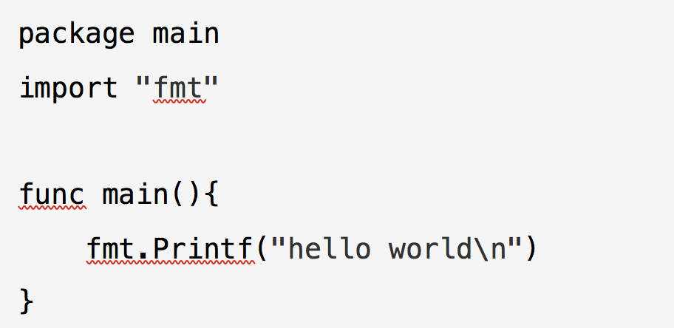**Scala**

IDE: Intellij

SDK: scala-sdk-2.12.8

Code

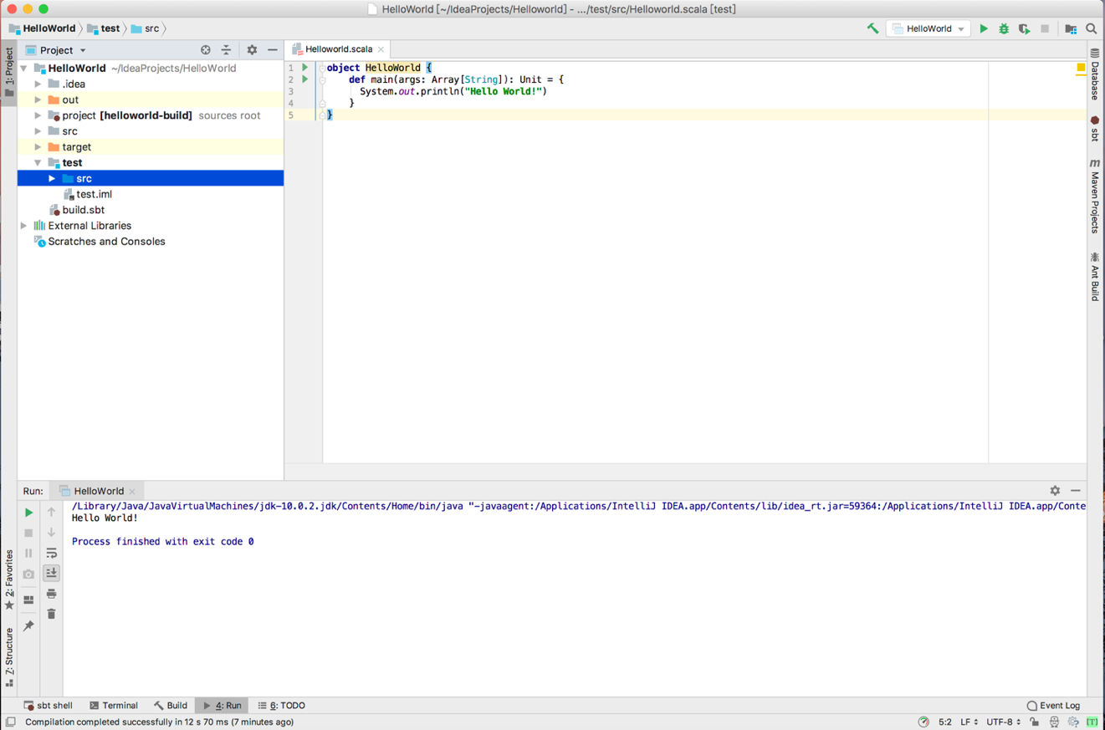

**Prolog**

IDE: SWI-Prolog

SDK: Version 8.0.1

