To print triangle:

def pascalTriangle(n : int) -> List[List[int]]:

    l=[[1]]

    if n==1:

        return l

    for i in range(1,n):

        k=[1]

        for j in range(1,i+1):

            if i==j:

                k.append(1)

            elif i-1>=0 and j-1>=0:

                k.append(l[i-1][j-1]+l[i-1][j])

        l.append(k)

    return l

To print element given row and column=r-1Cc-1

def nCr(n, r):

res = 1

*# calculating nCr:*

for i in range(r):

res = res \* (n - i)

res = res // (i + 1)

return res

def pascalTriangle(r, c):

element = nCr(r - 1, c - 1)

return element

ex 10c3=10!/3!\*7!

It needs to run only 3 times

As 7!will cancel out

Print Row Variant:

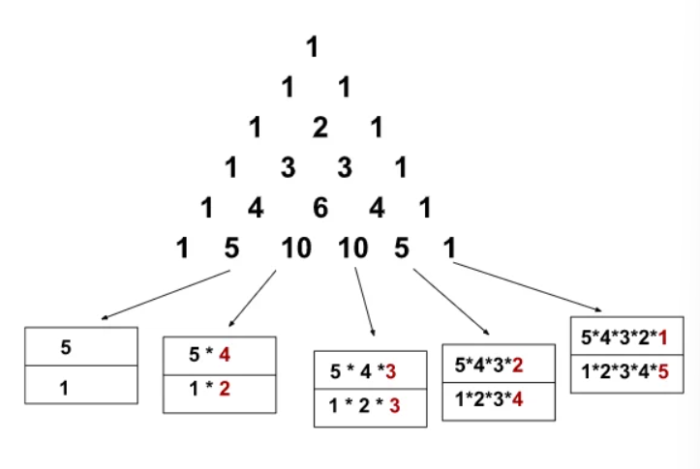

Current element = prevElement \* (rowNumber - colIndex) / colIndex