RULES:
1)outer loop for rows
2)for the inner loop focus on columns and connect to rows
3)print inside in the inner loop
4)Observe symmetry

1)

def nForest(n:int) ->None:
for i in range(n):
for j in range(n):
print("*",end=" ")
print("\n")
2)

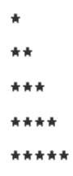
def nForest(n:int) ->None:
for i in range(n):
for j in range(i+1):
print("*",end=" ")
print("\n")
3)
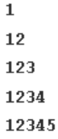
def nTriangle(n:int) ->None:
for i in range(n):
for j in range(i+1):
print(j+1,end=" ")
print("\n")
4)
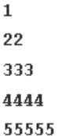
def triangle( n:int) ->None:
for i in range(n):
for j in range(i+1):
print(i+1,end=" ")
print("\n")
5)
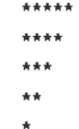
def seeding(n: int) -> None:
for i in range(n):
for j in range(n-i):
print("*",end=" ")
print("\n")
6)
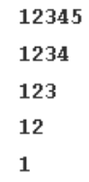
def nNumberTriangle(n: int) -> None:
for i in range(n):
for j in range(n-i):
print(j+1,end=" ")
print("\n")
7)
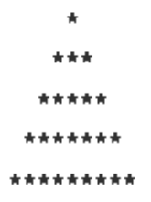
def nStarTriangle(n: int) -> None:
for i in range(n):
for h in range(n-i-1):
print(" ",end=" ")
for j in range(2*i+1):
print("*",end="")
print("\n")
8)
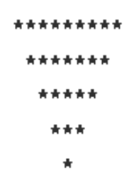
def nStarTriangle(n: int) -> None:
for i in range(n):
for h in range(i):
print(" ",end=" ")
for j in range(2*n-(2*i+1)):
print("*",end="")
print("\n")
9)
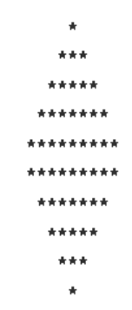
def nStarDiamond(n: int) -> None:
for i in range(n):
for h in range(n-i-1):
print(" ",end=" ")
for j in range(2*i+1):
print("*",end="")
print("\n")
for i in range(n):
for h in range(i):
print(" ",end=" ")
for j in range(2*n-(2*i+1)):
print("*",end="")
print("\n")

10)
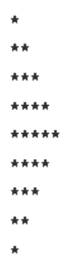
def nStarTriangle(n: int) -> None:

for i in range(2*n-1):
if i<n:
for j in range((i+1)):
print("*",end="")
else:
for j in range((2*n-i-1)):
print("*",end="")
print("\n")
11)
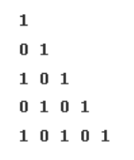
def nBinaryTriangle(n: int) -> None:
for i in range(n):
for j in range(i+1):
if (i+j)%2==0:
print("1",end=" ")
else:
print("0",end=" ")
print("\n")
12)
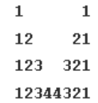
def numberCrown(n: int) -> None:
for i in range(n):
for j in range(1,i+2):
print((j),end=" ")
for l in range(2*n-i-2):
print(" ",end="")
for k in reversed(range(1,i+2)):
print((k),end=" ")
print("\n")

13)
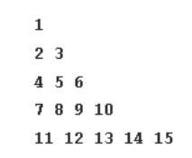
def nNumberTriangle(n: int) -> None:
count=1
for i in range(n):
for j in range(i+1):
print(count,end=" ")
count+=1
print("\n")

14)
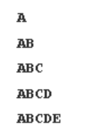
def nLetterTriangle(n: int) -> None:

for i in range(n):
s='A'
for j in range(i+1):
print(s,end=" ")
s=chr(ord(s)+1)
print("\n")
15)
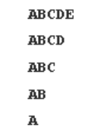
def nLetterTriangle(n: int):
for i in range(n):
s='A'
for j in range(n-i):
print(s,end=" ")
s=chr(ord(s)+1)
print("\n")
16)
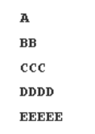
def alphaRamp(n: int) -> None:
s='A'
for i in range(n):
for j in range(i+1):
print(s,end=" ")
s=chr(ord(s)+1)
print("\n")
17)
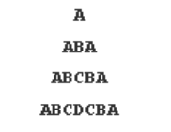
def alphaHill(n: int):
s='A'
for i in range(n):
for k in range(n-i-1):
print(" ",end="")
s='A'
for j in range(2*i+1):
print(s,end=" ")
if j<i:
s=chr(ord(s)+1)
else:
s=chr(ord(s)-1)

print("\n")
18)
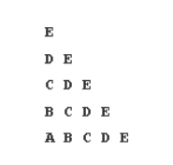
def alphaTriangle(n: int):
for i in range(n):
s='A'
s=chr(ord(s)+n-1)
for j in range(i+1):
print(s,end=" ")
s=chr(ord(s)-1)
print("\n")
19)
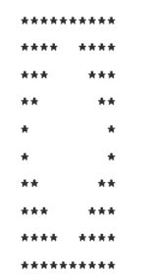
def symmetry(n: int):
for i in range(2*n):
if i<n:
for j in range(n-i):
print("*",end=" ")
for j in range(2*i):
print(" ",end=" ")
for j in range(n-i):
print("*",end=" ")
else:
for j in range(i-n+1):
print("*",end=" ")
for j in range(2*(i-n+1)):
print(" ",end=" ")
for j in range(i-n+1):
print("*",end=" ")
print("\n")

20)
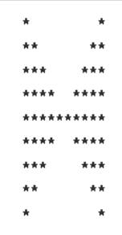
def symmetry(n: int):
for i in range(2*n):
if i<n:
for j in range(i+1):
print("*",end=" ")
for j in range(2*(n-i)-2):
print(" ",end=" ")
for j in range(i+1):
print("*",end=" ")
else:
for j in range(2*n-i-1):
print("*",end=" ")
for j in range(2*(i-n+1)):
print(" ",end=" ")
for j in range(2*n-i-1):
print("*",end=" ")
print("\n")

21)

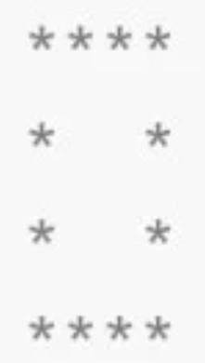
def getStarPattern(n: int) -> None:
for i in range(n):
if i==0 or i==n-1:
for j in range(n):
print("*",end="")
else:
for j in range(1):
print("*",end="")
for j in range(n-2):
print(" ",end="")
for j in range(1):
print("*",end="")
print("\n")
22)

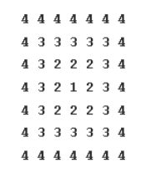
def getNumberPattern(n: int) -> None:
#we subtract n from all elemts and observe that the value is the minimum distance the subtarct from n to obtain desired pattern
for i in range(2*n-1):
for j in range(2*n-1):
top=i
down=(2*n-2)-i
left=j
right=(2*n-2)-j
a=min(min(top,down),min(left,right))
print(n-a,end="")
print("\n")

