**COVID 19 - CASES ANALYSIS**

**Phase 4**

**Development Part-2**

**Analyzing COVID-19 Data: Mean Values, Standard Deviations, Trends, Variations, and Correlations**

**Introduction**:

The analysis presented here delves into the mean values and standard deviations of COVID-19 cases and associated deaths, with the objective of unearthing trends, variations, and potential correlations within the data. Mean values offer insights into the typical figures, while standard deviations provide a measure of data dispersion, which can highlight fluctuations in the numbers.

**Analysis of Mean Values** :

* Mean values provide insights into the central tendency of the data.
* They represent the average or typical number of daily COVID-19 cases and associated deaths.
* Mean values can help identify general patterns in the data over time or across regions.
* They serve as a baseline for understanding the magnitude of the pandemic’s impact.

**Analysis of Standard Deviations** :

* Standard deviations indicate the dispersion or variability in the data.
* A higher standard deviation for COVID-19 cases suggests fluctuations in daily case counts, potentially indicating waves or surges in infections.
* A lower standard deviation for deaths implies more consistent daily mortality rates, with less fluctuation in the number of deaths.
* Standard deviations provide a measure of the “spread” of data points around the mean.
* They can be used to identify periods of instability or relative stability in the progression of the pandemic.

**Identifying Trends**:

* Examining trends in mean case values can reveal whether the pandemic is on the rise, stable, or declining.
* Trends in mean death values can help track the impact of the virus and inform healthcare resource allocation.
* Long-term trends may show seasonality or changes in public health measures.
* Short-term trends might highlight specific events or policy changes that affect COVID-19 cases and deaths.
* Identifying trends is crucial for forecasting and resource planning.

**Variations**:

* Variations in standard deviations for cases can indicate the presence of spikes or unusual events, such as outbreaks or clusters.
* Variations in standard deviations for deaths can suggest changes in healthcare system capacity or treatment effectiveness.
* Seasonal variations may become evident, especially in areas with distinct weather patterns.
* Variations can help prioritize areas or time periods that require focused intervention and support.
* Understanding variations can guide the allocation of testing and healthcare resources.

**Potential Correlations**:

* Investigating potential correlations between mean cases and deaths can help determine the impact of COVID-19 on mortality rates.
* Positive correlations may suggest that higher case numbers lead to more deaths, highlighting the need for strict control measures.
* Negative correlations may indicate effective interventions or healthcare capacity.
* The strength and direction of correlations can guide decision-making in response to the pandemic.
* Identifying correlations can support resource allocation and intervention strategies.

**Number of daily cases and death in India :**

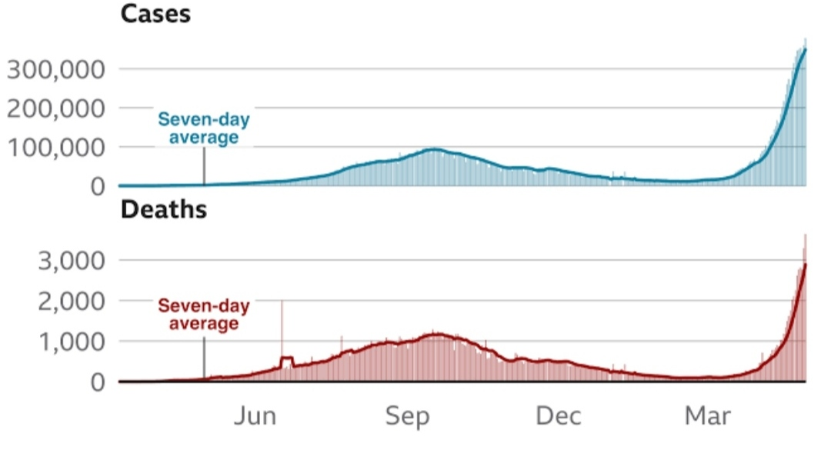

**Conclusion**:

Through this analysis, we’ve unearthed significant insights. The standard deviation for cases points towards potential variations in the spread of COVID-19, highlighting periods of greater volatility. In contrast, the lower standard deviation for deaths suggests more consistent patterns in the mortality associated with these cases.