 

**Placement Empowerment Program**

**Cloud Computing and DevOps Centre**

**Set Up a Virtual Machine in the Cloud**

**“*Create a free-tier AWS, Azure, or GCP account. Launch a virtual machine and SSH into it.*”**

Name: **SHIYAM MARTEIN A S** DEPARTMENT: **IT**



**Introduction**

Cloud computing has revolutionized how businesses and individuals deploy applications, reducing the need for physical hardware and providing scalable solutions. One of the fundamental tasks in cloud computing is setting up a Virtual Machine (VM), which allows users to run applications in an isolated environment.

**Overview**

A Virtual Machine (VM) is a software-based computer that runs an operating system and applications just like a physical machine. Cloud providers such as AWS, Azure, and GCP offer virtual machines with different configurations to suit various needs. This guide will walk you through creating a VM on the cloud and connecting to it via SSH.

**Objective**

**The primary objectives of this POC are:**

* Set up a free-tier cloud account on AWS, Azure, or GCP.
* Launch a virtual machine using the respective cloud platform.
* Connect to the virtual machine using SSH.
* Understand the basic operations of a cloud-hosted VM.

**Important**

* **Cost-Effective:** Free-tier cloud services allow users to experiment without incurring costs.
* **Scalability:** VMs can be easily scaled up or down as per requirements.
* **Security:** Cloud providers offer built-in security features for VMs.
* **Accessibility:** VMs can be accessed from anywhere, enabling remote work and development.

**Step-by-Step Overview**

**Step 1:**

**Create a Free-Tier Cloud Account**

Choose a cloud provider and create an account:

**Step 2:**

**Launch a Virtual Machine**

**AWS (EC2 Instance)**

1. Sign in to AWS Console.
2. Navigate to **EC2 Dashboard** → Click **Launch Instance**.

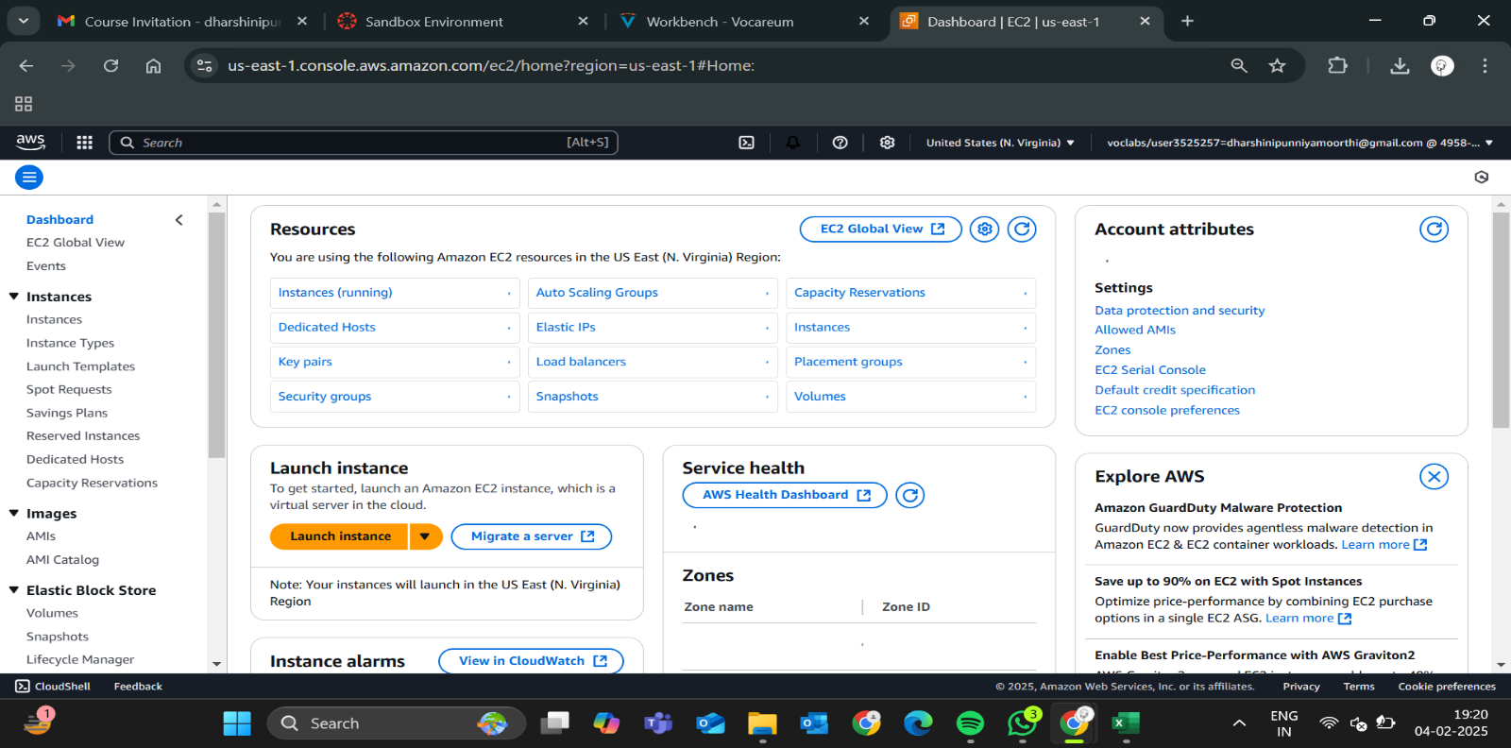

1. Choose an OS (e.g., Amazon Linux, Ubuntu).

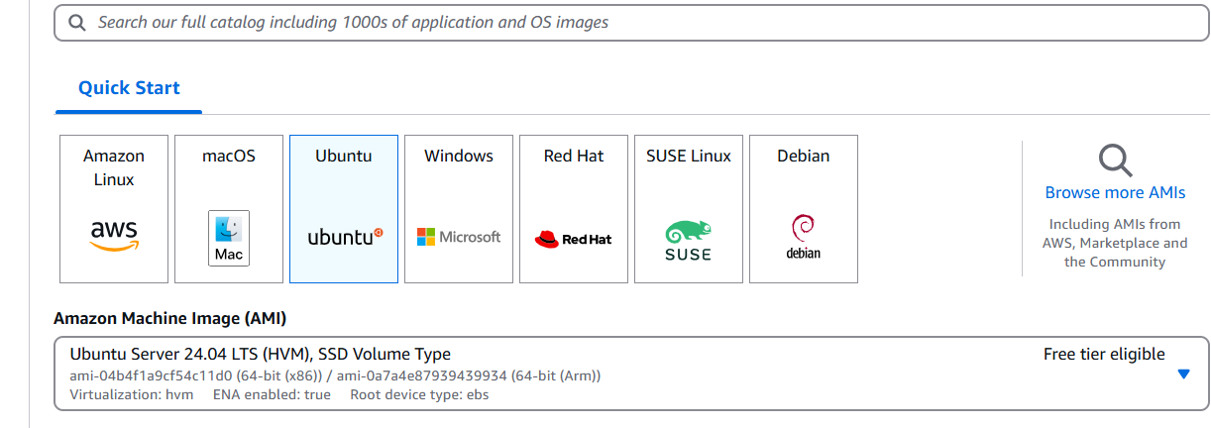

1. Select an **Instance Type** (e.g., t2.micro for free-tier).

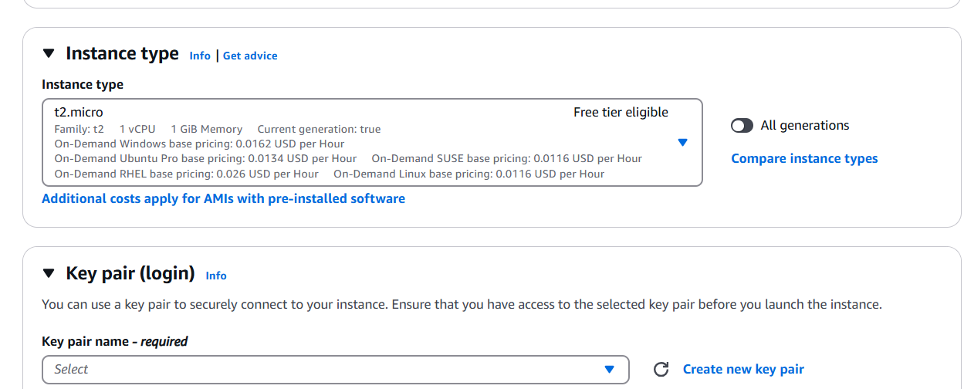

1. Configure security settings (allow SSH on port 22).

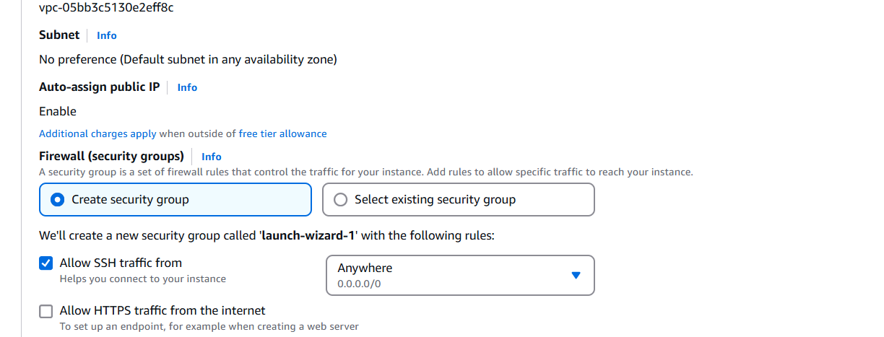

1. Generate and download a key pair for SSH authentication.

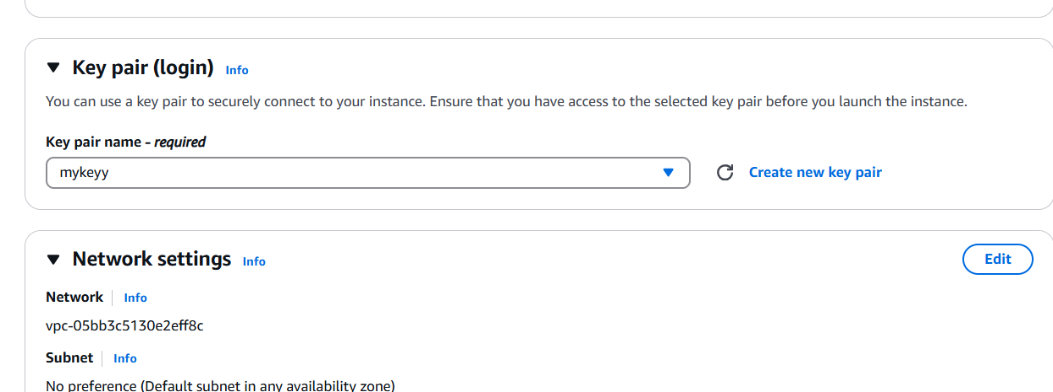

1. Click **Launch Instance** and wait for it to initialize.

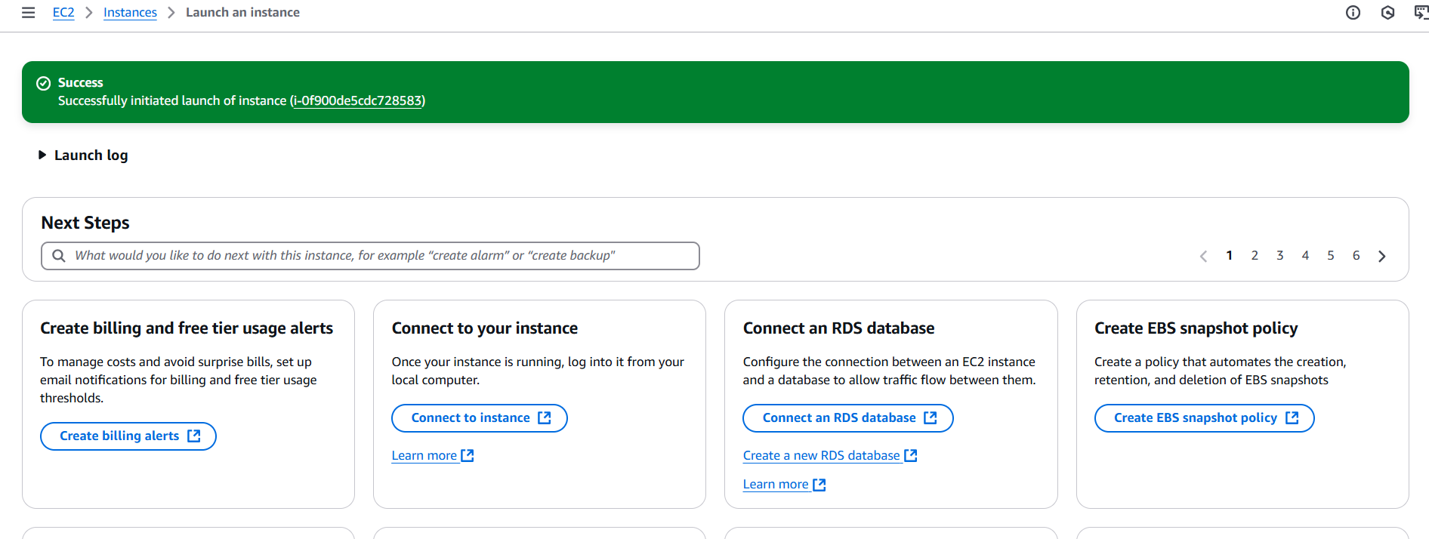

**Step 3:**

**SSH into the EC2 Instance**

Once your EC2 instance is running, follow these steps to connect to it using SSH.

**1️. Open Command Prompt or Terminal**

* **Windows:** Open **Command Prompt** or **Git Bash** (recommended).
* **Mac/Linux:** Open **Terminal**.

**2️. Navigate to the Key Pair Location**

When you launched your EC2 instance, you downloaded a **private key file** (.pem). Navigate to the folder where it is stored:

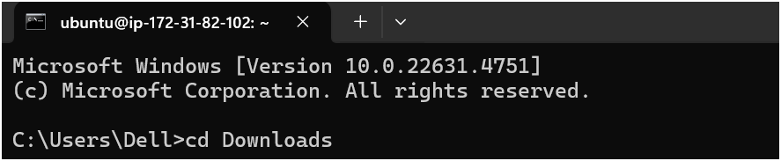

**3.Find Your Public IP**

* Go to **AWS EC2 Console** → **Instances**.
* Copy the **Public IPv4 Address** of your instance.

**4.Connect to the Instance via SSH**

**For Ubuntu**

ssh -i your-key.pem ubuntu@your-public-ip

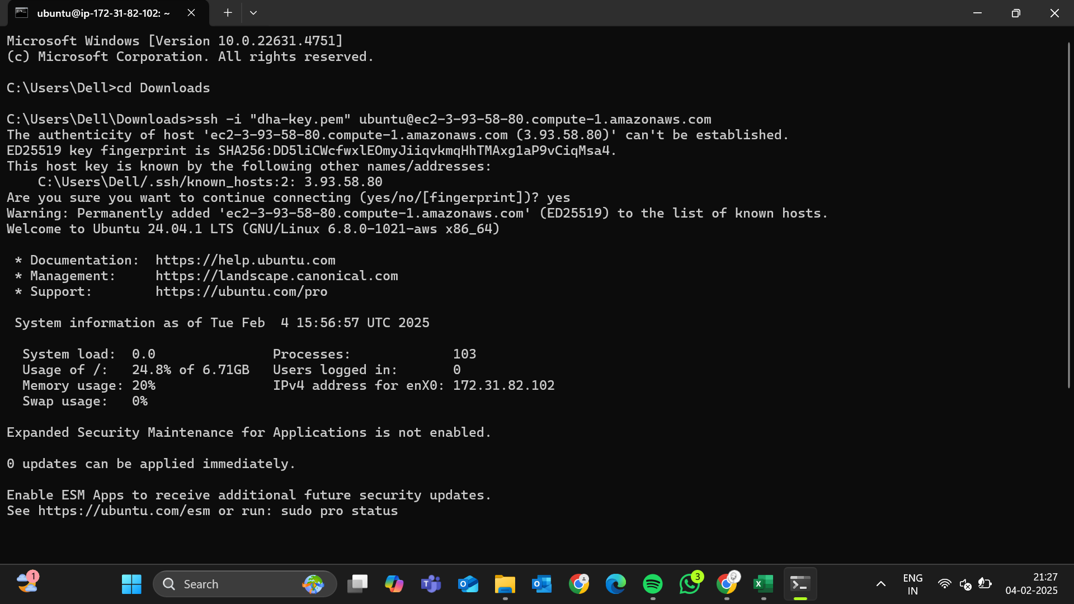

**Expected Outcome:**

By the end of this process, you will have:

* A virtual machine running in the cloud.
* Secure SSH access to the VM.
* A foundational understanding of cloud-based virtual machines.