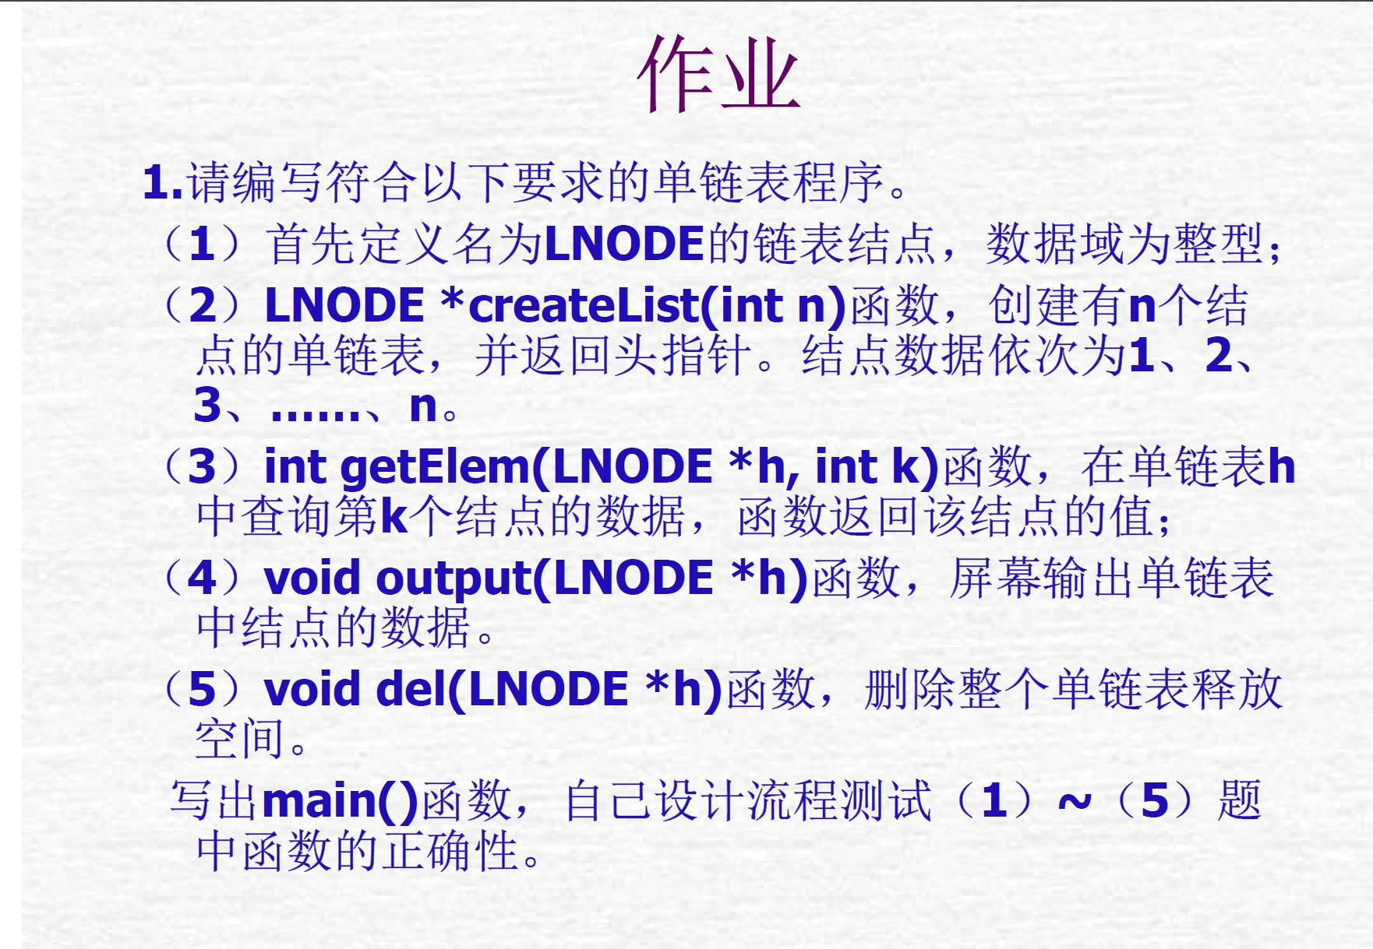

*/\**

*#include <stdio.h>*

*#include <stdlib.h>*

*typedef struct lnode*

*{*

*int data;*

*struct lnode *next;*

*} LNODE;*

*LNODE *createList(int n);     //创建有n个结点的单链表*

*int getElem(LNODE *h, int k); //查询链表中第k个节结的数据*

*void output(LNODE *h);        //输出单链表中结点的数据*

*void del(LNODE *h);           //删除整个单链表并释放空间*

*int main(void)*

*{*

*int n, k, data, i;*

*LNODE *head;*

*i = 1;*

*while (i)*

*{*

*printf("请输入想要创建链表的结点个数:");*

*scanf("%d", &n);*

*head = createList(n);*

*printf("\n请输入想要查询结点的位置:");*

*scanf("%d", &k);*

*data = getElem(head, k);*

*printf("\n该结点数据为:%d\n", data);*

*printf("\n现输出该单链表中结点的数据:\n");*

*output(head);*

*printf("\n现将删除整个单链表并释放空间!\n");*

*printf("\n请输入 0 or 1(0将结束程序,1将继续执行程序):");*

*scanf("%d", &i);*

*}*

*printf("\nDone!");*

*return 0;*

*}*

*LNODE *createList(int n) //创建有n个结点的单链表*

*{*

*int i, m;*

*LNODE *h, *p, *r;*

*h = NULL;*

*r = NULL;*

*for (i = 1; i <= n; i++)*

*{*

*p = (LNODE *)malloc(sizeof(LNODE));*

*printf("\n请输入想要存入链表第%d个位置的数据:", i);*

*scanf("%d", &m);*

*p->data = m;*

*p->next = NULL;*

*if (h)*

*{*

*r->next = p;*

*r = p;*

*}*

*else*

*{*

*h = p;*

*r = p;*

*}*

*}*

*return h;*

*}*

*int getElem(LNODE *h, int k) //查询链表中第k个节结的数据*

*{*

*int i, m;*

*for (i = 1; i < k; i++)*

*{*

*h = h->next;*

*}*

*m = h->data;*

*return m;*

*}*

*void output(LNODE *h) //输出单链表中结点的数据*

*{*

*int i;*

*i = 1;*

*while (h)*

*{*

*printf("单链表中第%d个结点的数据为:%d\n", i, h->data);*

*i++;*

*h = h->next;*

*}*

*return;*

*}*

*void del(LNODE *h) //删除整个单链表并释放空间*

*{*

*LNODE *p;*

*while (h)*

*{*

*p = h;*

*free(p);*

*h = h->next;*

*}*

*return;*

*}*

*\*/*

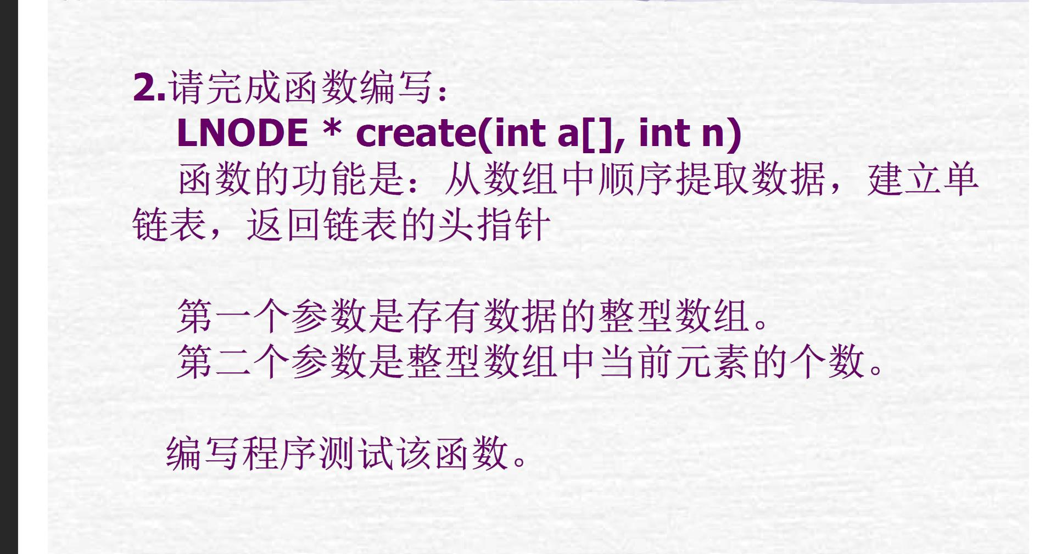

*/\**

*#include <stdio.h>*

*#include <stdlib.h>*

*typedef struct lnode*

*{*

*int data;*

*struct lnode *next;*

*} LNODE;*

*LNODE *create(int a[], int n);*

*void print(int a[], int n);*

*void output(int a[], int n);*

*void output_l(LNODE *h, int n);*

*int main(void)*

*{*

*int n;*

*int *a;*

*LNODE *head;*

*printf("请输入想要创建的数组大小：");*

*scanf("%d", &n);*

*a = (int *)malloc(sizeof(int) * n);*

*print(a, n);*

*printf("\n数组形式表示为：\n");*

*output(a, n);*

*head = create(a, n);*

*printf("\n链表表示形式为：\n");*

*output_l(head, n);*

*return 0;*

*}*

*LNODE *create(int a[], int n)*

*{*

*int i;*

*LNODE *h, *p, *r;*

*h = r = NULL;*

*for (i = 0; i < n; i++)*

*{*

*p = (LNODE *)malloc(sizeof(LNODE));*

*p->data = a[i];*

*p->next = NULL;*

*if (h)*

*{*

*r->next = p;*

*r = p;*

*}*

*else*

*{*

*h = p;*

*r = p;*

*}*

*}*

*return h;*

*}*

*void print(int a[], int n)*

*{*

*int i;*

*for (i = 0; i < n; i++)*

*{*

*printf("\n请输入:");*

*scanf("%d", &a[i]);*

*}*

*return;*

*}*

*void output(int a[], int n)*

*{*

*int i;*

*for (i = 0; i < n; i++)*

*{*

*printf("\na[%d] = %d\n", i, a[i]);*

*}*

*return;*

*}*

*void output_l(LNODE *h, int n)*

*{*

*int i;*

*for (i = 0; i < n; i++)*

*{*

*printf("\n链表中第%d结点处数为:%d\n", i + 1, h->data);*

*h = h->next;*

*}*

*return;*

*}*

*\*/*