Name: Section Leader:

**ISTA 350 Final Review Worksheet**

Recall that class Binary objects have a single instance variable, bit_array, that holds a numpy ints array of length 16. Write an instance method called is_square that returns True if the number represented by the Binary object is a perfect square, False if not. Deal with the case of negative numbers, also.

Negate the following two's complement binary number. Show your work and write down the resulting two's complement binary number. **Also, write down the decimal (base 10) equivalents of this number and its negative.**

01101100

Given the following class definitions:

**class** **Node:**

**def** __init__**(**self**,** datum**):**

self**.**datum **=** datum

self**.**next **=** **None**

**class** **LinkedList:**

**def** __init__**(**self**):**

self**.**head **=** **None**

**def** append**(**self**,** item**):**

**<** some code **>**

Write an instance method called prepend for LinkedList that takes a datum and inserts it at the head of the list. Also write a class method called from_list that takes a list of items and makes a LinkedList containing the items from the list in the same order. Write one line of code that will create a LinkedList with 3, 8, and 10 in it.

Given the following class definitions:

**class** **Node:**

**def** __init__**(**self**,** datum**):**

self**.**datum **=** datum

self**.**left **=** **None**

self**.**right **=** **None**

**class** **BST:**

**def** __init__**(**self**,** datum **=** **None):**

**if** datum **is** **None:**

self**.**root **=** **None**

**else:**

self**.**root **=** Node**(**datum**)**

Write contains magic methods for Node and BST that take an item and return True if the item is in the object, False otherwise.

Write a function called get_table_soup that takes a URL and a table number (zero-indexing) and returns a soup object representing the appropriate table on the page. This webpage: <https://www.iii.org/fact-statistic/facts-statistics-tornadoes-and-thunderstorms> contains 10 tables. The first one looks like this:

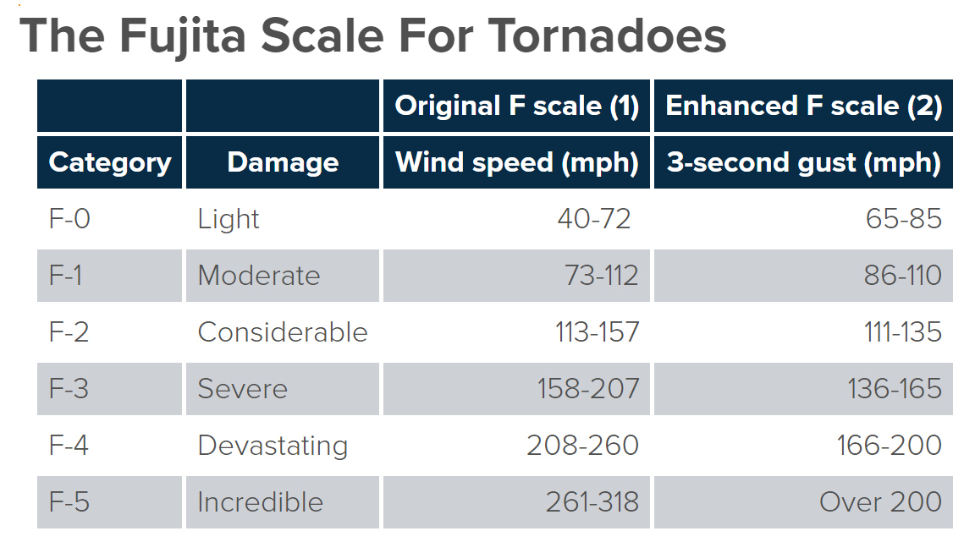

Write a function called get_speed that takes a category number and returns the associated wind speed range. Raise an error if the category is less than 0 or greater than 5. Here is some of the html for the first table row in this table:

>>> trs[0]

<tr>

<td class="tablewrapper">

<table border="0" cellpadding="0" cellspacing="0">

<thead>

<tr height="20">

<th height="20" style="height: 20px; white-space: nowrap; text-align: center;"> </th>

<th style=" white-space: nowrap; text-align: center;"> </th>

<th style=" white-space: nowrap; text-align: center;">Original F scale (1)</th>

<th style=" white-space: nowrap; text-align: center;">Enhanced F scale (2)</th>

</tr>

<tr height="20">

<th height="20" style="height: 20px; white-space: nowrap; text-align: center;">Category</th>

<th style="white-space: nowrap; text-align: center;">Damage</th>

<th style="white-space: nowrap; text-align: center;">Wind speed (mph)</th>

<th style="white-space: nowrap; text-align: center;">3-second gust (mph)</th>

</tr>

</thead>

<tbody>

<tr class=" odd" height="20">

<td height="20" style="height:20px;">F-0</td>

<td>Light</td>

<td style="text-align: right;">40-72 </td>

<td style="text-align: right;">65-85</td>

</tr>

<tr class=" even" height="20">

<td height="20" style="height:20px;">F-1</td>

<td>Moderate</td>

<td style="text-align: right;">73-112</td>

<td style="text-align: right;">86-110</td>