DD2360 Assignment 4

Group 35

Shiyuan Shan

Github repository: [ShiyuanShan/DD2360HT23 (github.com)](https://github.com/ShiyuanShan/DD2360HT23)

Exercise 1

* 1. 16*16 threads per block / 32 threads per warp = 8 warps per block,

In total ceil(800/16) * ceil(600/16) = 1900 blocks.

Thus 1900 * 8 = 15200 warps.

800 % 16 = 0, so no block has divergence in horizontal direction.

600 % 16 = 8, the bottom most blocks have divergence.

Each warp is a 16*2 thread array,

8 % 2 = 0, Thus no warp has divergence. In a bottom most block there would be 4 warps following “THEN” statement and the rest 4 following “ELSE” statement.

* 1. 600 % 16 = 8, the right most blocks have divergence.

800 % 16 = 0, thus only the right most blocks have divergence.

Each warp is a 16*2 thread array.

800 / 2 = 400. There are 400 warps that have divergence.

* 1. 600 % 16 = 8, the right most blocks have divergence.

799 % 16 = 15, the bottom most blocks have divergence.

Each warp is a 16*2 thread array.

15 % 2 = 1, each bottom most block has one warp that has control divergence.

Ceil(600 / 16) = 38. There are 38 bottom most warps with control divergence

Ceil(799 / 2) = 400. There are 400 right most warps with control divergence.

In total 38+400-1 = 437 warps with control divergence. (-1 is for bottom right corner overlap)

Exercise 2

2.1

With the increment of vector size from 1000 to 100000000, the performance decrement becomes less and less. It is sensible to make a guess that with even bigger vector size, the performance will increase.

2.2

!nvprof --output-profile hw4_ex2_stream_profile.nvprof ./hw4_ex2 100000000 4

2.3

Here we use fixed vector size of 100000000 and different segment number of 4, 8, 16, and 32. No big difference is spotted.

Exercise 3

3.1

The sparse matrix-vector multiplication consists of 2*nzv = 6*dimX-12 FLOPs.

AXPY needs 2*dimX FLOPs.

Vector Norm Calculation requires 2*dimX FLOPs for squaring and summing.

In total there thus are 10*dimX-12 FLOPS per nstep.

Greater input size will increase the FLOP rate to approach the peak.

3.2 Higher nstep leads to lower error.

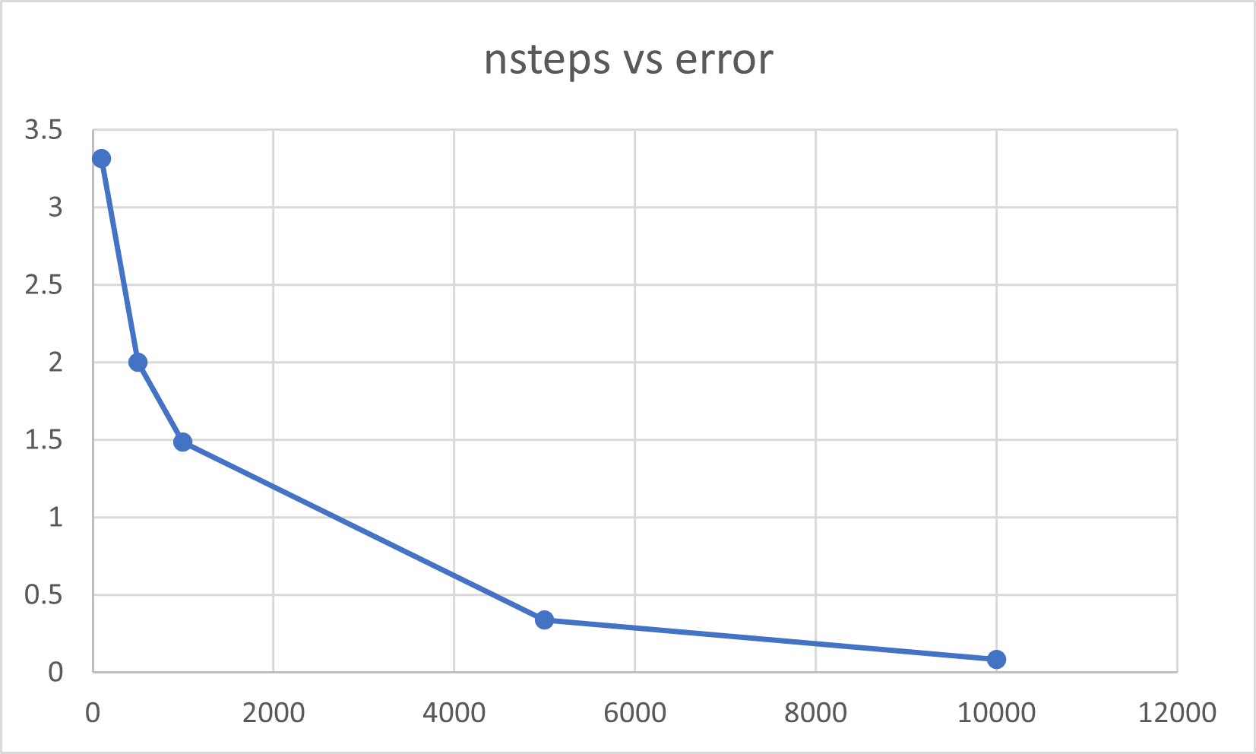

3.3 Performance with prefetching is shown as followed.

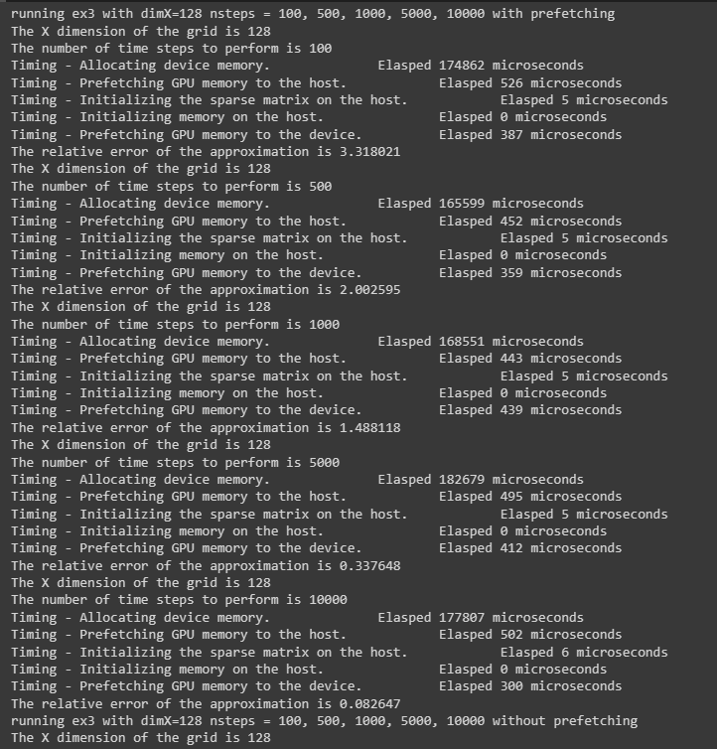

And here is the performance without prefetching.

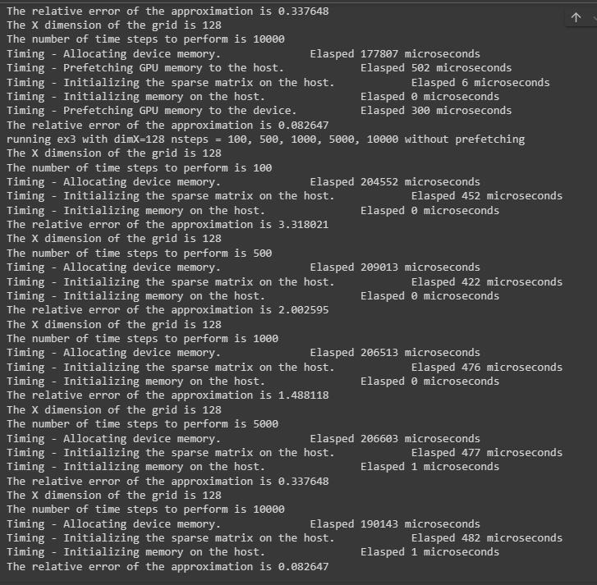

With prefetching the time cost is reduced obviously.