**Serial monitor:**

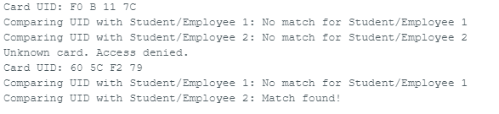

**Hardware**:

