**Four-way traffic light system**

Shiza Jamil  
EE  
FAST NUCESISLAMABAD, PAKISTAN  
i202312@nu.edu.pk

# **ABSTRACT - TO HELP US GAIN EXPERIENCE IN IMPLEMENTING AND SOLVING PROBLEMS WITHIN A DIGITAL SYSTEM, A DESIGN PROJECT FOR A FOUR-WAY TRAFFIC LIGHT SYSTEM WAS PRESENTED. WE IMPLEMENTED A COMPLETELY FUNCTIONAL TRAFFIC SIGNAL SYSTEM IN THIS PROJECT. A FOUR-WAY INTERSECTION WITH ONE ROAD NORTH AND SOUTHBOUND AND THE OTHER ROAD EAST AND WESTBOUND IS WHERE THE LIGHTS ARE SUPPOSED TO OPERATE.**

# **INTRODUCTION**

A four-way traffic light system is a key to ensuring a smooth and safe movement of traffic. It helps in regulating the traffic in places where there are high chances of accidents for example road intersections pedestrian crossings etc. They assign the way to users by the use of lights in standard colors I.e. Red yellow and green. They are mostly used at busy intersections where there are high chances of congestion. With the use of these traffic lights, a lot of time is saved from being wasted by having to wait in a traffic jam.

# **METHODOLOGY**

**How TRAFFIC LIGHT SYSTEM usually works?**

**“When drivers encounter a yellow light, then it's necessary to slow down and come to a stop at the intersection. The red light indicates that drivers must stop and wait for a green light before traveling through the intersection.”**

The red light indicates the traffic to stop while the yellow light indicates **“to get ready ”** after the yellow light green light appears which indicates **“clear to go”** again yellow light appears to indicate **“get ready** and it goes on

**Working based on the circuit?**

This circuit is consist of **555 timer IC**, **counter**, **AND OR NOT GATEs**.555 timer control the time duration for the LEDs.

**Decade Counter:**

A decade counter with the IC4017 is a counter that we use in the application of low range counting. This IC will count from 0 to 10.

*Working of counter:*

* When this IC detects a high pulse from the clock pin(pin 14), it will increment the count from 0 to 9 (Q0 to Q9)
* To keep this IC running, we'll need a clock source. This clock source can be a basic Timer circuit that generates pulses.
* Every high pulse from the Clock pin causes the output to change consecutively from Q0 to Q9, although this sequence can be disrupted by two pins. Clock Enable (pin 13) and Reset (pin 15). By default, these pins are set to low (grounded), however, when the Clock Enable pin is set to high, the counting stops. For example, if the count was at pin Q3 when the Clock Enable pin was set to high, the count will pause at pin Q3 regardless of any high clock pulses and will only continue incrementing when the Clock Enable pin is set to low. If the reset pin is set to high, the same thing happens. The count will reset to Q0 and remain there until Q0 is made low once more.
* PIN 12 is a carry-out pin

**555 timer :**

* PIN 1 is the ground pin
* PIN 3 is output
* PIN 4 reset
* PIN 5 control voltage
* PIN 8 is the power supply pin

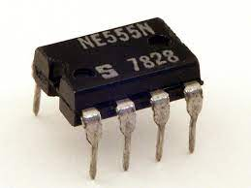

* 555 timer ic will generate a pulse signal to start the counter first Q2 will be at “1” which is directly connected to the green LED and the green LED turn ON then Q3 will be “1” and (1OR0) will be “1” so Yellow LED will turn ON as well as Yellow LED for signal2 will also turn on a signal is going to change from RED to GREEN
* When Q4 will become “1” the GREEN light of the 2nd SIGNAL will turn ON when Q5 will become “1” YELLOW light of SIGNAL 2 or 3 turns on
* When Q5 will become 1 the RED light of the 2nd SIGNAL will turn ON along with the GREEN light of the 3rd Signal, Q6 will become “1” the yellow light the of 3rd and 4th SIGNAL will turn ON
* Then Q0 will become “1” and the GREEN light for the 4th SIGNAL will turn ON and when Q1 will become 1 the yellow light for both 1st SIGNAL AND 2nd SIGNAl will turn ON and this process will continue to happen as long as the clock is running

1. This combination is connected to every RED LED of the circuit as when the both GREEN n YELLOW LED’s are off only then RED LED will turn ON so both “NOT” gates will reverse the 0’s to 1’s and when both 0’s are converted to “1” only the combination will give “1” as an output and YELLOW light will turn ON
2. The OR gate is connected to the YELLOW LED of each signal one end of this gate is connected to the previous state from the previous SIGNAL and one end with the decade counter with (specific output) and the output of the OR gate is connected to the one end of the circuit given above in 1st bullet point.

# **PROTEUS (DESIGN AND WORKING)**

**WORKING ON PROTEUS:**

* Select the following components from the library of proteus 555timer,4017 ic (decade counter),7408,7404, Traffic Light, Resistor, Capacitor, and Or gate
* Place the 555 timer IC on the circuit connect the 5V power to R and TR with the 200uF capacitor C2 and connect the other side with the Ground, connect another capacitor C1 of 1000uF connect the one side with the R line, and the other with the ground, connect 6 with 2, connect 6 with Resistor R1 with 10k and another side with 7(DC) place Resistor R2 connect one side of resistor with 8 and another side with the other end of resistor R1

Place a resistor R3 of resistance 220 and connect one side with Q.

* Now place the decade counter of IC 4017 connect the clk with the other end of resistor R3 and enable E with the ground to connect 9 pins of IC 4017 with 15.
* Place four Traffic Lights connect the Q4 of the counter with the GREEN LED OF 1st SIGNAL place a or gate and connect its one input to Q1 and Q3 and output with YELLOW LED do same with the 2nd,3rd, and 4th Signal as shown in the proteus diagram
* Place two NOT gates and connect their output as an input to AND gate connect one end of the not gate with the output of or gate and another end with Q2 do the same with other SIGNALS as shown in the upper diagram

# **pcb design and explanation**

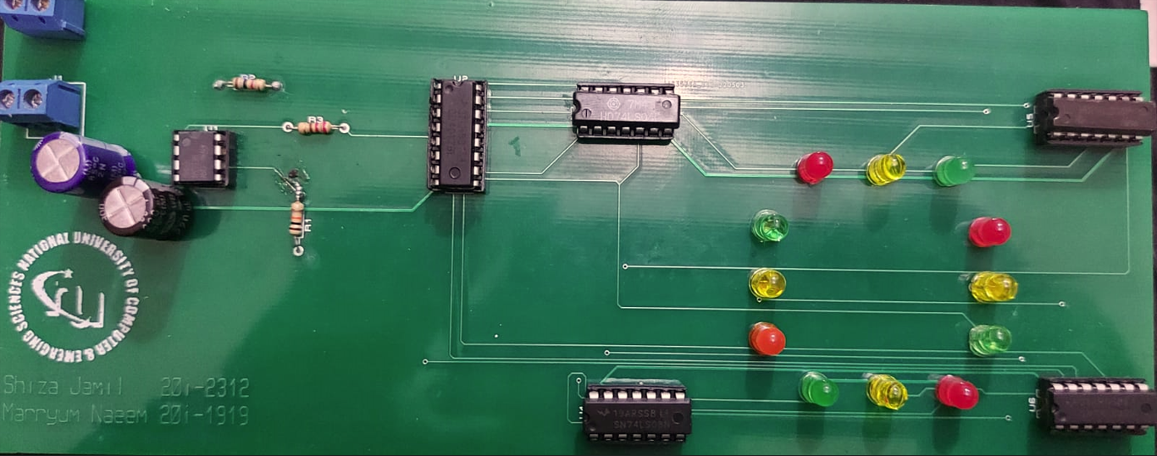

**Working based on the PCB circuit?**

This circuit is consist of **555 timer IC**, **counter**, **AND OR NOT GATEs**.555 timer control the time duration for the LEDs and is also used to generate pulses after every five seconds the color of LEDs will change

**Decade Counter:**

A decade counter with the IC4017 is a counter that we use in the application of low range counting. This IC will count from 0 to 10. The IC CD4017can work from 3V-15V, however usually powered through +5V toward the Vdd or Vcc pin & the GND or Vss pin can be connected to the ground. Here, 10 output pins range from Q0 to Q9, which are connected to any load however we are using LEDs in the circuit.

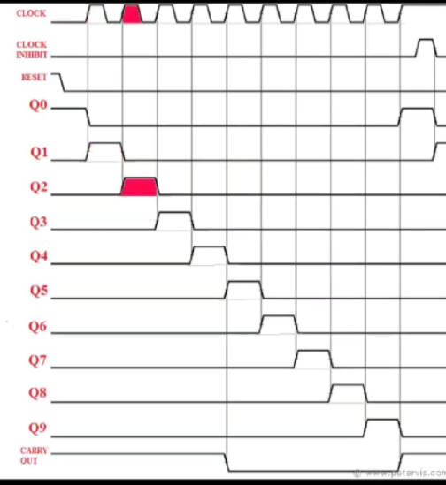

# **block diagrams and flowcharts**

flowchart:

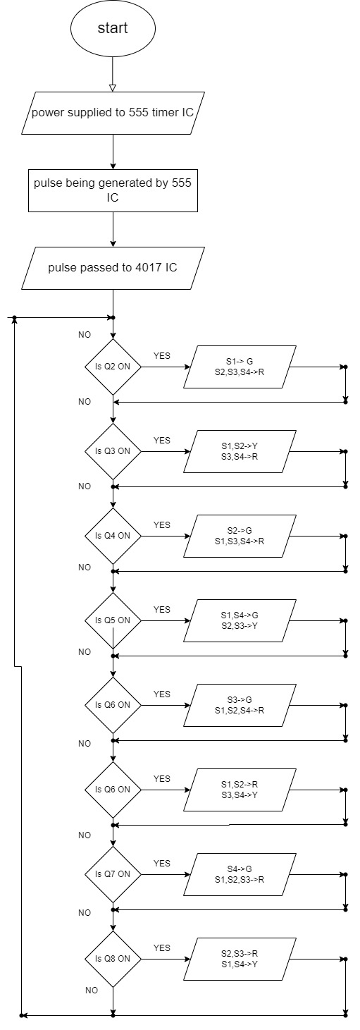

Block diagram:

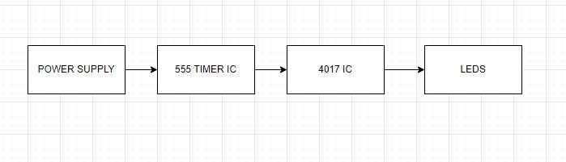

# **circuit diagram**

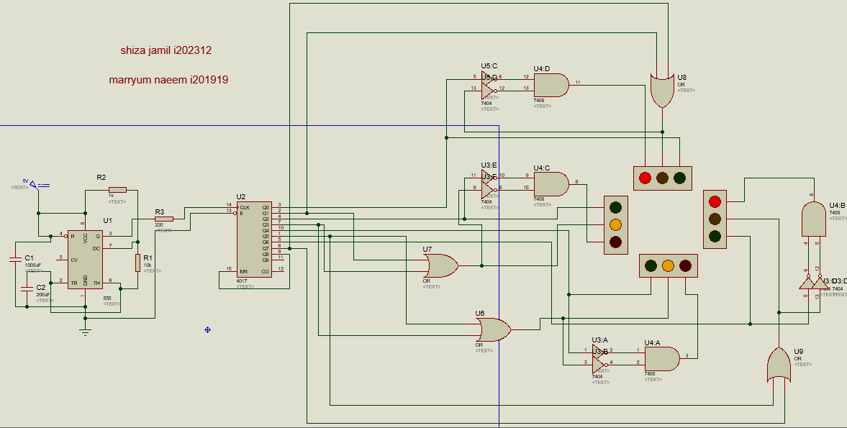

# **specifications**

After the pulse is generated and passed through decade counter the:

**Combination 1(yellow,yellow,red,red):**

**At signal1:**

The inputs of OR gate are Q1(=0)and Q7(=1) so the output is one as a result yellow light turns ON.The input for NOT gate 1 is Q2(=0) so output is 1 for NOT gate 2 input is the output of OR gate i.e. 1 so the output is 0. The inputs for AND gate are the outputs for NOT gate i.e. 0 and 1 so the output is 0 and hence red light is off.

**At signal2:**

The inputs of OR gate are Q5(=0)and Q3(=0) so the output is 0 as a result yellow light is OFf.The input for NOT gate 1 is Q4(=0) so output is 1 for NOT gate 2 input is the output of OR gate i.e. 0 so the output is 1. The inputs for AND gate are the

outputs for NOT gate i.e. 1 and 1 so the output is 1 and hence red light is ON.

**At signal3:**

The inputs of OR gate are Q5(=0)and Q7(=0) so the output is 0 as a result yellow light is OFF.The input for NOT gate 1 is Q6(=0) so output is 1 for NOT gate 2 input is the output of OR gate i.e. 0 so the output is 1. The inputs for AND gate are the outputs for NOT gate i.e. 1 and 1 so the output is 1 and hence red light is ON.

**At signal4:**

The inputs of OR gate are Q1(=1)and Q7(=0) so the output is 1 as a result yellow light is ON.The input for NOT gate 1 is Q0(=0) so output is 1 for NOT gate 2 input is the output of OR gate i.e. 1 so the output is 0. The inputs for AND gate are the outputs for NOT gate i.e. 1 and 0 so the output is 0 and hence red light is OFF.

**Combination 2(green,red,red,red):**

**At signal1:**

The inputs of OR gate are Q1(=0)and Q3(=0) so the output is 0,as a result yellow light turns OFF.The input for NOT gate 1 is Q2(=1) so output is 0 for NOT gate 2 input is the output of OR gate i.e. 0 so the output is 1. The inputs for AND gate are the outputs for NOT gate i.e. 0 and 1 so the output is 0 and hence red light is OFF.

**At signal2:**

The inputs of OR gate are Q5(=0)and Q3(=0) so the output is 0 as a result yellow light is OFf.The input for NOT gate 1 is Q4(=0) so output is 1 for NOT gate 2 input is the output of OR gate i.e. 0 so the output is 1. The inputs for AND gate are the outputs for NOT gate i.e. 1 and 1 so the output is 1 and hence red light is ON.

**At signal3:**

The inputs of OR gate are Q5(=0)and Q7(=0) so the output is 0 as a result yellow light is OFF.The input for NOT gate 1 is Q6(=0) so output is 1 for NOT gate 2 input is the output of OR gate i.e. 0 so the output is 1. The inputs for AND gate are the outputs for NOT gate i.e. 1 and 1 so the output is 1 and hence red light is ON.

**At signal4:**

The inputs of OR gate are Q1(=0)and Q7(=0) so the output is 0 as a result yellow light is OFF.The input for NOT gate 1 is Q0(=0) so output is 1 for NOT gate 2 input is the output of OR gate i.e. 0 so the output is 1. The inputs for AND gate are the outputs for NOT gate i.e. 1 and 1 so the output is 1 and hence red light is ON.

# **COMPONENETS USED**

**1**: Decade Counter (IC-4017)

**2**: 555 timer

**3**: Basic gates (IC-7408, IC-7404)

**4**: LED’s (RED, YELLOW, GREEN)

**5**: Resistors(1k,10k,220)

**6**: Capacitors(1000uF,200uF)

# **CONCLUSION**

It is proposed to construct a four-way traffic light system for this project.In order to complete the design, the duties of

seeking, coming up with ideas, making, and checking our design

to create a usable product. The layout was

obtaining all prerequisite components before initialization and keeping the desired design's correct functionalities functioning. code. After that, the circuit was created, and errors were corrections were made before the last project was displayed. It can be quite difficult to achieve the level of perfection needed to

a precise output or outcome .