

Information Assurance
Project Report

Project Title:
Simulating TalkTalk Customer Portal SQL Injection: Vulnerability Assessment, Web Scraping, and Snyk Analysis Using OWASP Juice Shop
Group Members:
- Shiza Aijaz (22k-4683)
- Aaminah Binte Farooq (22k-4671)
- Umer Ahmed (22k-4684)

Section: BCY-7B
Instructor Name: Sir Ali Naseer
Date: 25-11-2025

- TalkTalk 2015 Data Breach – Background (Use-Case)
In October 2015, UK telecom provider TalkTalk suffered a major cyber-attack in which attackers exploited a SQL Injection vulnerability in their website. The weakness existed in one of their customer-facing portals. Because input was not validated or sanitized, attackers were able to directly send malicious SQL queries to the backend database.
Impact of the breach:
- 157,000 customer records stolen
- Including names, addresses, birthdates
- 15,000 bank account numbers leaked
- Over £60 million financial loss
- Brand damage and customer loss
Why the attack succeeded:
- No input filtering
- Outdated website components
- No WAF (Web Application Firewall)
- Weak database protections
- Lack of monitoring/logging

- THREAT MODEL OF TALK TALK

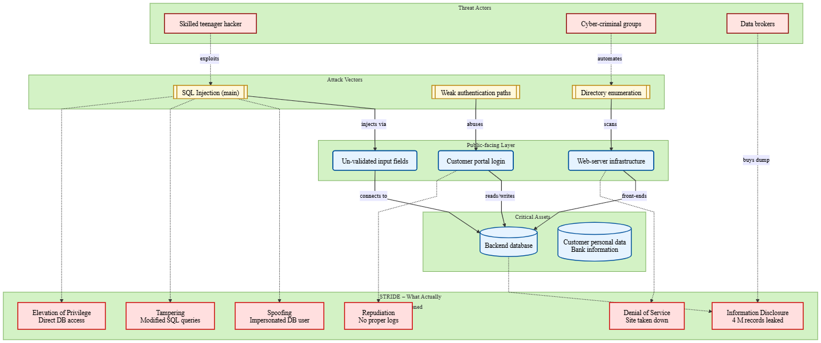

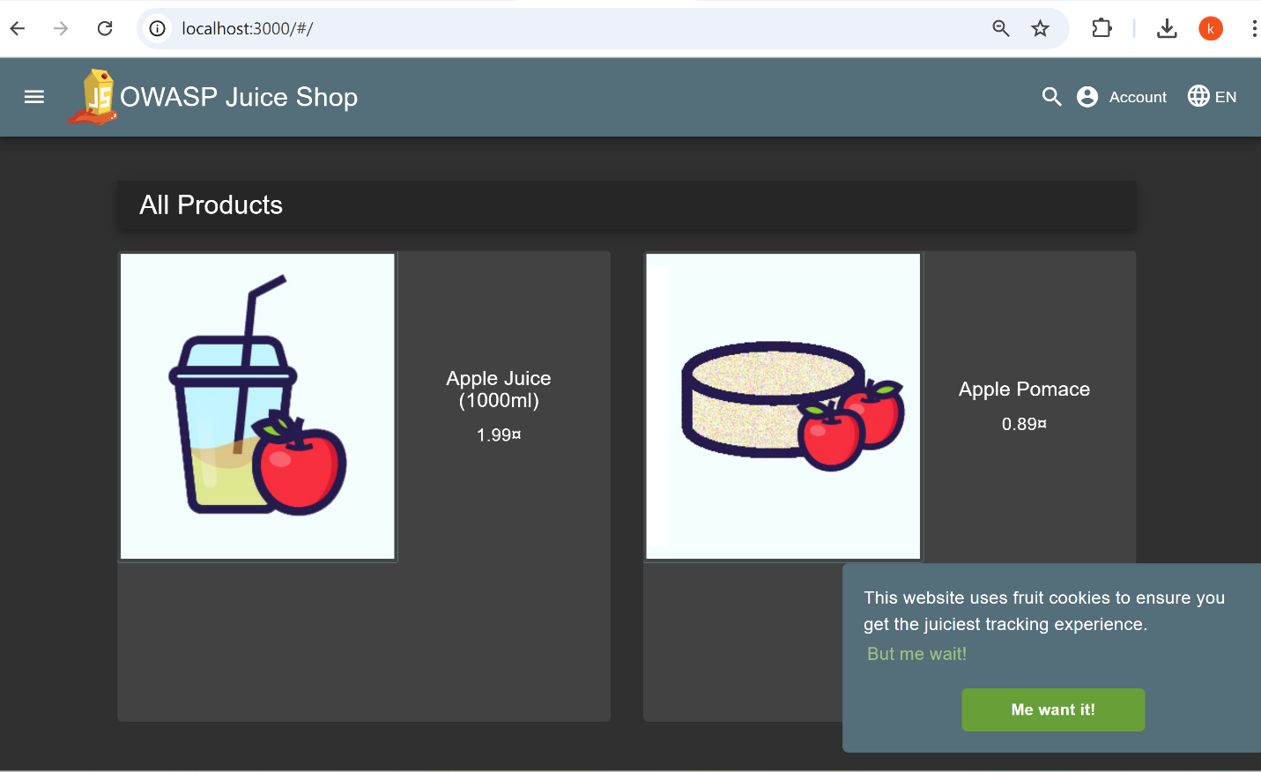
INSTALL OWASP JUICE SHOP ON WINDOWS
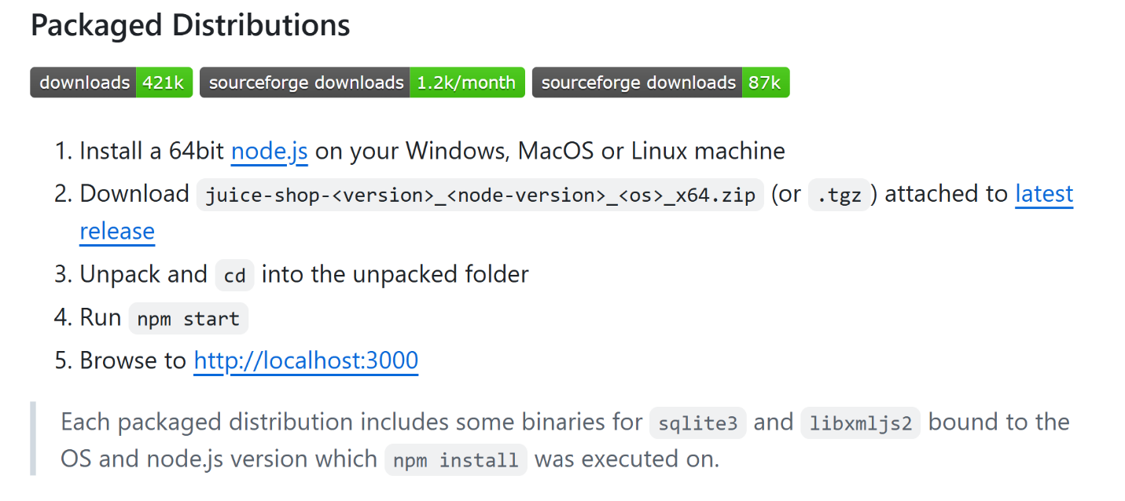

RUN DAST USING OWASP ZAP
— Open OWASP ZAP & Set your target: http://localhost:3000
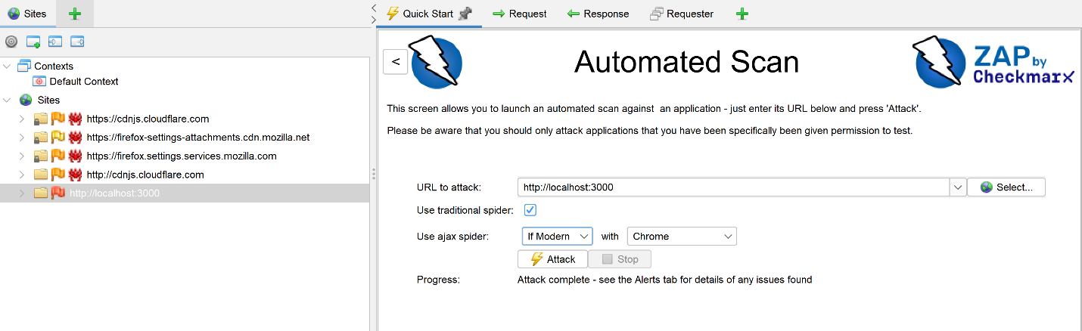

— Attack with Spider, AJAX Spider and perform Active Scan
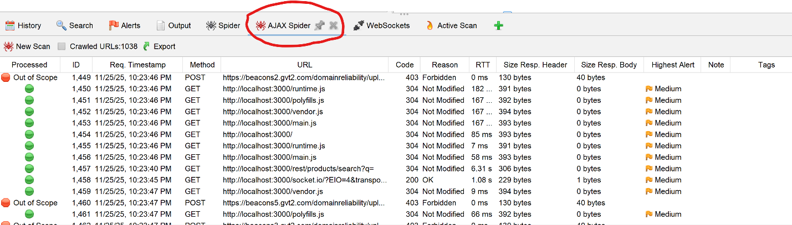
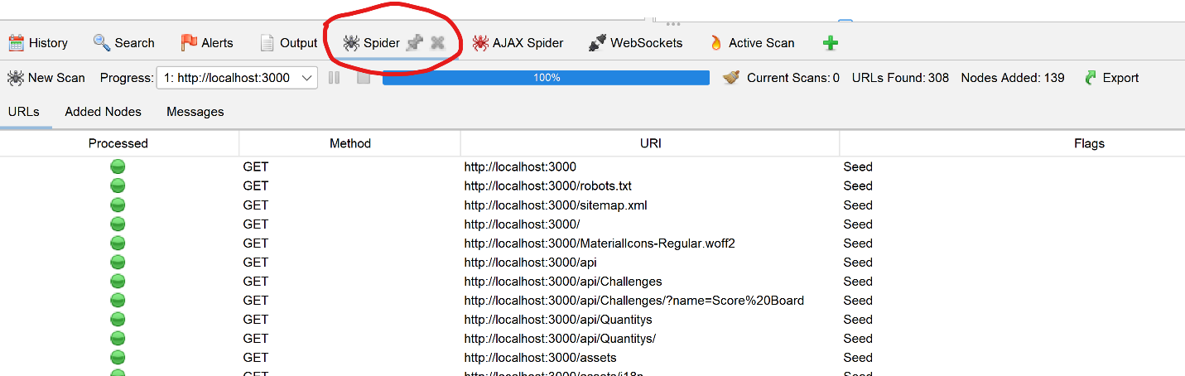

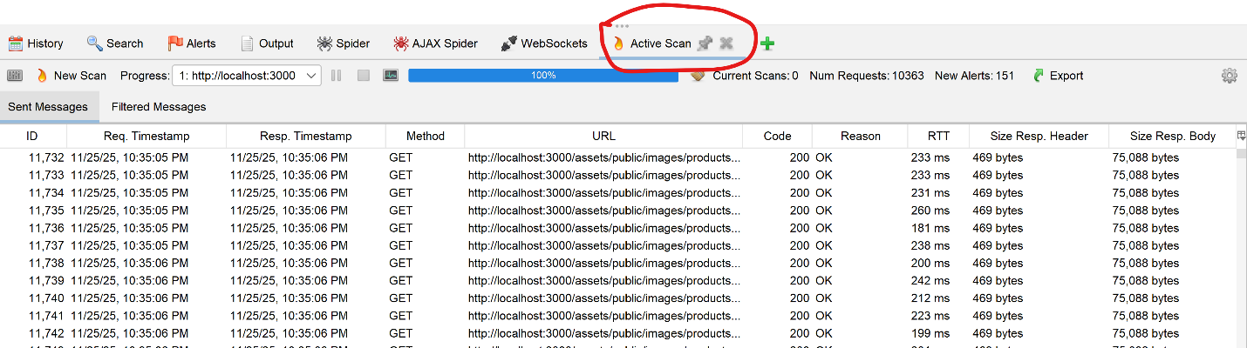

— Collect vulnerabilities
ZAP will detect:
- SQL Injection
- XSS
- Broken Authentication
- Insecure JWT
- Sensitive data exposure
- Server errors
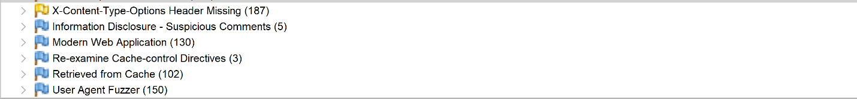
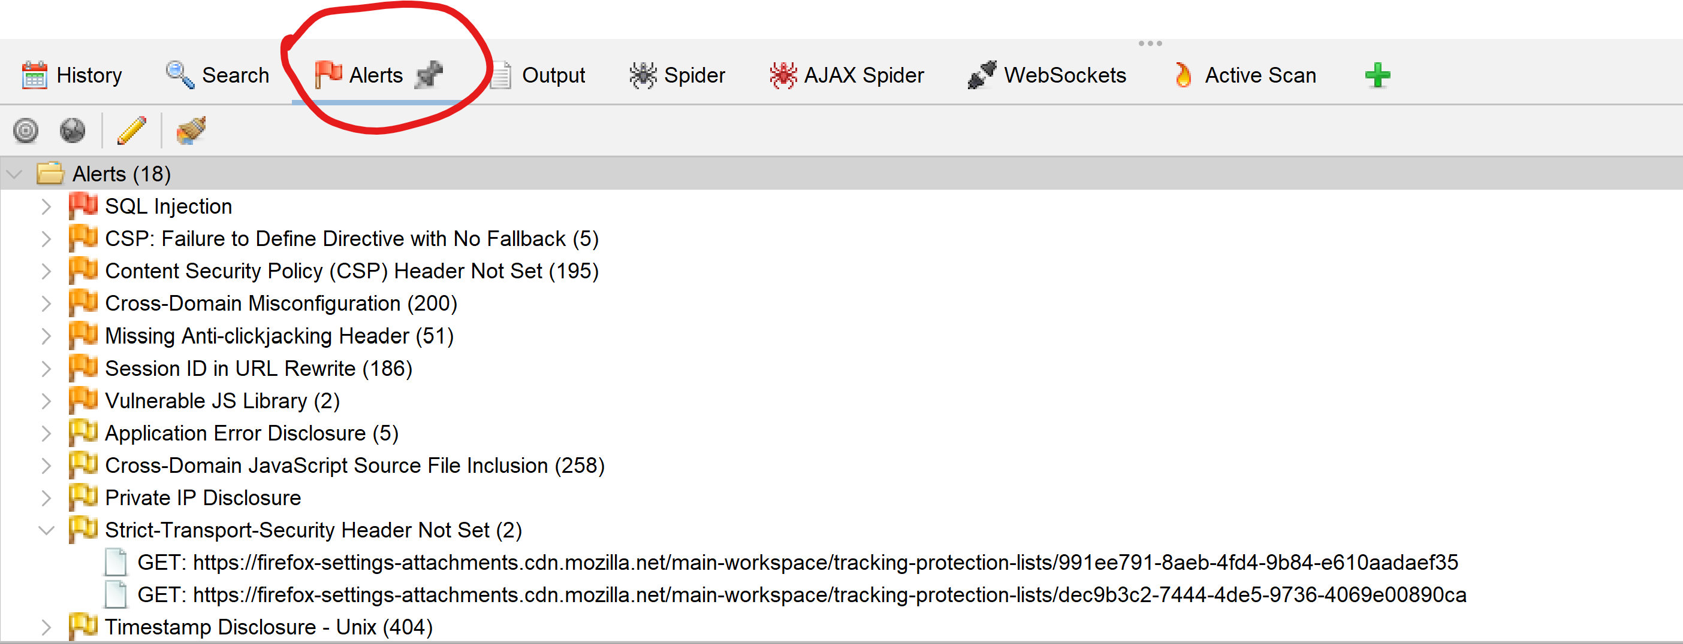
- Directory traversal

EXPLOIT VULNERABILITIES (DEMONSTRATION)
SQL INJECTION
Go to Login Page: http://localhost:3000/#/login
Enter this in Email field: ' OR 1=1—
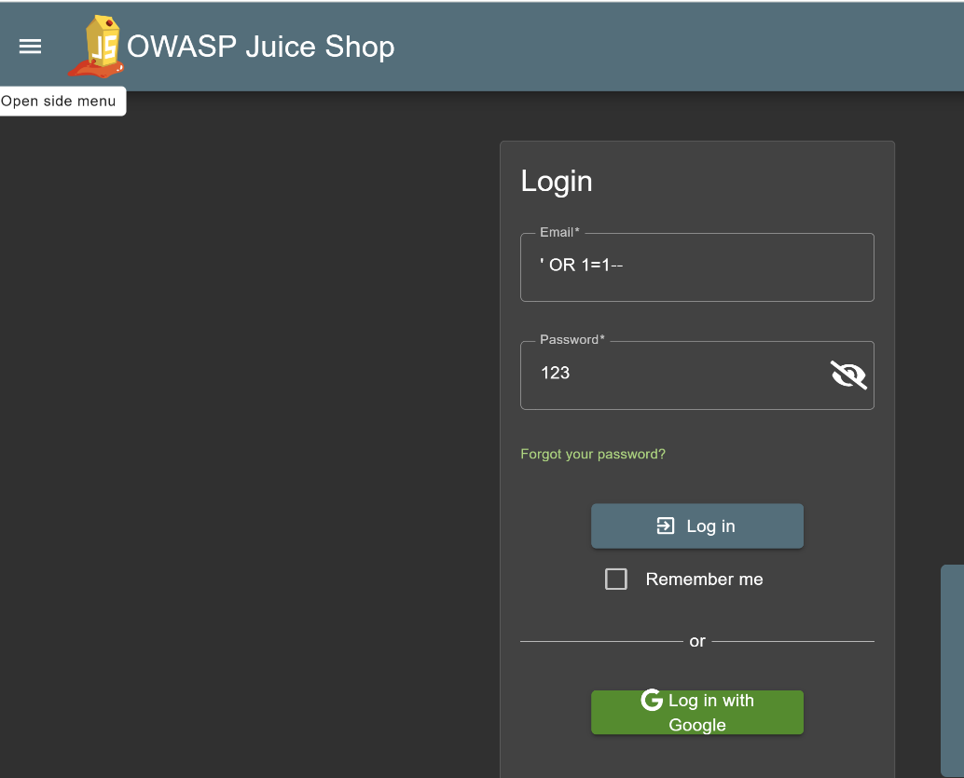
Enter anything as password.

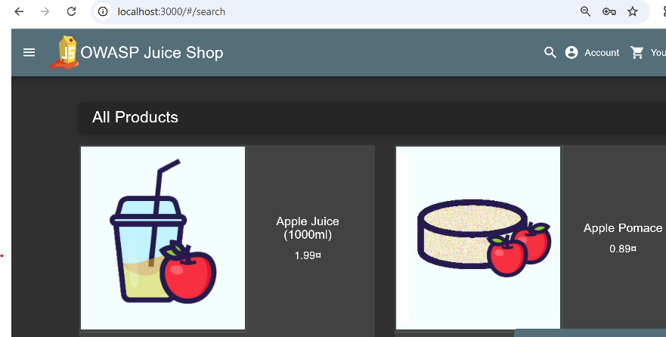

LOGIN SUCCESSFUL

XSS CROSS SITE SCRIPTING
Open Contact Page: http://localhost:3000/#/contact
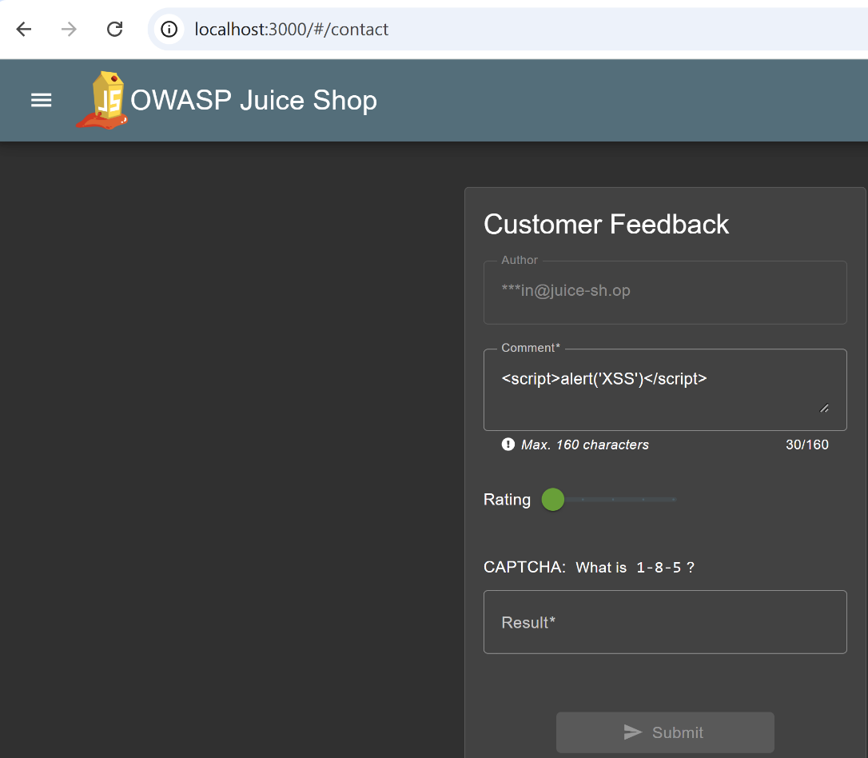
Enter this payload in “Comment” field: <script>alert('XSS')</script>

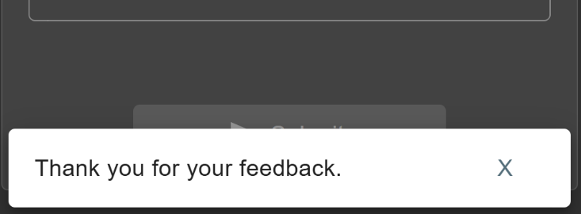

✔ Your JavaScript executed

✔ The reflected page accepted payload

✔ The application is vulnerable

✔ exploited XSS successfully

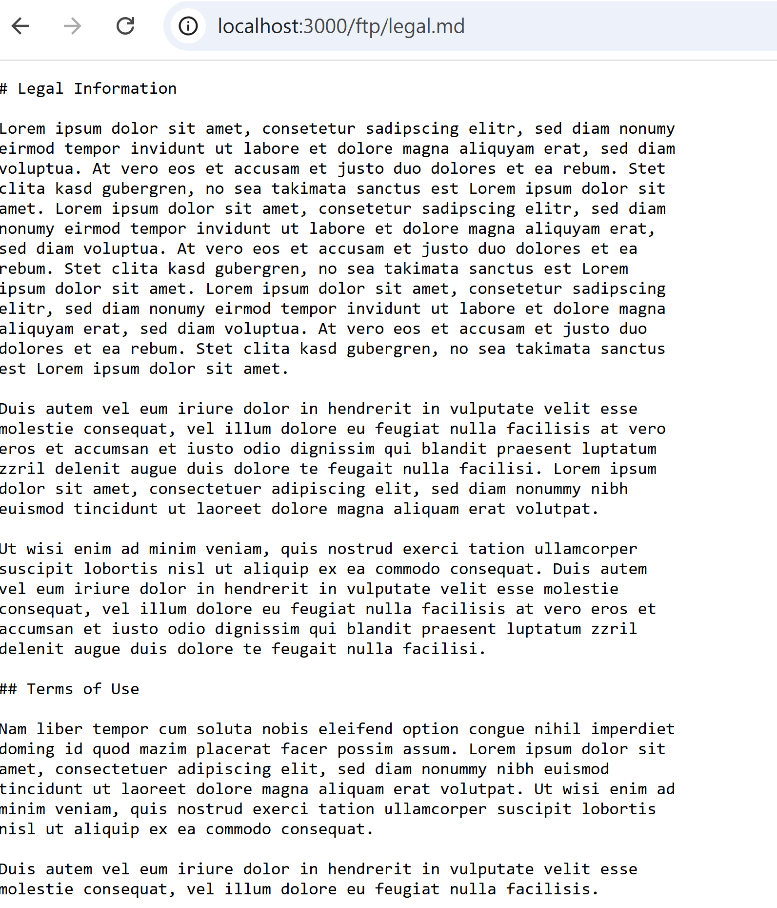
SENSITIVE DATA EXPOSURE
Open Juice Shop main page: http://localhost:3000/#/score-board
Find the challenge “Access confidential document”
Visit this path manually: http://localhost:3000/ftp/legal.md
sensitive documents exposed publicly

Hidden Admin Panel / URL Manipulation
Visit Robots.txt: http://localhost:3000/robots.txt
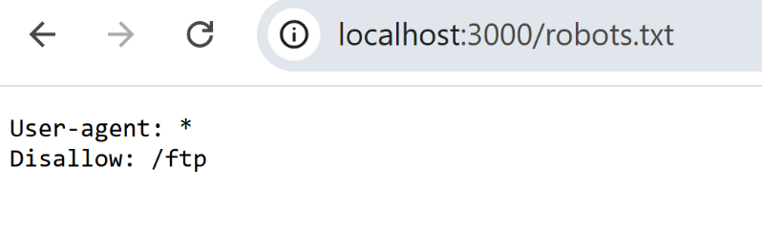
This tells attackers EXACTLY where the admin page is.

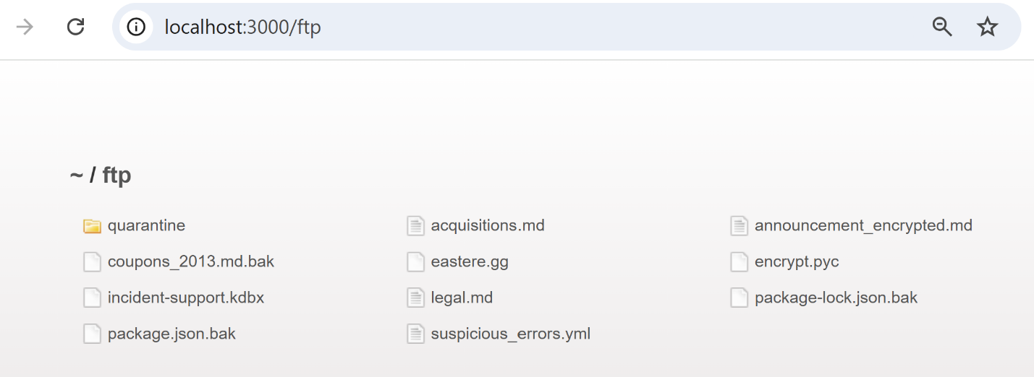
Open the hidden admin page: http://localhost:3000/ftp
- USING WEB SCRAPER TO EXTRACT SITE CODE
We are using HTTrack Website Copier:
Steps performed:
- Installed HTTrack from
https://www.httrack.com
- Created a new project
- Enter URL:
http://localhost:3000

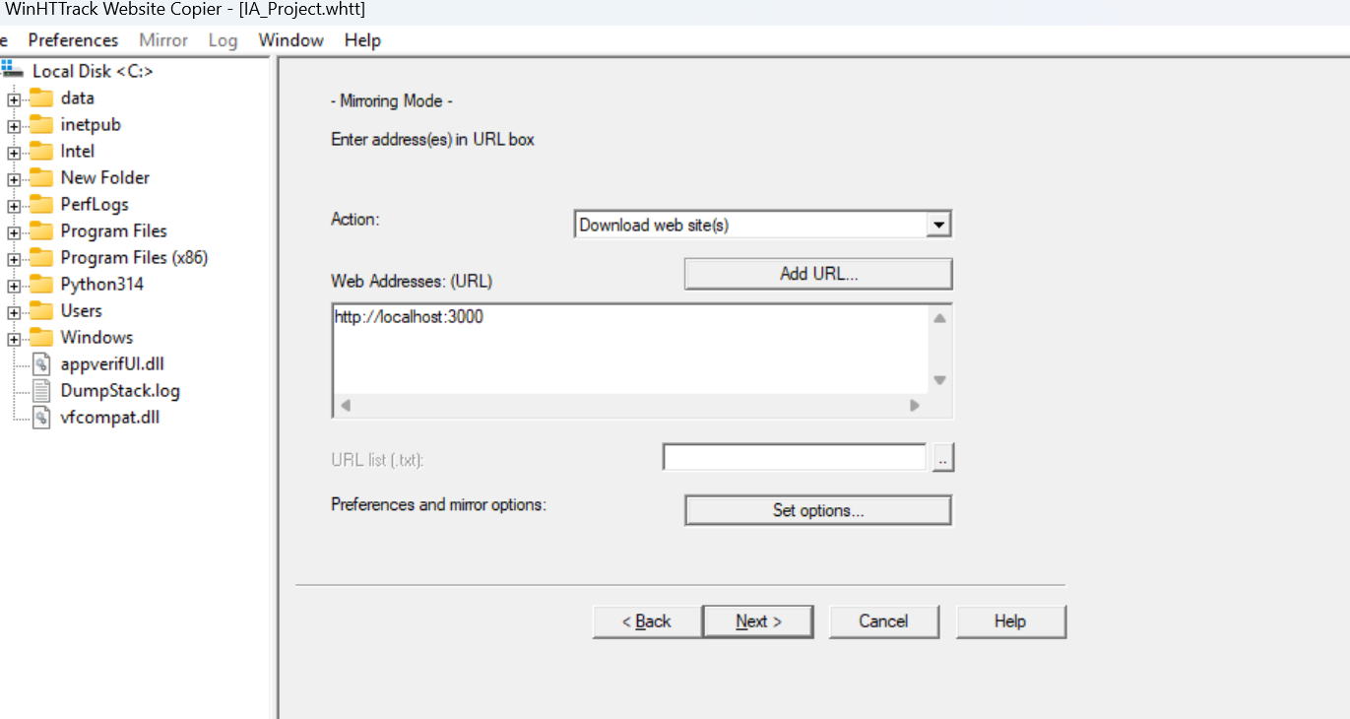
Configured the options:

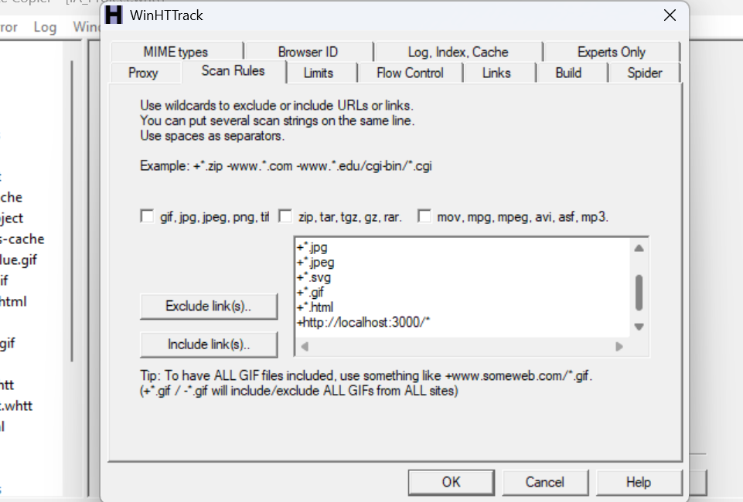

Performed mirroring:
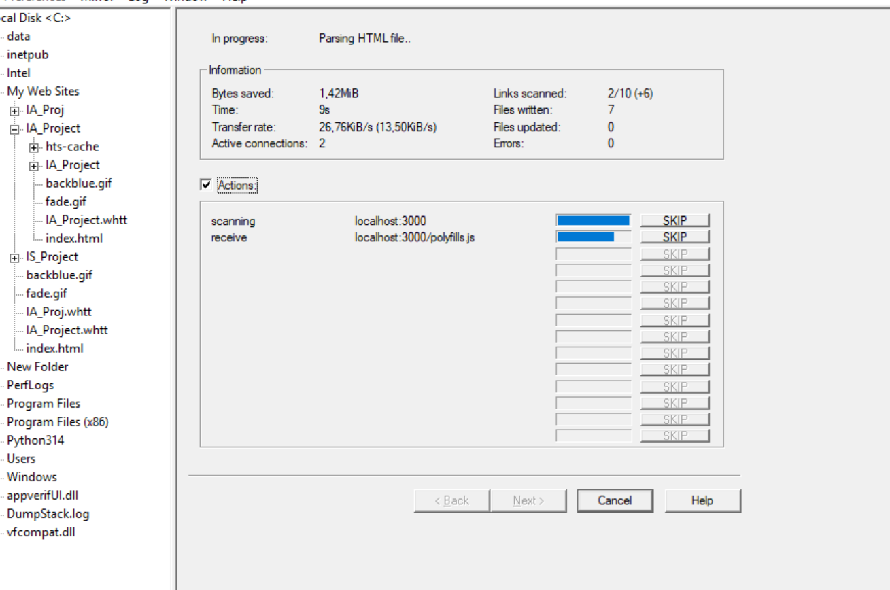
Mirroring has been performed successfully:
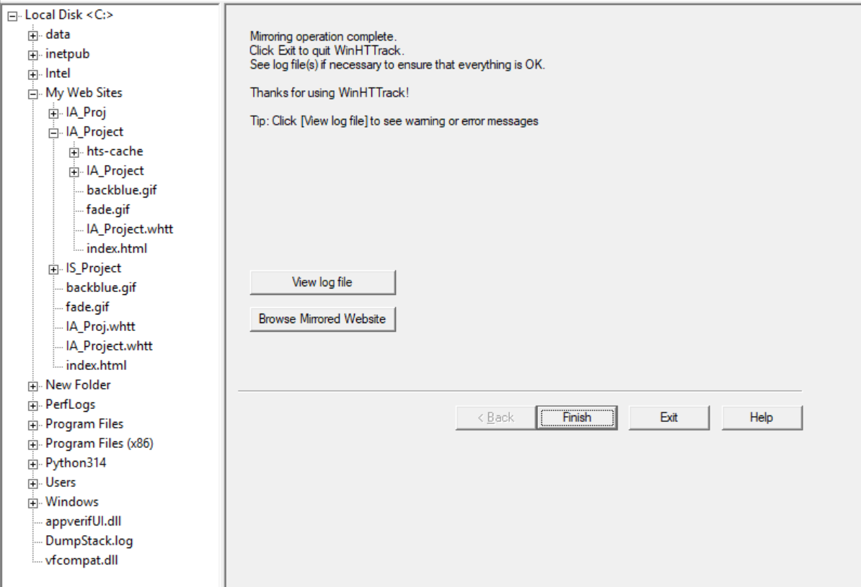

HTTrack has downloaded:
- HTML files
- JS
- Assets
- API calls

