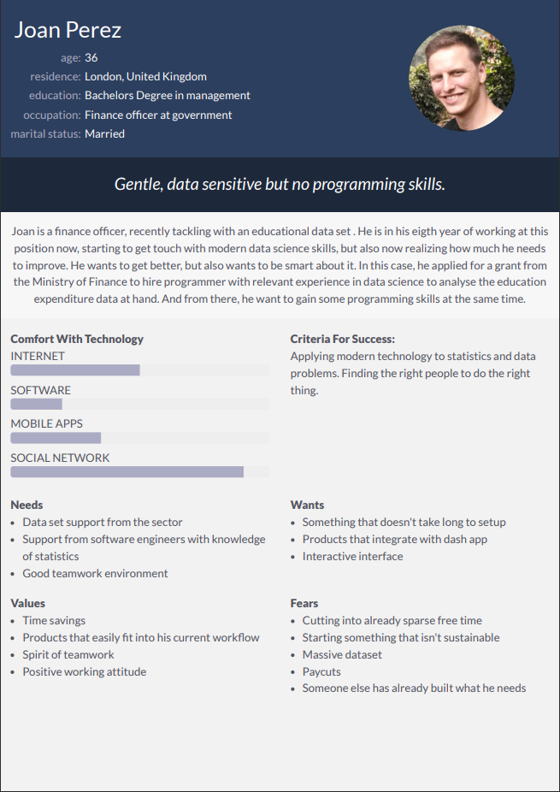

Joan Perez’s needs:

1: Using dash app to make sure that even citizens don’t know anything about coding could access the data easily and

Solution: create a dash app

2: forecasting data