**AFD–DFID Green Mini-grids £30-million Support Facility: Call for projects**

1. **Purpose**

The purpose of this Call for Projects is to solicit information from mini-grid project developers currently operating or with intentions of operating in Kenya. This could include private sector companies, NGOs, community groups or other stakeholders supporting this sector.

We seek information on the existing and planned projects in Kenya as well as the perceived investments risks or barriers. This information received under this call will be used to design a **Capital Support and Transaction Advisory Facility for the Development of Green Mini-grids (GMGs)**. GMGs are defined as mini-grids integrating renewable energy for power generation.

1. **Background**

Agence Française de Développement (AFD) is a bi-lateral development finance institution established in 1941 that works on behalf of the French government. Its mission is to finance development according to France’s Overseas Development Assistance policies. The Department for International Development (DFID) leads the UK’s work to end extreme poverty. UK aid is helping the world's poorest people change their lives.

In cooperation with DFID, AFD wishes to further encourage rural electrification in Kenya by promoting investments in GMGs involving the private sector. DFID plans to provide £30 million via AFD to support a five-year programme of support to the GMGs sector. Some of the financing support mechanisms under consideration include loans through credits lines administered by Kenyan local partner banks, concessional finance, results-based incentives, grants and guarantees. The program could also provide technical and business support to mini-grid developers and communities.

This programme could benefit a wide range of GMG initiatives, from grid-connected/ grid proximate projects to very small isolated networks. The figure below provides an indicative classification of the types of projects that will be considered.

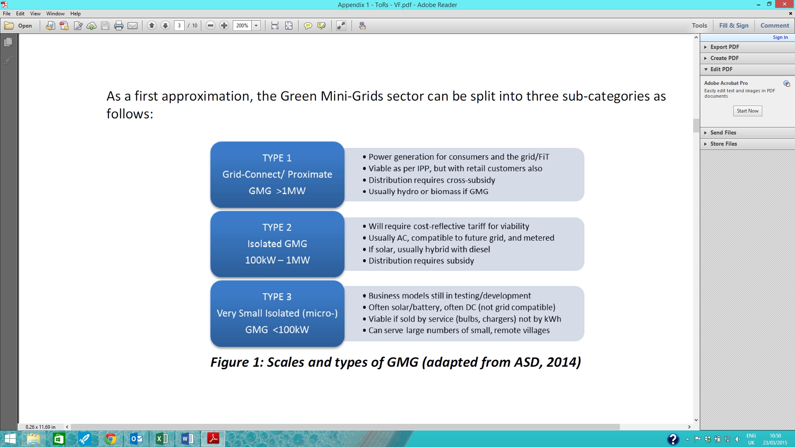

*Scales and types of GMG (adapted from ASD, 2014)*

Other initiatives supporting these types of mini-grid projects will also be given consideration. These may include other technologies providing electricity access or activities such as project facilitation, community mobilization, etc.

1. **Design of the Support Facility**

This programme is currently at its **inception phase**. Consulting firms *Economic Consulting Associates* of the United Kingdom and *EED Advisory* of Kenya have been engaged by AFD to provide recommendations on the design of the capital support and transaction advisory facility under this programme.

The information provided by project developers and other stakeholders under this call and subsequent interactions will feed into the process of designing the £30-million facility in Kenya.

The timeline for this inception phase is of 6 months, ending in August 2015. The **implementation phase of this programme will only start after this period** and will be contingent to the results of the inception phase.

1. **Submission Instructions and Next Steps**

Please complete the form provided below and return it by email to [greenminigrids@eedadvisory.com](mailto:greenminigrids@eedadvisory.com) **at your earliest convenience and prior to April 10th**. Kindly provide sufficient information for evaluation; best responses will receive additional enquiries for assistance in the design of the prospective facility. You may include additional information or documents that you consider relevant to this programme.

Information provided under this call will be kept strictly confidential. Any information used for the design of the support facility will be aggregated before dissemination.

We expect to receive sufficient responses by 10 April in order to conduct a preliminary assessment. We will then organise a workshop on the week of 20 April (exact date and venue to be confirmed) to discuss further with the most relevant contributors. One-on-one interviews may also be beneficial.

1. **Additional Notes**

This Call for Projects is requesting information for the design of this programme. It is not to be construed as a commitment by AFD or DFID to support any of the submitting entities. It should be noted that responding to this Call for Projects will not give any advantage to any organisation.

1. **Information Form**

|  |  |  |  |  |
| --- | --- | --- | --- | --- |
| **AFD-DFID Green Mini-grids Support Facility: Cal for Projects Form** | | | | |
| 1. **CONTRIBUTOR’S INFORMATION** | | | | |
| COMPANY/ORGANISATIONAL DETAILS | | | | |
| A1 | Name of Company/Org |  | | |
| Physical Address |  | | |
| Postal Address |  | Postal Code |  |
| City / Town |  | Country |  |
| Telephone Number |  | | |
| Website |  | | |
| CONTACT PERSON DETAILS | | | | |
| A2 | Salutation | Select | | |
| First Name |  | | |
| Surname |  | | |
| Position |  | | |
| Telephone |  | | |
| Email |  | | |
| BUSINESS DETAILS | | | | |
| A3 | Year of Incorporation |  | | |
| Description of business (Max 300 words) |  | | |

|  |  |  |
| --- | --- | --- |
| 1. **CURRENT AND PLANNED OPERATION STATUS** | | |
| B1 | 1. Are you currently operating an off-grid electrification project (including mini-grid projects) in Kenya or elsewhere? ☐ Yes (if YES, proceed to B1.b-) ☐ No (if NO proceed to question B1.c-) | |
| 1. Please provide details of the current operations below:  |  |  |  |  |  |  |  |  | | --- | --- | --- | --- | --- | --- | --- | --- | | **Location [Country, Nearest Town)** | **Installed capacity (kW)** | **Current Operations** | | **Technology** | **Number of Clients** | | **Range of expected IRR (if available)** | | Peak  Demand | Service  Hours/day | **Households** | **Other** |  | |  |  |  |  | Select |  |  |  | |  |  |  |  | Select |  |  |  | |  |  |  |  | Select |  |  |  | |  |  |  |  | Select |  |  |  | |  |  |  |  | Select |  |  |  | | |
| 1. Please provide details of planned or prospective projects including information on location, installed capacities, technology and number of target clients: | |
| B2 | Please comment on the stage of development of your mini-grid projects | |
| B3 | Please explain, in your perspective, what are the leading risks and challenges associated with private sector and community mini-grids development in Kenya | |
| B4 | Please explain, in your perspective, what are the main issues which this programme specifically could do to accelerate your efforts, bearing in mind the focus on capital support and TA | |
| B5 | Please indicate, in order or priority, what type of financial support your company requires. | |
| **Type** | **Rank** [*Where number 1 is the top priority*] |
| Grants ☐ |  |
| Equity ☐ |  |
| Results-based ☐  incentives |  |
| Debt ☐ |  |
| Guarantees ☐ |  |
| Other ☐ (please give details) |  |
| B6 | Please indicate whether you have already received (or are in the process of securing) private investment or other financing for your initiative, and if so please provide details | |
| B7 | Please provide any additional comments or questions. Additional relevant documents may be attached to this submission (submission should not exceed 10 megabytes). | |