**TITLE: Generating Food Suggestions Based On User Choice**

Shirin Sultana, SK, and Shaik

Masters in Computer Science, University of Massachusetts Lowell, [shirinsultana_shaik@student.uml.edu](mailto:shirinsultana_shaik@student.uml.edu)

Juveria, SK, and Shaik

Masters in Computer Science, University of Massachusetts Lowell, [shaik_juveria@student.uml.edu](mailto:shaik_juveria@student.uml.edu) Venkata Swetha, and Punati

Masters in Computer Science, University of Massachusetts Lowell, [venkataswetha_punati@student.uml.edu](mailto:venkataswetha_punati@student.uml.edu)

# ABSTRACT:

Getting through monthly menstruation is a thing in itself. Food should be the least of any woman’s worries during this time. All women go through this never-ending process of not knowing what to eat but just wanting to eat something, AKA cravings. We wish to make a website or an app that acts as a simulator to help women all over the world get better food suggestions for the kind of cravings and common symptoms, like bloating, cramps, irritability, headaches, etc., they have during their monthly menstrual cycle. We plan on doing so with the help of filters, which allows the users to select from various options provided in the filters, and CookBook, a recipe guide, to get food suggestions for their cravings and symptoms. This app or website aims to help women eat what they crave while maintaining their health. So, the recommendations would also include the calorie count of each item in the recipe or the overall recipe so that all women worldwide need not stress about over-eating and live peacefully, staying healthy.

# INTRODUCTION:

Food cravings during menstruation are other things that all women worldwide share. Along with these cravings, there are symptoms like bloating, cramps, irritability, headaches, etc., which makes their life even more difficult. These symptoms often affect one’s mood. What if they can get relief from these kinds of signs and calm down the cravings with the help of food? Well, we have just the right solution for this problem. Our website, *Cravings Hub,* is designed in such a way that it could give food suggestions to women based on their cravings and the common symptoms that occur during menstruation, with the help of Filters and Cookbook. The FILTERS have options like - Meal of the day: Breakfast, Lunch, Dinner, and Beverages; Meal type: Vegetarian, Non-Vegetarian, Gluten-free, Vegan; Symptoms: Bloating, Fatigue, Cramps, Heaviness in head / Headache, and Irritability. The COOKBOOK is designed so that the user can give either ingredients or the main dish leading to a search bar, which would provide many suggestions for the user to choose from to calm down their cravings. On the HOME page we have some useful links that would direct the users to another page that has helpful content like *what to do when: having heavy cramps, unbearable headaches, etc.; foods to avoid; Situation-Suitable product recommendations* and some content like what’s mentioned.

# CONTRIBUTION:

## Methods:

The languages HTML and CSS are used to design the front end of the website. The nav bar consists of Home, About, Filters, CookBook, and a Contact form. Among these sections: - on the home page, there is the company logo, which was created using Figma, the company name, tagline, and some useful information for the users. On the About page, there is a short description of the aim of the website, and the team members’ information. The copyrights are on the footer of the webpage, where the date/year is updated in real-time. The Filters page has a set of options, for the user to choose from, such as Meal of the day: Breakfast, Lunch, Dinner, and Beverages; Meal type: Vegetarian, Non-Vegetarian, Gluten-free, Vegan; Symptoms: Bloating, Fatigue, Cramps, Heaviness in head / Headache, and Irritability, upon the selection, the user would be returned with some food suggestions that match with their request along with calorie count, link to the recipe, and the total time required to make that dish. The CookBook page has a search bar, where the user can enter either an ingredient name or the primary dish name, or any of the common symptoms during menstrual cycle, with the help of which, some recipes would be directly suggested, without any need to use filters, containing either the ingredient or the primary dish name along with the calorie count, diet and health labels. Edamam.com’s Recipe Search API is being used to show the results on the CookBook page. The Contact Page has a form for the user to fill out if they feel the need to get in touch with the creators, whose responses are received on the company’s email. The frontend, that is, the design of company logo and company name on the HOME page and ABOUT, and CookBook pages are designed and linked appropriately to get the results by our team member-1: Shirin

Sultana Shaik. The FILTERS page and on the HOME page, the ‘useful content’ section is designed by team member-2: Shaik Juveria. The data required for the FILTERS page and the CONTACT form is created by team member-3: Punati Venkata Swetha.

# DISCUSSION:

In this section, we will show the interface of the website in the order of the page that appears when an user opens the website.

# SCREEN LAYOUT:

The screen layout overall the website is designed to fit in Full screen mode, Tablet mode, Mobile mode.

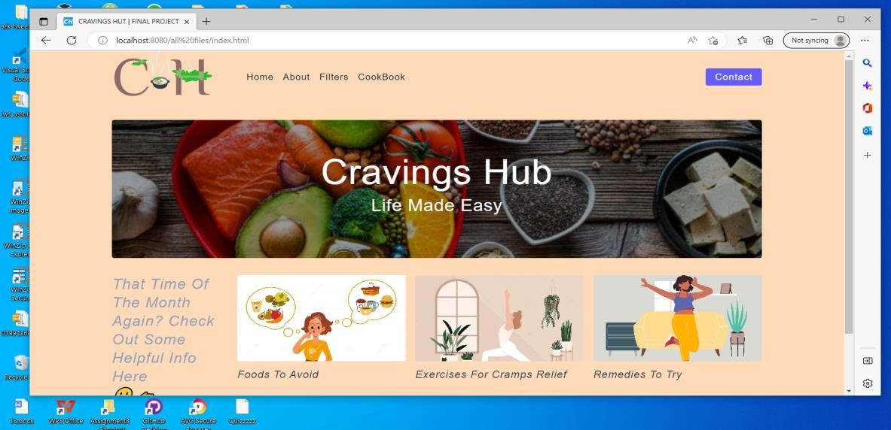

Full screen mode

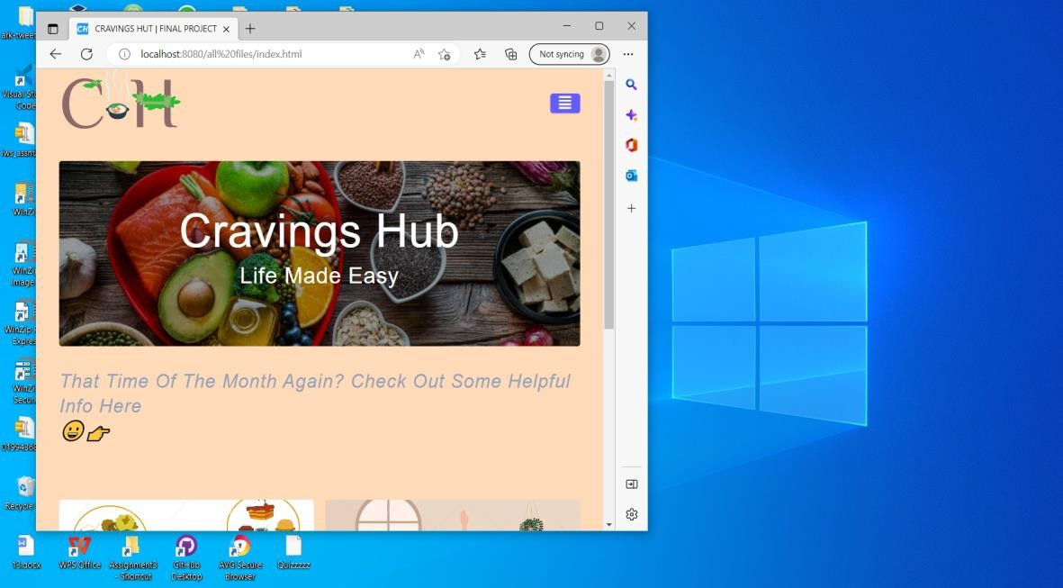

Tablet mode

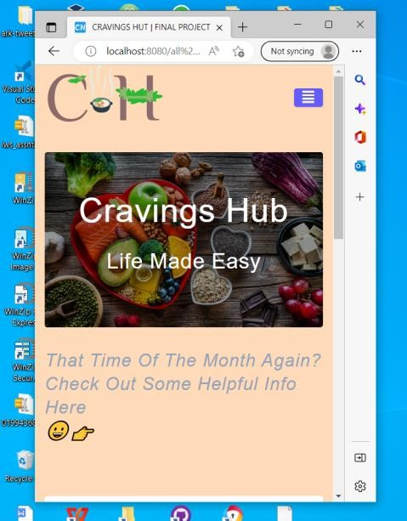

Mobile Mode

**HOME PAGE :**

On Home page we have home, about, filters, cookbook, footer and contact sections. Below the company tag line some useful content is displayed related to menstrual cycle issues, such as, foods to avoid, useful exercises for cramps relief and few useful remedies to feel better.

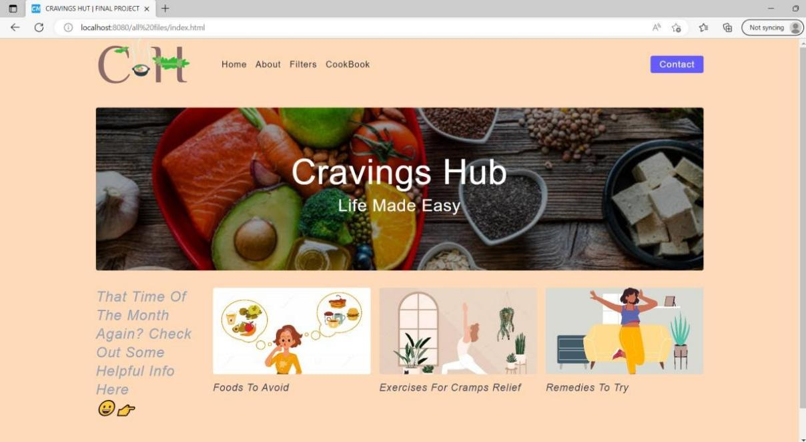

**ABOUT PAGE:**

On this page the aim of our website is displayed including the Information about our team members and their social links.

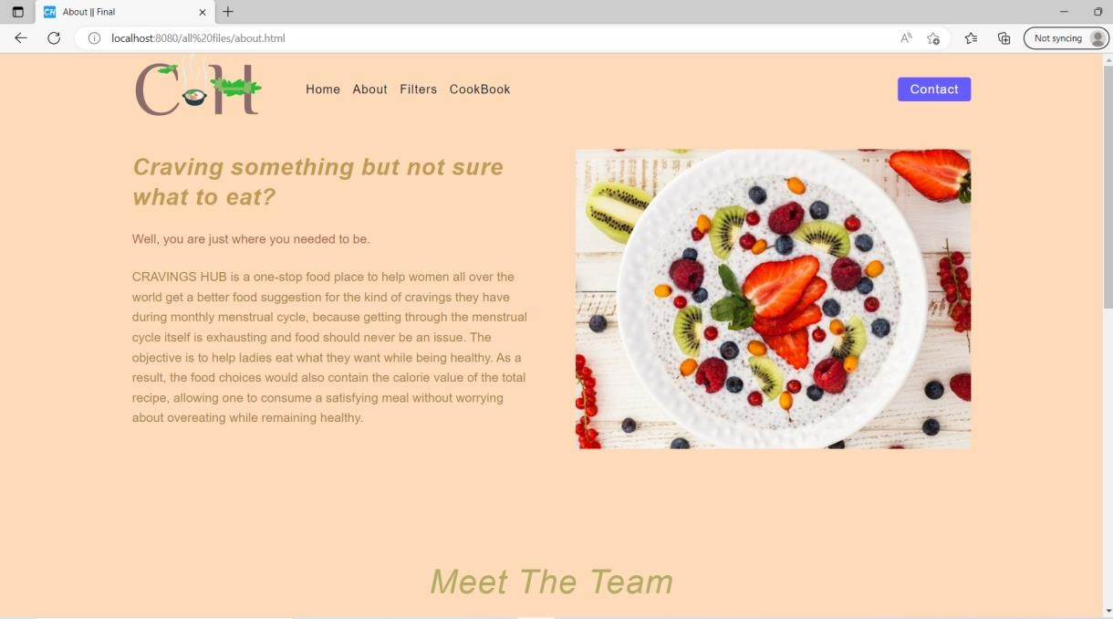

About page - Website Information

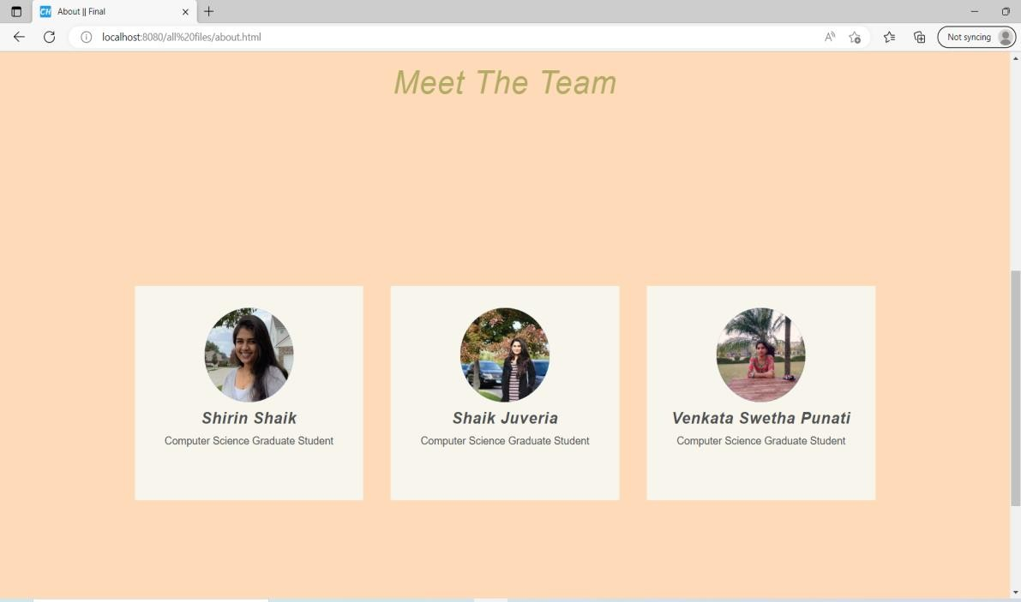

About page - Meet The Team

**FILTERS PAGE:**

This page suggests user to choose among few options- breakfast, lunch, dinner, beverages.

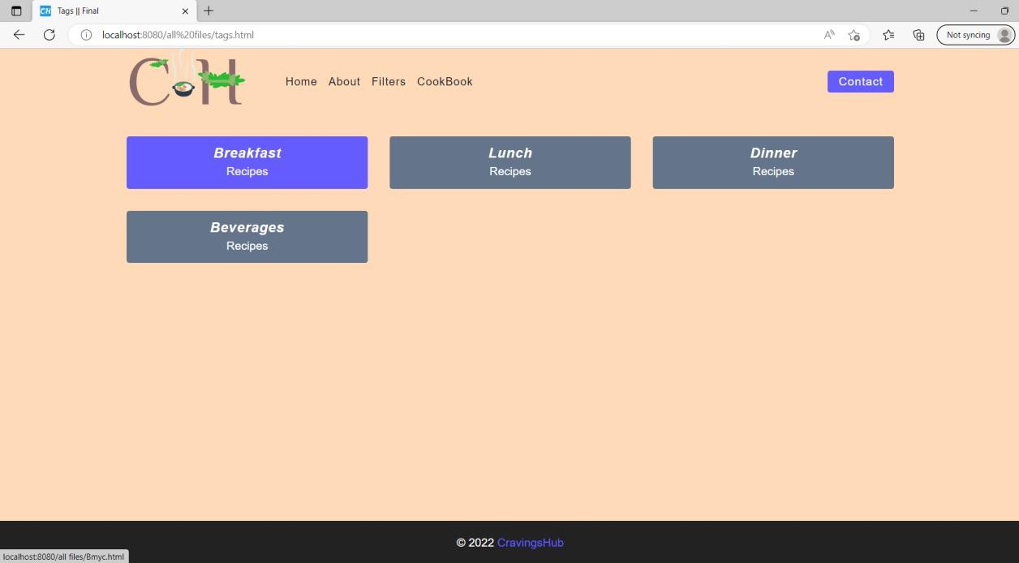

The below page suggests users few recipes based on their selection of what common symptoms they are facing such as, fatigue, headaches, cramps and Bloating. Upon clicking ‘Breakfast’ the following recipes will show up.

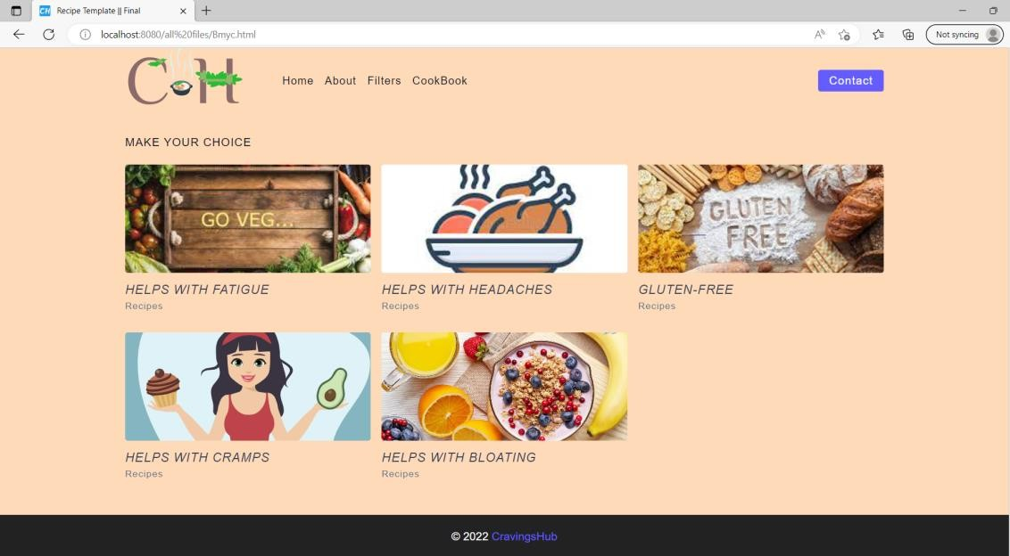

Filters Page

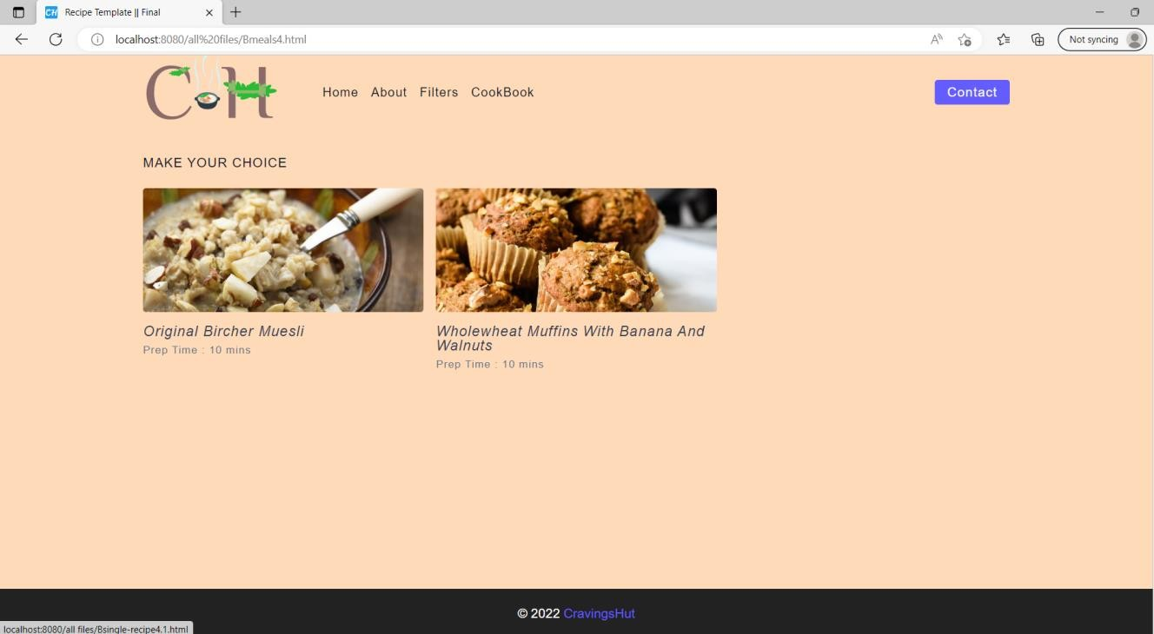

Filters Page - Recipes

**COOKBOOK PAGE:**

On this page the user can get recipes by entering the ingredient name or one of the common symptoms they go through during the menstrual cycle**.**

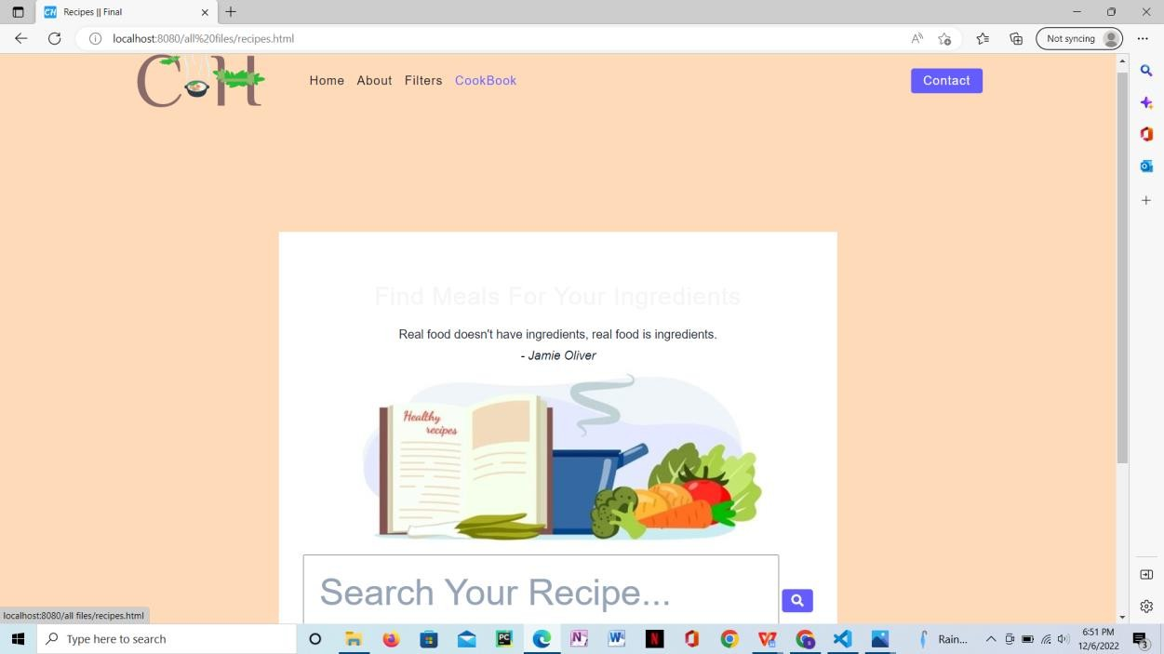

**CONTACT PAGE:**

The user can enter their information, name, Email-Id, and any of their preferences. Upon clicking send the user information will be stored and retrieved back to the company’s email. Like this we will get the responses of the users.

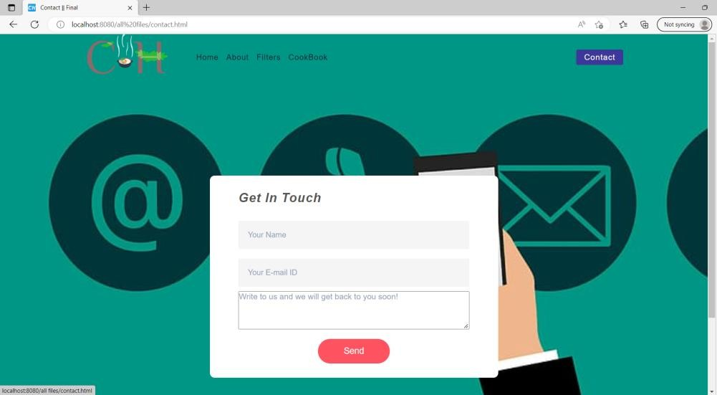

# ANALYSIS:

On Filters page, upon selecting one of the option the following recipe will be displayed including little description about the recipe, cook time, calorie count, servings and link to the recipe which will redirect to the main recipe in detail.

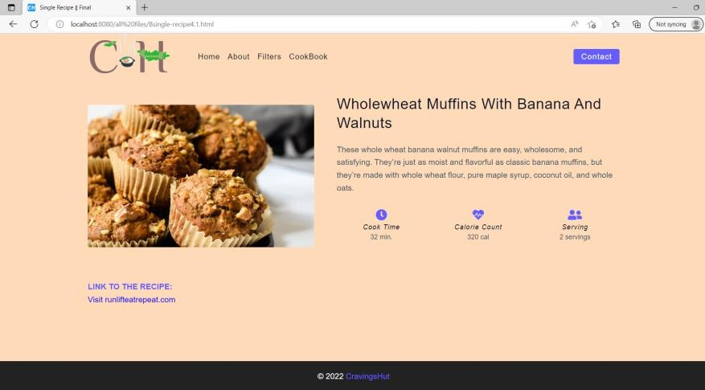

On Cookbook page, by entering the ingredient name the following recipes will be displayed**.**

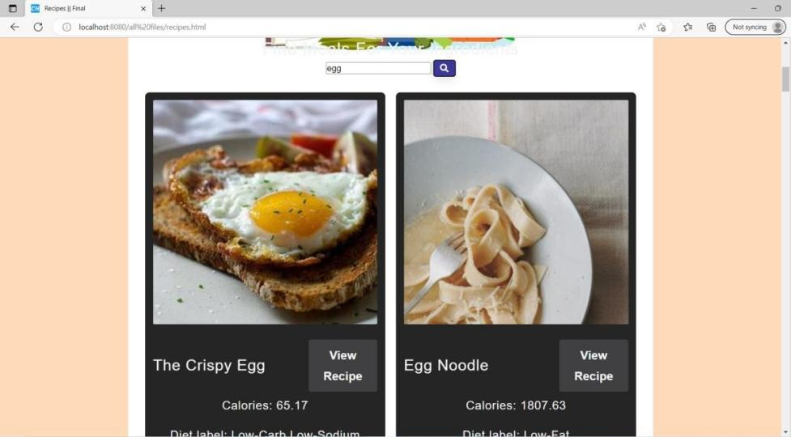

On Cookbook page, by entering one of the common symptoms the following results will be displayed.

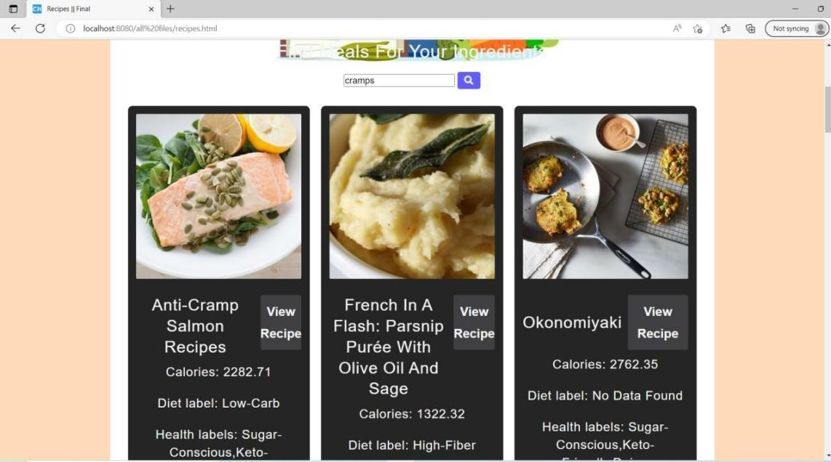

# CONCLUSION:

We designed our website to be a public platform so that it is accessible to everyone and that is why we do not have a user registration or login form. We believe that our website may help women worldwide to help maintain their diets as well as curb down their cravings. Cravings hub is not only limited to women. Since it’s a public platform, anyone can access the website and get their hands on the recipes.

# FUTURE WORK:

In the future, if there is provided scope for this website to grow by hypothetical users, this website can be useful not only for women going through the menstruation cycle but also for pregnant women, as the cravings and the common symptoms that we take about in the previous sections are usual in pregnancy too but these symptoms may vary from what they could be during menstruation. If such an audience were to make use of this website, they must be mindful of the food suggestions, as some recipes might contain ingredients that might not benefit the said audience. Cravings app can be developed in such a way that the users can have in the website, personalize, chart maker, and a the recipe remember tab or a recipe favorite tab that they can save all the favorite recipes.

Additionally, an application could be developed that could contain suitable medications for the appropriate issue, a custom- generated diet, and yoga/exercise information that might help the target audience stay healthy.

# REFERENCES:

1. https://adrianmeule.files.wordpress.com/2017/03/richard_2017_appetite.pdf
2. https://web.archive.org/web/20200909004544/https://academicjournals.org/journal/IJNAM/article-full-text- pdf/F0B4E8964399.pdf
3. https://[www.hsph.harvard.edu/nutritionsource/cravings/](http://www.hsph.harvard.edu/nutritionsource/cravings/)
4. https://[www.ncbi.nlm.nih.gov/pmc/articles/PMC4172095/](http://www.ncbi.nlm.nih.gov/pmc/articles/PMC4172095/)