Dailogflow :

Integration:Facebook Messenger

Topic: Coronavirus Chatbot

Features:

1. It accepts user details and remember the user till the end of the conversation
2. It gives latest updates around the world
3. It gives latest updates of any country
4. It also show cases of world and country by date
5. It is able to answer all the FAQ’s
6. It shows map of world wide cases and even demographic view of india
7. It also shows many preventive measures
8. It also shows a video of washing hands
9. It also mail the detail report and preventive measures.

Snapshots:

1. Start of the Bot

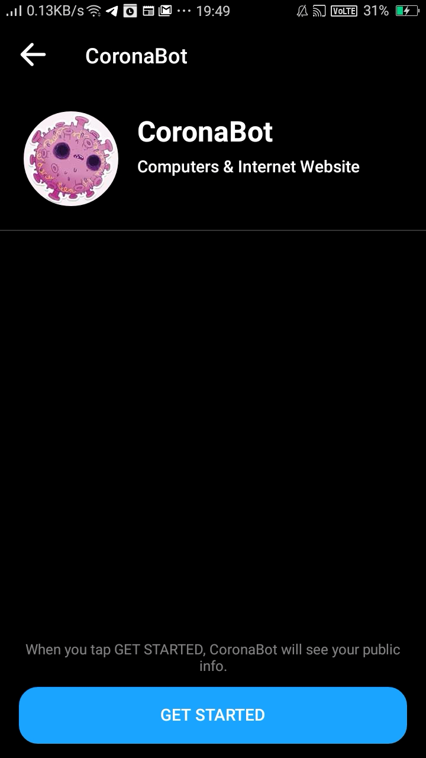

2. Bot Interacting with user by showing preventive measures

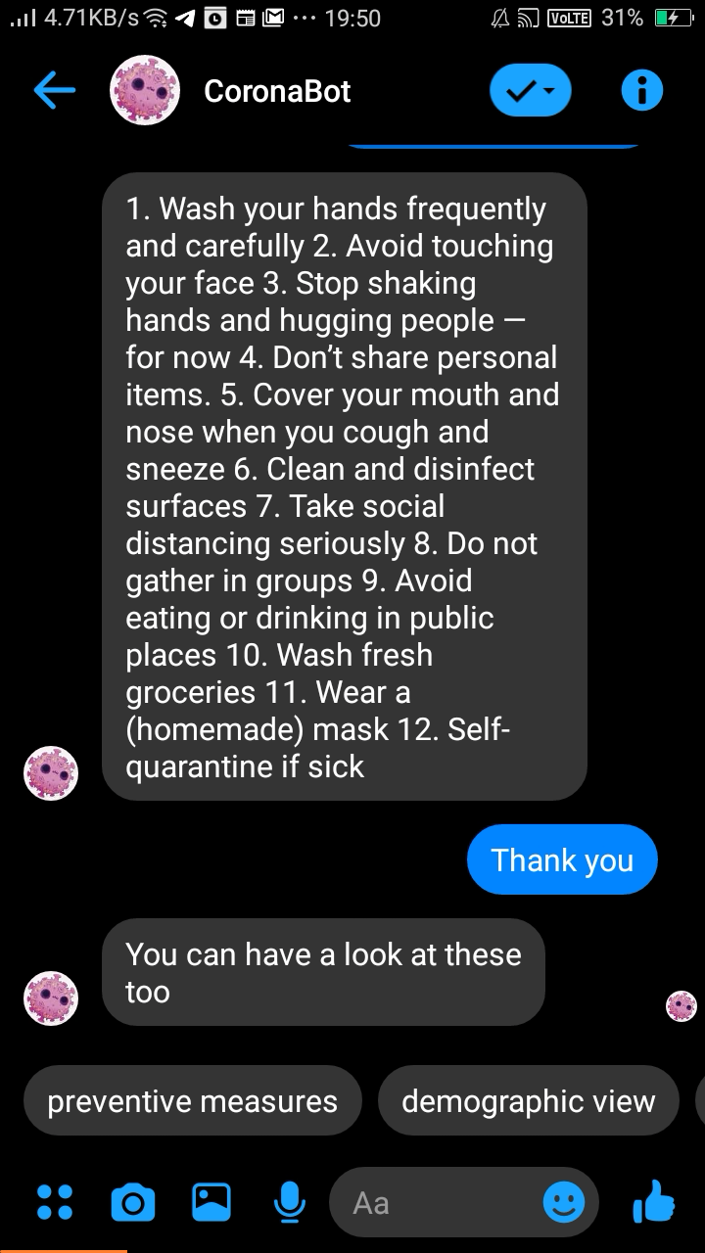

3. Updates of County by Date and showing videos of washing hands

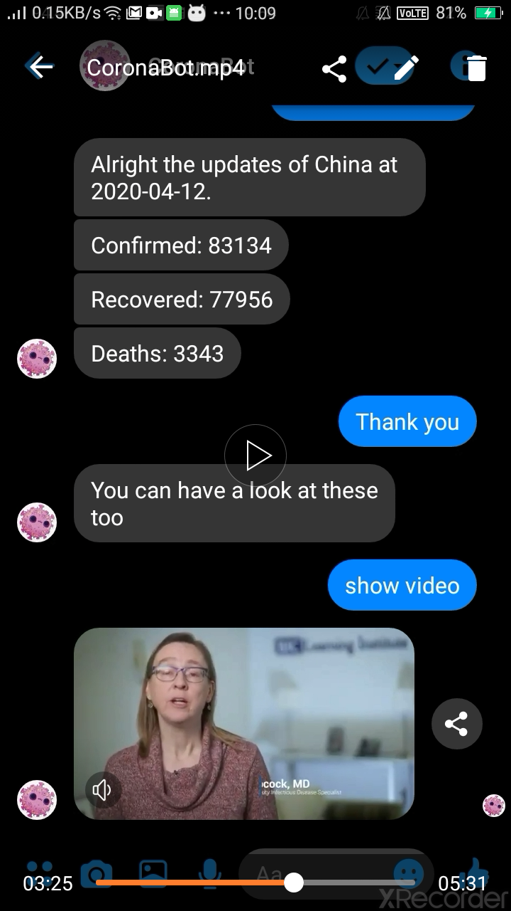

4. Cases by state and showing updates of world by date

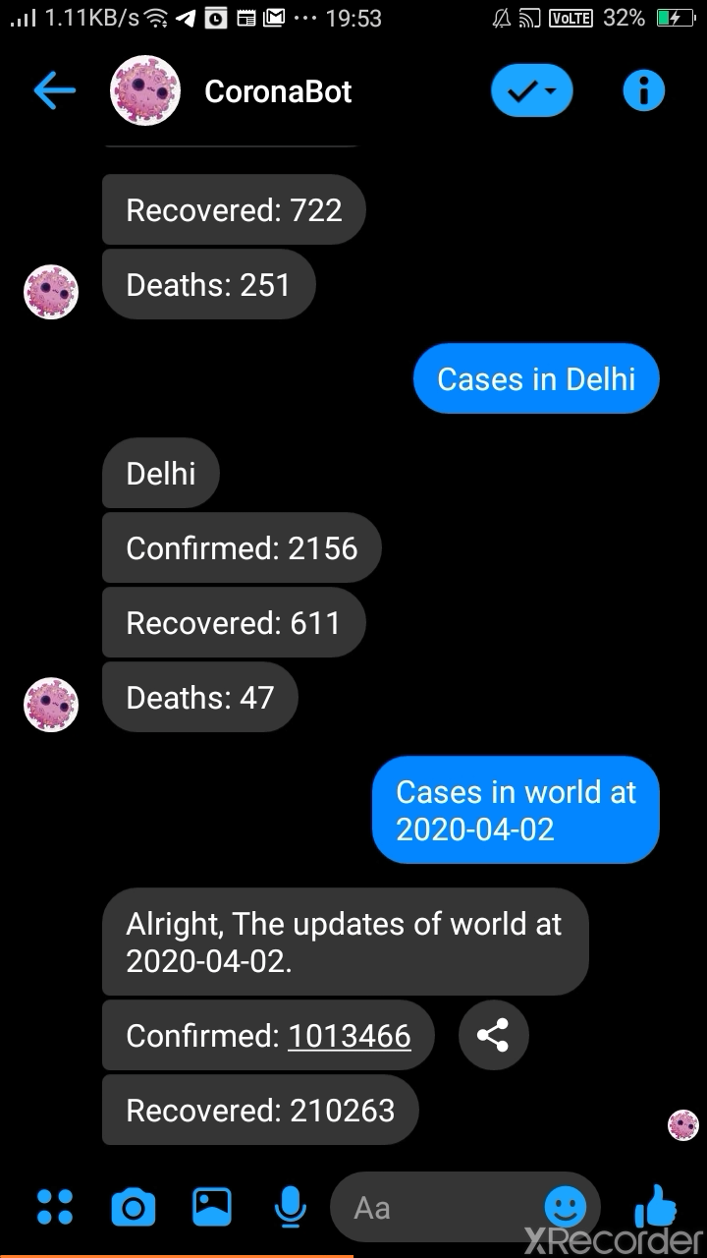

Integration:Telegram

same chats with telegram too

