Rasa NLU

Integrations: Telegram

Topic: Coronavirus Chatbot

Features:

1. It accepts user details and remember the user till the end of the conversation
2. It gives latest updates around the world
3. It gives latest updates of any country
4. It also show cases of world and country by date
5. It is able to answer all the FAQ’s
6. It shows map of world wide cases and even demographic view of india
7. It also shows many preventive measures
8. It also shows a video of washing hands
9. It also saves the conversaton between the user and bots in sql database
10. It also mail the detail report and preventive measures.

Snapshots:

1. Chats with bot

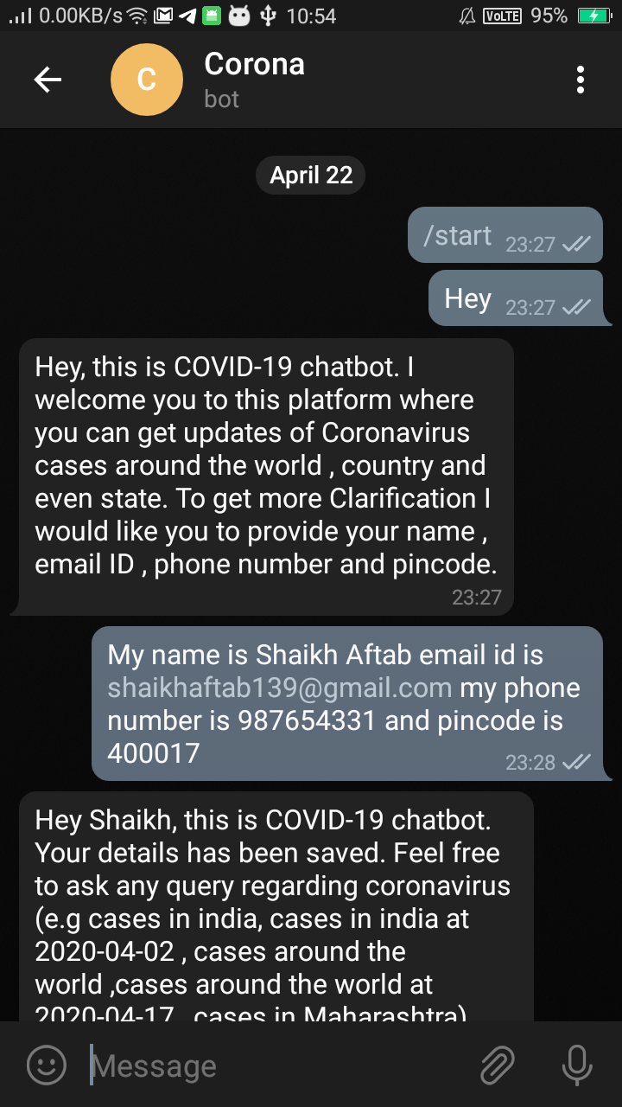

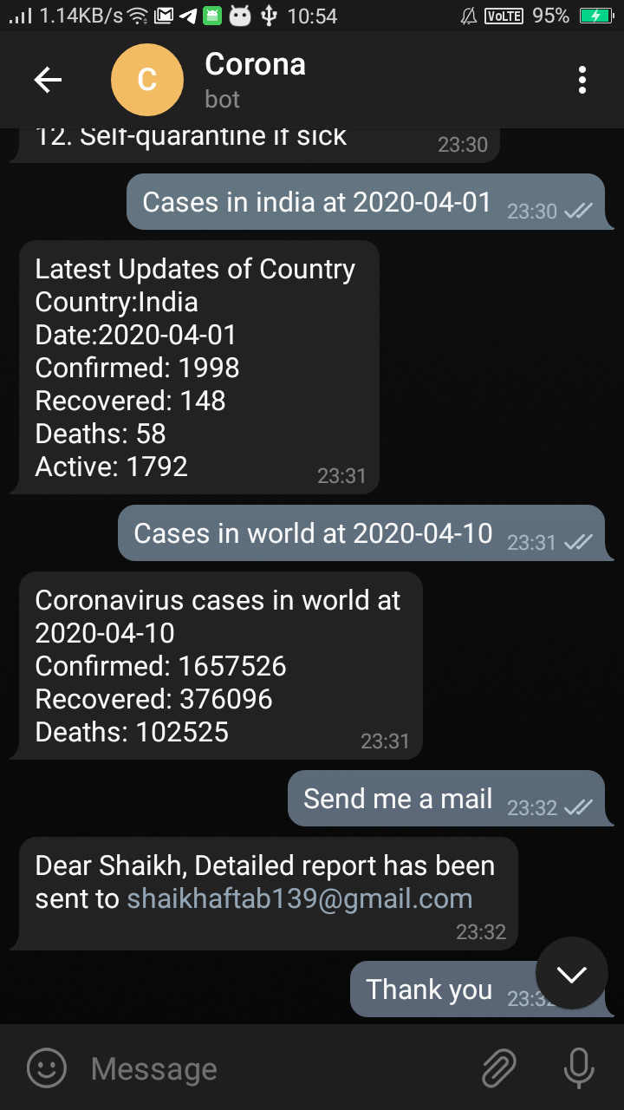

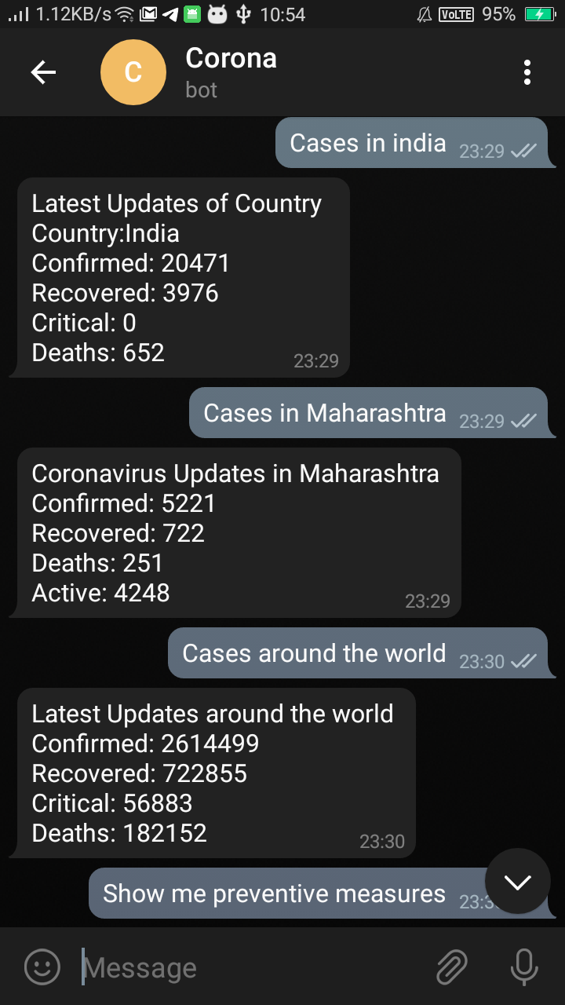

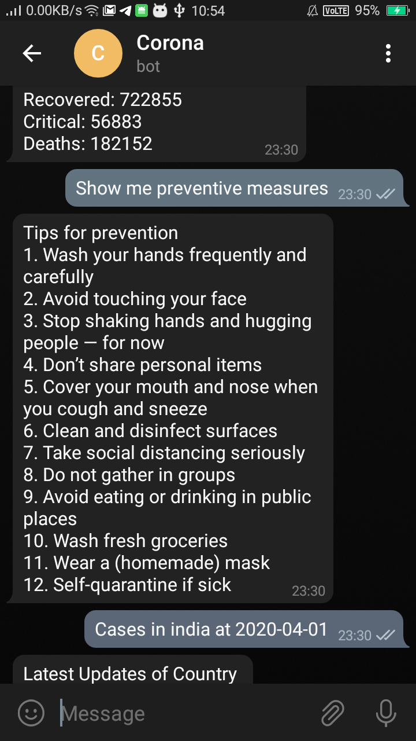

Integreations: Facebook Messenger

