Short example of script usage on the example data

Run run_pipeline.sh in the terminal window, making sure to install all requirements beforehand.
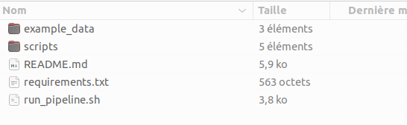
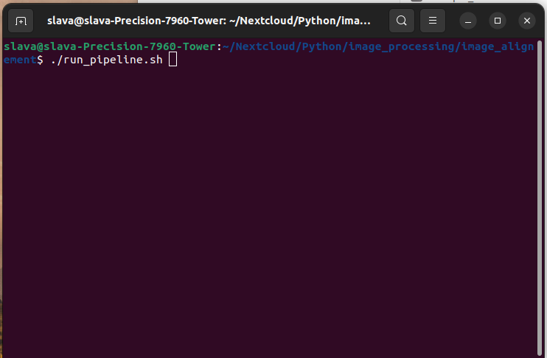

Follow the instruction appearing and guiding you through 5 steps of image alignment.

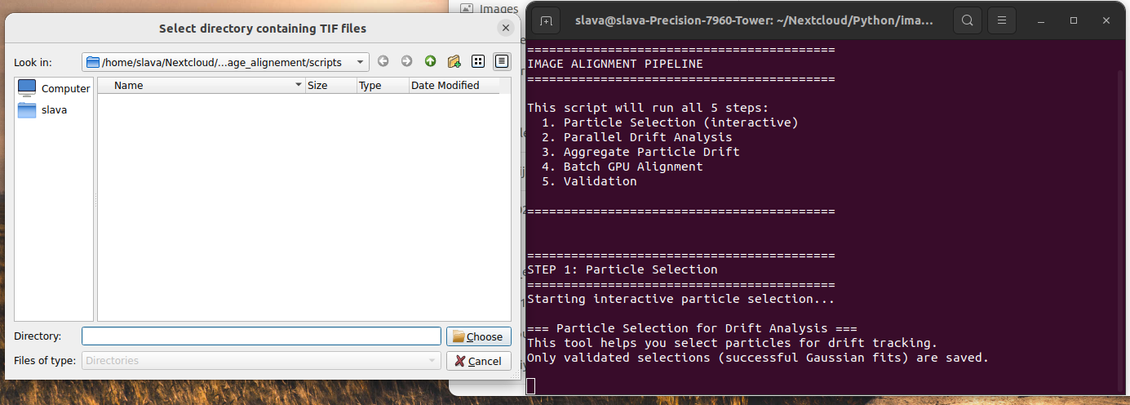
In the first step, select a folder containing TIFF files. The script will then prompt you to choose multiple sets of folders with corresponding data, if necessary, as it can process several data sets in parallel.

Choose ‘detection boxes’:

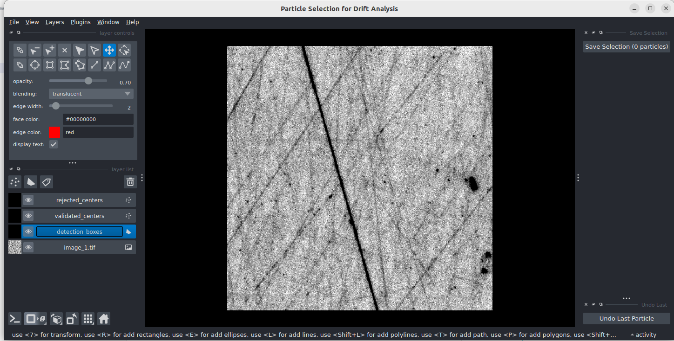
Then use the rectangle tool from the toolbox to manually locate the particles. Each particle will be fitted to a Gaussian distribution and, if successful, marked with a dot; if not, it will be indicated with a red cross. To remove a particle, click on "Undo last particle" (bottom right). Once you've made your selections, click on "Save selection" (top right) and proceed to another dataset if prompted by the interface. We recommend selecting at least 4 particles in each corner of the image. Ideally, aim for 4–6 particles per corner. Keep in mind that selecting more particles increases the chances of successful fits, especially if some image areas are not fitted correctly.

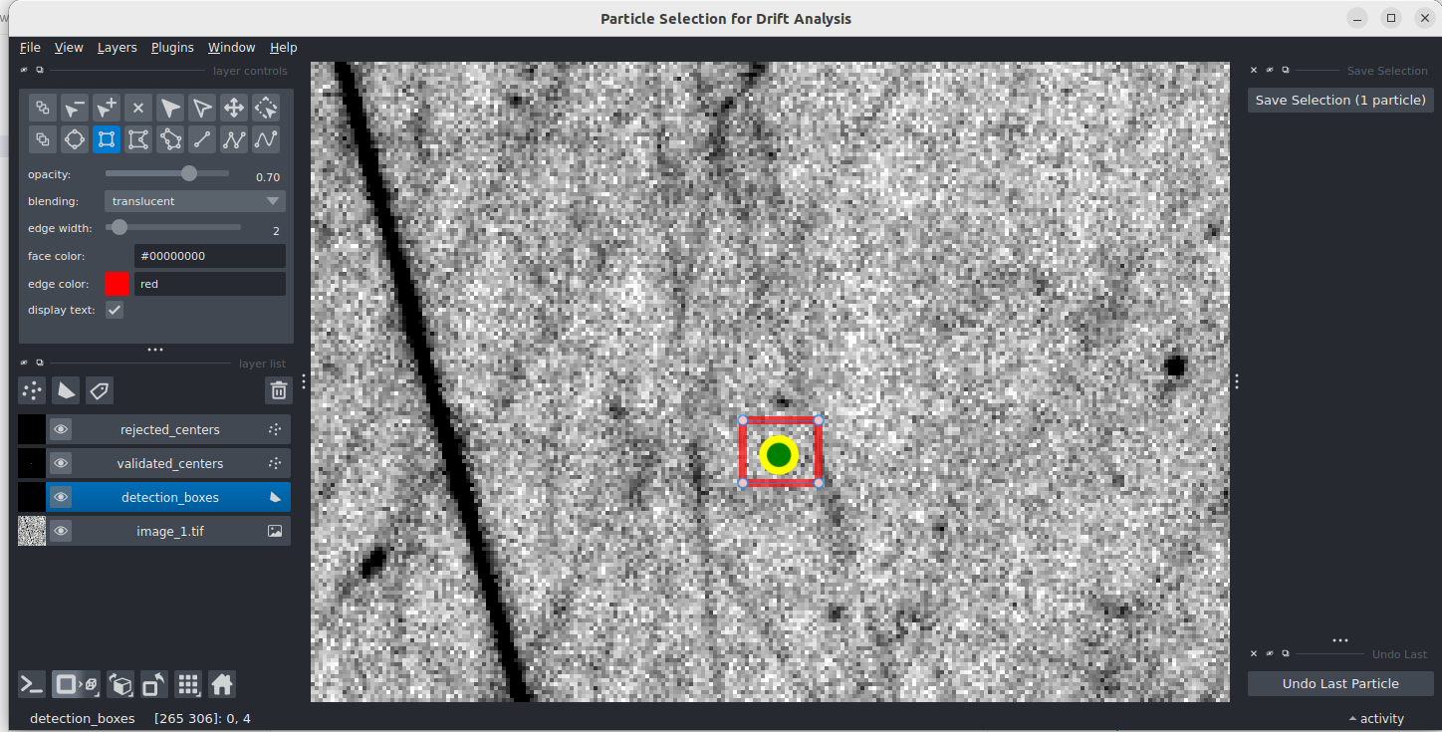
After you finish, observe the terminal as the script executes all necessary image processing steps, providing information about the results and the output folder containing all data, along with the before and after drift values.
