Завдання 1  
import numpy as np  
import math  
from scipy.misc import derivative  
def f(x):  
return x ** 4 - 4 * x -1  
a = 1  
b = 2  
eps = 0.0001  
def nuton(a,b,eps):  
df2 = derivative(f, b, n = 2)  
if (f(b) * df2 > 0):  
xi = b  
else:  
xi = a  
df = derivative(f,xi, n= 1)  
xi_1 = xi - f(xi) / df

while (abs(xi_1 - xi) > eps):  
xi = xi_1  
xi_1 = xi - f(xi) / df  
return print('Solving the equation by Newton*s method x = ', xi_1)  
nuton(a,b,eps)

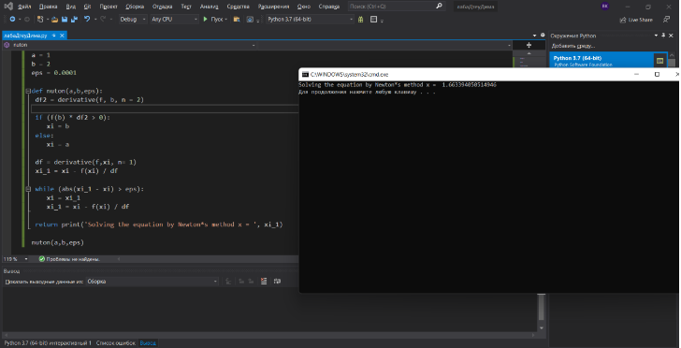

Завдання 2  
import numpy as np  
import math  
from scipy.misc import derivative  
def f(x):  
return x ** 4 - 4 * x -1  
a = 1  
b = 2  
eps = 0.00001  
def komb(a,b,eps):  
if(derivative(f, a, n = 1) * derivative(f, a, n = 2) > 0):  
an = a  
bn = b  
an_1 = an - f(an) * (bn - an) / (f(bn) - f(an))  
bn_1 = bn - f(bn) / derivative(f, bn, n = 1)  
else:

an = a  
bn = b  
an_1 = an - f(an) / derivative(f, an, n = 1)  
bn_1 = bn - f(bn) * (bn - an) / (f(bn) - f(an))  
while(abs(bn_1 - an_1) > eps):  
an = an_1  
b1 = bn_1  
if (derivative(f, an, n = 1) * derivative(f, an, n = 2) > 0):  
an_1 = an - f(an) * (bn - an) / (f(bn) - f(an))  
bn_1 = bn - f(bn) - f(bn) / derivative(f, bn, n = 1)  
else:  
an_1 = an - f(an) - f(an) / derivative(f, an, n = 1)  
bn_1 = bn - f(bn) * (bn - an) / (f(bn) - f(an))  
return print("Корень = ", bn_1)  
komb(a,b,eps)

