**CHILD INFORMATION**

Name: Iker Valadez ID Number: 532857 Grade: 07 Date of Birth: 12/02/2010

Street: 318 Avalanche Ave City: Georgetown State: TX Zip: 78626

Campus Name: Wagner Middle School Campus ID: 246904045

**PARENT/GUARDIAN INFORMATION**

Name: Guadalupe Valadez

Street: 318 Avalanche Ave City: Georgetown State: TX Zip: 78626

Home phone: (512) 577-0984 Work phone: (512) 577-0984

Cell phone: (512) 577-0984 Email: [guadalupepacheco151706@gmail.com](mailto:guadalupepacheco151706@gmail.com)

Name: Juan Valadez

Street: 318 Avalanche Ave City: Georgetown State: TX Zip: 78626

Home phone: (512) 577-0984 Work phone: (512) 677-1187

Cell phone: (512) 677-1187 Email: [jvirrigation@gmail.com](mailto:jvirrigation@gmail.com)

**EVALUATION INFORMATION**

**FIE Date:** 11/06/2023

**FIE Type:**

 Initial  Reevaluation

**Review of Existing Evaluation Data (REED) Completed:** *(Required for reevaluations)*

 Yes  No

**REED Date:** 09/01/2023

In Texas, the group of qualified professionals that determines whether the child is a child with a disability and the educational needs of the child is the child's Admission, Review and Dismissal (ARD) Committee.

**GROUP OF QUALIFIED PROFESSIONALS:** The group that collects or reviews evaluation data in connection with the determination of a child's eligibility for special education and related services must include, but is not limited to the following:

A licensed specialist in school psychology, an educational diagnostician, or other appropriately certified or licensed practitioner with experience and training in the area of the disability; or

A licensed or certified professional for a specific eligibility category.

**INITIAL EVALUATIONS:** The district must conduct a full individual and initial evaluation before the initial provision of special education and related services to the child with a disability. The initial evaluation must consist of procedures to determine:

Whether the child is a child with a disability; and The educational needs of the child.

**REEVALUATIONS:** The LEA must ensure that a reevaluation of each child with a disability is conducted:

If the LEA determines the educational or related services needs, including improved academic achievement and functional performance, of the child warrant a reevaluation;

If a reevaluation is requested by the child's parents or teacher; or Before determining that the child is no longer a child with a disability.

A reevaluation must occur:

Not more frequently than once a year, unless the parent and the LEA agree otherwise; and

At least once every three years, unless the parent and the LEA agree that a reevaluation is unnecessary.

An evaluation must be included as part of the summary of performance for a child graduating under certain conditions. An evaluation is not required before the termination of the child's eligibility due to exceeding the age eligibility for a free appropriate public education under state law.

The scope of a reevaluation for the child with a visual impairment must be determined by a multidisciplinary team that includes a certified orientation and mobility specialist.

**1. DEVELOPMENT OF EVALUATION**

**REASON FOR REFERRAL TO SPECIAL EDUCATION**

Iker was referred for his triennial full and individual evaluation (FIE) in order to determine if he continues to demonstrate a disability condition and a need for specially designed instruction. A Review of Existing Evaluation Data (REED) was held on 9/1/2023. This committee reviewed all existing data and then set forth the scope of this evaluation. Formal evaluation was requested in the following areas: cognitive, and achievement.

Iker is a 7th grade student at Wagner Middle school in Georgetown ISD. He attended Carver Elementary and participated in the school’s dual language program. Iker has not been retained.

**SUSPECTED DISABILITY(IES)**

|  |  |
| --- | --- |
| **Reevaluations:** At the time of this evaluation, child is receiving special education and related services under the following eligibility(ies) | **Initial evaluations:** Area(s) of suspected disability(ies)  **Reevaluations:** Additional area(s) of suspected disability(ies) |
| Primary Disability: (08) Specific Learning Disability Secondary Disability:  Tertiary Disability:  Area of specific learning disability, if applicable: Basic reading skills  Child has dyslexia or related disorder. Yes  No Child has multiple disabilities.  Yes No  Child is medically fragile.  Yes No | 1. Orthopedic Impairment 2. Other Health Impairment 3. Deaf/Hard of Hearing 4. Visual Impairment 5. Deaf-Blind 6. Intellectual Disability 7. Emotional Disturbance 8. Specific Learning Disability. Area:   Reading (dyslexia), Math, Academic Oral Language & Listening Comprehension   1. Speech Impairment   (10) Autism  (13) Traumatic Brain Injury  (14) Noncategorical Early Childhood |

Comments:

**SOURCES OF INFORMATION**

Information provided by parents/guardians or adult student Evaluations

Current classroom-based, local, or state assessments Classroom-based observations

Observations by teachers and related services providers Other:

|  |  |  |
| --- | --- | --- |
| **\*Sources of Data Formal and Informal measures** | **Assessment Person / Title** | **Assessment Dates** |
| Parent Interview/Questionnaire | Guadalupe Valadez, Parent | 11-1-23 |
| Teacher information | Kiersten Acevedo, math teacher | 11-6-2023 |
| Jillian Shanks, ESL teacher Barbara Prisco, science teacher | 11-6-2023  11-6-2023 |
|  | Juan Ibarra, Spanish teacher |  |
| Health information, H/V screening | Lindsey Love, RN, school nurse | 9-26-2023 |
| Home Language Survey | Guadalupe Valadez, Parent |  |
| Academic Record Review | Ruth Zane, Educational Diagnostician | 9-1-2023 |
| Classroom/School Observation |  | 5-20-2015 |
| Comprehensive Test of Phonological Processing-2nd Edition | Ruth Zane, Educational Diagnostician | 11-1-2023 |
| Test of Auditory Processing Skills, Spanish - Bilingual Edition (TAPS-3: SBE) | Ruth Zane, Educational Diagnostician | 10-27-2023 |
| Woodcock Johnson IV Tests of Oral Language | Ruth Zane, Educational Diagnostician | 10-2-2023 |
| Wechsler Intelligence Scale for Children, 5th Edition (WISC-V) | Ruth Zane, Educational Diagnostician | 10-31-2023 |
| Wechsler Individual Achievement Test, 4th Edition (WIAT-4) | Melissa Pepper, Testing Teacher | 10-20-2023 |
| Bateria IV: Pruebas de Aprovechamiento | Ruth Zane, Educational Diagnostician | 11-6-2023 |
| Dyslexia Collaboration/Review | Ruth Zane, Educational Diagnostician Mary Tracy Smith, Provider of Dyslexia Instruction | 11-6-2023 |

**SUMMARY OF INFORMATION PROVIDED BY PARENTS/GUARDIANS OR ADULT STUDENT**

Iker's mom, Ms. Valadez, says she is pleased with Iker’s academic progress. She would like to have an update on how he is doing this year. She says that one thing he’s mentioned to her is that he often does not understand classroom directions the first time around, and he asks his teachers to explain directions to him several times in order for him to understand.

**EVALUATION PLANNING**

The purpose of this section is to plan any additional evaluations that shall be completed as part of this FIE, if applicable. Completed evaluation results should be documented in parts 2A-H "Initial Evaluator's Results".

|  |  |  |  |  |
| --- | --- | --- | --- | --- |
| **Area** | **Additional Data Needed** | **Type/Nature of Evaluation Position Responsible Due By** | | |
| A. Language/  Communication | Yes | Language dominance testing. | Evaluation team | 11/06/2023 |
| B. Physical (Vision,  Hearing, Health, Motor) | Yes | Hearing/Vision screening | Evaluation team | 11/06/2023 |
|  | | |
| C. Sociological | Yes | Informal parent input | Evaluation team | 11/06/2023 |
| D. Emotional/ Behavioral | Yes | Informal input | Evaluation team | 11/06/2023 |
| E. Cognitive/ Intellectual | Yes | Standardized cognitive assessment. | Evaluation team | 11/06/2023 |
| F. Adaptive Behavior | Yes | Informal input | Evaluation team | 11/06/2023 |
| G. Academic/  Developmental Performance | Yes | Standardized achievement assessment | Evaluation team | 11/06/2023 |
|  | | |
| H. Assistive Technology | Yes | Informal input | Evaluation team | 11/06/2023 |

1. **DETERMINATION OF PRESENT LEVELS OF ACADEMIC ACHIEVEMENT AND FUNCTIONAL PERFORMANCE**

Child must be assessed in all areas of suspected disability.

**2A. LANGUAGE/COMMUNICATION**

Child's native language: English



Spanish Other

Child's academic language: English

Spanish Other



Emergent bilingual: Yes No

Child's preferred method of communication *(required for a child with hearing loss):*

Iker's preferred method of communication is oral.

The remainder of this evaluation was conducted in the language and form most likely to yield accurate information on what the child knows and can do academically, developmentally and functionally as follows:

English



Spanish Other:

 Combination:

Bilingual assessor conducted the evaluation



Interpreter used. Specify language or mode of communication:

**Results and interpretations:**

Iker's 11-6-2020 initial FIE reports the following:

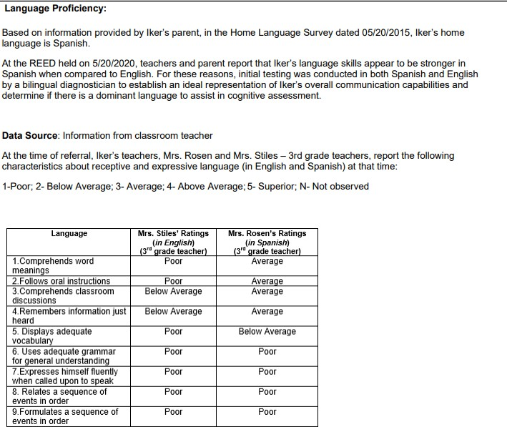

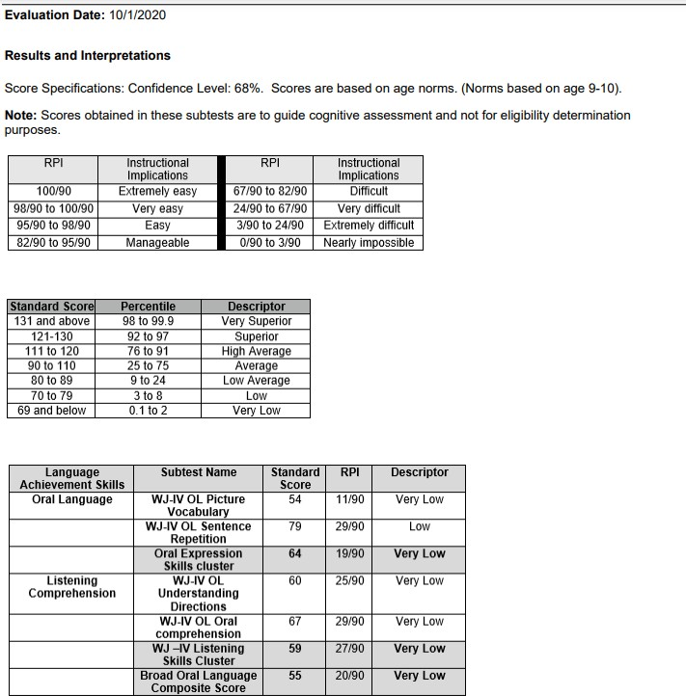

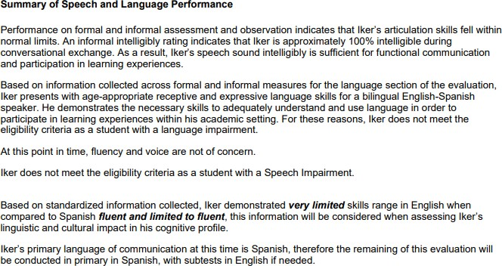

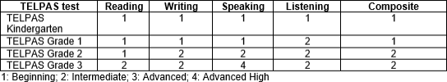

**Current Oral Language / Language Proficiency Assessment**

# Communicative Status

Iker's Home Language Survey indicates a language other than English is spoken in the home. Iker participated in GISD's dual language program at Carver Elementary since kindergarten, and reports communicating with his family at home in Spanish. Iker is identified as an Emergent Bilingual student, formerly known as limited english proficient (LEP); therefore, a language proficiency assessment was conducted in order to determine language dominance.

A student’s cognitive-academic language proficiency (CALP) score can predict how an emergent bilingual student will respond to the demands of instruction in a specific language. By understanding BICS and CALP, educators can better instruct their language learners.

The Woodcock-Johnson IV Tests of Oral Language (WJIV OL) is used to calculate a student’s CALP proficiency. The WJIV OL consists of four subtests in English and three subtests in Spanish. The English cluster is made up of: Oral Language, Broad Oral Language, Listening Comprehension, and Oral Expression. The Spanish assessment consists of the following clusters: Lenguaje Oral, Amplio Lenguaje Oral, and Comprension Auditva. The summary below describes each section on this assessment.

The Oral Language/Lenguaje oral cluster is an aggregate measure of comprehension knowledge including lexical knowledge, listening ability, and verbal comprehension. The Oral Expression cluster is an aggregate measure of the student’s overall vocabulary and of the student’s auditory memory. The Listening Comprehension/Comprensión Auditiva cluster is an aggregate measure of listening ability and verbal comprehension. Broad Oral Language/ Amplio lenguaje oral is an aggregate measure of lexical knowledge, listening ability, verbal comprehension, syntactic knowledge, working memory, and auditory memory span.

The following chart interprets the WJIV OL’s CALP scores and descriptors *(from the WJIV Oral Language Examiner’s manual edited by Maher and Wendling, 2014)*:

|  |  |  |
| --- | --- | --- |
| **CALP Score** | **CALP Level** | **Instructional Implications** |
| 6 | Very Advanced | Extremely Easy |
| 5 | Advanced | Very Easy |
| 4-5 (4.5) | Fluent to Advanced | Easy |
| 4 | Fluent | Manageable |
| 3-4 (3.5) | Limited to Fluent | Difficult |
| 3 | Limited | Very Difficult |
| 2 | Very Limited | Extremely Difficult |
| 1 | Extremely Limited | Nearly Impossible |

Iker's results on the WJ IV OL Language Dominance testing results are listed below:

|  |  |  |  |
| --- | --- | --- | --- |
| **Cluster Name** | **Cluster Score** | **CALP Level** | **Descriptor** |
| Oral Language  *(English)* | 59 | 2 | Very Limited |
| Broad Oral Language  *(English)* | 60 | 3 | Limited |
| Oral Expression  *(English)* | 68 | 3 | Limited |
| Listening Comprehension  *(English)* | 65 | 3 | Limited |
|  |  |  |  |
| Lenguaje Oral  *(Spanish)* | 82 | 3 | Limited |
| Amplio Lenguaje Oral  *(Spanish)* | 73 | 3 | Limited |
| Comprensión Auditiva  *(Spanish)* | 65 | 3 | Limited |

# CALP SUMMARY

When compared with his peers, Iker demonstrates Limited proficiency in the English and Spanish clusters of Oral Language, Broad Oral Language, Oral Expression, and Listening Comprehension. This proficiency level indicates Iker's CALP is equal in English and Spanish. When provided instruction in either language, it is expected that Iker will find the language demands of the learning task ***very difficult***. Based on the above scores, information from teachers, parent, and other educational records, it has been determined that Iker's language proficiency is equal at this time. It should be noted that Iker's academic instruction at this time is in English. His assessments, therefore, will be offered in both languages, as per input from the student. The full and individual evaluation was conducted by a qualified English/Spanish speaking evaluator.

# Impact

Limited vocabulary may impact Iker's academic oral expression and listening comprehension, thereby limiting his understanding in all subject areas. ESL learning strategies are recommended.

# TELPAS / LPAC Information:

As part of Iker's English proficiency evaluation, his scores on the Texas English Language Proficiency Assessment System (TELPAS) were reviewed. This assessment measures English language proficiency of English language learners (ELLs) in four language domains: listening, speaking, reading, and writing. Student performance is reported in terms of four English language proficiency ratings: 1 - Beginning, 2- Intermediate, 3- Advanced, and 4 - Advanced High.

Iker's TELPAS assessments have been administered since kindergarten. Listed below are his scores for the past two years:

TELPAS Scores

|  |  |  |  |  |  |
| --- | --- | --- | --- | --- | --- |
| **Grade Level** | **Reading** | **Writing** | **Speaking** | **Listening** | **Composite** |
| Grade 5 | 2 | 2 | 4 | 3 | 3 |
| Grade 6 | 1 | 2 | 3 | 2 | 2 |

Iker's TELPAS scores indicate his composite score in 5th grade was higher than his composite score in 6th grade. His scores in 6th grade decreased one level in all areas except writing, which remained the same.

# Speech/Language/Communication

Iker's teachers provided Informal input on Iker's oral language skills, which include receptive and expressive language skills. The following teachers provided input on Iker's oral language skills in the classroom.

Jonathan Luther, ELAR teacher Kiersten Acevedo, math teacher Barbara Prisco, science teacher

Receptive language skills: Iker's teachers rated his ability to understand and comprehend spoken language that he hears or reads.

1=POOR 2=BELOW AVERAGE 3=AVERAGE 4=ABOVE AVERAGE 5=SUPERIOR N=NOT OBSERVED

|  |  |  |  |  |  |
| --- | --- | --- | --- | --- | --- |
| **Receptive Language Skills** | **1** | **2** | **3** | **4** | **5** |
| **Comprehends word meanings** |  | Acevedo | Prisco |  |  |
| **Follows oral instructions** |  | Acevedo | Prisco |  |  |
| **Comprehends classroom discussions** |  | Acevedo | Prisco |  |  |
| **Remembers information just heard** | Acevedo | Prisco |  |  |  |

# Expressive Language

Expressive language skills: Iker's teachers rated his ability to choose the right words to communicate a message effectively. They rated him as follows:

1=POOR 2=BELOW AVERAGE 3=AVERAGE 4=ABOVE AVERAGE 5=SUPERIOR N=NOT OBSERVED

|  |  |  |  |  |  |
| --- | --- | --- | --- | --- | --- |
| **Expressive Language Skills** | **1** | **2** | **3** | **4** | **5** |
| **Displays adequate vocabulary** | Acevedo |  | Prisco |  |  |
| **Uses adequate grammar for general understanding** | Acevedo |  | Prisco |  |  |
| **Expresses self fluently when called upon to speak** |  | Acevedo | Prisco |  |  |
| **Relates a sequence of events in order (telling a story)** | Acevedo | Prisco |  |  |  |
| **Organizes and relates ideas and factual information** | Acevedo |  | Prisco |  |  |

**Woodcock-Johnson IV Tests of Oral Language**

WJ IV Tests of Oral Language

Oral Language is a measure of Iker's language development and comprehension, including lexical (word knowledge) and listening ability. His results are listed below.

*WJIV OL (based on age 12)*

|  |  |  |  |  |
| --- | --- | --- | --- | --- |
| **WJIV Oral Language Tests** | | | | |
| **Cluster / Test** | **SS** | **Percentile** | **RPI** | **SS Classification** |
| **Oral Expression** | **68** | **2** | **26/90** | **Very Low** |
| Picture Vocabulary | 56 | 0.2 | 14/90 | Extremely Low |
| *Vocabulario sobre* |  |  |  |  |
| *dibujos* | 91 | 27 | 79/90 | Average |
| Sentence Repetition | 83 | 12 | 42/90 | Below Average |
| **Listening Comprehension** | **65** | **1** | **40/90** | **Very Low** |
| ***Comprensión auditiva*** | **65** | **1** | **40/90** | **Very Low** |
| Oral Comprehension  *Comprension oral* | 67  75 | 1  5 | 33/90  49/90 | Very Low  Low |
| Understanding Directions | 73 | 4 | 48/90 | Low |
| *Comprensión de indicaciones* | 65 | 1 | 32/90 | Very Low |

The Oral Expression cluster measured Iker's expressive English language competency, including lexical (word) knowledge and sentence repetition ability. This composite score consisted of Picture Vocabulary and Sentence Repetition. Iker obtained a composite score of 68, which is in the 2nd percentile (low range). Picture Vocabulary measured Iker's expressive vocabulary, requiring him to provide names of objects. Iker obtained a standard score of 56, which is in the 1st percentile (low range). On the Spanish version of this subtest, Vocabulario sobre dibujos, Iker obtained a score of 91, which is in the 27th percentile (average range). The Sentence Repetition subtest measured Iker's short- term memory span. Iker was required to remember and repeat sentences presented orally. Iker appeared focused with the initial tasks, but as the sentences increased in length, he began omitting words. Iker obtained a standard score of 83, which is in the 12th percentile (below average range).

The Listening Comprehension cluster measured Iker's receptive language competency, including listening ability, verbal comprehension, and verbal working memory capacity. Iker obtained a composite score of 65, which is in the 1st percentile (very low range). On the Spanish cluster of Comprension Auditiva, Iker demonstrated a similar ability, obtaining a score of 65. This cluster consisted of Oral Comprehension, and Understanding Directions. Understanding Directions measured Iker's verbal working memory. This test required Iker to listen to a sequence of instructions and then follow the directions by pointing to various objects in a picture. Iker obtained a standard score of 73, which is in the 4th percentile (low range). On the Spanish version of this subtest, Comprensión de indicaciones, Iker obtained a score of 65, which is in the 1st percentile (very low range). The Oral Comprehension subtest measured listening ability and language development. Iker was asked to listen to a short passage, and then provide the final missing word. Iker obtained a score of 67, which is in the 1st percentile (very low range). On the Spanish version of this subtest, Comprension Oral, Iker obtained a score of 75, which is in the 5th percentile (low range).

## Academic Oral Language Summary

As noted above, Iker's initial FIE dated 11-6-2020, noted deficits in his Oral Expression, and Listening Comprehension. At that time, Iker's language acquisition was cited as a possible factor in his Oral Expression scores being in the low range.

Iker's current standardized assessment scores of his Oral Language abilities, also place his Oral Expression and Listening Comprehension scores in the low range, in both languages.

Iker has expressed to his parents that he experiences difficulty understanding directions in his classes, and often has to

ask for a repeat of directions several times.

Iker's cognitive abilities relative to his Oral Expression and Listening Comprehension abilities will be explored.

**2B. PHYSICAL** (Vision, Hearing, Health, Motor Abilities)  Not applicable

**VISION**

**Results and interpretations:**

Iker passed his vision screening, on 9/29/2023. Iker wears eyeglasses.

**HEARING**

**Results and interpretations:**

Iker passed his vision screening, unaided, on 9/29/2023.

**HEALTH**

**Results and interpretations:**

School health information, provided by Lindsey Love RN, school nurse at Wagner Middle School, indicates Iker passed his vision and hearing screening on 9-29-2023. Iker is not currently reported to have a health or medical condition which impacts learning.

Child has a significant health history.  Yes  No

*If yes, explain:*

Child appears to have one or more health-related conditions, which directly affect their ability to profit from the educational process.

*If yes, explain:*

Yes No

**MOTOR ABILITIES**

**Results and interpretations:**

## Motor Skills

Gross motor skills are the ability to control and coordinate the large muscles of the body to produce large body movements, such as walking, running, jumping, or sitting. Iker demonstrated developmentally appropriate gross motor skills such as the ability to independently ambulate within the school environment, open and close doors, and transition independently from one location to another, in the school setting.

Fine motor skills are the ability to control and coordinate the small muscles in the hand to produce controlled, precise movements. Iker's parent and teachers do not report concerns in this area.

## Teacher Information:

1=POOR 2=BELOW AVERAGE 3=AVERAGE 4=ABOVE AVERAGE 5=SUPERIOR N=NOT OBSERVED

|  |  |  |  |  |  |
| --- | --- | --- | --- | --- | --- |
| **Fine/Gross motor functioning in the classroom** | **1** | **2** | **3** | **4** | **5** |
| Exhibits adequate gross motor coordination |  |  | Acevedo Prisco |  |  |
| Displays adequate or functional fine motor coordination (i.e. opening doors, cutting, buttoning, zipping, etc) |  |  | Acevedo Prisco |  |  |
| Displays adequate fine motor skill related to handwriting |  |  | Acevedo Prisco |  |  |

Adapted physical education is recommended.  Yes  No

*If yes, explain:*

**2C. SOCIOLOGICAL**

**Results and interpretations:**

Iker's 11-6-2020 initial FIE reports the following:

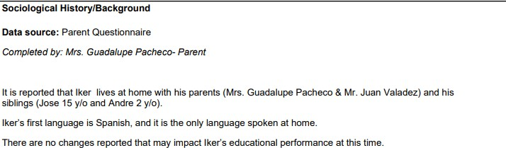

**Current Sociological Information Data Source**: Parent interview

According to a parent interview with Iker's mom, Mrs. Valadez, Iker lives at home with his biological parents and younger brother. His older brother is in college. Iker says he gets along very well with his younger brother. He enjoys eating out with his family, and in his free time, he likes playing chess. He says he’s learned many shortcuts that allow him to beat his opponent in four moves. Iker says some of his classmates have said that chess is for nerds. But he adds that he thinks his classmates don’t understand how to play it.

When asked which class he likes best this year, Iker responded that he wasn’t sure. He said that last year was very difficult for him academically, but he feels that this year is better. When asked how he felt about specific academic subjects, he said he didn’t know. He shared that he is very excited about the upcoming holidays and wants to spend time with his family.

Ms. Valadez says that she thinks Iker is doing better this year. She says that Iker likes to read at home, and while he can read in English and Spanish, Iker prefers to read in English. Ms. Valadez says that she is pleased Iker has retained his Spanish while learning English. Spanish continues to be the primary language spoken in the home. Ms. Valadez says that Iker tells her that Iker has commented to her that he sometimes needs to have his teacher explain things to him several times for him to understand. He sometimes does not understand what to do the first time around.

Ms. Valadez says that she is not aware of a history of learning disabilities within the family.

Cultural and/or lifestyle factors influence child's learning and behavioral patterns.  Yes  No

*If yes, explain:*

Iker is an emergent bilingual student. He participated in GISD's dual language program throughout elementary. A convergence of data indicates that Iker's language proficiency is almost equal in both languages, with oral expression being slightly strong in Spanish. While language acquisition may contribute to Iker difficulties, it is not the primary factor in his academic struggles.

Child's sociological status indicates a lack of previous educational opportunities in reading and/or math. Yes No

*If yes, explain:*

Iker's sociological status and educational opportunities do not appear to be factors in Iker's academic difficulties.

Excessive absences have influenced child's learning and behavioral patterns.  Yes  No

*If yes, explain:*

Iker's attendance does not appear to be a factor in his academic difficulties.

**2D. EMOTIONAL/BEHAVIORAL ** Not applicable

**Results and interpretations:**

**Iker's 11-6-2020 initial FIE reports the following**:

Behavior Assessment System for Children, Third Edition (BASC-3): Parent Rating Scale ±Child (PRS-C) Evaluator: Tanner, Mary Clare

Evaluation Date: 10/4/2020

The BASC-3 is a comprehensive set of rating scales designed to help you understand the behaviors and emotions of children and adolescents. The rating scales provide a comprehensive measure of a child's adaptive and problem behaviors in community and home settings.

The BASC was completed by Iker's teacher, Naomi Stiles, and mother, Guadalupe Pacheco.

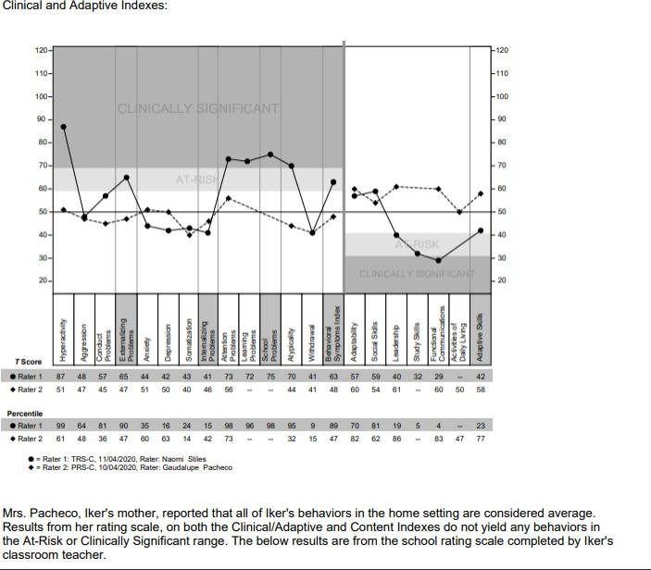

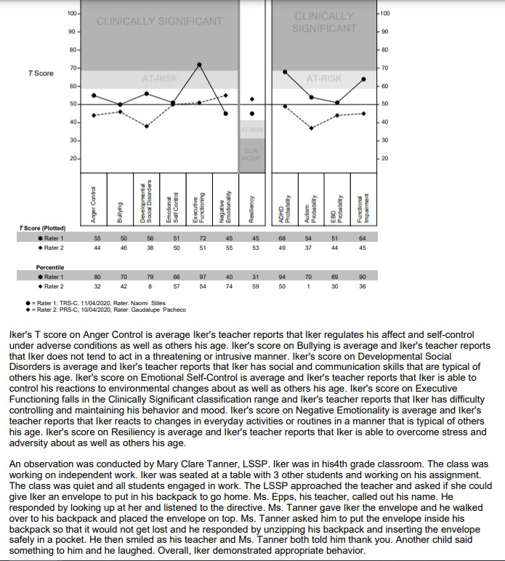

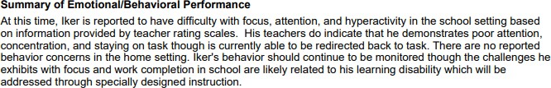

**Current Emotional/ Behavior Data**

## Parent Information

Iker's mother, Ms. Valadez, describes Iker as very well behaved. She reports that he loves spending time with his family. She describes him as thoughtful, and sympathetic to other’s feelings.

## Teacher Feedback

Emotional/behavioral competencies were reviewed for Iker's current evaluation. His teachers rated him in the average to above average range on all classroom behaviors listed below.

1= POOR 2=BELOW AVERAGE 3=AVERAGE 4=ABOVE AVERAGE 5= SUPERIOR N=NOT OBSERVED

|  |  |  |  |  |  |  |
| --- | --- | --- | --- | --- | --- | --- |
| **Emotional / Behavioral Skills** | 1 | 2 | 3 | 4 | 5 | N/A |
| **Social** |  | | | | | |
| Makes and keeps friends at school. |  |  | Acevedo Prisco |  |  |  |
| Works cooperatively with others. |  |  | Acevedo | Prisco |  |  |
| Enjoys socializing with peers |  |  | Acevedo | Prisco |  |  |
| Is respectful of peers and adults |  |  | Acevedo | Prisco |  |  |
| Likes to please adults |  |  | Acevedo | Prisco |  |  |
| **Informal Behavior Observations across school settings** |  | | | | | |
| Generally cooperates or complies with teacher requests. |  |  | Acevedo | Prisco |  |  |
| Adapts to new situations without getting upset. |  |  | Acevedo | Prisco |  |  |
| Accepts responsibility for their own actions. |  |  |  | Prisco |  |  |
| Has an even, usually happy, disposition |  |  | Acevedo | Prisco |  |  |
| Is pleased with good work |  |  | Acevedo | Prisco |  |  |
| Responds appropriately to praise and correction. |  |  | Acevedo | Prisco |  |  |
| Participates in classroom discussions | Acevedo |  |  | Prisco |  |  |

Iker's teachers rated additional behavior characteristics in the school setting. They indicated “Yes, “No,” or “Not Observed.” In the area of Executive Functioning, both teachers noted that Iker has difficulty starting tasks independently.

|  |  |  |  |
| --- | --- | --- | --- |
|  | **Yes** | **No** | **Not Observed** |
| **Sensory** |  |  |  |
| Under/over sensitive to noise |  | Acevedo | Prisco |
| Avoids being touched |  | Acevedo | Prisco |
| Avoids getting hands / self dirty |  | Acevedo | Prisco |
| **Executive Functioning** |  |  |  |
| Difficulty following directions | Acevedo | Prisco |  |
| Difficulty completing assignments | Acevedo | Prisco |  |
| Difficulty making transitions | Prisco | Acevedo |  |
| Interrupts and disrupts group activities |  | Acevedo | Prisco |
| Makes careless mistakes | Acevedo | Prisco |  |
| Student forgets homework assignments/materials | Acevedo | Prisco |  |
| Difficulty starting an assignments independently | Acevedo Prisco |  |  |
| Disorganized | Acevedo |  | Prisco |

## Additional Teacher Input

Ms. Acevedo notes math problem solving concerns. She notes Iker has difficulty remembering basic addition, subtraction, and multiplication facts, and sometimes confuses operational signs. She says Iker completes problems very slowly and has difficulty correcting his own errors. She notes that he guesses at answers instead of trying to solve problems. Specifically, Ms. Acevedo notes that Iker has difficulty completing one-digit and two or more digit multiplication. He also has difficulty with one step problems and multi-step problems.

Ms. Prisco, Iker’s science teacher says that Iker is a great communicator, who wants to do well, and is capable of learning information. She notes that Iker appears to have difficulty staying on task. She says Iker often is unable to tie what is learned into a class discussion. He begins talking about a topic far from the lecture topic. She adds that Iker may do exceptionally well one day, but need continuous reminders to stay on task the next day. This causes him to get quite behind at times. She says that Iker is in a large class and he is often caught daydreaming.

Ms. Shanks, Iker’s ESL teacher, reports that Iker has an abundance of knowledge and he enjoys telling her about all the things he knows about. He is especially interested in the weather. He has a hard time socializing and often shows repetitive behaviors. She adds that he sometimes withdraws from other students, has difficulty picking up on social cues, which results in awkward interactions with peers.

Ms. Shanks reports that when reading aloud, Iker appears to just skim the word and guess what it is based on the context of the sentence rather than actually reading it. She notes that this is evidenced by his oral reading where he often skips words or adds in other words that make the sentence make sense, but are not actually present on the page. (For example: if the sentence were *The boys went down the stairs after they heard the noise,* he might read it as *The boys went down the slide after they heard that the noise was there.*)

Mr. Ibarra, Iker's Spanish teacher, says that Iker is doing well in his class. He says he grasps the material and participates in class. However, Mr. Ibarra notes that Iker has difficulty completing tasks independently, and he often needs reminders. Mr. Ibarra says it has proved beneficial to pair Iker with classmates that can keep each other on task.

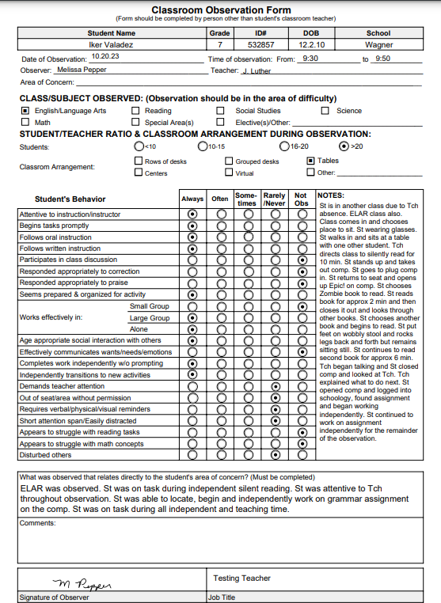

## Assessment Observations

Iker participated in his testing sessions willingly and appeared to put forth a strong effort on his standardized assessments. He appeared talkative and often brought the conversation around to history topics. He noted that some of his classmates are not nice to him, but that he has learned how to ignore them. He says he likes all his classes and hopes to someday work as a meteorologist. He says he would love to be a storm chaser and run a private business. Iker asked if the examiner could look up salary expectations for storm chasers. While there was little data on storm chasers, the examiner reviewed meteorologist salaries. Iker noted that if working as a meteorologist doesn’t work out, he would consider a career as a dentist.

Functional behavior assessment (FBA) results and interpretation:

Child's behavior impedes their learning. Yes No

Child's behavior impedes the learning of others. Yes No

*If yes to either question above, clarify problem behavior(s) that interfere with learning.*

**2E. COGNITIVE/INTELLECTUAL ** Not applicable

**Results and interpretations:**

Iker's 11-6-2020 initial FIE reports the following:

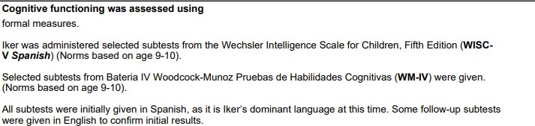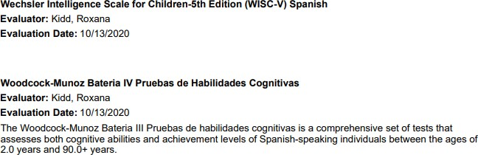

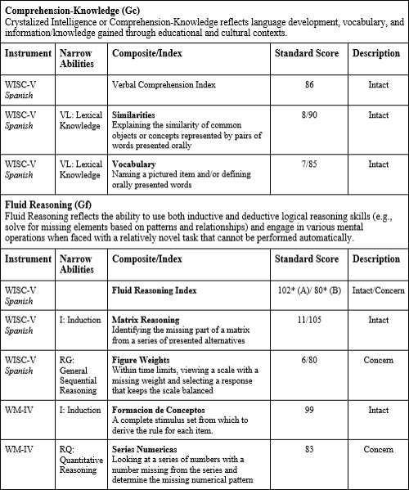

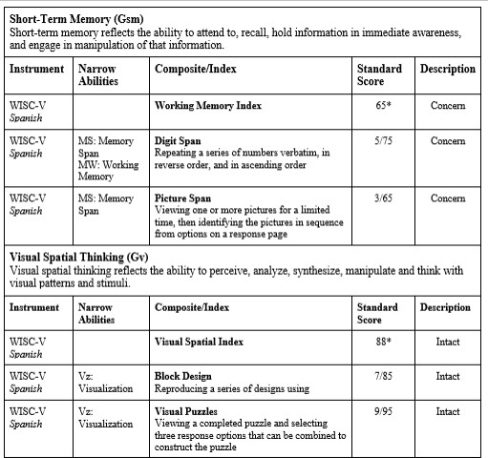

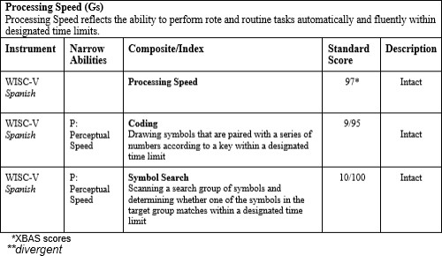

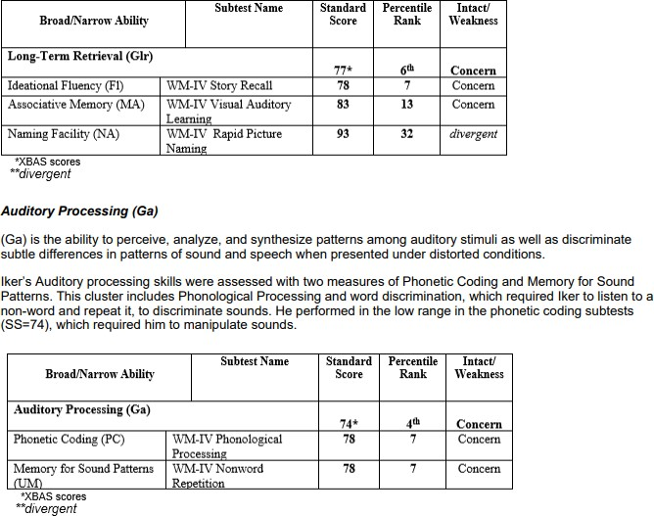

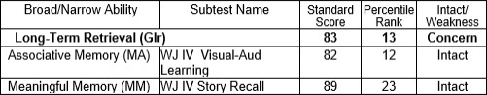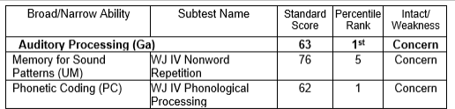

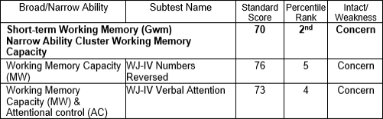

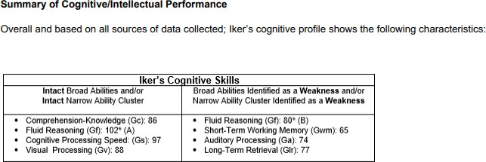

**Current Cognitive Evaluation**

## Current Cognitive Assessment

Diagnostician: Ruth Zane Date: 10-27-2023, 11-1-2023

Wechsler Intelligence Scale for Children – Fifth Edition (WISC-V) Comprehensive Test of Phonological Processing - Second Edition (CTOPP-2)

Test of Auditory Processing Skills, Third Edition, Spanish-Bilingual Edition (TAPS-3: SBE)

|  |  |  |  |  |
| --- | --- | --- | --- | --- |
| **Comprehension-Knowledge (Gc)**  Crystalized Intelligence or Comprehension-Knowledge reflects language development, vocabulary, and information/knowledge gained through educational and cultural contexts. | | | | |
| **Instrument** | **Narrow Abilities** | **Composite/Index** | **Standard Score** | **Description** |
| **WISC-V**  **Spanish** |  | **Verbal Comprehension Index Composite** | **98** | **Average** |
| WISC-V | VL: Lexical Knowledge | **Similarities**  This subtest measures logical thinking, verbal concept formation and verbal abstract reasoning. Explaining the similarity of common objects or concepts represented by pairs of words presented orally | 110 | High Average |
| WISC-V | VL: Lexical Knowledge | **Vocabulary**  This subtest measures the students' verbal fluency and concept formation, word knowledge, and word usage.  Naming a pictured item and/or defining orally presented words | 85 | 16 |

Comprehension-Knowledge is defined as the depth and breadth of knowledge and skills, including verbal communication and information. It represents a person’s acquired knowledge, general language development, an understanding of words, extent of vocabulary, and the ability to listen to and comprehend oral communication. The Similarities test required Iker to describe a similarity between two words that represent a common object or concept. At times, Iker translated the terms into Spanish, and then stated similarities between the terms. He obtained a score of 110, which is in the 75th percentile (high average range). The vocabulary subtest required Iker to define words that were read aloud to him. Iker appeared to have difficulty understanding the vocabulary word that was read aloud to him. For example, when he read the word “absorb,” Iker said he heard “observe.” Iker demonstrated a somewhat limited vocabulary, saying several times “I’ve never heard of that word.” He obtained a score of 85, which is in the 16th percentile (average range).

|  |  |  |  |  |
| --- | --- | --- | --- | --- |
| **Fluid Reasoning (Gf)**  Fluid Reasoning reflects the ability to use both inductive and deductive logical reasoning skills (e.g., solve for missing elements based on patterns and relationships) and engage in various mental operations when faced with a relatively novel task that cannot be performed automatically. | | | | |
| **Instrument** | **Narrow Abilities** | **Composite/Index** | **Standard Score** | **Description** |
| WISC-V |  | **Fluid Reasoning Index** | **91** | **Average** |
| WISC-V | I: Induction | **Matrix Reasoning**  This subtest measures visual processing and abstract, spatial perception. Identifying the missing part of a matrix from a series of presented alternatives | 110 | Above Average |
| WISC-V | RG: General Sequential Reasoning | **Figure Weights**  This subtest measures quantitative reasoning and induction. Within time limits, viewing a scale with a missing weight and selecting a response that keeps the scale balanced | 75 | Low |

Fluid reasoning is a measure of the ability to reason and solve problems that often involve unfamiliar information or procedures that cannot be performed automatically. It is often referred to as a problem-solving type of intelligence. Iker obtained a standard score of 91, which falls in the 45th percentile (average range). The Fluid Reasoning composite score was based on Iker's performance on the Matrix Reasoning and Figure Weights subtests. The first subtest in this cluster required Iker to view an incomplete matrix or series and select the response option that completed the matrix or series.

Iker obtained a score of 110, which is in the 75th percentile (above average range). On the Figure Weights subtest, Iker was asked to view scales with missing weights and select the response option that was best suited to keep the scales balanced. Iker appeared to experience difficulty with scales that required

mathematical reasoning skills, also known as the narrow cognitive ability of Quantitative Reasoning. Iker’s performance on his initial evaluation in 2020, also resulted in a split cognitive ability: a higher score on Matrix Reasoning: Inductive Reasoning, and a lower score on Figure Weights: Quantitative Reasoning.

|  |  |  |  |  |
| --- | --- | --- | --- | --- |
| **Short-Term Memory (Gsm)**  Short-term memory reflects the ability to attend to, recall, hold information in immediate awareness, and engage in manipulation of that information. | | | | |
| **Instrument** | **Narrow Abilities** | **Composite/Index** | **Standard Score** | **Description** |
| WISC-V |  | **Working Memory Index** | **97** | **Average** |
| WISC-V | MS: Memory Span,  MW:  Working Memory | **Digit Span**  This subtest measures verbal short-term memory with tasks that include: remembering a sequence of numbers, one at a time; repeating a series of numbers verbatim, in reverse order, and in ascending order. | 85 | Average |
| WISC-V | MS: Memory Span | **Picture Span**  This subtest measures visual working memory. The student views a stimulus page of one or more pictures for a specified time and then selects the picture(s) (in sequential order, if possible) from options on a response page. | 110 | High Average |

Short-Term Working Memory is the ability to encode, maintain, and manipulate visual and auditory information in immediate awareness. This composite consists of the Digit Span and Picture Span subtests. Iker obtained a score of 97, which is in the 9th percentile (average range).The Digit Span subtest required Iker to listen to a sequence of numbers read aloud and recall them in the same order, reverse order and ascending order. He obtained a score of 85, which is in the 16th percentile (low average range). The Picture Span subtest required Iker to memorize one or more pictures presented on a stimulus page and then identify the correct pictures (in sequential order, if possible) from options on a response page. Iker easily responded to the first several picture tasks but as the number of pictures increased, he recalled the correct pictures, but not in the correct order. He obtained a score of 110, which is in the 75th percentile (above average range).

|  |  |  |  |  |
| --- | --- | --- | --- | --- |
| **Processing Speed (Gs)**  Processing Speed reflects the ability to perform rote and routine tasks automatically and fluently within designated time limits. | | | | |
| **Instrument** | **Narrow Abilities** | **Composite/Index** | **Standard Score** | **Description** |
| WISC-V |  | **Processing Speed** | **103** | **Average** |
| WISC-V | P: Perceptual Speed | **Coding**  This subtest measures information processing speed and visual perception. Drawing symbols that are paired with a series of numbers according to a key within a designated time limit | 95 | Average |
| WISC-V | P: Perceptual Speed | **Symbol Search**  It measures information processing speed and visual perception. Scanning a search group of symbols and determining whether one of the symbols in the target group matches within a designated time limit | 110 | High Average |

The Processing Speed cluster on the WISC-V consists of the Coding and Symbol Search subtests. Iker obtained a composite score of 103, which is in the 58th percentile (average range). The Coding subtest measures visual motor dexterity and required Iker to copy symbols that corresponded to numbers. Iker appeared to carefully form the symbols with ease. He obtained a score of 95, which is in the 37th percentile. The Symbol Search subtest was timed, and required Iker to discriminate between visual stimuli by scanning a series of symbols and indicating whether the target symbol was present. Iker appeared to complete this task with ease. He obtained a score of 110, which is in the 75th percentile (above average range).

**Auditory Processing (Ga)**

Auditory processing is the ability to notice, compare, discriminate, and distinguish sounds. It reflects phonetic coding skills (e.g., blending, deletion, phoneme manipulation).H

|  |  |  |  |  |
| --- | --- | --- | --- | --- |
| **Instrument** | **Narrow Abilities** | **Composite/Index** | **Standard Score** | **Descriptor** |
| CTOPP-2 |  | **Auditory Processing (Ga)** | **58** | **Extremely Low** |
| Elison | PC:  Phonetic Coding | The Elision subtest requires the examinee to say a word after dropping designated sounds. | 75 | Low |
| Blending Words | PC:  Phonetic Coding | The Blending Words subtest asks examinees to combine sounds to create words. | 55 | Extremely Low |
| Phoneme Isolation | PC:  Phonetic Coding | The Phoneme Isolation subtest requires examinees to identify target sounds in words. | 70 | Low |

Auditory Processing is the ability to discriminate, encode, employ and synthesize auditory stimuli and is related to phonological awareness and sensitivity. The CTOPP-2’s Phonological Awareness Composite measures auditory processing with three subtests: Elision, Blending Words, and Phoneme Isolation. Iker obtained a composite score of 58, which is in the 0.2nd percentile (extremely low range). Elision measures the ability to remove phonological segments from spoken words to form other words. Iker appeared to experience difficulty identifying the beginning and middle sounds in words. Iker obtained a score of 75, which is in the 5th percentile (low range). Blending Words measures the ability to synthesize sounds to form words. Iker obtained a score of 55 on this subtest, which is in the <1st percentile (extremely low range). Phoneme Isolation is the ability to identify where a sound appears in a word. Iker appeared to experience difficulty identifying the middle and end sound of words. He obtained a score of 70, which is in the 2nd percentile (low range). Iker’s CTOPP-2 scores should be interpreted with caution, because Iker is a bilingual student who is still in the language acquisition phase.

|  |  |  |  |  |
| --- | --- | --- | --- | --- |
| **Auditory Processing (Ga)**  Auditory processing is the ability to notice, compare, discriminate, and distinguish sounds. It reflects phonetic coding skills (e.g., blending, deletion, phoneme manipulation). | | | | |
| **Instrument** | **Narrow Abilities** | **Composite/Index** | **Standard Score** | **Descriptor** |
| **TABS-3: SBE** |  | **Auditory Processing (Ga)** | **88** | **Below Average** |
| Word Discrimination | PC:  Phonetic Coding | The Word Discrimination subtest requires the student to listen to pairs of words spoken by the examiner, and is asked to discriminate between them. | 95 | Average |
| Phonological Segmentation | PC:  Phonetic Coding | The Phonological Segmentation subtest requires the student to correctly delete specific syllables or sounds from words. | 85 | Low Average |
| Phonological Blending | PC:  Phonetic Coding | The Phonological Blending subtest requires the student to listen to a series of phonemes and then blend these sounds into a word. | 85 | Low Average |

Iker also was administered the Test of Auditory Processing Skills, Third Edition, Spanish Bilingual Edition (TAPS-3: SBE). Iker participated in the GISD’s dual language program in grades K-5. His CALP scores in English and Spanish were similar. Given that Spanish is a transparent (one-to-one correspondence) language, Iker's Phonological Awareness cognitive ability was assessed with the TAPS-3: SBE.

Auditory Discrimination required Iker to listen to pairs of words spoken by the examiner, and was then asked to discriminate between them. The words in each pair are of equal length but differ on one phoneme (e.g., dog – log, compute – commute, eliminate - illuminate). Iker took a long time in responding to several of these tasks. He repeated the words to himself and then produced an answer. He was able to correctly discriminate most of the words presented, obtaining a standard score of 95, which is in the 37th percentile (average range).

Phonological Segmentation required Iker to correctly delete specific syllables or sounds from words. The examiner read aloud a target word, and asked Iker to repeat it, and then asked him to repeat it again while deleting one of the sounds. Iker removed beginning and ending sounds with ease. He appeared to experience difficulty removing middle sounds from words, and responded “I don’t know” to several tasks. He obtained a score of 85, which is in the 16th percentile (low average range).

The Phonological Blending subtest required Iker to listen to a series of phonemes and then blend these sounds into a word. Iker’s performance varied, even among the first few tasks, which consisted of short phonemes. For example for the phoneme a/s/i, Iker responded, “salir.” Iker obtained a standard score of 85, which is in the 16th percentile (average range).

|  |  |  |  |  |
| --- | --- | --- | --- | --- |
| **Long-Term Retrieval - Learning Efficiency (Gl)**  Long-term retrieval is the ability to store information in long-term memory and to retrieve it later fluently through association. | | | | |
| **Instrument** | **Narrow Abilities** | **Composite / Index** | **Standard Score** | **Descriptor** |
| WISC-V | MA: Associative Memory | Immediate Symbol Translation | 93 | Average |

Long-Term Retrieval-Learning Efficiency is the ability to learn, store, and consolidate information over a period of time. Immediate Symbol Translation measures associative memory, which is the ability to form a link between information that has already been learned and newly-presented information. Iker was presented with symbols, and told the meaning of each. He was presented with strings of symbols of varying lengths and complexities, and asked to recall the meanings. Iker at times appeared to experience difficulty waiting for the examiner to name each symbol. He attempted to jump ahead and guess the symbol. The directions were reread to Iker, and he was asked to follow them carefully. Iker obtained a score of 93, which is in the 32nd percentile (average range).

|  |  |  |  |  |
| --- | --- | --- | --- | --- |
| **Long-Term Retrieval - Retrieval Fluency (Gr)**  Rapid naming of objects, colors, digits, or letters requires efficient retrieval of phonological information from long-term memory. | | | | |
| **Instrument** | **Narrow Abilities** | **Composite/Index** | **Standard Score** | **Descriptor** |
| CTOPP-2 |  | **Rapid Symbolic Naming** | 76 | Low |
| CTOPP-2 | NA: Naming Ability | **Rapid Digit Naming**  It measures the ability to include efficient retrieval of information from long-term or permanent memory and name quickly and repeatedly letters | 80 | Below Average |
| CTOPP-2 | NA: Naming Ability | **Rapid Letter Naming**  It measures the ability to include efficient retrieval of information from long-term or permanent memory and name quickly and repeatedly letters | 80 | Below Average |

Long-Term Retrieval- Retrieval Fluency is the rate and fluency at which individuals can access information stored in long- term memory. This retrieval process is also used when retrieving pronunciations of words or parts of words when you read them. This composite is known as The Rapid Symbolic Naming Composite, consisting of the subtests Rapid Digit Naming and Rapid Letter Naming. Iker obtained a standard score of 76, which is in the 5th percentile (low range). For the Rapid Digit Naming, Iker was asked to read across rows of numbers, while making as few errors as possible. He obtained a score of 80, which is in the 9th percentile (below average range). For the Rapid Letter Naming, Iker was asked to read across rows of letters, while making as few errors as possible. He obtained a score of 80, which is in the 9th percentile (below average range).

|  |  |  |  |  |
| --- | --- | --- | --- | --- |
| **Visual Spatial Thinking (Gv)**  Visual spatial thinking reflects the ability to perceive, analyze, synthesize, manipulate and think with visual patterns and stimuli. | | | | |
| **Instrument** | **Narrow Abilities** | **Composite/Index** | **Standard Score** | **Descriptor** |
| WISC-V |  | **Visual Spatial Index** | **102** | **Average** |
| WISC-V | Vz: Visualization | **Block Design**  This subtest measures visual perception, perceptual organization, and attention to visual detail. Reproducing a series of designs using blocks by rearranging blocks that have various color patterns on different sides to match a pattern. | 100 | Average |
| WISC-V | Vz: Visualization | **Visual Puzzles**  This subtest measures nonverbal reasoning and the ability to analyze and synthesize abstract visual stimuli. Viewing a completed puzzle and selecting three response options that can be combined to construct the puzzle | 105 | Average |

The Gv cluster yields differential performance depending on task demands, and consists of the Block Design subtest, and Visual Puzzles. He obtained a composite score of 102, which is in the 55th percentile (average range). On the Block Design subtest, Iker was presented with a graphic presented on the iPad, and asked to recreate it with colored blocks.

Iker appeared persistent on these tasks, at times exceeding the allotted time, but determined to complete the task. He was successful in replicating the model, but he did not receive credit. Iker obtained a score of 100, which is in the 50th percentile (average range). The Visual Puzzles subtest required Iker to review a completed puzzle and select three response options that together would reconstruct the puzzle. Iker obtained a score of 105, which is in the 63rd percentile (average range).

Overall and based on all sources of data collected; Iker's cognitive profile shows the following strengths and weaknesses.

|  |  |
| --- | --- |
| **Iker's Cognitive Skills** | |
| **Strengths** | **Weaknesses** |
| **omprehension Knowledge** (Gc)  **hort-Term Memory** (Gwm)  **luid Reasoning** (Gf): (Induction)  **Processing Speed** (Gs)  **Long-Term Retrieval Learning Efficiency** (Gl)  **Visual Processing** (Gv) | **Fluid Reasoning:** RG (General Sequential Reasoning)  **Auditory Processing** (Ga): Phonetic Coding  **Long-Term Retrieval - Retrieval Fluency** (Gr) |

**2F. ADAPTIVE BEHAVIOR ** Not applicable

**Results and interpretations:**

Iker's 11-6-2020 initial FIE reports the following:

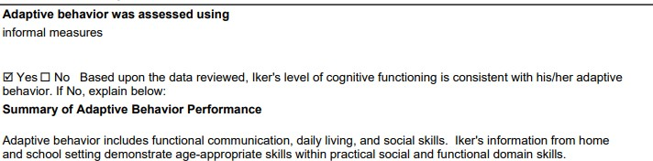

## 11-6-2023 Informal Adaptive Teacher Feedback

Iker's adaptive behavior was assessed using informal measures. Adaptive behavior refers to the degree to which a student is socially and personally independent. Iker's adaptive functioning was assessed informally through reports from parents, teachers, and observations of behavior during testing sessions. Iker's teachers rated additional behavior characteristics in the school setting. They indicated “Yes, “No,” or “Not Observed.”

|  |  |  |  |
| --- | --- | --- | --- |
| **Adaptive Behavior** | **Yes** | **No** | **Not Observed** |
| Concerns with eating lunch independently |  |  | Prisco Acevedo |
| Concerns with understanding social cues | Prisco Shanks |  |  |
| Concerns during Specials |  |  | Prisco Acevedo |
| Concerns navigating the school building independently |  | Acevedo | Prisco |
| Concerns with self-care (dressing, feeding, hygiene, etc) |  | Acevedo | Prisco |
| Follows school schedule without assistance | Acevedo |  | Prisco |

## Adaptive Behavior Summary

Parent input, teacher input, and behavior observations during testing indicate adaptive behavior concerns for Iker in one area: three of his teachers cited concerns with understanding social cues. Other than this concern, Iker appears able to negotiate social and environmental demands, which appears consistent with measures of his intellectual functioning.

**2G. ACADEMIC/DEVELOPMENTAL PERFORMANCE ** Not applicable

**Results and interpretations:**

**Iker's 11-6-2020 initial FIE's Standardized Academic Assessment reports the following**:

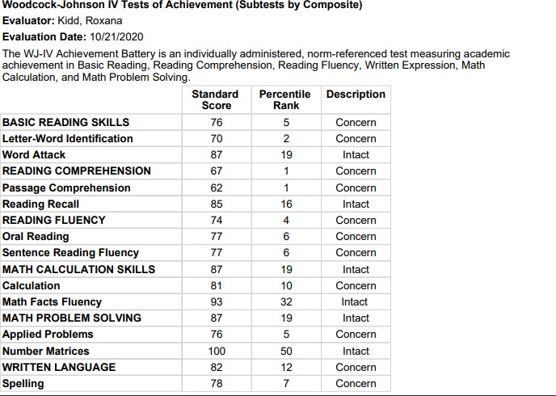

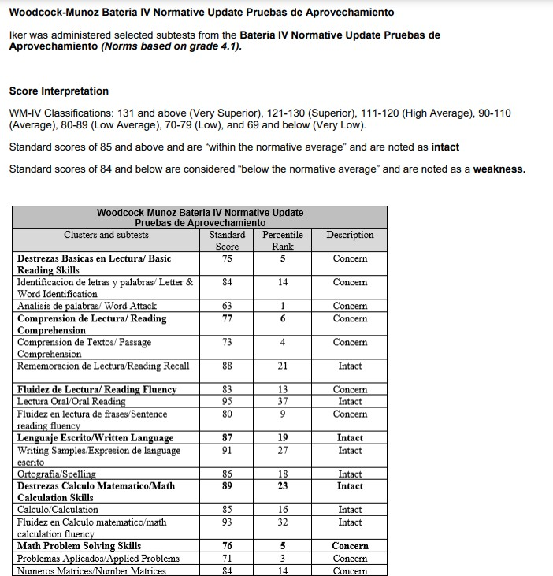

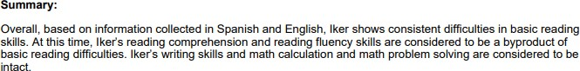

# READING, STAAR 6th Grade

Iker's most recent STAAR from May, 2023 indicates that he did not meet grade level expectations. He correctly answered 9 out of 56 questions, or 16%. The reading standards measured on his reading STAAR include: reading, understanding and analyzing a variety of written texts across reading genres; and Writing Revising and Editing: revise and edit a variety of texts from various genres. The graph below compares how Iker (blue bar) performed compared to his campus peers (black bar) and to that of his district peers (green bar).

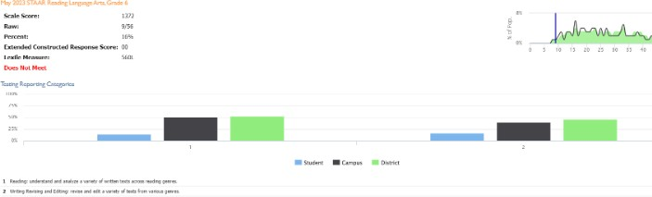

# MATH, STAAR Assessment, 6th Grade

Iker's 6th grade May, 2023 math STAAR indicates Iker did not meet grade level expectations. He correctly answered 12 out of 43 questions, or 28%. The standards assessed were: Numerical Representations and Relationships, Computations and Algebraic Relationships, Geometry and Measurement, Data Analysis and Personal Financial Literacy. Iker performed best on Data Analysis and Personal Financial Literacy. He appeared to need the most support in the area of Geometry and Measurement. The graph below shows Iker's performance (blue bar) compared to his campus peers (black bar), and district peers (green bar).

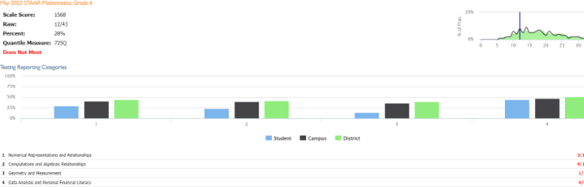

## NWEA Map Growth

Iker's Northwest Evaluation Association (NWEA) Measure of Academic Growth (MAP) performance tracks Iker's performance in math, and reading.

## Math

Iker's September 7, 2023 math Northwest Evaluation Association (NWEA) growth scores indicate that his growth rate is in the 27th percentile (below the mean), while his achievement rate is in the 12th percentile, also below the mean. Iker’s scores indicate low growth and low achievement. He scored highest on numerical representations and probability, and lowest on data analysis. The graph below tracks Iker's 2-year progress in this academic area.

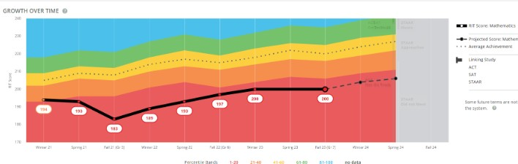

## Reading

Iker's September 13, 2023 Northwest Evaluation Association (NWEA) reading growth scores indicate that Iker's growth rate is in the 86th percentile, which is above the mean. His achievement rate is in the 12th percentile, which is below the mean. Iker’s highest score was in multiple genres, and his lowest score was in author’s purpose and craft. The graph below tracks Iker's 2-year progress in this academic area.

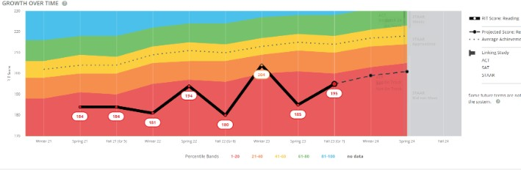

# Reading, Spanish

Iker's Spanish language reading assessment was administered April 7, 2022. His Spanish reading NWEA growth scores indicate that Iker's Spanish reading growth was in the 56th percentile, which is at the mean, and his Spanish reading achievement was in the 46th percentile, which is below the mean. Iker performed best on the author’s purpose and craft, and lowest on multiple genres. The graph below tracks Iker's progress in this academic area.

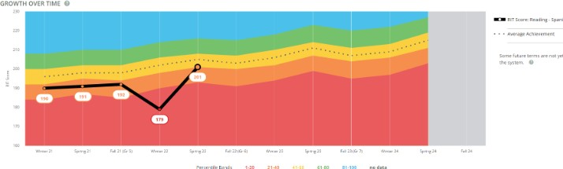

**Additional Classroom Data**

Ms. Jillian Shanks, Iker's ESL teacher, provided the following classroom data:

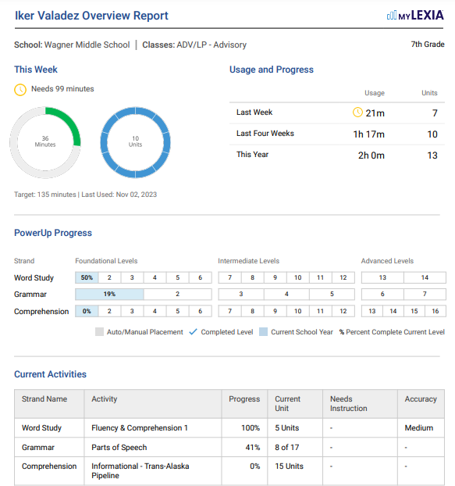

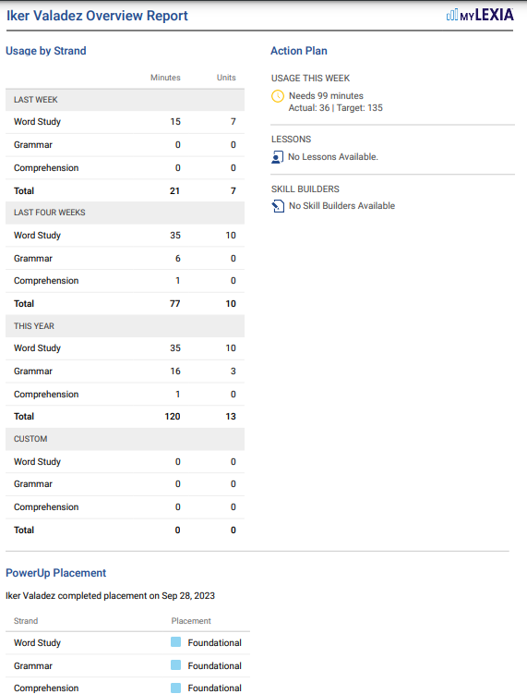

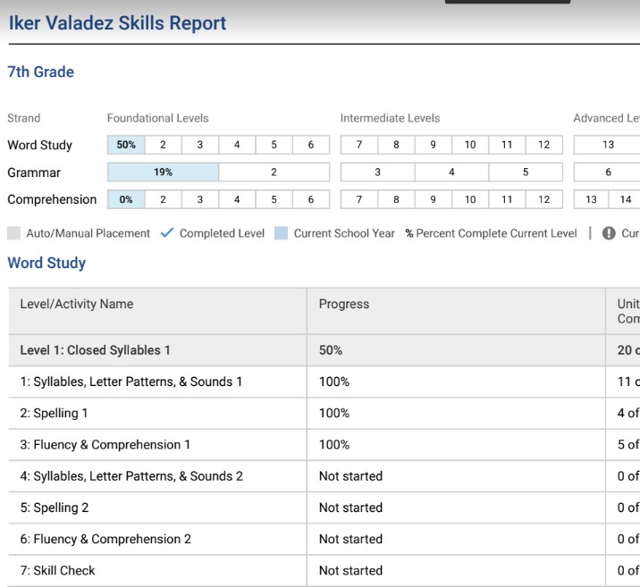

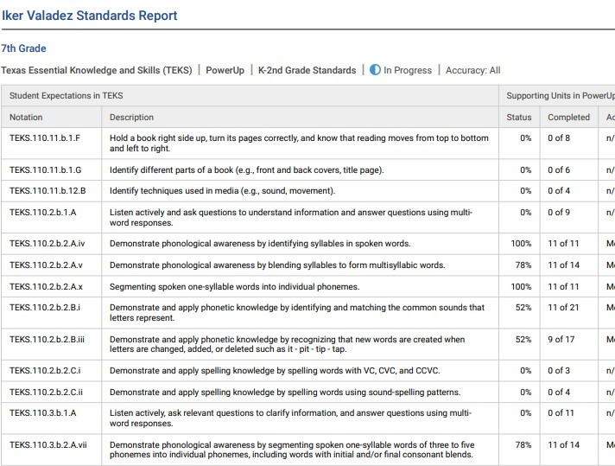

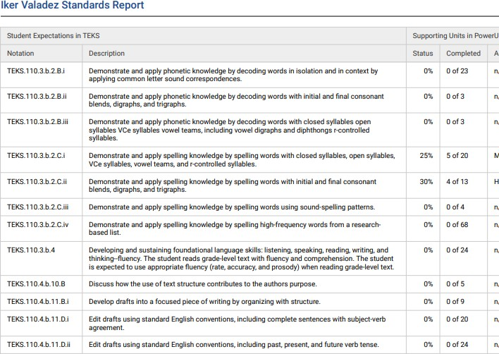

**Report Cards**

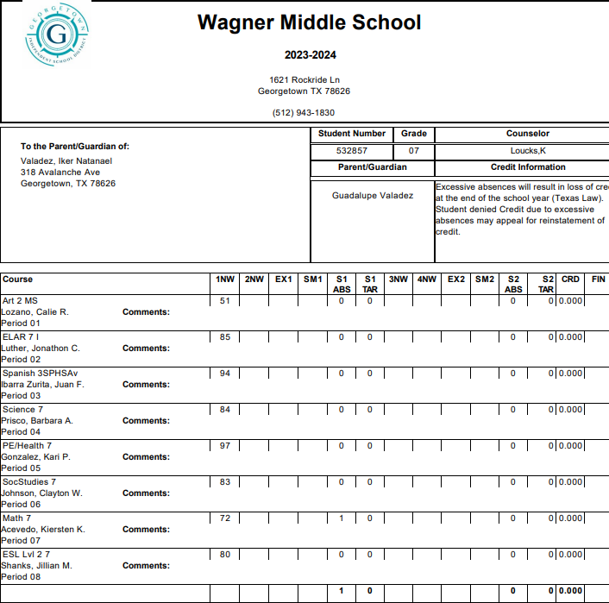

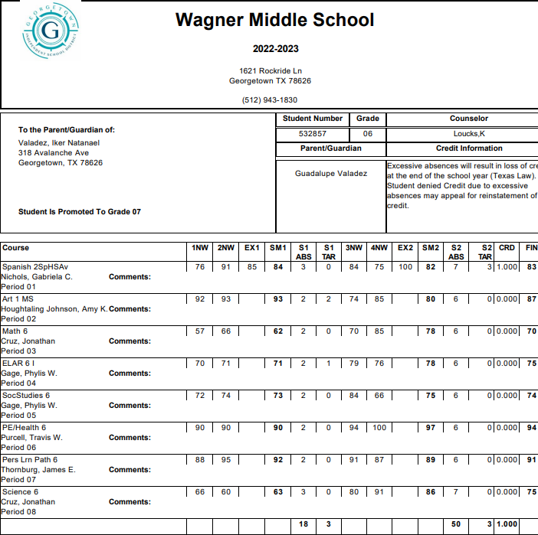

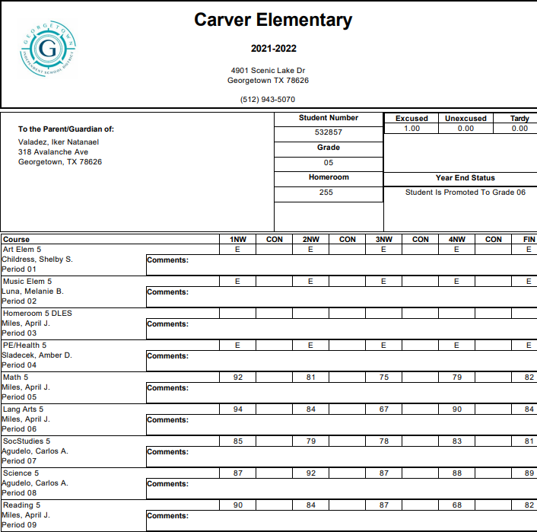

**Current Achievement Results**

**Wechsler Individual Achievement Test – Fourth Edition (WIAT-4) Administered by: Melissa Pepper, Testing Teacher**

**Evaluation Date: 10-20-2023**

Iker's achievement was evaluated using a standardized achievement test along with classroom-based data. The Wechsler Individual Achievement Test, 4th Edition (WIAT-4) is an individually administered test of academic achievement in the areas of reading, writing, and math. It includes basic skills, fluency, and application skills in all three areas. Iker obtained the following scores:

Wechsler Individual Achievement Test, 4th Edition *(Norms based on grade 7)*

|  |  |  |  |
| --- | --- | --- | --- |
| **Cluster/Test** | **SS** | **Proficiency** | **PR** |
| **DECODING** | **81** | **Below Average** | **10** |
| Pseudoword Decoding | 80 | Below Average | 9 |
| Word Reading | 84 | Below Average | 14 |
| **ORAL READING FLUENCY** | **82** | **Below Average** | **12** |
| **READING COMPREHENSION** | **69** | **Very Low** | **2** |
| **MATH CALCULATION SKILLS**  ***(Numerical Operations)*** | 77 | Low | 6 |
| Math Fluency | 87 | Low Average | 19 |
| **MATH PROBLEM SOLVING** | **71** | **Low** | **3** |
| **WRITTEN EXPRESSION** | **68** | **Very Low** | **2** |
| Sentence Building | 92 | Average | 30 |
| Sentence Combining | 70 | Low | 2 |
| Essay | 68 | Very Low | 2 |
| Spelling | 75 | Low | 5 |
| Dyslexia Index | 79 | Low | 8 |
| Word Reading | 84 | Below Average | 14 |
| Pseudoword Decoding | 80 | Below Average | 9 |
| Orthographic Fluency | 81 | Below Average | 10 |

*\*Mean = 100, SD = 15*

## Decoding (Basic Reading Skills)

The Decoding composite provides insight on basic reading skills. This composite consists of Word Reading and Pseudoword Decoding, which measure word vocabulary and the application of phonics. Iker obtained a composite score of 81, which falls in the 10th percentile (below average range). The Word Reading subtest required Iker to read aloud a list of words that increased in difficulty. He appeared to experience difficulty reading smoothly, as he decoded them. In another instance, Iker seemed to recognize only the beginning of a word. He obtained a score of 84, which is in the 14th percentile (below average range). Pseudoword Decoding required Iker to sound out nonsense words. He obtained a score of 80, which is in the 9th percentile (below average range).

## Reading Comprehension

The Reading Comprehension test measures aspects of reading fluency, as well as the ability to understand what is being read. On this subtest, Iker was asked to read a short passage silently and then respond to a series of questions that were asked orally. The story remains open, allowing the student to refer back to the text. Iker laid his head down on the desk and read silently. He appeared to read very quickly, saying he was done soon after he began. When asked the reading comprehension questions, Iker appeared to search for the answer in the text. Iker obtained a score of 69, which is in the 2nd percentile (very low range).

## Oral Reading Fluency

The Oral Reading Fluency test measures oral reading fluency kills across more than one passage. This subtest recorded the time elapsed in oral reading and evaluated fluency, prosody, automaticity, and accuracy. Iker read very quickly, misreading many words. Very little pacing and appropriate intonation made it difficult to understand Iker’s oral reading.

He obtained a score of 82, which is in the 12th percentile (below average range).

## Math Calculation Skills

Iker's math calculation skills were evaluated using the Numerical Operations subtest. This subtest measures written mathematics calculations skills under untimed conditions. Specifically, it measures addition, subtraction, multiplication, division, algebraic equations and geometric operations as well as higher level skills. Iker was asked to complete as much of the subtest as he could. Iker was able to complete single digit addition and subtraction, and grouping with addition and subtraction. He often counted on his fingers. Iker’s performance on single-digit multiplication varied - some of his responses were correct, and others incorrect. He attempted division, but did not arrive at a response. Iker obtained a score of 77 on Numerical Operations, which is in the 6th percentile (low range).

## Math Fluency

Iker also was administered the Math Fluency subtests, which consisted of timed exercises in addition, subtraction, and multiplication. While these subtests were not factored into his Math Calculation Skills composite score, these subtests measured Iker's ability to complete simple, single-digit math problems with automaticity. His composite score on the Math Fluency subtests was 87, which is in the 19th percentile. His detailed subtest scores are as follows: on the Math Fluency Addition subtest, Iker obtained a score of 94, which is in the 34th percentile (average range); on the Math Fluency Subtraction subtest, Iker obtained a score of 88, which is in the 21st percentile (low average range); on the Math Multiplication subtest, Iker obtained a score of 84, which is in the 14th percentile (below average range).

## Math Problem Solving

The Math Problem Solving subtest measures math problem-solving skills under untimed conditions. Iker was asked to listen to orally read math problems, look at the corresponding visual stimuli where applicable and then provide oral responses. Iker was offered scratch paper to work out problems whenever necessary. However, he said he would not need it. Iker was able to correctly respond to oral questions involving single-step word problems, and some number sequencing. He appeared to experience difficulty interpreting graphs, reading an analog clock, identifying place value, and working with fractions. As the math problems increased in difficulty, Iker was reminded he could use the scratch paper provided, but he said he liked to do them in his head. Iker obtained a score of 71, which is in the 3rd percentile (low range).

## Written Expression Sentence Composition

The Sentence Composition composite has two components: Sentence Building and Sentence Combining. Iker obtained a composite score of 78, which is in the 7th percentile (low range). The Sentence Building subtest required Iker to write sentences using a provided word in context. Iker obtained a score of 92, which is in the 30th percentile (average range). On the Sentence Combining subtest, Iker was asked to combine two and three sentences into one clear, succinct sentence. His performance on these tasks varied. His first sentence was missing key information. His second and third sentences were complete, and included all the ideas presented. However, they lacked punctuation. His writing was legible, with consistently small lettering, evenly written on the lines provided. Iker obtained a score of 70, which is in the 2nd percentile (low range).

## Essay

The essay subtest measured Iker's ability to respond to a presented prompt with a clear thesis and supporting details. This task had a minimum 30 word requirement. Iker appeared to experience difficulty generating ideas for the essay prompt. His essay contained a thesis and supporting details. However, it did not have any punctuation, which resulted in a run-on sentence. Iker obtained a score of 68, which is in the 2nd percentile (very low range).

## Spelling

The Spelling subtest required Iker to write words that were read aloud to him, and used in a sample sentence. Iker's performance varied - correctly spelling common sight words, but appearing to have difficulty with the order of letters. For example, Iker spelled ***night*** as “***nigth***.” Iker demonstrated a similar pattern while writing his essay. He wrote ***smart*** as “***sarmt***.” Iker obtained a score of 75, which is in the 5th percentile (low range).

## Dyslexia Index

The WIAT-4’s Dyslexia Index is comprised of the following three subtests: Word Reading, Pseudoword Decoding, and Orthographic Fluency. The first two subtests were described above. The third subtest, Orthographic Fluency, measured Iker's orthographic lexicon, or sight vocabulary. Iker read aloud a list of irregular words as quickly as possible during two timed trials. He obtained a score of 79, which is in the 8th percentile (low range).

**Standardized Achievement Test:** Bateria IV Woodcock-Munoz, Pruebas de Aprovechamiento Evaluator: Ruth Zane

Date: 11-6-2023

|  |  |  |  |
| --- | --- | --- | --- |
| Bateria IV Pruebas de Aprovechamiento | **Standard Score** | **PR** | **Descriptor** |
| Des Bas en Lectura | 76 | 5 | Low |
| Identificación de letras y palabras | 76 | 5 | Low |
| Análisis de palabras | 79 | 6 | Low |

Language proficiency assessments and parent feedback indicate that Iker has similar language proficiency in English and Spanish, and he enjoys reading books in Spanish.

## Basic Reading Skills, Spanish

Iker was administered the Bateria IV Pruebas de Aprovechamiento’s basic reading skills cluster, which is comprised of Identificación de letras y palabras; and Análisis de palabras.

Identificación de letras y palabras/Letter-Word Identification subtest measured Iker’s sight words recognition ability. He obtained a score of 76, which is in the low range. Iker demonstrated deficit skills in this subtest when asked to identify and read words in isolation. Iker read up to 3-syllable words fluently but showed difficulties when asked to read 4- and 5- syllable words fluently.

Analisis de palabras/ Word Attack subtest measured Iker decoding skills of non-words. He obtained a score of 79, which falls in the low range. Iker read the presented words quickly, sometimes making the words indiscernible.

## Additional Classroom Data

**Achievement Summary:**

A convergence of data indicates Iker has academic deficits in basic reading skills, reading fluency, reading comprehension, math calculation skills, and math problem solving. While he shows deficits in written expression, his performance on Sentence Combining was in the average range, and his difficulties in Sentence Building, and the Essay subtests appear related to his spelling difficulties. Additionally, Iker shows deficits in Oral Expression and Listening Comprehension in both English and Spanish.

Iker’s 11-6-2020 initial FIE indicated Iker met TEA eligibility criteria as a student with a specific learning disability in basic reading skills. A convergence of data in English and Spanish indicated that Iker demonstrated academic deficits in basic reading, with secondary academic deficits in reading comprehension, reading fluency, and written expression. Data from Iker’s initial FIE also cited deficits in Listening Comprehension in both English and Spanish. Oral Expression also showed deficits in English, but not Spanish. As noted earlier in this FIE, Iker participated in Carver Elementary’s dual language program. ESL strategies were recommended, as Iker continued language acquisition.

## Dyslexia Collaboration

Ms. Mary Tracy Smith, Provider of Dyslexia Instruction at Wagner reviewed Iker's current data, as well as his academic history, including his specialized instruction in the area of basic reading skills. Because Iker shows persistent deficits in his English and Spanish Auditory Processing assessments, as well as all academic areas, it has been recommended that Iker participate in direct dyslexia instruction.

|  |  |  |
| --- | --- | --- |
| Child is below grade level in reading.  *If yes, describe child's history of reading instruction:* | Yes | No |
| Multiple sources of data as presented above support that this student is working below grade level in reading. |  |  |
| Child is below grade level in math.  *If yes, describe child's history of math instruction:* | Yes | No |
| Multiple sources of data as presented above support that this student is working below grade level in math. |  |  |
| Child's low achievement is the result of limited English proficiency.  *If yes, describe:* | Yes | No |

While Iker is an emergent bilingual student, and shows limited proficiency in both English and Spanish, this is not the primary factor in his learning difficulties.

**2H. ASSISTIVE TECHNOLOGY ** Not applicable

**Results and interpretations:**

Iker's assistive technology needs were considered. Based on the evaluation data gathered in all areas of this Full and Individualized Evaluation, Iker would benefit from assistive technology in the area of spelling, and content language supports. For math, a calculator would benefit Iker, as needed. While assistive technology is recommended, it is an ARD committee decision.

Assistive technology devices and/or services are recommended.  Yes  No *If yes, child is not be able to participate in the educational program or make resonable progress toward mastery of IEP goals and objectives without assistive technology, devices and/or services.* Explain:

Please see above.

1. **SUMMARY OF ASSESSMENT RESULTS**

Iker is a 7th grade student at Wagner Middle School in Georgetown ISD. Iker previously met TEA criteria as a student with a specific learning disability in the area of basic reading skills. The purpose of this reevaluation is to obtain updated information on Iker's strengths and weaknesses for his educational programming, and to determine whether or not Iker continues to require special education services to enable him to progress academically.

Iker does not exhibit any health or sociological problems that would be the primary cause of his learning patterns. Iker began attending Wagner Middle School in 6th grade, and previously attended Carver Elementary. Academic records do not indicate excessive absences. Lack of educational opportunity is not a factor in Iker's learning difficulties.

## Language Proficiency

Iker is an emergent bilingual learner. His Home Language Survey indicates Spanish is spoken in the home. Iker participated in GISD's dual language program at Carver Elementary since kindergarten. Iker was administered a language proficiency assessment in order to determine language dominance. Iker's results indicate that his cognitive academic proficiency proficiency is equal in English and Spanish. However, Iker has been receiving academic instruction in English since 6th grade. Iker's language acquisition should be considered when interpreting his evaluation results.

## SLD Consideration

Iker's current cognitive assessments indicate a pattern of strengths and weaknesses. His cognitive strengths include: Comprehension Knowledge, Fluid Reasoning (Inductive Reasoning), Short-Term Working Memory, Processing Speed, Long-Term Retrieval - Learning Efficiency, and Visual Processing. His cognitive deficits include Fluid Reasoning (RG: General Sequential Reasoning), Auditory Processing, and Long-Term Retrieval - Retrieval Fluency. Iker's cognitive profile, which is comprised of strengths and weaknesses, indicates that Iker meets the eligibility criteria for a Specific Learning Disability 34 CFR, §300.8(c) (10).

A cognitive deficit in the area of Auditory Processing could make it difficult for Iker to discriminate auditory stimuli, which is important in the development of language skills. A deficit in this ability may cause a student difficulty in identifying, processing, and manipulating phonological units that compose spoken words of different complexity and size - thereby making decoding and reading difficult. A student with a cognitive deficit in the area of Long-Term Retrieval - Retrieval Fluency could experience difficulty retrieving phonological information from long-term memory. This could result in difficulty with reading fluency as well as completing timed math calculation operations. According to the Double Deficit Hypothesis, itt has been hypothesized that individuals who have double deficits – that is, deficits in both rapid naming and phonological awareness – appear to have greater difficulties learning to read than do individuals with deficits in either rapid naming or phonological awareness alone *(the Double-Deficit Hypothesis was developed by Maryanne Wolf and Patricia Bowers as an extension of the dominant phonological-deficit explanation of developmental dyslexia: Bowers & Wolf, 1993; Wolf & Bowers, 1999).*

When applying the pattern of strengths and weaknesses model, to find that the student meets the eligibility criteria for a Specific Learning Disability 34 CFR, §300.8(c) (10) , a determination must be made that: [1] The child exhibits a pattern of strengths and weaknesses in performance and/or achievement; [2] The pattern is relative to age, state-approved grade-level standards, or intellectual development; [3] The pattern is evident as indicated by significance variance among specific areas of cognitive functioning, between specific areas of cognitive functioning and academic achievement; and

[4] The pattern is relevant to the identification of an SLD using appropriate assessments. Iker meets TEA eligibility criteria in the academic areas of **basic reading skills (dyslexia), reading fluency, reading comprehension, math calculation skills, math problem solving, oral expression, and listening comprehension.**

***Final decisions regarding eligibility remain the responsibility of the ARD committee.***

## Dyslexia Consideration:

1. Is there a deficit in one or more of the primary characteristics of dyslexia (difficulty reading real words in isolation, difficulty decoding nonsense words, poor reading fluency, and poor spelling, including alphabet fluency, letter knowledge, and letter/sound correspondence)? **YES**

Iker’s performance on Word Reading, Decoding, and Orthographic Fluency are in the very low to low range.

1. Is there a deficit in phonological processing or orthographic competencies (the underlying cause of dyslexia)? **YES**

Iker’s cognitive abilities in the Phonological Awareness abilities in English are in the extremely low range. In Spanish, Iker’s Phonological Awareness is in the below average range.

1. Is there evidence of unexpectedness (the child’s reading and spelling difficulties are unexpected in relation to other cognitive abilities)? **YES**

Iker’s cognitive abilities in the areas of Comprehension Knowledge, Fluid Reasoning (Narrow ability: Inductive Reasoning), Short Term Working Memory, Processing Speed, Long-Term Retrieval - Learning Efficiency, Visual Processing are in the average range.

Specific learning disability does not include learning problems that are primarily the result of visual, hearing, or motor disabilities, of intellectual disability, of emotional disturbance, or of environmental, cultural, or economic disadvantage.

Given the data presented, Iker meets the criteria for the condition of dyslexia.

## Dysgraphia Consideration:

It must be determined if a student’s difficulties in the areas of writing and spelling reflect a pattern of evidence for the primary characteristics of dysgraphia with unexpectedly low performance in some or all of the following: handwriting, writing fluency, written expression, and spelling.

## Do the data show the following characteristics and consequences of dysgraphia? NO

Illegible and/or inefficient handwriting with variably shaped and poorly formed letters Difficulty with unedited written spelling

Low volume of written output as well as problems with other aspects of written expression Iker's handwriting ***is*** legible, with proper letter and word spacing, and appropriate capitalization.

## Do these difficulties (typically) result from a deficit in graphomotor function (hand movements used for writing) and/or storing and retrieving orthographic codes (letter forms)? NO

Iker's handwriting does not indicate difficulty with letter formation.

1. Are these difficulties unexpected for the student’s age in relation to the student’s other abilities and the provision of effective classroom instruction? **NO**

Iker's cognitive profile is in the average range, and consists of more strengths than weaknesses. His difficulties in written expression appear to be related to his difficulties with spelling and decoding.

1. Does the pattern indicate the student has dysgraphia? **NO**

Given the data presented, Iker ***does not*** meet the disability criteria for the condition of dysgraphia.

When considering the results of this evaluation and all contributing sources of data it is concluded that Iker ***does* meet** IDEA/TEA disability criteria as a student with a Specific Learning Disability in the areas of **basic reading skills (dyslexia), reading fluency, reading comprehension, math calculation skills, math problem solving, oral expression, and listening comprehension.**

*Based on multiple sources of data, Iker appears to meet the criteria for dyslexia as outlined in the 2021 Dyslexia Handbook and HB 3928 - Dyslexia Evaluation, Identification and Instruction (Source: Texas Legislature 88th Legislative Session - August 3, 2023).

## Additional Resources related to Dyslexia:

For a student identified with dyslexia or a related disorder, see the Dyslexia Handbook and Talking Book Program web pages or [https://www.spedtex.org](http://www.spedtex.org/) for more information.

HB 3928 - Dyslexia Evaluation, Identification and Instruction (Source: Texas Legislature 88th Legislative Session - August 3, 2023): Dyslexia is a specific learning disability (SLD). The bill created TEC §29.0031 that now states dyslexia is an example of and meets the definition of a SLD under IDEA. This is in conformity with IDEA’s federal regulations at 34

C.F.R. §300.8(c)(10), which specifically lists dyslexia as an example of an SLD. https://tea.texas.gov/about-tea/news-and-multimedia/correspondence/taa-letters/house-bill-hb-3928

1. **RECOMMENDATIONS TO THE ARD COMMITTEE**

The group of qualified professionals that determines whether the child is a child with a disability and the educational needs of the child is the child's Admission, Review and Dismissal (ARD) Committee.

**ELIGIBILITY**

1. Child meets the criteria for a specific disability condition.

*Complete applicable disability reports. If yes, check:*

* 1. Orthopedic Impairment
  2. Other Health Impairment
  3. Deaf/Hard of Hearing
  4. Visual Impairment
  5. Deaf-Blind
  6. Intellectual Disability
  7. Emotional Disturbance
  8. Specific Learning Disability. Area:

Yes No

Basic reading skills, reading fluency, reading comprehension, math calculation skills, math problem solving, oral expression, and listening comprehension.

* 1. Speech Impairment

(10) Autism

(13) Traumatic Brain Injury

(14) Noncategorical Early Childhood

1. By reason of the disability, the child needs special education and related services.

*If the child has one of the disabilities but only needs a related service and not special education, the child is not a child with a disability under the Individuals with Disabilities Education Act.*

Explain:

Yes No

Iker's cognitive deficits in Auditory Processing, and Long-Term Retrieval - Retrieval Fluency impede his progress in the general curriculum. Iker's cognitive deficits in these two cognitive abilities are known as double deficit dyslexia, and not only affect Iker's decoding (phonological abilities) but also his reading fluency. A convergence of data indicates Iker is unable to read grade-level material in all academic areas independently. As a result, Iker has difficulty reading content, directions,word problems, worksheets, and completing assignments in a timely manner.

Iker’s cognitive deficit in Long-Term Retrieval - Retrieval Fluency, and Fluid Reasoning (RG) also affect his math calculation skills.

His deficits in Oral Expression, and Listening Comprehension affect his ability to understand directions, and participate in classroom discussions in all academic areas. Iker requires specialized instruction to progress in his grade level curriculum.

**Child meets the eligibility criteria for special education** *(answer to both questions above must be Yes).* Yes No

*If no, recommendations:*

## All determinations pertaining to eligibility, educational planning/programming, and the educational need for special education supports or services to be provided and placements remain the responsibility of the ARD committee.

*If yes:*

Primary Disability: Secondary Disability: Tertiary Disability:



|  |  |  |
| --- | --- | --- |
| Child has dyslexia or related disorder. | Yes | No |
| Child has multiple disabilities. | Yes | No |
| Child is medically fragile. | Yes | No |

(08) Specific Learning Disability

Area of specific learning disability, if applicable:

Basic reading skills, reading fluency, reading comprehension, math calculation skills, math problem solving, oral expression, listening comprehension.

**IEP RECOMMENDATIONS**

Recommendations for the content of the child's IEP. Include information related to enabling the child to be involved in and progress in the general education curriculum, or, for preschool children, to participate in appropriate activities:

## Accommodations

Oral read all

Extra time to complete assignments Content & language supports Spelling assistance

Repeat instructions

## Instructional Strategies

Evidence-based instructional strategies are recommended for developing Iker's IEP. Given that Iker appears to have the condition of dyslexia, the instructional/intervention requirements of the Dyslexia Handbook must be considered by the ARDC.

Recommended Instructional strategies include:

Before introducing a new concept or skill, activate prior knowledge to enhance understanding. Prior knowledge can be activated by: 1.) asking questions about the topic being taught, 2.) sharing personal experiences related to the topic, 3.) brainstorming everything the student(s) knows about the topic, 4.) asking the student to identify what the student still needs to learn about the subject matter, 5.) asking the student to respond to opinion statements that prompt discussion regarding the topic (e.g., when discussing the defining characteristics of fruits and vegetables ask: What do you like best about spinach? About apples?, etc.).

Use a multi-method, multi-sensory approach to teach sight words. Teach individual sight words by reading the word to the student, having the student read the word back several times, having the student use the word in sentences, having the student trace over the written word while saying the sounds, and having the student write the word from memory while checking and correcting after each attempt. Provide immediate feedback/error correction. Assigning a peer tutor or parent volunteer might be necessary to accomplish this routine.

Provide opportunities for the student to preview passages from the basal reading program before the passages are read in class. In this procedure, the student listens to a peer tutor read a passage or reads along with a peer tutor. Use the repeated reading method to improve reading fluency. In this strategy a baseline reading rate of words correct per minute is established for a passage from the student=s basal reading text. The instructor assists the student to plot this information on a graph and set a goal. Across daily sessions the student re-reads the same passage orally and plots his reading fluency (i.e., words correct per minute) on the graph. Reinforcement is provided when the student reaches the reading fluency goal and the process begins again with a new passage. Goal setting and regular plotting of data by the student are important parts of this method.

Review rote information frequently. Expand time for rehearsal and practice by using peer tutors or teaching assistants to employ structured practice activities. Rehearsing information immediately after it is learned and intermittently thereafter will likely be helpful.

Strong phonemic awareness skills predict ease in reading development. As a result, it is important that steps be taken to develop and strengthen phonemic awareness skills including segmenting words into syllables, development of rhyming ability, blending phonemes into words and segmenting words into phonemes. In addition, the student should develop skills to manipulate phonemes in words including deleting, adding and substituting phonemes to make new words.

Ensure that Iker reads connected text every day to support reading rate, accuracy, and expression. Reading familiar books or passages will allow Iker’s skills to become more automatic, which assist him in freeing up his attention to connect ideas in the text to background knowledge and increase his reading comprehension.

Use manipulatives and concrete objects to teach math concepts (e.g., fractions, place value, subtraction, etc). This might also include having Iker drawing objects. Provide opportunities for Iker to not only observe but actually manipulate objects during instruction. Move from the concrete to the abstract making sure that comprehension is established before progressing to the next step.

Have Iker create or write story problems. It would be helpful for Iker to write problems that involve classroom materials so that with peers he might act out solving the story problem.

Provide adequate drill and practice so that math facts become automatic. During drill and practice activities, provide

immediate feedback/error correction.

To assist Iker in improving his oral expression, provide him quick opportunities to turn-and-talk to other students about what they have heard. Discussion themes provide topics for lengthier conversations that engage students in making connections and engage in critical thinking.

To help Iker improve his listening comprehension skills, provide opportunities for him to activate prior knowledge and build background knowledge. These listening skills exercises include questions to elicit what students know, as well as pictures of important people, places, or events from an audio story.

Specific recommendations for positive behavioral interventions and supports, and other strategies (required for a child who meets the criteria for autism or emotional disturbance):

**RELATED SERVICES**

**Results and interpretations:**

Does the child require a related service to benefit from special education? Yes No

|  |  |  |  |
| --- | --- | --- | --- |
| Related Service | Minutes | Frequency | Location |

1. **ASSURANCES**

**Initials**

Assessments and other evaluation materials used to assess the child were: RZ

Selected and administered so as not to be discriminatory on a racial or cultural basis;

Provided and administered in the child's native language or other mode of communication; and in the form most likely to yield accurate information on what the child knows and can do academically, developmentally, and functionally, unless it was not feasible to so provide or administer;

Used for the purposes for which the assessments or measures are valid and reliable; Administered by trained and knowledgeable personnel; and

Adminstered in accordance with any instructions provided by the producer of the assessments.

Assessments and other evaluation materials included those tailored to assess specific areas of educational need and RZ not merely those that are designed to provide a single general intelligence quotient.

Assessments were selected and administered so as to best ensure that if an assessment was administered to a child RZ with impaired sensory, manual, or speaking skills, the assessment results accurately reflect the child's aptitude or

achievement level or whatever other factors the test purports to measure, rather than reflecting the child's impaired sensory, manual, or speaking skills (unless those are the skills the test purports to measure).

The child was assessed in all areas of suspected disability, including, if appropriate, health, vision, hearing, social and RZ emotional status, general intelligence, academic performance, communicative status, and motor abilities.

The evaluation was sufficiently comprehensive to identify all of the child's special education and related services RZ needs, whether or not commonly linked to the disability category in which the child has been classified.

Assessment tools and strategies that provide relevant information that directly assists persons in determining the RZ educational needs of the child were provided.

Evaluation implemented assessment procedures that differentiate between language proficiency and disability. RZ

1. **SIGNATURES**

The names, titles and signatures below identify the members of the evaluation team and indicate whether or not each team member is in agreement with the conclusions of the report.

|  |  |  |  |  |
| --- | --- | --- | --- | --- |
| NAME | TITLE | SIGNATURE | DATE | AGREED |
| Ruth Zane | Educational Diagnostician |  | 11/06/2023 | Yes  No |
| Mary Tracy Smith | Provider of Dyslexia Instruction |  | 11/06/2023 | Yes  No |

**STATEMENT OF DISAGREEMENT**

If a team member is not in agreement with the team's determination, the team member may include a written statement of the basis of the disagreement.

**DISABILTY REPORT | SPECIFIC LEARNING DISABILITY**

*Specific learning disability* (SLD) is a disorder in one or more of the basic psychological processes involved in understanding or in using language that is spoken or written, that may manifest itself in the imperfect ability to listen, think, speak, read, write, spell, or to do mathematical calculations:

The term includes conditions such as perceptual disabilities, brain injury, minimal brain dysfunction, dyslexia, and developmental aphasia; and

The term does not include a learning problem that is primarily the result of visual, hearing, or motor disabilities, of an intellectual disability, or emotional disturbance, or of environmental, cultural, or economic disadvantage.

Child: Iker Valadez Student ID: 532857 DOB: 12/02/2010

**EVALUATION PROCEDURES**

*The group of qualified professionals that collected or reviewed evaluation data in connection with the determination of the child's eligibility based on an SLD included:*

* 1. The child's regular teacher; or if the child does not have a regular teacher, a regular classroom teacher qualified to teach children of this age; or for a child whose age is less than school age, an individual qualified by the Texas Education Agency to teach children of this age.
  2. At least one person qualified to conduct individual diagnostic examinations of children such as a licensed specialist in school psychology; a speech-language pathologist; or a remedial reading teacher.

 Yes  No

Yes No

*Observation:*

* 1. Child was observed in the child's learning environment, including the regular classroom setting, to document the child's academic performance and behavior in the areas of difficulty. For the child less than school age or out of school, a member of the group of qualified professionals observed the child in an environment appropriate for a child of that age.

*Explain or reference data or evidence:*

See Emotional/Behavioral section of the FIE.

Yes No

In determining whether the child has an SLD, the group of qualified professionals:

 Used information from an observation in routine classroom instruction and monitoring of the child's performance that was done before the child was referred for an evaluation

 Had at least one member of the group conduct an observation of the child's academic performance in the regular classroom after the child was referred for an evaluation and consent was obtained from the parent.

Relevant behavior, if any, noted during the observation of the child: See Emotional/Behavioral section of the FIE.

Relationship of that behavior to the child's academic functioning:

**ELIGIBILITY CRITERIA**

* 1. Child has been determined through a variety of assessment tools and strategies to meet the criteria for the SLD.  Yes  No

*Explain or reference data or evidence:*

Iker's current cognitive assessments indicate a pattern of strengths and weaknesses. His cognitive strengths include: Comprehension Knowledge, Fluid Reasoning (Inductive Reasoning), Short-Term Working Memory, Processing Speed, Long-Term Retrieval - Learning Efficiency, and Visual Processing. His cognitive deficits include Fluid Reasoning (RG: General Sequential Reasoning), Auditory Processing, and Long-Term Retrieval - Retrieval Fluency. Iker's cognitive profile, which is comprised of strengths and weaknesses, indicates that Iker meets the eligibility criteria for a Specific Learning Disability 34 CFR, §300.8(c) (10).

* 1. Child does not achieve adequately for the child's age or to meet state-approved grade-level standards, in one or more of the following areas.

*If yes, check:*

Yes No

 Oral expression  Written expression  Listening comprehension  Basic reading skills  Reading fluency skills  Reading comprehension  Mathematics calculation  Mathematics problem solving

*Explain or reference data or evidence:*

A convergence of data indicates Iker is below grade level in all academic areas.

* 1. Child's lack of adequate achievement is indicated by performance on multiple measures.  Yes  No

*If yes, check:*

 In-class tests  Grade average over time (e.g., six weeks, semester)  Norm or criterion-referenced tests  Statewide assessments  A process based on the child's response to evidence-based intervention

*Explain or reference data or evidence:*

The preponderance of data, including answers to #4, #5, and #8, indicate a lack of adequate achievement for Iker. Please see FIE for more information.

* 1. Child meets one of the following criteria.  Yes  No

*If yes, select:*

Child does not make sufficient progress under the additional criteria of the *RtI Model*



Child meets the additional criteria of the *Pattern of Strengths and Weaknesses Model*

**PATTERNS OF STRENGTHS AND WEAKNESSES MODEL**

**ADDITIONAL CRITERIA** *(answers to all questions below must be Yes)*

* + 1. Child exhibits a pattern of strengths and weaknesses in performance, achievement or both.  Yes  No

*Explain or reference data or evidence:*

When applying the pattern of strengths and weaknesses model, to find that the student meets the eligibility criteria for a Specific Learning Disability 34 CFR, §300.8(c) (10) , a determination must be made that: [1] The child exhibits a pattern of strengths and weaknesses in performance and/or achievement; [2] The pattern is relative to age, state-approved grade-level standards, or intellectual development; [3] The pattern is evident as indicated by significance variance among specific areas of cognitive functioning, between specific areas of cognitive functioning and academic achievement; and

[4] The pattern is relevant to the identification of an SLD using appropriate assessments. Iker meets TEA eligibility criteria in the academic areas of **basic reading skills (dyslexia), reading fluency, reading comprehension, math calculation skills, math problem solving, oral expression, and listening comprehension.**

* + 1. The pattern is relative to age, state-approved grade-level standards or intellectual development.  Yes  No

*Explain or reference data or evidence:*

A convergence of data relative to age and academic data indicates Iker demonstrates a pattern of strengths and weaknesses.

* + 1. The pattern is evident as indicated by significant variance among specific areas of cognitive function such as working memory and verbal comprehension or between specific areas of cognitive function and academic achievement.

*Explain or reference data or evidence:*

Yes No

Iker's current cognitive assessments indicate a pattern of strengths and weaknesses. His cognitive strengths include: Comprehension Knowledge, Fluid Reasoning (Inductive Reasoning), Short-Term Working Memory, Processing Speed, Long-Term Retrieval - Learning Efficiency, and Visual Processing. His cognitive deficits include Fluid Reasoning (RG: General Sequential Reasoning), Auditory Processing, and Long-Term Retrieval - Retrieval Fluency. Iker's cognitive profile, which is comprised of strengths and weaknesses, indicates that Iker meets the eligibility criteria for a Specific Learning Disability 34 CFR, §300.8(c) (10).

* + 1. The pattern is relevant to the identification of an SLD using appropriate assessments.  Yes  No

*Explain or reference data or evidence:*

Please see above.

* 1. Child has a disorder in one or more of the basic psychological processes involved in understanding or in using language that is spoken or written. Disorder may manifest itself in the imperfect ability to listen, think, speak, read, write, spell, or to do mathematical calculations. Includes conditions such as perceptual disabilities, brain injury, minimal brain dysfunction, dyslexia, and developmental aphasia.

*Explain or reference data or evidence:*

Yes No

## Dyslexia Consideration:

1. Is there a deficit in one or more of the primary characteristics of dyslexia (difficulty reading real words in isolation, difficulty decoding nonsense words, poor reading fluency, and poor spelling, including alphabet fluency, letter knowledge, and letter/sound correspondence)? **YES**

Iker’s performance on Word Reading, Decoding, and Orthographic Fluency are in the very low to low range.

1. Is there a deficit in phonological processing or orthographic competencies (the underlying cause of dyslexia)? **YES**

Iker’s cognitive abilities in the Phonological Awareness abilities in English are in the extremely low range. In Spanish, Iker’s Phonological Awareness is in the below average range.

1. Is there evidence of unexpectedness (the child’s reading and spelling difficulties are unexpected in relation to other cognitive abilities)? **YES**

Iker’s cognitive abilities in the areas of

Comprehension Knowledge, Fluid Reasoning (inductive reasoning), Short Term Working Memory, Processing Speed, Long-Term Retrieval - Learning Efficiency, and Visual Processing are in the average range.

Specific learning disability does not include learning problems that are primarily the result of visual, hearing, or motor disabilities, of intellectual disability, of emotional disturbance, or of environmental, cultural, or economic disadvantage.

Given the data presented, Iker meets the criteria for the condition of dyslexia.

## Dysgraphia Consideration:

It must be determined if a student’s difficulties in the areas of writing and spelling reflect a pattern of evidence for the primary characteristics of dysgraphia with unexpectedly low performance in some or all of the following: handwriting, writing fluency, written expression, and spelling.

* 1. Do the data show the following characteristics and consequences of dysgraphia? **NO**

Illegible and/or inefficient handwriting with variably shaped and poorly formed letters Difficulty with unedited written spelling

Low volume of written output as well as problems with other aspects of written expression Iker's handwriting ***is*** legible, with proper letter and word spacing, and appropriate capitalization.

1. Do these difficulties (typically) result from a deficit in graphomotor function (hand movements used for writing) and/or storing and retrieving orthographic codes (letter forms)? **NO**

Iker's handwriting does not indicate difficulty with letter formation.

1. Are these difficulties unexpected for the student’s age in relation to the student’s other abilities and the provision of effective classroom instruction? **YES**

Iker's cognitive profile is in the average range, and consists of more strengths than weaknesses. His difficulties in written expression appear to be related to his difficulties with spelling and decoding.

1. Does the pattern indicate the student has dysgraphia? **NO**

Given the data presented, Iker ***does not*** meet the disability criteria for the condition of dysgraphia.

When considering the results of this evaluation and all contributing sources of data it is concluded that Iker ***does* meet**

## IDEA/TEA disability criteria as a student with a Specific Learning Disability in the areas of basic reading skills (dyslexia), reading fluency, reading comprehension, math calculation skills, math problem solving, oral expression, and listening comprehension.

*Based on multiple sources of data, Iker appears to meet the criteria for dyslexia as outlined in the 2021 Dyslexia Handbook and HB 3928 - Dyslexia Evaluation, Identification and Instruction (Source: Texas Legislature 88th Legislative Session - August 3, 2023).

## Additional Resources related to Dyslexia:

For a student identified with dyslexia or a related disorder, see the Dyslexia Handbook and Talking Book Program web pages or [https://www.spedtex.org](http://www.spedtex.org/) for more information.

HB 3928 - Dyslexia Evaluation, Identification and Instruction (Source: Texas Legislature 88th Legislative Session - August 3, 2023): Dyslexia is a specific learning disability (SLD). The bill created TEC §29.0031 that now states dyslexia is an example of and meets the definition of a SLD under IDEA. This is in conformity with IDEA’s federal regulations at 34

C.F.R. §300.8(c)(10), which specifically lists dyslexia as an example of an SLD. https://tea.texas.gov/about-tea/news-and-multimedia/correspondence/taa-letters/house-bill-hb-3928

|  |  |  |
| --- | --- | --- |
| **EXCLUSIONARY FACTORS**  9. Visual, hearing or motor disability  *Effects on the child's achievement level:* |  | |
| This student does not exhibit visual, hearing, or motor disability deficits that affect him learning. |
| Child's lack of adequate performance is **NOT** primarily the result of a visual, hearing, or motor disabilty. | Yes | No |
| 10. Intellectual disability  *Effects on the child's achievement level:* |  |  |
| This student does not exhibit the characteristics of a student with an intellectual disability. |  |  |
| Child's lack of adequate performance is **NOT** primarily the result of an intellectual disability. | Yes | No |
| 11. Emotional disturbance  *Effects on the child's achievement level:* |  |  |
| This student does not exhibit emotional health concerns. |  |  |
| Child's lack of adequate performance is **NOT** primarily the result of emotional disturbance. | Yes | No |
| 12. Cultural factors  *Effects on the child's achievement level:* |  |  |
| See FIE. |  |  |
| Child's lack of adequate performance is **NOT** primarily the result of cultural factors. | Yes | No |
| 13. Environmental or economic disadvantage  *Effects on the child's achievement level:* |  |  |
| Environmental, and economic disadvantages do not contribute to this student's learning difficulties. |  |  |
| Child's lack of adequate performance is **NOT** primarily the result of environmental or economic disadvantage. | Yes | No |

1. Limited English proficiency

*Effects on the child's achievement level:*

Iker is an emergent Bilingual/English learner; however, his lack of adequate achievement does not appear to be the result of him Emergent Bilingual status.

Child's lack of adequate performance is **NOT** primarily the result of limited English proficiency. Yes No

**DETERMINANT FACTORS**

1. Child's underachievement is **NOT** due to a lack of appropriate instruction in reading or math.

*If yes:*

Data that demonstrates the child was provided appropriate instruction in reading and/or math in the general education settings delivered by qualified personnel.

See FIE.

Data-based documentation of repeated assessments of achievement at reasonable intervals, reflecting formal evaluation of progress of the child during instruction, which was provided to the parent of the child. *Data-based documentation of repeated assessments may include, but is not limited to response to intervention (RtI) progress monitoring results; in-class tests on grade-level curriculum; or other regularly administered assessments.*

*Intervals are considered reasonable if consistent with the assessment requirements of the child's specific instructional program.*

See FIE.

Yes  No

Yes  No

Yes No

|  |  |  |
| --- | --- | --- |
| **DISABILITY DETERMINATION**  16. Child meets the criteria for specific learning disability *(answers to all questions above must be Yes)*. | Yes | No |
| **ADDITIONAL DOCUMENTATION**  17. Educationally relevant medical findings, if any. |  |  |

*Each member of the group of qualified professionals must certify in writing whether the report reflects the member's conclusion. If the report does not reflect a group member's conclusion, that group member must submit a separate statement presenting the member's conclusion.*

|  |  |  |  |
| --- | --- | --- | --- |
| **POSITION** | **NAME** | **AGREED/SIGNATURE** | **DATE** |
| Educational Diagnostician | Ruth Zane | Yes No | 11/06/2023 |
| Provider of Dyslexia Instruction | Mary Tracy Smith | Yes No | 11/06/2023 |