## Full and Individual Evaluation Date of Report: 11/30/2023

**Name:** Allison M. Figueroa **Current Campus:** Meridian World School

**Student ID:** 002736 **Grade:** 09

**Gender:** Female **Date of Birth:** 12/27/2008 **| Age:** 14

**Parent/Guardian(s):** SILVIA ROBLES

## Multidisciplinary Team Members:

The multidisciplinary team that collects or reviews evaluation data in connection with the determination of a student's eligibility must include an appropriately certified or licensed practitioner with experience and training in the area of the disability, or a licensed or certified professional for the specific disability category. The following district staff members and the parent(s) are part of the multidisciplinary team that evaluated Allison:

Israelson, Rachel - Speech Language Pathologist Doan , Lesli - School Psychologist, LSSP

## Reason for Referral

Allison has been receiving special education services as a student with a Specific Learning Disability. The Independent Educational Evaluation completed 8/8/2023 was reviewed by the district and accepted. As a part of the IEE, the eligibility of Other Health Impairment was recommended. Parent would like this eligibility to be considered by the district; however, a comprehensive social-emotional examination related to this potential eligibility was not completed. The home setting ratings were obtained, but not school setting to examine impact of ADHD on educational placement or potential adverse educational impact. Thus, the district will complete the school setting portion of the social-emotional assessment to complete and examine this eligibility. In addition, the IEE for the communication portion indicated updated assessment completed by the school district.

In accordance with the Individuals with Disabilities Education Act (IDEA), which requires that the Individual Education Program (IEP) Team define the content of evaluation information needed to continue special education and/or related services every three years (300.533).

This report will serve to substantiate that the IEP Team reviewed previous evaluations and information provided by the parents, current classroom-based assessments and observations, and the observations of teachers and related service providers. Information gathered and/or evaluation results will be used to determine Allison's eligibility and need for special education services.

## Current Eligibility

Based on Allison's last IEP meeting, she meets specific eligibility criteria (has both a disability and educational need for special education services) based on the following conditions: Specific Learning Disabilities.

## Standard Measurement Procedures

Standard measures are used unless noted otherwise noted.

## Review of Existing Evaluation Data

Speech and Language:

## An outside Speech and Language Evaluation was completed by Austin's Communication Station on 11/3/21. According to the report, Allison presented with "moderate deficit" in receptive, expressive, and pragmatic language. According to this evaluation, "retesting for Receptive and Expressive Language by the school (or review of the testing completed during this IEE) is recommended to determine the extent that Allison's deficits in receptive and expressive language are impacting her during the school day."

**A re-evaluation of Allison's receptive, expressive, and pragmatic language is requested to determine her current abilities and determine eligibility for SPED with a speech impairment in the school environment.**

Previous testing at Meridian:

Full & Individual Evaluation (Meridian): 3/22/2017

The following information was reported: Comprehensive Assessment of Spoken Language

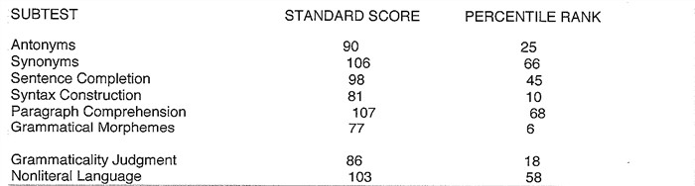





Full & Individual Evaluation (Meridian):1/10/2020

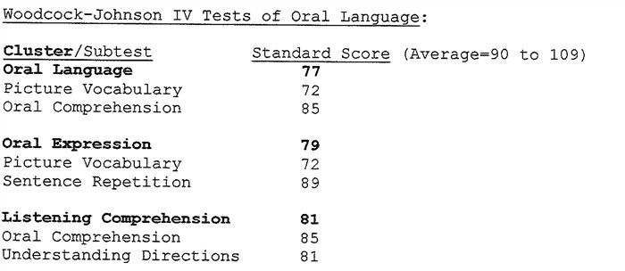

FIE Addendum: 2/3/2020

Oral and Written Language Scales-Second Edition

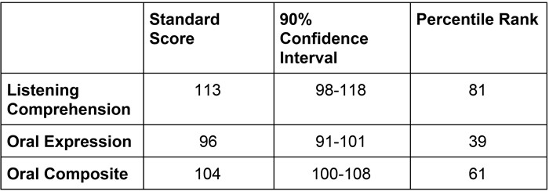

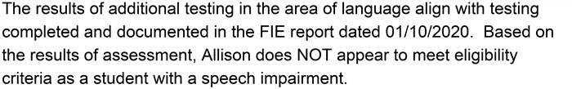

An Independent Educational Evaluation was requested in this area based off the 2020 assessment. Please refer to the IEE for specific information.

Physical:

According to the most recent review of records

Allison's mother was 48 years old at the time of her birth. She reported a typical pregnancy with no complications. Allison was born full term via vaginal delivery, and she weighed 2 pounds. She was admitted to the NICU, and Ms. Robles reported that Allison "would stop breathing and turn blue." Allison is currently followed by allergist, Dr.

Rosenblatt, pediatrician, Dr. Bacares, and neurologist, Dr. Kerr. She is currently reported to be in good health but has severe allergies as well as asthma.

Allison has been clinically diagnosed with Autism Spectrum Disorder, asthma, and attention deficit hyperactivity disorder.

Immunizations: Ms. Robles reported that Allison is not up to date on vaccinations due to her allergies. She commented that she is allergic to the vaccines that contain egg protein.

Allergies: eggs, wheat, all nuts, dairy, oats, avocado, all fish, all seafood

History of private services:

&bull; 2008 - 2019 - Speech therapy through Seton Reavis Rehabilitation &bull; 2008 - 2019 - Occupational therapy through Seton Reavis Rehabilitation

&bull; 2010 - 2019 - Applied Behavioral Analysis therapy through Center for Autism and Related Disorders

Occupational Therapy Evaluation (Pencils to Paper): 12/3/2019 Bruininks-Oseretsky Test of Motor Proficiency-Second Edition

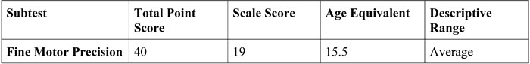

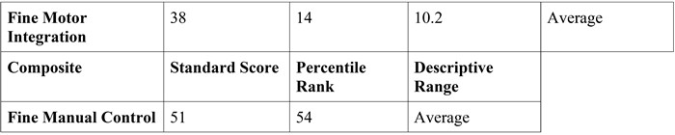

Test of Handwriting Skills-Revised

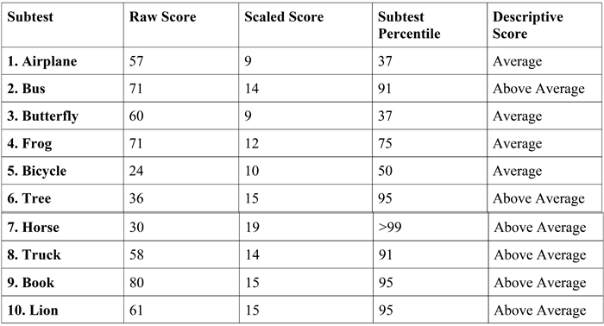

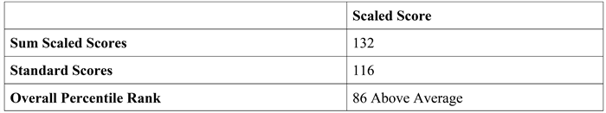

It was recommended that Allison be dismissed from Occupational Therapy.

An Independent Educational Evaluation was requested in the area of Occupational Therapy based off the previous assessment. Please refer to the IEE for specific information.

Sociological:

According to the most recent review of records:

Allison lives with her mother, Sylvia, and two brothers. She also has a sister who does not live in the home.

Educational History

A review of records indicates that Allison received ECI services prior to attending school and PPCD beginning in preschool in Round Rock ISD. She attended RRISD from preschool until the first grade. She then enrolled at Meridian World School for the second grade, where she has remained. Allison is currently in the eighth grade.

Emotional/Behavioral:

*Full & Individual Evaluation (Meridian): 3/22/2017*

It was noted during this evaluation that an Independent Educational Evaluation was completed while a student at Round Rock ISD, by the Johnson Center for Child Health and Development. The following was noted:

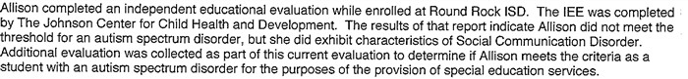

Meridian does not have a copy of this IEE.

The following information was reported for the 2017 FIE: Childhood Autism Rating Scale-Second Edition

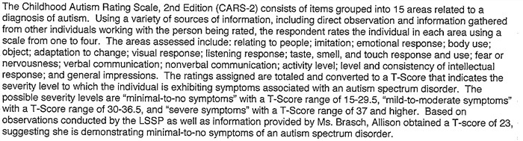

Social Responsiveness Scale-Second Edition

## Scales T

Social Awareness

54

Social Cognition 60

Social Communication 64

Social Motivation 72

Repetitive/ Restricted Behaviors 56

## Total Score 64

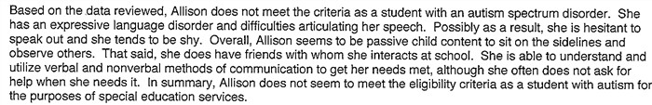

*Full & Individual Evaluation (Meridian):1/10/2020*

Behavior Assessment System for Children-Third Edition Teacher 1: All scales within typical range.

Teacher 2: All scales within typical range.

Parent

Clinically Significant scores:

Hyperactivity

Attention Problems Atypicality Withdrawal Adaptability

Social Skills

Functional Communication Activities of Daily Living

Autism Spectrum Rating Scales Teacher: All scales within typical range.

Parent

Clinically Significant scores:

Overall Total Social/Communication Index Unusual Behaviors Index Self-Regulation Index

Peer Socialization Social/Emotional Reciprocity Behavioral Rigidity

Sensory Sensitivity

Behavior Rating Inventory of Executive Function-Second Edition Teacher 1: All scales within typical range.

Teacher 2: All scales within typical range.

It was indicated that Allison did not meet eligibility criteria for autism at that time.

*Independent Educational Evaluation (Lassiter): 8/8/2023* **Comprehensive Executive Function Inventory** *Parent*

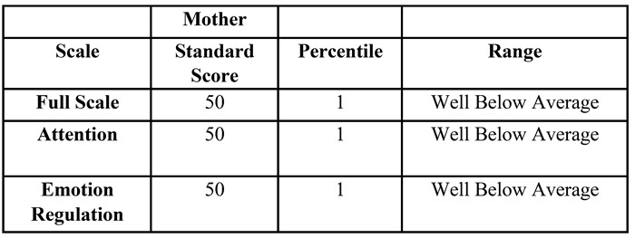

*Self-Report*

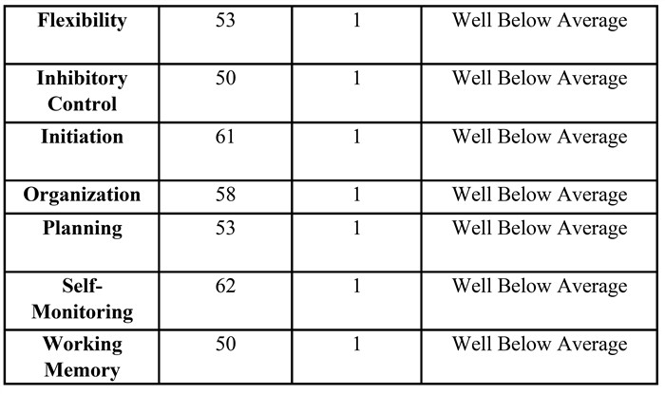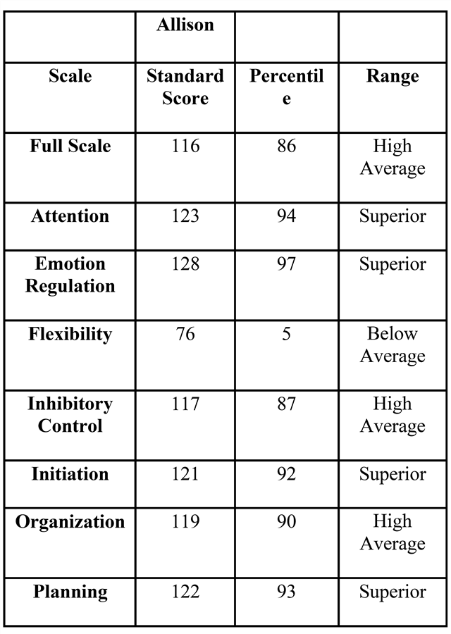

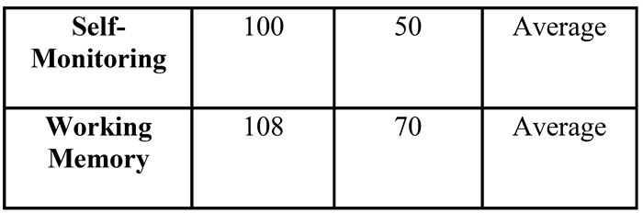

## Conners-Fourth Edition

*Parent*

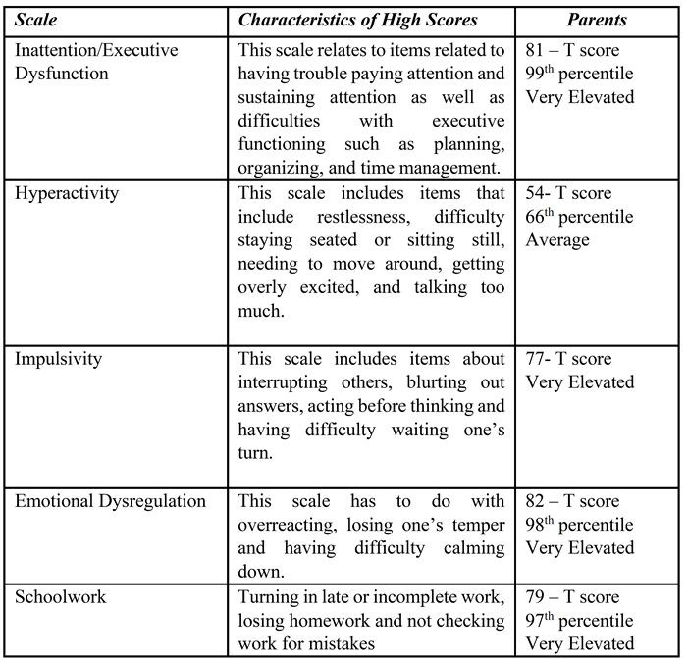

## Multidimensional Anxiety Scale for Children-Second Edition

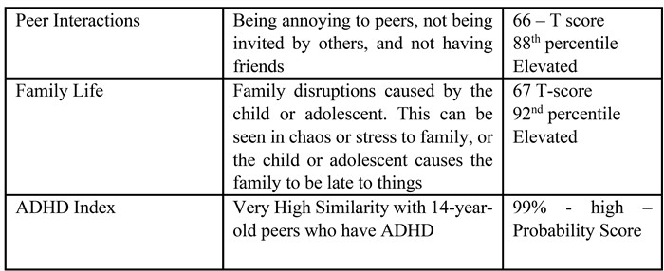

*Self-Report*

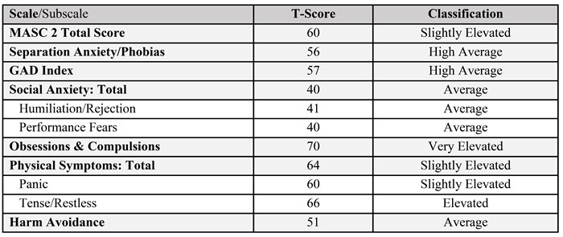

## Social Responsiveness Scale, Second Edition (SRS-2)

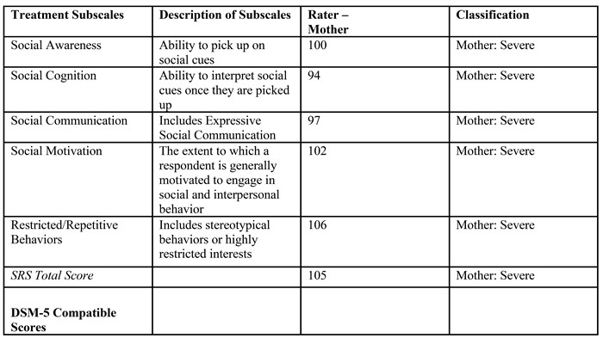

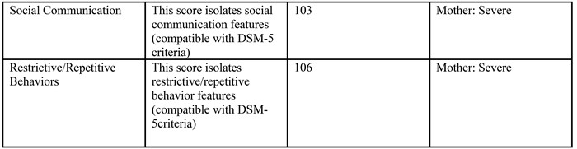

**Autism Spectrum Rating Scales**

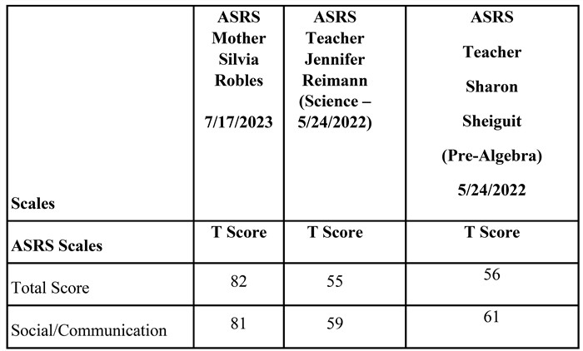

Cognitive/Intellectual:

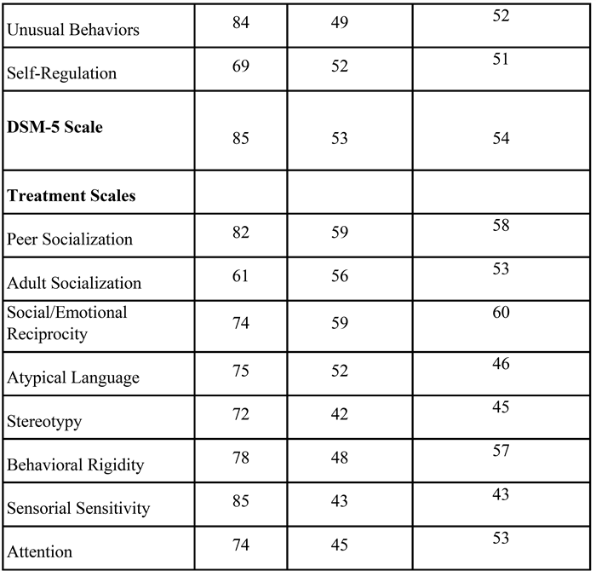

*Full & Individual Evaluation (Meridian): 3/22/2017*

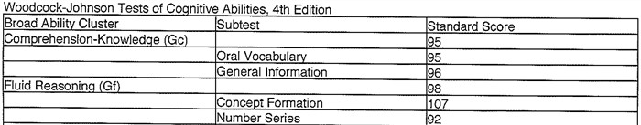

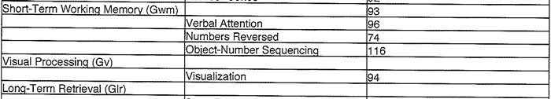

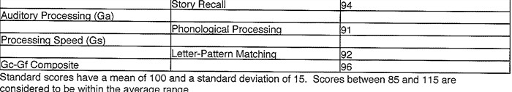

Bluebonnet Trails Community Services: 2/20/2018 Slosson Intelligence Scales IQ: 79

It was noted that this score was an understimation of cognitive ability since previous assessment (FIE 2017) demonstrated skills within the typical range.

*Full & Individual Evaluation (Meridian):1/10/2020*

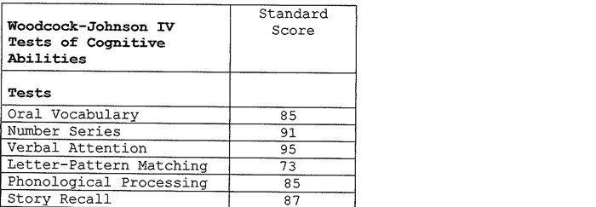

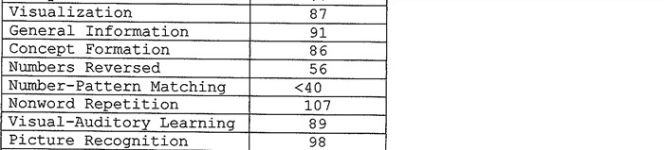

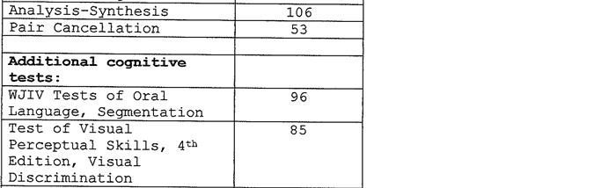

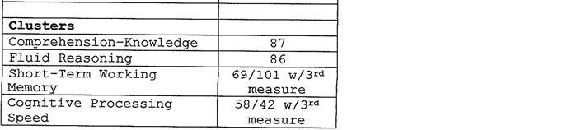

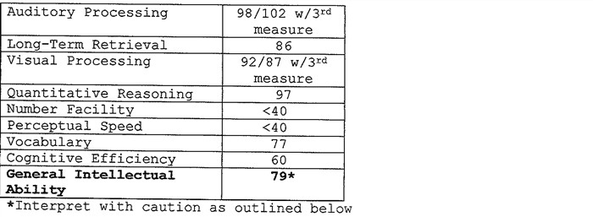

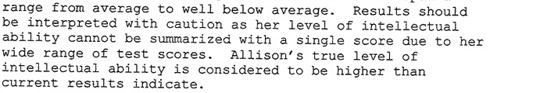

*Independent Educational Evaluation (Lassiter): 8/8/2023*

Wechsler Intelligence Scale for Children-Fifth Edition (WISC-V)

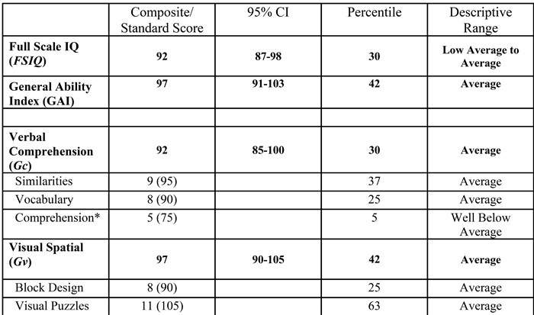

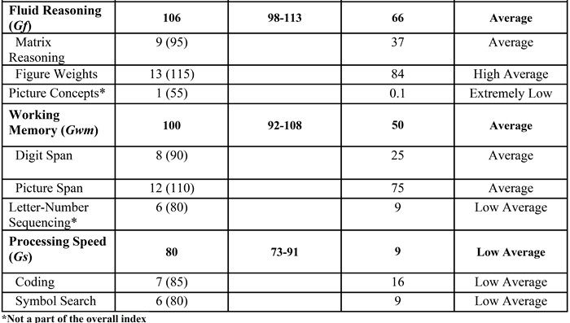

Adaptive Behavior:

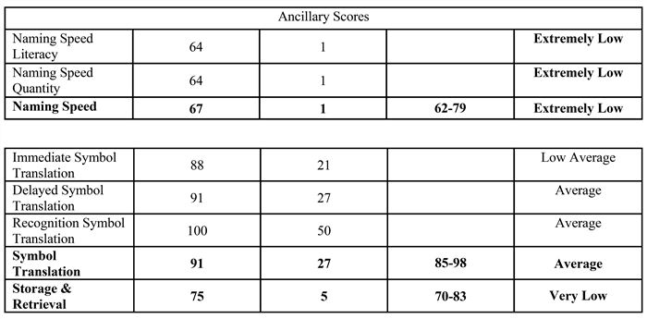

*Bluebonnet Trails Community Services: 2/20/2018*

Vineland Adaptive Behavior Scales-Third Edition Adaptive Behavior Composite: 52 (Low) Communication: 47 (Low)

Daily Living Skills: 47 (Low) Socialization: 44 (Low)

*Independent Educational Evaluation (Lassiter): 8/8/2023*

## Vineland Adaptive Behavior Scales-Third Edition

Educational/Developmental Performance:

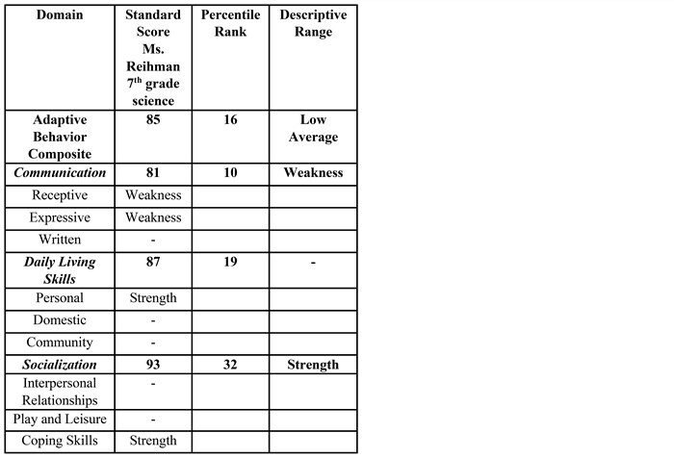

*Full & Individual Evaluation (Meridian): 3/22/2017*

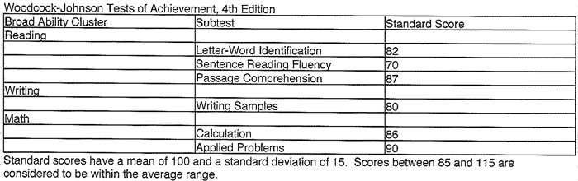

*Full & Individual Evaluation (Meridian):1/10/2020*

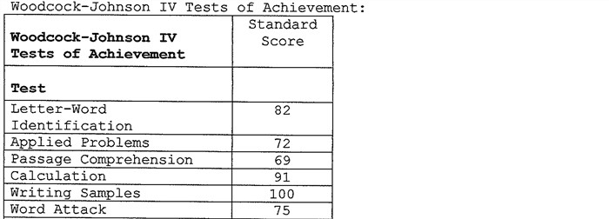

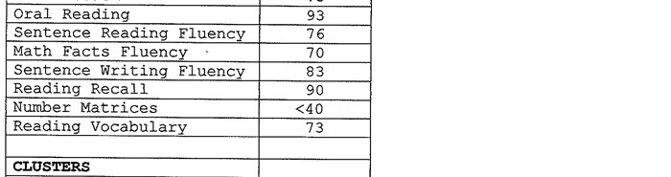

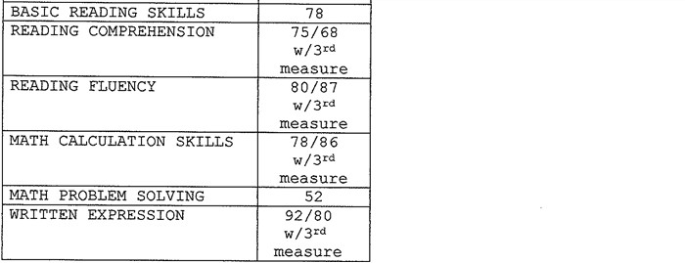

It was determined that Allison met criteria as a student with a Specific Learning Disability.

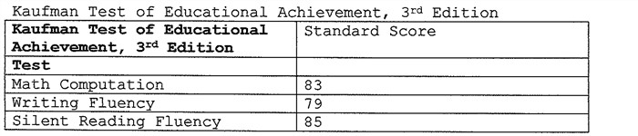

*Independent Educational Evaluation (Lassiter): 8/8/2023*

## Wechsler Individual Achievement Tests - Fourth Edition (WIAT-4)

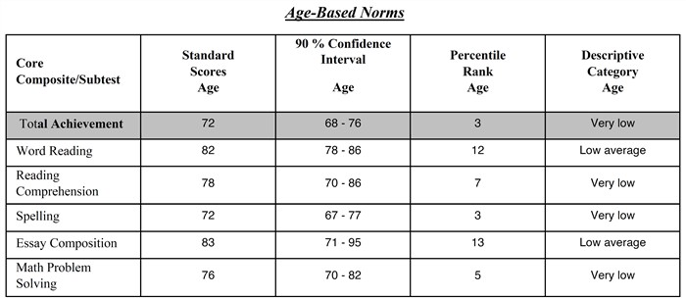

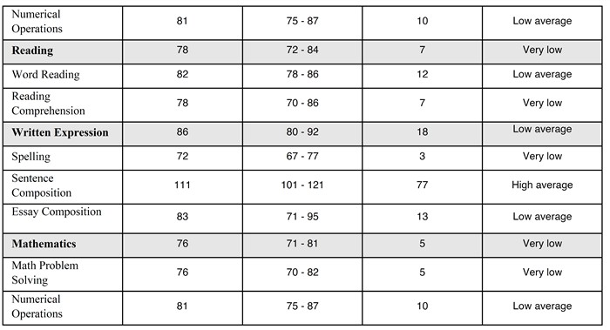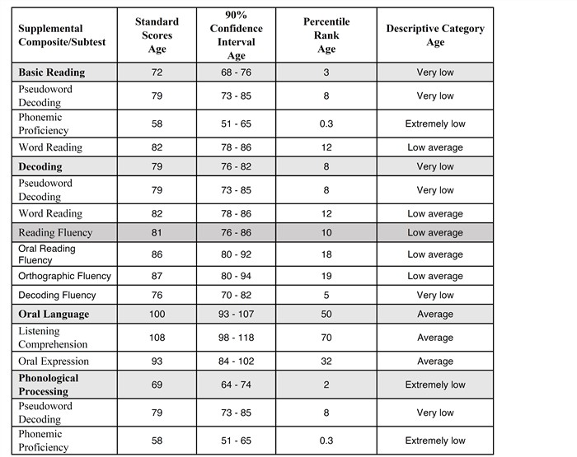

Assistive Technology:

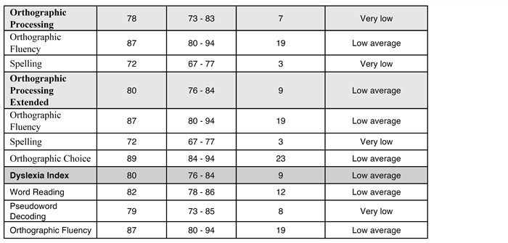

Based on a review of records, Allison does not require specially designed instruction within assistive technology in order to make adequate progress in the general education classroom at this time.

Vocational:

Vocational information are not available at this time, due to student age.

Additional Information:

The Independent Educational Evaluation completed 8/8/2023 was reviewed by the district and accepted. As a part of the IEE, the eligibility of Other Health Impairment was recommended. Parent would like this eligibility to be considered by the district; however, a comprehensive social-emotional examination related to this potential eligiblity was not completed. The home setting ratings were obtained, but not school setting to examine impact of ADHD on educational placement or potential adverse educational impact. Thus, the district will complete the school setting portion of the social-emotional assessment to complete and examine this eligibility.



## This evaluation includes the following sections:

☑ Speech and Language ☑ Emotional/Behavioral D Educational/Developmental Performance



D Physical D Cognitive/Intellectual D Assistive Technology

D Sociological D Adaptive Behavior D Present Levels of Academic Achievement and

Functional Performance



# SPEECH AND LANGUAGE

## Language Proficiency:

Allison's primary language is English. In English she showed average receptive and average expressive levels of proficiency. Allison expresses herself best orally. Based on the assessment of Allison's language abilities, the remainder of this Full and Individual Evaluation was conducted using English.

## Summary of Speech and Language Performance BACKGROUND:

Allison previously qualified for SPED services with a speech impairment at Meridian World School per her initial FIE dated 03/22/2017.

Allison presented with an expressive language disorder (syntax) and an articulation disorder. She was therefore eligible for special education services with a speech impairment and received direct speech therapy to address these deficits.

Results of progress reports and teacher feedback indicated she made great progress over the years with direct speech therapy. Upon re-evaluation on 01/10/2020, she was no longer eligible for SPED with a speech impairment. Her language and articulation skills, including narrative skills, were all well within normal limits.

Allison's mother contested the dismissal from speech. She stated the following concern regarding Allison's eligibility for SPED services with a speech impairment: "We would also like Allison to continue Speech Therapy but for her goals to change and adapt to match her age level. Targets that I think a speech therapist could help her with are the following: vocabulary, written expression, reading comprehension, improving her ability to express herself verbally." She requested an outside evaluation to assess Allison's abilities and needs. This evaluation was completed at Austin's Communication Station on 11/03/2021. Results of that report included the following with regards to speech and language:

According to parent report, data, and clinical observations, Allison presents with: Moderate deficit in Receptive Language

Moderate deficit in Expressive Language Moderate deficit in Pragmatic Language

Recommendations for the team to consider from the IEE:

Further testing recommendations:

Retesting for Receptive and Expressive Language by the school (or review of the testing completed during this IEE) is recommended to determine the extent that Allison's deficits in receptive and expressive language are impacting her during the school day.

The IEE was reviewed by the ARD committee on 09/07/2023 and a new evaluation was requested in the area of language and pragmatic communication at Meridian World School.

The evaluation was completed in the month of November, 2023, across multiple sessions per Allison's availability.

Tools utilized:

Standardized Testing: Comprehensive Assessment of Spoken Language, 2nd Edition Teacher feedback

Language sample and analysis

Review of evaluation data presented by Austin's Communication Station

# STANDARDIZED TESTING

Comprehensive Assessment of Spoken Language, 2nd Edition: The CASL-2 measures oral language processing skills of comprehension and expression across four structural categories:

Lexical/semantic: Knowledge and use of words and word combinations. Syntactic: Knowledge and use of grammar.

Supralinguistic: Knowledge and use of language in which meaning is not directly available from the surface lexical and syntactic information.

Pragmatic: Knowledge of language that is appropriate across different situational contexts and the ability to modify language according to a social situation.

Standard Scores: Scores are calculated by converting raw scores (correct responses) to standard scores with a mean of 100, and a standard deviation of 15 (i.e. scores between 85 and 115 are in the average range).

Standard scores enable comparison of an individuals' performance to the performance of typically developing individuals of the same age or grade, taking into account the variability of scores among those peers.

Confidence Intervals: Additionally, like all test scores, the CASL-2 standard scores include a component of measurement error. Measurement error consists of random, unpredictable variations in scores that are unrelated

to the ability being measured. Confidence intervals help discern the extent of this measurement error and should be taken into account when interpreting CASL-2 results. Each CASL-2 standard score is an estimate of the individual's true scores. A confidence interval is simply a range of standard scores that contain the hypothetical true score. A confidence interval has a probability level that specifies the degree of certainty that the interval includes the individual's true score (that is, the scores that would be obtained if measurement error did not exit). The 95% confidence interval is recommended because it is a more conservative estimate; the 95% confidence interval represents the range of standard scores has a 95% probability of containing an individual's true score.

Percentile Rank: A percentile rank is the percentage of same-age/same-grade individuals in the CASL-2 standardization sample who scored lower that the individual being tested. For example, if a student's standard score yields a percentile rank of 45, this means the student scored higher than 45% of the normative sample for his or her age on that subtest.

Subtests and Allison's scores:

Receptive Vocabulary

(Lexical/Semantic): Items are presented verbally with pictures; responses are given verbally or nonverbally to indicate the multiple-choice option. This test measures auditory comprehension of spoken words that refer to basic perceptual and conceptual relations. Poor performance on this test likely indicates a lack of specific word knowledge; the student has not mastered the underlying concept or perceptual relationship of the word.

Standard Score: 101

95% confidence interval: 92-110

Percentile: 53 Range: Average

Synonyms

(Lexical/Semantic): Items are presented verbally without pictures; responses are given verbally or nonverbally to indicate the multiple-choice option. This test measures recognition of words that have similar meanings. Poor performance on this test likely indicates lack of specific word knowledge for similar meanings; the student has not mastered understanding of all features of a word.

Standard Score: 101

95% confidence interval: 96-106

Percentile: 53 Range: Average

Expressive Vocabulary

(Lexical/Semantic): Twenty items are presented verbally with pictures, then 51 items are presented without pictures. Responses are given verbally (one word). This test measures word knowledge, retrieval, and oral expression of a word that best completes a sentence. Poor performance on this test likely indicates lack of specific word knowledge, or knowledge is imprecise. The student may have difficulty in retrieval even when given contextual information.

Standard Score: 101

95% confidence interval: 93-109

Percentile: 53 Range: Average

Sentence Expression

(Syntactic): Items are presented verbally with pictures; responses are given verbally as a word, phrase, or sentence(s). This test measures oral expression of accurate syntax; grammatical morphemes, sentence structure, and word order. Poor performance on this test likely indicates a lack of specific syntactic knowledge; the student hasn't acquired specific syntactic structures yet.

Standard Score: 101

95% confidence interval: 94-108

Percentile: 53 Range: Average

Grammatical Morphemes

(Syntactic): 34 items are presented verbally with pictures, followed by 32 items without pictures; responses are given verbally as a word or phrase. Poor performance on this test likely indicates lack of knowledge, retrieval, and oral expression of inflections and function words.

Standard Score: 87

95% confidence interval: 82-92

Percentile: 19 Range: Average

Sentence Comprehension

(Syntactic): 42 items are presented verbally with pictures, followed by 14 items without pictures. Responses are given verbally or nonverbally to indicate the multiple choice option. This test measures the recognition of the meaning of sentences that have similar structures and words. Poor performance on this test likely indicates a lack of syntactic knowledge for word order and sentence types; the student may not grasp the relation of sentence meaning when unfamiliar word combinations are used.

Standard Score: 100

95% confidence interval: 92-108

Percentile: 50 Range: Average

Nonliteral Language

(Supralinguistic): Items are presented verbally without pictures; responses are given verbally as a word, phrase, or sentence. This test measures one's understanding of the meaning of spoken sentences, independent of the literal interpretation of the surface structure. Poor performance on this test likely indicates a lack of understanding of indirect requests, figurative language, and sarcasm; the student lacks experience needed to suspend the literal meaning.

Standard Score: 114

95% confidence interval: 110-118

Percentile: 82 Range: Average

Meaning from Context

(Supralinguistic): Items are presented verbally without pictures; responses are given verbally as a word, phrase, or sentence. This test measures one's ability to recognize the meaning of an unknown word by using the linguistic context in which the word is presented. Poor performance on this test likely indicates a lack of lexical/semantic and/or syntactic knowledge of the context sentence, and/or lack of generalization skills needed to make inferences.

Standard Score: 95

95% confidence interval: 91-99

Percentile: 37 Range: Average

Inference

(Supralinguistic): Eighteen items are presented verbally with pictures, followed by 47 items without pictures. Responses are given verbally as a word, phrase, or sentence. This test measures one's expression of past experience or prior knowledge used to draw conclusions that are not explicitly provided in the given context. Poor performance on this test likely indicates a lack of knowledge from past experience, or difficulties in applying background knowledge to infer meaning.

Standard Score: 100

95% confidence interval: 96-104

Percentile: 50 Range: Average

Double Meaning

(Supralinguistic): Items are presented verbally with pictures, followed by 45 items without pictures; responses are

given verbally as a word, phrase, or sentence. This test measures the ability to understand and apply pragmatic language rules that are recognized by society to be appropriate for a given context. Poor performance on this test likely indicates an inability to recognize that words can have more than one meaning; the student lacks knowledge necessary to construct two word meanings.

Standard Score: 81

95% confidence interval: 77-85

Percentile: 10

Range: Below Average

Pragmatic Language

(Supralinguistic): Eleven items are presented verbally with pictures, followed by 45 items without pictures. Responses are given verbally as a word, phrase, or sentence. This test measures the ability to understand and apply pragmatic language rules that are recognized by society to be appropriate for a given context. Poor performance on this test likely indicates a lack of understanding of societal norms/expected responses in given social situations, or may be related to lack of experience in these situations.

Standard Score: 89

95% confidence interval: 85-93

Percentile: 23 Range: Average

Index Scores

General Language Ability Index

(The General Language Ability Index score indicates the examinee's general spoken language skill.)

Standard Score: 95

95% confidence interval: 92-98

Percentile: 37 Range: Average

Receptive Language Index

(The Receptive Language Index score indicates the examinee's overall skill in auditory comprehension, across the categories of linguistic structure.)

Standard Score: 94

95% confidence interval: 90-98

Percentile: 34 Range: Average

Expressive Language Index

(The Expressive language Index score indicates the examinee's overall skill in oral expression, across the categories of linguistic structure.)

Standard Score: 95

95% confidence interval: 92-98

Percentile: 37 Range: Average

Supralinguistic Index

(The Supralinguistic Index score indicates the examinee's overall ability to understand the deeper meaning of vocabulary and syntax in order to use language flexibly, across both receptive and expressive formats.)

Standard Score: 96

95% confidence interval: 94-98

Percentile: 39 Range: Average

Analysis of assessment data:

All but one of Allison's subtests were within the average range (standard score of 85 115): The Average Range

includes scores from 1 standard deviation below to average performance of typically developing individuals. The average range extends from the 83rd to the 17th percentile. Individuals who score in this range show overall competence, but there may be specific skills that can be identified as areas of strength or difficulty.

Allison showed the highest score and areas of strength with nonliteral language. She correctly identified when statements were sarcastic or indirect in meaning within given scenarios. She also scored consistently well (above 100) on her vocabulary subtests and sentence expression. Her pragmatic subtest scores (including her confidence interval range) are right within the normative range as well.

On the pragmatic subtest, she scored within normal limits but on the lower end of 1 standard deviation. Her errors were usually due to short/imprecise responses, or may have reflected more of her own personal experience or cultural background. She asked clarifying questions as the test stimuli became more nuanced, showing that she was trying to imagine the full context of a scenario and could consider multiple factors in determining what to say. In some instances, her responses were not entirely off-base, but still fell short compared to peer-normed responses. For example:

--When cued to clarify the due date of an assignment with a teacher, she responded "What's the date?" (instead of "When is the assignment due?")

--When cued to say "hello" to a grandparent and then make a follow-up comment, she struggled to think of a response and finally said "I made food" (instead of "How are you"/"how was your trip"/"welcome, come in"/"I'm glad to see you," etc).

--When cued to politely decline a friend's invitation without hurting her feelings, she said "My mom said I can't go" (instead of "I'm sorry but I have plans"/"I'm sorry but I can't go"/"I'd love to but I'm already busy that night," etc.)

--When cued to redirect a comment she finds inappropriate (ex: a coach asking how much money your father makes) she said, "Excuse you" (instead of "I don't know"/"I'd rather not say"/"My dad doesn't want me to say," etc.)

Allison only showed a slight weakness on the Grammatical Morphemes subtest when taking into account the confidence interval for her standard score. She made the following errors on this subtest:

In a sentence:

One error using past tense -ed

One error using the conjunction "until"

One error using the preposition "around"

One error using past perfect verb tense with negation (had not -ed) One error using future perfect verb tense (will have + past participle)

Completing grammatical analogies ( is to , as is to ) One error identifying present verb tense, plural -es

One error identifying possessive pronoun "theirs" One error identifying irregular comparative "better" One error identifying pronoun "they"

One error identifying conjunction "nor"

One error identifying copula "are"

One error identifying possessive pronoun "your"

One error identifying past verb tense "gone"

Allison scored just below average on the "Double Meaning" subtests with a standard score of 81: Scores in this range (70-84) are 1 standard deviation or more below the average performance (16th to 3rd percentile). Below Average scores usually indicate that the individual has some difficulty with oral language, which may be associated with mild to moderate deficits in oral language. Allison missed only a few of these questions; sentences were read aloud and she would have to independently identify which word was a multiple meaning word in order to explain at least two meanings behind the sentence. The ones she missed were the following:

--The cold kept him from the party

--She did not react immediately to the ring.

--She used the tape to help her finish the job she had started.

--How many carrots (carats) is that?

--Mrs. Hall, the librarian, said to Tommy, "Please keep quiet. The people around you can't read." Tommy answered, "I can't believe that, Mrs. Hall. I could read when I was 5 years old." Explain the two meanings in this

joke.

# SUMMARY OF STANDARDIZED TESTING:

**Overall, her subtest scores yielded Index scores that were all within normal limits. Results indicate that Allison does NOT demonstrate a language disorder based on standardized testing. Areas of weakness may be present with regards to understanding double meanings in words, and using grammatical morphemes correctly in oral language. However, these weaknesses do not significantly impact her ability to communicate or influence her ability to learn because these errors/lower scores are still within the normal range for her age, commensurate with peers.**

# TEACHER FEEDBACK

Teacher feedback was also collected to determine Allison's level of functioning in the classroom setting. Teachers were asked to comment on her receptive, expressive, and pragmatic language abilities. Feedback was mostly positive overall. Only a few concerns were noted in specific classes/contexts.

With regards to her comprehension of material, including nuanced/inferential material: Positive feedback:

*--Overall, she has done okay without extra help, with the exception of when she misses class and explanations of new concepts.*

*--She does [understand more nuanced material] if there is time. I have noticed that once she makes sense of something, she is able to remember it. She sometimes struggles to extend that knowledge beyond direct applications in math.*

*--Yes, she's inferring in problems what she thinks she's supposed to do. Often times this is wrong so we are working on some self-checking strategies.*

*--She does not have any issues with comprehension of material.*

*--Before asking for more information or asking for help to reteach any concepts,*

*--Allison understands 4&frasl;5 concepts being taught in a class day.*

*--Allison can understand more nuanced material, and she advocates for herself when she cannot.*

*--Allison can make inferences on content being taught and concepts/ practice she has to do independently. She will often have doubts, so reassurance and asking the student to repeat verbal instructions or "turn and talk" with a peer helps her*

*--Allison has done excellent in working to understand deeper/hidden meanings in text. EX: student has been able to produce short reflections based on statements of inquiry for units done in class.*

*--Allison demonstrates a strong grasp of academic material, comprehending concepts at a level consistent with her peers. To ensure her understanding, I employ a method where I prompt Allison to explain problem-solving approaches back to me, a technique that verifies her comprehension. Occasionally, she may initially struggle with certain aspects, yet upon further explanation, she comprehends the concepts thoroughly. This aligns with typical classroom dynamics where students may encounter occasional challenges.*

Areas of concern:

*--I think she gets the basics and some of the more advanced [concepts], but misses some of the nuance. I think she struggles to go a little deeper with the meaning of text or concepts, making connections. (World geography) --She does need reteaching. She comprehends about 40% on the first lesson. With peer support, small group, and check ins, she's able to make sense of about 80% of the content. Additionally, she needs extra time understanding things! (Math)*

*--She tends to struggle with comprehension. (Computer science)*

*--In Spanish she does not ask for help much, she many times tells me she understands. However, her last reading test she did scored a 70 and that was with modifications of having the questions translated to English. This score tells me she has some difficulty with making inferences. I don't think she understood the deeper meanings but it is hard for me to say since it could be the challenge of the Spanish language. (Spanish)*

## Comprehension in Spanish, computer science, math, and possibly world geography, seem to be areas in which she may benefit from extra check-ins from the teacher/instructional aides, and/or she could attend tutorials.

With regards to her expression of ideas, including rephrasing/retelling information or sharing narratives, and her grammar skills:

Positive feedback:

*--I think she does well retelling information or providing a narrative. Her thoughts are mostly organized and convey a clear message*

*--[Are her responses clear, complete sentences, intelligible/understandable?] Yes, but she does show a lack of confidence with her words.*

*--Allison can communicate well in rephrasing/ retelling. There has not been any visible complications in my class. -- Allisons spoken responses are well spoken and intelligible.*

*--Allison communicates her ideas effectively, expressing herself clearly and cohesively in age-appropriate language.*

*--Allison got a 5 (84)and 6 (91) on the Song Analysis, and a 100 and a 4 (77) on her other recent formative grades. These, overall, are average scores in comparison to my other students. I'm not seeing major problems or concerns in her written work that differs beyond the norm.*

## No significant areas of concern for expressive communication were noted by teachers.

With regards to her pragmatic communication skills (advocating for herself if she needs help, communicating with peers and adults, working in groups, conflict resolution/coping with setbacks, appropriate tone/body language, etc.):

Positive feedback:

*--She advocates for herself and asks for help when needed. She is turning in assignments and is passing all classes.*

*--She is very good about coming to me with questions and spending time to articulate her questions.*

*--Allison does advocate for herself many times and asks for clarification. I have noticed that if I am busy working with another student, she would rather wait or not ask than seek help for the instructional aide in the room.*

*--We have not yet had a proper group project yet, but she does work well with others in the class in terms of talking through different ideas and responses for questions.*

*--Recently she has fallen behind in World Geography. She missed a class that had a challenging activity and so she has been playing catch up ever since then. Initially, she kind of shut down, but has now gotten back on track and is caught up. She currently has a B.*

*--Sometimes, she won't raise her hand but she will come up to me. Sometimes she'll do it after class, sometimes if I go up to her she will advocate.*

*--She works well with peers she's comfortable with. She is very shy and quiet with peers that are not her close friends.*

*--I haven't noticed her handling of conflict. Setbacks she seems to bounce back from but sometimes it can take her a bit of time.*

*--She sometimes interacts with others if everyone is done with the assignment and there's 5 minutes left in class, she does get up from her assigned seat and go talk to her friends, which is good since others do it too.*

*--She does turn in work and seems interested in doing well. Mrs. Sofia comes in to help sometimes but it's not something that she depends on.*

*--Allison is a consistent self advocate and attends tutorials as well when needed.*

*--Allison is a consistent hard worker in class. She works well with peers, talks with peers during group work, and has made and kept friends in class.*

*--She is turning in assignments, she uses her accommodations appropriately and communicates well with me as well when she needs the additional help.*

*--Regarding pragmatic language skills, Allison confidently advocates for herself, seeking assistance or clarification when necessary, utilizing appropriate language, tone, and body language.*

*--Her interactions with peers are respectful and conducive to productive group work, particularly within her chosen groups. While more reserved with less familiar peers, she maintains appropriate engagement and contributes well in group settings.*

*--My only concern is that she speaks pretty softly, and she also wears a mask, so sometimes it is difficult to hear/ understand her. But she doesn't seem to mind when I ask her to repeat herself.*

*--Allison adeptly manages conflicts or setbacks, displaying resilience in various situations. Notably, her response to stress during the mandala project remains an isolated incident, indicating her generally composed approach to challenges.*

Areas of concern:

*--However, I will say when it comes to advocating for herself, in class questions, feedback (which I give a lot of) Allison struggles very much so. She is often very quiet and very nervous about speaking up in class and while talking to me about academic material. I've noticed talking to her when she's comfortable outside of class that she is quiet even outside of my class, so some of that's relatively normal for her, but I can just tell she gets nervous when it comes to checking in on academic tasks and the like. (Language arts)*

*--I have also noticed that she hasn't turned in her most recent summative (as of yesterday, I haven't had time to check yet today), and I do think that late work is a fairly common practice for her. I don't think she actually has a*

*ton to worry about, but I wonder if anxiety is a struggle for her. (Language arts)*

*--She is turning in her assignments. Sometimes it is late, but she has made use of lunch time learning support. She got a 16% on the Geometry interim, which is concerning. It does not match her grades in my class -- I would say she is sitting around a 3 on the IB scale on content knowledge. (Math)*

*--She tends to work by herself even during group work. (Computer science)*

*--She shows nervousness and minor stress but hopefully with us working together it has helped her stay on track. (Computer science)*

*--[Her grades are] average - she has a C right now but may get to a B as the quarter progresses. (Computer science)*

## Pragmatic communication in language arts, computer science, and math seem to be areas in which she may benefit from extra check-ins from the teacher/instructional aides, and/or she could attend tutorials. Nearly all teachers did note that she is often quiet or soft-spoken, or may hesitate to ask for help in class but still asks for help after class. These are signs of personality traits rather than a disability.

LANGUAGE SAMPLES

Allison was asked to describe a favorite memory of a vacation or birthday. Allison was shy at first and said she didn't want to share anything. The speech therapist then asked if she could describe a television show she liked. She said "Full House" and was then prompted to explain the premise of the show to someone who has never seen it before. She said the following:

*Uh I like full house Kinda*

*I watched it as a kid*

*Um there was someone named Jesse And there's these 3 people -these 3 guys This one guy-his wife died*

*Which was the mom*

*And they had like 1 2 3 4 children or something And so they wouldn't-*

*They um-had to live without a mom So um*

*And the guy who lost his wife He had like friends*

*And it was a really big house But it was like-*

*I don't know where it was But it was like um*

*They had this really big [unintelligible] And um*

*So they would have to live-*

*They would have to like take care of girls Cuz most of them were all girls*

*And they didn't know how to do that Because they were just guys*

*Like Thanksgiving was really hard*

*Because they didn't know how to cook a turkey But there was like a recipe book that their mom left And so they tried their best*

*But there was a whole storm And their grandma was coming*

*But then there was a storm over there It snowed out over there*

*So they couldn't-*

*So their grandma couldn't come*

*And that was the first time it snowed there So it was crazy*

*And um*

*They had to learn how to make a turkey But they couldn't-didn't*

*I don't remember how it ended But yah*

*They just tried to figure it out So yah, a sitcom*

Allison's summary of the sitcom included characters and a basic premise/background, i.e. that a family of men has to raise girls after their mother died. She also included an inciting incident or problem from a specific episode, i.e. Thanksgiving and cooking a dinner, plus a storm. She mentioned a setting (their house, and the weather in the region). She also noted the family's attempt to cook (solve the problem), but said she could not remember how the specific episode ended. Her summary lacks some specific details (i.e. the exact number of kids and/or any other identifying information like names, or city name). She spoke in a rushed, soft voice, resulting in multiple false starts and one unintelligible word (too quiet to understand). However, false starts and missing details are not uncommon for recalling something that one may have watched in the past. Per teacher feedback, her recall of details and retelling information/personal narratives in the classroom is not a significant struggle. Additionally, her use of "um" or "like" is common for her age, and did not detract, overall, from what she was saying.

Allison then appeared more comfortable speaking about siblings and recalling details/information about her sister's business:

(The speech therapist asked if she'd been to California before.)

*No*

*But my siblings wanna go on a trip there*

*Cuz they went there for like a Con [convention] But like this incident happened*

*Cuz my sister-*

*They were sleeping when it happened though It was like -*

*They were near like-*

*I don't know what it's called like- San Japan*

*This area- This tiny area*

*Has a lot of Japanese stuff*

(The speech therapist suggested it could have been Japan Town in San Francisco or Los Angeles)

*Or it was Chinatown Yah like Anime Expo*

*And they were like doing a Con*

*And they were like sleeping at a hotel*

*And there was this incident where a car like hit a shop And it was a lot of like news about it*

*And there was like bad news about Anime Expo Because like there was this huge line*

*It was really really hot*

In this section, Allison recalled some specific details like a location. She also identified an inciting incident/problem that occurred (car crash plus people standing in a long, hot line). The speech therapist next asked Allison to explain why the long, hot line was a problem for people at the expo:

*Cuz they sweat a lot*

*And they're all like outside And it smells really bad*

*I can't survive it*

[laughter]

(The speech therapist asked why the people would smell)

*Like-cosplays*

*Or they just smell in general*

Allison demonstrated the ability to make an inference about the effect of multiple people standing outside on a very hot day, while wearing elaborate costumes.

(The speech therapist asked if her siblings were dressed up/what they were doing at the expo)

*They were selling stuff*

*My sister does art*

*And my brother just works for my sister I work for her sometimes*

(The speech therapist asked how Allison helps her sister)

*Uh I do packages*

*But like you can add to it*

*It's really easy to make an accident So yah*

Allison appeared to be implying it's easy to make a mistake on addressing the packages, so she is inferring she takes the job seriously.

(The speech therapist asked if her sister sells art on Ebay or Etsy)

*No*

*She has her own website*

(The speech therapist asked what her sister likes to draw)

*I don't know Just like um- Couples*

*Or like um- Different anime*

*Or she draws like pictures from a real life show*

(The speech therapist asked if she wants to go with her siblings to more anime expos in the future)

*They said they would pay me if I did If I get my passport*

*Which I'm getting like in December Cuz I have to go to Mexico also And they wanna go-*

*We first planned California For December*

*Like this year But then um-*

*My passport didn't come in Like we were waiting for it We had to do the meeting But they totally forgot*

*And I kept telling them "Oh we gotta do the meeting thing" And they were like "Oh we'll do it later"*

*And so they kinda forgot*

*And so I didn't get my passport And so we can't go to like Mexico Cuz like it takes like 9 weeks*

Allison shifted the topic, albeit somewhat abruptly. However, her train of thought is easy enough to follow-she was thinking about traveling, which made her think of her passport, which triggered a memory about her efforts to acquire a passport in time to travel to Mexico. She quoted her own words and her siblings' words regarding the passport issue. She identified the problem (she didn't get it in time), the cause (her siblings forgot), and the effect/consequence (now she can't go to Mexico). It should be noted that when she quoted herself, she used an exasperated tone, signifying her annoyance with her siblings. When she quoted her siblings, she used a slightly different pitch (imitating older voices). This is appropriate tone and pitch for the subject she's explaining, using emotional intonation to convey her feelings about the mishap with her passport.

(The speech therapist expressed sadness that she didn't get her passport in time)

*It's okay*

*We just have to-*

*Cuz my grandma got her surgery For her eyes*

*Cuz she was like becoming blind And so um-*

*My mom-she's gonna go over there During like Thanksgiving*

*So she won't be here*

*But once she comes back we're gonna have to make her a cake Cuz it's gonna be her birthday*

Allison responded appropriately when the speech therapist expressed regret on her behalf (not being able to go to Mexico), saying "It's okay" with a slightly downward/sad pitch. She then relayed more personal information about her grandmother's health. She then explained her mother's travel plans and then her family's plans to celebrate her mother's birthday. It should be noted that when saying they'd make a cake for her mom's birthday, her vocal pitch raised, demonstrating excitement for the occasion. This is appropriate given the topic (birthday celebration).

Positives pragmatic and syntactic markers from Allison's language sample includes:

--As Allison appeared more comfortable speaking, her volume improved slightly

--Allison used fluctuating intonation to express emotion at times

--Overall she used fewer "um" and "like" fillers when discussing more familiar topics

--She used conjunctions to connect her sentences, such as "because/cuz," "and," "so," and "but"

--She switched between tenses appropriately, for instance, saying her grandmother "got" her surgery because she "was becoming" blind, or saying "we first planned" to go to one place, but then her passport "didn't come in," even though they "were waiting"

Areas of weakness:

--Her speaking rate was rushed/switched topics quickly (although topics were related)

--There were still multiple fragments/false starts

--She lacked specifics/few details (i.e. explaining what her sister draws, her what kind of "meeting" she needed to have to get her passport)

# SUMMARY OF LANGUAGE SAMPLE

## Overall, Allison's quiet, rushed speech, use of fragments/filler words ("um" and "like"), and imprecise details (at times) can make her speech sound immature for her age. However, her conversational speech was still intelligible and cohesive, she made use of supralinguistic/tonal changes, she answered questions and elaborated on some personal narratives appropriately, and used appropriate grammar to convey sequential events. Her foundational syntax/expressive language skills are within normal limits per standardized assessment and based on therapist and teacher observation/feedback. Allison can improve her own expressive language skills by reading books daily (at least 15 minutes at a time) that are at-or just above-her reading level. She may also benefit from extra check-ins with teacher/instructional aides, and/or she could attend tutorials.

REVIEW OF OUTSIDE EVALUATION

Allison's language skills were assessed by Austin's Communication Station in early November of 2021-two years ago. She completed a standardized assessment called the Test of Integrated Language and Literacy Skills. Her scores on the following subsets were rated below average to poor:

--Vocabulary awareness

--Phonemic awareness

--Story retelling

--Nonword repetition

--Nonword spelling

--Listening comprehension

--Following directions

--Delayed story retelling

--Nonword reading

--Written expression discourse

--Written expression sentence score

--Social communication

--Digit span forward

--Digit span backward

She scored average on the following subtests:

--Reading comprehension

--Reading fluency

--Written expression word score

While the Test of Integrated Language and Literacy Skills and the Comprehensive Assessment of Spoken Language (used at Meridian) are not identical assessments, the overall/foundational knowledge tested in areas like vocabulary and oral expression and comprehension is comparable. Presently, Allison is demonstrating vocabulary and oral language skills within normal limits for her age based on current standard testing. Additionally, teachers note no significant concerns regarding her vocabulary or oral language skills.

The other subtests measured by the Test of Integrated Language and Literacy Skills indicated that Allison struggles with spelling and written expression, including foundational skills in phonological awareness and memory/processing for understanding directions and number recall. These skills have already been identified as areas of impairment via a Licensed Specialist in School Psychology at Meridian World School (per the full and individual evaluation dated 03/22/2017). Results of that testing indicated that Allison qualifies for special education with a Specific Learning Disability in the areas of basic reading skills, reading comprehension, math calculation, and math problem solving.

Allison already receives support via an Individualized Education Plan to address these learning disabilities; she receives classroom accommodations and modifications to her curriculum, and instructional support provided by special education staff and instructional aides.

Further testing at Austin's Communication Station included a social communication subtest from the Test of Integrated Language and Literacy Skills, and an informal assessment of social skills based on the Social Curriculum created by Michelle Garcia Winner. Allison scored in the Severely Impaired/Delayed range on the subtest. The subtest "is designed to assess the student's pragmatic ability to formulate responses to fit a social context, including their tone of voice. This subtest requires the ability to understand language describing social situations (particularly vocabulary associated with communicative intentions) as well as the ability to think about how people with certain characteristics or intentions might respond in complex social situations."

Allison completed a similar subtest on the Comprehensive Assessment of Spoken Language at Meridian-the pragmatic communication subtest, in which responses are given verbally as a word, phrase, or sentence. This test measures the ability to understand and apply pragmatic language rules that are recognized by society to be appropriate for a given context. Allison scored in the average range. She also completed additional supralinguistic subtests from the Comprehensive Assessment of Spoken Language (inferencing, non-literal language, meaning from context) that further assess her ability to make inferences and deduce meaning from contextual cues, including tone of voice. She scored within normal limits on all these subtests.

During the informal testing at Austin's Communication Station, Allison first participated in an interview with the therapist. Reportedly, her "answers were very short, and she required cues to understand some of the clinician's comments and jokes and to expand her answers." Allison's joint attention was also tested informally, in which she had to "follow the clinician's eyes" to determine what the therapist was looking at and then what the therapist was thinking. "She was able to successfully identify what the examiner was looking at in 4/5 trials without cues." She was then asked to identify what the therapist could be thinking about the items she looked at: "She has difficulty understanding the relation between the things people look at, and their thoughts related to it. She was able to do the simple objects which had clear "factual" functions but demonstrated more difficulty when the clinician was looking at people." Finally, Allison had to make inferences and deductions about what's going on in social scenarios presented in pictures. She reportedly named more "thoughts" instead of actual "feelings," and she demonstrated "rigid" thinking and focused too much on details rather than the gestalt of a situation.

Allison's responses during the language sample at Meridian were also short at times. However, as she grew more comfortable with the therapist, she dominated the conversation. She also paused and waited appropriately when the therapist interjected to comment or ask a follow-up question. Furthermore, she sat facing the speech therapist the whole time, made appropriate eye contact and used mild inflection in her voice, explained/described different scenarios while taking into account other perspectives, cause and effect, and future plans. She asked and answered questions, navigated a few different topics, and transitioned to and from the speech room without incident. She could have elaborated more and used less fillers/false starts, but again, her overall message was conveyed.

Allison's teachers also did not report any significant concerns with her social language or behavior, besides her talking too softly or being shy. There is no report of her struggling to convey emotions or struggling to

interact/cooperate with peers.

# SUMMARY OF OUTSIDE EVALUATION VS. CURRENT EVALUATION

**Allison's language and pragmatic skills have shown improvement since her outside evaluation was**

**completed in 2021. While her conversational speech is still brief and lacks some details at times, her foundational language skills are normal for her age based on testing, and her informal speech is functional for the school setting based on teacher feedback.**

# SUMMARY

**Based on standardized assessment, teacher feedback, therapist observation, and review of previous data, Allison does NOT demonstrate a speech impairment in the area of language (expressive, receptive, or pragmatic).**

# EMOTIONAL/BEHAVIORAL

## Emotional Functioning



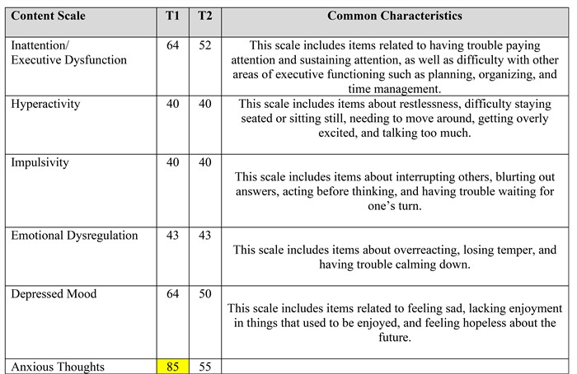

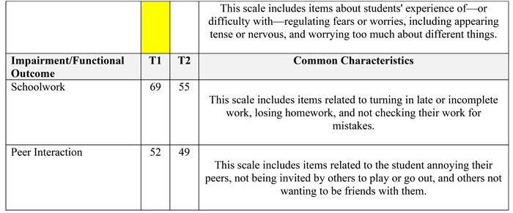

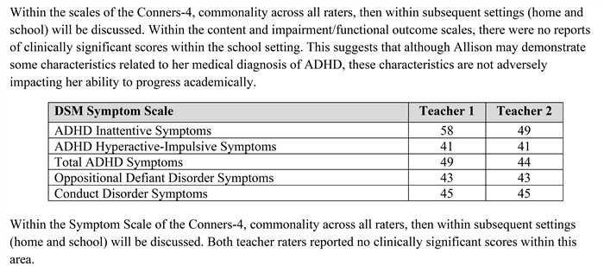

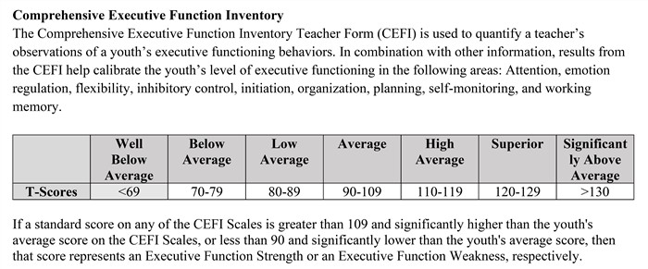



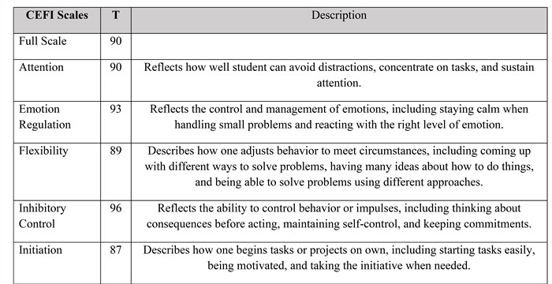

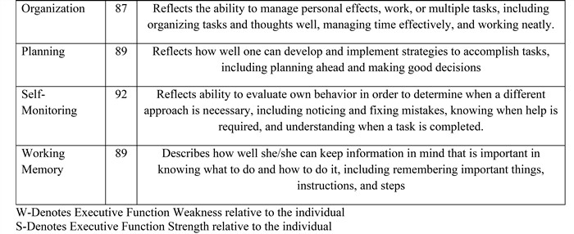

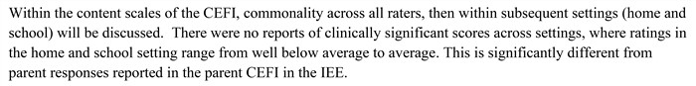

* Yes 0 No Based on the data reviewed, characteristics of Allison's behavior, as manifested in in-school and/or out- of-school settings, appear to influence her educational placement, programming, or discipline.

If yes, list the characteristic behaviors below:

# SUMMARY AND CONCLUSIONS

## Significant educational/developmental deficits

Allison receives special education services as a student with a Specific Learning Disabilty.

## Significant emotional/behavioral deficits

See below.

## Summary and Conclusions

Allison is a 14-year old ninth grader who attends Meridian charter school. Allison has been receiving special education services as a student with a Specific Learning Disability. The Independent Educational Evaluation completed 8/8/2023 was reviewed by the district and accepted. As a part of the IEE, the eligibility of Other Health Impairment was recommended. Parent would like this eligibility to be considered by the district; however a comprehensive social-emotional examination related to this potential eligibility was not completed. The home setting ratings were obtained, but not school setting to examine impact of ADHD on educational placement or potential adverse educational impact. Thus, the district will complete the school setting portion of the social- emotional assessment to complete and examine this eligibility. In addition, the IEE for the communication portion indicated updated assessment completed by the school district.

Specific assessment related to characteristics related to attention and executive functioning was completed using the Comprehensive Executive Function Inventory and Conners-Fourth Edition, which were completed by Allison's mother during the Independent Educational Evaluation. Unlike parent report, teacher reports no clinically significant scores within this area.

## Considering Other Health Disorder.

Other health impairment means having limited strength, vitality, or alertness, including a heightened alertness to environmental stimuli, that results in limited alertness with respect to the educational environment, that- (i) Is due to chronic or acute health problems such as asthma, attention deficit disorder or attention deficit hyperactivity disorder, diabetes, epilepsy, a heart condition, hemophilia, lead poisoning, leukemia, nephritis, rheumatic fever, sickle cell anemia, and Tourette syndrome; and (ii) Adversely affects a child's educational performance.

At this time, medical conditions provided through Allison's doctor (i.e. ADHD) are not directly related to her adverse educational impact. Thus, the eligibility of Other Health Impairment is not recommended at this time.

When determining potential eligibility under the Individuals with Disabilities Education Act, it must be determined that specially or individually designed instruction is required due to an adverse educational impact in the general education curriculum. Based on data obtained, Allison continues require specially or individually designed instruction in order to progress at this time in the area of Specific Learning Disability.

# SPEECH THERAPY CONCLUSIONS

Determination of eligibility for individualized education program (IEP) services with a Speech Impairment is a three-stage process that involves collecting data to answer two questions to document disability determination and a third question, if a disability is documented, for the ARD Committee to deliberate regarding the need for specially designed instruction and services from the SLP.

If the answers to the Stage 1 and Stage 2 questions are both yes, the criteria have been met for the determination of a disability. When the disability condition of Speech Impairment is documented, consideration is given to the Stage 3 question.

Stage One - Is there a communication disorder (such as stuttering, impaired articulation, a language impairment, or a voice impairment)?

A communication disorder is an impairment in the ability to send receive, process, and

comprehend verbal, nonverbal, and graphic symbol systems. A communication disorder may be evident in the process of hearing, language, or speech; may be developmental or acquired; and may range in severity from mild to profound (ASHA, 1993).

**STAGE ONE: With regards to Allison's language abilities, is there evidence of a communication disorder?**

# NO

Stage Two - Is there an adverse effect on educational performance (academic achievement and/or functional performance) resulting from the communication disorder?

This stage of the eligibility process recognizes that a child with a communication disorder may or may not be disabled by the disorder at different stages of his or her educational career. The U. S. Department of Education makes it clear that "educational performance as used in the IDEA and its implementing regulations is not limited to academic performance. Whether a speech and language impairment adversely affects a child's educational performance must be determined on a case-by-case basis, depending on the unique needs of a particular child and not based only on discrepancies in age or grade performance in academic subject areas" (USDE, 2006).

The decision that the communication disorder adversely affects educational performance a two-pronged consideration:

* Adverse effect on academic achievement - generally refers to a child's performance in academic areas such as reading or language arts, math, science and history. The determination regarding whether there is an adverse effect resulting from the communication disorder on academic achievement requires an understanding of the general education curriculum and the language, speech, and communication demands on the student to make progress in academic activities (ASHA, 2007).
* Adverse effect on functional performance - generally refers to skills or activities that are not considered academic or related to a child's academic achievement and often used in the context of routine activities of everyday living (Federal Register, 71[156], p. 46661). The determination of whether there is an adverse effect resulting from the communication disorder on functional performance requires analysis of how "functional" the student's communication is outside of the classroom learning environment. When the communication disorder limits participation in interpersonal activities (e.g., social conversations, group discussions, peer interactions) or extracurricular and nonacademic activities (e.g., athletics, meals, recess, and clubs), an adverse effect on functional performance is present (ASHA, 2007).

**STAGE TWO: With regards to Allison's academic and functional performance, is there evidence that a speech impairment impacts her academic and functional performance in the school setting?**

# NO

Stage Three - Are specially designed instruction or related services and supports needed to help the student

make progress in the curriculum?

The third stage of evaluation addresses the student's need for special education in order to make progress in the curriculum and if so, who should provide the services.

Determine current level of functioning of communication skills:

--Independent performance (student communicates effectively most of the time, student knows what to do and only require periodic reminders)

--Minimal support (the student needs more cues, models, explanations, progress monitoring or assistance than typical students in the class, the student may need instructional accommodations to master grade level standards)

--Maximum support (the student may need curriculum modifications to make progress, the student does not perform effectively most of the time despite modifications and supports)

--Remedial instruction and/or intensive interventions needed (determine amount of support, if any, needed from the SLP to maximize communication skills at school, at home and in the community)

**STAGE THREE: With regards to Allison's need for specially designed instruction related/related services and supports, is speech therapy needed to help Allison make progress in the curriculum?**

# NO

## Allison does not demonstrate a speech or language impairment. Her language abilities do not adversely affect her academic achievement or functional performance in the school setting. Therefore, she does not demonstrate a need for specially designed instruction in the area of speech therapy.

**0 Yes □ No Allison meets criteria for the disability(ies) below based on information contained in the Full and Individual Evaluation report.**

**Condition 1:** Specific Learning Disabilities

* **Yes 0 No Allison has been identified as having Dyslexia or Related Disorders**

# RECOMMENDATIONS AND ASSURANCES

## Recommendations

* + Allison continues to require specially designed instruction in order to make adequate progress in the general education curriculum.
  + The eligibility of Specific Learning Disability is recommended to continue
  + The eligibility of Other Health Impairment has not been determined.
  + Remediation activities should be generated in these areas so as to enable Allison to be involved in and to progress in the general curriculum.
  + Accommodations and modifications that have been ongoing should continue if necessary to facilitate success in the general education classroom.

Speech Therapy recommendations:

While Allison does not qualify for speech therapy, she may benefit from attending tutorials with teachers/classes in which she feels she needs extra instruction or extra time to fully grasp concepts. She may also benefit from reading books daily (at least 15 minutes at a time) that are at-or just above-her reading level. She may also benefit from opportunities to practice public speaking, such as theater clubs, debate teams, or team-related sports.

**Assurances:**

The multi-disciplinary team assures that assessments and other evaluation materials used to assess a child under this framework:

* + are selected and administered so as not to be discriminatory on a racial, cultural or sexual basis;
  + are provided and administered in the child's native language or other mode of communication; and in the form most likely to yield accurate information on what the child knows and can do academically, developmentally, and functionally, unless it is not feasible to so provide or administer;
  + are used for the purposes for which the assessments or measures are valid and reliable;
  + are administered by trained and knowledgeable personnel;
  + and are administered in accordance with any instructions provided by the producer of such assessments. Assessments and other evaluation materials include those tailored to assess specific areas of educational need and not merely those that are designed to provide a single general intelligence quotient.

Assessments and instruments are selected and administered so as to best ensure that the assessment results accurately reflect the child's aptitude or achievement level or whatever other factors the test purports to measure, rather than reflecting the child's impaired sensory, manual, or speaking skills (unless those are the skills the test purports to measure).

The child is assessed in all areas of suspected disability, including, if appropriate, health, vision, hearing, social and emotional status, general intelligence, academic performance, communicative status, and motor abilities.

For a child with limited English proficiency, the LEA differentiates between language proficiency and disability.

The evaluation is sufficiently comprehensive to identify all of the child's special education and related services needs, whether or not commonly linked to the disability category in which the child has been classified.

Assessment tools and strategies that provide relevant information that directly assists persons in determining the educational needs of the child must be provided.

## Signatures of Multidisciplinary Team Member(s)

**Multidisciplinary Team Member Position**

Lic Spec in School Psych



Lesli Doan

Speech Language Pathologist

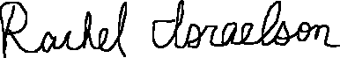

Rachel Israelson