**CHILD INFORMATION INFORMACIÓN DEL NIÑO**

**EVALUATION INFORMATION INFORMACIÓN DE EVALUACIÓN**

Name:

Nombre:

Xavi Avila ID Number:

Número de Identificación:

535568

**FIE Date:**

10/17/2023

Grade:

Grado:

06 Date of Birth:

Fecha de Nacimiento:

08/14/2012

**Fecha de la FIE:**

**FIE Type: Tipo de FIE:**

Street:

Calle:

202 Meadow View Cv

 Initial

Inicial

 Reevaluation Reevaluación

City: Hutto State: Ciudad: Estado:

TX Zip:

Código Postal:

78634

**Review of Existing Evaluation Data**

Campus Name: Nombre del Campus:

Campus ID:

Wagner Middle School

246904045

**(REED) Completed:**

**Revisión de los Datos de Evaluación Existentes (REED por sus siglas en inglés) Completada:**

Número de Identificación del Campus:

*(Required for reevaluations) (Requerido para reevaluaciones)*

**PARENT/GUARDIAN INFORMATION INFORMACIÓN DEL PADRE / TUTOR**

 Yes  No

Si No

Name: Jorge Avila Nombre:

**REED Date:**

**Fecha de la REED:**

08/23/2023

Street: 202 Meadow View Cv Calle:

City:

Ciudad:

Hutto State:

Estado:

TX Zip:

Código Postal:

78634

Home phone: Teléfono de casa:

(512) 952-8050

Work phone:

Teléfono del trabajo:

Cell phone: Teléfono celular:

Email:

(512) 713-5079

[jorge_avila8041@outlook.com](mailto:jorge_avila8041@outlook.com)

Correo electrónico:

Name:

Nombre:

Xochilt Panchi

Street:

Calle:

202 Meadow View Cv

City:

Ciudad:

Hutto State:

Estado:

TX Zip:

Código Postal:

78634

Home phone: Teléfono de casa:

(512) 952-8050

Work phone:

Teléfono del trabajo:

Cell phone:

Teléfono celular:

Email:

Correo electrónico:

[xochilt1082@gmail.com](mailto:xochilt1082@gmail.com)

In Texas, the group of qualified professionals that determines whether the child is a child with a disability and the educational needs of the child is the child's Admission, Review and Dismissal (ARD) Committee.

En Texas, el grupo de profesionales calificados que determina si el niño es un niño con una discapacidad y las necesidades educativas del niño es el Comité de Admisión, Revisión y Retiro (ARD por sus siglas en inglés) del niño.

**GROUP OF QUALIFIED PROFESSIONALS: GRUPO DE PROFESIONALES CALIFICADOS:**

The group that collects or reviews evaluation data in connection with the determination of a child's eligibility for special education and related services must include, but is not limited to the following:

El grupo que recopila o revisa datos de evaluación en relación con la determinación de la elegibilidad de un niño para educación especial y servicios relacionados debe incluir, entre otros, lo siguiente:

A licensed specialist in school psychology, an educational diagnostician, or other appropriately certified or licensed practitioner with experience and training in the area of the disability; or

Un especialista licenciado en psicología escolar, un especialista en diagnóstico educativo u otro profesional debidamente certificado o licenciado con experiencia y capacitación en el área de la discapacidad; o

A licensed or certified professional for a specific eligibility category.

Un profesional licenciado o certificado para una categoría de elegibilidad específica.

**INITIAL EVALUATIONS: EVALUACIONES INICIALES:**

The district must conduct a full individual and initial evaluation before the initial provision of special education and related services to the child with a disability. The initial evaluation must consist of procedures to determine:

El distrito debe realizar una evaluación individual completa inicial antes de la prestación inicial de educación especial y servicios relacionados al niño con una discapacidad. La evaluación inicial debe consistir en procedimientos para determinar:

Whether the child is a child with a disability; and

Si es que el niño es un niño con una discapacidad; y The educational needs of the child.

Las necesidades educativas del niño.

**REEVALUATIONS: REEVALUACIONES:**

The LEA must ensure that a reevaluation of each child with a disability is conducted:

La LEA debe garantizar que se realice una reevaluación de cada niño con una discapacidad:

If the LEA determines the educational or related services needs, including improved academic achievement and functional performance, of the child warrant a reevaluation;

Si la LEA determina que las necesidades educativas o de servicios relacionados, incluido un mejor rendimiento académico y desempeño funcional, del niño justifican una reevaluación;

If a reevaluation is requested by the child's parents or teacher; or

Si es que los padres o el maestro del niño solicitan una reevaluación; o Before determining that the child is no longer a child with a disability.

Antes de determinar que el niño ya no es un niño con una discapacidad.

A reevaluation must occur:

Debe realizarse una reevaluación:

Not more frequently than once a year, unless the parent and the LEA agree otherwise; and No más de una vez al año, a menos que el padre y la LEA acuerden lo contrario; y

At least once every three years, unless the parent and the LEA agree that a reevaluation is unnecessary.

Al menos una vez cada tres años, a menos que el padre y la LEA acuerden que una reevaluación es innecesaria.

An evaluation must be included as part of the summary of performance for a child graduating under certain conditions. An evaluation is not required before the termination of the child's eligibility due to exceeding the age eligibility for a free appropriate public education under state law.

Se debe incluir una evaluación como parte del resumen de desempeño de un niño que se gradúa bajo ciertas condiciones. No se requiere una evaluación antes de la terminación de la elegibilidad del niño debido a que excede la edad de elegibilidad para una educación pública gratuita y apropiada según la ley estatal.

The scope of a reevaluation for the child with a visual impairment must be determined by a multidisciplinary team that includes a certified orientation and mobility specialist.

El alcance de una reevaluación para el niño con impedimento visual debe ser determinado por un equipo multidisciplinario que incluir un especialista certificado en orientación y movilidad.

|  |  |
| --- | --- |
| **Reevaluations: Reevaluaciones:**  At the time of this evaluation, child is receiving special education and related services under the following eligibility(ies)  Al momento de esta evaluación, el niño está recibiendo educación especial y servicios relacionados según la(s) siguiente(s) elegibilidad(es): | **Initial evaluations: Evaluaciones Iniciales:**  Area(s) of suspected disability(ies)  Área(s) de discapacidad(es) sospechada(s)  **Reevaluations: Reevaluaciones:**  Additional area(s) of suspected disability(ies)  Área(s) adicional(es) de discapacidad(es) sospechada(s) |
| (08) Specific Learning Disability  / (08) Discapacidad Específica  Primary Disability: de Aprendizaje Discapacidad Primaria:  Secondary Disability: Discapacidad Secundaria:  Tertiary Disability: Discapacidad Terciaria:  Area of specific learning disability, if applicable:  Área de discapacidad específica de aprendizaje, si es que aplica:  Basic reading skills (dyslexia)  Yes  Child has dyslexia or related disorder. Si  El niño tiene dislexia o trastorno  No relacionado. No | (01) Orthopedic Impairment   1. Impedimento Ortopédico   (02) Other Health Impairment   1. Otro Impedimento de Salud   (03) Deaf/Hard of Hearing   1. Sordo/con Dificultades Auditivas   (04) Visual Impairment   1. Impedimento Visual   (05) Deaf-Blind   1. Sordo-Ciego   (06) Intellectual Disability   1. Discapacidad Intelectual   (07) Emotional Disturbance   1. Trastorno Emocional   (08) Specific Learning Disability. Area:   1. Discapacidad Específica de Aprendizaje   (09) Speech Impairment   1. Impedimento del Habla   (10) Autism  (10) Autismo |

**1. DEVELOPMENT OF EVALUATION**

**1. DESARROLLO DE LA EVALUACIÓN**

**REASON FOR REFERRAL TO SPECIAL EDUCATION MOTIVO DE LA REFERENCIA A EDUCACIÓN ESPECIAL**

Xavi was referred for his triennial full and individual evaluation (FIE) in order to determine if he continues to demonstrate a disability condition and a need for specially designed instruction. A Review of Existing Evaluation Data (REED) was held on 08/23/2023. This committee reviewed all existing data and then set forth the scope of this evaluation. Formal evaluation was requested in the following areas: cognitive, and achievement.

Xavi is a 6th grade student at Wagner Middle school in Georgetown ISD. He attended Carver Elementary and participated in the school’s dual language program. Xavi has not been retained.

**SUSPECTED DISABILITY(IES) DISCAPACIDAD(ES) SOSPECHADA(S)**

|  |  |
| --- | --- |
| Yes  Child has multiple disabilities. Si  El niño tiene múltiples  No discapacidades. No  Child is medically fragile.  Yes  No  El niño es médicamente frágil. Si No | (13) Traumatic Brain Injury   1. Lesión Cerebral por Trauma   (14) Noncategorical Early Childhood   1. Primera Infancia No Categórica |

Comments: Comentarios:

**SOURCES OF INFORMATION FUENTES DE INFORMACIÓN**

 Information provided by parents/guardians or adult student

Información proporcionada por padres / tutores o estudiante adulto.

 Evaluations Evaluaciones

 Current classroom-based, local, or state assessments Evaluaciones actuales en el aula, locales o estatales

 Classroom-based observations Observaciones en el aula

 Observations by teachers and related services providers Observaciones de maestros y proveedores de servicios relacionados

 Other:

Otro:

|  |  |  |
| --- | --- | --- |
| **\*Sources of Data Formal and Informal measures** | **Assessment Person / Title** | **Assessment Dates** |
| Parent Questionnaire | Xochilt Panchi | 9-22-2023 |
| Teacher information | Marjorie Davis, Provider of Dsylexia | 10-5-2023 |
|  | Instruction |  |
|  | Amy Rodriguez, Social Studies Teacher | 10-5-2023 |
|  | Phylis Gage, ELAR Teacher | 10-5-2023 |
| Health information, H/V screening | Lindsey Love, RN, School Nurse | 9-28-2023 |
| Home Language Survey | Jorge Avila, Parent | 8-10-2016 |
| Academic Record Review | Ruth Zane, Educational Diagnostician | 8-23-2023 |
| Classroom/School Observation | Melissa Pepper, Intern LSSP | 9-15-2023 |
| Comprehensive Test of Phonological Processing-2nd Edition | Ruth Zane, Educational Diagnostician | 9-22-2023 |
| Test of Auditory Processing Skills, Spanish - Bilingual Edition (TAPS-3: SBE) | Ruth Zane, Educational Diagnostician | 9-26-2023 |
| Woodcock Johnson IV Tests of Oral Language | Ruth Zane, Educational Diagnostician | 9-22-2023 |
| Wechsler Intelligence Scale for Children, 5th Edition (WISC-V) | Ruth Zane, Educational Diagnostician | 9-29-2023 |
| Wechsler Individual Achievement Test, 4th Edition (WIAT-4) | Ruth Zane, Educational Diagnostician | 9-20-2023 |

**SUMMARY OF INFORMATION PROVIDED BY PARENTS/GUARDIANS OR ADULT STUDENT**

**RESUMEN DE INFORMACIÓN PROPORCIONADA POR PADRES / TUTORES O ESTUDIANTE ADULTO**

## Parent Information

Mrs. Xochilt Panchi, Xavi's mom, says Xavi is a very intelligent boy, and has made progress in his academics. However, she says that as he makes progress, he needs his teachers to be patient with him. She would like to know a bit more about his strengths and weaknesses to better help him.

**EVALUATION PLANNING PLANIFICACIÓN DE LA EVALUACIÓN**

The purpose of this section is to plan any additional evaluations that shall be completed as part of this FIE, if applicable. Completed evaluation results should be documented in parts 2A-H "Initial Evaluator's Results".

El propósito de esta sección es planificar cualquier evaluación adicional que se completará como parte de esta FIE, si es que aplica. Los resultados de la evaluación completa deben documentarse en las partes 2A-H ‘Resultados Iniciales del Evaluador’.

|  |  |  |  |  |
| --- | --- | --- | --- | --- |
| **Area Área** | **Additional Data Needed**  **Se Necesitan Datos Adicionales** | **Type/Nature of Evaluation Position Responsible Due By**  **Tipo / Naturaleza de la Puesto Responsable Debe ser Evaluación realizado antes**  **de** | | |
| A. Language/ Communication  A. Lenguaje /  Comunicación | Yes / Si | Language dominance testing. | Ruth Zane, Educational Diagnostician | 10/19/2023 |
| B. Physical (Vision, Hearing, Health, Motor)  B. Físico (Visión, Audición, Salud, Motor) | Yes / Si | Hearing/Vision screening | Lindsey Love, RN School Nurse | 10/19/2023 |
|  | | |
| C. Sociological  C. Sociológico | Yes / Si | Informal parent input | Ruth Zane, Educational Diagnostician | 10/19/2023 |
| D. Emotional/ Behavioral  D. Emocional / Conductual | Yes / Si | Informal input | Ruth Zane, Educational Diagnostician | 10/19/2023 |

|  |  |  |  |  |
| --- | --- | --- | --- | --- |
| E. Cognitive/ Intellectual  E. Cognitivo / Intelectual | Yes / Si | Standardized cognitive assessment. | Ruth Zane, Educational Diagnostician | 10/19/2023 |
| F. Adaptive Behavior  F. Comportamiento Adaptativo | Yes / Si | Informal input | Ruth Zane, Educational Diagnostician | 10/19/2023 |
| G. Academic/ Developmental Performance  Desempeño Académico / del Desarrollo | Yes / Si | Standardized achievement assessment. | Ruth Zane, Educational Diagnostician | 10/19/2023 |
|  | | |
| H. Assistive Technology  H. Tecnología de Asistencia | Yes / Si | Informal input | Ruth Zane, Educational Diagnostician | 10/19/2023 |

**2. DETERMINATION OF PRESENT LEVELS OF ACADEMIC ACHIEVEMENT AND FUNCTIONAL PERFORMANCE**

**2. DETERMINACIÓN DE LOS NIVELES ACTUALES DE RENDIMIENTO ACADÉMICO Y DESEMPEÑO FUNCIONAL**

Child must be assessed in all areas of suspected disability.

El niño debe ser evaluado en todas las áreas de sospecha de discapacidad.

**2A. LANGUAGE/COMMUNICATION**

**2A. IDIOMA / COMUNICACIÓN**

Child's native language: Idioma nativo del niño:

Child's academic language: Idioma académico del niño:

Emergent bilingual: Bilingüe emergente:

 English

Inglés  Spanish

Español

 Other

Otro

 English

Inglés  Spanish

Español

 Other

Otro

 Yes  No

Si No

Child's preferred method of communication

El método de comunicación preferido del niño. Xavi communicates best orally.

*(required for a child with hearing loss): (requerido para un niño con pérdida auditiva):*

The remainder of this evaluation was conducted in the language and form most likely to yield accurate information on what the child knows and can do academically, developmentally and functionally as follows:

El resto de esta evaluación se realizó en el idioma y la forma con mayor probabilidad de brindar información precisa sobre lo que el niño sabe y puede hacer académicamente, relativo al desarrollo y funcionalmente de la siguiente manera:

 English

Inglés  Spanish

Español

 Other:

Otro:

 Combination: Combinación:

 Bilingual assessor conducted the evaluation Un evaluador bilingüe realizó la evaluación.

 Interpreter used. Specify language or mode of communication:

Se utilizó un intérprete. Especificar idioma o modo de comunicación:

**Results and interpretations: Resultados e interpretaciones:**

Xavi's 10-22-2020 initial FIE indicates the following:

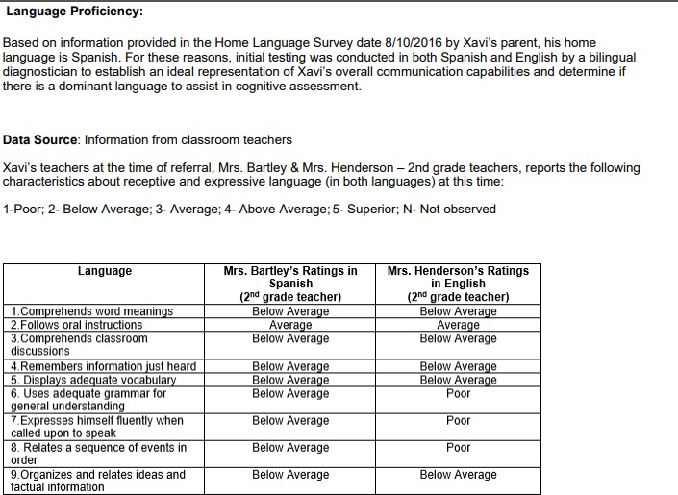

**Woodcock-Johnson IV Tests of Oral Language (WJ-IV Oral Language) Evaluator: Kidd, Roxana**

**Evaluation Date: 9/22/2020**

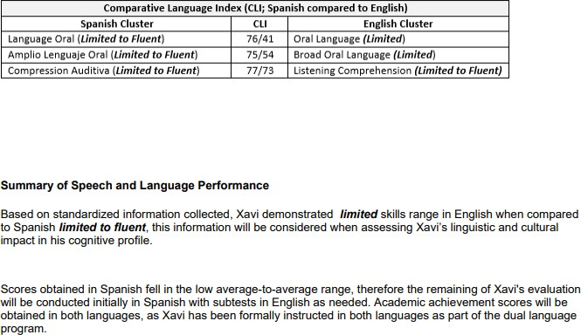

# Communicative Status

Xavi’s Home Language Survey indicates a language other than English is spoken in the home. Xavi participated in GISD's dual language program at Carver Elementary since kindergarten, and reports communicating with his family at home in Spanish. Xavi is identified as an Emergent Bilingual student, formerly known as limited english proficient (LEP); therefore, a language proficiency assessment was conducted in order to determine language dominance.

Students acquire two types of language proficiencies: Basic Interpersonal Communication Skill (BICS) and Cognitive-Academic Language Proficiency (CALP) (Cummins, 1984). BICS is the language used in everyday conversations such as the playground, and casual interactions. CALP is the language acquired via formal schooling. Specifically, CALP indicates a student’s language abilities in comparing, classifying, synthesizing, evaluating, and inferring. A student’s CALP score can predict how an emergent bilingual student will respond to the demands of instruction in a specific language. By understanding BICS and CALP, educators can better instruct their language learners.

The Woodcock-Johnson IV Tests of Oral Language (WJIV OL) is used to calculate a student’s CALP proficiency. The WJIV OL consists of four subtests in English and three subtests in Spanish. The English cluster is made up of: Oral Language, Broad Oral Language, Listening Comprehension, and Oral Expression. The Spanish assessment consists of the following clusters: Lenguaje Oral, Amplio Lenguaje Oral, and Comprension Auditva. The summary below describes each section on this assessment.

The Oral Language/Lenguaje oral cluster is an aggregate measure of comprehension knowledge including lexical knowledge, listening ability, and verbal comprehension. The Oral Expression cluster is an aggregate measure of the student’s overall vocabulary and of the student’s auditory memory. The Listening Comprehension/Comprensión Auditiva cluster is an aggregate measure of listening ability and verbal comprehension. Broad Oral Language/ Amplio lenguaje oral is an aggregate measure of lexical knowledge, listening ability, verbal comprehension, syntactic knowledge, working memory, and auditory memory span.

The following chart interprets the WJIV OL’s CALP scores and descriptors *(from the WJIV Oral Language Examiner’s manual edited by Maher and Wendling, 2014)*:

|  |  |  |
| --- | --- | --- |
| **CALP Score** | **CALP Level** | **Instructional Implications** |
| 6 | Very Advanced | Extremely Easy |
| 5 | Advanced | Very Easy |
| 4-5 (4.5) | Fluent to Advanced | Easy |
| 4 | Fluent | Manageable |
| 3-4 (3.5) | Limited to Fluent | Difficult |
| 3 | Limited | Very Difficult |
| 2 | Very Limited | Extremely Difficult |
| 1 | Extremely Limited | Nearly Impossible |

Xavi's results on the WJ IV OL Language Dominance testing results are listed below:

|  |  |  |  |
| --- | --- | --- | --- |
| **Cluster Name** | **Cluster Score** | **CALP Level** | **Descriptor** |
| Oral Language  *(English)* | 72 | 3 | Limited |
| Broad Oral Language  *(English)* | 71 | 3 | Limited |
| Oral Expression  *(English)* | 70 | 3 | Limited |
| Listening Comprehension  *(English)* | 76 | 3 | Limited |
|  |  |  |  |
| Lenguaje Oral  *(Spanish)* | 66 | 3 | Limited |
| Amplio Lenguaje Oral  *(Spanish)* | 67 | 3 | Limited |
| Comprensión Auditiva  *(Spanish)* | 72 | 3 | Limited |

# CALP SUMMARY

When compared with his peers, Xavi demonstrates Limited proficiency in the English and Spanish clusters of Oral Language, Broad Oral Language, Oral Expression, and Listening Comprehension. This proficiency level indicates Xavi's CALP is equal in English and Spanish. When provided instruction in either language, it is expected that Xavi will find the language demands of the learning task ***very difficult***. Based on the above scores, information from teachers, parent, and other educational records, it has been determined that Xavi's language proficiency is equal at this time. It should be noted that Xavi’s academic instruction at this time is in English. His assessments, therefore, will be offered in both languages, as per input from the student. The full and individual evaluation was conducted by a qualified English/Spanish speaking evaluator.

# Impact

Limited vocabulary may impact Xavi’s academic oral expression and listening comprehension, thereby limiting his understanding in all subject areas. ESL learning strategies are recommended.

# TELPAS / LPAC Information:

Results/Score:

As part of Xavi's English proficiency evaluation, his scores on the Texas English Language Proficiency Assessment System (TELPAS) were reviewed. This assessment measures English language proficiency of English language learners (ELLs) in four language domains: listening, speaking, reading, and writing. Student performance is reported in terms of four English language proficiency ratings: 1 - Beginning, 2- Intermediate, 3- Advanced, and 4 - Advanced High.

Xavi's TELPAS assessments have been administered since kindergarten. Listed below are his scores for the past two years:

TELPAS Scores

|  |  |  |  |  |  |
| --- | --- | --- | --- | --- | --- |
| **Grade Level** | **Reading** | **Writing** | **Speaking** | **Listening** | **Composite** |
| Grade 4 | 2 | 2 | 4 | 3 | 3 |
| Grade 5 | 2 | 1 | 3 | 2 | 2 |

Xavi's TELPAS scores indicate his composite score in 4th grade was higher than his composite score in 5th grade. His scores in 5th grade decreased one level in all areas except reading. Xavi's TELPAS scores are consistent with the most recent language dominance testing described in this report.

# Speech/Language/Communication

Xavi's teachers provided Informal input on Xavi's oral language skills, which include receptive and expressive language skills. The following teachers provided input on Xavi’s oral language skills in the classroom.

Marjorie Davis, Provider of Dsylexia Instruction Amy Rodriguez, Social Studies Teacher

Phylis Gage, ELAR Teacher

Receptive language skills: Xavi's teachers rated his ability to understand and comprehend spoken language that he hears or reads.

1=POOR 2=BELOW AVERAGE 3=AVERAGE 4=ABOVE AVERAGE 5=SUPERIOR N=NOT OBSERVED

|  |  |  |  |  |  |
| --- | --- | --- | --- | --- | --- |
| **Receptive Language Skills** | **1** | **2** | **3** | **4** | **5** |
| **Comprehends word meanings** |  |  | Davis Rodriguez Gage |  |  |
| **Follows oral instructions** |  |  | Davis Rodriguez Gage |  |  |
| **Comprehends classroom discussions** |  |  | Davis Rodriguez Gage |  |  |
| **Remembers information just heard** |  |  | Davis Rodriguez Gage |  |  |

# Expressive Language

Expressive language skills: Xavi's teachers rated his ability to choose the right words to communicate a message effectively. They rated him as follows:

1=POOR 2=BELOW AVERAGE 3=AVERAGE 4=ABOVE AVERAGE 5=SUPERIOR N=NOT OBSERVED

|  |  |  |  |  |  |
| --- | --- | --- | --- | --- | --- |
| **Expressive Language Skills** | **1** | **2** | **3** | **4** | **5** |
| **Displays adequate vocabulary** |  |  | Davis Rodriguez Gage |  |  |
| **Uses adequate grammar for general understanding** |  |  | Davis Rodriguez Gage |  |  |
| **Expresses self fluently when called upon to speak** |  |  | Davis Rodriguez Gage |  |  |
| **Relates a sequence of events in order (telling a story)** |  | Gage | Davis Rodriguez |  |  |
| **Organizes and relates ideas and factual information** |  | Gage |  |  |  |

**Woodcock-Johnson IV Tests of Oral Language**

WJ IV Tests of Oral Language measured Xavi’s language development and comprehension, including lexical (word knowledge) and listening ability. His results (English and Spanish) are listed below.

*WJIV OL (based on age 11.1)*

|  |  |  |  |  |
| --- | --- | --- | --- | --- |
| **WJIV Oral Language Tests** | | | | |
| **Cluster / Test** | **SS** | **Percentile** | **RPI** | **SS Classification** |
| **Oral Expression** | **70** | **2** | **29/90** | **Low** |
| Picture Vocabulary | 67 | 1 | 30/90 | Very Low |
| *Vocabulario sobre* |  |  |  |  |
| *dibujos* | *63* | *1* | *23/90* | *Very Low* |
| Sentence Repetition | 79 | 8 | 28/90 | Low |
| **Listening Comprehension** | **76** | **5** | **59/90** | **Low** |
| ***Comprensión auditiva*** | ***72*** | ***3*** | ***52/90*** | ***Low*** |
| Oral Comprehension  *Comprension oral* | 80  73 | 10  4 | 60/9045/90 | Below Average  Low |
| Understanding Directions | 77 | 7 | 58/90 | Low |
| *Comprensión de indicaciones* | *78* | *7* | *59/90* | *Low* |

The Oral Expression cluster measured Xavi’s expressive English language competency, including lexical (word) knowledge and sentence repetition ability. This composite score consisted of Picture Vocabulary and Sentence Repetition. Xavi obtained a composite score of 70, which is in the 2nd percentile (low range). Picture Vocabulary measured Xavi’s expressive vocabulary, requiring him to provide names of objects. Xavi obtained a standard score of 67, which is in the 1st percentile (low range). On the Spanish version of this subtest, Vocabulario sobre dibujos, Xavi obtained a score of 63, which is in the 1st percentile (very low range). The Sentence Repetition subtest measured Xavi’s short-term memory span. Xavi was required to remember and repeat sentences presented orally. Xavi appeared focused with the initial tasks, but as the sentences increased in length, he began omitting words. Xavi obtained a standard score of 79, which is in the 5th percentile (low range).

The Listening Comprehension cluster measured Xavi’s receptive language competency, including listening ability, verbal comprehension, and verbal working memory capacity. Xavi obtained a composite score of 76, which is in the 5th percentile (low range). On the Spanish cluster of Comprensión auditiva, Xavi obtained a score of 72, which is in the 3rd percentile (low range). This cluster consisted of Oral Comprehension, and Understanding Directions. Understanding Directions measured Xavi’s verbal working memory. This test required Xavi to listen to a sequence of instructions and then follow the directions by pointing to various objects in a picture. Xavi obtained a standard score of 77, which is in the 7th percentile (low average range). On the Spanish version of this subtest, Comprensión de indicaciones, Xavi obtained a score of 78, which is in the 7th percentile. The Oral Comprehension subtest measured listening ability and language development. Xavi was asked to listen to a short passage, and then provide the final missing word. Xavi obtained a score of 80, which is in the 10th percentile (low average range). On the Spanish version of this subtest, Comprensión oral, Xavi obtained a score of 73, which is in the 4th percentile (low range).

## Academic Oral Language Summary

As noted above, Xavi’s initial FIE dated 10-22-2020, noted deficits in his Oral Expression. At that time, Xavi’s language acquisition was cited as a possible factor in his Oral Expression scores being in the very low range.

Xavi’s current standardized assessment scores of his Oral Language abilities, also place his Oral Expression and Listening Comprehension scores in the low range. Teacher input cites his Oral Expression abilities in the average range, with the exception of relating a sequence of events, and organizing ideas and factual information, on which one teacher rated him in the below average range. Teachers rated Xavi’s listening comprehension skills as shown in the classroom, in the average range.

Xavi’s cognitive abilities relative to his Oral Expression and Listening Comprehension abilities in the academic setting will be explored.



**2B. PHYSICAL** (Vision, Hearing, Health, Motor Abilities)

**2B. FÍSICO** (Visión, Audición, Salud, Habilidades Motoras)

Not applicable

No aplica

**VISION**

**VISIÓN**

**Results and interpretations: Resultados e Interpretaciones:**

Xavi passed his vision screening on 9/28/2023, unaided.

**HEARING AUDICIÓN**

**Results and interpretations: Resultados e Interpretaciones:**

Xavi passed his hearing screening on 9/28/2023, unaided.

**HEALTH**

**SALUD**

**Results and interpretations: Resultados e Interpretaciones:**

Data from Xavi's 10-22-2023 FIE indicates the following health history:

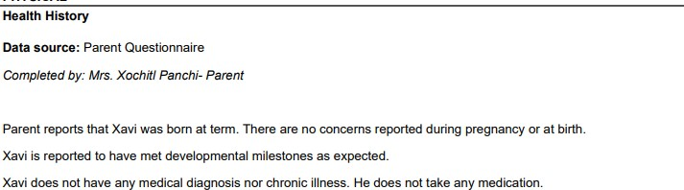

## Current Health Information

School health information, provided by Lindsey Love, RN, school nurse at Wagner Middle School, indicates that Xavi passed a vision and hearing screening, unaided, on 9/28/2023. Xavi is not currently reported to have a health or medical condition which impacts learning.

Child has a significant health history.

El niño tiene un historial de salud importante.

 Yes  No

Si No

*If yes, explain:*

*En caso afirmativo explicar:*

Child appears to have one or more health-related conditions, which directly affect their ability to profit from the educational process.

El niño parece tener una o más condiciones relacionadas con la salud, que afectan directamente su capacidad para beneficiarse del proceso educativo.

*If yes, explain:*

*En caso afirmativo explicar:*

 Yes  No

Si No

**MOTOR ABILITIES HABILIDADES MOTORAS**

**Results and interpretations: Resultados e Interpretaciones:**

## Motor Skills

Gross motor skills are the ability to control and coordinate the large muscles of the body to produce large body movements, such as walking, running, jumping, or sitting. Xavi demonstrated developmentally appropriate gross motor skills such as the ability to independently ambulate within the school environment, open and close doors, and transition independently from one location to another, in the school setting.

Fine motor skills are the ability to control and coordinate the small muscles in the hand to produce controlled, precise movements. Xavi's parent and teachers do not report any concerns in this area.

## Teacher Information:

1=POOR 2=BELOW AVERAGE 3=AVERAGE 4=ABOVE AVERAGE 5=SUPERIOR N=NOT OBSERVED

|  |  |  |  |  |  |
| --- | --- | --- | --- | --- | --- |
| **Fine/Gross motor functioning in the classroom** | **1** | **2** | **3** | **4** | **5** |
| Exhibits adequate gross motor coordination |  |  | Gage | Davis |  |
| Displays adequate or functional fine motor coordination (i.e. opening doors, cutting, buttoning, zipping, etc) |  |  | Rodriguez Gage | Davis |  |
| Displays adequate fine motor skill related to handwriting |  |  | Rodriguez Gage | Davis |  |

Adapted physical education is recommended. Se recomienda educación física adaptada.

*If yes, explain:*

*En caso afirmativo explicar:*

 Yes  No

Si No



**2C. SOCIOLOGICAL**

**2C. SOCIOLÓGICO**

Not applicable

No aplica

**Results and interpretations: Resultados e interpretaciones:**

## Xavi's 10-22-2020 initial FIE indicates the following sociological information.

**Source: Parent questionnaire**

Xavi is a third grade student who attends Carver Elementary. He lives in Georgetown, Texas with his parents and siblings. Xavi has friends in his neighborhood and enjoys playing outside. When in a group, he can be a leader or a follower. Other activities Xavi enjoys in his free time include bike riding, gaming, and watching movies. As a family, Xavi enjoys dinners and afternoon outings.

## Current Sociological Information

According to the parent questionnaire completed by Xavi’s mom, Mrs. Panchi, Xavi lives in the home with his parents and two siblings. Mrs. Panchi says that in the past three years, the family has experienced a death in the family and unemployment. While Xavi has expressed sadness at these events, Mrs. Panchi says that he is a happy boy who is very active and affectionate. She describes him as very active, talkative, sensitive to others’ feelings, and sometimes temperamental. In his free time Xavi enjoys playing basketball, riding his bicycle. She adds that Xavi is very intelligent and loves learning new things.

Xavi says he loves middle school and enjoys all his teachers. He says his favorite subject is math, because it is what he finds easiest. He says he likes the way his teacher, Ms. Kerchen projects math problems on the TV screen, and students are able to use an electronic pen to work them out as a group. Xavi describes his classmates as very nice and friendly and says he looks forward to working on group activities with them.

Cultural and/or lifestyle factors influence child's learning and behavioral patterns.

Los factores culturales y/o de estilo de vida influyen en los patrones de aprendizaje y comportamiento del niño.

*If yes, explain:*

*En caso afirmativo, explicar:*

There are no indications that sociological factors are the primary cause of Xavi's difficulties in school.

Child's sociological status indicates a lack of previous educational opportunities in reading and/or math.

El estatus sociológico del niño indica una falta de oportunidades educativas previas en lectura y/o matemáticas.

*If yes, explain:*

*En caso afirmativo, explicar:*

 Yes  No

Si No

 Yes  No

Si No

Xavi's sociological status is not a factor in his learning difficulties. There are no indications that Xavi has had lack of educational opportunities.

Excessive absences have influenced child's learning and behavioral patterns.

Las ausencias excesivas han influido en los patrones de aprendizaje y comportamiento del niño.

 Yes  No

Si No

*If yes, explain:*

*En caso afirmativo, explicar:*

School records do not indicate excessive absences. Xavi has attended school consistently since kindergarten.



**2D. EMOTIONAL/BEHAVIORAL**

**2D. EMOCIONAL / CONDUCTUAL**

Not applicable

No aplica

**Results and interpretations: Resultados e interpretaciones:**

Data from Xavi’s initial **10-22-2020** FIE indicates the following in the area of emotional/behavioral feedback: Data source: Parent Questionnaire

Completed by: Mrs. Xochilt Panchi - Parent

Xavi’s parent describes him as an active and creative child. Xavi enjoys playing soccer, coloring, playing hide and seek. Parent report concerns regarding Xavi’s poor concentration and that he becomes easily distracted. There are no major concerns about Xavi’s behavior at home.

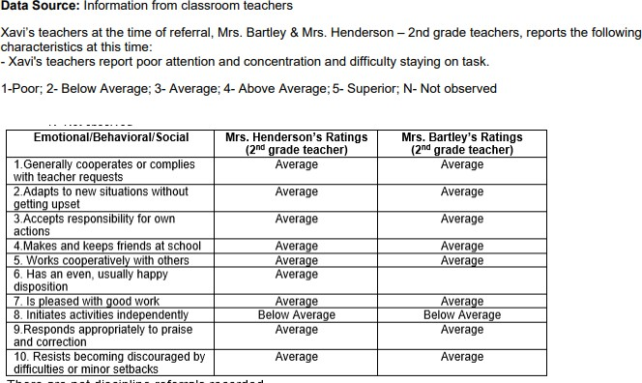

## Parent Information

Xavi’s mother describes Xavi as very well behaved. She reports that he is funny, creative, and sympathetic to other’s feelings.

## Teacher Feedback

Emotional/behavioral competencies were reviewed for Xavi’s current evaluation. His teachers rated him in the average to above average range on all classroom behaviors listed below.

1= POOR 2=BELOW AVERAGE 3=AVERAGE 4=ABOVE AVERAGE 5= SUPERIOR N=NOT OBSERVED

|  |  |  |  |  |  |  |
| --- | --- | --- | --- | --- | --- | --- |
| **Emotional / Behavioral Skills** | 1 | 2 | 3 | 4 | 5 | N/A |
| **Social** |  | | | | | |
| Makes and keeps friends at school. |  |  | Rodriguez Gage |  |  | Davis |
| Works cooperatively with others. |  |  | Rodriguez Gage | Davis |  |  |
| Enjoys socializing with peers |  |  | Rodriguez Gage | Davis |  |  |
| Is respectful of peers and adults |  |  | Rodriguez | Davis Gage |  |  |
| Likes to please adults |  |  | Rodriguez | Davis Gage |  |  |
| **Informal Behavior Observations across school settings** |  | | | | | |
| Generally cooperates or complies with teacher requests. |  |  | Rodriguez | Davis Gage |  |  |
| Adapts to new situations without getting upset. |  |  | Rodriguez | Davis Gage |  |  |
| Accepts responsibility for their own actions. |  |  | Rodriguez | Davis Gage |  |  |
| Has an even, usually happy, disposition |  |  | Rodriguez | Davis Gage |  |  |
| Is pleased with good work |  |  | Rodriguez | Davis Gage |  |  |
| Responds appropriately to praise and correction. |  |  | Rodriguez | Davis Gage |  |  |
| Participates in classroom discussions |  |  | Rodriguez | Davis Gage |  |  |

Xavi's teachers rated additional behavior characteristics in the school setting. They indicated “Yes, “No,” or “Not Observed.”

|  |  |  |  |
| --- | --- | --- | --- |
|  | **Yes** | **No** | **Not Observed** |
| **Sensory** |  |  |  |
| Under/over sensitive to noise |  | Davis Gage | Rodriguez |
| Avoids being touched |  | Davis Gage | Rodriguez |
| Avoids getting hands / self dirty |  | Davis Gage | Rodriguez |
| **Executive Functioning** |  |  |  |
| Difficulty following directions |  | Davis Rodriguez Gage |  |
| Difficulty completing assignments | Gage | Davis Rodriguez |  |
| Difficulty making transitions |  | Davis Rodriguez Gage |  |
| Interrupts and disrupts group activities |  | Davis Rodriguez Gage |  |
| Makes careless mistakes |  | Davis Rodriguez Gage |  |
| Student forgets homework assignments/materials |  | Davis Rodriguez Gage |  |
| Difficulty starting an assignments independently |  | Davis Rodriguez Gage |  |
| Disorganized |  | Davis Rodriguez Gage |  |

Teachers further noted the following:

Ms. Davis, Xavi’s dyslexia teacher, says that Xavi’s low decoding and poor spelling are leading to a low fluency rate. This also affects Xavi’s reading comprehension. She adds that Xavi is very willing to learn.

Ms. Rodriguez, Xavi’s social studies teacher, says that Xavi always makes an effort. She says she would like to see him ask more questions and advocate when he needs help. She also notes that he seems to get along well with others.

Ms. Gage, Xavi’s ELAR teacher, reports writing concerns for Xavi. She notes that his handwriting is illegible. She says Xavi always tries to do his best. She adds that he struggles with socializing in class, but is easily redirected. She says that he seems to enjoy SSR time everyday as well. She notes that Xavi is generally a good student and always seems to put forth his best effort. However, she says she would like to see him advocate more for himself.

## Classroom Observation

**Assessment Observations**

Xavi participated in his testing sessions willingly and appeared to put forth a strong effort on his standardized assessments. He appeared talkative and energetic. He shared that he loves school and enjoys his classmates.

Functional behavior assessment (FBA) results and interpretation:

Resultados e interpretación de la evaluación de la conducta funcional (FBA por sus siglas en inglés):

Child's behavior impedes their learning.

El comportamiento del niño impide su aprendizaje.

Child's behavior impedes the learning of others.

El comportamiento del niño impide el aprendizaje de los demás.

*If yes to either question above, clarify problem behavior(s) that interfere with learning.*

 Yes  No

Si No

 Yes  No

Si No

*En caso afirmativo a cualquiera de las preguntas anteriores, aclarar las conductas problemáticas que interfieren con el aprendizaje.*



**2E. COGNITIVE/INTELLECTUAL**

**2E. COGNITIVO / INTECTUAL**

Not applicable

No aplica

**Results and interpretations: Resultados e interpretaciones:**

In order to make the determination of a specific learning disability (SLD), the examiner looks for a pattern of cognitive strengths and weaknesses, academic strengths and weaknesses, along with a convergence of academic and sociological data. Children with a SLD exhibit overall average intelligence, but will have a deficit in a specific cognitive process that correlates with difficulty learning in a particular achievement area.

Xavi's 10-22-2020 FIE indicates the following cognitive assessment results:

Wechsler Intelligence Scale for Children-5th Edition (WISC-V) Spanish Evaluator: Kidd, Roxana

Evaluation Date: 9/23/2020

Woodcock-Munoz Bateria IV Pruebas de Habilidades Cognitivas Evaluator: Kidd, Roxana

Evaluation Date: 9/23/2020

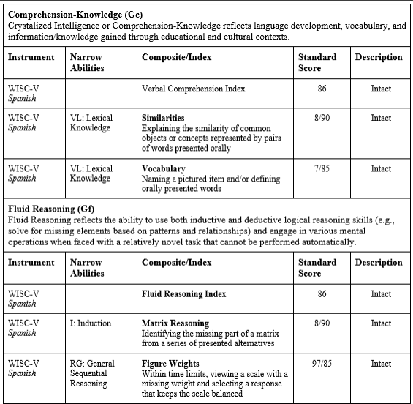

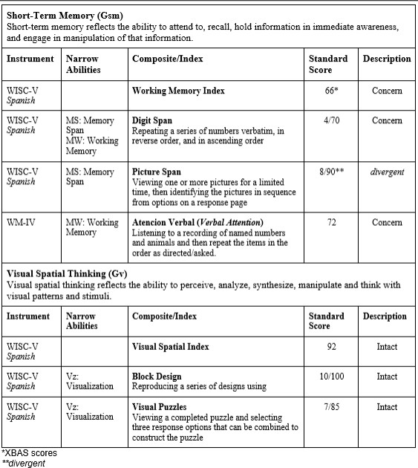

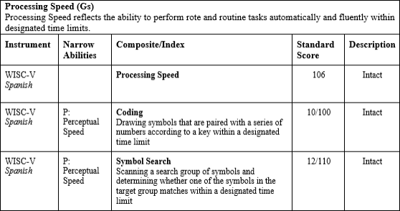

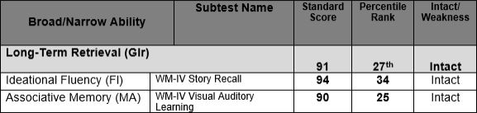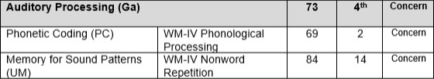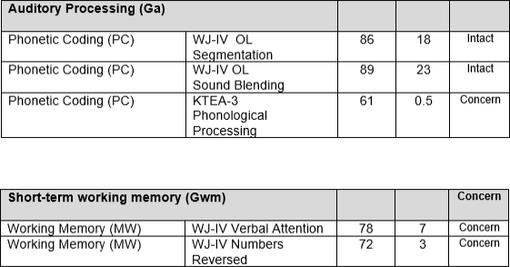

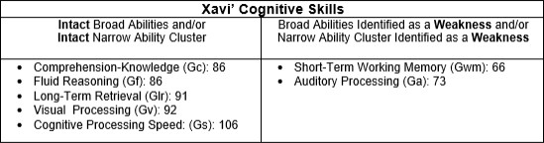

**Current Evaluation Results**

Selected tests from the following cognitive and language assessments were administered to determine whether Xavi exhibits a pattern of strengths and weaknesses within his cognitive profile:

Comprehensive Test of Phonological Processing - Second Edition (CTOPP-2). The CTOPP-2 is a comprehensive instrument designed to assess phonological awareness, phonological memory, and rapid naming.

Wechsler Intelligence Scale for Children – Fifth Edition (WISC-V), an individually administered clinical instrument for assessing the cognitive ability of children aged 6 years 0 months through 16 years 11 months

Test of Auditory Processing Skills, Third Edition, Spanish-Bilingual Edition (TAPS-3: SBE). This battery assesses auditory processing difficulties, imperceptions of auditory modality, language problems, and/or learning disabilities in Spanish speaking children and teens, ages 4 to 18 years.

Xavi's cognitive assessments measured his cognitive processing Broad abilities (G’s), which are comprised of narrow abilities that measure different skills within the cluster.

## Current Standardized Assessments

Wechsler Intelligence Scale for Children – Fifth Edition (WISC-V) Comprehensive Test of Phonological Processing - Second Edition (CTOPP-2)

Test of Auditory Processing Skills, Third Edition, Spanish-Bilingual Edition (TAPS-3: SBE)

**Diagnostician**: Ruth Zane

**Date**: 8-28-2023, 9-26-2023

|  |  |  |  |  |
| --- | --- | --- | --- | --- |
| **Comprehension-Knowledge (Gc)**  Crystalized Intelligence or Comprehension-Knowledge reflects language development, vocabulary, and information/knowledge gained through educational and cultural contexts. | | | | |
| **Instrument** | **Narrow Abilities** | **Composite/Index** | **Standard Score** | **Description** |
| **WISC-V**  **Spanish** |  | **Verbal Comprehension Index Composite** | **103** | **58** |
| WISC-V | VL: Lexical Knowledge | **Similarities**  This subtest measures logical thinking, verbal concept formation and verbal abstract reasoning. Explaining the similarity of common objects or concepts represented by pairs of words presented orally | 110 | 75 |
| WISC-V | VL: Lexical Knowledge | **Vocabulary**  This subtest measures the students' verbal fluency and concept formation, word knowledge, and word usage.  Naming a pictured item and/or defining orally presented words | 95 | 37 |

Comprehension-Knowledge is defined as the depth and breadth of knowledge and skills, including verbal communication and information. It represents a person’s acquired knowledge, general language development, an understanding of words, extent of vocabulary, and the ability to listen to and comprehend oral communication. Xavi was administered the Gc composite in Spanish, as he obtained a CALP score of 3 in both languages. He obtained a standard score of 103, which falls in the 58th percentile (average range). The Comprehension-Knowledge composite score was based on Xavi's performance on the WISC-V Spanish Similarities and Vocabulary subtests. The Similarities test required Xavi to describe a similarity between two words that represent a common object or concept. He provided detailed comparisons for the terms provided, and obtained a score of 110 on this subtest, which is in the 75th percentile (high average range). The Vocabulary subtest required Xavi to name depicted objects and/or define words that were read aloud. He obtained a score of 95, which is in the 37th percentile (average range).

|  |  |  |  |  |
| --- | --- | --- | --- | --- |
| **Fluid Reasoning (Gf)**  Fluid Reasoning reflects the ability to use both inductive and deductive logical reasoning skills (e.g., solve for missing elements based on patterns and relationships) and engage in various mental operations when faced with a relatively novel task that cannot be performed automatically. | | | | |
| **Instrument** | **Narrow Abilities** | **Composite/Index** | **Standard Score** | **Description** |
| WISC-V |  | **Fluid Reasoning Index** | **100** | **50** |
| WISC-V | I: Induction | **Matrix Reasoning**  This subtest measures visual processing and abstract, spatial perception. Identifying the missing part of a matrix from a series of presented alternatives | 100 | 50 |
| WISC-V | RG: General Sequential Reasoning | **Figure Weights**  This subtest measures quantitative reasoning and induction. Within time limits, viewing a scale with a missing weight and selecting a response that keeps the scale balanced | 100 | 50 |

Fluid reasoning is a measure of the ability to reason and solve problems that often involve unfamiliar information or procedures that cannot be performed automatically. It is often referred to as a problem-solving type of intelligence. Xavi obtained a standard score of 100, which falls in the 50th percentile (average range). The Fluid Reasoning composite score was based on Xavi's performance on the Matrix Reasoning and Figure Weights subtests. The first subtest in this cluster required Xavi to view an incomplete matrix or series and select the response option that completed the matrix or series. Xavi obtained a score of 100, which is in the 50th percentile (average range). On the Figure Weights subtest, Xavi was asked to view scales with missing weights and select the response option that was best suited to keep the scales balanced. Xavi obtained a score of 100, which is in the 50th percentile (average range).

|  |  |  |  |  |
| --- | --- | --- | --- | --- |
| **Short-Term Memory (Gsm)**  Short-term memory reflects the ability to attend to, recall, hold information in immediate awareness, and engage in manipulation of that information. | | | | |
| **Instrument** | **Narrow Abilities** | **Composite/Index** | **Standard Score** | **Description** |
| WISC-V |  | **Working Memory Index** | **79** | **Low** |
| WISC-V | MS: Memory Span,  MW:  Working Memory | **Digit Span**  This subtest measures verbal short-term memory with tasks that include: remembering a sequence of numbers, one at a time; repeating a series of numbers verbatim, in reverse order, and in ascending order. | 80 | Below Average |
| WISC-V | MS: Memory Span | **Picture Span**  This subtest measures visual working memory. The student views a stimulus page of one or more pictures for a specified time and then selects the picture(s) (in sequential order, if possible) from options on a response page. | 95 | Average |

Short-Term Working Memory is the ability to encode, maintain, and manipulate visual and auditory information in immediate awareness. This composite consists of the Digit Span and Picture Span subtests. Xavi obtained a score of 85, which is in the 16th percentile (below average range).The Digit Span subtest required Xavi to listen to a sequence of numbers read aloud and recall them in the same order, reverse order and ascending order. Xavi said the numbers aloud to himself. At times, he appeared to experience difficulty remembering the numbers, even when there were few. He obtained a score of 80, which is in the 9th percentile (below average range). The Picture Span subtest required Xavi to memorize one or more pictures presented on a stimulus page and then identify the correct pictures (in sequential order, if possible) from options on a response page. Xavi easily responded to the first several picture tasks but as the number of pictures increased, he recalled the correct pictures, but not in the correct order. He obtained a score of 95, which is in the 37th percentile (average range). Xavi’s score on Digit Span indicates a deficit on his working memory, and is consistent with his performance on this cognitive ability on his initial 10-22-2020 evaluation.

|  |  |  |  |  |
| --- | --- | --- | --- | --- |
| **Processing Speed (Gs)**  Processing Speed reflects the ability to perform rote and routine tasks automatically and fluently within designated time limits. | | | | |
| **Instrument** | **Narrow Abilities** | **Composite/Index** | **Standard Score** | **Description** |
| WISC-V |  | **Processing Speed** | **111** | **High Average** |
| WISC-V | P: Perceptual Speed | **Coding**  This subtest measures information processing speed and visual perception. Drawing symbols that are paired with a series of numbers according to a key within a designated time limit | 105 | Average |
| WISC-V | P: Perceptual Speed | **Symbol Search**  It measures information processing speed and visual perception. Scanning a search group of symbols and determining whether one of the symbols in the target group matches within a designated time limit | 115 | Above Average |

The Processing Speed cluster on the WISC-V consists of the Coding and Symbol Search subtests. Xavi obtained a composite score of 111, which is in the 77th percentile (high average range). The Coding subtest measures visual motor dexterity and required Xavi to copy symbols that corresponded to numbers. Xavi appeared to carefully form the symbols with ease. He obtained a score of 105, which is in the 63rd percentile. The Symbol Search subtest was timed, and required Xavi to discriminate between visual stimuli by scanning a series of symbols and indicating whether the target symbol was present. Xavi appeared to complete this task with ease. He obtained a score of 115, which is in the 84th percentile (above average range).

**Auditory Processing (Ga)**

|  |  |  |  |  |
| --- | --- | --- | --- | --- |
| Auditory processing is the ability to notice, compare, discriminate, and distinguish sounds. It reflects phonetic coding skills (e.g., blending, deletion, phoneme manipulation).H | | | | |
| **Instrument** | **Narrow Abilities** | **Composite/Index** | **Standard Score** | **Descriptor** |
| CTOPP-2 |  | **Auditory Processing (Ga)** | **82** | **Below Average** |
| Elison | PC:  Phonetic Coding | The Elision subtest requires the examinee to say a word after dropping designated sounds. | 70 | Low |
| Blending Words | PC:  Phonetic Coding | The Blending Words subtest asks examinees to combine sounds to create words. | 100 | Average |
| Phoneme Isolation | PC:  Phonetic Coding | The Phoneme Isolation subtest requires examinees to identify target sounds in words. | 85 | Below Average |

Auditory Processing is the ability to discriminate, encode, employ and synthesize auditory stimuli and is related to phonological awareness and sensitivity. The CTOPP-2’s Phonological Awareness Composite measures auditory processing with three subtests: Elision, Blending Words, and Phoneme Isolation. Xavi obtained a composite score of 82, which is in the 12th percentile (below average range). Elision measures the ability to remove phonological segments from spoken words to form other words. Xavi appeared to experience difficulty identifying the beginning and middle sounds in words. Xavi obtained a score of 70, which is in the 2nd percentile (low range). Blending Words measures the ability to synthesize sounds to form words. Xavi obtained a score of 100 on this subtest, which is in the 50th percentile (average range). Phoneme Isolation is the ability to identify where a sound appears in a word. Xavi appeared to experience difficulty identifying the middle and end sound of words. He obtained a score of 85, which is in the 16th percentile (below average range).

|  |  |  |  |  |
| --- | --- | --- | --- | --- |
| **Auditory Processing (Ga)**  Auditory processing is the ability to notice, compare, discriminate, and distinguish sounds. It reflects phonetic coding skills (e.g., blending, deletion, phoneme manipulation). | | | | |
| **Instrument** | **Narrow Abilities** | **Composite/Index** | **Standard Score** | **Descriptor** |
| TABS-3: SBE |  | **Auditory Processing (Ga)** | **102** | **Average** |
| Word Discrimination | PC:  Phonetic Coding | The Word Discrimination subtest requires the student to listen to pairs of words spoken by the examiner, and is asked to discriminate between them. | 115 | High Average |
| Phonological Segmentation | PC:  Phonetic Coding | The Phonological Segmentation subtest requires the student to correctly delete specific syllables or sounds from words. | 100 | Average |
| Phonological Blending | PC:  Phonetic Coding | The Phonological Blending subtest requires the student to listen to a series of phonemes and then blend these sounds into a word. | 90 | Average |

Xavi also was administered the Test of Auditory Processing Skills, Third Edition, Spanish Bilingual Edition (TAPS-3: SBE). Xavi participated in the GISD’s dual language program in grades K-5. His CALP scores in English and Spanish were similar. Given that Spanish is a transparent (one-to-one correspondence) language, Xavi’s Phonological Awareness cognitive ability was assessed with the TAPS-3: SBE.

Auditory Discrimination required Xavi to listen to pairs of words spoken by the examiner, and was then asked to discriminate between them. The words in each pair are of equal length but differ on one phoneme (e.g., dog – log, compute – commute, eliminate - illuminate). Xavi was able to correctly discriminate most of the words presented, obtaining a standard score of 115, which is in the 84th percentile (high average range).

Phonological Segmentation required Xavi to correctly delete specific syllables or sounds from words. The examiner read aloud a target word, and asked Xavi to repeat it, and then asked him to repeat it again while deleting one of the sounds. Xavi removed beginning and ending sounds with ease. He appeared to experience difficulty removing middle sounds from words. He obtained a score of 100, which is in the 50th percentile (average range).

The Phonological Blending subtest required Xavi to listen to a series of phonemes and then blend these sounds into a word. Xavi responded to the first seven items with ease, but appeared to experience difficulty with a longer string of phonemes. Xavi obtained a standard score of 90, which is in the 25th percentile (average range).

|  |  |  |  |  |
| --- | --- | --- | --- | --- |
| **Long-Term Retrieval - Learning Efficiency (Gl)**  Long-term retrieval is the ability to store information in long-term memory and to retrieve it later fluently through association. | | | | |
| **Instrument** | **Narrow Abilities** | **Composite / Index** | **Standard Score** | **Descriptor** |
| WISC-V |  | Symbol Translation | 96 | Average |
| WISC-V | MA: Associative Memory | Immediate Symbol Translation | 93 | Average |
| WISC-V | MA: Associative Memory | Delayed Symbol Translation | 94 | Average |
| WISC-V | MA: Associative Memory | Recognition Symbol Translation Recognition of visual-verbal pairs | 105 | Average |

Long-Term Retrieval-Learning Efficiency is the ability to learn, store, and consolidate information over a period of time. Associative memory is the ability to form a link between information that has already been learned and newly-presented information. Meaningful memory is the ability to remember narratives and other forms of semantically-related information. Xavi obtained a composite score of 96, which is in the 39th percentile (average range). This composite score was based on Xavi's performance on the following subtests: Immediate Symbol Translation, Delayed Symbol Translation, and Recognition Symbol Translation. For the first subtest in this composite, Immediate Symbol Translation, Xavi was shown symbols and taught the word that each symbol represented. He obtained a score of 93, which is in the 32th percentile (average range). The second subtest, Delayed Symbol Translation, required Xavi to translate symbol strings into phrases or sentences immediately and then again after a specified time delay. He obtained a score of 94, which is in the 34th percentile (average range). Xavi then was provided a multiple-choice recognition format of the symbols, which is the Recognition Symbol Translation subtest. He obtained a score of 105, which is in the 63rd percentile (average range).

|  |  |  |  |  |
| --- | --- | --- | --- | --- |
| **Long-Term Retrieval - Retrieval Fluency (Gr)**  Rapid naming of objects, colors, digits, or letters requires efficient retrieval of phonological information from long-term memory. | | | | |
| **Instrument** | **Narrow Abilities** | **Composite/Index** | **Standard Score** | **Descriptor** |
| CTOPP-2 |  | **Rapid Symbolic Naming** | 95 | Average |
| CTOPP-2 | NA: Naming Ability | **Rapid Digit Naming**  It measures the ability to include efficient retrieval of information from long-term or permanent memory and name quickly and repeatedly letters | 95 | Average |
| CTOPP-2 | NA: Naming Ability | **Rapid Letter Naming**  It measures the ability to include efficient retrieval of information from long-term or permanent memory and name quickly and repeatedly letters | 95 | Average |

Long-Term Retrieval- Retrieval Fluency is the rate and fluency at which individuals can access information stored in long- term memory. This retrieval process is also used when retrieving pronunciations of words or parts of words when you read them. This composite is known as The Rapid Symbolic Naming Composite, consisting of the subtests Rapid Digit Naming and Rapid Letter Naming. Xavi obtained a standard score of 95, which is in the 37th percentile (average range). For the Rapid Digit Naming, Xavi was asked to read across rows of numbers, while making as few errors as possible. He obtained a score of 95, which is in the 37th percentile (average range). For the Rapid Letter Naming, Xavi was asked to read across rows of letters, while making as few errors as possible. He obtained a score of 95, which is in the 37th percentile (average range).

|  |  |  |  |  |
| --- | --- | --- | --- | --- |
| **Visual Spatial Thinking (Gv)**  Visual spatial thinking reflects the ability to perceive, analyze, synthesize, manipulate and think with visual patterns and stimuli. | | | | |
| **Instrument** | **Narrow Abilities** | **Composite/Index** | **Standard Score** | **Descriptor** |
| WISC-V |  | **Visual Spatial Index** | **89** | **Low Average** |
| WISC-V | Vz: Visualization | **Block Design**  This subtest measures visual perception, perceptual organization, and attention to visual detail. Reproducing a series of designs using blocks by rearranging blocks that have various color patterns on different sides to match a pattern. | 100 | 50 |
| WISC-V | Vz: Visualization | **Visual Puzzles**  This subtest measures nonverbal reasoning and the ability to analyze and synthesize abstract visual stimuli. Viewing a completed puzzle and selecting three response options that can be combined to construct the puzzle | 80 | 9 |

The Gv cluster yields differential performance depending on task demands, and consists of the Block Design subtest, and Visual Puzzles. He obtained a composite score of 89, which is in the 23rd percentile (below average range). On the Block Design subtest, Xavi was presented with a graphic presented on the iPad, and asked to recreate it with colored blocks. Xavi appeared persistent on these tasks, at times exceeding the allotted time, but determined to complete the task. He was successful in replicating the model, but he did not receive credit. Xavi obtained a score of 100, which is in the 50th percentile (average range). The Visual Puzzles subtest required Xavi to review a completed puzzle and select three response options that together would reconstruct the puzzle. Xavi obtained a score of 80, which is in the 9th percentile (below average range). Xavi appeared to perform better with the use of manipulatives on these visual tasks.

Overall and based on all sources of data collected; Xavi's cognitive profile shows the following characteristics:

|  |  |
| --- | --- |
| **Xavi's Cognitive Skills** | |
| **Strengths** | Weaknesses |
| **Comprehension Knowledge** (Gc)  **Short-Term Memory** (Gsm): MS: Memory Span,  **Fluid Reasoning** (Gf)  **Processing Speed** (Gs)  **Long-Term Retrieval Learning Efficiency** (Gl) **Long-Term Retrieval - Retrieval Fluency** (Gr) **Visual Processing** (Gv) | **Auditory Processing** (Ga)  **Short-Term Memory** (Gwm): MW: Working Memory |



**2F. ADAPTIVE BEHAVIOR**

**2F. COMPORTAMIENTO ADAPTATIVO**

Not applicable

No aplica

**Results and interpretations: Resultados e interpretaciones:**

Xavi’s adaptive behavior was assessed using informal measures.

Adaptive behavior refers to the degree to which a student is socially and personally independent. Xavi’s adaptive functioning was assessed informally through reports from parents, teachers, and observations of behavior during testing sessions.

## 9-14-2023 Informal Adaptive Teacher Feedback

Xavi's adaptive behavior for this reevaluation was assessed using informal measures. Xavi's teachers rated additional behavior characteristics in the school setting. They indicated “Yes, “No,” or “Not Observed.”

Teacher ratings indicate that Xavi’s development in the areas of personal independence and social responsibility appears to be within normal limits.

|  |  |  |  |
| --- | --- | --- | --- |
| **Adaptive Behavior** | **Yes** | **No** | **Not Observed** |
| Concerns with eating lunch independently |  | Gage | Rodriguez Davis |
| Concerns with understanding social cues |  | Gage Rodriguez Davis |  |
| Concerns during Specials |  | Gage Davis | Rodriguez |
| Concerns navigating the school building ndependently |  | Gage | Rodriguez Davis |
| Concerns with self-care (dressing, feeding, hygiene, etc) |  | Gage | Rodriguez Davis |
| Follows school schedule without assistance |  | Gage Davis | Rodriguez |

## Adaptive Behavior Summary

Parent input, teacher input, and behavior observations during testing do not indicate adaptive behavior concerns for Xavi. His ability to negotiate social and environmental demands appears consistent with measures of his intellectual functioning



**2G. ACADEMIC/DEVELOPMENTAL PERFORMANCE**

**2G. DESEMPEÑO ACADÉMICO / DEL DESARROLLO**

Not applicable

No aplica

**Results and interpretations: Resultados e interpretaciones:**

Xavi's standardized achievement assessment results from his 10-22-2020 initial evaluation are listed below.

Kaufman Test of Educational Achievement, Third Edition (KTEA-3) Evaluator: Kidd, Roxana

Evaluation Date: 10/1/2020

The Kaufman Test of Educational Achievement, Third Edition (KTEA-3 Comprehensive Form) is an individually administered measure of academic achievement for grades pre-kindergarten through 12 or ages 4 through 25 years.

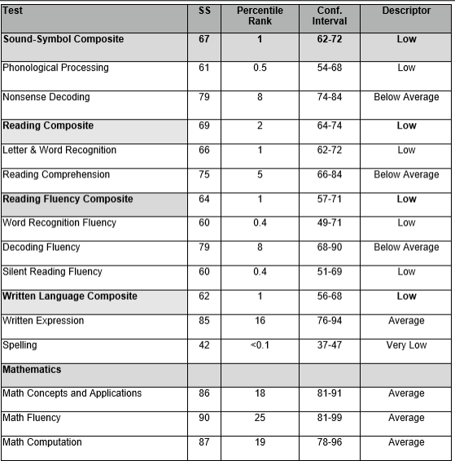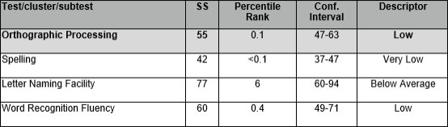

**Woodcock-Munoz Bateria IV Pruebas de Aprovechamiento Evaluator: Kidd, Roxana**

**Evaluation Date: 9/22/2020**

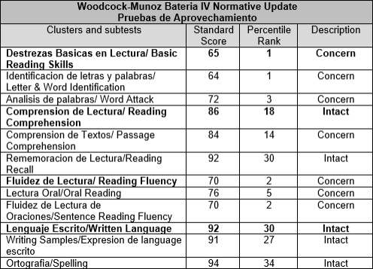

**Summary**:

Overall, and based on information collected in Spanish and English as part of this evaluation, Xavi shows difficulties in basic reading skills in both languages, which has impacted his reading comprehension and reading fluency. At this time, Xavi's scores in Math fall in the average and low average range, it is important to consider language differences and monitor his progress as he transitions to instruction in English and his proficiency in English progresses.

**Academic Assessment History**

**READING, STAAR 5th Grade**

Xavi’s most recent STAAR from May, 2023 indicates that he did not meet grade level expectations. He correctly answered 14 out of 52 questions, or 27%. The reading standards measured on his reading STAAR include: reading: understand and analyze a variety of written texts across reading genres, and writing Revising and Editing: revise and edit a variety of texts from various genres. The graph below compares how Xavi (blue bar) performed compared to his campus peers (black bar) and to that of his district peers (green bar).

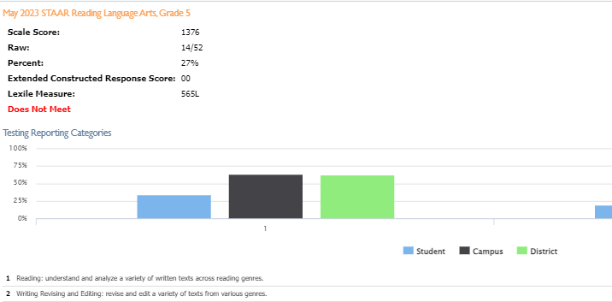

## NWEA Map Growth Reading

Xavi’s September 11, 2023 Northwest Evaluation Association (NWEA) reading growth scores indicate that Xavi’s achievement rate is in the 23rd percentile - indicating low achievement. Xavi scored highest on multiple genres, and lowest on foundational language skills, vocabulary. The graph below tracks Xavi’s 2-year progress in this academic area.

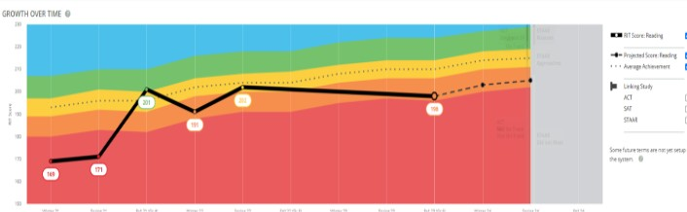

# Reading, Spanish

Xavi’s Spanish language reading assessment was administered April 20, 2022. His Spanish reading NWEA growth scores indicate that Xavi’s Spanish reading growth is in the 23rd percentile, while his Spanish reading achievement was in the 52nd percentile. Xavi performed best on the author’s purpose and craft, and lowest on multiple genres. The graph below tracks Xavi’s 6 month progress in this academic area.

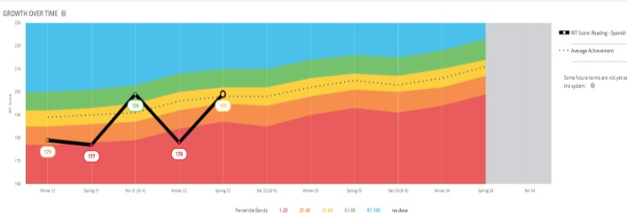

**MATH, STAAR, 5th Grade**

Xavi’s 5th grade May, 2023 math STAAR indicates he scored in the 29th percentile and did not meet grade level expectations. He correctly answered 12 out of 42 questions. The standards assessed were: Numerical Representations and Relationships, Computations and Algebraic Relationships, Geometry and Measurement, Data Analysis and Personal Financial Literacy. The graph below shows Xavi’s performance (blue bar) compared to his campus peers (black bar), and district peers (green bar).

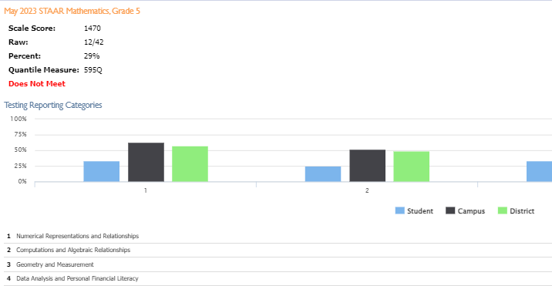

## NWEA Map Growth

Xavi’s September 7, 2023 math Xavi’s Northwest Evaluation Association (NWEA) growth scores indicate that his growth rate is in the 36th percentile, while his achievement rate is in the 27th percentile - indicating low growth and low achievement. Xavi scored highest on data analysis, and lowest on geometry and measurement. The graph below tracks Xavi’s 2-year progress in this academic area.

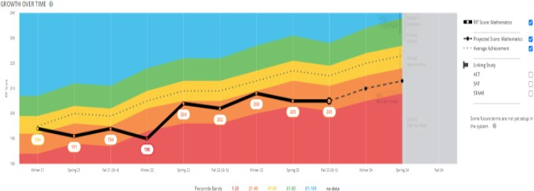

## Report Cards

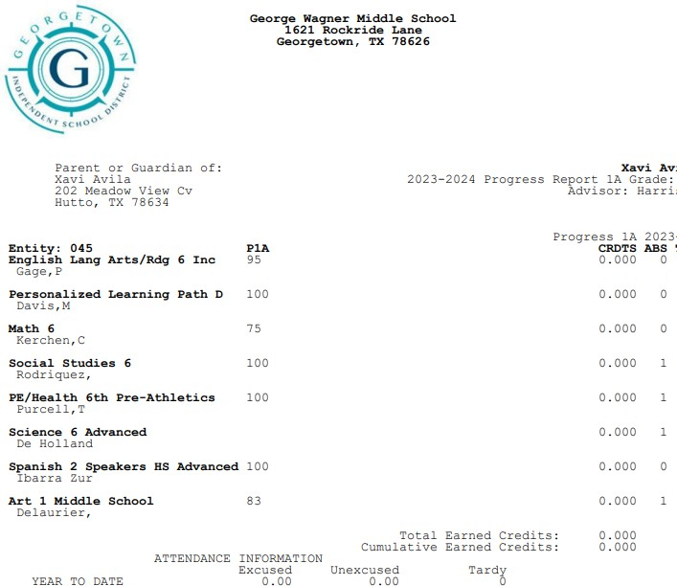

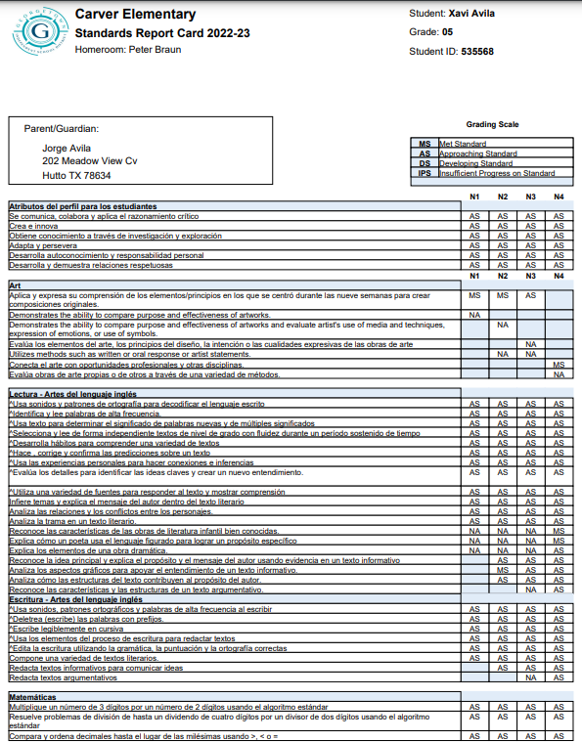

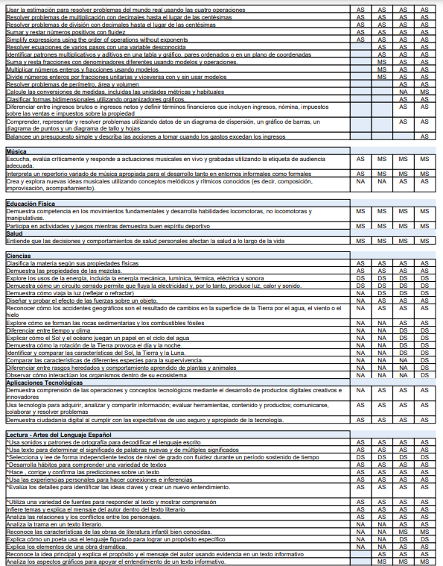

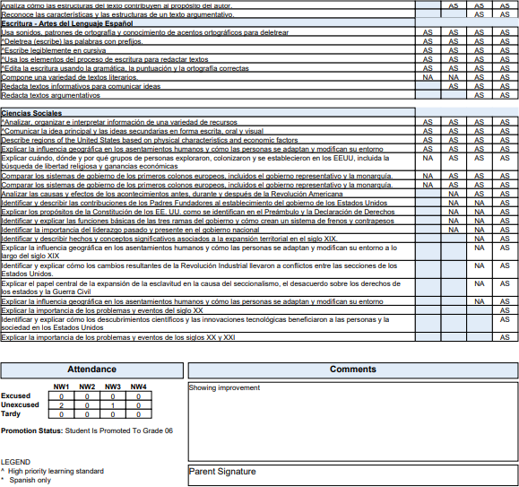

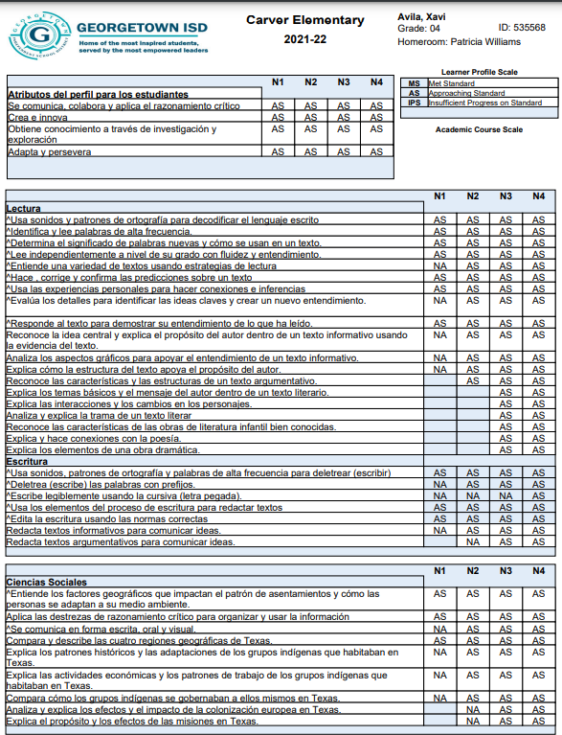

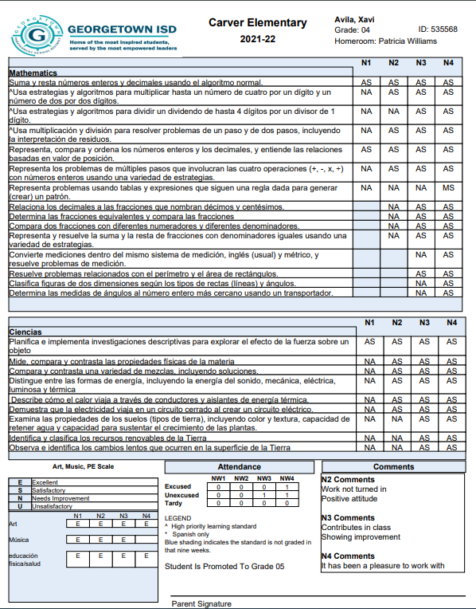

**Current Achievement Evaluation Results**

## Wechsler Individual Achievement Test – Fourth Edition (WIAT-4) Administered by: Ruth Zane

**Evaluation Date: 9-29-2023**

Xavi’s achievement was evaluated using a standardized achievement test along with classroom-based data. The Wechsler Individual Achievement Test, 4th Edition (WIAT-4) is an individually administered test of academic achievement in the areas of reading, writing, and math. It includes basic skills, fluency, and application skills in all three areas. Xavi obtained the following scores:

Wechsler Individual Achievement Test, 4th Edition *(Norms based on grade 6)*

|  |  |  |  |
| --- | --- | --- | --- |
| **Cluster/Test** | **SS** | **Proficiency** | **PR** |
| **DECODING** | **79** | **Low** | **8** |
| Pseudoword Decoding | 80 | Below Average | 9 |
| Word Reading | 81 | Below Average | 10 |
| **ORAL READING FLUENCY** | **74** | **Low** | **4** |
| **READING COMPREHENSION** | **87** | **Low Average** | **19** |
| **MATH CALCULATION SKILLS** | – | – | – |
| Numerical Operations | 89 | Low Average | 23 |
| Math Facts Fluency | 98 | Average | 45 |
| **MATH PROBLEM SOLVING** | **85** | **Low Average** | **16** |
| **WRITTEN EXPRESSION** |  |  |  |
| Sentence Building | 93 | Average | 32 |
| Sentence Combining | 99 | Average | 47 |
| Essay | 72 | Low | 3 |
| Spelling | 66 | Very Low | 1 |

*\*Mean = 100, SD = 15*

**Decoding** **(Basic Reading Skills)**

The Decoding composite provides insight on basic reading skills. This composite consists of Word Reading and Pseudoword Decoding, which measure word vocabulary and the application of phonics. Xavi obtained a composite score of 79, which falls in the 8th percentile (low range). The Word Reading subtest required Xavi to read aloud a list of words that increased in difficulty. He appeared to experience difficulty reading smoothly, as he decoded them. In another instance, Xavi seemed to recognize only the beginning of a word. For instance, he read the word “technique” as “teaching.” He obtained a score of 81, which is in the 10th percentile (below average range). Pseudoword Decoding required Xavi to sound out nonsense words. At times, Xavi added letters to pseudowords presented. He obtained a score of 80, which is in the 9th percentile (below average range).

**Reading** **Comprehension**

The Reading Comprehension test measures aspects of reading fluency, as well as the ability to understand what is being read. On this subtest, Xavi was asked to read a short passage silently and then respond to a series of questions that were asked orally. The story remains open, allowing the student to refer back to the text. Xavi elected to read silently. He was able to correctly answer the initial reading comprehension questions without referring back to the passage to search for the answer. For analytical comprehension questions, Xavi found the text with the information, and read the paragraph back to the evaluator, verbatim. He was asked to answer the question in his own words. The third passage Xavi read was lengthier. When asked his reading comprehension questions, he responded that he forgot what part of the passage the answer was in, and said he did not know. It appeared that the lengthier passages were daunting for him. On one of the last comprehension questions, that asked him to derive the theme of the story, he appeared to guess, responding with a date that was listed in the story. Xavi obtained a score of 87, which is in the 19th percentile (low average range).

## Oral Reading Fluency

The Oral Reading Fluency test measures oral reading fluency kills across more than one passage. This subtest recorded the time elapsed in oral reading and evaluated fluency, prosody, automaticity, and accuracy. Xavi appeared to put forth his best effort but appeared to experience difficulty decoding unfamiliar words. At times, he appeared to recognize the first portion of the word, and then he guessed the rest of the word. For example, for the word “predict” Xavi incorrectly read “protect.” Other difficulties included: skipping lines, difficulty with smoothness and pacing - rarely stopping at the end of a sentence. Xavi was unable to answer the comprehension question that followed each passage. He obtained a score of 74, which is in the 4th percentile (low range).

## Math Calculation Skills

Xavi’s math calculation skills were evaluated using the Numerical Operations subtest. This subtest measures written mathematics calculations skills under untimed conditions. Specifically, it measures addition, subtraction, multiplication, division, algebraic equations and geometric operations as well as higher level skills. Xavi was asked to complete as much of the subtest as he could. Xavi was able to complete single digit addition and subtraction, but only grouping with addition. He attempted single digit multiplication and division, but his responses were not correct. Xavi obtained a score of 89 on Numerical Operations, which is in the 23rd percentile (low average range).

## Math Fluency

Xavi also was administered the Math Fluency subtests, which consisted of timed exercises in addition, subtraction, and multiplication. While these subtests were not factored into his Math Calculation Skills composite score, these subtests measured Xavi’s ability to complete simple, single-digit math problems with automaticity. His composite score on the Math Fluency subtests was 98, which is in the 45th percentile. His detailed subtest scores are as follows: on the Math Fluency Addition subtest, Xavi obtained a score of 103, which is in the 58th percentile (average range); on the Math Fluency Subtraction subtest, Xavi obtained a score of 98, which is in the 45th percentile (average range); on the Math Multiplication subtest, Xavi obtained a score of 94, which is in the 34th percentile (average range).

## Math Problem Solving

The Math Problem Solving subtest measures math problem-solving skills under untimed conditions. Xavi was asked to listen to orally read math problems, look at the corresponding visual stimuli where applicable and then provide oral responses. Xavi was able to correctly respond to oral questions involving coins, graphs, number sequencing, and multi- step word problems. He appeared to experience difficulty with reading an analog clock, identifying place value, and working with fractions. Xavi obtained a score of 85, which is in the 16th percentile (below average range).

## Written Expression Sentence Composition

The Sentence Composition composite has two components: Sentence Building and Sentence Combining. Xavi obtained a composite score of 94, which is in the 34th percentile (average range). The Sentence Building subtest required Xavi to write sentences using a provided word in context. Xavi was able to complete the first five sentences with proper capitalization and punctuation. Xavi wrote fluently and only paused to ask how to spell a word. He was told to sound out words as best he could. Xavi’s sentences expressed logic and organization, with errors that included spelling, and sometimes omitting the “s” out of plural words. Xavi’s 5th sentence was incomplete, resulting in a sentence fragment. Xavi obtained a score of 93, which is in the 32nd percentile (average range). On the Sentence Combining subtest, Xavi was asked to combine two and three sentences into one clear, succinct sentence. His first four sentences contained all the required information, and had proper punctuation, and capitalization. The last two tasks required Xavi to combine three sentences into one, resulting in his last sentence being a run-on sentence. Xavi obtained a score of 99, which is in the 47th percentile (average range).

## Essay

The essay subtest measured Xavi's ability to respond to a presented prompt with a clear thesis and supporting details. This task had a minimum 30 word requirement. Xavi said he enjoyed writing. Xavi wrote his ideas fluently. He did not appear to have difficulty with letter formation, and his writing was legible. He attempted to use commas in his sentence, but they were not used correctly and resulted in a run-on sentence. Xavi obtained a score of 72, which is in the 3rd percentile (low range).

## Spelling

The Spelling subtest required Xavi to write words that were read aloud to him, and used in a sample sentence. Xavi's performance varied - correctly spelling common sight words, but appearing to have difficulty with common vowel diphthongs. Xavi obtained a score of 66, which is in the 1st percentile (very low range).

## Dyslexia Index

The WIAT-4’s Dyslexia Index is comprised of the following three subtests: Word Reading, Pseudoword Decoding, and Orthographic Fluency. The first two subtests were described above. The third subtest, Orthographic Fluency, measured Xavi's orthographic lexicon, or sight vocabulary. Xavi read aloud a list of irregular words as quickly as possible during two timed trials. He obtained a score of 77, which is in the 6th percentile (low range).

## Achievement Summary:

Xavi was successful in the area of reading comprehension, math problem solving, and math calculation skills. Sentence Composition. Xavi appears to struggle in basic reading skills, reading fluency, and written expression. Compared to standardized achievement scores Xavi wrote his ideas fluently. He did not appear to have difficulty with letter formation, and his writing was neat and legible. According to data from his 2020 FIE, Xavi’s academic areas in: reading comprehension, and written expression were significantly lower.

## Dyslexia Review

Ms. Marjorie Davis, Provider of Dyslexia Instruction at Wagner reviewed Xavi's current data, as well as his academic history. Ms. Davis provides Xavi direct dyslexia instruction, and she indicates Xavi continues to benefit from decoding / spelling instruction.

Xavi appears to need specialized instruction in the areas of decoding, spelling, reading fluency, oral expression, and listening comprehension.

This evaluation is considered a valid representation of the student’s current levels of functioning in the areas assessed. The purpose of the Full and Individual Evaluation is to identify the presence or absence of a disability condition and provide information regarding the student’s needs within the educational setting. All determinations pertaining to eligibility, educational planning/programming, services to be provided, and placements remain the responsibility of the ARD committee.

Child is below grade level in reading.

El niño está por debajo del nivel de grado en lectura.

*If yes, describe child's history of reading instruction:*

*En caso afirmativo, describir el historial de instrucción de lectura del niño:*

Xavi has been receiving specialized instruction in reading.

Child is below grade level in math.

El niño está por debajo del nivel de grado en matemáticas.

*If yes, describe child's history of math instruction:*

*En caso afirmativo, describir la historia de instrucción matemática del niño:*

Child's low achievement is the result of limited English proficiency.

El bajo logro del niño es el resultado de un dominio limitado del inglés.

*If yes, describe:*

*En caso afirmativo, describir:*

 Yes  No

Si No

 Yes  No

Si No

 Yes  No

Si No

While Xavi is an emergent bilingual learner and participated in GISD's dual language program, his limited English proficiency is not the primary factor in his learning difficulties.



**2H. ASSISTIVE TECHNOLOGY**

**2H. TECNOLOGÍA DE ASISTENCIA**

Not applicable

No aplica

**Results and interpretations: Resultados e interpretaciones:**

Xavi’s assistive technology needs were considered. Based on the evaluation data gathered in all areas of this Full and Individualized Evaluation, Xavi would benefit from the following assistive technology: text-to-speech, speech-to-text, and content language supports. While assistive technology is recommended, it is an ARD committee decision.

Assistive technology devices and/or services are recommended.

Resultados e interpretaciones:

 Yes  No

Si No

*If yes, child is not be able to participate in the educational program or make resonable progress toward mastery of IEP goals and objectives without assistive technology, devices and/or services.*

*En caso afirmativo, el niño no podrá participar en el programa educativo ni lograr un progreso razonable hacia el dominio de las metas y objetivos del IEP sin tecnología, dispositivos y/o servicios de asistencia.*

Explain:

Explicar:

In order for Xavi to progress in the general education curriculum, the above assistive technology is recommended.

**3. SUMMARY OF ASSESSMENT RESULTS**

**3. RESUMEN DE LOS RESULTADOS DE LA EVALUACIÓN**

Xavi is a 6th grade student at Wagner Middle School in Georgetown ISD. Xavi previously met TEA criteria as a student with a specific learning disability in the area of basic reading skills (dyslexia). The purpose of this reevaluation is to obtain updated information on Xavi’s strengths and weaknesses for his educational programming, and to determine whether or not Xavi continues to require special education services to enable him to progress academically.

Xavi does not exhibit any health or sociological problems that would be the primary cause of his learning patterns. Xavi began attending Wagner Middle School in 6th grade, and previously attended Carver Elementary. Academic records do not indicate excessive absences. Lack of educational opportunity is not a factor in Xavi’s learning difficulties.

## Language Proficiency

Xavi is an emergent bilingual learner. Xavi's Home Language Survey indicates Spanish is spoken in the home, and he participated in GISD's dual language program at Carver Elementary since kindergarten. Xavi was administered a language proficiency assessment was conducted in order to determine language dominance. Xavi’s results indicate that his cognitive academic proficiency proficiency (CALP) is equal in English and Spanish. Xavi’s language acquisition should be considered when interpreting his evaluation results.

## SLD Consideration

Xavi’s current cognitive assessments indicate a pattern of strengths and weaknesses. His cognitive strengths include: Comprehension Knowledge, Fluid Reasoning, Short-Term Working Memory, Processing Speed, Long-Term Retrieval - Learning Efficiency, Long-Term Retrieval - Retrieval Fluency, and Visual Processing. His cognitive deficit is the narrow ability of Phonetic Coding, within the broad ability of Phonological Awareness. Xavi has been receiving dyslexia instruction, thus the other narrow abilities under the Phonological Awareness ability are within the low average and average range. Xavi’s cognitive profile, which is comprised of strengths and weaknesses, indicates that Xavi meets the eligibility criteria for a Specific Learning Disability 34 CFR, §300.8(c) (10).

A student with a cognitive deficit in the narrow ability of Phonological Awareness may experience difficulty in decoding, and discriminating auditory stimuli, which is important in spelling, and reading fluency.

When applying the pattern of strengths and weaknesses model, to find that the student meets the eligibility criteria for a Specific Learning Disability 34 CFR, §300.8(c) (10) , a determination must be made that: [1] The child exhibits a pattern of strengths and weaknesses in performance and/or achievement; [2] The pattern is relative to age, state-approved grade-level standards, or intellectual development; [3] The pattern is evident as indicated by significance variance among specific areas of cognitive functioning, between specific areas of cognitive functioning and academic achievement; and

[4] The pattern is relevant to the identification of an SLD using appropriate assessments. Xavi’s cognitive deficit in Phonological Awareness appears to be related to his academic difficulties in **basic reading skills, reading fluency, oral expression, and listening comprehension.**

***Final decisions regarding eligibility remain the responsibility of the ARD committee.***

**Dyslexia and Dysgraphia Considerations**

**Dyslexia Consideration:**

1. Is there a deficit in one or more of the primary characteristics of dyslexia (difficulty reading real words in isolation, difficulty decoding nonsense words, poor reading fluency, and poor spelling, including alphabet fluency, letter knowledge, and letter/sound correspondence)? **YES**

1. Is there a deficit in phonological processing or orthographic competencies (the underlying cause of dyslexia)?

## YES

1. Is there evidence of unexpectedness (the child’s reading and spelling difficulties are unexpected in relation to other cognitive abilities)? **YES**

Specific learning disability does not include learning problems that are primarily the result of visual, hearing, or motor disabilities, of intellectual disability, of emotional disturbance, or of environmental, cultural, or economic disadvantage.

Given the data presented, Xavi meets the criteria for the condition of dyslexia. Therefore, he meets disability criteria for a student with a learning disability in (basic reading, and reading fluency).

**Dysgraphia Consideration:**

It must be determined if a student’s difficulties in the areas of writing and spelling reflect a pattern of evidence for the primary characteristics of dysgraphia with unexpectedly low performance in some or all of the following: handwriting, writing fluency, written expression, and spelling.

1. Do the data show the following characteristics and consequences of dysgraphia? **NO**

Illegible and/or inefficient handwriting with variably shaped and poorly formed letters Difficulty with unedited written spelling

Low volume of written output as well as problems with other aspects of written expression

Xavi’s handwriting is legible, with proper spacing, and attempts at punctuation. Xavi says he likes to write, and he does not appear to delay transferring his ideas to paper. However, teacher feedback indicates that Xavi has a low volume of written output.

1. Do these difficulties (typically) result from a deficit in graphomotor function (hand movements used for writing) and/or storing and retrieving orthographic codes (letter forms)? **NO**

Xavi’s handwriting does not indicate difficulty with letter formation.

1. Are these difficulties unexpected for the student’s age in relation to the student’s other abilities and the provision of effective classroom instruction? **YES**

Xavi’s cognitive profile is in the average range, and consists of more strengths than weaknesses. His difficulties in written expression appear to be related to his difficulties with spelling and decoding.

1. Does the pattern indicate the student has dysgraphia? **NO**

Given the data presented, Xavi **does not** meet the disability criteria for the condition of dysgraphia.

When considering the results of this evaluation and all contributing sources of data it is concluded that Xavi ***does* meet** IDEA/TEA disability criteria as a student with a Specific Learning Disability in the areas of **basic reading skills (dyslexia), reading fluency, oral expression, and listening comprehension.**

*Based on multiple sources of data, Xavi appears to meet the criteria for dyslexia as outlined in the 2021 Dyslexia Handbook and HB 3928 - Dyslexia Evaluation, Identification and Instruction (Source: Texas Legislature 88th Legislative Session - August 3, 2023).

## Additional Resources related to Dyslexia:

For a student identified with dyslexia or a related disorder, see the Dyslexia Handbook and Talking Book Program web pages or [https://www.spedtex.org](http://www.spedtex.org/) for more information.

HB 3928 - Dyslexia Evaluation, Identification and Instruction (Source: Texas Legislature 88th Legislative Session - August 3, 2023): Dyslexia is a specific learning disability (SLD). The bill created TEC §29.0031 that now states dyslexia is an example of and meets the definition of a SLD under IDEA. This is in conformity with IDEA’s federal regulations at 34

C.F.R. §300.8(c)(10), which specifically lists dyslexia as an example of an SLD. https://tea.texas.gov/about-tea/news-and-multimedia/correspondence/taa-letters/house-bill-hb-3928

**4. RECOMMENDATIONS TO THE ARD COMMITTEE**

**4. RECOMENDACIONES AL COMITÉ ARD**

The group of qualified professionals that determines whether the child is a child with a disability and the educational needs of the child is the child's Admission, Review and Dismissal (ARD) Committee.

El grupo de profesionales calificados que determina si el niño es un niño con una discapacidad y las necesidades educativas del niño es el Comité de Admisión, Revisión y Retiro (ARD) del niño.

**ELIGIBILITY ELEGIBILIDAD**

1. Child meets the criteria for a specific disability condition.
   1. El niño cumple con los criterios para una condición de discapacidad específica.

*Complete applicable disability reports.*

*Complete los informes de discapacidad aplicables.*

*If yes, check:*

*En caso afirmativo, marque:*

 (01) Orthopedic Impairment

* + 1. Impedimento Ortopédico

 (02) Other Health Impairment

* + 1. Otro Impedimento de Salud

 (03) Deaf/Hard of Hearing

* + 1. Sordo/con Dificultades Auditivas

 (04) Visual Impairment

* + 1. Impedimento Visual

 (05) Deaf-Blind

* + 1. Sordo-Ciego

 (06) Intellectual Disability

* + 1. Discapacidad Intelectual

 (07) Emotional Disturbance

* + 1. Trastorno Emocional

 (08) Specific Learning Disability. Area:

* + 1. Discapacidad Específica de Aprendizaje

Basic reading skills (dyslexia), reading fluency, oral expression, and listening comprehension.

 (09) Speech Impairment

* + 1. Impedimento del Habla

 (10) Autism

(10) Autismo

 (13) Traumatic Brain Injury

(13) Lesión Cerebral por Trauma

 (14) Noncategorical Early Childhood

(14) Primera Infancia No Categórica

 Yes  No

Si No

1. By reason of the disability, the child needs special education and related services. 

II. Por razón de la discapacidad, el niño necesita educación especial y servicios relacionados.

*If the child has one of the disabilities but only needs a related service and not special education, the child is not a child with a disability under the Individuals with Disabilities Education Act.*

*Si el niño tiene una de las discapacidades, pero solo necesita un servicio relacionado y no educación especial, el niño no es un niño con una discapacidad según la Ley de Educación para Individuos con Discapacidades.*

Explain:

Explicar:

**Impact Statement**

Yes  No

Si No

Xavi’s deficit in the narrow ability of Phonetic Coding within the broader Auditory Processing may make it difficult for Xavi to decode unfamiliar words, thereby affecting his reading fluency. Without targeted, systematic and explicit instruction/interventions along with accommodations students with dyslexia may have reduced reading experiences that may impact the growth of vocabulary and background knowledge, as well as reading fluency.

Xavi’s narrow ability of Short-Term Working Memory may impact his ability to acquire new content, and he may experience difficulty memorizing sight words. Additionally, this cognitive deficit could cause Xavi difficulties in organizing his ideas to verbally express himself, thereby making oral expression difficult. Remembering multi-step directions may also be difficult for Xavi, impacting his listening comprehension in the classroom.

**Child meets the eligibility criteria for special education**

**El niño cumple con los criterios de elegibilidad para educación especial.**

*(answer to both questions above must be Yes).*

*(La respuesta a ambas preguntas anteriores debe ser Si).*

*If no, recommendations: Si no, recomendaciones:*

 Yes  No

Si No

## All determinations pertaining to eligibility, educational planning/programming, and the educational need for special education supports or services to be provided and placements remain the responsibility of the ARD committee.

*If yes:*

*En caso afirmativo:*

Primary Disability: Discapacidad Primaria:

Secondary Disability: Discapacidad Secundaria:

Tertiary Disability:

Discapacidad Terciaria:

(08) Specific Learning Disability / (08) Discapacidad Específica de Aprendizaje

Child has dyslexia or related disorder.

El niño tiene dislexia o trastorno relacionado.

Child has multiple disabilities.

El niño tiene múltiples discapacidades.

 Yes

Si

 No

No

 Yes

Si

 No

No Yes

Area of specific learning disability, if applicable:

Área de discapacidad específica de aprendizaje, si es que aplica:

basic reading skills (dyslexia), reading fluency, oral expression, and listening comprehension.

Si

Child is medically fragile.  No

El niño es médicamente frágil. No

**IEP RECOMMENDATIONS RECOMENDACIONES DEL IEP**

Recommendations for the content of the child's IEP. Include information related to enabling the child to be involved in and progress in the general education curriculum, or, for preschool children, to participate in appropriate activities:

Recomendaciones para el contenido del IEP del niño. Incluir información relacionada con permitir que el niño participe y progrese en el currículo de educación general o, para niños en edad preescolar, participe en actividades apropiadas:

## Recommendations include but are not restricted to the following:

**Accommodations**

Oral read all

Extra time to complete assignments Content & language supports Spelling assistance

Text-to-speech, speech to text

**Instructional Strategies**

Evidence-based instructional strategies are recommended for developing Xavi's IEP. Given that Xavi appears to have the condition of dyslexia, the instructional/intervention requirements of the Dyslexia Handbook must be considered by the ARD Committee.

Recommended Instructional strategies include:

Before introducing a new concept or skill, activate prior knowledge to enhance understanding. Prior knowledge can be activated by: 1.) asking questions about the topic being taught, 2.) sharing personal experiences related to the topic, 3.) brainstorming everything the student(s) knows about the topic, 4.) asking the student to identify what the student still needs to learn about the subject matter, 5.) asking the student to respond to opinion statements that prompt discussion regarding the topic (e.g., when discussing the defining characteristics of fruits and vegetables ask: What do you like best about spinach? About apples?, etc.).

Use a multi-method, multi-sensory approach to teach sight words. Teach individual sight words by reading the word to the student, having the student read the word back several times, having the student use the word in sentences, having the student trace over the written word while saying the sounds, and having the student write the word from memory while checking and correcting after each attempt. Provide immediate feedback/error correction. Assigning a peer tutor or parent volunteer might be necessary to accomplish this routine.

Provide opportunities for the student to preview passages from the basal reading program before the passages are read in class. In this procedure, the student listens to a peer tutor read a passage or reads along with a peer tutor. Use the repeated reading method to improve reading fluency. In this strategy a baseline reading rate of words correct per minute is established for a passage from the student=s basal reading text. The instructor assists the student to plot this information on a graph and set a goal. Across daily sessions the student re-reads the same passage orally and plots his reading fluency (i.e., words correct per minute) on the graph. Reinforcement is provided when the student reaches the reading fluency goal and the process begins again with a new passage. Goal setting and regular plotting of data by the student are important parts of this method.

Review rote information frequently. Expand time for rehearsal and practice by using peer tutors or teaching assistants to employ structured practice activities. Rehearsing information immediately after it is learned and intermittently thereafter will likely be helpful.

Strong phonemic awareness skills predict ease in reading development. As a result, it is important that steps be taken to develop and strengthen phonemic awareness skills including segmenting words into syllables, development of rhyming ability, blending phonemes into words and segmenting words into phonemes. In addition, the student should develop skills to manipulate phonemes in words including deleting, adding and substituting phonemes to make new words.

Consider using view guides, whereby the student completes a worksheet while watching an instructional video or movie. This worksheet guide assists the student in using listening comprehension skills purposefully during a lesson. To improve oral expression skills, provide safe opportunities for Xavi to practice. For example, do not grade presentations. Consider them an exercise in skill development.

Specific recommendations for positive behavioral interventions and supports, and other strategies (required for a child who meets the criteria for autism or emotional disturbance):

Recomendaciones específicas para intervenciones y apoyos conductuales positivos y otras estrategias (requeridas para un niño que cumple con los criterios de autismo o trastorno emocional):

**RELATED SERVICES SERVICIOS RELACIONADOS**

**Results and interpretations: Resultados e interpretaciones:**

Does the child require a related service to benefit from special education?

¿El niño requiere un servicio relacionado para beneficiarse de la educación especial?

 Yes  No

Si No

|  |  |  |  |
| --- | --- | --- | --- |
| **Related Service**  **Servicio Relacionado** | **Mins**  **Minutos** | **Frequency**  **Frecuencia** | **Location**  **Ubicación** |

**5. ASSURANCES**

**5. GARANTÍAS**

**Initials Iniciales**

Assessments and other evaluation materials used to assess the child were: RZ Las evaluaciones y otros materiales de evaluación utilizados para evaluar al niño fueron:

Selected and administered so as not to be discriminatory on a racial or cultural basis; Seleccionados y administrados de manera que no sean discriminatorios por motivos raciales o culturales;

Provided and administered in the child's native language or other mode of communication; and in the form most likely to yield accurate information on what the child knows and can do academically, developmentally, and functionally, unless it was not feasible to so provide or administer;

Proporcionados y administrados en el idioma nativo del niño u otro modo de comunicación; y en la forma que tenga más probabilidades de proporcionar información precisa sobre lo que el niño sabe y puede hacer académicamente, referente al desarrollo y funcionalmente, a menos que no fuera factible proporcionarlo o administrarlo;

Used for the purposes for which the assessments or measures are valid and reliable; Utilizados para los fines para los cuales las evaluaciones o medidas son válidas y confiables;

Administered by trained and knowledgeable personnel; and Administrados por personal capacitado y conocedor; y

Adminstered in accordance with any instructions provided by the producer of the assessments.

Administrados de acuerdo con las instrucciones proporcionadas por el productor de las evaluaciones.

Assessments and other evaluation materials included those tailored to assess specific areas of educational need RZ and not merely those that are designed to provide a single general intelligence quotient.

Las evaluaciones y otros materiales de evaluación incluyeron aquellos diseñados para evaluar áreas específicas de necesidad educativa y no simplemente aquellos que están diseñados para proporcionar un único coeficiente de inteligencia general.

Assessments were selected and administered so as to best ensure that if an assessment was administered to a RZ child with impaired sensory, manual, or speaking skills, the assessment results accurately reflect the child's

aptitude or achievement level or whatever other factors the test purports to measure, rather than reflecting the child's impaired sensory, manual, or speaking skills (unless those are the skills the test purports to measure).

Las evaluaciones se seleccionaron y administraron para garantizar mejor que si se administró una evaluación a un niño con impedimento sensorial, manual o del Habla, los resultados de la evaluación reflejen con precisión la aptitud o el nivel de logro del niño o cualquier otro factor que la prueba pretenda medir en lugar de reflejar los impedimentos sensoriales, manuales o del Habla del niño (a menos que esas sean las habilidades que la prueba pretende medir).

The child was assessed in all areas of suspected disability, including, if appropriate, health, vision, hearing, social RZ and emotional status, general intelligence, academic performance, communicative status, and motor abilities.

El niño fue evaluado en todas las áreas de sospecha de discapacidad, incluyendo, si era apropiado, salud, visión, audición, estado social y emocional, inteligencia general, rendimiento académico, estado comunicativo y habilidades motoras.

The evaluation was sufficiently comprehensive to identify all of the child's special education and related services RZ needs, whether or not commonly linked to the disability category in which the child has been classified.

La evaluación fue lo suficientemente completa como para identificar todas las necesidades de educación especial y servicios relacionados del niño, ya sea que estén o no comúnmente relacionadas con la categoría de discapacidad en la que se ha clasificado al niño.

Assessment tools and strategies that provide relevant information that directly assists persons in determining RZ the educational needs of the child were provided.

Se proporcionaron herramientas y estrategias de evaluación que brindan información relevante que ayuda directamente a las personas a determinar las necesidades educativas del niño.

Evaluation implemented assessment procedures that differentiate between language proficiency and disability. RZ La evaluación implementó procedimientos de evaluación que diferencian entre dominio del idioma y

discapacidad.

**6. SIGNATURES**

**6. FIRMAS**

The names, titles and signatures below identify the members of the evaluation team and indicate whether or not each team member is in agreement with the conclusions of the report.

Los nombres, títulos y firmas a continuación identifican a los miembros del equipo de evaluación e indican si cada miembro del equipo está de acuerdo o no con las conclusiones del reporte.

|  |  |  |  |  |
| --- | --- | --- | --- | --- |
| NAME  NOMBRE | TITLE  TÍTULO | SIGNATURE  FIRMA | DATE  FECHA | AGREED  ACORDÓ |
| Ruth Zane | Educational Diagnostician |  | 10/19/2023 | Yes  No  Si No |
| Marjorie Davis | Provider of Dyslexia Instruction |  | 10/19/2023 | Yes  No  Si No |

**STATEMENT OF DISAGREEMENT DECLARACIÓN DE DESACUERDO**

If a team member is not in agreement with the team's determination, the team member may include a written statement of the basis of the disagreement.

Si un miembro del equipo no está de acuerdo con la determinación del equipo, el miembro del equipo puede incluir una declaración escrita con la base del desacuerdo.

*Specific learning disability*

**DISABILTY REPORT | SPECIFIC LEARNING DISABILITY**

**INFORME DE DISCAPACIDAD | DISCAPACIDAD ESPECIFICA DE APRENDIZAJE**

*Discapacidad especifica de aprendizaje*

(SLD) is a disorder in one or more of the basic psychological processes involved in understanding or in using language that is spoken or written, that may manifest itself in the imperfect ability to listen, think, speak, read, write, spell, or to do mathematical calculations:

(SLD por sus siglas en inglés) es un trastorno en uno o más de los procesos psicológicos básicos involucrados en la comprensión o el uso del lenguaje hablado o escrito, que puede manifestarse en la capacidad imperfecta para escuchar, pensar, hablar, leer, escribir, deletrear o hacer cálculos matemáticos:

The term includes conditions such as perceptual disabilities, brain injury, minimal brain dysfunction, dyslexia, and developmental aphasia; and

El término incluye condiciones tales como discapacidades de percepción, lesiones cerebrales, disfunción cerebral mínima, dislexia y afasia del desarrollo; y

The term does not include a learning problem that is primarily the result of visual, hearing, or motor disabilities, of an intellectual disability, or emotional disturbance, or of environmental, cultural, or economic disadvantage.

El término no incluye un problema de aprendizaje que sea principalmente el resultado de discapacidades visuales, auditivas o motoras, de una discapacidad intelectual o de un trastorno emocional, o de una desventaja ambiental, cultural o económica.

Child:

Niño:

Xavi Avila Student ID:

Identificación del Estudiante:

535568 DOB:

Fecha de Nacimiento:

08/14/2012

**EVALUATION PROCEDURES PROCEDIMIENTOS DE EVALUACIÓN**

*The group of qualified professionals that collected or reviewed evaluation data in connection with the determination of the child's eligibility based on an SLD included:*

*El grupo de profesionales calificados que recopiló o revisó datos de evaluación en relación con la determinación de la elegibilidad del niño con base en un SLD incluyó:*

1. The child's regular teacher; or if the child does not have a regular teacher, a regular classroom teacher qualified to teach children of this age; or for a child whose age is less than school age, an individual qualified by the Texas Education Agency to teach children of this age.
   1. El maestro titular del niño; o si el niño no tiene un maestro regular, un maestro regular de aula calificado para enseñar a niños de esta edad; o para un niño cuya edad es menor que la edad escolar, una persona calificada por la Agencia de Educación de Texas para enseñar a niños de esta edad.

 Yes  No

Si No

* 1. At least one person qualified to conduct individual diagnostic examinations of children such as a licensed specialist in school psychology; a speech-language pathologist; or a remedial reading teacher.

1. Al menos una persona calificada para realizar exámenes de diagnóstico individuales de niños, como un especialista licenciado en psicología escolar; un terapeuta del Habla; o un maestro de lectura remedial.

 Yes  No

Si No

*Observation: Observación:*

1. Child was observed in the child's learning environment, including the regular classroom setting, to document the child's academic performance and behavior in the areas of difficulty. For the child less than school age or out of school, a member of the group of qualified professionals observed the child in an environment appropriate for a child of that age.
2. Se observó al niño en su ambiente de aprendizaje, incluido el aula regular, para documentar el desempeño académico y el comportamiento del niño en las áreas de dificultad. Para el niño menor de edad escolar o no escolarizado, un miembro del grupo de profesionales calificados observó al niño en un ambiente apropiado para un niño de esa edad.

*Explain or reference data or evidence:*

*Explicar o hacer referencia a datos o evidencia:*

See Emotional/Behavioral section of the FIE for a full narrative of his classroom observation.

 Yes  No

Si No

In determining whether the child has an SLD, the group of qualified professionals: Para determinar si el niño tiene una SLD, el grupo de profesionales calificados:

 Used information from an observation in routine classroom instruction and monitoring of the child's performance that was done before the child was referred for an evaluation

Se utilizó información de una observación en la instrucción rutinaria en el aula y el monitoreo del desempeño del niño que se realizó antes de que el niño fuera referido para una evaluación.

 Had at least one member of the group conduct an observation of the child's academic performance in the regular classroom after the child was referred for an evaluation and consent was obtained from the parent.

Que al menos un miembro del grupo realizara una observación del rendimiento académico del niño en el aula regular después de que el niño fuera referido para una evaluación y se obtuviera el consentimiento del padre.

Relevant behavior, if any, noted during the observation of the child:

Comportamiento relevante, si es que lo hay, notado durante la observación del niño:

Relationship of that behavior to the child's academic functioning:

Relación de ese comportamiento con el funcionamiento académico del niño:

**ELIGIBILITY CRITERIA CRITERIOS DE ELEGIBILIDAD**

1. Child has been determined through a variety of assessment tools and strategies to meet the criteria for the SLD.
2. Se ha determinado que el niño cumple con los criterios para la SLD mediante una variedad de herramientas y estrategias de evaluación.

*Explain or reference data or evidence:*

*Explicar o hacer referencia a datos o evidencia:*

## SLD Consideration

 Yes  No

Si No

Xavi’s current cognitive assessments indicate a pattern of strengths and weaknesses. His cognitive strengths include: Comprehension Knowledge, Fluid Reasoning, Short-Term Working Memory, Processing Speed, Long-Term Retrieval - Learning Efficiency, Long-Term Retrieval - Retrieval Fluency, and Visual Processing. His cognitive deficit is the narrow ability of Phonetic Coding, within the broad ability of Phonological Awareness. Xavi has been receiving dyslexia instruction, thus the other narrow abilities under the Phonological Awareness ability are within the low average and average range. Xavi’s cognitive profile, which is comprised of strengths and weaknesses, indicates that Xavi meets the eligibility criteria for a Specific Learning Disability 34 CFR, §300.8(c) (10).

A student with a cognitive deficit in the narrow ability of Phonological Awareness may experience difficulty in decoding, and discriminating auditory stimuli, which is important in spelling, and reading fluency.

When applying the pattern of strengths and weaknesses model, to find that the student meets the eligibility criteria for a Specific Learning Disability 34 CFR, §300.8(c) (10) , a determination must be made that: [1] The child exhibits a pattern of strengths and weaknesses in performance and/or achievement; [2] The pattern is relative to age, state-approved grade-level standards, or intellectual development; [3] The pattern is evident as indicated by significance variance among specific areas of cognitive functioning, between specific areas of cognitive functioning and academic achievement; and

[4] The pattern is relevant to the identification of an SLD using appropriate assessments. Xavi’s cognitive deficit in Phonological Awareness, and Short-Term Working Memory appears to be related to his academic difficulties in **basic reading skills, reading fluency, oral expression, and listening comprehension.**

1. Child does not achieve adequately for the child's age or to meet state-approved grade-level standards, in one or more of the following areas.
2. El niño no logra un rendimiento adecuado para su edad o para cumplir con los estándares de nivel de grado aprobados por el estado, en una o más de las siguientes áreas.

*If yes, check:*

*En caso afirmativo, marcar:*

 Yes  No

Si No

 Oral expression Expresión oral

 Written expression Expresión escrita

 Listening comprehension Comprensión auditiva

 Basic reading skills Habilidad de lectura básica

 Reading fluency skills

Habilidades de fluidez de lectura

 Mathematics problem solving

 Reading comprehension Comprensión de lectura

 Mathematics calculation Cálculo matemático

Resolución de problemas matemáticos

*Explain or reference data or evidence:*

*Explicar o hacer referencia a datos o evidencia:*

A convergence of data including standardized assessments, curriculum-based assessments, state-wide assessments, teacher input, and classroom observations indicate Xavi has achievement deficits in the areas of basic reading skills (dyslexia), reading fluency, oral expression, and listening comprehension.

1. Child's lack of adequate achievement is indicated by performance on multiple measures.
2. La falta de logro adecuado del niño se indica por el desempeño en múltiples medidas.

*If yes, check:*

*En caso afirmativo, marcar:*

 Yes  No

Si No

 In-class tests Pruebas en clase

 Grade average over time (e.g., six weeks, semester)

Promedio de calificaciones a lo largo del tiempo (por ejemplo, seis semanas, semestre)

 Norm or criterion-referenced tests Pruebas basadas en normas o criterios

 Statewide assessments Evaluaciones estatales

 A process based on the child's response to evidence-based intervention

Un proceso basado en la respuesta del niño a una intervención basada en evidencia

*Explain or reference data or evidence:*

*Explicar o hacer referencia a datos o evidencia:*

The preponderance of data, including answers to #4, #5, and #8, indicate a lack of adequate achievement for Xavi. Please see FIE for more information.

1. Child meets one of the following criteria.
2. El niño cumple con uno de los siguientes criterios.

*If yes, select:*

*En caso afirmativo, seleccionar:*

Child does not make sufficient progress under the additional criteria of the *RtI Model*

 Yes  No

Si No

El niño no progresa lo suficiente según los criterios adicionales del *Modelo RtI*

 Child meets the additional criteria of the

El niño cumple con los criterios adicionales del

*Pattern of Strengths and Weaknesses Model Modelo de Patrón de Fortalezas y Debilidades*

**PATTERNS OF STRENGTHS AND WEAKNESSES MODEL MODELO DE PATRONES DE FORTALEZAS Y DEBILIDADES**

**ADDITIONAL CRITERIA CRITERIOS ADICIONALES**

*(answers to all questions below must be Yes)*

*(Las respuestas a todas las preguntas a continuación deben ser Si)*

1. Child exhibits a pattern of strengths and weaknesses in performance, achievement or both.
   1. El niño exhibe un patrón de fortalezas y debilidades en el desempeño, logro o ambos.

*Explain or reference data or evidence:*

*Explicar o hacer referencia a datos o evidencia:*

 Yes  No

Si No

Xavi’s current cognitive assessments indicate a pattern of strengths and weaknesses. His cognitive strengths include: Comprehension Knowledge, Fluid Reasoning, Short-Term Working Memory, Processing Speed, Long-Term Retrieval - Learning Efficiency, Long-Term Retrieval - Retrieval Fluency, and Visual Processing. His cognitive deficit is the narrow ability of Phonetic Coding, within the broad ability of Phonological Awareness. Xavi has been receiving dyslexia instruction, thus the other narrow abilities under the Phonological Awareness ability are within the low average and average range. Xavi’s cognitive profile, which is comprised of strengths and weaknesses, indicates that Xavi meets the eligibility criteria for a Specific Learning Disability 34 CFR, §300.8(c) (10).

* 1. The pattern is relative to age, state-approved grade-level standards or intellectual development.

1. El patrón es relativo a la edad, los estándares de nivel de grado aprobados por el estado o el desarrollo intelectual.

*Explain or reference data or evidence:*

*Explicar o hacer referencia a datos o evidencia:*

 Yes  No

SI No

Xavi’s cognitive deficit in Phonological Awareness, and Short-Term Working Memory appears to be related to his academic difficulties in **basic reading skills, reading fluency, oral expression, and listening comprehension.**

1. The pattern is evident as indicated by significant variance among specific areas of cognitive function such as working memory and verbal comprehension or between specific areas of cognitive function and academic achievement.

C. El patrón es evidente como lo indica la variación significativa entre áreas específicas de la función cognitiva, como la memoria de trabajo y la comprensión verbal, o entre áreas específicas de la función cognitiva y el rendimiento académico.

 Yes  No

Si No

*Explain or reference data or evidence:*

*Explicar o hacer referencia a datos o evidencia:*

Xavi's cognitive profile demonstrates deficits in Phonological Awareness, and Short-Term Working Memory.

1. The pattern is relevant to the identification of an SLD using appropriate assessments.

d. El patrón es relevante para la identificación de una SLD mediante evaluaciones apropiadas.

*Explain or reference data or evidence:*

*Explicar o hacer referencia a datos o evidencia:*

Please see above.

1. Child has a disorder in one or more of the basic psychological processes involved in understanding or in using language that is spoken or written. Disorder may manifest itself in the imperfect ability to listen, think, speak, read, write, spell, or to do mathematical calculations. Includes conditions such as perceptual disabilities, brain injury, minimal brain dysfunction, dyslexia, and developmental aphasia.
2. El niño tiene un trastorno en uno o más de los procesos psicológicos básicos implicados en la comprensión o el uso del lenguaje hablado o escrito. El trastorno puede manifestarse en la capacidad imperfecta para escuchar, pensar, hablar, leer, escribir, deletrear o realizar cálculos matemáticos. Incluye afecciones como discapacidades de percepción, lesión cerebral, disfunción cerebral mínima, dislexia y afasia del desarrollo.

*Explain or reference data or evidence:*

*Explicar o hacer referencia a datos o evidencia:*

**Dyslexia Consideration:**

 Yes  No

Si No

 Yes  No

Si No

* 1. Is there a deficit in one or more of the primary characteristics of dyslexia (difficulty reading real words in isolation, difficulty decoding nonsense words, poor reading fluency, and poor spelling, including alphabet fluency, letter knowledge, and letter/sound correspondence)? **YES**

1. Is there a deficit in phonological processing or orthographic competencies (the underlying cause of dyslexia)?

## YES

1. Is there evidence of unexpectedness (the child’s reading and spelling difficulties are unexpected in relation to other cognitive abilities)? **YES**

Specific learning disability does not include learning problems that are primarily the result of visual, hearing, or motor disabilities, of intellectual disability, of emotional disturbance, or of environmental, cultural, or economic disadvantage.

Given the data presented, Xavi meets the criteria for the condition of dyslexia. Therefore, he meets disability criteria for a student with a learning disability in (basic reading, and reading fluency).

**Dysgraphia Consideration:**

It must be determined if a student’s difficulties in the areas of writing and spelling reflect a pattern of evidence for the primary characteristics of dysgraphia with unexpectedly low performance in some or all of the following: handwriting, writing fluency, written expression, and spelling.

1. Do the data show the following characteristics and consequences of dysgraphia? **NO**

Illegible and/or inefficient handwriting with variably shaped and poorly formed letters Difficulty with unedited written spelling

Low volume of written output as well as problems with other aspects of written expression

Xavi’s handwriting is legible, with proper spacing, and attempts at punctuation. Xavi says he likes to write, and he does not appear to delay transferring his ideas to paper. However, teacher feedback indicates that Xavi has a low volume of written output.

1. Do these difficulties (typically) result from a deficit in graphomotor function (hand movements used for writing) and/or storing and retrieving orthographic codes (letter forms)? **NO**

Xavi’s handwriting does not indicate difficulty with letter formation.

1. Are these difficulties unexpected for the student’s age in relation to the student’s other abilities and the provision of effective classroom instruction? **YES**

Xavi’s cognitive profile is in the average range, and consists of more strengths than weaknesses. His difficulties in written expression appear to be related to his difficulties with spelling and decoding.

1. Does the pattern indicate the student has dysgraphia? **NO**

Given the data presented, Xavi **does not** meet the disability criteria for the condition of dysgraphia.

When considering the results of this evaluation and all contributing sources of data it is concluded that Xavi ***does*** meet IDEA/TEA disability criteria as a student with a Specific Learning Disability in the areas of **basic reading skills (dyslexia), reading fluency, oral expression, and listening comprehension.**

*Based on multiple sources of data, Xavi appears to meet the criteria for dyslexia as outlined in the 2021 Dyslexia Handbook and HB 3928 - Dyslexia Evaluation, Identification and Instruction (Source: Texas Legislature 88th Legislative Session - August 3, 2023).

## Additional Resources related to Dyslexia:

For a student identified with dyslexia or a related disorder, see the Dyslexia Handbook and Talking Book Program web pages or [https://www.spedtex.org](http://www.spedtex.org/) for more information.

HB 3928 - Dyslexia Evaluation, Identification and Instruction (Source: Texas Legislature 88th Legislative Session - August 3, 2023): Dyslexia is a specific learning disability (SLD). The bill created TEC §29.0031 that now states dyslexia is an example of and meets the definition of a SLD under IDEA. This is in conformity with IDEA’s federal regulations at 34

C.F.R. §300.8(c)(10), which specifically lists dyslexia as an example of an SLD. https://tea.texas.gov/about-tea/news-and-multimedia/correspondence/taa-letters/house-bill-hb-3928

**EXCLUSIONARY FACTORS FACTORES DE EXCLUSIÓN**

1. Visual, hearing or motor disability

9. Discapacidad visual, auditiva o motora

*Effects on the child's achievement level: Efectos sobre el nivel de logro del niño:*

This student does not exhibit visual, hearing, or motor disability deficits that affect him learning.

Child's lack of adequate performance is

La falta de desempeño adecuado del niño es

**NOT**

**NO**

 Yes  No

Si No

primarily the result of a visual, hearing, or motor disabilty.

principalmente el resultado de una discapacidad visual, auditiva o motora

1. Intellectual disability

10. Discapacidad intelectual

*Effects on the child's achievement level: Efectos sobre el nivel de logro del niño:*

This student does not exhibit the characteristics of a student with an intellectual disability.

Child's lack of adequate performance is

La falta de desempeño adecuado del niño es primarily the result of an intellectual disability.

**NOT**

**NO**

 Yes  No

Si No

principalmente el resultado de una discapacidad intelectual.

1. Emotional disturbance

11. Trastorno emocional

*Effects on the child's achievement level: Efectos sobre el nivel de logro del niño:*

This student does not exhibit emotional health concerns.

Child's lack of adequate performance is

La falta de desempeño adecuado del niño es primarily the result of emotional disturbance.

**NOT**

**NO**

 Yes  No

Si No

principalmente el resultado de un trastorno emocional.

1. Cultural factors

12. Factores culturales

*Effects on the child's achievement level: Efectos sobre el nivel de logro del niño:*

Cultural and sociological factors do not contribute to student's learning difficulties.

Child's lack of adequate performance is

La falta de desempeño adecuado del niño es primarily the result of cultural factors.

**NOT**

**NO**

 Yes  No

Si No

principalmente el resultado de factores culturales.

1. Environmental or economic disadvantage

13. Desventaja ambiental o económica

*Effects on the child's achievement level: Efectos sobre el nivel de logro del niño:*

Environmental, and economic disadvantages do not contribute to this student's learning difficulties.

Child's lack of adequate performance is

La falta de desempeño adecuado del niño es

**NOT**

**NO**

 Yes  No

Si No

primarily the result of environmental or economic disadvantage.

La falta de desempeño adecuado del niño es

1. Limited English proficiency

14. Dominio limitado del inglés

*Effects on the child's achievement level: Efectos sobre el nivel de logro del niño*

Limited English proficiency is not a contributing factor to the student's learning difficulties.

Child's lack of adequate performance is

La falta de desempeño adecuado del niño es

**NOT**

**NO**

 Yes  No

Si No

primarily the result of limited English proficiency. principalmente el resultado de un dominio limitado del inglés.

**DETERMINANT FACTORS FACTORES DETERMINANTES**

1. Child's underachievement is **NOT**

Yes No

15. El bajo logro del niño **NO** Si No

due to a lack of appropriate instruction in reading or math.

es debido a la falta de instrucción adecuada en lectura o matemáticas.

*If yes:*

*En caso afirmativo:*

Data that demonstrates the child was provided appropriate instruction in reading and/or math in the general education settings delivered by qualified personnel.

Datos que demuestran que el niño recibió instrucción adecuada en lectura y/o matemáticas en el entorno de educación general impartida por personal calificado.

See FIE.

Data-based documentation of repeated assessments of achievement at reasonable intervals, reflecting formal evaluation of progress of the child during instruction, which was provided to the parent of the child.

Documentación basada en datos de evaluaciones repetidas de logros a intervalos razonables, que refleje la evaluación formal del progreso del niño durante la instrucción, que se proporcionó al padre del niño.

*Data-based documentation of repeated assessments may include, but is not limited to response to intervention (RtI) progress monitoring results; in-class tests on grade-level curriculum; or other regularly administered assessments. Intervals are considered reasonable if consistent with the assessment requirements of the child's specific instructional program.*

*La documentación basada en datos de evaluaciones repetidas puede incluir, entre otros, resultados de monitoreo del progreso de la respuesta a la intervención (RtI); pruebas en clase sobre el currículo del nivel de grado; u otras evaluaciones administradas periódicamente. Los intervalos se consideran razonables si son consistentes con los requisitos de evaluación del programa de instrucción específico del niño.*

 Yes  No

Si No

 Yes  No

Si No

**DISABILITY DETERMINATION DETERMINACIÓN DE DISCAPACIDAD**

1. Child meets the criteria for specific learning disability

16. El niño cumple con los criterios de discapacidad específica de aprendizaje.

 Yes  No

Si No

*(answers to all questions above must be Yes)* .

*(las respuestas a todas las preguntas anteriores deben ser Si)* .

**ADDITIONAL DOCUMENTATION DOCUMENTACIÓN ADICIONAL**

1. Educationally relevant medical findings, if any.

17. Hallazgos médicos educativamente relevantes, si es que los hay.

*Each member of the group of qualified professionals must certify in writing whether the report reflects the member's conclusion. If the report does not reflect a group member's conclusion, that group member must submit a separate statement presenting the member's conclusion.*

*Cada miembro del grupo de profesionales calificados deberá certificar por escrito si el reporte refleja la conclusión del miembro. Si el reporte no refleja la conclusión de un miembro del grupo, ese miembro del grupo debe presentar una declaración por separado presentando la conclusión del miembro.*

|  |  |  |  |
| --- | --- | --- | --- |
| **POSITION**  **PUESTO** | **NAME**  **NOMBRE** | **AGREED/SIGNATURE**  **ACORDÓ / FIRMA** | **DATE**  **FECHA** |
| Educational Diagnostician | Ruth Zane | Yes  No  Si No | 10/19/2023 |
| Provider of Dyslexia Instruction | Marjorie Davis | Yes  No  Si No | 10/19/2023 |