Create asdasd an ABAP package and an ABasdAP class in the SAP BTP, ABAP Environment with the ABAP Development Tools (ADT) in Eclipse.

**You will learn**

* How to create an ABAP cloud project in ADT
* How to create an ABAP package
* How to create an ABAP class
* How to execute the application console

Prerequisites

**For ABAP license:**  
- You have set up your ABAP environment as desasdcribed in [Getting Started with a Customer Account: Workflow in the ABAP Environment](https://help.sap.com/viewer/65de2977205c403bbc107264b8eccf4b/Cloud/en-US/e34a329acc804c0e874496548183682f.html)  
- You have a user in the ABAasP Environment [Connect to the AsBAP System](https://help.sap.com/viewer/65de2977205c403bbc107264b8eccf4b/Cloud/en-US/7379dbd2e1684119bc1dd28874bbbb7b.html)  
- You have downloaded the ABAP Development Tools (ADT). SAP recommends the latest version of ADT, available from [ABAP Development Tools](https://tools.hana.ondemand.com/#abap)  
**For ABAP Trial:**  
- You need an SAP BTP, ABAP environment [trial user](https://developers-test-green.wcms-nonprod.c.eu-de-2.cloud.sap/new_tuts/abap-environment-trial-onboarding.html).  
- You have downloaded the ABAP Development Tools (ADT). SAP recommends the latest version of ADT, available from [ABAP Development Tools](https://tools.hana.ondemand.com/#abap)

In this tutorial, wherever XXX appears, use a number (e.g. 000) or your initials.

For more information, see:- [SAP Help Portal: What is SAP BTP](https://help.sap.com/viewer/65de2977205c403bbc107264b8eccf4b/Cloud/en-US/6a2c1ab5a31b4ed9a2ce17a5329e1dd8.html)

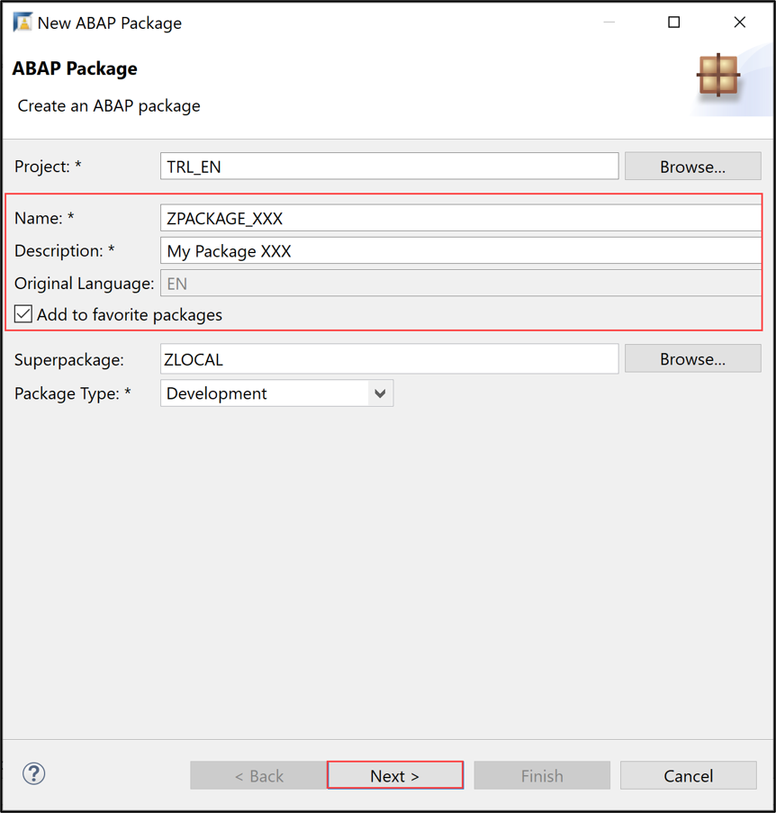

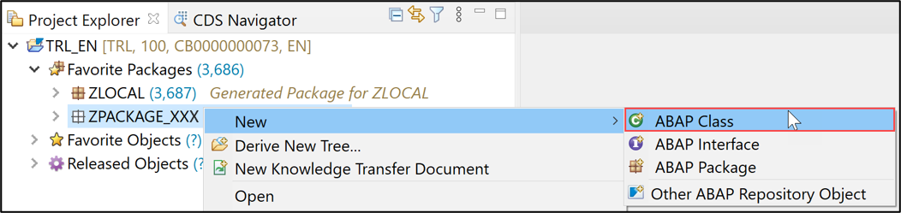

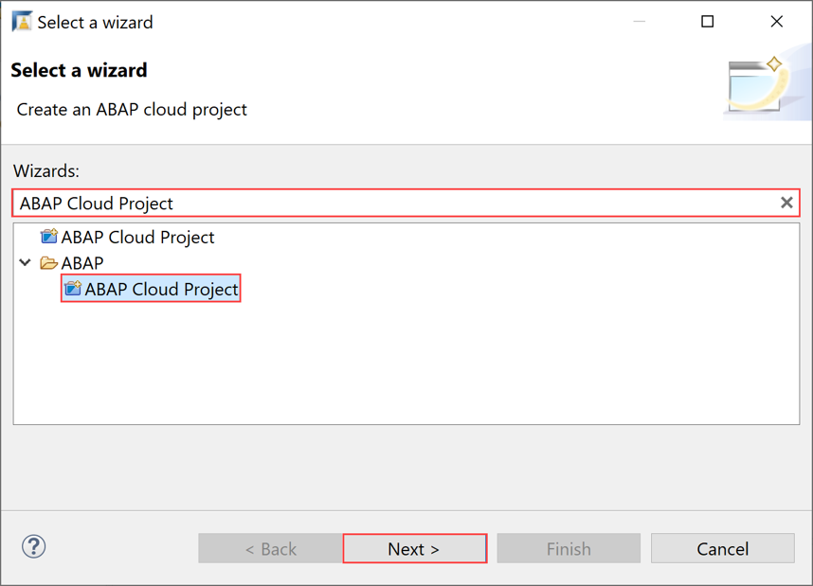

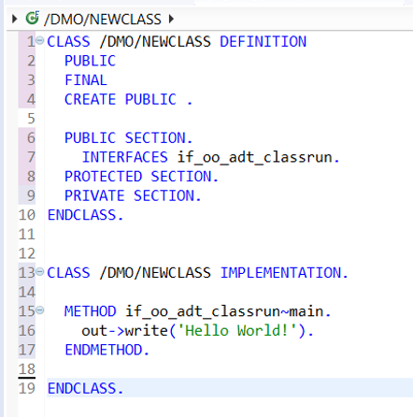

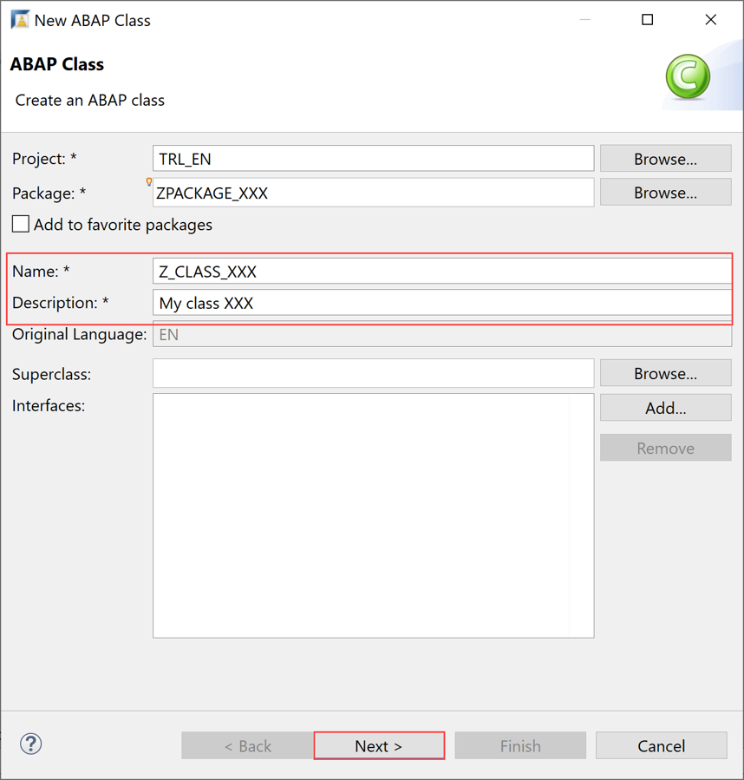  
  
Create asdasd an ABAP package and an ABasdAP class in the SAP BTP, ABAP Environment with the ABAP Development Tools (ADT) in Eclipse.

**You will learn**

* How to create an ABAP cloud project in ADT
* How to create an ABAP package
* How to create an ABAP class
* How to execute the application console

Prerequisites

**For ABAP license:**  
- You have set up your ABAP environment as desasdcribed in [Getting Started with a Customer Account: Workflow in the ABAP Environment](https://help.sap.com/viewer/65de2977205c403bbc107264b8eccf4b/Cloud/en-US/e34a329acc804c0e874496548183682f.html)  
- You have a user in the ABAasP Environment [Connect to the AsBAP System](https://help.sap.com/viewer/65de2977205c403bbc107264b8eccf4b/Cloud/en-US/7379dbd2e1684119bc1dd28874bbbb7b.html)  
- You have downloaded the ABAP Development Tools (ADT). SAP recommends the latest version of ADT, available from [ABAP Development Tools](https://tools.hana.ondemand.com/#abap)  
**For ABAP Trial:**  
- You need an SAP BTP, ABAP environment [trial user](https://developers-test-green.wcms-nonprod.c.eu-de-2.cloud.sap/new_tuts/abap-environment-trial-onboarding.html).  
- You have downloaded the ABAP Development Tools (ADT). SAP recommends the latest version of ADT, available from [ABAP Development Tools](https://tools.hana.ondemand.com/#abap)

In this tutorial, wherever XXX appears, use a number (e.g. 000) or your initials.

For more information, see:- [SAP Help Portal: What is SAP BTP](https://help.sap.com/viewer/65de2977205c403bbc107264b8eccf4b/Cloud/en-US/6a2c1ab5a31b4ed9a2ce17a5329e1dd8.html)











Create asdasd an ABAP package and an ABasdAP class in the SAP BTP, ABAP Environment with the ABAP Development Tools (ADT) in Eclipse.

**You will learn**

* How to create an ABAP cloud project in ADT
* How to create an ABAP package
* How to create an ABAP class
* How to execute the application console

Prerequisites

**For ABAP license:**  
- You have set up your ABAP environment as desasdcribed in [Getting Started with a Customer Account: Workflow in the ABAP Environment](https://help.sap.com/viewer/65de2977205c403bbc107264b8eccf4b/Cloud/en-US/e34a329acc804c0e874496548183682f.html)  
- You have a user in the ABAasP Environment [Connect to the AsBAP System](https://help.sap.com/viewer/65de2977205c403bbc107264b8eccf4b/Cloud/en-US/7379dbd2e1684119bc1dd28874bbbb7b.html)  
- You have downloaded the ABAP Development Tools (ADT). SAP recommends the latest version of ADT, available from [ABAP Development Tools](https://tools.hana.ondemand.com/#abap)  
**For ABAP Trial:**  
- You need an SAP BTP, ABAP environment [trial user](https://developers-test-green.wcms-nonprod.c.eu-de-2.cloud.sap/new_tuts/abap-environment-trial-onboarding.html).  
- You have downloaded the ABAP Development Tools (ADT). SAP recommends the latest version of ADT, available from [ABAP Development Tools](https://tools.hana.ondemand.com/#abap)

In this tutorial, wherever XXX appears, use a number (e.g. 000) or your initials.

For more information, see:- [SAP Help Portal: What is SAP BTP](https://help.sap.com/viewer/65de2977205c403bbc107264b8eccf4b/Cloud/en-US/6a2c1ab5a31b4ed9a2ce17a5329e1dd8.html)





