MICROSERVICES

What is Monolithic Architecture
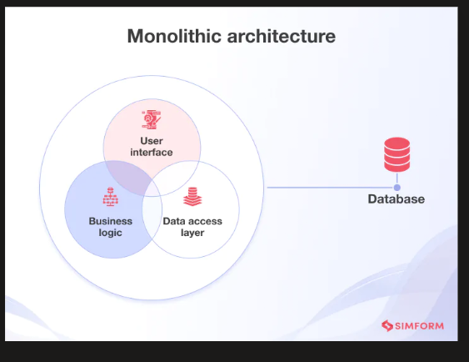

- Definition: Monolithic architecture is a software design where the entire application is built as a single, integrated unit, with all components like UI, business logic, and database tightly connected and deployed together.
- It is easy to develop initially, but becomes complex as the application grows in size and functionality.
⚠️ Disadvantages:
- Poor scalability: The whole application must be scaled even if only one part needs it.
- Single point of failure: A bug or failure in one module can bring down the entire system.
- Difficult maintenance: Large codebase makes it hard to understand and update.
- Slow deployment: Even small changes require testing and redeploying the entire application.

What are Microservices
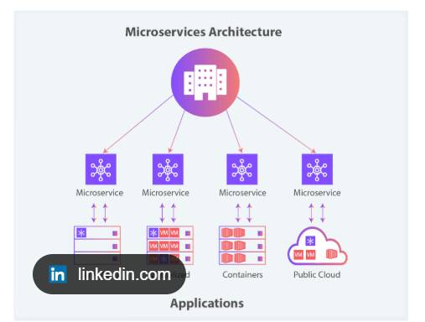
🧩 What are Microservices?
- Definition: Microservices are a software architecture style where an application is built as a collection of small, independent services, each responsible for a specific function.
- Each service runs separately, communicates through APIs (like HTTP/REST), and can be developed, deployed, and scaled independently.
- Example: In an e-commerce system, services like user management, product catalog, payment, and orders are all separate.

🏗️ Microservices Application Architecture
- The application is divided into multiple small services, each with its own logic and database.
- Each service:
  - Focuses on one specific task
  - Runs in its own process
  - Communicates with others using API calls (REST, messaging)
- Components of architecture:
  - ✅ API Gateway – handles client requests and routes them
  - ✅ Service Registry/Discovery – helps services find each other
  - ✅ Independent Databases – each service manages its own data
  - ✅ Communication – via HTTP, REST, or messaging queues
- Services can be deployed on different servers or cloud environments

✅ Advantages of Microservices
- Scalability:
  - Only the required service can be scaled
  - Improves performance and resource usage
- Independent Deployment:
  - Each service can be updated without affecting others
  - Faster and safer releases
- Fault Isolation:
  - Failure in one service does not crash the whole system
- Faster Development:
  - Multiple teams can work on different services simultaneously
- Technology Flexibility:
  - Different services can use different technologies
  - Example: Java for one service, Python for another
- Better Maintainability:
  - Smaller codebases are easier to understand and modify

❌ Disadvantages of Microservices
- Complexity:
  - Managing many services is harder than a single system
- Communication Overhead:
  - Services need to communicate over network → can slow performance
- Difficult Debugging:
  - Harder to trace issues across multiple services
- Deployment Complexity:
  - Requires tools like Docker, Kubernetes, CI/CD pipelines
- Data Management Challenges:
  - Each service has its own database → maintaining consistency is difficult
- Higher Infrastructure Cost:
  - More servers, monitoring tools, and management effort needed

✅ Service Discovery in Microservices
📌 Definition
Service Discovery is a mechanism that enables microservices to dynamically locate and communicate with each other using service names instead of fixed IP addresses and ports.

🔹 Key Points
- ✅ Services in microservices architecture run on dynamic IPs and ports
- ✅ Due to scaling, multiple instances of the same service can exist
- ✅ A central registry is maintained to track all services
- ✅ Each service registers itself with its:
  - Service name
  - IP address
  - Port number
- ✅ Other services do not call by IP, they call using service name
- ✅ The registry returns the current active instance details
- ✅ If a service instance fails, it is removed from the registry
- ✅ New instances with same service name but different IP are automatically updated
- ✅ Helps with:
  - Load balancing
  - Fault tolerance
  - Dynamic scaling

🔄 Core Idea (Your Understanding Included)
- Registry maintains a table like this:
Service Name IP Address Port
PRODUCT-SERVICE 10.0.0.5 8080
PRODUCT-SERVICE 10.0.0.6 8080
ORDER-SERVICE 10.0.0.7 9090
- If one instance fails, it is removed
- If a new instance comes up:
  - Same service name
  - Different IP
  - It gets registered automatically
- When another service wants to call:
Call → PRODUCT-SERVICE
👉 Service Discovery returns:
- Available instance IP + port
👉 Request is sent to that instance

✅ Eureka Server
📌 Definition
Eureka Server is a Netflix-developed service registry that maintains a directory (table) of all microservice instances, allowing services to register themselves and discover other services dynamically by name.

🔹 Key Points (Including Your Concept)
- ✅ Acts as a central service registry (database/table)
- ✅ Maintains mapping of:
  - Service name
  - IP address
  - Port
- ✅ Microservices (Eureka Clients) register themselves on startup
- ✅ If a service goes down:
  - It stops sending heartbeat
  - Eureka removes it from the table
- ✅ If a new service instance starts:
  - Same name + different IP
  - It is automatically added
- ✅ Other services query Eureka using:
- SERVICE NAME → Get IP + PORT
- ✅ Enables calling services like:
- http://PRODUCT-SERVICE/getAll
instead of:
http://10.0.0.5:8080/getAll

🔄 Simple Flow
- Service starts → registers in Eureka
- Eureka stores details in table
- Another service searches by name
- Eureka returns IP + port
- Request is sent to that instance

API GATEWAY :

✅ API Gateway – Definition
API Gateway is a central entry point for all client requests in a microservices architecture. It handles authentication, routing, and sometimes load balancing across services.

🔹 Main Responsibilities of API Gateway
✅ 1. Authentication & Authorization
- Verifies who the user is (JWT, OAuth, etc.)
- Allows/blocks access

✅ 2. Routing
- Routes incoming requests to the correct microservice
Example:
/products → Product Service
/orders → Order Service

✅ 3. Request Aggregation
- Combines multiple service responses into one

✅ 4. Rate Limiting
- Prevents too many requests from a client

✅ 5. Logging & Monitoring
- Tracks request/response data
👉 Load Balancer is responsible for mapping a request to a specific service instance
👉 API Gateway only routes to the service, not to specific instance

🔄 Full Flow (Very Important)
Client
↓
API Gateway
↓
Load Balancer
↓
Service Instances (multiple copies)

✅ Responsibilities Clearly
🔹 1. API Gateway
- ✅ Accepts client request
- ✅ Authenticates request
- ✅ Routes to correct service (by name/path)
Example:
/products → Product Service
🚫 It does NOT decide:
- which instance (IP) to call

🔹 2. Load Balancer
- ✅ Receives request from gateway
- ✅ Selects one instance (based on algorithm)
Example:
Instance 1 (10.0.0.5)
Instance 2 (10.0.0.6)
Instance 3 (10.0.0.7)
👉 It chooses using:
- Round Robin
- Least connections
- Health-based routing

🔹 3. Auto Scaling
- ✅ Creates/deletes instances based on load

📊 Example Scenario
Situation:
- Product Service has 3 instances
- High traffic (100K requests)
Flow:
- Client hits API Gateway
- API Gateway routes:
- /products → Product Service
- Request goes to Load Balancer
- Load Balancer decides:
Req1 → Instance 1
Req2 → Instance 2
Req3 → Instance 3
Req4 → Instance 1
...

⚠️ Important Clarification
❌ API Gateway does NOT:
- pick instance IP
- handle detailed load balancing logic
✅ Load Balancer DOES:
- map request → specific service instance
- handle distribution

🧩 In Some Systems (Special Case)
Sometimes API Gateway can do basic load balancing, but:
👉 In real production (AWS, microservices):
- API Gateway → routing
- Load Balancer → instance selection

✅ Config Server in Microservices
📌 Definition
Config Server is a central place where configuration properties of all microservices are stored and managed (e.g., DB URL, credentials, API keys), so services can fetch them at runtime instead of hardcoding.

🔹 What Config Server Actually Does
- ✅ Stores configuration for multiple microservices
- ✅ Fetches configs from:
  - Git repository ✅ (most common)
  - File system
  - Database
- ✅ Provides configs to services at startup
- ✅ Supports centralized configuration management
- ✅ Allows changing config without redeploying services
🧠 What Actually Happens
Example Setup:
You have 5 microservices:
- Product Service
- Order Service
- User Service
- Payment Service
All need:
- DB connection
- API keys
- common configs

📊 ✅ Config Server Architecture Diagram
┌──────────────────────┐
│ Git Repository │
│ (All config files) │
└─────────▲────────────┘
│
│ (Reads configs)
│
┌─────────┴────────────┐
│ Config Server │
│ (Central Config) │
└─────────▲────────────┘
│
┌────────────────────┼────────────────────┐
│ │ │
│ │ │
┌────┴─────┐ ┌─────┴─────┐ ┌────┴─────┐
│ Product │ │ Order │ │ Payment │
│ Service │ │ Service │ │ Service │
└──────────┘ └───────────┘ └──────────┘

(each service fetches config from Config Server)

🧠 ✅ Explanation (Step-by-Step)
🔹 Step 1: Configuration Stored in Git
- All configs are stored in a Git repository
- Example:
product-service.yml
order-service.yml
application.yml (common config)

🔹 Step 2: Config Server Reads Git
- Config Server connects to Git
- Reads all configuration files
- Acts as a central config provider

🔹 Step 3: Microservices Request Config
When a service starts:
Product Service → calls Config Server

🔹 Step 4: Config Server Responds
It sends back:
DB_URL=xyz
USERNAME=abc
PASSWORD=***

🔹 Step 5: Service Uses Config
- Service connects to DB using received config
- No need to hardcode values
📌 ✅ What If (Without Config Server)?
Without Config Server:
- Each microservice will have its own config:
Product Service → has DB config
Order Service → has DB config
❌ Problems:
- Duplicate config everywhere
- Hard to update
- Need redeployment if config changes
🔹 Why Not Access Git Directly?
If every service connects to Git:
❌ Each service needs:
- Git access setup
- Credentials management
- Logic to read config files
❌ Problems:
- Duplicate logic in every service
- Security issues (Git credentials everywhere)
- Hard to manage and maintain
- Tight coupling with Git
🔄 Flow
- Config stored in Git
- Config Server reads Git
- Microservices call Config Server
- Config Server returns config
- Services use config (DB, etc.)
• ✅ Config Server acts as a central configuration provider
• ✅ All configs are stored in Git repository
• ✅ Microservices do NOT directly connect to Git
• ✅ Each service makes a request to Config Server
• ✅ Config Server fetches data from Git and returns it
• ✅ So services don’t need separate config setup for Git, DB, etc.

✅ Circuit Breaker – Definition / hysterix
Circuit Breaker is a design pattern used in microservices to prevent cascading failures by stopping requests to a failing service and allowing it time to recover.

🧠 Why Circuit Breaker is Needed
In microservices:
- Services depend on each other
- If one service fails or becomes slow
- It can cause chain failures (system crash)
👉 Circuit Breaker prevents this situation ✅

🔹 Key Idea
🔥 “If a service is failing, stop calling it temporarily instead of waiting for timeouts again and again.”

⚙️ Working (Step-by-Step)
✅ Normal Flow (All fine)
Service A → Service B → Response ✅

❌ When Service B starts failing
- Many requests fail
- Timeouts increase
- System load increases
👉 Circuit Breaker detects failure

🔁 States of Circuit Breaker
✅ 1. Closed State (Normal)
- Requests go through normally
- Failures are monitored
A → B ✅

❌ 2. Open State (Service is failing)
- Requests are blocked
- No calls to Service B
A ✖ B (blocked)
👉 Returns fallback response instead

🔄 3. Half-Open State (Recovery check)
- Allows few test requests
- If successful → system recovers
- If fails → goes back to Open

📊 Diagram
┌──────────────┐
│ Closed State │
│ (Normal) │
└──────┬───────┘
│ failures increase
↓
┌──────────────┐
│ Open State │
│ (Blocked) │
└──────┬───────┘
│ after timeout
↓
┌──────────────┐
│ Half-Open │
│ (Testing) │
└──────┬───────┘
success ↑ │ ↓ failure
Closed Open

🔹 What Happens When Circuit is Open
- Service calls are NOT sent
- Instead, fallback response is returned
Example:
"Service unavailable, try later"

✅ Key Benefits
- ✅ Prevents cascading failures
- ✅ Improves system stability
- ✅ Reduces waiting time (timeouts)
- ✅ Protects resources
- ✅ Improves user experience

🔧 Common Implementations
- ✅ Resilience4j (modern, Spring Boot)
- ✅ Hystrix (Netflix, older)
- ✅ Spring Cloud Circuit Breaker

🧩 Example Scenario
Services:
- Order Service → calls Payment Service
Problem:
- Payment Service is down ❌
Without Circuit Breaker:
- Order keeps retrying → system overload 💥
With Circuit Breaker:
- Stops calling Payment
- Returns fallback
✅ System stays stable

- Eureka Server the student and using student MS is registered to Eureka server ,here we can see both the MS are up
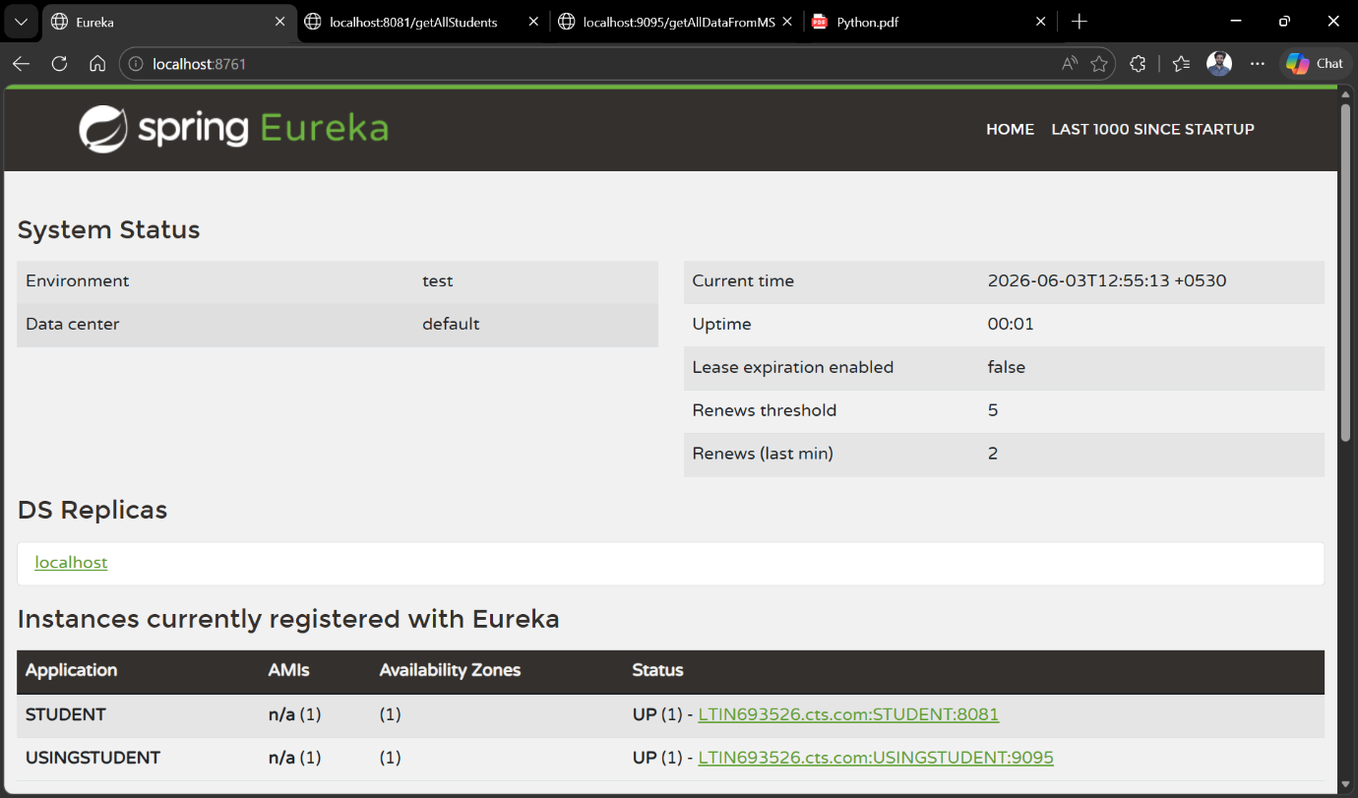

- Client Microservice Student This MS has all the data of the student
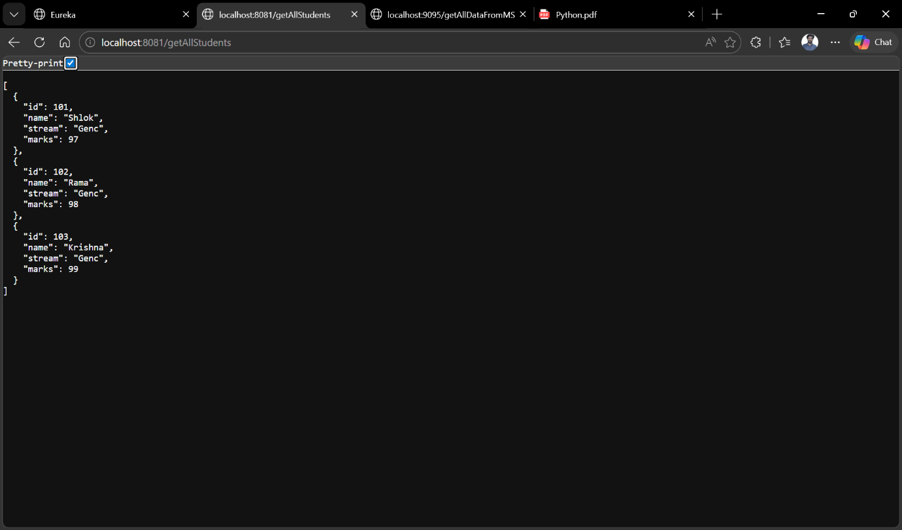

3.Using Student MS -- It is using the student MS and getting the data from the student MS using the feign client(which is an interface ), here through the eureka server we fetch the student MS
