DOCKER
1. docker pull hello-world
2. docker images.
3. docker run hello-world
4. docker ps -a --> lists all the containers.
5. docker ps --> Shows only running containers.
6. docker version --> Gives the version of docker.
7. docker help --> Gives all the commands of the docker.
8. docker rm --> Removes the container.
9. docker inspect <container id> --> Gives complete details about the container.
10. docker logs <container id> --> Gives all the commands executed in the container with the output it has given in the container.
11. docker start <container id> --> Starts the container.
12. docker exec <container id> <command> --> Executes the command in that container.
13. docker volume ls --> Lists all the volumes in the system.
14. docker volume creates myvol --> Creates a new volume named myvol.
15. docker run -it -v myvol:/data unbuntu --> Run the image in a container with a volume attached myvol as data directory.
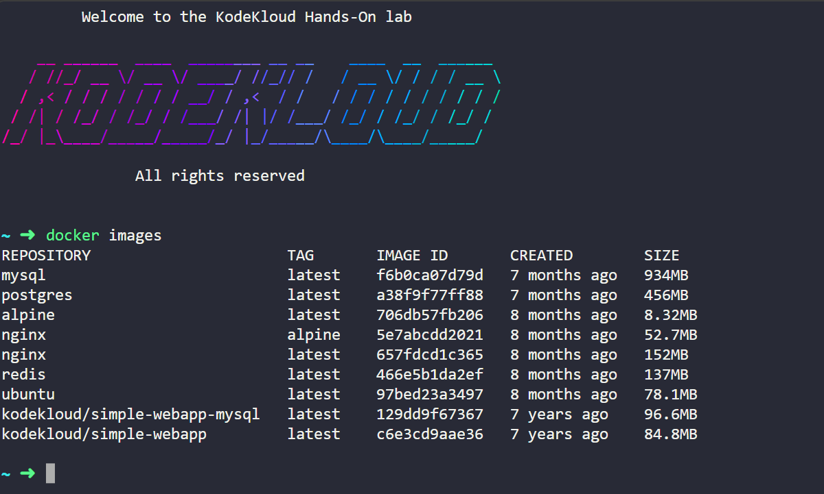

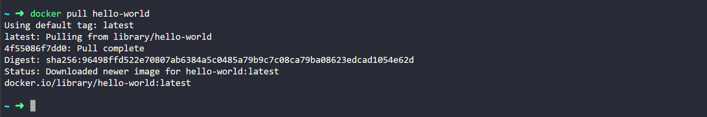
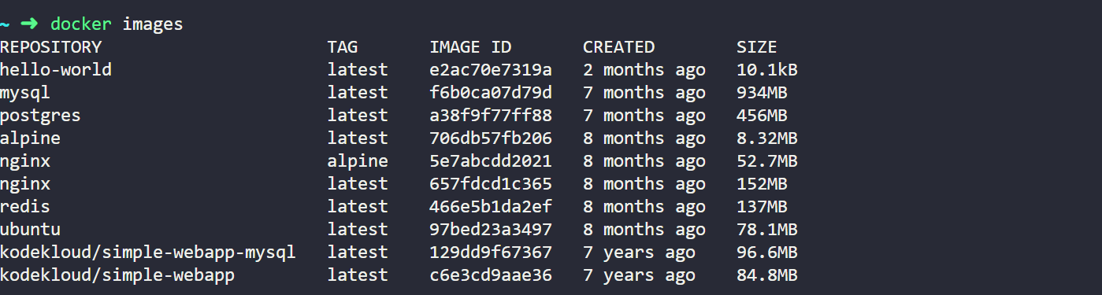
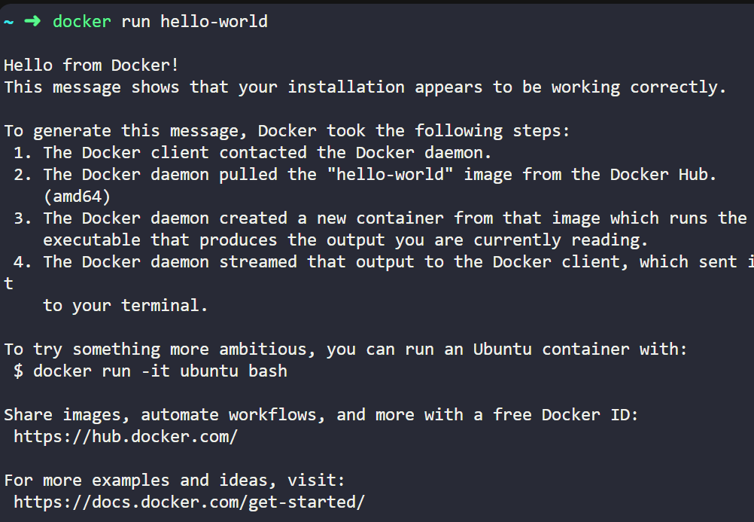
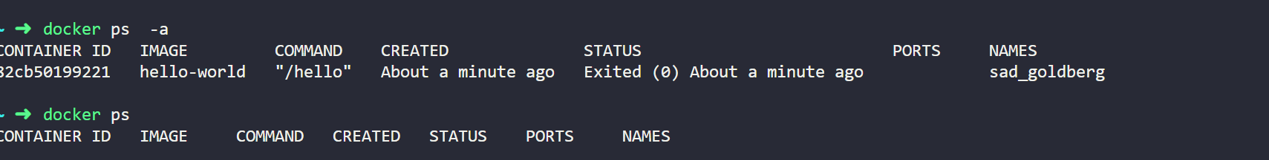

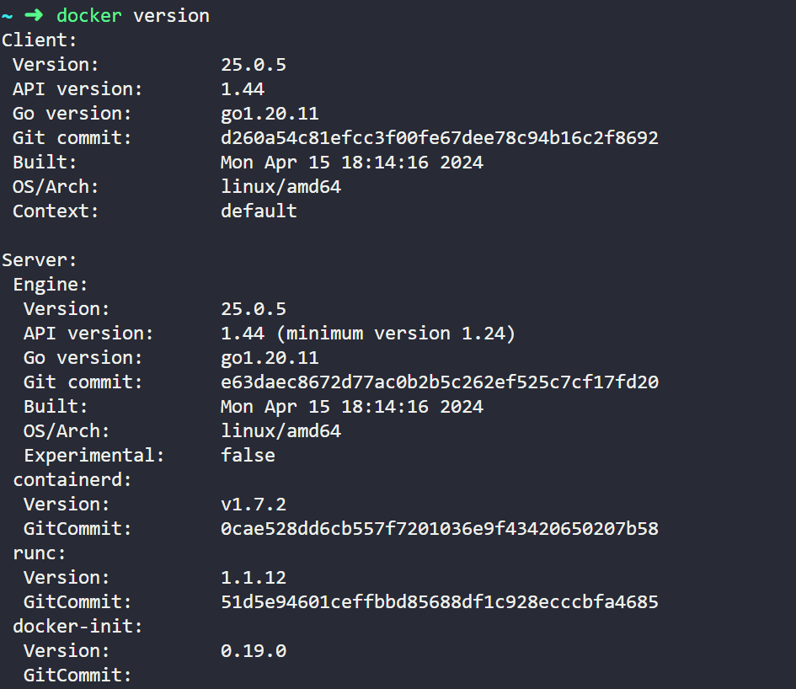
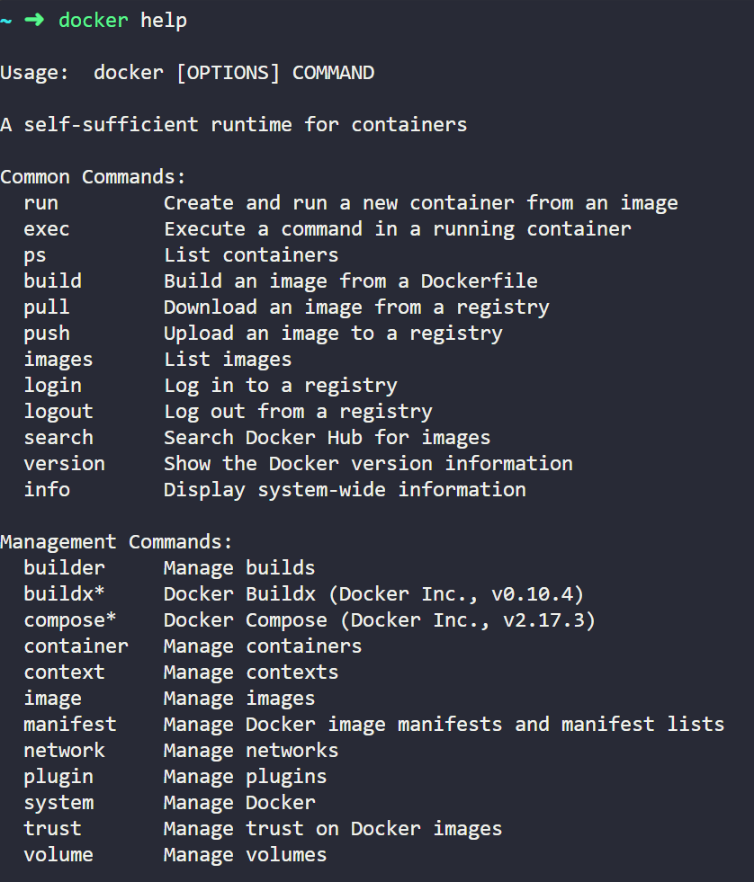
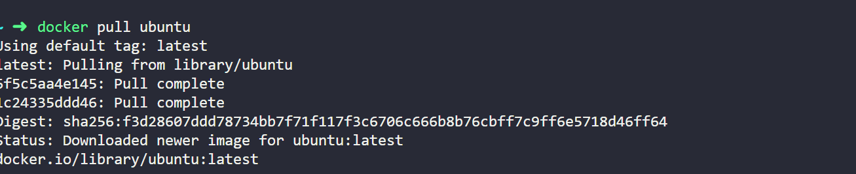
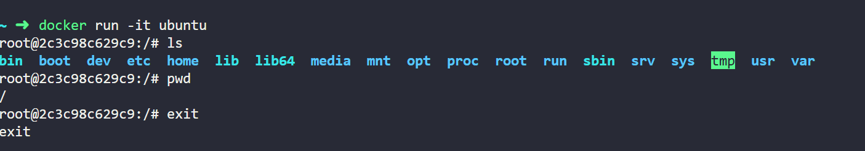
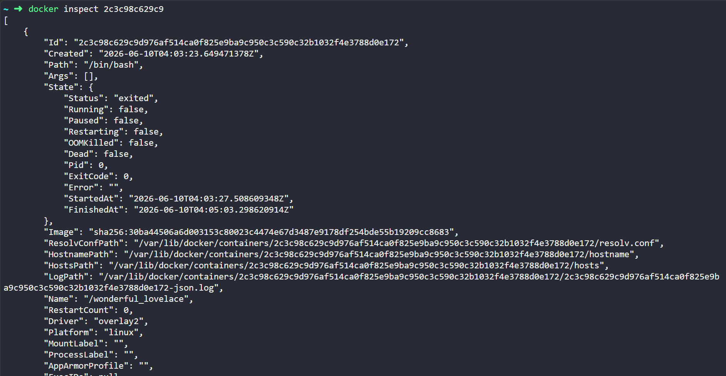
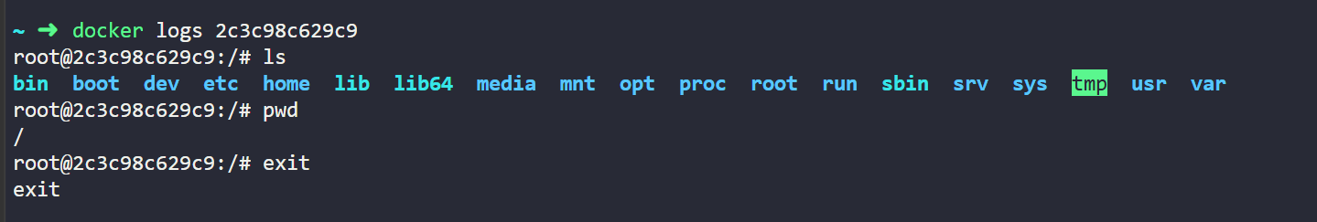
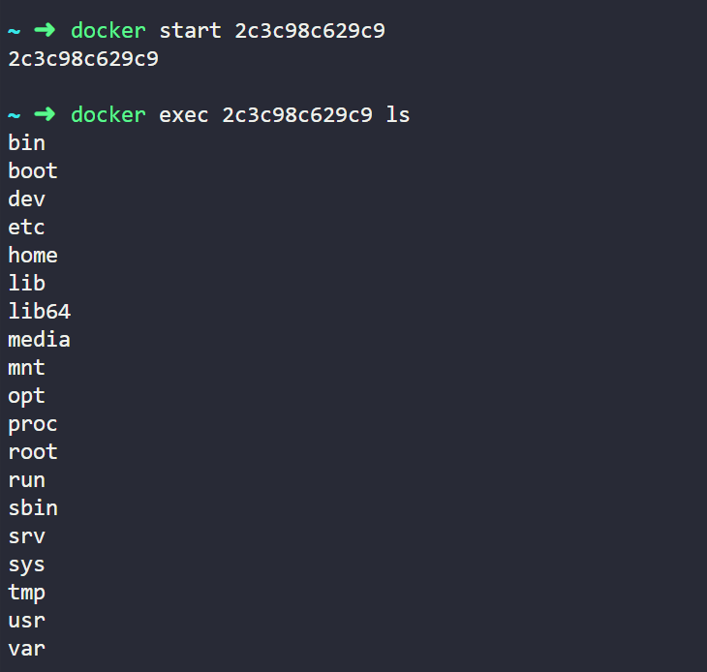
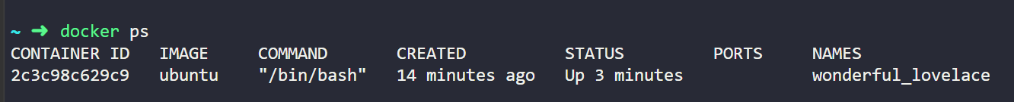
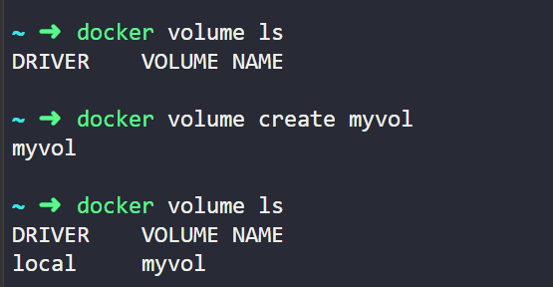

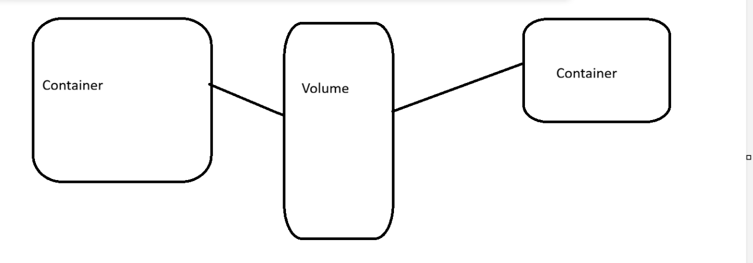

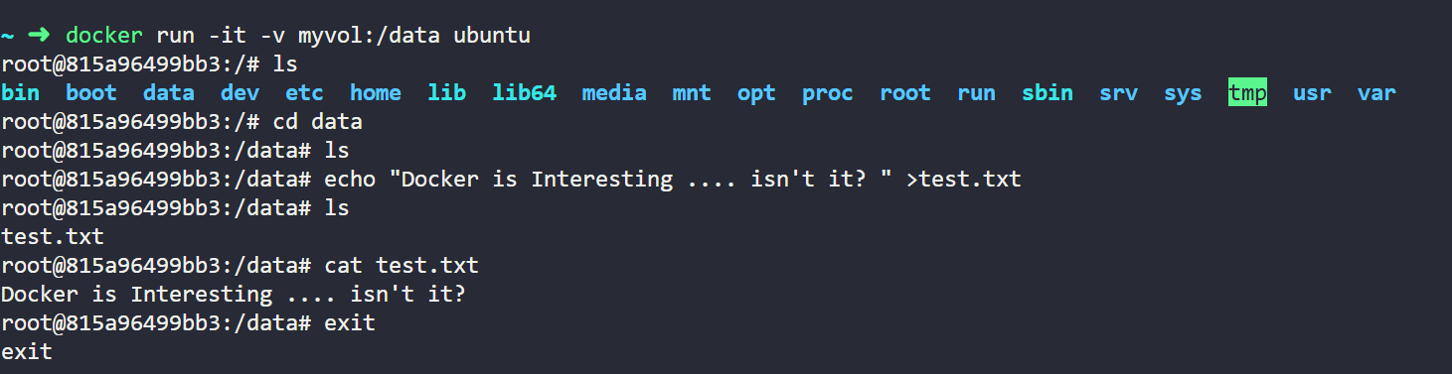
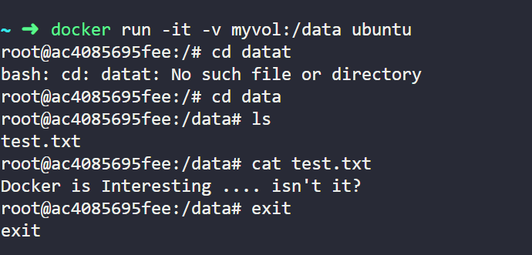
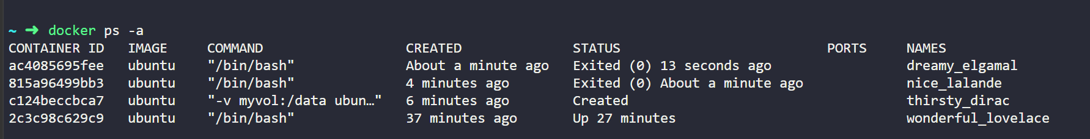

nginx --> Apache tomcat in Linux..

- HTML File... index.html -- Create this file..
2. Create a Dockerfile --> Download nginx and install and copy index.html
3. Build the image --> docker build -t myinx . --> Builds the image named myinx by picking up the Dockerfile from the . i.e., current directory.
4. docker run -d -p 8081:80 myinx --> Executes image myinx in a container. -d is to run in daemon mode. -p is used to connect external port with internal port. 8081 is the external port and 80 is the internal port for nginx. nginx is a web server, is like apache tomcat. --> Click on 3 dots of kodekloud and click on view port and enter 8081 is the externally exposed port and click on open port. You will see the index.html executes from nginx to the external users.

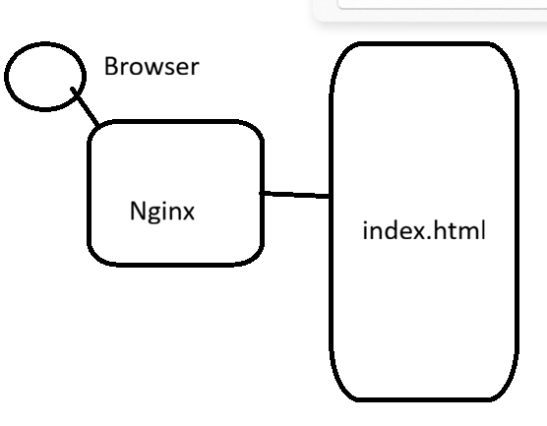

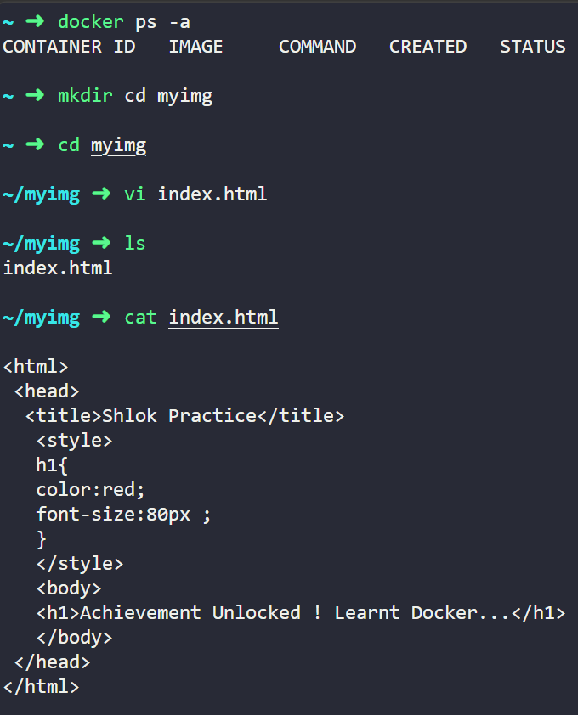
vi index.html -> type -> i -> enter
press esc key then :wq
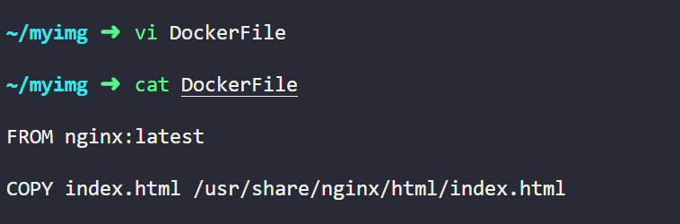
vi Dockerfile -> press enter -> i -> enter
press esc key then :wq

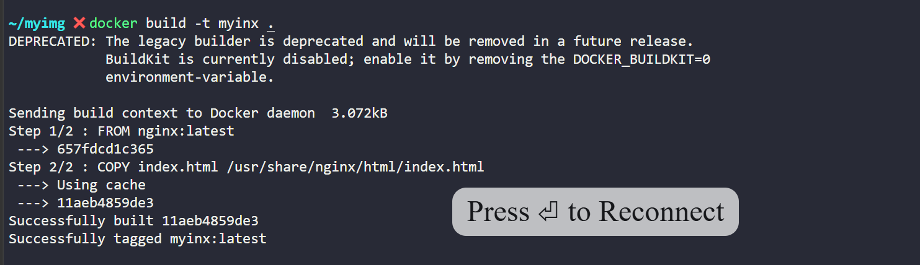
Run the image in a container. -d is for running in the daemon mode and -p is exposing the port. External port attached to internal port
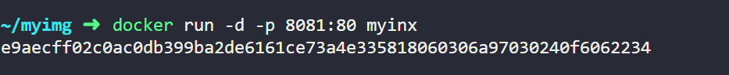
Click on 3 dots of kodkloud
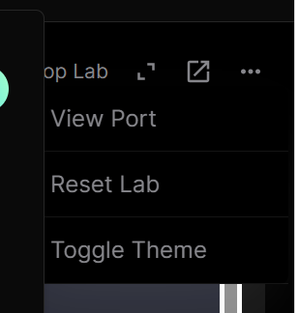
Click on View port
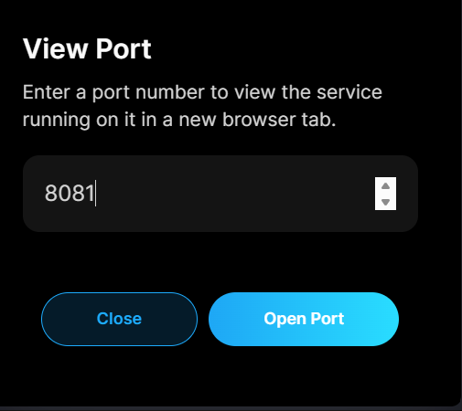
click on open port
