PYTHON
Python is a high-level, interpreted, general-purpose programming language created by Guido van Rossum (1991).
Key points:
- Easy to read and write
- Uses indentation instead of braces
- Supports multiple paradigms:
→ Procedural
→ Object-Oriented
→ Functional
- Python is called an interpreted language because code runs line-by-line, not compiled at once.
1.First Python Program
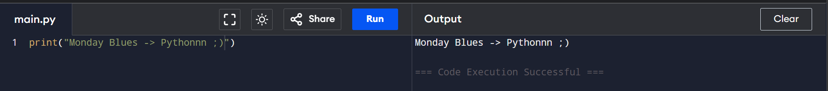
2.Comments
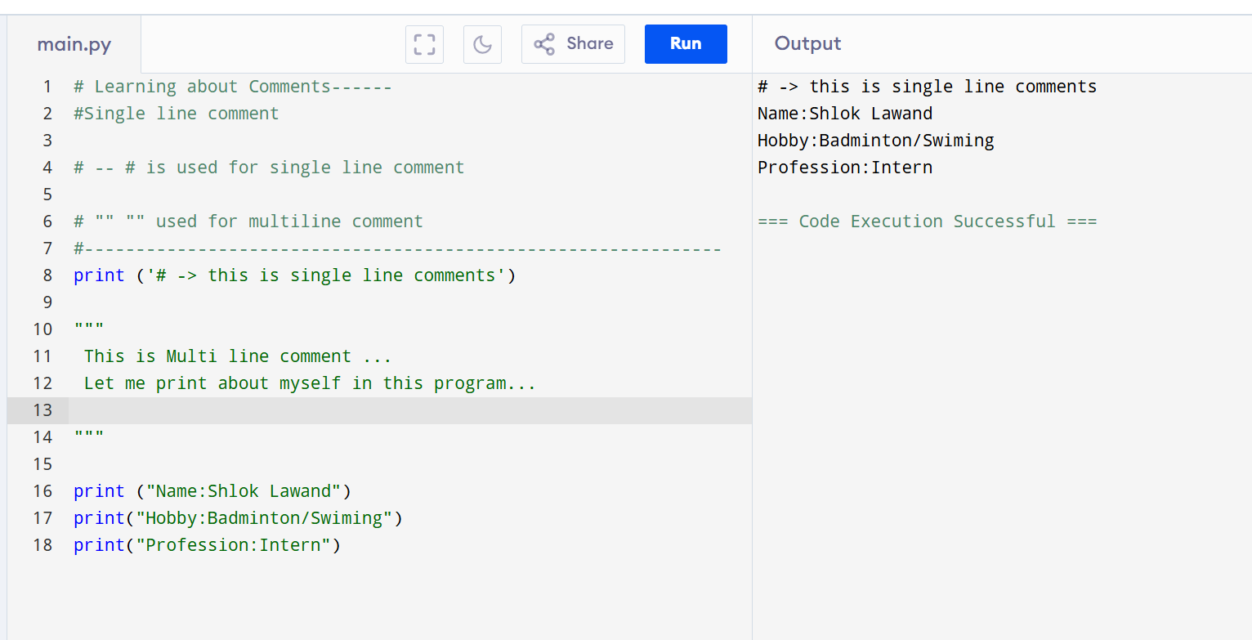

3.Indentation
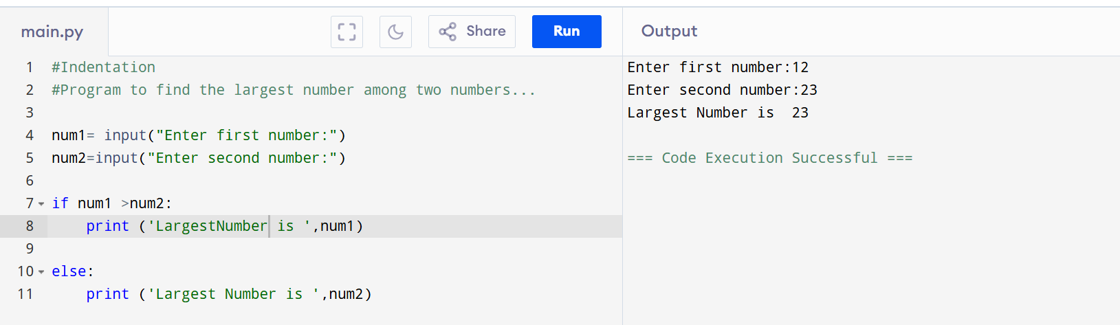

Python Features:
1. Easy to Learn
- Simple syntax (almost like English)
2. Interpreted
- No compilation needed
- Executes line-by-line
3. Dynamically Typed
- No need to declare variable type
4. Object-Oriented
- Supports classes & objects
5. Cross-Platform
- Runs on Windows, Linux, Mac
6. Large Community & Libraries
- NumPy, Pandas, Django, Flask
7. Automatic Memory Management
- Uses Garbage Collection
💡 Interview Tip:
👉 If asked “Why Python?” mention:
- readability
- rapid development
- huge libraries

Python Environment Variables
1. PATH
- Tells OS where Python is installed
C:\Python311\
2. PYTHONPATH
- Used to locate modules
3. PYTHONHOME
- Points to Python installation directory
✅ Example (Linux/Mac):
export PYTHONPATH=/home/user/project
✅ Example (Windows CMD):
set PYTHONPATH=C:\project
💡 Interview Tip:
👉 PYTHONPATH helps Python find custom modules.

Running Python Code from Command Line
✅ Run Python interpreter:
python
This opens interactive mode:
>>> print("Hello")
✅ Run a Python file:
python file.py
✅ Check Python version:
python --version
💡 Interview Tip:
👉 Interactive mode is used for quick testing.

.py Files
✅ What is a .py file?
- A file containing Python code
- Extension: .py
✅ Types of Python files:
Type | Description
.py | Source code
.pyc | Compiled bytecode
✅ Important Concept:
- .py → Python converts to bytecode (.pyc) → executes in Python Virtual Machine (PVM)
💡 Interview Tip:
👉 Python is interpreted but internally compiles to bytecode.

4.Data Type
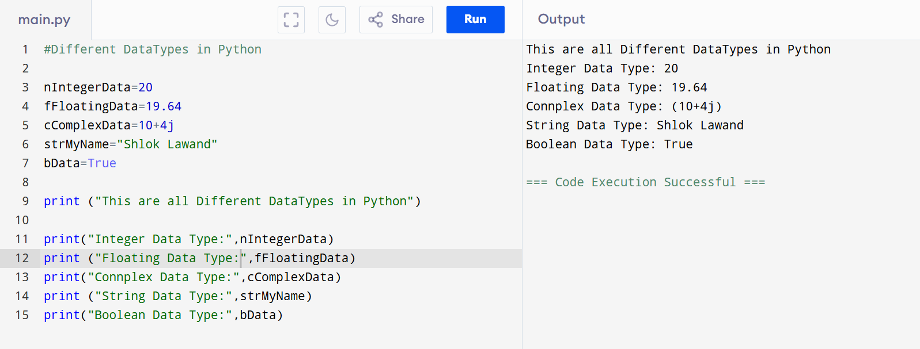

5.String Operations
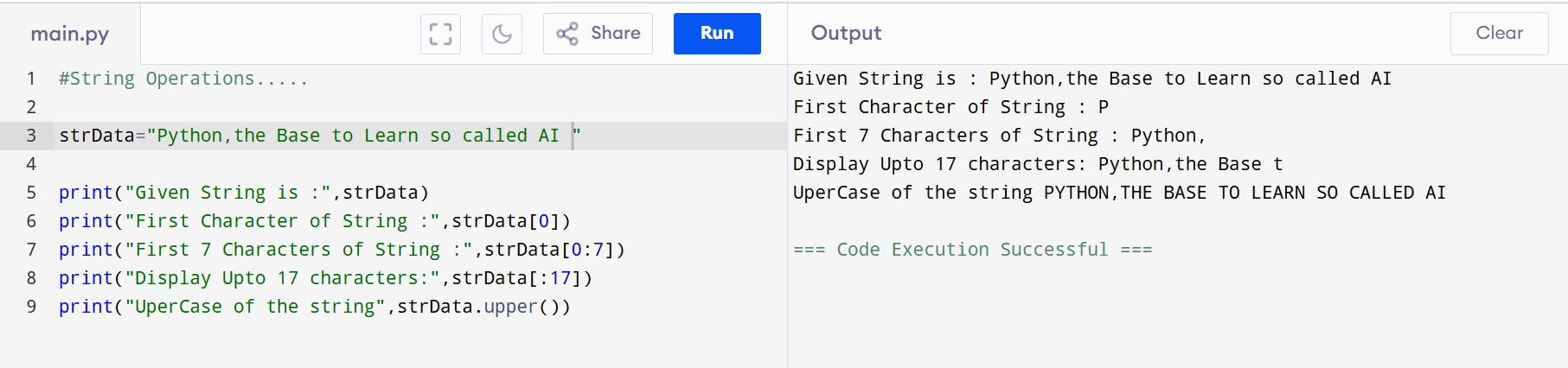
String methods: upper(),lower()
strip()=>Removes spaces,
replace()=> s.replace(‘h’ , ‘H’)
split()
s = "a,b,c"
s.split(",") # ['a', 'b', 'c']
find()
s = "python"
s.find("t") # 2

Operators
1.Arithematic Operators
+ # Addition
- # Subtraction
* # Multiplication
/ # Division
% # Modulus (remainder)
// # Floor Division
** # Exponent (power)
2.Assignment Operators
x += 5 # x = x + 5
x -= 3
x *= 2
x /= 2
x %= 3
x //= 2
x **= 2
3.Comparison Operator
== # equal
!= # not equal
> # greater
< # smaller
>= # greater equal
<= # smaller equal

4.logical Opeators
And,or,not
👉 and → both conditions must be True
👉 or → any one True is enough
a = 10
b = 5

print(a > 5 and b < 10) # True
print(a < 5 or b < 10) # True
print(not(a > b)) # False
5.Membership Operators=>Used to check if value exists in a sequence.
in , not in
x = "python"

print("p" in x) # True
print("z" not in x) # True
6.Identity Operators => Used to compare memory location (object identity).
Is,isnot
👉 == → compares values
👉 is → compares memory (object
a = [1, 2]
b = [1, 2]

print(a == b) # True (values same)
print(a is b) # False (different objects)
7.Bitwise Operator =>Used to perform operations on binary numbers.
& # AND
| # OR
^ # XOR
~ # NOT
<< # Left Shift
>> # Right Shift
8.Operator Precedence =>Defines which operation runs first.
Order
() → Parentheses
** → Exponent
* / // %
+ -
Comparison (==, >, <)
Logical (not, and, or)

6.Conditions if and elif
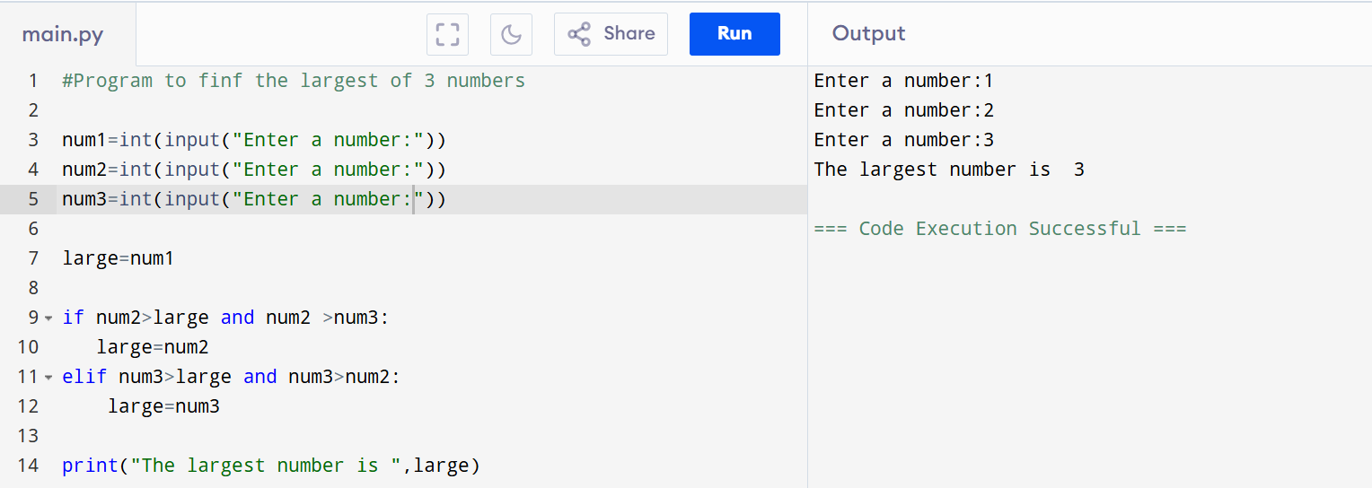

7.Conditions using while
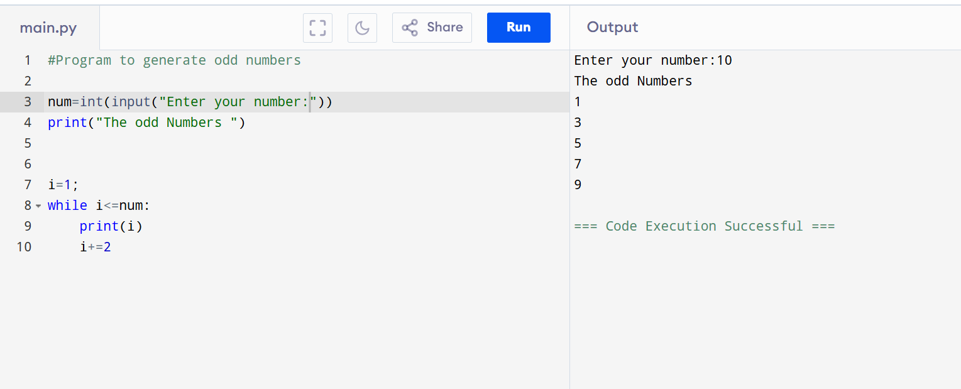

8.Conditions For loop
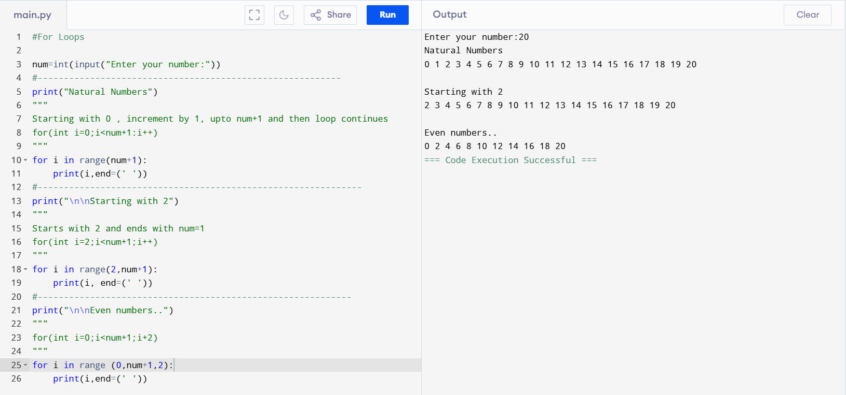

9.Print the list of cities using for loop
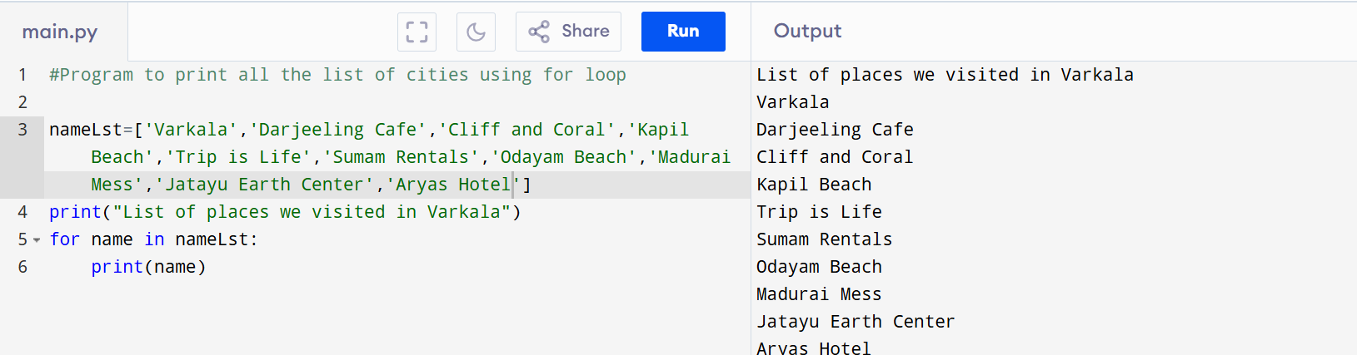

10.Define a Function
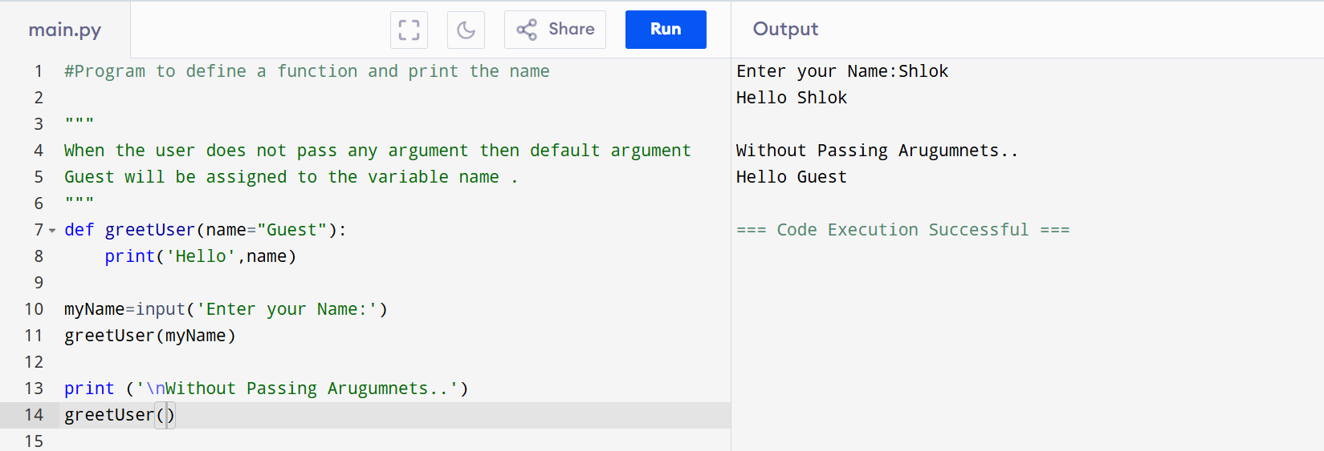
Keyword arguments Arguments are passed using name = value.

11.Variable number of arguments Used when number of arguments is unknown.
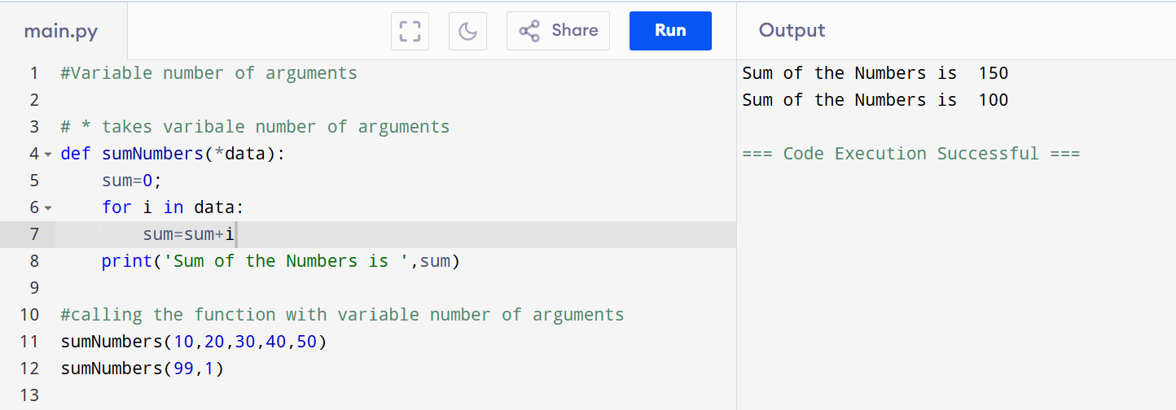
11.2. **kwargs (Keyword)
def show data(**data)
print(data)
show(name=’Shlok’ , age=22)

*args -----> tuple
**kwargs ------->dictionary

12.Call By Reference and Call By Value
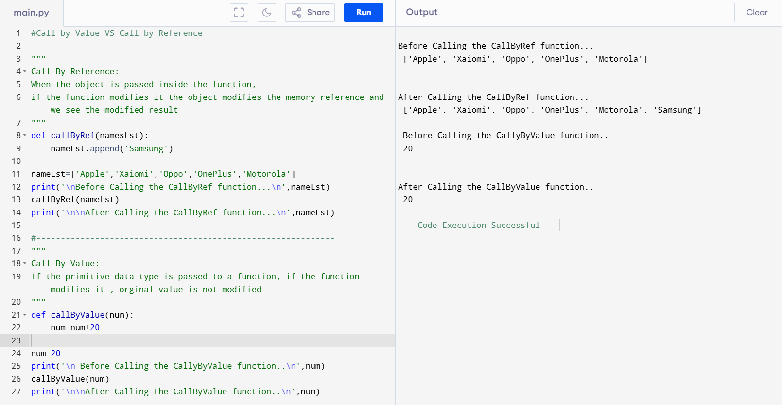

13.List Operations ---- MUTABLES
Uses [ ]
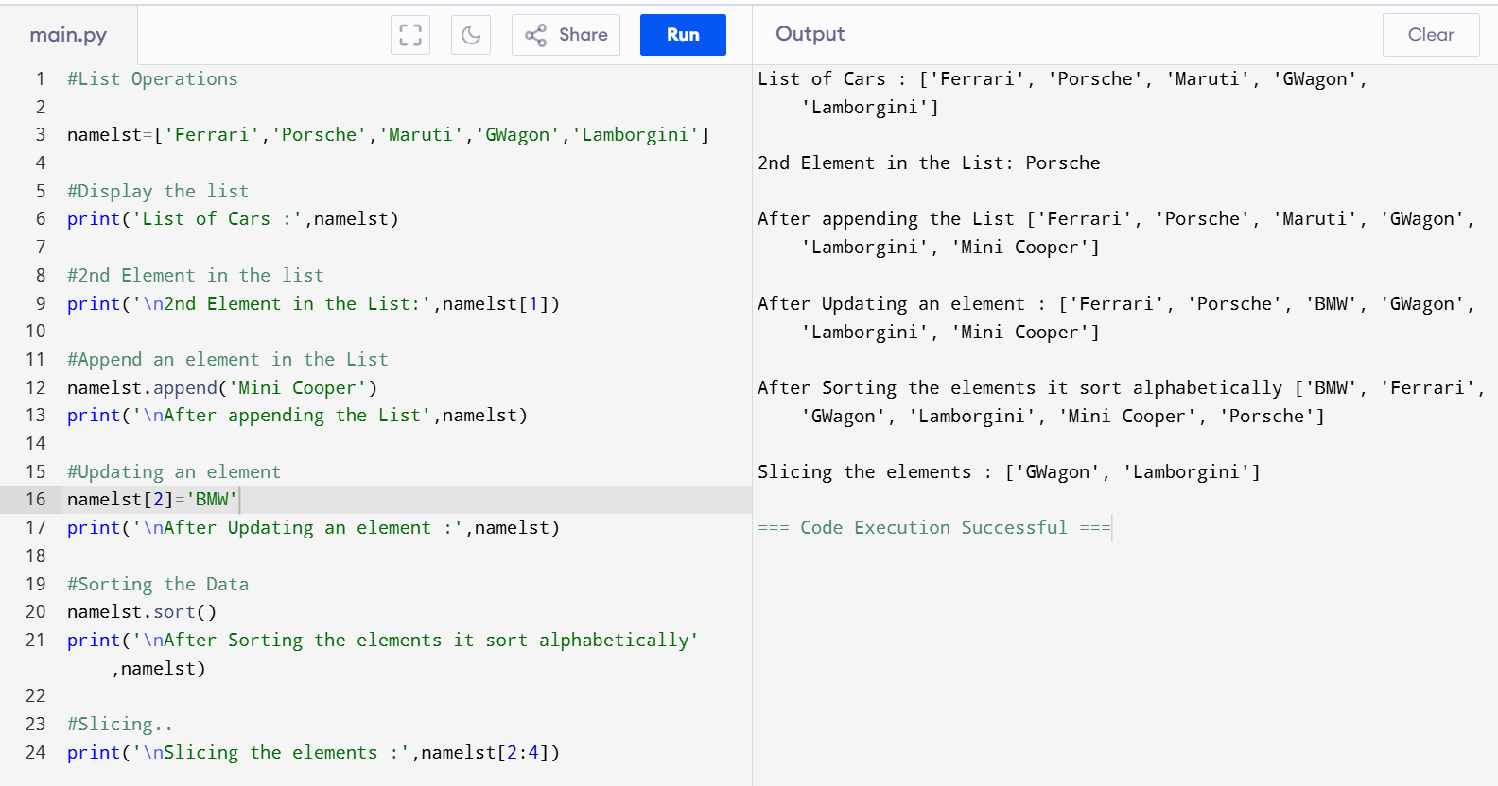
Built in length functions
len(lst) # length
max(lst) # maximum
min(lst) # minimum
sum(lst) # sum of elements
sorted(lst) # returns sorted list
list methods:
append() adds single element in the end,
extend() adds multiple element,
insert(),remove(),pop(),sort(),reverse()

14.Tuples ----- IMMUTABLE
Uses ()
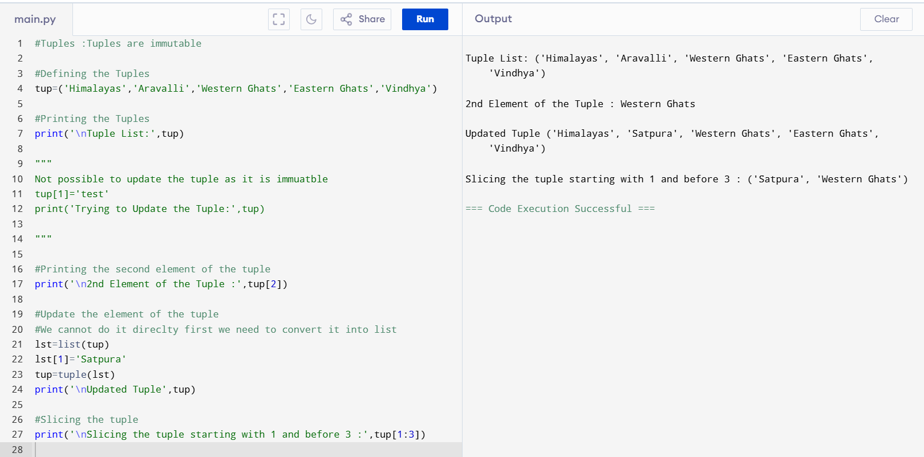

We cannot delete the individual elements , we can delete the entire tuple itself .
Build in tuple functions:
t = (3, 1, 4, 1)

len(t) # 4
max(t) # 4
min(t) # 1
sum(t) # 9

15.Dictionary
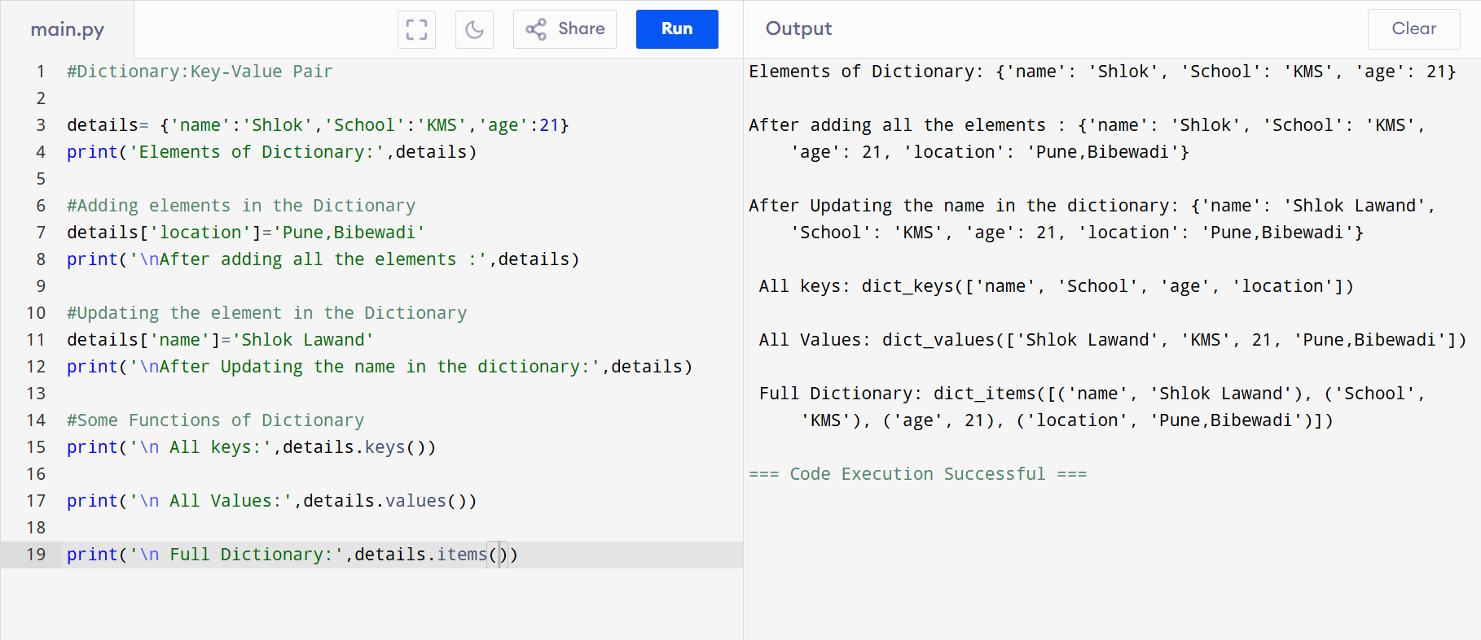
Dictionary Functions:len(),type(),str()
Dictionary Methods: keys(), values(),items(),update(),get(),pop()

16.Class in python
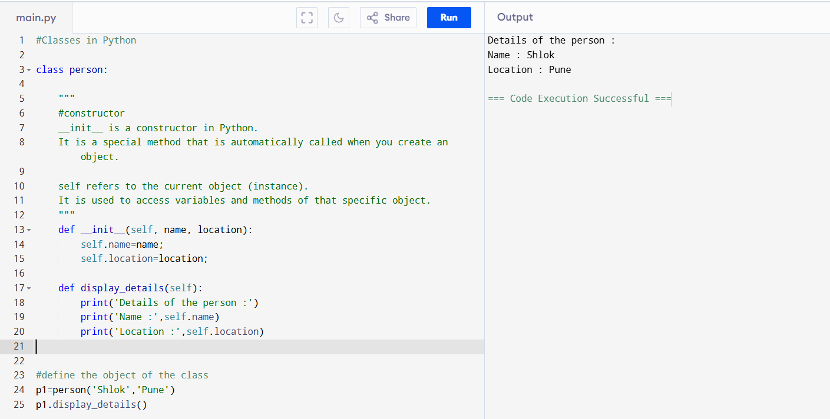

17. Class Function Return- Functions can return values.
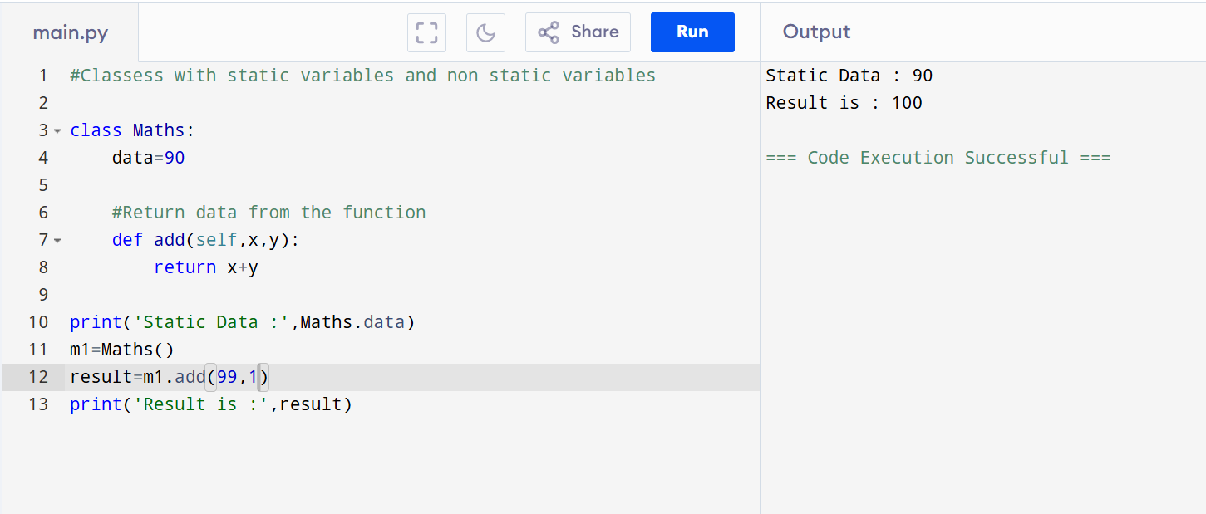

18.Inheritance
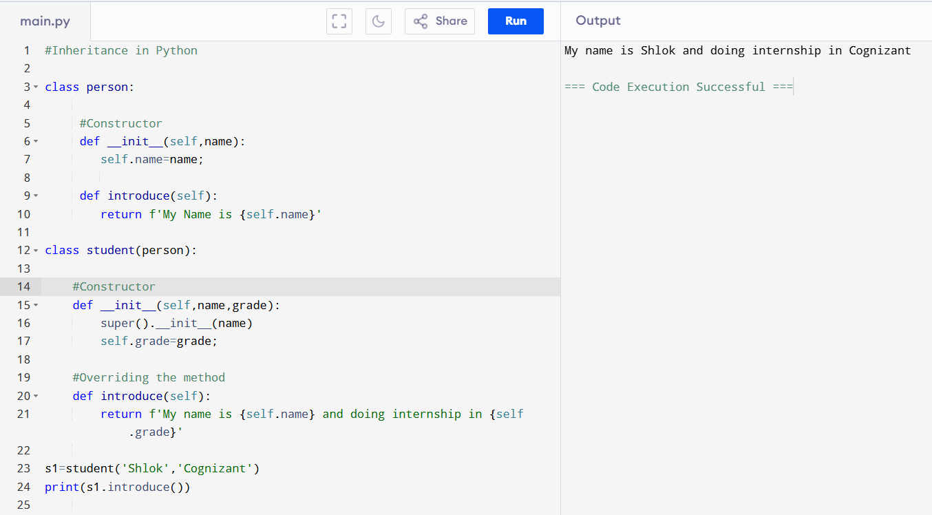

19.File Handling
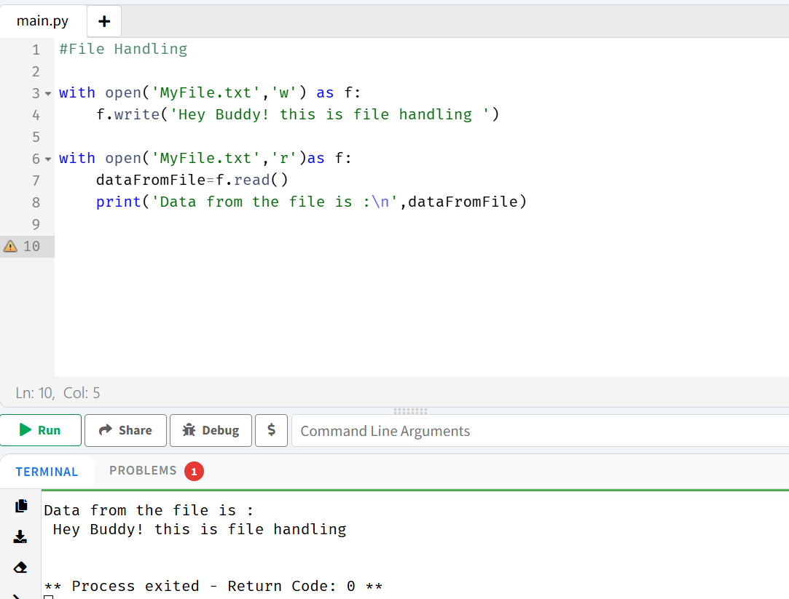

20.File Handling Attributes
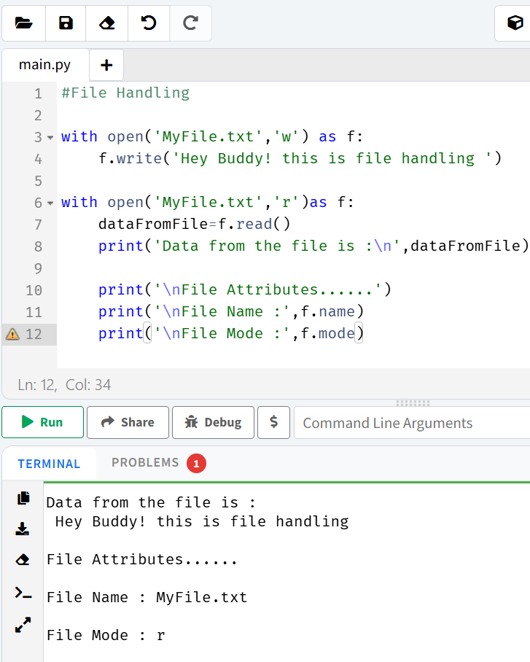

21.Using for Loop to print the contents of the filet
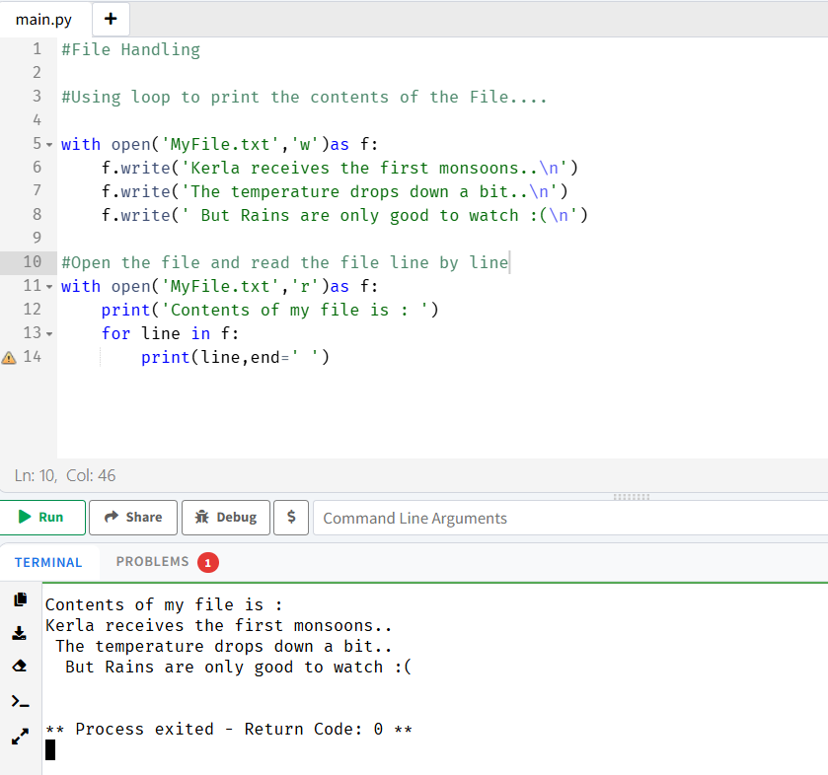

22.OS directory Functions:
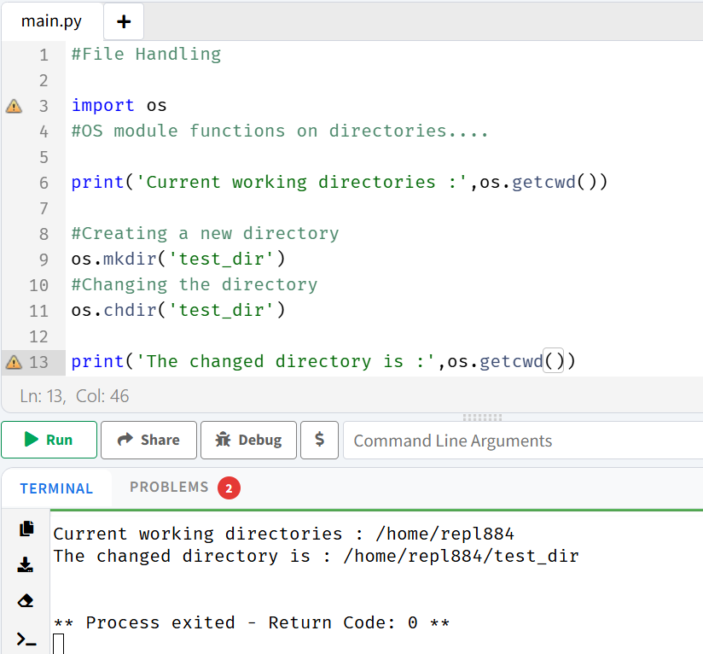
File and directory Methods:
os.getcwd()
os.chdir()
os.mkdir()
os.listdir(), os.path.exists() ,
os.rmdir() rename a directory
os.rename(“old.txt”,”new.txt”)----- renames the file

23.Modules
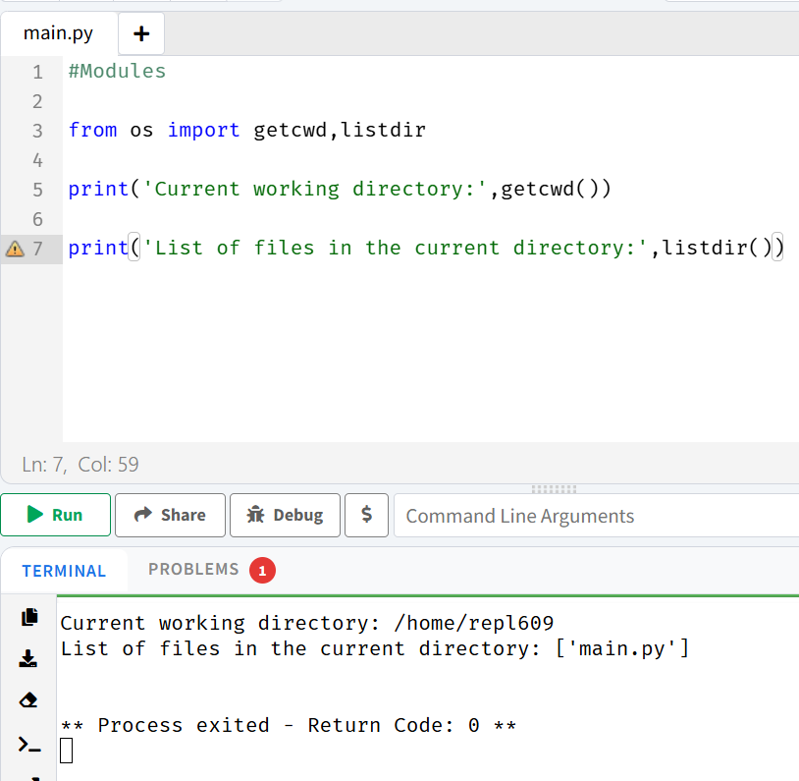
24.Modules PythonPath
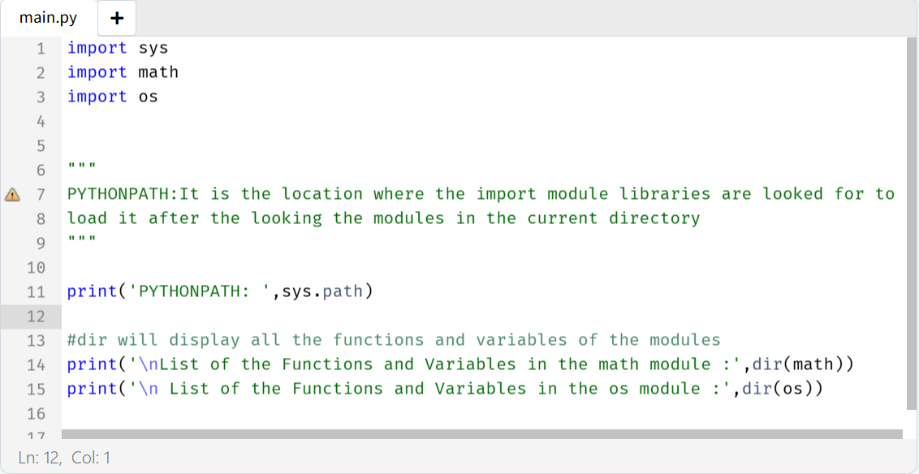
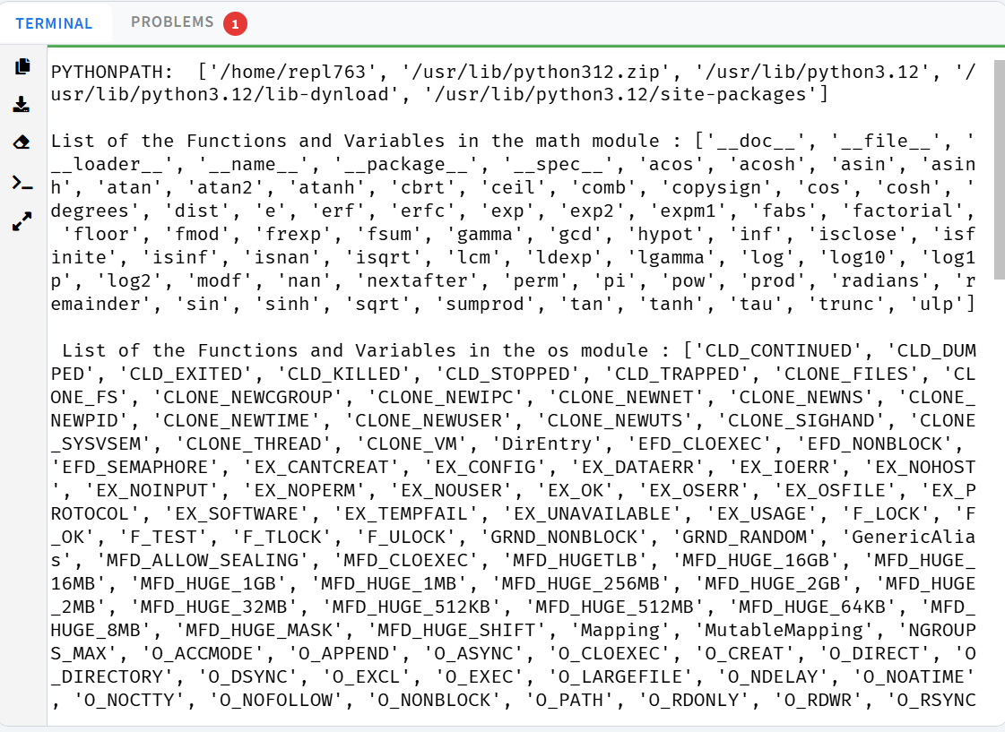

25.locals()and globals()
