PowerBI Home Loan Dashboard

Project Overview
Brief intro explaining that the dataset represents home loan records across multiple branches, covering loan applications, sanctions, disbursements, recoveries, and customer details.
It will mention the use of Power BI for data visualization, KPI tracking, and performance monitoring.

Dataset Description
Each table will be clearly explained:
- Branch Table (location, pin code, for map visualization)
- Channel Table (loan acquisition channels)
- Customer Table (loan application info)
- Sanction Table
- Recovery Table

Business Objectives
The main objective of this dashboard project is to analyse Home Loan performance and gain actionable business insights that support data-driven decision-making. The key goals include:
- Analyze loan performance across branches
- Track loan lifecycle (Applied → Sanctioned → Disbursed → Recovered)
- Identify top-performing channels and branches
- Understand customer demographics (age, occupation, income level)

Key Business Questions
- What is the total loan applied, sanctioned, and disbursed?
- Which branch or channel brings the highest applications?
- What is the recovery rate by branch or month?
- Which customer segments (age/salary/occupation) dominate loan applications?

Tools & Techniques
Power BI Desktop
- Data Modelling & Relationships
- DAX for KPIs
- Power Query for Data Cleaning
- Interactive Dashboards (Maps, Bar Charts, Slicers, KPI Cards)

Deliverables :
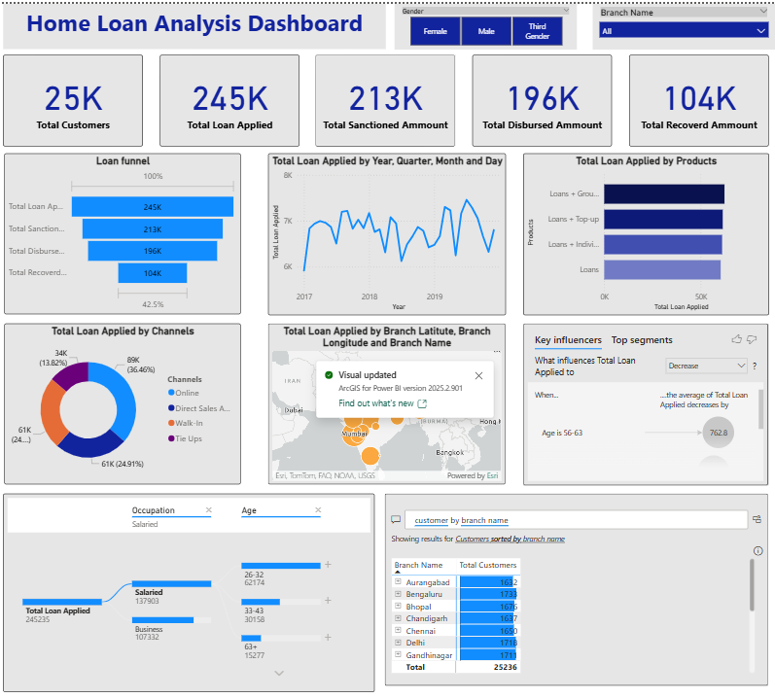

Insights :
Total Loan Applied: 245K (in lacs)
Total Sanctioned Loan: 213K (in lacs)
Total Disbursed Amount: 196K (in lacs)
Total Recovered Amount: 104K (in lacs)

